

Programme: BA (Hons) Business Management
Module: Academic Skills
Module code: LCBB4012
Assignment Title: Component 1: Coursework

Title of the assignment: Time Management for academic success

Lecturer’s name: Dr. Roopa Aruvanahalli Nagaraju
Student name: Roxana Dumitru
Student ID: 2332951
Table of Contents
1. Introduction 3
2. Definition of Time Management 3
3. Importance of Time Management 3
4. Time Management strategies 4
5. Conclusion 5
Reference List 6

1. Introduction
Time management is a fundamental activity in the achievement of academic success. Academic activities are highly important and continuous in nature. The achievement of deadlines is a crucial requirement that needs to be adopted in a limited period. Distractions have been commonly identified in the students. The purpose of this report is to examine the importance of time management in the achievement of academic success. The definitions, significance, and application of time management has been discussed to emphasise its role in the achievement of academic success.

2. Definition of Time Management
Time management is the systematic planning and conscious control of time required for the execution of specific activities to enhance efficiency. Time management is the ability to organise, prioritise, and allocate time in accordance with set goals and responsibilities (Ghafar, 2023). Thus, time management is a systematic process through which academic activities are planned and executed in accordance with set deadlines (Samsudin et al., 2023). Effective time management which helps in the establishment of set goals, priorities tasks, and minimisation of distractions. The application of planning tools, schedules, and routines are crucial activities in time management (Fathima, 2025). Academic activities are planned in a systematic manner in accordance with available time periods. Thus, time management helps in minimising the levels of stress, and efficiency is enhanced. Time management helps in supporting enhanced academic performance.

3. Importance of Time Management
Time management is highly essential for academic performance as academic activities are diversified and ongoing in nature. It is necessary for academic activities such as assignments, examinations, and project completion to be completed within a fixed time. Effective time management is positively related with academic performance, and students achieving high grades mostly have good time management skills (Samsudin et al., 2023). There is a significant relevance of time management in relation to enhancement in academic performance. Students who are organised in nature show improved concentration and completion of tasks (Ghafar, 2023). In addition to this, academic stress is reduced in students whose activities are planned in advance.
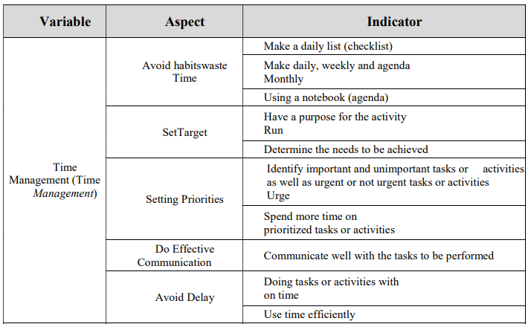
Figure 1: Academic performance and time management
(Source: Samsudin et al., 2023)
It is emphasised that distractions in academic activities have to be controlled to enhance academic potential in students (Harrington, 2025). For example, students can minimise distractions such as social media from interfering with their academic activities by setting specific times for studying. Academic performance in students is improved when there is balanced allocation of time between academic activities, free time, and other activities such as sports (Fathima, 2025). Thus, academic tiredness is prevented in students whose activities are planned in advance. Thus, time management is regarded as an essential skill in enhancing academic performance.

4. Time Management strategies
Eisenhower Matrix
The Eisenhower Matrix is a prioritisation tool that is used to group tasks according to their urgency and importance levels (Fathima, 2025). Tasks are grouped into four categories that include urgent and important, important but not urgent, urgent but not important, and not urgent and not important. Using this matrix, academic tasks are clearly defined and grouped. Important academic tasks are dealt first before less important ones. Time is saved by eliminating less important tasks. The significance of prioritisation in academic contexts is a vital aspect for goal clarity and academic planning (Harrington, 2025). When academic tasks are prioritised, academic performance is enhanced (Ghafar, 2023). Using the Eisenhower Matrix, examination preparation is classified as urgent and important, while free time activities are classified as less important.
Pomodoro Technique
The Pomodoro technique is a time management technique in which study sessions are divided into small intervals of focused study, lasting for a maximum of twenty-five minutes. Concentration occurs during the intervals, by avoiding any kind of distractions. After the fourth interval, a break occurs to help the student regain energy. The control of distractions has been highlighted as a requirement for academic clarity and attention (Harrington, 2025). Academic performance has been linked with the allocation of time in a disciplined manner (Samsudin et al., 2023). The application of the technique enables the management of study sessions in a strategic manner. For example, the study of chapters can be divided into smaller intervals. The application of the technique increases productivity, which helps in reducing delay.

5. Conclusion
Time management is a crucial requirement for great academic performance. Academic performance has been enhanced through the application of time management. Stress levels have been reduced by the use of time management. The application of the Eisenhower Matrix technique and the Pomodoro technique can be applied to ensure the achievement of academic goals in a successful manner.

Reference List
Fathima, S.A. (2025) ‘The role of time management in enhancing student performance’, International Journal of Farm Sciences, 15(1), pp.31-36.
Ghafar, Z.N. (2023) ‘The relevance of time management in academic achievement: A critical review of the literature’, International Journal of Applied and Scientific Research, 1(4), pp.347-358.
Harrington, J. (2025) Focused Future: Mastering Clarity, Controlling Distractions, and Unlocking Academic Success. BookRix.
Samsudin, H., Sari, A.R., Akob, M. and Kurniawan, A. (2023) ‘Analysis of academic performance time management and achievement’, GEMILANG: Jurnal Manajemen dan Akuntansi, 3(2), pp.87-93.

