

Data Security, Governance and Compliance (ACCA7028)

Caribbean Coffee’s Report: Research of Security Frameworks and Design of Caribbean Coffee’s Security Frameworks

Submitted by:
Yinan Yan
Student ID: 2006532

Contents
1. Introduction 2
2. Research of security frameworks 3
2.1 DMBOK2 3
2.2 ISACA 6
2.3 HESA 7
3. Design of Caribbean Coffee’s security frameworks 10
3.1 Analysis of Caribbean Coffee’s situation 10
3.2 Design of framework 10
4. Conclusions 13
References 13

Caribbean Coffee’s Report: Research of security frameworks and design of Caribbean Coffee’s security frameworks

Abstract: With the rapid development of IT technology, data security governance has become an important research topic, and ensuring data security has become the primary task. This report conducts research on three security frameworks, which are DMBOK2 data governance framework, ISACA data governance framework and HESA data governance framework, and analyses and critique these frameworks. According to the research above, this report will build a suitable security framework for the Caribbean Coffee’ situation. The approach of security framework will meet the need of the Caribbean Coffee’s information system security, governance and compliance.

Key word: data governance, security
- Introduction
As global use of the Internet continues to grow, the demand for and reliance on Internet-based information creates an increasing expectation of access. Businesses are reliant on the Internet, which creates an increasing threat of attacks on information assets and need for greater number of professionals capable of protecting those assets. Realizing data governance will improve data management performance, ensure data quality, and form a new situation of open sharing [1]. Data governance is an organic combination of decision-making and operation implementation, and the governance entity should take responsibility for these data assets to build a data governance model, which can provide intuitive and clear operation guidelines and action guidelines for the organization's data governance work[2].We make an research on three data governance framework, and learn something from these framework, and then apply the experience to the Caribbean Coffee Company’s situation. After the building of the new data governance framework, we can learn many things from the process. We can know that the framework is updating with the improvement of the technology.
- Research of security frameworks

2.1 DMBOK2
The International Data Management Association (DAMA), launched DMBOK2 (Data Management Body of Knowledge 2. nd Edition) has certain guidance for the construction of enterprise data governance system. DAMA-DMBOK defines 11 Data Management Knowledge Areas for Guide the evaluation of the organization's data management functions and data strategy, and advise and guide the start-up organizations to implement and improve data management.
The 11 Data Management Knowledge Areas are shown in the figure 1 [3].
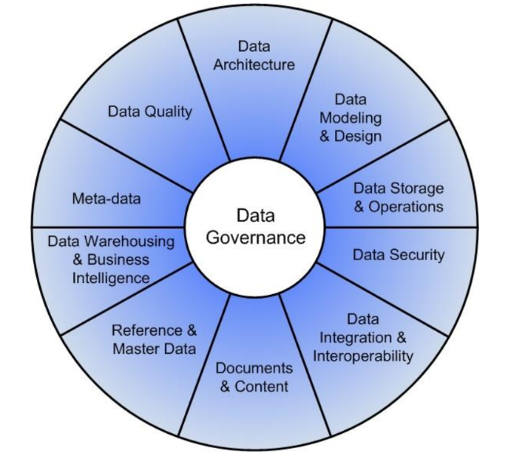
Figure 1 11 Data Management Knowledge
The 11 Data Management Knowledge Areas are:
Data Governance – planning, oversight, and control over management of data and the use of data and data-related resources. While we understand that governance covers ‘processes’, not ‘things’, the common term for Data Management Governance is Data Governance, and so we will use this term.
Data Architecture – the overall structure of data and data-related resources as an integral
part of the enterprise architecture
Data Modeling & Design – analysis, design, building, testing, and maintenance (was Data Development in the DAMA-DMBOK 1st edition)
Data Storage & Operations – structured physical data assets storage deployment and management (was Data Operations in the DAMA-DMBOK 1st edition)
Data Security – ensuring privacy, confidentiality and appropriate access
Data Integration & Interoperability –acquisition, extraction, transformation, movement, delivery, replication, federation, virtualization and operational support ( a Knowledge Area new in DMBOK2)
Documents & Content – storing, protecting, indexing, and enabling access to data found in unstructured sources (electronic files and physical records), and making this data available for integration and interoperability with structured (database) data.
Reference & Master Data – Managing shared data to reduce redundancy and ensure better data quality through standardized definition and use of data values.
Data Warehousing & Business Intelligence – managing analytical data processing and enabling access to decision support data for reporting and analysis
Metadata – collecting, categorizing, maintaining, integrating, controlling, managing, and delivering metadata
Data Quality – defining, monitoring, maintaining data integrity, and improving data quality
The advantage of the DAMA framework is that it fully considers the impact of functions and environmental elements on the data itself and establishes a corresponding relationship. However, the shortcomings of this framework are also here. The 11 Data Management Knowledge Areas summarized by the functional sub-frame cannot fully summarize the data management functions. With the development of the times, the popularity of big data has become more and more diversified, and its functions have become more and more diversified. However, the DAMA framework is limited to these 11 areas, which obviously cannot meet the future needs of data management and governance.
  - ISACA
Information Systems Audit and Control Association (ISACA) is a globally recognized leading organization for information technology management and monitoring. ISACA constructed the ISACA data governance model from four perspectives: administrative funding, culture, management indicators, training and awareness training, as shown in Figure 2[4]. ISACA data governance determines the data governance strategy or goal based on the organization’s vision and mission, organizational interests, and specific goals under the premise of organizational funding. Through this process, the positioning of the data governance model will be more precise and rooted in the needs of the organization itself. Since governance is flexible, the scope of governance can be appropriately expanded or reduced according to the needs, so this model is not "rigid", and adjustments within a controllable range are a major feature. Another feature of this model is that it fully embodies the initiative and leading role of people, and its full participation in the process of data governance. In addition, the model adopts a top-level design and grassroots implementation method, upholds the simple and practical principle, only conducts governance where needed, and does not incorporate additional steps into the governance process, ensuring that all links of the model add value to the entire organization.
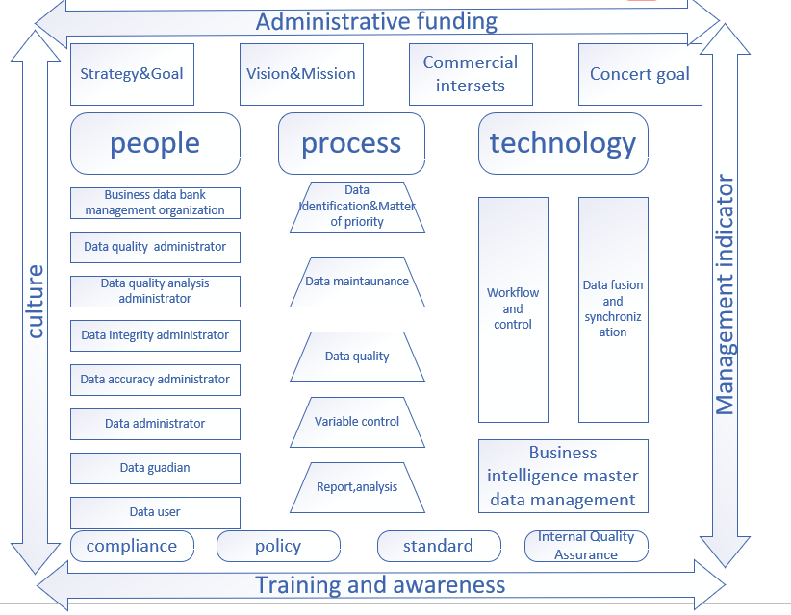
Figure 2. ISACA data governance model
The advantages of the model is specific and detailed; it gives full play to the initiative and leading role of people; considers the environmental factors of governance. The disadvantages of the model is too detailed, it will increase the complexity of model application.

2.3 HESA
The Higher Education Statistics Agency (HESA) is the official institution that collects, analyzes and disseminates quantitative information on higher education in the United Kingdom. It proposes a HESA data governance model, as is shown in Figure 3 [5]. HESA emphasis data governance model is closely related to the design and management structure of the organization, it is pointed out that each organization should appropriately modify the general model according to its own focus, that is, to achieve "specialization". Therefore, in this model, HESA puts the data governance team and legal, security, human resources and other teams in a parallel position, and is jointly guided by the data governance committee. At the same time, HESA authorizes data stewards, business personnel and data users. HESA pointed out that the governance model reflects the concept of "fair access to data for all" to a certain extent, and data should be regarded as an organizational asset rather than an island. Therefore, the scope of data governance of this model includes: (1) Ensure data security and ensure that the risks faced by the organization are controllable; (2) Prevent and correct data errors, thereby continuously improving the data governance plan; (3) Measuring data quality and providing testing And the improvement framework for evaluating data quality; (4) formulating standards to record data and its use in the organization; (5) as a reference for data-related issues and specific decisions. As can be seen from the main part of Figure 3, data governance presents a progressive trend. In the data governance model, some key roles need to be defined and assigned. HESA first proposed the concept of university data trustee (University Data Trustee), pointing out that the university data trustee is responsible for the strategic coordination of data management. In essence, the university data trustee is a high-level data manager, such as the director of the school planning department. This is similar to the role assignment of the University of Illinois Data Bank under the stakeholder theory. The university data trustee assumes a governance position to ensure that data management activities are optimized to coordinate and support the achievement of the organization's strategic goals. In addition, from the overall structure of the model, it can be seen that the organization's data governance is inseparable from operation-level management and policy-level guidance. Therefore, policy guidelines are an essential part of the data governance model. The author believes that the policy guidelines include two parts: one is a data management policy based on the data life cycle, which should be embedded in the governance process; the other is a macro-level policy that runs through the entire governance process. The "guidance" and "authorization" steps in the HESA model are the concrete manifestations of this policy. HESA pointed out that some key roles will be defined and assigned while building the model. The important thing is that roles are assigned, not jobs. The data governance process should be a whole, and the model clarifies and concretizes this process.
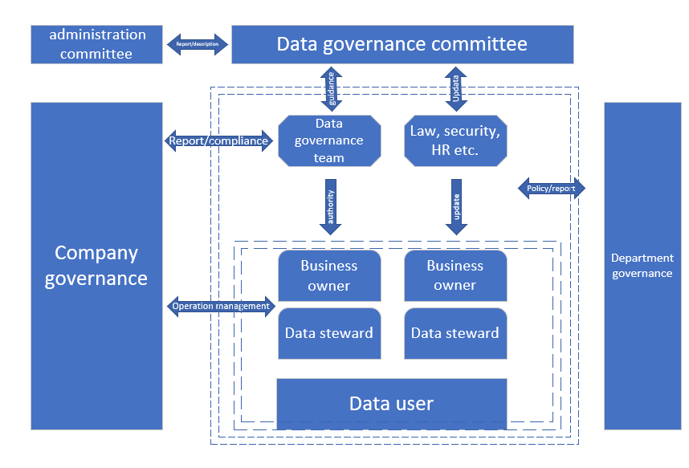
Figure 3. HESA data governance model
The advantages of the model are that the model interprets the concept of "fair access to data for all" to a certain extent: it relies on the design and management structure of the organization. The disadvantages of the model is that the model is too detailed, which will increase the complexity of model application.
- Design of Caribbean Coffee’s security frameworks
  - Analysis of Caribbean Coffee’s situation
We can analyze the case of Caribbean Coffee and know that the security framework that needs to be built in this case needs to meet the following requirements
- Caribbean Coffee’s business is global.
- The company's IT service is based on cloud services, and the company's internal coordination and communication is basically based on wireless.
- The company has online business and social media business
- The focus of the security framework should be on staff’s data and customers’ data.
  - Design of framework
Caribbean Coffee Company is a large-scale company, so in the process of designing the data security governance framework, the steps of its security governance should be detailed to improve its efficiency, instead of worrying about the cost increased which is caused by the cumbersome framework. The success of data security governance in a large number of companies will bring relatively large cost savings. Caribbean Coffee Company’s business is global, so when building a framework for data governance, it is necessary to consider the ethics and legal compliance of all countries and regions where the business is conducted.
Caribbean Coffee Company’ IT service is based on cloud services. Within a reasonable range, it should have its own server and professional data maintenance personnel to ensure the basic security of data. When Caribbean Coffee Company is engaged in online business and media business, it should also pay attention to the compliance of policies and the rationality of media releases. In the process of building the security framework, the security of customers data and staff data should be put in the first place, because customers are a company's unique resource, and the security of staff data ensures the normal operation of the company. It is also very important that there should be a special protection department for the protection of the company's intellectual property rights.
Based on all the requirements of the appeal and general solution ideas, the following ideas are needed in the data security governance framework:
- The level of data governance should be divided into the following 3 levels: Company Data Governance, Department Data Governance, and Staff Personal Data Governance.
- The company's independent server support is required in the process of data security governance.
- Need to develop emergency plans to ensure data security.
- Carry out simulation practice for some possible risks to improve.
- Develop performance appraisal for data security governance.
Based on the above ideas, the following data security governance model is constructed.
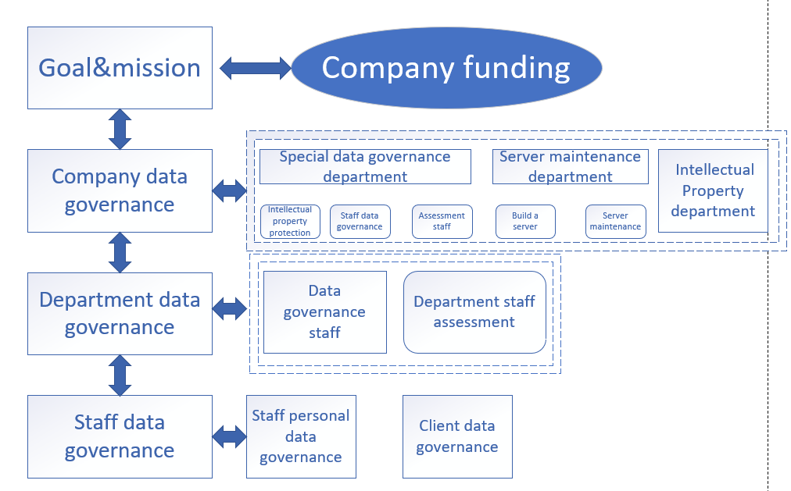
Figure 4. Caribbean Coffee’s Data Governance Framework
The company’s data governance funds come from the company itself, and then work of data governance have the company’s support. The amount of data governance funds depends on the results that the efficiency of data governance can achieve. When the achievable goals and mission improve, the more support the company can be obtained, the more fund data governance can get. Company Data Governance, Department Data Governance and Staff Data Governance is in the same situation. The relationship between them is a positive feedback relationship. At the Company Data Governance level, the company has standard data governance departments, server maintenance departments, intellectual property departments, etc., which are used to coordinate data governance at the company level. At the Department Data Governance level, each department has dedicated data governance specialists, as well as assessors for the performance of data governance in each department. Using the assessment of data governance as a performance appraisal can increase the importance of data governance by company employees. At the level of Staff Data Governance, employees need to conduct data governance on personal data, and need to conduct data governance on customers personal data.
In the overall data governance framework, we also need to consider Compliance (Laws and Ethics), Governance and Strategic Planning for Security, Security Policies, Risk Management, Security Management Models and Practices, Contingencies Planning, Protection Mechanisms, Service Level Agreement, and perform reasonable data governance operations
- Conclusions
This article analyzes the three existing excellent data governance frameworks and has a deeper understanding of the data governance framework. Then we took the essence and removed the dross, and constructed a data governance framework which is suitable for Caribbean Coffee Company. This framework is relatively incomplete, but what I can build is the most suitable framework for the company. This framework proposes certain solutions to the corresponding problems faced by the company.
With the continuous development of IT technology, the data governance framework is also constantly updated and improved. In the process of technological change, the old framework is no longer adapted to the new technical environment, and the old framework cannot play its role in data governance for the new technology. Therefore, the framework is constantly changing, and the overall development is towards a better and safer direction.

References
[1] Sonia P. Six critical success factors for data governance -viewpoints on innovation [EB/ OL]. [2017- 06-15]. http://viewpoints.io/entry/six-critical-success-factors-for-data- governance
[2] Dutta H. Graph based data governance model for real time data ingestion [EB/ OL]. [2017-05-27]. https:// link. springer. com/article/10. 1007/ s40012- 016- 0079- y.
[3] Cupoli, P. , Earley, S. , & Henderson, D. . (2014). DAMA-DMBOK2 Framework
[4] ISACA data governance overview [EB/ OL]. [2017-10-10]. https;//www.isaca.org/ chapters3/Atlanta/AboutOurChapter/Documents/GW2014/Implementing%20a%20Data%20Governance%20Program%20- 20Chalker%202014. Pdf
[5] HESA data governance EB/OL].[2017-10-11].https:// www.hesa.ac.uk/ support/ tools/ data- capability/signposting/ governance.

