ALDI's International Market Entry into Canada: A Strategic Analysis

Module Title: International Business Strategy

Assessment Title: International Market Entry Strategy Report
Name: Akul Panchal
Student Id: 2428878

Company: ALDI Group
Target Market: Canada
Table of Contents

Introduction 4
Section 1: 5
1. Organisational Classification and Global Strategy 5
1.1 Strategic Categorisation: Bartlett and Ghoshal Analysis 5
1.2 Critical Analysis: Strengths and Limitations 6
1.3 Global Configuration and Geographic Footprint 7
1.4 Competitive Advantage and Value Creation 8
2. Macro-Environmental Appraisal and Market Attractiveness 9
2.1 Host Country Analysis 9
2.1.1 Political Factors 9
2.1.2 Economic Factors 11
2.1.3 Legal Factors 13
2.1.4 Cultural Factor 15
2.2 Market Entry Analysis: The Eclectic (OLI) Paradigm Synthesis 16
2.2.1 Ownership (O) Advantages 16
2.2.2 Location (L) Advantages 18
2.2.3 Internalisation (I) Advantages 20
2.3 Identify Key Factors Influencing Entry Success 21
2.4 Critically Evaluate the Attractiveness of the Chosen Market 21
3. Entry Mode Strategy and Strategic Synthesis 23
3.1 Historical Pattern Recognition 23
3.1.1 Review of Historical Entry Modes 23
3.1.2 Strategic Implications 24
3.2 Strategic Fit & Justification for Canada 25
3.2.1 Assessing the Suitability of ALDI's Historical Entry Mode for Canada 25
3.2.2 Risk and Resource Commitment 26
3.2.3 Control versus Flexibility 27
3.2.4 Long-Term Strategic Fit 28
3.3 Conclusion & Recommendations 28
Section 2: Reflective Account 29
Gibbs' Reflective Cycle (1988) 29
1. Description 29
2. Feelings 29
3. Evaluation 30
4. Analysis: Supporting the Work with Theory and Lectures 30
5. Conclusion: Lessons Learned 31
6. Action Plan: Improving Future Research 31
Reference List 32

Introduction
This report looks at the possibility of ALDI entering the Canadian market as a foreign company, and will look at how the internationally tested business model of the German based discount grocery retailer could be adapted to the Canadian market. This analysis starts with the categorization of the international strategy of ALDI and the macro-environmental evaluation of Canada with references to political, economic and legal aspects. The OLI paradigm developed by Dunning is also used to determine whether foreign direct investment is viable along with a history of suitable entry modes discussed. The report finally concludes by giving the suggested entry strategy and a reflective process of the research process based on Gibbs Reflective Cycle.

Section 1:

1. Organisational Classification and Global Strategy

1.1 Strategic Categorisation: Bartlett and Ghoshal Analysis
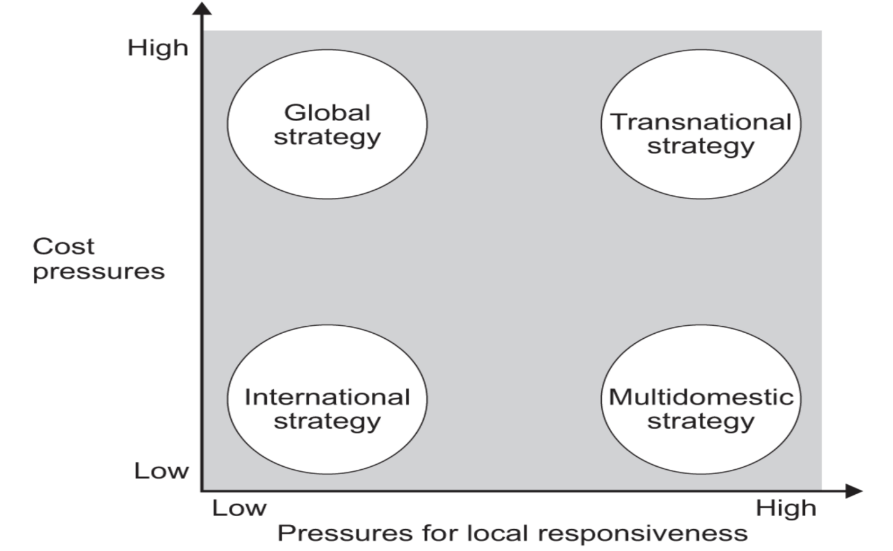
Figure 1: Bartlett and Ghoshal’s Model
(Source: AQA, 2020)
Using the Bartlett and Ghoshal framework, ALDI has a high level of global integration and low level of local responsiveness, as it has a Global Strategy (Mehra, Loonkar and Desai, 2026). Moon Technolabs (2025) supports this categorisation by adding that, at ALDI, the business model is based on the small number of SKUs in its operations, where more than 90-percent of its mix of products is owned-label, powered by a standardised cost-leadership strategy offered by its extensive network of supermarkets in the 18 countries, bringing annualised group together revenues of around 112-billion in 2023. As Davis (2025) notes, such a standardised format is recreated with very little customisation to specific markets in Europe, the United States, and Australia, it is, in fact, very clear that the ALDI looking to emphasise on global efficiency, not on market-by-market changes. As is the case with Canada, this changing positioning means that although the globally efficient template offered by ALDI can be used in entry, there will be a need to localize selectively to meet unique consumer expectations and regulatory needs in Canada.

1.2 Critical Analysis: Strengths and Limitations
ALDI's approach on a global level has some big advantages. The standardised format of its stores, the bare, unadorned shelves, and its private label strength with 80% of its units being owned rather than made by other brands results in ample economies of scale and purchasing power, allowing them to offer prices as much as 30% lower than conventional supermarket prices (Petro, 2024).
According to Patterson, (2026), this inflexible standardisation has distinct restrictions in the Canadian situation. Canadian consumers in 2026 prioritize discount banners, but, at the same time, demand product assortments tailored to the region, labelling in their native language, preference to local products, and food selections based on the cultural needs, which the globally focused model by ALDI fails to provide.

1.3 Global Configuration and Geographic Footprint
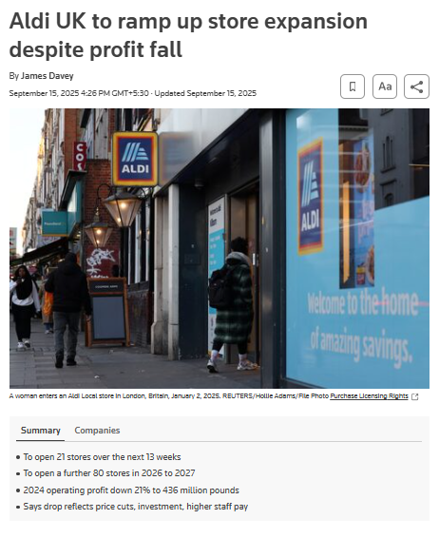
Figure 1: Aldi UK ramps up store expansion
(Source: Davey, 2025)
ALDI is present worldwide in 18 countries with around 12,000 stores, and is legally divided into two entities, ALDI Nord and ALDI Süd (ALDI SÜD HOLDING, 2026). The American market is dominated by ALDI Süd, and the UK, Ireland and Australia belong to ALDI Süd, whereas Northern and parts of Southern Europe go to the ALDI Nord. As of 2025, there are 2,400 stores of ALDI in the US with about 2,800 stores expected to be open at the end of 2026, plus the addition of 800 stores by 2028. The UK market totals £18 billion in turnover for 11% of the market (and more than 1060 UK stores) (Davey, 2025).

1.4 Competitive Advantage and Value Creation
ALDI's competitive advantage is based on its integrated cost leadership approach. Its 90% private label offering eliminates intermediary brand costs and global purchasing power from 18 markets puts suppliers in the negotiating mode. Standardised stores with an average size of 12,000 sq.ft. bring down the expenses of capital and operation per store. ALDI's customer value creation was effective in 2025, as it gained 17 million customers in the country and had 7.1% year-on-year store traffic (Seafoodnews, 2026). Investments in digitalisation, such as the partnerships between Generative AI and Digital Wave Technology for the delivery of content around the products, as well as the SAP S/4HANA transformation that is a partnership between Genpact (Genpact, 2026).

2. Macro-Environmental Appraisal and Market Attractiveness

2.1 Host Country Analysis

2.1.1 Political Factors
Stability and Institutional Quality
Canada is among the world's most stable democratic countries and has a federal parliamentary system and a constitutional monarchy, with 10 provinces and 3 territories, that have a legislative power over various issues such as healthcare, education and some aspects of commercial regulation (Government of Canada, 2026). ALDI is a retailer and such a division is important because certain law areas regulated by the provincial government have impact on consumers, such as liquor licensing and land-use zoning.
Foreign Investment Climate
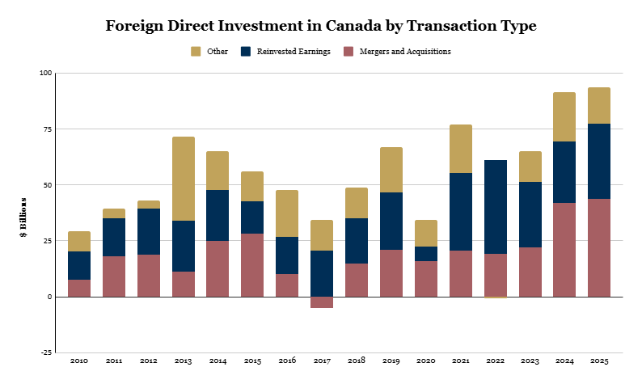
Figure 2: FDI in Canada
(Source: C.D. Howe Institute, 2026)
Foreign direct investment market conditions are conducive. Canada received a record amount in FDI in 2025 ($93.6 billion), which is an increase of 36% from 2023, and is 2nd on the Kearney FDI Confidence Index in 2026, just behind the United States. Canada's ratio of FDI stock to GDP is the second highest among G20 countries and in 2025, Canada had the highest FDI inflows per capita among G7 countries (C.D. Howe Institute, 2026). Canada's statutory corporate income tax rate is 26%, competitive among G7 countries, and Canada's 13% overall effective tax rate on new business investment is the lowest of G7 countries — significantly below the US rate of 19.7% (Tax Foundation, 2026).
Government Grocery-Sector Stance
The issue of food affordability is a political one. The price of groceries is a public issue as prices rise by 26.9% from 2021-26. So, the federal government has put price pressure on key grocery stores, and the Competition Bureau has beefed up its investigation of retailing (Beauchemin, 2026). This political climate works in ALDI's favour because they are stuck with a cost-leadership business model, which is the same message that is pushed by the government on affordability. In markets with more centralised governance, ALDI would have to deal with the federal and provincial regulatory regimes at the same time – which is more complex than working with a more centralised control system (Vidanagamachchi, Ginige and Nakandala, 2025).

2.1.2 Economic Factors
GDP and Growth Trajectory
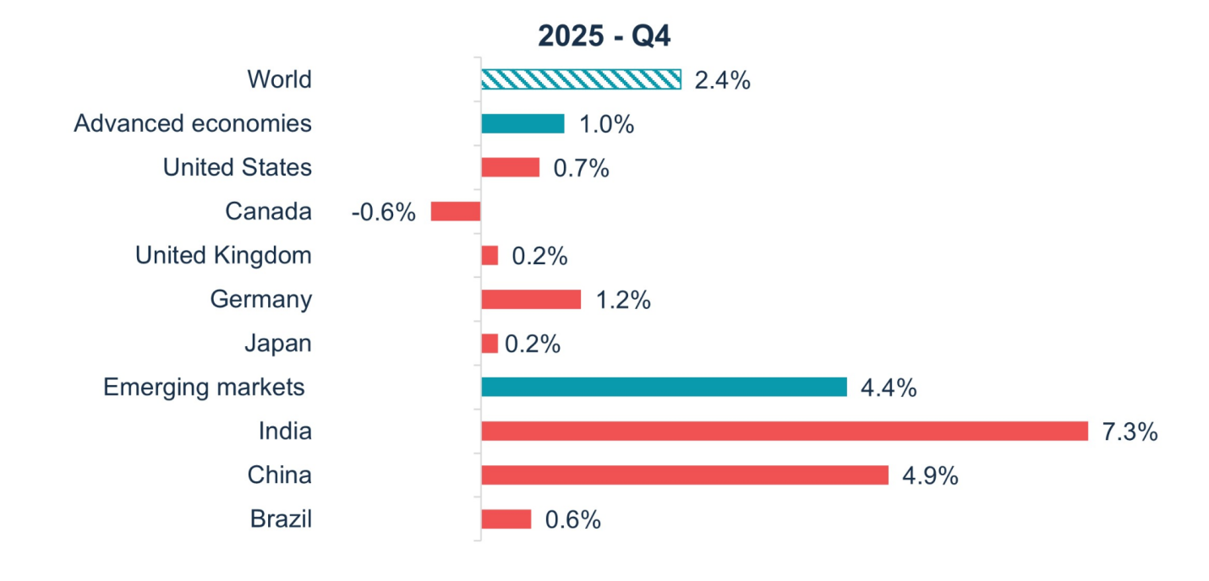
Figure 3: GDP and Growth Trajectory of Canada
(Source: RBC Economics, 2026)
GDP growth in Canada has been relatively weak. The economy contracted by 0.6% in Q4 2025 and stalled in Q1 2026. The private sector forecasts are for real GNP growth of about 1.1% in 2026 and 1.9% in 2027 (Global Affairs Canada, 2026). Overall, growth has been projected to be relatively weak across the G7 group, with Canada's projected growth at the second highest level. The share of GDP contributed by households is around 60%, which is the biggest share and makes consumer spending the biggest economic driver—straight growing grocery retailers (RBC Economics, 2026).

Inflation and Food Prices
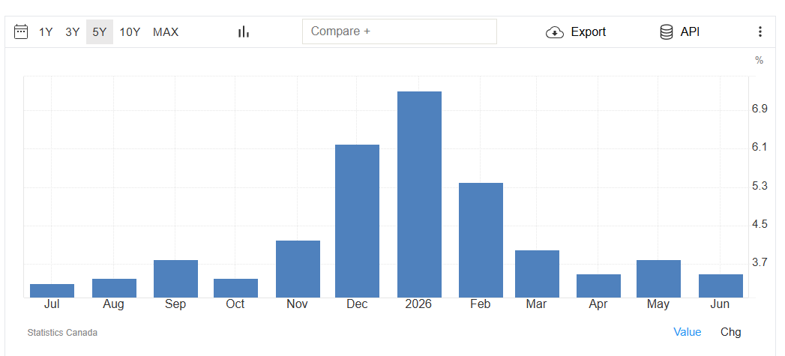
Figure 4: Canada Food Inflation
(Source: Trading Economics, 2026)
The cost of food in Canada increased 3.50 percent in June of 2026 over the same month in the previous year. Grocery prices had an average 4.0% inflation rate, July to Dec 2025, with meat prices up 8.5% y-o-y in December. Headline inflation was 1.8% in February 2026, but the general inflation rate differs from food-specific inflation, creating a heightened consumer pain point—the type of space that a discount grocer can work in very well (Trading Economics, 2026). The Bank of Canada lowered its policy rate to 2.5% in more than a year to curb some of the negative effects on purchasing power in the past year, thus providing an extra boost to consumer spending (Bank of Canada, 2025).

Market Size
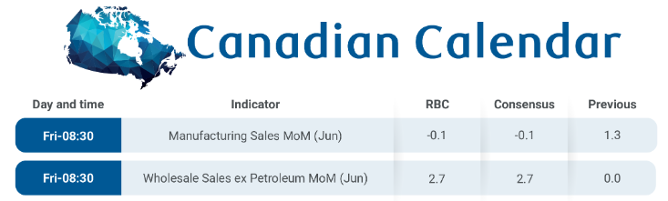
Figure 5: Canadian Purchasing Power
(Source: RBC Economics, 2026b)
Canada's total value of the supermarket and grocery industry is estimated at CAD 121.3 billion in 2026, increasing by 1.0% compared to the previous year. In 2025, the total value of the wider retail industry was $834.55 billion (IBISWorld, 2026). More than 70% of Canadian consumers are now opting for discount or value banners to make their first grocery purchase. This means that the company's low-price strategy is a structural opportunity to overcome the premium-format channels (The Canadian Press, 2026). Consumer spending power, with lower interest rates and more than 3 quarters of real wage gains beyond a fairly stable rate of inflation into 2026, gives consumers fuel to spend, but they're not doing so at the pump (RBC Economics, 2026b).

2.1.3 Legal Factors
Competition and Consumer Protection
Policies are in place in Canada to prevent misleading or misleading information on the product label, including policies in place under the Competition Act, enforced by the Competition Bureau and CFIA. The Competition Bureau has started a series of investigations in the grocery sector on pricing and market concentration (Competition Bureau Canada, 2025). For ALDI, it's a need for an environment where it is able to be highly compliant in advertising and pricing claims.
Food Labelling and Safety
One of the most complicated areas that ALDI would be dealing with is food labelling. According to the Consumer Packaging and Labelling Act, all necessary labelling details are laid out in both English and French – there is no exception for this. All measurements to be taken in metric units. Finally, as of January 2026, the new Front-of-Package nutrition labelling regulations went into full effect (Schifferstein, de Boer and Lemke, 2021). In addition to serving as a warning to consumers, the "High In" symbol now includes nutritional thresholds that need to be met. Quebec is a world all its own. Bill 96, the recently revised Charter of the French Language, stipulates that French take precedence over English on all packaging; in addition, from June 2025, generic or descriptive terms in trademarks will have to be shown in French (Zuroff and Proulx, 2025).
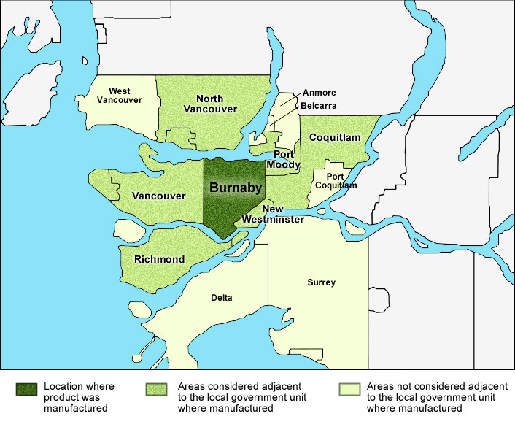
Figure 6: Example of a local food for the purposes of the bilingual labelling exemption.
(Source: Canadian Food Inspection Agency, 2025)
90% of items are private brand, which is a good thing for ALDI, however, every product line would require Canadian specific bilingual labelling requirements, French and English nutrition panel per CFIA packaging requirements, and FOP compliance. Additionally, there are variations in employment standards, minimum wage, labour law etc. across the provinces of Ontario, Alberta, British Columbia and Quebec that further make their operational planning a challenge (Canadian Food Inspection Agency, 2025).
Imported Food Regulations
CFIA enforces country of origin labelling for meat, dairy, fish, fruits and vegetables. The model would have to meet Safe Food for Canadians Regulations, covering all imported food products, such as documentation – in both official languages – and licensing (SafetyCulture, 2025). These are not prohibitive challenges, but require strong regulatory infrastructure to get going.

2.1.4 Cultural Factor
Demographic Diversity and Multiculturalism.
Canada is a highly diversified country. It actually grew to 41.47 million in Q1 2026 and the population of visible minorities is expected to have 28.4% national population in 2026, compared to a mere 4.7% in 198 (Statcan, 2026). Only Toronto has a 55.7% population of racialized people. Almost every fourth Canadian speaks a language other than either English or French, with Chinese, Punjabi, Spanish, and Arabic some of the most common languages. The Immigration Levels Plan of Canada is aiming to have 301,000 new permanent immigrant residents each year in 2025 and 2026, which would continue to help this country demographically diversify. In the case of ALDI, the standardised product offering will not be appropriate anymore because the Canadian people expect the presence of the multicultural offering foods of South Asian, East Asian, Middle Eastern, and Latin American cuisine in addition to the western famous ones (TransforML Platforms Inc, 2025).
Consumer Behaviour, Language.
The Canadian consumer culture isn’t exactly the same as those that ALDI has already in the market. Bilingualism is a constitutional fact-54.9% of Canadians are those who speak English and 19.6% are French speakers. Bill 96, as fortified in June of 2025, Quebec requires French-first packaging, which exceeds federal legislations of bilingualism. According to the Canadian Diversity Study (2026), the nation exhibits a consumer base that appreciates inclusivity in brand positioning by identifying 66% of Canadians thinking multiculturalism has a positive impact on national identity (Government of Canada, 2023). To compete in the Canadian market, ALDI would have to devise region-specific collections, especially in Quebec and multicultural urban centres such as Toronto and Vancouver, yet the operational simplicity that defines the cost advantage should prevail.

2.2 Market Entry Analysis: The Eclectic (OLI) Paradigm Synthesis

2.2.1 Ownership (O) Advantages
Brand Equity and Cost Leadership
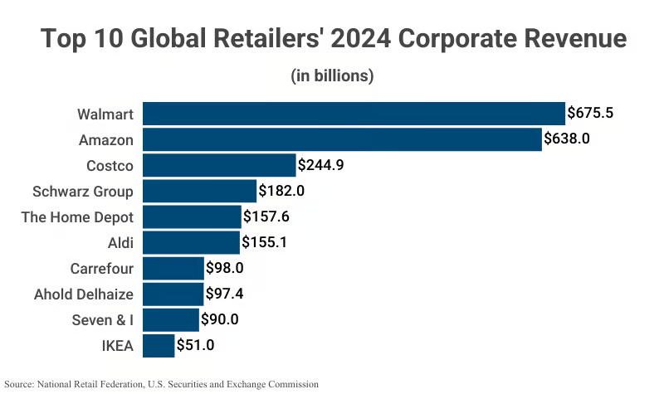
Figure 7: Top 10 Global Retailers
(Source: Capital one, 2026)
ALDI has very powerful ownership advantages in the market they enter. With combined global revenues of $155.1 billion in 2024, ALDI is the second-largest grocery retailer in the world. The brand stands on that value proposition, not on the amount of money that's been spent on marketing it, with prices always 30% lower than regular supermarkets, and all of the operating model is slimmed down to eliminate all waste (Capital one, 2026).
Private-Label Dominance
The private label is ALDI's most unique advantage in terms of ownership. Over 80% of the units sold in ALDI stores overseas are own-label products and 90% of the range sold in the United States is private-label. This is contrasted with less than 28% private label carry-out at an average grocery store in North America (Miller et al., 2026). Recently, ALDI started using their brand name on every private label package inside the United States stores, which can boost consumer trust and greater brand name recognition. Development of product, supplier management, quality control and packaging design—the private label know-how that took several decades to develop and would be very hard for any of the Canadian incumbents to duplicate at a similar scale (Petropoulos et al., 2025).
Operational Know-How
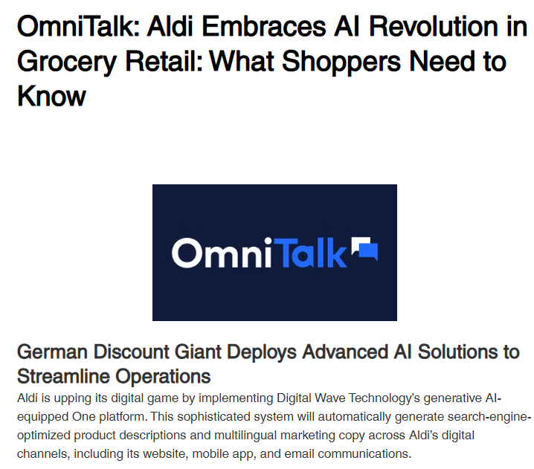
Figure 7: OmniTalk: Aldi Embraces AI Revolution
(Source: Hamilton, 2025)
Standardised operating systems at ALDI—little frills shelves, display shipping boxes, small SKU selection, shopping carts that are less tall than they are long, or cashiers sitting down and scanning products with oversized product codes—decrease the cost of labour, fixtures investment, and operating store expenses per square foot. ALDI has also recently leveraged Generative AI for content management of its product and has embarked on its SAP S/4HANA, Ariba, and ServiceNow journey across a multi-year digital transformation initiative where management sophistication has been proven in scaling its processes (Hamilton, 2025). These systems, processes, and digital tools are transferable to Canada.

2.2.2 Location (L) Advantages
Consumer Market Scale
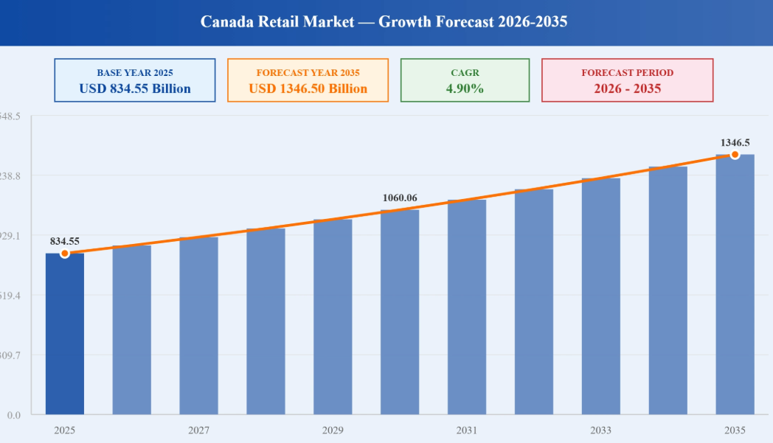
Figure 8: Canada Retail Market
(Source: Kumar, 2026)
The Canadian consumer market is estimated to reach about 41 million consumers, and is heavily urbanised, with more than 80% of Canadians residing within 160km of the United States. Dense, high spending catchment populations, like the five largest metros (Toronto, Montreal, Vancouver, Calgary and Ottawa) are ideal for ALDI's small format store model. The Canada retail market reached a value of USD 834.55 Billion in 2025 and is projected to expand at a CAGR of around 4.90% during the forecast period of 2026-2035. The lack of uniformity makes them more expensive due to demand for larger varieties of food items, and their price sensitivity is increasing (Kumar, 2026).
Demand for Affordable Groceries
The one strongest location advantage is the trend towards discount grocery shops. In 2026, more than 70% of Canadian consumers look to discount and/or value banners as their go-to grocery shopping category. Growth is strong in both FreshCo and No Frills, plus Food Basics and Super C are growing very rapidly as well. The company anticipates opening 80 new stores in 2025, half of which will be discounts. During the 2026 fiscal year, Metro opened 12 new discount stores. People in Canada are definitely embracing value; the discount retail segment has increased its share of the grocery market consistently and the trend is the only one seeing growth (Secord, 2026). Canada's strategic location benefiting from a well-established supply chain with ALDI's US operations, having more than 2,400 stores in the United States and plans to grow those to 2,800 by the end of 2026, offers an obvious advantage for distribution centre development and cross-border sourcing (Patterson, 2026).
Geographic and Provincial Challenges
The obstacle is Canada's geography. The population is widely dispersed over a vast area, with low densities in areas not directly connected to larger metropolitan areas. Clarification costs and complexity are raised by provincial regulatory fragmentation (such as Quebec's language law, the various employment standards in different provinces, and the differing provincial municipal zoning requirements) (Lévesque, 2025). Reliability of supply chains and construction times are impacted by winter conditions in most parts of the country, for 6 months each year. These are actual constraints, but the equality applies for each competitor.

2.2.3 Internalisation (I) Advantages
Protecting the Business Model
For ALDI there is compelling economic rationale to internalize its market entry in Canada, and not go the path of franchising, licensing or joint ventures. Much of the company's value is that it has systems which are highly interdependent: private-label sourcing networks; operating procedures of each store; pricing algorithms; and supply-chain co-ordination, which would be undermined by being shared with outside parties (Moon Technolabs, 2025). The quality control measures, proprietary product specifications, and direct relationships between ALDI and manufacturers are required for its private label products. Such licensing would make it more difficult to maintain the level of commitment for quality which is expected and trusted by consumers (Bouncken and Fredrich, 2024).
Operational Control
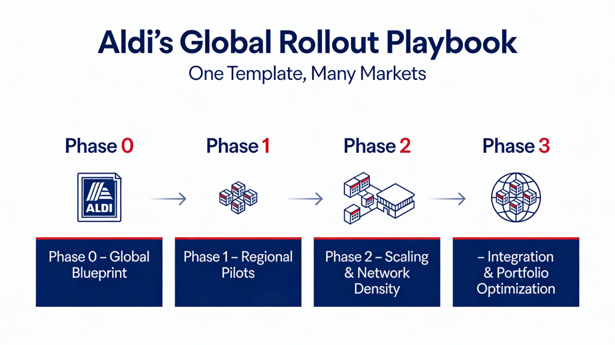
Figure 9: Aldi’s Global Rollout Playbook
(Source: Sivasubramanian, 2026)
ALDI rely on their pricing power through being centralised in their buying - this can only work if ALDI controls all nodes in the supply chain from the factory gate to checkout. These include staff cross-training, display design, product rotation, and so on, and are all standardised, constantly developed and improved with ALDI's international system of more than 12,000 stores (Bugg, 2025). This is operational intelligence gained from the US market where one in three American households now does their grocery shopping at ALDI that only a fully owned subsidiary can fully learn from and put into practice. In other words, the ALDI internalisation strategy is straightforward; in order to feed into profit, operational control has become an essential, not a voluntary component of the business (Sivasubramanian, 2026).

2.3 Identify Key Factors Influencing Entry Success
ALDI's Canadian offering is pitched on multiple points that are linked together. Ownership advantages are significant - as is the capability of cost-leadership, private-label expertise and internationally proven operating systems, with which Canadians have not seen at this level. So, the attractiveness of the market is obvious, for 71.7% of consumers in the CAD 121.3 billion grocery market will actively take account of discount banners in 2026 (Patterson, 2026a). On top of that, the competition is fierce as ALDI launches upon some forcefully aggressive discounting retailers like Loblaw, Sobeys and Metro, who account for about 80% of the market. Nearly 2,800 stores in the United States will trigger the "arrival of ALDI" by EoY 2026 to bolster supply-chain feasibility and further ease the cold-start logistics challenge leveraging the established North American distribution network (Caldwell, 2025). Consumer adaptation is a must; the demand for bilingual labelling, nutritional compliance, adaptation to regional preferences and multicultural food requirements can not be addressed by mere format duplication, and cost investment is needed to do so.

2.4 Critically Evaluate the Attractiveness of the Chosen Market
Canada is an intriguing but debatable proposition. As per Stephens et al. (2025) a healthy consumer base with continued food inflation, plus structural consumer migration to the discount grocery segment. The biggest risk that would be raised is the competitive one. With an already well known value proposition, there are the incumbents who are desperate to widen discount banners with deep private-label portfolios and known loyalty programmes. Building on the findings of Hüttl-Maack and Munz (2024), ALDI doesn't have to deal with the changes in language requirements under Bill 96 in Quebec and the complexities of bilingual labelling or FOP symbols imposed from 2026 in its more simplified U.S. and Australian markets. However, with respect to its OLI features, ALDI is a worthy entry. No one in Canada has ever done quite what ALDI does with its 90% of private label brands, the short list of SKUs it carries and the efficiency of its small stores. From the findings of Bandi, Cohen and Ray (2024) it can be stated that the match point cannot be dismissed when ALDI has cost leadership capability and Canada's market dynamics are for the value grocery.

3. Entry Mode Strategy and Strategic Synthesis

3.1 Historical Pattern Recognition

3.1.1 Review of Historical Entry Modes
Country | Year of Entry | Entry Mode | Key Details
Austria | 1968 | Acquisition | Acquired existing grocery chain Hofer; ALDI's first international move (ALDI, 2025)
USA | 1976 | Greenfield (Wholly Owned) | Single store in Iowa; built from scratch with own distribution network (ALDI, 2025)
UK | 1990 | Greenfield (Wholly Owned) | Organic store-by-store expansion; now exceeds 1,060 stores
Australia | 2001 | Greenfield (Wholly Owned) | First stores opened in Sydney area; own supply chain established (Aldi, 2024)
Switzerland | 2005 | Greenfield (Wholly Owned) | Entered a market dominated by Migros, Coop and Denner
Italy | 2018 | Greenfield (Wholly Owned) | Built own stores and distribution infrastructure (Aldi, 2024)
USA (Southeast) | 2024 | Acquisition-Conversion Hybrid | Acquired Southeastern Grocers; converting 220 Winn-Dixie and Harveys stores to ALDI format through 2027 (ALDI, 2025)
Table 1: Entry Modes of Aldi
(Source: self-developed)

3.1.2 Strategic Implications
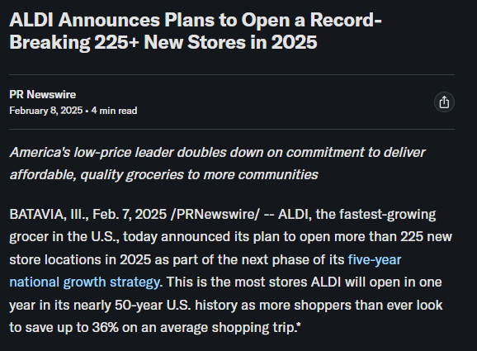
Figure 10: ALDI Announces new stores
(Source: PR Newswire, 2025)
The choice of green field wholly owned subsidiaries that ALDI has is not by chance. The discounting model relies on overall control of operations-store design, proportions of staffing, product mix, price structure, and integration of supply-chain are closely combined (StudyCorgi, 2026). Any system that is proprietary would be opened up to third parties through franchising or licensing. Joint ventures would entail the distribution of decision-making power of pricing and product range and this is in total contradiction with ALDI cost control model that is centralised with authority. Greenfield investment is costly and time consuming yet fully safeguards the business model (Sherman, 2024). The Southeastern Grocers differentiated indicates that ALDI has no qualms changing when time is of the essence but even in this case, the stores have been literally transformed to the ALDI standardised formats instead of running them to their present formats (PR Newswire, 2025).

3.2 Strategic Fit & Justification for Canada

3.2.1 Assessing the Suitability of ALDI's Historical Entry Mode for Canada
The most coherent entry mode of Canada is a greenfield mode of entry. Loblaw, Sobeys, and Metro are the three main players controlling the Canadian grocery market and none of them would sell their discount banners- No Frills, FreshCo and Food Basics- to one of their direct competitors (Willick, 2025). There is no meaningful acquisition target to Canadian discount grocery that would be of the scale that ALDI would require. The independent grocers that are available are not standardized as ALDI needs. Greenfield development will enable ALDI to choose the best location which is in high-density urban corridors such as Greater Toronto, Metro Vancouver, Calgary and Ottawa where population concentration will support the small-format model (Supermarket News Staff, 2026).

3.2.2 Risk and Resource Commitment
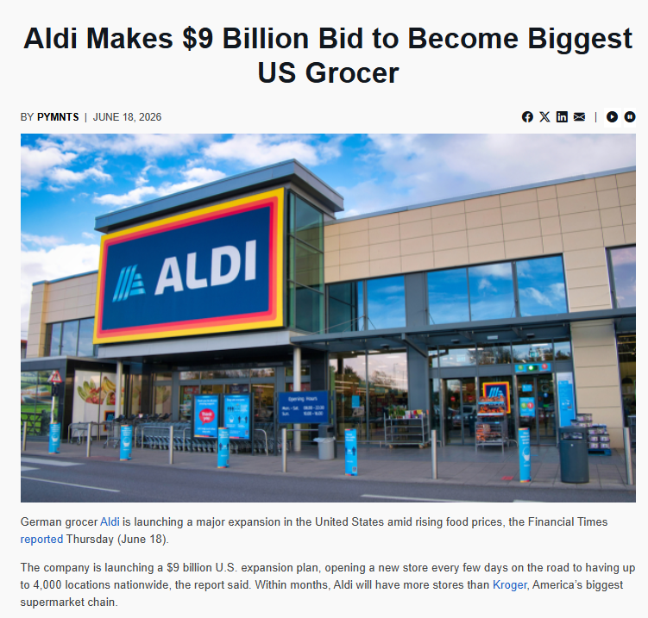
Figure 11: Aldi Makes $9 Billion Bid in US
(Source: PYMNTS, 2026)

Risk Category | Assessment | Key Considerations
Political Risk | Low | Canada is second on 2026 Kearney FDI Confidence Index; has least net debt-to-GDP in G7; federal democracy is stable with clear regulatory institutions.
Financial Risk | Moderate | Initial costs of CAD 500-800 million in five years as 50-80 stores and distribution infrastructure; readily controllable versus the $9 billion US programme of ALDI (PYMNTS, 2026).
Operational Risk | Moderate–High | The implementation of bilingual packaging compliance, FOP labelling: 2026, and Quebec Bill 96 French-first mandates.
Market Risk | High | Control by incumbents (80% of the market); intensive growth by discount-format Loblaw, Metro and Sobeys; no prior brand awareness of ALDI among Canadian consumers (Patterson, 2026a).
Supply-Chain Risk | Low–Moderate | Closeness to 2,800 US locations by end 2026 gives cross-border sourcing benefit; Canadian winter logistics and geographical dispersion introduces seasonality difficulty.
Table 2: Risk Assessment
(Source: self-developed)
Resource Commitment
The Canadian entrance of ALDI would cost the company an estimated 500-800 million US dollars in 5 years, consisting of 50-80 store construction, minimum of one distribution centre in the region and the development of specific, Canadian based supply chain of its own-labeled products. This is considerable yet relative compared to the investment programme of ALDI in the US to a tune of 9 billion by the year 2028 (PYMNTS, 2026). Capital investment would be required in store construction, cold-chain logistics facilities, bilingual packaging design, regulatory compliance initiatives, and staffing of various provinces.

3.2.3 Control versus Flexibility
A completely operated greenfield entry provides ALDI with utmost freedom of its pricing, sourcing on its own brand name, the running of its stores, and brand placement, none of which can be compromised by its model. Acquisition would offer access to markets faster but it would almost certainly incur legacy systems, trade union work forces and format of stores which would require dearly bought renovations. Local market familiarity, supplier contacts, and regulatory experience could be offered through a joint venture with a Canadian partner, such as a regional chain, or a wholesaler distributor (International Trade Administration and U.S. Department of Commerce, no date).

3.2.4 Long-Term Strategic Fit
Canada is an extension of the North American strategy that ALDI has. As ALDI has almost 2,800 stores in the US that are estimated to be opened by the end of 2026 and intends to add more than 180 new stores in the US only in 2026, the North American supply chain, management capacity, and brand presence of the ALDI company are already on scale (Grasmick, 2025). Cross-border supply-chain efficiencies that are associated with US distribution centres, specifically those located in northern states adjacent to Ontario, have a possibility of lowering the standalone cost of an operation in Canada by a large margin .

3.3 Conclusion & Recommendations
ALDI has a good opportunity to enter the Canadian market. The location advantages are strong in Canada, as it has a large and affluent consumer base, which is undergoing a structural shift towards discount grocery, a stable institutional base, high levels of FDI inflows and geographic closeness to the established US operations of ALDI (ALDI, 2026). The benefits of internalisation are obvious-ALDI only has the thin-margin model that takes full command of the sourcing, price and operations that can only be provided by a wholly owned subsidiary.
The mode of entry suggested is phased greenfield investment of wholly owned subsidiaries in Canada, with 15-20 stores in the Greater Toronto Area to start, and a sole regional distribution centre, along with a supply agreement complying with Canadian laws, which will be under its own brand. In three years, phase two would spread to Metro Vancouver and Calgary (FasterCapital, 2024).

Section 2: Reflective Account

Gibbs' Reflective Cycle (1988)

1. Description
I chose ALDI due to the unique discount grocery model that is one of the unique internationalisation strategies in global retail. The reason why Canada was chosen as the target market is that the country had provided an interesting tension of opportunity; of an affluent and stable economy and rising demand in value grocery, without the footprint of a world-class discount company like ALDI (Farhan, 2023). My strategy was to use Bartlett and Ghoshal framework to categorize the international strategy used by ALDI, a PEST based host-country analysis, whether the conditions favoured foreign direct investment using Dunning OLI paradigm and the entry modes based on the past expansion behaviour of ALDI. Literature based on corporate reports, state information, trade journals and general regulation sources (Bais, Nassimbeni and Orzes, 2024).

2. Feelings
My initial belief was that it would be very easy to make the case to allow ALDI to enter Canada; a winning formula of low cost-based groceries entering a market that obviously desired low-cost groceries seemed like a match made in heaven. Such a belief was false. When I looked at the regulatory environment of Canada, especially the bilingual labelling standards, Bill 96 law of Quebec and the Front-of-Package nutritional law, I understood that the intricacy of business operations was much higher than expected (Sarokin, 2022). Competitive analysis was also more difficult than thought. I had not fully appreciated the fact that Canadian incumbents were already aggressively spreading their own forms of discounts and thus the story that ALDI would merely cut a hole was difficult to swallow. To leave the account of these findings behind, and to start assessing them critically, was the most difficult part--all these things can be easy enough to list what ALDI does, and what Canada has to offer, but far more difficult to balance one thing against another, and to arrive at the verdict that should be truly earned, without seeming to be assumed (Ditlev-Simonsen, 2022).

3. Evaluation
The OLI framework was truly helpful - it compelled me to disregard the ownership capabilities and location attractiveness, as well as internalisation logic, which would subjugate the analysis to the generic list of pros and cons (Abdessamad Douraid and Laradi, 2026). They were reliable sources of quantitative data with government sources, and contextual information within the sector that trade publication usually lacks in academic journals. The area that I had difficulties with was conflicting information. The number of stores, their revenue and market-share estimates were different across various sources. The fact that ALDI is privately held exacerbated this situation--annual reports cannot be compared. Certain scholarly writings of entry-mode theory were disillusioned with practice. Entry modes can be considered as discrete options in theoretical frameworks, yet as observed in the case of the acquisition of Southeastern Grocers by ALDI, strategies in practice tend to be more friendly and pragmatic than fitting into the textbook categories in theory (Kupfer, Marchand and Thorsten Hennig-Thurau, 2024).

4. Analysis: Supporting the Work with Theory and Lectures
The classification framework by Bartlett and Ghoshal was effective in classification but depicted their limitations. ALDI lies squarely between Global and Transnational classifications- its fundamental value model is globally-standardised, with recent adaptations to the US market indicating growing responsiveness to locality. The framework is more of a spectrum than an actual 4 boxes, which only became truly visible to me only when it was put into practice (SLM, 2024).
The most fruitful paradigm was the Dunning OLI paradigm. It helped me to think over whether or how ALDI should enter Canada, rather than how. The advantages of ownership were apparent, location advantages high and contested whilst internalisation logic was oriented squarely towards wholly owned entry - as in the lecture content about such firms with proprietary systems favouring high-control modes (Batschauer da Cruz, Elite Floriani and Amal, 2020).
Entry-mode theory was in line with module cases. The unsuccessful Fresh and Easy project by Tesco demonstrated the lack of local adaptation, which when done by a retailer, proved to be disastrous, and provides ALDI with some lessons. The incremental greenfield would follow another trend in the history of ALDI, and support the reason why the entry mode that is dominated by control is well participated by the company where the competitive advantage lies in company operations (Kar, Bansal and Mishra, 2021). There was an opposite solution with the joint-venture strategy of Starbucks in new markets, but the model of ALDI is much less flexible towards shared ownership.

5. Conclusion: Lessons Learned
This evaluation helped me understand that market-entry decisions are never clean as will be informed by a framework. Any benefit comes at a price, any opportunity is accompanied by a threat and the quality of analysis must be comfortable with that uncertainty instead of attempting to force it (Whitfield and Wuttke, 2024). Evidence-based analysis implies allowing evidence to influence the argument, even in the complicating aspects of things. The ALDI-Canada case affirmed that the need to balance global collaboration with local responsibility is not an issue that can be resolved once but that is a pressure that companies have to deal with at all times. Evaluation worked in this way, as my skills in critical-thinking were tested more than ever before, as I needed to balance competing evidence and draw defensible judgements out of various pieces of evidence (The Talent Games, 2021).

6. Action Plan: Improving Future Research
In subsequent work, the emphasis of preference lies on the peer-reviewed literature, in the very first instance, instead of emphasizing trade sources as much. I would locate firstless sources, corporate filings, regulatory sources, government reports and then consult second-order commentary minimizing conflicting-figures issues (Sprong et al., 2021). I would put together quantitative evidence at the outset in a well-structured evidence log. Communicators I would exert more effort on critical evaluation through the express comparison of competing strategic alternatives instead of developing an argument in support of one suggestion (Li et al., 2025).

Reference List
Abdessamad Douraid and Laradi, M. (2026) “The evolution of the eclectic paradigm: A review of the OLI framework in international business research,” ISSN: 3085–4873(15), pp. 616–633. Available at: https://www.researchgate.net/publication/403450750_The_Evolution_of_the_Eclectic_Paradigm_A_Review_of_the_OLI_Framework_in_International_Business_Research
Aldi (2024) ALDI history | Aldi South Group, Aldisouthgroup.com. Available at: https://sustainability.aldisouthgroup.com/about-aldi/aldi-history
ALDI (2025) ALDI history | Aldi us, Aldi.us. Available at: https://corporate.aldi.us/about-us/aldi-history
ALDI (2026) Aldi is doubled down on growth in 2026, ALDI. Available at: https://corporate.aldi.us/newsroom/news/aldi-us-doubles-down-on-growth-in-2026
ALDI SÜD HOLDING (2026) Our business | aldi süd holding, ALDI SÜD HOLDING. Available at: https://aldi-sued-holding-careers.com/about-us/we-as-an-employer/our-business
AQA (2020). Teaching Guide: Bartlett and Ghoshal’s international, Multi-Domestic, Transnational and Global Strategies. [online] Aqa.org.uk. Available at: https://www.aqa.org.uk/resources/business/as-and-a-level/business-7131-7132/teach/teaching-guide-bartlett-and-ghoshals-international-multi-domestic-transnational-and-global-strategies.
Bais, B., Nassimbeni, G. and Orzes, G. (2024) “Global reporting initiative: Literature review and research directions,” Journal of Cleaner Production, 471, pp. 143428–143428. Available at: https://doi.org/10.1016/j.jclepro.2024.143428.
Bandi, N., Cohen, M.C. and Ray, S. (2024) “Behavioral retail operations: Tactics to win customers,” Foundations and Trends® in Technology Information and Operations Management, 18(3–4), pp. 214–420. Available at: https://doi.org/10.1561/0200000111.
Bank of Canada (2025) Bank of Canada lowers policy rate to 2¼%, Bankofcanada.ca. Available at: https://www.bankofcanada.ca/2025/10/fad-press-release-2025-10-29/
Batschauer da Cruz, C.B., Elite Floriani, D. and Amal, M. (2020) “The OLI paradigm as a comprehensive model of FDI determinants: A sub-national approach,” International Journal of Emerging Markets, 17(1). Available at: https://doi.org/https://doi.org/10.1108/IJOEM-07-2019-0517.
Beauchemin, G. (2026) Here’s a look at some of the grocery store products that saw steep inflation, according to new data, CP24. Available at: https://www.cp24.com/news/money/2026/07/21/heres-a-look-at-some-of-the-grocery-store-products-that-saw-steep-inflation-according-to-new-data/
Bouncken, R.B. and Fredrich, V. (2024) “Coopetition: A vehicle for business model distinctiveness,” Industrial Marketing Management, 124, pp. 113–127. Available at: https://doi.org/10.1016/j.indmarman.2024.11.010.
Bugg, D. (2025) How many Aldi stores are there worldwide?, Yahoo Life. Available at: https://www.yahoo.com/lifestyle/articles/many-aldi-stores-worldwide-233500672.html
C.D. Howe Institute (2026) Foreign direct investment in Canada hits a $93b high, but much is not new investment, C.D. Howe Institute. Available at: https://cdhowe.org/publication/foreign-direct-investment-in-canada-hits-a-93b-high-but-much-is-not-new-investment/
Caldwell, A. (2025) Aldi announces two major changes for 2026: Here’s what you need to know, MARCA. Available at: https://www.marca.com/en/lifestyle/us-news/personal-finance/2025/12/06/6934994346163f4d6b8b45c2.html
Canadian Food Inspection Agency (2025) Bilingual food labelling - inspection.Canada.Ca, Canada.ca. Available at: https://inspection.canada.ca/en/food-labels/labelling/industry/bilingual-food-labelling
Capital one (2026) Largest Retailers, Capital One Shopping. Available at: https://capitaloneshopping.com/research/largest-retailers/
Competition Bureau Canada (2025) “Product of Canada” and “made in Canada” claims, Canada.ca. Available at: https://competition-bureau.canada.ca/en/how-we-foster-competition/education-and-outreach/publications/product-canada-and-made-canada-claims
Davey, J. (2025) “Aldi UK to ramp up store expansion despite profit fall,” Reuters, 15 September. Available at: https://www.reuters.com/business/retail-consumer/aldi-uk-ramp-up-store-expansion-despite-profit-fall-2025-09-15/
Davis, E. (2025) Your local Aldi is about to look a lot different, Entrepreneur. Available at: https://www.entrepreneur.com/business-news/aldi-is-changing-packaging-putting-its-name-on-everything/497540
Ditlev-Simonsen, C.D. (2022) A guide to sustainable corporate responsibility. Springer International Publishing. Available at: https://doi.org/10.1007/978-3-030-88203-7.
Farhan, B.Y. (2023) “Canada’s leadership and housing affordability: Evidence from the Canadian real estate market,” Journal of Urban Management, 13(1). Available at: https://doi.org/10.1016/j.jum.2023.11.001.
FasterCapital (2024) Entry modes and strategies - FasterCapital, FasterCapital. Available at: https://fastercapital.com/topics/entry-modes-and-strategies.html/1
Genpact (2026) Powering AI innovation, Genpact.com. Available at: https://www.genpact.com/case-studies/powering-ai-innovation
Global Affairs Canada (2026) Quarterly economic and trade report: Spring 2026, GAC. Available at: https://international.canada.ca/en/global-affairs/corporate/reports/chief-economist/quarterly/spring-2026
Government of Canada (2026) Democracy in Canada - Canada.Ca, Canada.ca. Available at: https://www.canada.ca/en/democratic-institutions/services/democracy-canada.html
Government of Canada, S.C. (2023) English–French bilingualism in Canada: Recent trends after five decades of official bilingualism, www12.statcan.gc.ca. Available at: https://www12.statcan.gc.ca/census-recensement/2021/as-sa/98-200-X/2021013/98-200-X2021013-eng.cfm
Grasmick, J. (2025) Today #TheLoneCanadian shops at a Buffalo ALDI USA because of 1) low prices & 2) quality., LinkedIn. Available at: https://www.linkedin.com/posts/jgrasmick_thelonecanadian-canada-usa-activity-7362149158708809731-c9za/
Hamilton, T. (2025) OmniTalk: Aldi embraces AI revolution in grocery retail: What shoppers need to know, My Site. Available at: https://www.digitalwavetechnology.com/post/omnitalk-aldi-embraces-ai-revolution-in-grocery-retail-what-shoppers-need-to-know
Hüttl-Maack, V. and Munz, R. (2024) “Lost in translation? How multilingual packaging influences product evaluations by impeding consumers’ processing fluency,” Journal of Retailing, 101(1). Available at: https://doi.org/10.1016/j.jretai.2024.12.004.
IBISWorld (2026) Supermarkets & grocery stores in Canada - market research report (2015-2030), Ibisworld.com. Available at: https://www.ibisworld.com/canada/industry/supermarkets-grocery-stores/1040/
International Trade Administration and U.S. Department of Commerce (no date) Canada - distribution & sales channels, www.trade.gov. Available at: https://www.trade.gov/country-commercial-guides/canada-distribution-sales-channels
Kar, S.K., Bansal, R. and Mishra, S. (2021) “Tesco: Entry and expansion strategy in India,” Emerging Economies Cases Journal, 3(1), p. 251660422110384. Available at: https://journals.sagepub.com/doi/10.1177/25166042211038465
Kumar, J. (2026) Canada Retail Market Report and Forecast 2024-2032, www.expertmarketresearch.com. Available at: https://www.expertmarketresearch.com/reports/canada-retail-market
Kupfer, A.-K., Marchand, A. and Thorsten Hennig-Thurau (2024) “Explaining physical retail store closures in digital times,” Journal of Retailing, 100(4). Available at: https://doi.org/10.1016/j.jretai.2024.07.001.
Lévesque, E. (2025) “Exploring the geographical diversity of Canada: Landscapes, climate, and human interaction,” OTS Canadian Journal, 4(5), pp. 82–90. Available at: https://doi.org/10.58840/cpyxa586.
Li, W., Li, Z., Li, W., Zhang, Y. and Li, A. (2025) “Mapping the empirical literature of the GDPR’s (in-)effectiveness: A systematic review,” Computer Law & Security Review, 57, p. 106129. Available at: https://doi.org/10.1016/j.clsr.2025.106129.
Mehra, A., Loonkar, S. and Desai, K. (2026) “Determinants of local responsiveness strategy: Impact of host countries culture on global integration,” Advances in Social Science, Education and Humanities Research, pp. 260–270. Available at: https://doi.org/10.2991/978-2-38476-559-1_18.
Miller, D., Sänger, F., Moulton, J., Am, J.B., Konstantin Habernoll and Schmutzler, R. (2026) State of Food and Beverage: The choices CPG leaders can make to renew growth, McKinsey & Company. Available at: https://www.mckinsey.com/industries/consumer-packaged-goods/our-insights/state-of-food-and-beverage
Moon Technolabs (2025) ALDI Business Model: Features, Revenue, and Success, Moon Technolabs. Available at: https://www.moontechnolabs.com/blog/aldi-business-model/
Patterson, C. (2026a) Loblaw plans about 75 store openings in 2027 as discount expansion continues, Retail Insider. Available at: https://retail-insider.com/retail-insider/2026/07/loblaw-plans-about-75-store-openings-in-2027-as-discount-expansion-continues/
Patterson, C. (2026b) Q1 2026 grocery retail report: Discount expansion and the shift to value, Retail Insider. Available at: https://retail-insider.com/reports/2026/05/q1-2026-grocery-retail-report-discount-expansion-and-the-shift-to-value/
Patterson, C. (2026c) Why Aldi and Lidl are unlikely to enter Canada, Retail Insider. Available at: https://retail-insider.com/retail-insider/2026/03/why-aldi-and-lidl-are-unlikely-to-enter-canada/
Petro, G. (2024) How Aldi’s “aisle of shame” helped fuel a grocery juggernaut, Firstinsight.com. Available at: https://www.firstinsight.com/greg-petro-forbes-blog/how-aldis-aisle-of-shame-helped-fuel-a-grocery-juggernaut
Petropoulos, F., Akkermans, H., Aksin, O.Z., and Zheng, T. (2025) “Operations &amp; supply chain management: Principles and practice,” International Journal of Production Research, pp. 1–184. Available at: https://doi.org/10.1080/00207543.2025.2555531.
PR Newswire (2025) ALDI announces plans to open a record-breaking 225+ new stores in 2025, Yahoo Finance. Yahoo! Finance. Available at: https://finance.yahoo.com/news/aldi-announces-plans-open-record-221800159.html
PYMNTS (2026) Aldi makes $9 billion bid to become biggest US grocer, PYMNTS.com. Available at: https://www.pymnts.com/news/retail/2026/aldi-makes-9-billion-dollar-bid-become-biggest-united-states-grocer/
RBC Economics (2026a) Affordability: Decoding Canada’s uneven household realities, RBC Economics. Available at: https://www.rbc.com/en/economics/canadian-analysis/featured-analysis/insights/affordability-decoding-canadas-uneven-household-realities/
RBC Economics (2026b) Canada’s growth momentum likely persisted near the end of Q2, RBC Economics. Available at: https://www.rbc.com/en/economics/forward-guidance/canadas-growth-momentum-likely-persisted-near-the-end-of-q2/
SafetyCulture (2025) Safe food for canadians regulations (SFCR) | SafetyCulture, SafetyCulture. Available at: https://safetyculture.com/topics/food-safety/safe-food-for-canadians-regulations
Sarokin, D. (2022) Corporate sustainability: Does it make a difference?, ResearchGate. Amazon. Available at: https://www.researchgate.net/publication/358037306_Corporate_Sustainability_Does_It_Make_A_Difference
Schifferstein, H.N.J., de Boer, A. and Lemke, M. (2021) “Conveying information through food packaging: A literature review comparing legislation with consumer perception,” Journal of Functional Foods, 86, p. 104734. Available at: https://doi.org/10.1016/j.jff.2021.104734.
Seafoodnews (2026) Aldi marks 50 years in the US with expansion, investment, and digital upgrades, Seafoodnews. Available at: https://www.seafoodnews.com/Story/1330557/Aldi-Marks-50-Years-in-the-US-With-Expansion-Investment-and-Digital-Upgrades
Secord, K. (2026) Metro reports discount growth in Q1 as consumers continue to seek value, Canadian Grocer. Available at: https://canadiangrocer.com/metro-reports-discount-growth-q1-consumers-continue-seek-value
Sherman, M. (2024) Aldi’s generic competitive strategy & growth strategies, Panmore Institute. Available at: https://panmore.com/aldi-generic-competitive-strategy-intensive-growth-strategies-case-study
Sivasubramanian, K. (2026) How Aldi Runs a Global Rollout Program on One Template, LinkedInEditors. Available at: https://www.linkedin.com/pulse/how-aldi-runs-global-rollout-program-one-template-pm-sivasubramanian-o8cre/
SLM (2024) Bartlett & ghoshal’s organizational forms: MNC strategies in IHRM • SLM (self learning material) for MBA, SLM (Self Learning Material) for MBA. Available at: https://slm.mba/mmph-009/bartlett-ghoshal-mnc-strategies-ihrm/
Sprong, N., Driessen, P.H., Hillebrand, B. and Molner, S. (2021) “Market innovation: A literature review and new research directions,” Journal of Business Research, 123, pp. 450–462. Available at: https://doi.org/10.1016/j.jbusres.2020.09.057.
Statcan (2026) The daily — Canada’s population estimates, first quarter 2026, Statcan.gc.ca. Available at: https://www150.statcan.gc.ca/n1/daily-quotidien/260617/dq260617a-eng.htm
Stephens, P., Madziak, V., Gerhardt, A. and Cantafio, J. (2025) “Exploring price changes in local food systems compared to mainstream grocery retail in Canada during an era of ‘greedflation,’” Food Policy, 130, p. 102773. Available at: https://doi.org/10.1016/j.foodpol.2024.102773.
StudyCorgi (2026) Aldi Supermarket’s strategic management | free essay example, StudyCorgi.com. Available at: https://studycorgi.com/aldi-supermarkets-strategic-management/
Supermarket News Staff (2026) Aldi plans to open 180 new stores this year, aiming for 3,200 by the end of 2028, Supermarket News. Available at: https://www.supermarketnews.com/new-stores/aldi-plans-to-open-180-new-stores-this-year-aims-for-3-200-by-end-of-2028
Tax Foundation (2026) Canada tax data explorer, Tax Foundation. Available at: https://taxfoundation.org/location/canada/
The Canadian Press (2026) Discount is the new name of the game. What does that mean for conventional stores?, CTVNews. Available at: https://www.ctvnews.ca/business/article/discount-is-the-new-name-of-the-game-what-does-that-mean-for-conventional-stores/
The Talent Games (2021) Why pre-employment critical thinking tests are so important, The Talent Games. Available at: https://thetalentgames.com/why-pre-employment-critical-thinking-tests-are-so-important/
Trading Economics (2026) Canada food inflation, Tradingeconomics.com. TRADING ECONOMICS. Available at: https://tradingeconomics.com/canada/food-inflation
TransforML Platforms Inc (2025) Aldi’s strategy and competitive analysis, Transforml.co. Available at: https://strategy.transforml.co/aldi-strategy-cascade-analysis
Vidanagamachchi, K., Ginige, A. and Nakandala, D. (2025) “Viable agri-food supply chains: Survival through systemic adaptations,” Systems, 13(12), p. 1056. Available at: https://doi.org/10.3390/systems13121056.
Whitfield, L. and Wuttke, T. (2024) Incumbent advantage, barriers to entry, and latecomer catch-up in the global automotive industry. Available at: https://www.researchgate.net/publication/385243929_Incumbent_Advantage_Barriers_to_Entry_and_Latecomer_Catch-up_in_the_Global_Automotive_Industry
Willick, F. (2025) Can a non-corporate grocery chain work across Canada?, CBC. Available at: https://www.cbc.ca/news/canada/nova-scotia/non-corporate-grocery-stores-canada-1.7616836
Zuroff, R. and Proulx, R. (2025) Bill 96: New rules for the use of trademarks on commercial signage and product packaging soon to come into effect, Business Law firm | Stikeman Elliott. Stikeman Elliott. Available at: https://stikeman.com/en-ca/kh/competitor/bill-96-new-rules-for-the-use-of-trademarks-on-commercial-signage-and-product-packaging

