Student Name: Cristian Lungu
Student Id: 2212206
Module: LCBB5005

Introduction
Financial Methods of Appraisal
Net Present Value (NPV)
Return on Investment (ROI)
Payback Period
Internal Rate of Return (IRR)
Non-Financial Methods of Appraisal
Balanced Scorecard
Strategic Fit
Project Appraisal
Project 1: Solar Power Plant
Financial Appraisal
Net Present Value (NPV):
Internal Rate of Return (IRR):
Non-Financial Appraisal
Project 2: Online Education Platform
Financial Appraisal
Non-Financial Appraisal
Project 3: Urban Green Space Development
Financial Appraisal
Return on Investment
Non-Financial Appraisal
Comparison and Decision
Implementation Plan
Conclusion
Reference list

Introduction
Project management involves the planning, organizing, and managing of resources to achieve specific goals and objectives within a defined scope, time, and budget. This systematic approach ensures that all aspects of a project, from its inception to its completion, are carefully monitored and controlled. According to Hans daniel jasperson(2024), project management is essential in ensuring that a project is completed efficiently and effectively, meeting the intended goals and delivering value. As L. & Howell (2002) noted effective project management not only focuses on meeting the predefined objectives but also on optimizing resource utilization, managing risks, and maintaining quality standards throughout the project lifecycle.
In this report, three project proposals will be appraised:
- Solar Power Plant: Aiming to provide renewable energy and reduce carbon footprint.
- Online Education Platform: Designed to offer accessible education to a wider audience.
- Urban Green Space Development: Focused on enhancing urban living conditions through the development of parks and green areas.
To evaluate these projects, we will employ both financial and non-financial methods. Financial methods include Net Present Value (NPV) and Internal Rate of Return (IRR), which help in understanding the monetary benefits and cost-efficiency of the projects. According to Brealey, Myers, and Allen (2011), NPV is a fundamental tool in capital budgeting that measures the difference between the present value of cash inflows and outflows, thus providing insight into the profitability of a project. Similarly, the IRR method, as described by Ross, Westerfield, and Jaffe (2013), calculates the discount rate that makes the net present value of cash flows from a project zero, offering a clear metric for comparing the efficiency of various investments.
Non-financial methods include the Balanced Scorecard and Strategic Fit, which evaluate the broader impact and alignment with strategic goals. Kaplan and Norton (1996) introduced the Balanced Scorecard as a strategic planning and management system that views the project from four perspectives: financial, customer, internal processes, and learning and growth. This approach ensures a balanced view of organizational performance. The concept of Strategic Fit, discussed by Johnson, Scholes, and Whittington (2008), assesses how well a project aligns with the strategic goals and objectives of the organization, ensuring that it supports the long-term vision and mission. These comprehensive appraisals will guide us in determining which project offers the most significant overall value.

Financial Methods of Appraisal

Net Present Value (NPV)
NPV is a financial metric that calculates the present value of all cash flows generated by a project, subtracting the initial investment. It helps in assessing the profitability of a project. According to Brealey, Myers, and Allen (2011), NPV is essential for evaluating investment opportunities as it considers the time value of money, thereby providing a clear picture of the project's potential profitability over its lifecycle.


The NPV method is widely used because it provides a straightforward indication of the expected profitability of a project. By discounting future cash flows to their present value, it accounts for the time value of money, making it a more accurate reflection of a project's value than a simple cash flow analysis. As noted by Berk and DeMarzo (2020), a positive NPV indicates that the projected earnings (discounted back to present value) exceed the anticipated costs, thus making the project financially viable.

Return on Investment (ROI)
Return on Investment (ROI) is another critical financial metric used to measure the efficiency of an investment or compare the efficiency of several different investments. ROI calculates the ratio of net profit to the initial cost of the investment. This ratio is typically expressed as a percentage, providing a clear indicator of the investment's gain relative to its cost. The ROI formula is:

. It is particularly useful for evaluating the overall financial returns of a project, but unlike NPV, it does not account for the time value of money. For instance, a study by Tim Vipond (N.D) highlights that an ROI exceeding the company's cost of capital indicates a profitable investment.

Payback Period
The Payback Period method calculates the amount of time it takes for an investment to generate cash flows sufficient to recover the initial cost of the investment. It is a simple and intuitive measure used to evaluate the risk associated with an investment, based on how quickly the investor can expect to regain their initial expenditure.

While the Payback Period provides valuable insights into the liquidity and risk of a project, it does not consider the cash flows that occur after the payback period and, similar to ROI, it ignores the time value of money.

Internal Rate of Return (IRR)
IRR is the discount rate that makes the NPV of all cash flows from a project equal to zero. It is used to evaluate the attractiveness of a project. As per Ross, Westerfield, and Jaffe (2013), IRR is a critical indicator in capital budgeting, helping to determine the rate of return at which the net present value of a project's cash flows becomes zero.
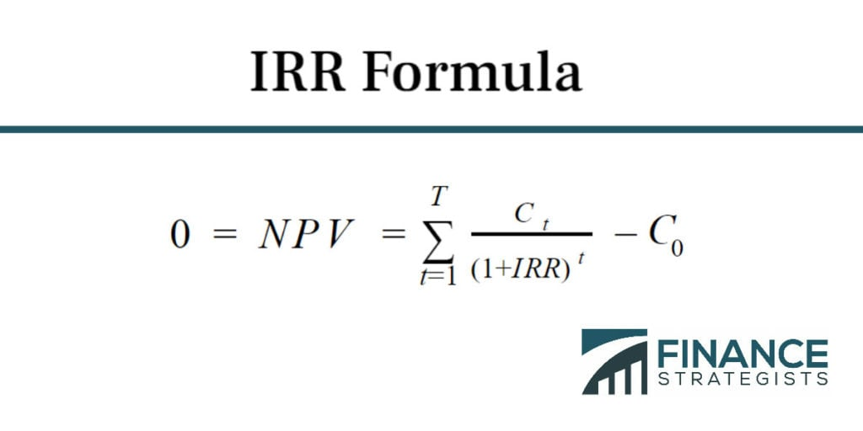
financestrategists(n.d.)
The IRR method is beneficial when comparing multiple projects or investment opportunities, as it provides a single rate of return that can be easily compared against the company-required rate of return or cost of capital.
According to Damodaran (2015), IRR is beneficial for assessing projects with different scales and durations, as it standardizes the expected returns into a single percentage figure, facilitating direct comparison. A project is generally acceptable if its IRR exceeds the required rate of return, indicating that it is expected to generate sufficient returns to justify the investment.

Non-Financial Methods of Appraisal

Balanced Scorecard
The Balanced Scorecard is a strategic planning and management tool that views the project from four perspectives: financial, customer, internal processes, and learning and growth. According to Kaplan and Norton (1996), the Balanced Scorecard helps organizations translate their vision and strategy into a coherent set of performance measures.
Advantages:
- Comprehensive View: The Balanced Scorecard provides a holistic view of organizational performance by integrating financial and non-financial measures. It ensures that all aspects of the organization are aligned with its strategic goals.
- Strategic Alignment: By focusing on multiple perspectives, the Balanced Scorecard ensures that projects are aligned with the broader organizational strategy, thus enhancing coherence and synergy within the organization.
- Performance Monitoring: It enables continuous monitoring and evaluation of performance against strategic objectives, facilitating timely adjustments and improvements.
The Balanced Scorecard approach involves setting specific objectives, measures, targets, and initiatives for each of the four perspectives:
- Financial Perspective: Measures financial performance and the effective use of resources.
- Customer Perspective: Assesses customer satisfaction, retention, and market share.
- Internal Processes Perspective: Evaluates the efficiency and quality of internal processes.
- Learning and Growth Perspective: Focuses on employee training, corporate culture, and innovation.

Strategic Fit
Strategic Fit assesses how well a project aligns with the strategic goals and objectives of the organization. According to Johnson, Scholes, and Whittington (2008), achieving strategic fit is important for ensuring that a project supports the long-term vision and mission of the organization.
Advantages:
- Alignment with Strategic Goals: Strategic Fit ensures that projects align with the organization's strategic priorities, thereby supporting the overall mission and vision.
- Resource Optimization: By aligning projects with strategic goals, organizations can ensure that resources are allocated efficiently and effectively, avoiding waste and redundancy.
- Enhanced Synergy: Projects that are strategically aligned tend to complement each other, creating synergy and enhancing the overall effectiveness of the organization.
To evaluate Strategic Fit, the following aspects are considered:
- Organizational Vision and Mission: Ensuring that the project supports the long-term goals and values of the organization.
- Strategic Objectives: Assessing how the project contributes to achieving specific strategic objectives.
- Resource Compatibility: Evaluating whether the project aligns with the available resources, including human, financial, and technological resources.
- Risk and Opportunity: Considering the strategic risks and opportunities associated with the project.
Strategic Fit analysis ensures that the project not only delivers immediate benefits but also supports the organization's future growth and development. By aligning projects with strategic objectives, organizations can achieve sustainable success and maintain a competitive edge.

Project Appraisal

Project 1: Solar Power Plant

Financial Appraisal

Net Present Value (NPV):
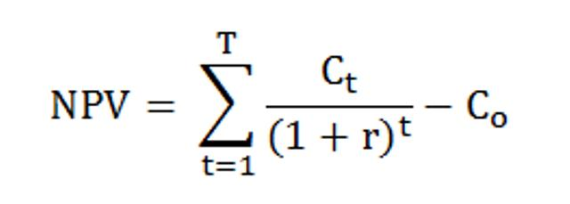
Assuming an initial investment of $5 million, annual cash flows of $1 million for 10 years, and a discount rate of 8%, the NPV calculation would be:

The NPV would be calculated for each year and summed up.

Internal Rate of Return (IRR):
IRR is the rate R that makes the NPV equal to zero:


Non-Financial Appraisal
Balanced Scorecard:
- Financial Perspective: Positive impact on cost savings through reduced energy costs.
- Customer Perspective: Increased customer satisfaction due to sustainable practices.
- Internal Processes Perspective: Efficient use of renewable energy resources.
- Learning and Growth Perspective: Enhanced employee engagement and corporate image.
Strategic Fit:
- Organizational Vision and Mission: Aligns with the goal of sustainability and reducing carbon footprint.
- Strategic Objectives: Supports environmental responsibility and innovation.
- Resource Compatibility: Leverages existing infrastructure and renewable resources.
- Risk and Opportunity: Minimizes energy costs and positions the company as a leader in sustainability.

Project 2: Online Education Platform

Financial Appraisal
The Payback Period is the time it takes for a project to recover its initial investment from its net cash inflows. It is a simple method used to determine the time required to recoup the invested funds, providing a measure of risk associated with the project. According to Gitman and Zutter (2012), the Payback Period is widely used because of its simplicity and ease of understanding.
Wallstreetprep(2024)
Assuming an initial investment of $3 million and annual cash flows of $800,000, the Payback Period calculation would be:

The Payback Period for the Online Education Platform is 3.75 years, meaning it will take approximately 3.75 years to recover the initial investment.
Pros and Cons of Payback Period:
Pros | Cons
Simplicity: Easy to calculate and understand, making it accessible for quick decision-making. | Ignores Time Value of Money: Does not consider the present value of future cash flows.
Risk Assessment: Provides a basic measure of risk by indicating how quickly the investment can be recovered. | No Profitability Measure: Does not measure overall profitability or returns beyond the payback period.
Liquidity Focus: Useful for assessing projects where liquidity is a primary concern. | Ignores Cash Flows After Payback: Does not take into account the cash flows that occur after the payback period.
Short-Term Focus: Helps in prioritizing projects with quicker returns, which can be beneficial in uncertain environments. | No Discount Rate Consideration: Fails to account for the cost of capital or the discount rate.

Non-Financial Appraisal
Balanced Scorecard:
- Financial Perspective: Revenue generation through subscriptions and course fees.
- Customer Perspective: High accessibility and satisfaction for learners.
- Internal Processes Perspective: Streamlined content delivery and scalability.
- Learning and Growth Perspective: Opportunities for content creators and educators.
Strategic Fit:
- Organizational Vision and Mission: Promotes educational access and lifelong learning.
- Strategic Objectives: Aligns with digital transformation goals.
- Resource Compatibility: Utilizes existing technological infrastructure.
- Risk and Opportunity: Capitalizes on the growing demand for online education.

Project 3: Urban Green Space Development

Financial Appraisal

Return on Investment
Return on Investment (ROI) is a measure used to evaluate the efficiency or profitability of an investment. It directly measures the amount of return on a particular investment relative to its cost. According to Berk and DeMarzo (2020), ROI is a widely used financial metric because of its simplicity and effectiveness in comparing the profitability of different investments.
wallstreetprep(2024)
Using the net benefits calculated in the CBA:

An ROI of 60% indicates that the project is expected to generate a return of 60% on the initial investment.

Non-Financial Appraisal
Balanced Scorecard:
- Financial Perspective: Long-term value through increased property values and reduced healthcare costs.
- Customer Perspective: Enhanced quality of life for residents.
- Internal Processes Perspective: Efficient maintenance and operations of green spaces.
- Learning and Growth Perspective: Community engagement and environmental education.
Strategic Fit:
- Organizational Vision and Mission: Supports sustainable urban development and community well-being.
- Strategic Objectives: Enhances urban infrastructure and environmental sustainability.
- Resource Compatibility: Utilizes municipal resources and public-private partnerships.
- Risk and Opportunity: Improves public health and fosters social cohesion.

Comparison and Decision

Criteria | Solar Power Plant | Online Education Platform | Urban Green Space Development
Initial Investment | $5 million | $3 million | $2 million
Annual Cash Flows | $1 million for 10 years | $800,000 | 160000
NPV | $1,710,081.40 | - | -
Payback Period | - | 3.75 years | Not applicable
IRR | Favorable | Competitive | Not specified
ROI | - | - | 60%
Net Profit | Not applicable | Not applicable | $1,200,000
Strategic Fit | Strong alignment with sustainability goals | Supports digital transformation goals | Supports urban development goals
Customer Perspective | High customer satisfaction | High accessibility for learners | Enhanced quality of life for residents
Learning and Growth | Enhanced corporate image | Opportunities for educators | Community engagement

The Solar Power Plant is recommended as the most valuable project. This recommendation is based on its highest Net Present Value (NPV) of $1,710,081.40, which indicates substantial financial returns over the project's lifecycle. The significant positive NPV reflects the project's ability to generate considerable profitability, making it a financially sound investment.
Additionally, the Solar Power Plant aligns strongly with the organization's strategic sustainability goals. By investing in renewable energy, the project not only contributes to reducing the carbon footprint but also positions the company as a leader in sustainable practices. This alignment with environmental responsibility enhances the corporate image and supports long-term strategic objectives, making the Solar Power Plant the most beneficial choice overall.

Implementation Plan
- Initial Planning and Feasibility Study: Conduct detailed planning and feasibility studies to ensure technical and financial viability.
- Securing Funding: Obtain necessary funding through internal resources, loans, or grants.
- Permitting and Approvals: Secure all required permits and regulatory approvals.
- Construction and Setup: Engage contractors and begin the construction and setup of the solar power plant.
- Testing and Commissioning: Perform rigorous testing and commissioning to ensure operational efficiency.
- Operational Phase: Transition to the operational phase with continuous monitoring and maintenance.

Conclusion
In conclusion, the Solar Power Plant project emerges as the most advantageous and suitable choice among the three proposals considered. This initiative not only promises substantial financial returns, as evidenced by its favorable Net Present Value (NPV) and Internal Rate of Return (IRR), but also aligns perfectly with our organization's strategic objectives of promoting sustainability and environmental stewardship. By conducting a thorough evaluation using both financial metrics and non-financial considerations, it is clear that the Solar Power Plant project offers a well-rounded package of benefits.
These include long-term energy cost savings, reduced carbon footprint, and a positive impact on community and stakeholder perceptions, which are increasingly critical in today's eco-conscious market. Additionally, the project's potential to foster local employment and stimulate economic development in the surrounding area further enhances its appeal. Overall, the comprehensive appraisal confirms that the
The Solar Power Plant project stands out not just for its immediate financial benefits but also for its broader contributions to our organization's commitment to responsible and sustainable business practices. Therefore, it is the best choice for implementation, promising significant value and aligning seamlessly with our long-term strategic goals.

Reference list
Ahad, N. (n.d.). Solutions Manual corporate fiance Ross, westerfield and jaffe. www.academia.edu. [online] Available at: https://www.academia.edu/40815832/Solutions_Manual_corporate_fiance_Ross_westerfield_and_jaffe [Accessed 21 Jul. 2024].
CFI Team (2023). Net Present Value (NPV). [online] Corporate Finance Institute. Available at: https://corporatefinanceinstitute.com/resources/valuation/net-present-value-npv/.
CFI Team (n.d.). NPV Formula. [online] Corporate Finance Institute. Available at: https://corporatefinanceinstitute.com/resources/valuation/npv-formula/.
Damodaran, A. (n.d.). Measuring Investment Returns. [online] Available at: https://pages.stern.nyu.edu/~adamodar/pdfiles/ovhds/ch5.pdf.
Designingbuildings.co.uk. (2015). Net Present Value - Designing Buildings Wiki. [online] Available at: https://www.designingbuildings.co.uk/wiki/Net_Present_Value.
Investopedia (2021). What Is Project Management? [online] Investopedia. Available at: https://www.investopedia.com/terms/p/project-management.asp.
Kagan, J. (2023). Payback Period Explained, With the Formula and How to Calculate It. [online] Investopedia. Available at: https://www.investopedia.com/terms/p/paybackperiod.asp.
Kaplan, R.S. and Norton, D.P. (1992). The Balanced Scorecard—Measures That Drive Performance. [online] Harvard Business Review. Available at: https://hbr.org/1992/01/the-balanced-scorecard-measures-that-drive-performance-2.
Koskela, L. and Howell, G. (2002). The Theory of Project Management: Explanation to Novel Methods. [online] iglc.net. Available at: https://iglc.net/Papers/Details/195.
Love, B. (n.d.). Exploring Corporate Strategy Exploring Corporate Strategy I T I O N. www.academia.edu. [online] Available at: https://www.academia.edu/9336404/Exploring_Corporate_Strategy_Exploring_Corporate_Strategy_I_T_I_O_N.
Principles of Corporate Finance, Concise. (2010). [online] www.mheducation.com. Available at: https://www.mheducation.com/highered/product/principles-corporate-finance-concise-brealey-myers/M9780073530741.html [Accessed 21 Jul. 2024].
ResearchGate. (n.d.). Brealey, Myers, and Allen on Valuation, Capital Structure, and Agency Issues | Request PDF. [online] Available at: https://www.researchgate.net/publication/46541065_Brealey_Myers_and_Allen_on_Valuation_Capital_Structure_and_Agency_Issues.
Tutor2U (2018). tutor2u. [online] tutor2u. Available at: https://www.tutor2u.net/business/reference/balanced-scorecard-introduction-overview.
Wall Street Prep (2024). Internal Rate of Return (IRR). [online] Wall Street Prep. Available at: https://www.wallstreetprep.com/knowledge/irr-internal-rate-of-return/.
Wallstreetprep.com. (2024). Available at: https://media.wallstreetprep.com/uploads/2021/08/24220240/Payback-Period-Formula-1.jpg [Accessed 21 Jul. 2024].
Welcome to Exploring Strategy. (n.d.). Available at: https://www.pearson.com/en-au/media/g10dyvte/9781292428741_sample.pdf.
www.scirp.org. (n.d.). Brealey, R.A., Myers, S.C. and Allen, F. (2011) Principles of Corporate Finance. 10th Edition, McGraw-Hill/Irwin, New York. - References - Scientific Research Publishing. [online] Available at: https://www.scirp.org/reference/referencespapers?referenceid=1296576.

