NAME : ALINA NICOLETA PRECUP
STUDENT NUMBER : 1816777
MODULE LECTURES : MANAGING PEOPLE LCBB5004
MODULE LECTURES : MARY MARCH
ASSIGMENT 2



Executive summary
The main aim of this report is to study the concept of employee engagement and its impact on organisational success and growth. During the covid-19 pandemic situation, all the organisations must look for measures and strategies that will help to increase employee engagement. Thus here in this report, the main drivers of engagement along with few strategies that will help in its enhancement will be displayed. Lastly, an EVP will be created with regards to the pandemic situation.

Table of Contents
Introduction 4
The concept of employee engagement: 5
Importance of employee engagement: 5
Drivers of employee engagement: 6
Diagnostic tools to measure engagement 7
An employee value proposition from the ideas and analysis previously covered: 10
Strategies to raise levels of engagement: 10
Conclusion 11
Reference list 11

Introduction
Here in this report, the concept of employee engagement that prevails within a workplace shall be studied deeply. Employee engagement is an approach within the workplace which results in good/right conditions for all the employees in an organisation which supports them to give in their best performances daily (Venkatesan, 2017). It is thus believed employee engagement is an important factor that needs to be present in an organisation as it keeps each member committed towards the goals and objectives of the company and thus keeps them motivated towards the company's success. Thus in this report, various topics of employee engagement and its impact upon organizational success will be highlighted.

The concept of employee engagement:
The basic concept of employee engagement is based upon a simple logic of the extent up till which the employees within an organisation have a passionate feeling about their jobs and the company as a whole. It makes them committed towards hard work and efficient efforts that are entirely focused upon the fulfilment of the objectives of the organisation. There is a belief that an organisation should try to develop a positive environment within its premises that promotes employee engagement and thus improves the overall performances along with productivity rates.
However, it is important to note down that employee engagement is not just as similar to employee satisfaction. Satisfaction as the term states the contentment and happiness that is present within an employee and it does not address factors like motivation, emotional commitment, and involvement and so on. When employees are satisfied it necessarily does not mean that their productivity is high. At times a few situations within an organisation that satisfy few employees frustrate the high performing workforce. It is the top-performing employees that try to embrace the change and look for ways to improve and thus challenge the status quo (Harmeling et al., 2017).

Importance of employee engagement:
Engaging the employees within an organisation is extremely crucial as it helps in retaining the valuable employees who have the best of talents in them and it acts as an important segment of the employee satisfaction puzzle. Disengagement within the employees increases the cases of turnover and absenteeism. Thus according to Forbes, the employees or the workforce that is engaged within the organisation are generally much more motivated and committed towards the work and the employer.

Drivers of employee engagement:
Multiple factors act as major drivers of employee engagement. However, the company as a whole has the most impact on the engagement of employees. Now the key drivers of employee engagement are as follows:
Direction and purpose: It has been observed that more than 80% of the employees are much more engaged when they are given a certain direction they should be working towards. When the employees know that their company's mission and core values are specific they tend to be much clearer with their activities and thus work towards the fulfilment of the company objectives. Thus the organisation must inform its employees about the purpose of the company and thus they have a collaborative approach towards the future of the company. Also, the company can develop a cohesive employer branding strategy (Fehrer et al., 2018). Work environment: 65% of the employees have stated that they are affected by various environmental factors like temperature control, lighting, furniture provided which affects their overall productivity and performance. Since it is the time of the pandemic the company can allow the employee to tailor a work environment that is according to their preferences. There are different types of employees; few prefer working in dim lighting and less noise whereas few are okay with the background noise and bright lighting (Dixit and Singh, 2020). Transparency: this has to be one of the most important factors that promote employee engagement. More than 70% of the employees have stated that they are much more engaged when they are informed and updated about the strategies and important events happening within the organisation. All the people must be kept at the same boat when any particular decision is to be taken. However, it is also important that the organisation maintains the transparency levels that protect personal data, if leaked might cause distrust among employees (Fehrer et al., 2018). A transparent organisation allows the employees to openly discuss their queries and concerns. Diversity and inclusion: The impact that diversity and inclusion that upon employee engagement are immense. With time this factor has benefited the organisations of all sorts. This is because an organisation when it promotes inclusion and diversity it treats each employee on the same grounds and does no differentiation between them. Thus employees engage without having any negative thoughts or feelings (Chiang et al., 2017).
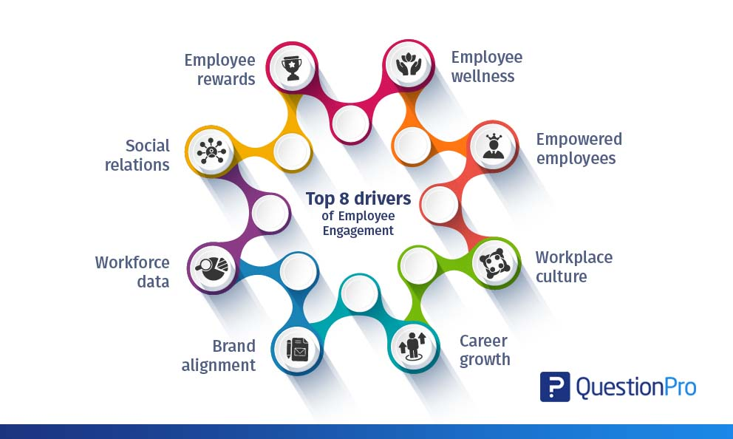
Figure 1: Key drivers of employee engagement
Source: (Fehrer et al., 2018)

Diagnostic tools to measure engagement
Measuring the employee engagement that is present within an organisation is quite difficult just because it cannot be measured in physical forms or is not quantifiable. Each organisation has a different perception with regards to the engagement of employees; few consider it as happiness and contentment among employees, some state it is as satisfaction whereas few states it as a commitment towards the final aim. However, it is much more complex that what it is expected to be (Raeisi and Lingjie, 2017).
Thus few of the diagnostic tools that can be used to measuring the engagement rates are as follows:
- Pulse surveys: Also referred to an as short and frequent survey is an effective tool that can help in maintaining the vibe within an organisation. It is quite a simple and straightforward approach and nothing complex. Within this tool, the employees working in an organisation can be asked a set of five to ten questions about how they are feeling working in the office, if they have any queries or not and so on. The main aim of this survey as a tool is to engage with the employees and ask a few general questions which are quite general and nothing too serious. Another aim of this survey is to make sure if all the actions plans are working or not and if not modifications can be made quickly. All the questions asked are mainly engagement questions thus the feedback received helps in understanding what has been helping in increasing rates of engagement.
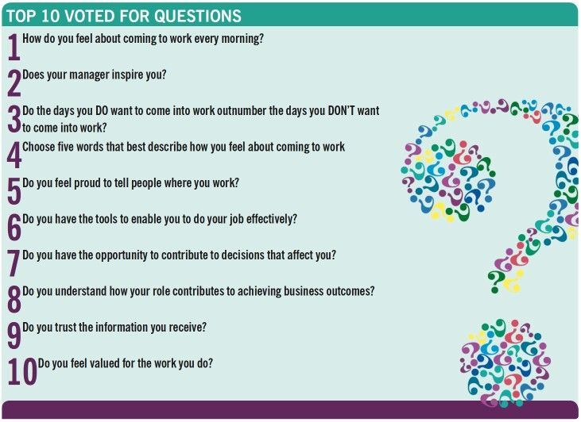
Figure 2: Sample questions asked in the survey
Source: (Palmatier et al, 2017)
- 1-on-1s: Having a one on one meeting with the employees is another great tool that can help in assessing the engagement levels of the employees. This particular is very much chilled out and has an informal touch. Since due to the pandemic most of the companies are working from home this particular tool can be used through video chats and zoom meetings. This survey can be informed to employees through emails or texts and thus each employee will be asked very informal questions and know what are the factors that are keeping them motivated during the work from the home situation and so on. The main merit of this tool is that it involves a personal touch where each employee is asked about their experience and maximum details are obtained regarding different topics. The main aim of this tool is to allure the employees open up and discuss on various topics (Risley, 2020).
- Stay/exit interviews: Here in this tool, a structured interview can be used to obtain feedback regarding work and know about what are the factors that have kept them holding on to the organisation. The exit interview tool is quite common in most of the organisation however they stay interviews should be conducted more often so that employees can be asked what keeps them connected to the organisation and thus they want to stay. Within the exit interview, the employees can be asked what are the things or the segments that need improvements and so on (Risley, 2020).

Figure 3: Types of questions that are asked in stay and exit interviews
Source: (Created by learner)
- eNPS: An abbreviation for Employee net promoter score is one of the simplest yet effective ways that are used for measuring the engagement rates of the employees. Here only one simple question is asked to the employee and it shows the loyalty of the person towards the company. For example, the employees will be asked if they would recommend the company to other people or not? Or would to recommend others to buy the products sold by the company?
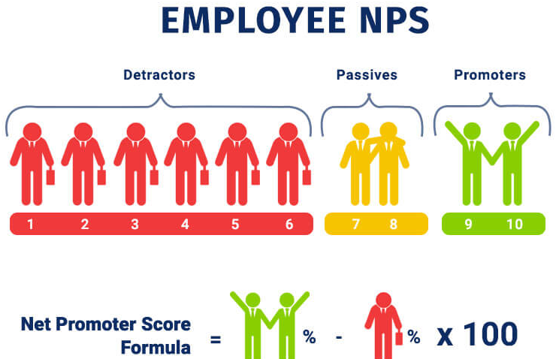
Figure 4: The metric used for obtaining answers/feedback from employees
Source: (Love, 2016)
Thus the different tools that have been mentioned above each one of them have different benefits in knowing about the rates of engagement within an organisation. Perhaps, measuring is just the first step before which an organisation must be committed to enhancing the rates; and when measured communication is the key through which improvements can be made.

An employee value proposition from the ideas and analysis previously covered:
The employee value proposition is a balance between the benefits and rewards that are received by the employees within an organisation for their performances. In simple terms, it is the values along with the benefits that are offered by an organisation to its employees to motivate them and thus receive superior performance. EVP is a return for all the skills that are applied by an employee (Pawar, 2018).
The 4 key building blocks of EVP are as follows:
Compensation: Regarding the compensation block in the employee value proposition can be such which supports the employees during this pandemic. As most of the work is happening at a work from a home situation the employees will be given extra bonuses and incentives who work extra or does over time. Moreover better compensation and incentives plans will be offered based on the performance.
Benefits: Regarding the second block, the benefits to be received by the company's employees will include flexibility to work because of the work from the situation. Then all of the employees will get a facility which will allow them some extra time to cover their commitments at home and so on. Other than this if any of the employees want to resume with the office working, the premises will be made covid-19 safe through proper sanitization processes and social distancing (Risley, 2020).
Career development: For the career development of the employees the organisation will offer various options for career growth like the fulfilment of certain goals and fulfilment of a few targets and promotion options. The culture has changed entirely after the pandemic hit the entire world various new career development schemes and plans have been created.
Working environment and employee survey: Lastly after the pandemic, various measures have been taken like options for work from home along with flexible working hours. The premises have been made covid-19 safe through regular sanitization and thus whoever wants to resume office can come and start working.

Strategies to raise levels of engagement:
Few strategies for improving the levels of engagement rates are as follows:
- The organisation should be focused around its core values and give its employees a direction that they should be working towards even during a work from home situation.
- The organisation should not stop supporting its employees in any case. Supporting and encouraging them to perform better will keep them motivated every during tough times like the Covid-19.
- The organisation should gather regular feedback from the employees and ask for open opinions regarding the good as well as the bad. Moreover, the organisation should ask for ideas for development from employees as well.
- Then the companies should communicate regularly with its employees and thus try and gather as much as information possible which might be valuable for the company (Love, 2016).

Conclusion
Thus it can be concluded by saying that engaging with the employees has become a crucial segment in today's world due to the pandemic. If the organisations want to stay at the top positions of the industry it should then aim towards new plans and techniques which will increase the overall employee engagement rates. Employee engagement is considered to be of the key factors towards the success of the organisation. All the different tools that have been above can be strategically used to improve the rates.

Reference list :
Chiang, C.T., Wei, C.F., Parker, K.R. and Davey, B., 2017. Exploring the drivers of customer engagement behaviours in social network brand communities: towards a customer-learning model. Journal of Marketing Management, 33(17-18), pp.1443-1464.
Dixit, R. and Singh, S., 2020. Understanding Drivers of Engagement from Employees' Perspective during COVID-19. International Journal of Management, 11(10).
Fehrer, J.A., Woratschek, H., Germelmann, C.C. and Brodie, R.J., 2018. Dynamics and drivers of customer engagement: Within the dyad and beyond. Journal of Service Management.
Harmeling, C.M., Moffett, J.W., Arnold, M.J. and Carlson, B.D., 2017. Toward a theory of customer engagement marketing. Journal of the Academy of marketing science, 45(3), pp.312-335.
Love, Z.M., 2016. Rules of (employee) engagement: A comprehensive model.
Palmatier, R.W., Kumar, V. and Harmeling, C.M. eds., 2017. Customer engagement marketing. Springer.
Pawar, A., 2018. Analyzing Organizational Elements of Employee Value Proposition: The Employees Perspective. In Proceedings of Asia Conference on Business and Economic Studies (ACBES) by University of Economics Ho Chi Minh City on 8th–9th Sep 2018 at Ho Chi Minh City, Vietnam. (pp. 94-103). UEH Publishing House.
Raeisi, S. and Lingjie, M., 2017. The importance of customer engagement and service innovation in value co-creation. International Journal of Economics and Management Engineering, 11(4), pp.813-818.
Risley, C., 2020. Maintaining Performance and Employee Engagement During the COVID-19 Pandemic. Journal of Library Administration, 60(6), pp.653-659.
Venkatesan, R., 2017. Executing on a customer engagement strategy.

