4/22/2026
University of WALES Trinity Saint David
London campus
Assessment 2
Computer Architecture and Operating Systems
Module Name: Computer Architecture and Operating Systems
Module Code: (ACCA4022_LON)
Student Name: Dzhenifer Oleksandra Safutina
Student ID: 2514100
Group: 2
Lecturer’s Name: Redhwan Al Amri
Contents
Introduction…………………………………………………………………….3
Task 1. Key Functions of General Operating Systems……………..3
Task 2. Use of Windows OS CLI commands………………………….8
Task 3. Use of Linux OS CLI commands………………………………16
Task 4. Use of Windows OS scripts…………………………………….23
Task 5. Use of Linux OS scripts………………………………………….24
Conclusion…………………………………………………………………….25
References…………………………………………………………………….26
Appendices……………………………………………………………………26

Introduction
Operating systems are critical components of computers as they facilitate the management of hardware as well as provide an interface to interact between the user and the computer. Operating systems are known for their management of processes, memory management, files, devices, security, and networking among others.
In this report, a detailed examination of the roles played by general operating systems has been conducted, with particular emphasis on the roles played by operating systems running on Windows and Linux platforms. The report also includes information concerning the use of command lines and scripts used in administration purposes. Practical examples have also been provided along with some screenshots of commands used for demonstrating operating system concepts.
Task 1. Key Functions of General Operating Systems
1.1 Process Management
Process management is a critical component in an operating system since it controls process execution, resource allocation, and makes multitasking possible. The operating system has the ability to create, schedule, suspend, and terminate processes. Users are able to view the state of a process using Task Manager in Windows or top/ps command in Linux.
Screenshot:
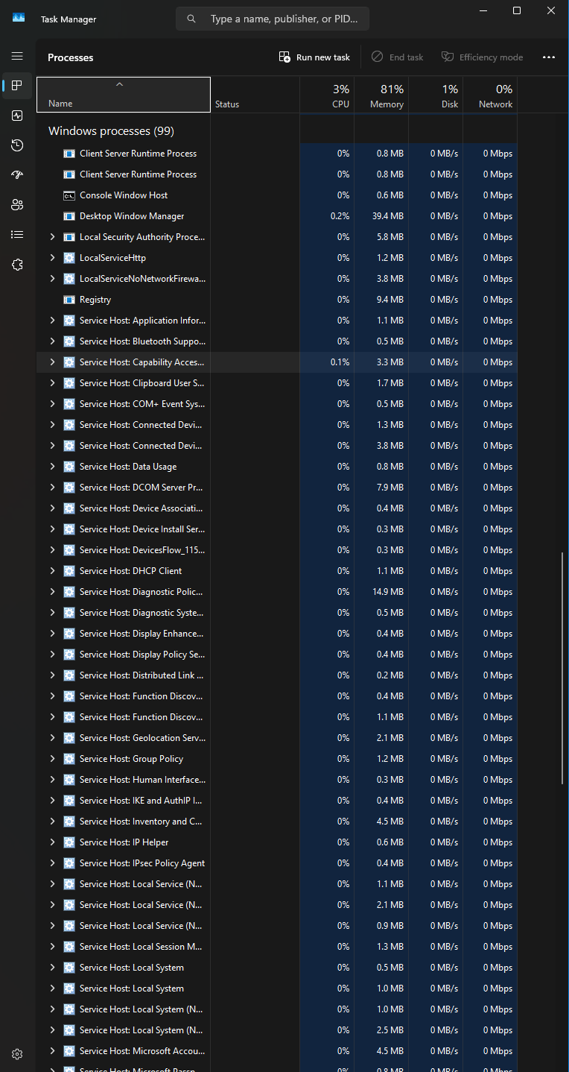
1.2 Memory Management
The Memory Management function handles the allocation and utilization of RAM. This is managed by the operating system to determine how the memory will be allocated among the programs. Efficient memory management will help improve system performance while avoiding conflicts among programs.
Windows users can check their memory usage through Task Manager Performance section. For Linux systems, command lines like "free -h" can be utilized.
Screenshot: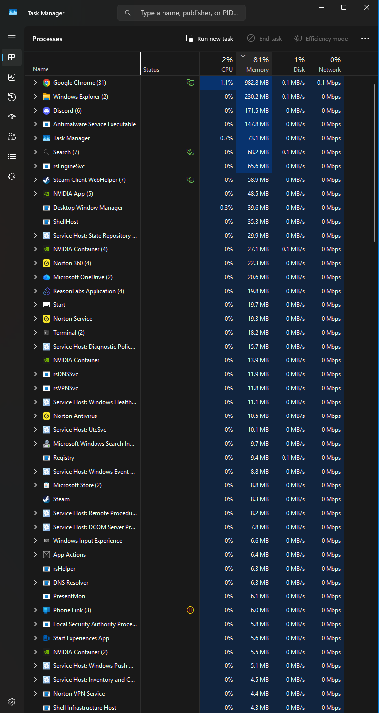
1.3 File Management
File systems are used by operating systems for managing files. These include creating, deleting, copying, and securing files and directories.
Examples of Windows file systems are NTFS, whereas examples of Linux file systems are ext4. Files can be managed using the GUI such as File Explorer, or using command line tools such as dir, ls, cp, and mkdir.
Screenshot: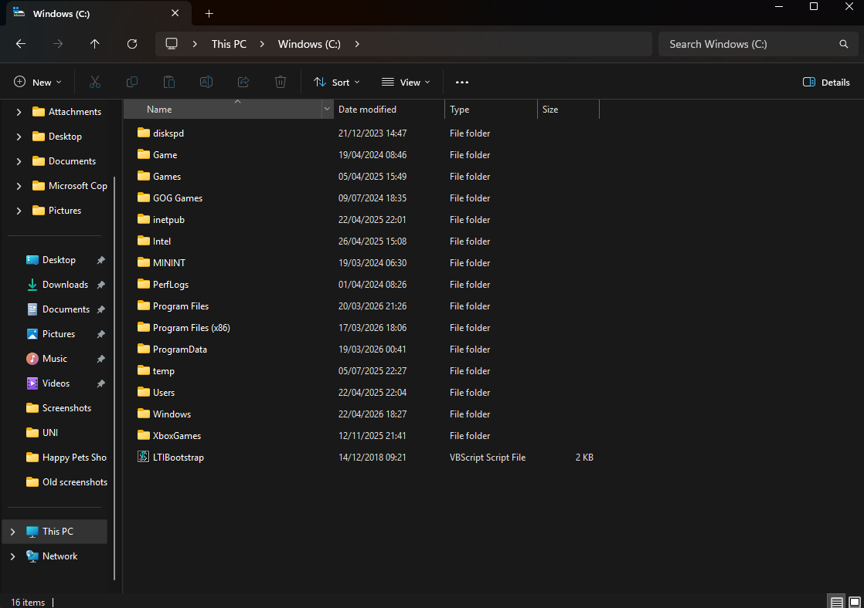
1.4 Device Management
Operating systems manage communication between hardware devices and software through drivers. This includes printers, keyboards, storage devices and network adapters.
Windows uses Device Manager to monitor and configure hardware devices. Linux uses kernel modules and terminal commands to manage devices.

Screenshot:
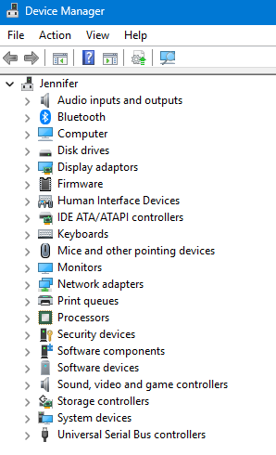
1.5 Security and User Management
Security services contribute to safeguarding the system from any form of tampering. The operating systems control user accounts, passwords, permissions, and access controls.
User Account Control is used by Windows, whereas the Linux operating system uses user permissions and the chmod and passwd commands.
Screenshot: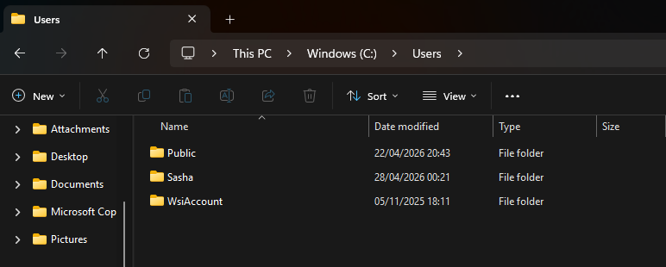
1.6 Network Management
Operating systems support network connectivity by managing IP addresses, communication protocols and network resources.
Windows provides tools such as Network Settings and commands like ipconfig, while Linux supports networking through commands such as ifconfig or ip.
Screenshot: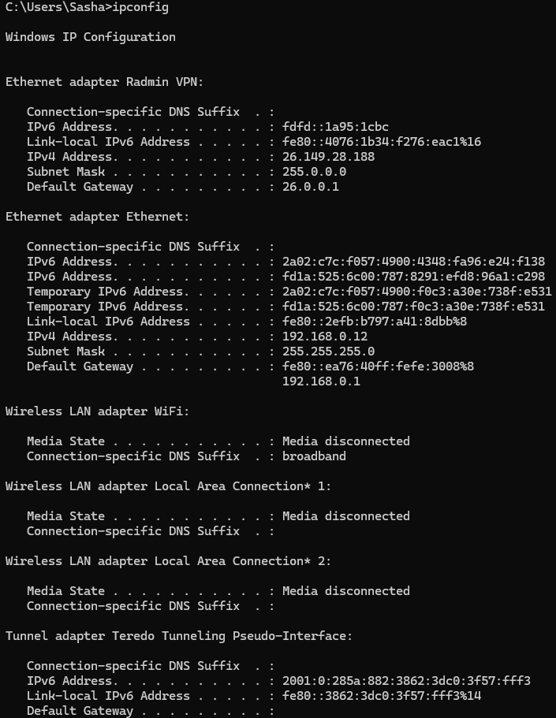
Task 2. Use of Windows OS CLI commands
Process Management
1. Command: tasklist
Purpose: Shows the active processes currently running on the computer's system.
Example Output: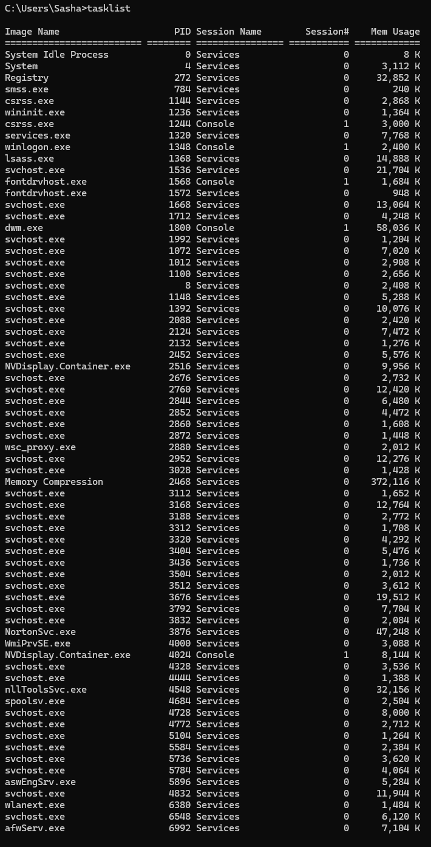
Analysis: Useful for tracking how much resources the computer uses and managing processes.
2. Command: taskkill
Purpose: Designed to force the termination of one or more processes on the computer.
Example Output:
Analysis: Used to close frozen applications, background services and terminate processes on a local or remote computer.
File and Directory Management
3. Command: dir or dir /p
Purpose: Shows a list of files and subdirectories in the current or specified folder.
Example Output: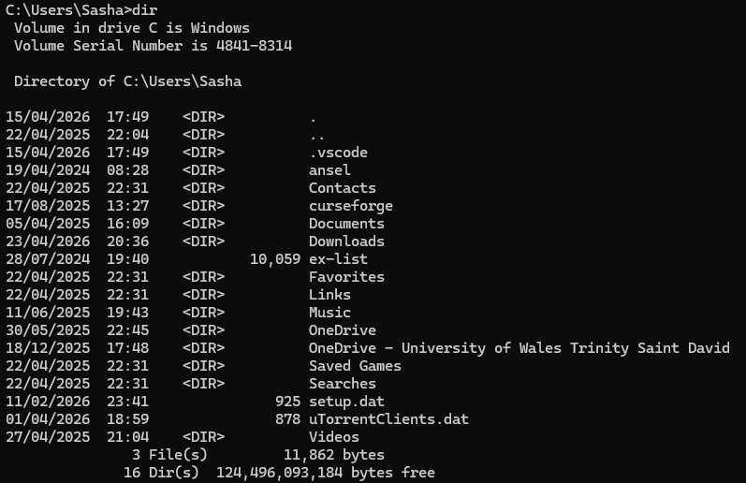
Analysis: Used to simplify file management, acting as a navigator in a computing system.
4. Command: mkdir
Purpose: Creating new folders in the file system.
Example Output: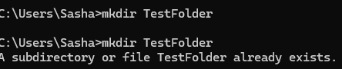
Analysis: Useful for quick organisation of file structure, automation of directory creation through scripts and simultaneous creation of entire chains of subfolders without using a graphical interface.
5. Command: copy
Purpose: Copying one or more files from one location to another.
Example Output: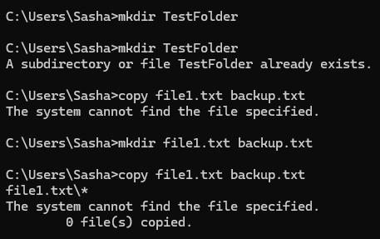
Network Testing and Monitoring
6. Command: ipconfig
Purpose: Shows and manages network connection settings.

Example Output: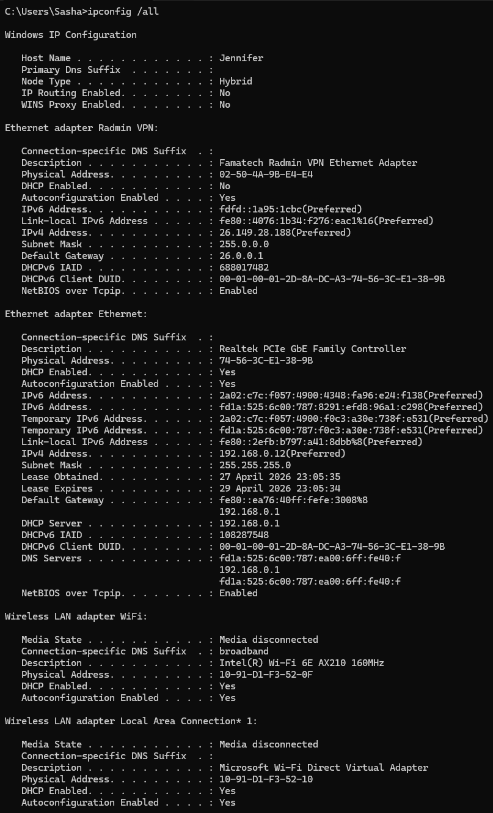
Analysis: Used for quick diagnostics and network configuration: it allows you to instantly find out the current IP address of the computer and the address of the router, identify problems with data acquisition, as well as restore access to sites by clearing the DNS cache. It is useful when you need to forcibly update the network connection without rebooting the system, check the physical address of the device to configure the router security or understand why the computer does not see other devices on the local network.
7. Command: ping or ping -n
Purpose: Checking the availability of nodes in the IP network by sending them ICMP echo requests and measuring the response time.
Example Output: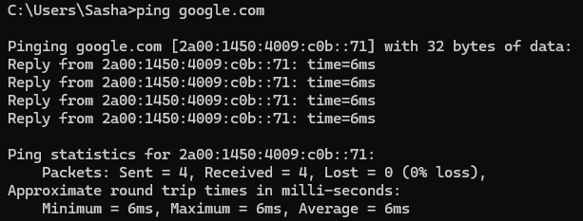
Analysis: Used to determine the presence of communication, network delay and check the operation of DNS.
8. Command: netstat
Purpose: Checking network connections, protocol statistics and information about network interfaces.

Example Output: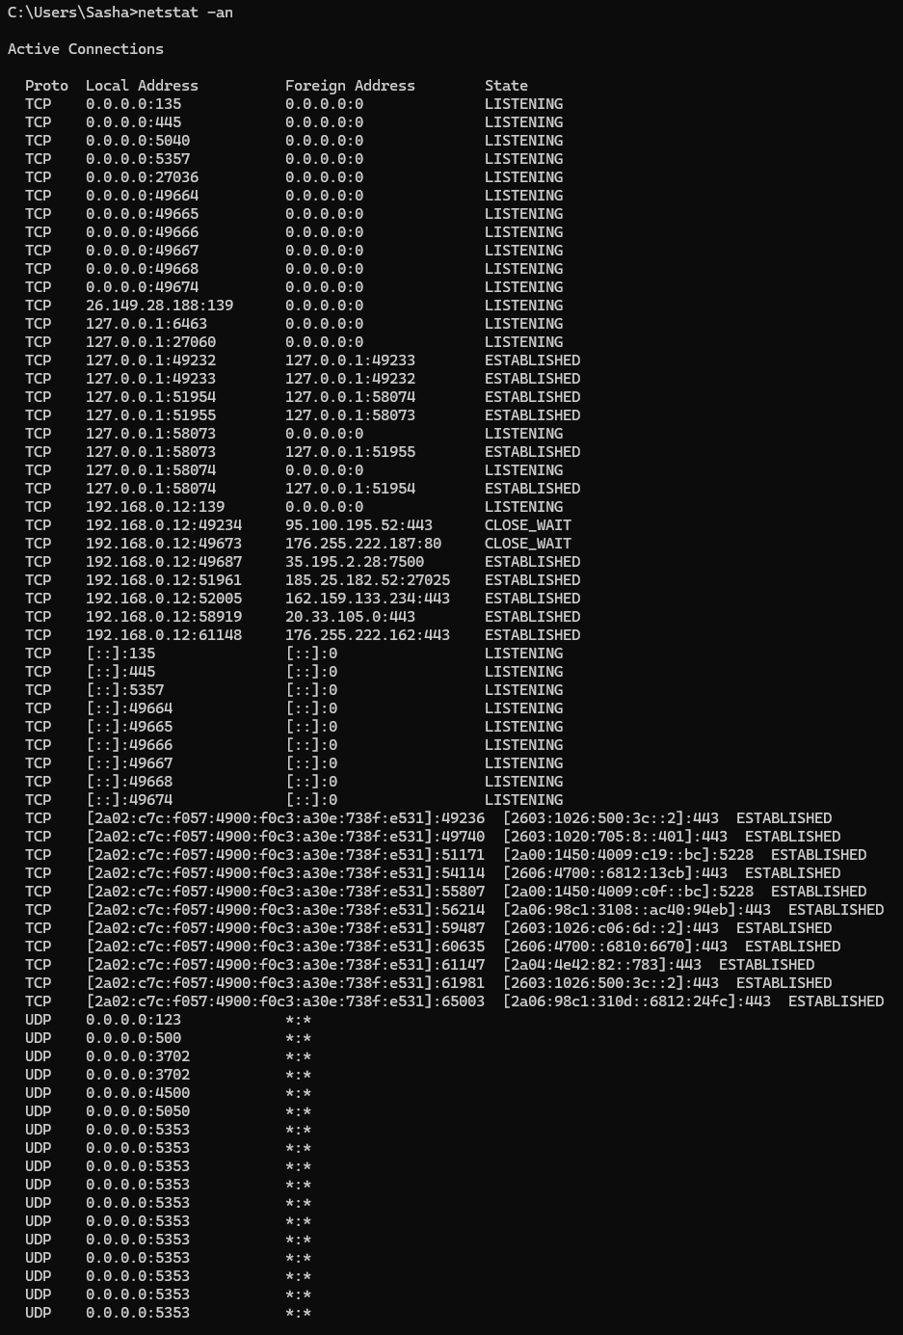
Analysis: Used to detect suspicious activity and hidden malware connections, check open ports and find out which specific application uses them, diagnose network failures and confirm service availability, analyse network interface error statistics, as well as view traffic routes and current sessions between your device and the Internet.
User Management
9. Command: whoami
Purpose: Shows the name of the user which the current session or script is currently running.
Example Output:
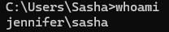
Analysis: Used to quickly identify the current user on the system, which is critical when working with multiple accounts or remote servers. It is indispensable in automation and scripts for checking access rights before executing commands, as well as during debugging, when you need to confirm under which account a particular application or process is running.
10. Command: net user or net user yourusername
Purpose: Create, modify, delete, and display user account information on the computer or domain using the command line.
Example Output: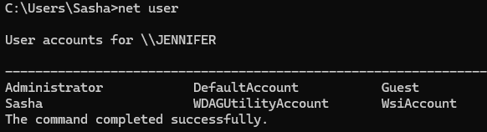
Analysis: Used to manage users, change passwords, activate or deactivate accounts and limit login time without using a graphical interface.
Task Scheduling
11. Command: schtasks
Purpose: Managing the task scheduler via the command line.
Example Output: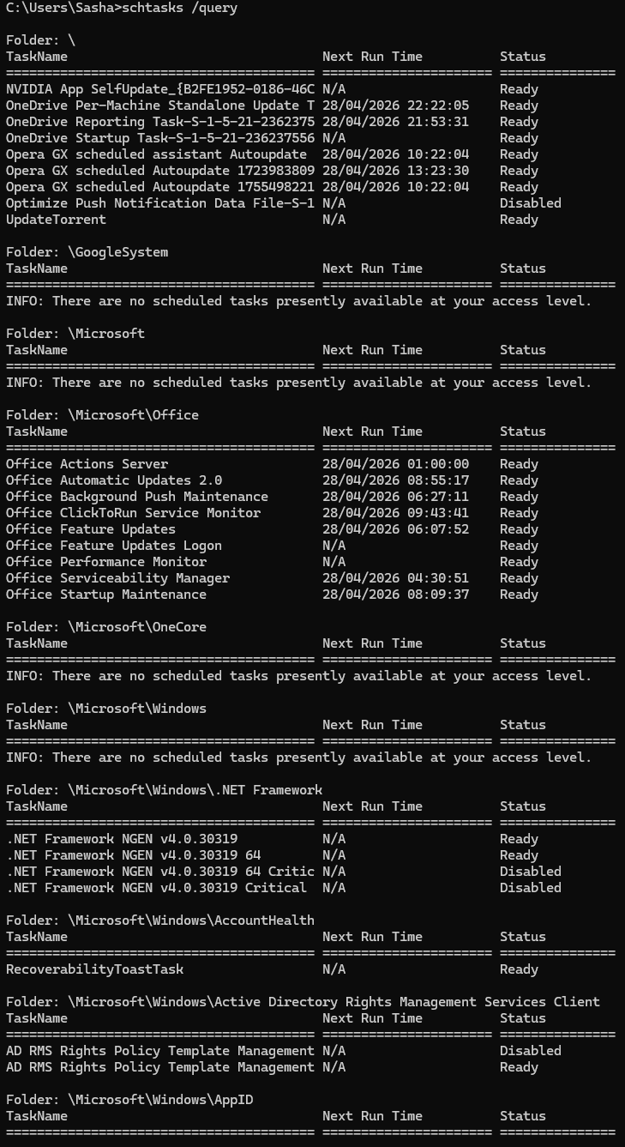
Analysis: Used for automation. Allows you to run backups, clean the system, run maintenance scripts after hours and configure tasks on remote computers on the network without user participation.
Task 3. Use of Linux OS CLI commands
Process Management
1. Command: ps
Purpose: Creating a static snapshot of current processes.
Example Output: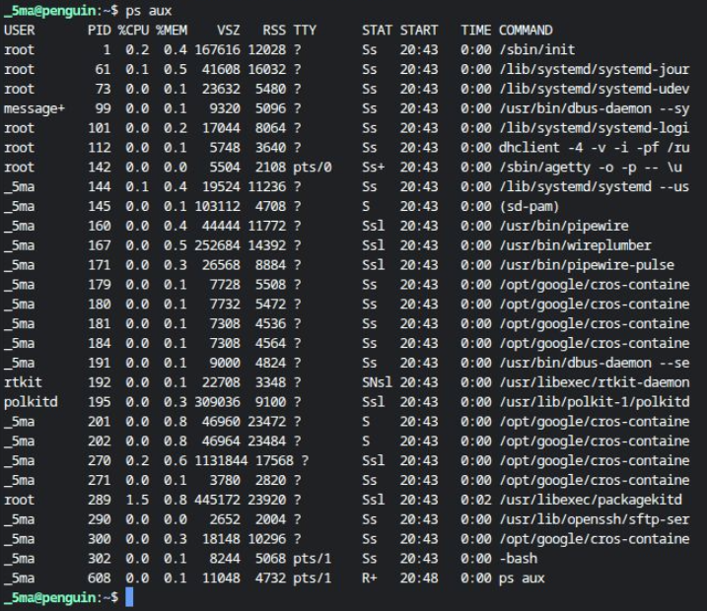
Analysis: Used to monitor the system, search for frozen processes, analyse the load and manage access rights.
2. Command: top
Purpose: Console task manager designed to monitor the system in real time.
Example Output: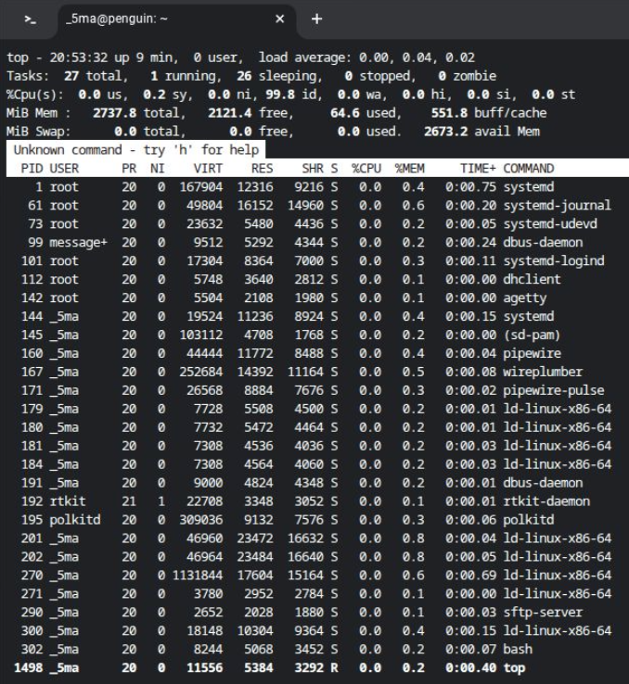
Analysis: Used to view the system status in real time. Allows you to quickly find and complete processes that overload the processor or all RAM, assess the total load on the server and notice the lack of resources in time, which makes it an indispensable tool for diagnosing brakes, monitoring user activity and operational management of running programs without rebooting the system.
3. Command: kill
Purpose: Sending signals to processes for their forced or correct completion by PID.
Example Output: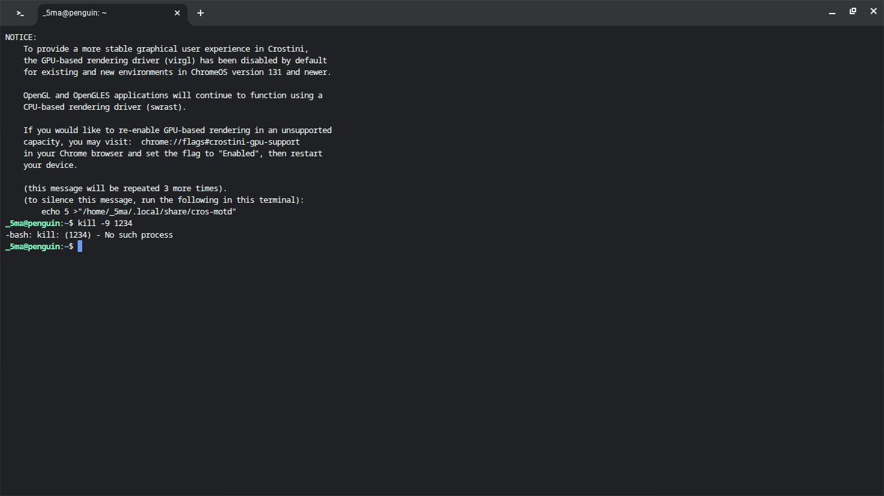
Analysis: Used to control the system in situations where graphical interfaces do not help. Allows you to forcibly close frozen processes, free up RAM from resource-intensive tasks and complete unnecessary background operations. In addition, it is indispensable for system administration, as it allows you to update service settings without completely stopping them and quickly put in order in the list of running applications by their identifiers.
File and Directory Management
4. Command: ls
Purpose: The main tool for viewing the contents of the catalogues.
Example Output: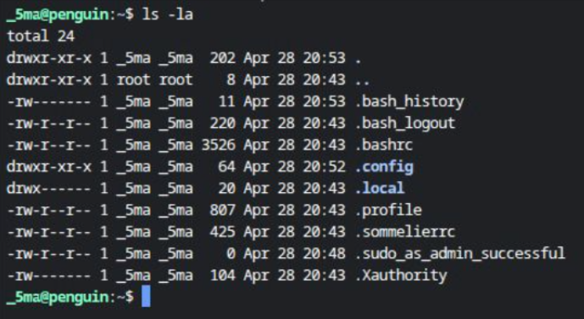
Analysis: Used for quick navigation and control of the file system. Allows you to instantly see the list of files in the folder, find hidden system configurations, check access rights and owners, as well as evaluate the size of data and track recently changed objects by sorting by time.
5. Command: mkdir
Purpose: Creating new folders in the file system.
Example Output: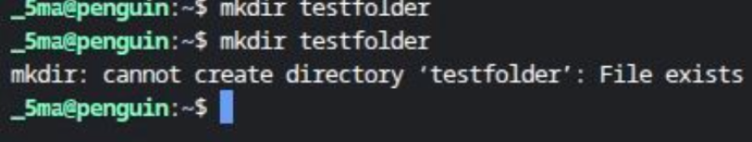
Analysis: Used for quick organisation of the workspace and automation of tasks. You can create complex subfolder structures with one command, prepare directories for logs or backups in scripts and immediately set the necessary access rights. This eliminates routine when deploying projects and helps maintain strict order in the file system.
6. Command: cp
Purpose: Copying files and catalogues from one place to another.
Example Output: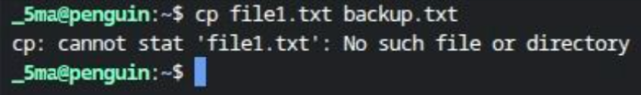
Analysis: Used for backup, configuration backup and data duplication.
Network Testing and Monitoring
7. Command: ping
Purpose: Network diagnostics tool, used to check the availability of the node on the network and measure the quality of the connection.
Example Output: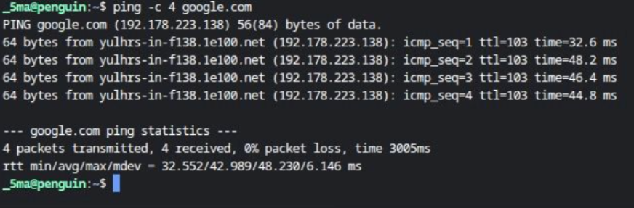
Analysis: Used to diagnose the network. Confirms the presence of an Internet connection, checks the availability of specific sites or devices on the local network and helps to identify problems with DNS. Determine the delay in milliseconds, which is critical for games and video communication, and also detect packet loss, indicating channel instability or equipment malfunction.
8. Command: ip
Purpose: Configuration of network interfaces, IP address management, routeing tables and tunnels.

Example Output: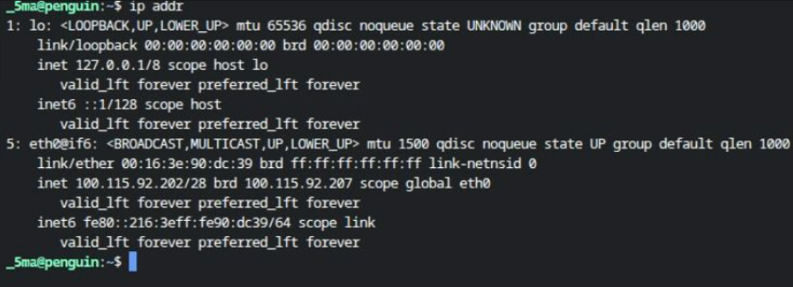
Analysis: Used for full control over the network. Allows you to view and assign IP addresses, manage the state of network interfaces, configure routeing tables and gateways, manage ARP tables and network tunnels, replacing legacy ifconfig and route utilities.
9. Command: netstat
Purpose: Monitoring of network connections, routeing tables, interface statistics and maskarading.
Example Output: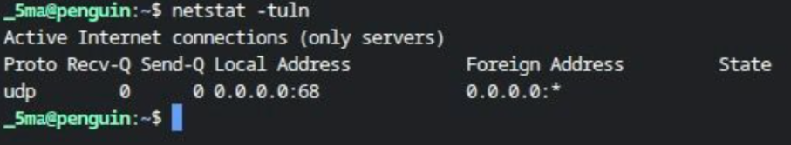
Analysis: Used to diagnose network problems, view active TCP/UDP connections and identify applications that occupy ports.
User Management
10. Command: who
Purpose: Displays a list of users who are currently logged in.
Example Output: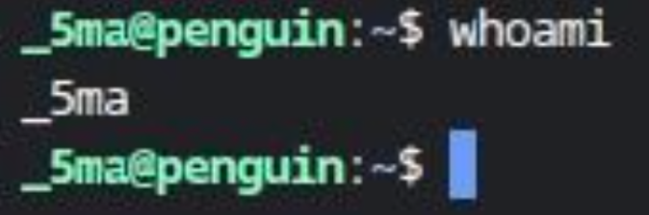
Analysis: Used to monitor activity, control security and administer multi-user servers.
11. Command: passwd
Purpose: Creating, changing and managing user account passwords.
Example Output: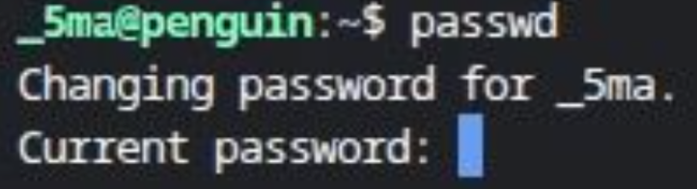
Analysis: Used for system security. Allows users to update their passwords on their own, and administrators to restore access to other people's accounts, block suspicious accounts and customise a policy of regular password change to protect against hacking.
Task Scheduling
12. Command: crontab
Purpose: Editing, viewing or deleting task tables that the cron task scheduler uses to automatically run scripts, scripts or commands at a specific time or with a specified periodicity.
Example Output: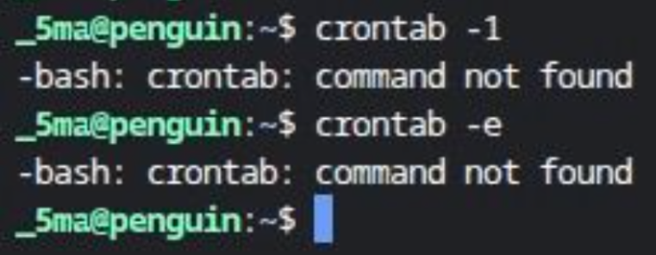
Analysis: Used for full routine automation. Allows you to make backups, clear the cache and old logs, update the system, send scheduled reports and restart services without user participation. This saves time and ensures that important maintenance tasks will be completed on time, even if you forget about them.
Task 4. Use of Windows OS scripts
Script 1. Even or Odd Number Checker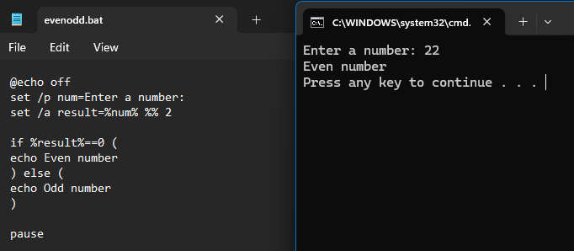
This is an example of how a batch file can enter input, perform mathematical calculations and use conditional statements. It takes an integer as a user input, and displays output determined by whether it is odd or even.
Script 2. Simple file Backup script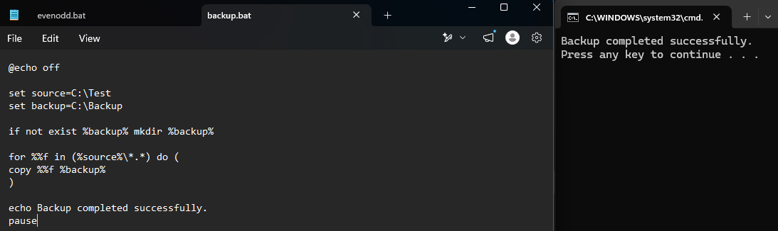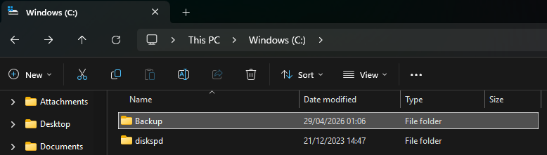
This code shows how automation can be achieved using variables, looping and file handling operations. It makes a backup of files from one folder to another folder.
Task 5. Use of Linux OS scripts
Script 1. Even or Odd Number Checker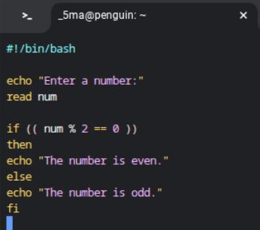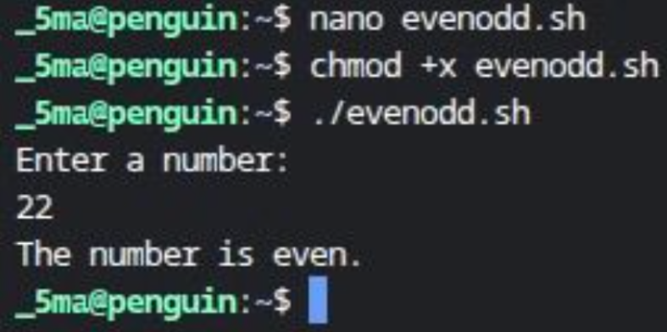
This Bash script demonstrates user input, arithmetic calculation and conditional logic by identifying whether a number entered by the user is even or odd.
Script 2. Simple file Backup script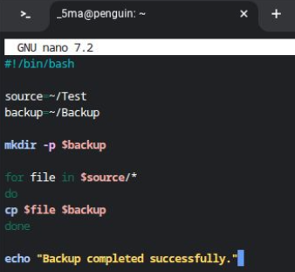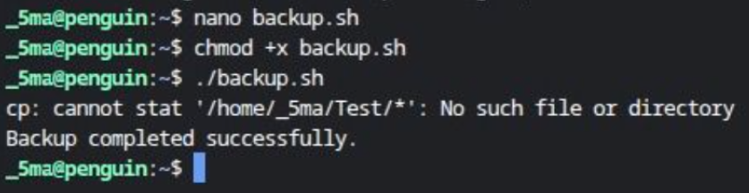
This script automates file backup by copying files from a source directory to a backup directory using variables and a loop.
Conclusion
In this report, the primary functions of operating systems have been discussed along with the way these functions are provided by operating systems like Windows and Linux. It is evident from the results that operating systems provide critical services to the computer system in terms of managing resources and facilitating user interactions.
Apart from that, the report also provides information regarding the application of command-line interface in both Windows and Linux using various administrative commands for controlling processes, performing networking operations, managing files, and scheduling jobs. This section shows that command-line interfaces may be used more effectively compared to graphical interfaces in certain scenarios.
Lastly, the application of Batch and Bash scripts was discussed where it was seen that these scripting languages may help automate tedious administrative operations, such as data validation and file backup.
References
[1] A. Silberschatz, P. Galvin and G. Gagne, Operating System Concepts, 10th ed. Hoboken: Wiley, 2018.
[2] W. Stallings, Operating Systems: Internals and Design Principles, 9th ed. Pearson, 2018.
[3] Microsoft, “Windows Commands Documentation,” Microsoft Learn, 2025.
[4] The Linux Foundation, “Linux Command Line Basics,” 2025.
[5] OpenAI ChatGPT, private communication, Apr. 2026.
Appendices
Appendix 1.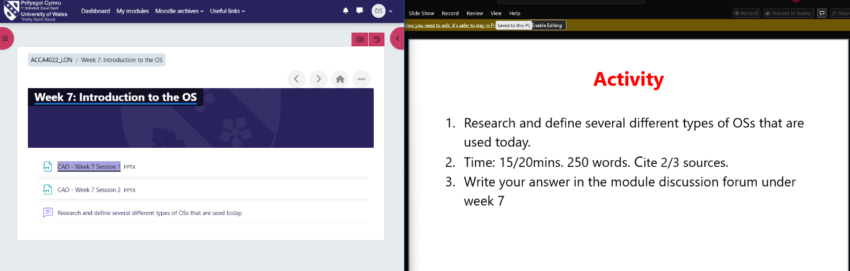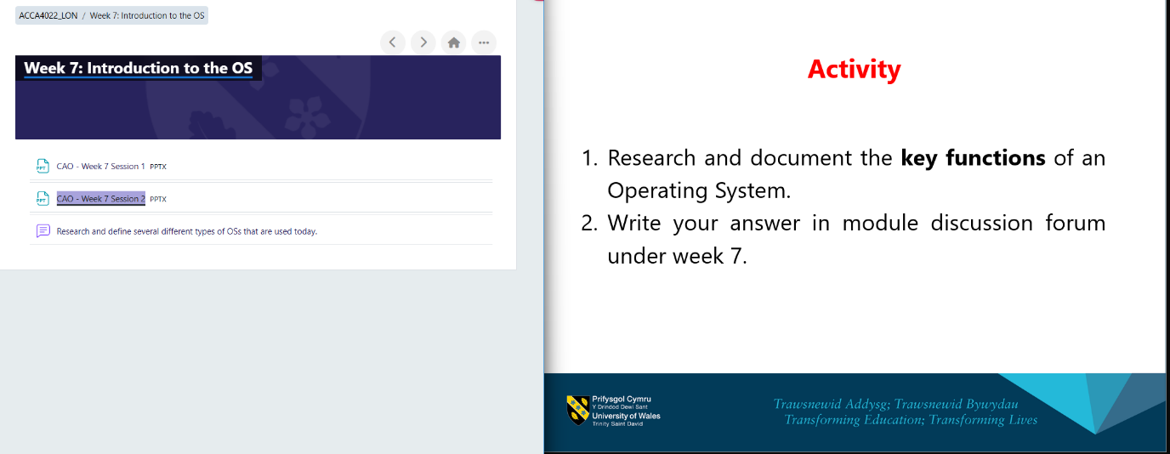
Appendix 2.

Week 7: Introduction to the OS
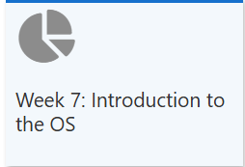
Week 8: Windows OS
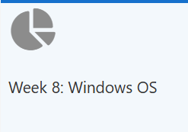
Week 9: Linux OS


