MODULE CODE: Foreign Languages & Cultural Awareness

MODULE CODE: M5X01923_LON

Program: International Hotel Management

Lecture Name: Olubukola Adegbite

Name: Dimitar Lazov

ID:1818541

HOTEL INTERNATIONAL

Contents

Introduction 3
Importance of cultural diversity at hotel industry 3
Key considerations in relation to the international visitors from cultural perspectives 4
Different cultures and behaviour of hotel staff 5
Do’s and Don’ts for the hotel staff regarding international visitors 10
Conclusion 11
References 12

Introduction
Cultural diversity is a natural phenomenon and is a significant factor in the hotel management service and hospitality industry. For this purpose, cultural diversity should be included and promoted amongst the hotel staff as well. There are various national and international laws as well as guidelines in this regard. The organizations including the hotels are required to provide equality and promote cultural as well as ethnic diversity. However, such cultural service requires knowledge regarding various cultures and nationalities. Knowing the different cultures and requirements as well as preferences of the international visitors help the hotels to not only improve their service quality but also gain competitive advantages in the concerned industry as more people are generally attracted to the hotels in foreign lands where their culture are being given priority (Badran and Khalifa, 2016). Therefore, the present report has presented the differences related culture of people from different countries; for this purpose, the countries of Japan, Britain, Germany and Bulgaria have been taken into consideration. The present report will provide examples of cultural differences and role played by hotel industry staff in promoting the same as well as providing service in accordance with it. It will also provide the do’s and don’ts for the hotel staff regarding dealing with international customers and service users in the concerned industry.

Importance of cultural diversity at hotel industry
The tourism industry is closely related to the hospitality or hotel management industry. Based on these aspects, the globalisation amongst people develops. These industries not only contribute to the national economy and international trade as well as political relations but other factors, such as social and cultural development as well. Hence, open-minded employees and more acceptable environment at the hotels would be beneficial for economical, social and cultural development globally. Moreover, it also helps in preventing any kind of discrimination. The cultural acceptance and promotion further help in improving the experience of people belonging to different countries. Hence, the different customs, preferences based on the culture of people can be very helpful and are significant factors in the concerned service providing business and the industry as well (Annan, et al., 2019). While dealing with international visitors, cultural acceptance and promotion encourage them to visit again. This aspect, hence, helps to boost tourism as well as the hotel industry.

Key considerations in relation to the international visitors from cultural perspectives
The basic aspects are always should be taken into consideration while dealing with visitors and guests at the hotel. In this regard, the cultural aspects should not create any kind of inconvenience for the guests. For instance, communication is the key to good hospitality service. In case of language barriers, the international hotels should always give preference to the different languages of the guests and for this purpose, the hotel staff should be given training in relation to the basics of different languages. Moreover, the hotels should also keep translators to mitigate the language-based issues or prevent any such issue while dealing with other inconveniences. Moreover, hygiene and clean hotel atmosphere should be one of the top priorities no matter what cultural differences are there amongst the guests. Thereafter, proper service and help should be available for the guests. These aspects will maintain equality and prevent any kind of discriminatory behaviour on the part of the hoteliers and employees of the hotels. On the other hand, the cultural preferences and special add-ons must not be overdone which might further annoy the guests. Hence, the balance should be maintained. Moreover, sustainability and other aspects are also related to global culture now. Therefore, the hotels must follow the sustainability rules but not at the cost of the inconvenience of the guests. The guests also should be provided with the basic required information and guide related to the local culture of the place they are visiting and the heritages. This aspect helps in cross-cultural communication (Savic and Dariecu, 2020). The cultural preferences to one nationality should not cause deprivation of the special treatment to another nationality. In other words, international hotel staff should be aware of almost all the cultural specifications so that no guest should feel left out. Moreover, proper research regarding the different cultures is also an important aspect before adopting any specific food or language or other activity for the guests as any wrong information or lack of facts might lead to stereotypical service towards the guests. The staff might adopt specific gestures and communication terms for providing specific culture-based service to the people. While doing this, the research regarding the same should be properly informed. Furthermore, the cultural diversity should be practised amongst the employees as well so that it can be reflected towards the guests. For this purpose, the hotel industry must follow the international guidelines and national laws to promote cultural diversity and prevent discrimination at workplaces (Choi, et al,. 2017).

Different cultures and behaviour of hotel staff
While providing services to the international guests or visitors, the hotel staff must keep in mind what to be done and what not to be done. Such as cultural stereotypes must not be got in the way of the service or their behaviour while specific cultural details can add extra value to their service. The basic norms of the hotel staff should be always maintined, such as polite behaviour, positive attitude, etc.
There are various stereotypes regarding people from every country; while providing service to international visitors, such stereotypes should be avoided. Some of the negative stereotypes related to the chosen countries are as the following:
German: Abrupt speaker, perfectionists, rude and straightforward, short-tempered, etc.
British: Classists, out of context talking, not so genuine, devious, etc.
Japanese: Haters of the western world because of World War II, the meat of all kinds is the staple food, Sumo Wrestling is the only sport they like, etc.
Bulgarian: Chauvinists, feebly religious, anxious and fearful, etc.
If these stereotypes are believed by any hotel staff, their behaviour towards the guest will be changed based on their pre-set mentality. Hence, to provide proper cultural service, culture-related stereotypes must be ignored. It should be kept in mind that nature and behaviour vary from human to human and not culture to culture in these matters. However, there are specifications related to these cultures as well. If such specifications can be included, international visitors can be kept more satisfied and happier with the hotel service.

On the basis of the country and culture, the cultural specifications are pointed out as the following:
Germans: Germans are one of the largest consumers of beers globally. Hence, if the specific hotel has liquor service, they should provide complimentary beer to the German guests. However, in this regard, the age of the service user should be kept in mind. The basics of German language should be known, such as ‘Herzlich Willkommen’ meaning welcome, ‘Danke’ meaning thank you, etc. The hotels also can employ translators for dealing with any inconvenience as such.
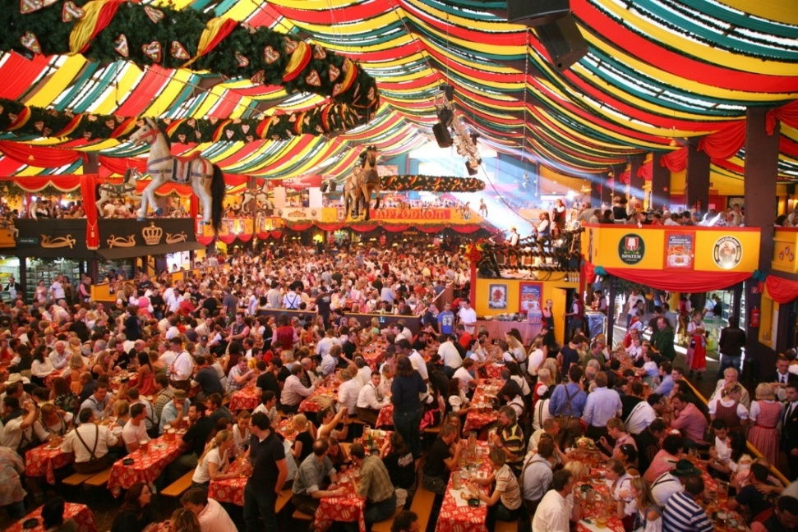
British: The Britishers are known for their love for tea. Hence, on the occasion of welcoming British visitors, the hotels can provide them with tea. This beverage can also be added as complementary to other meals as well, such as breakfast. Britishers are a fan of sports like rugby, polo, etc. Hence, the entertainment options at hotels should include programs related to popular British sports. As English is the most used international language and it is the native language for the Britishers, the language barrier is not an issue for the British visitors in international hotels.

Japanese: The Japanese language should be given priority while dealing with Japanese visitors. As the German language, basic Japanese language should be known by the hotel staff with a translator for any inconvenience. The Japanese food preferences should be taken into consideration; for instance, Sushi is one of the most popular Japanese food items; hence, it can be especially offered to Japanese guests. Often, the special food items can be given as complimentary dishes also, like tea for Britishers as mentioned earlier.
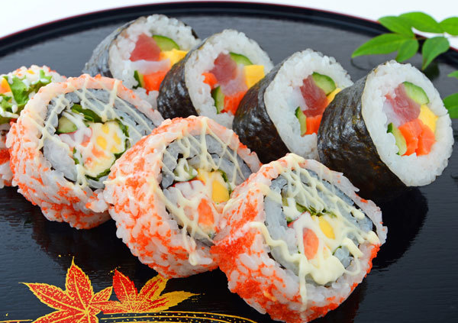
Bulgarian: Bulgarian culture is very vibrant and colourful. Such cultural specifications can be reflected while welcoming Bulgarian visitors at hotels. They can be provided with specially decorated rooms for a homely feeling. As the German language, the basics of Bulgarian language can be used for the guests with a translator for any inconvenience.
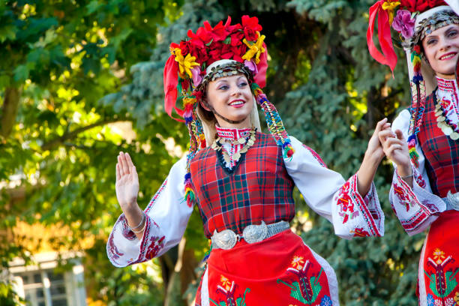
In this regard, there are various softwares available for mitigating language issues, such as Zingle. The softwares can be used by the hotel staff through texts and emails. Through these, the messages would be automatically translated in the required language, such as Bulgarian or Japanese (Badiu, 2017). Moreover, while welcoming and providing service to the foreign visitors, the traditional and cultural specifications should be always kept in mind because, often, one positive aspect of a culture can be a negative aspect of another culture (How to attract international travellers to your hotel - SiteMinder, 2020). For instance, thumbs up sign for people from Saudi Arabia can mean very disrespectful act while the same is taken as ‘fine’ or in a similar meaning in most of the other countries, such as the USA, etc.
Aide Memoire for the hotel staff to deal with international guests from cultural perspectives:
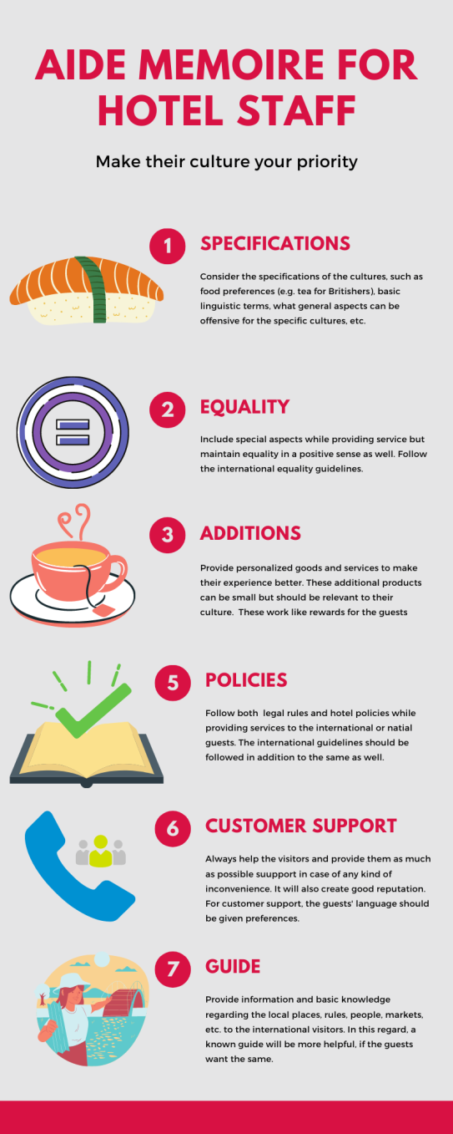

Do’s and Don’ts for the hotel staff regarding international visitors
Do’s | Don’ts
- Pay attention to details  - Be friendly but professional  - Write down things if necessary  - Know the Hotel’s policies  - Smile and be polite  - Give priority to the guests and their culture  - While using cultural things, languages, foods and beverages, conduct research before doing so.  - Provide help and support  - Maintain hygiene  - Communicate properly, listen mostly  - Learn their language properly before using  - Give guests an option to reject or refuse  (e.g. every German might not like beer)  - Maintain laws at any cost  - Ask for feedback and accept criticisms  - Rectify immediately  - Use customization  - Inform the higher authority handle in case of severe inconveniece  - Keep guests’ preferences in mind | - Don’t use things which are meant for the guests  - Don’t overdo the cultural aspects  - Don’t behave rudely  - Don’t disagree with the guests  - Don’t provide wrong/false information  - Don’t use complicated words and terms which might not be understood by foreign guests  - Don’t assume and conclude aimlessly  - Don’t keep stereotypes in mind while providing service  - Don’t interrupt the guests  - Don’t hesitate to apologise  - Don’t generalize  - Don’t discriminate  - Don’t break the laws, rules, and hotel policies

Conclusion
The present report has discussed various aspects related to different cultures of people belonging to different nations related to the hotel industry and the service that is being provided to these international visitors. Through globalization and other aspects like technological advancements, convenient transport system, the tourism and hospital industry deals with more culturally diverse people than any other industry. Hence, cultural diversity and acceptance should be reflected in the behaviour of the hotel staff in this regard. For this reason, the report has presented an aide Memoire for the hotel staff to deal with international customers. Moreover, the cultures of specifically four countries have been taken into consideration for a clear understanding of the perspective; the countries include Japan, Britain, Germany and Bulgaria. As it has been seen that there are many differences amongst these cultures, there are some basic similarities as well. Hence, on that basis, the report has also included a table of do’s and don’ts for these international visitors. Hence, the report has successfully discussed the cultural differences and the importance of behaviour of hotel staff regarding providing service to international visitors from the cultural perspectives.

References
Annan, C.Y., Sibanyoni, J.J. and Tabit, F.T., 2019. The socio-cultural diversity of hotel employees and their perception of the management styles in hotels of Gauteng province, South Africa.
Badran, N. and Khalifa, G., 2016. Diversity Management: Is it an Important Issue in Hotel Industry in Egypt?. International Journal of Heritage, Tourism, and Hospitality, 7(2).
Choi, E.K.C., Soifer, I. and Joung, H.W., 2017. Impact of culture on hospitality customers’ decision-making process. In Routledge Handbook of Hospitality Marketing (pp. 348-358). Routledge.
Baidu, L., 2017. Your Guests Are International - Your Hotel's Approach Should Be Too. [online] TrustYou. Available at: <https://www.trustyou.com/blog/trends-insights/guests-international-hotels-approach> [Accessed 10 September 2020].
Savic, D.D.A. and Dariescu, M., 2020. Cross-Cultural Management Within the Hospitality Industry. In Trends and Issues in International Planning for Businesses (pp. 187-196). IGI Global.
SiteMinder. 2020. How To Attract International Travellers To Your Hotel - Siteminder. [online] Available at: <https://www.siteminder.com/r/attract-international-travellers-hotels/> [Accessed 10 September 2020].

