Assessment of Practical Tasks

Student : Antu Bhomik
Student ID : 1818298
Module : Food & Beverage Operations
Module Code : BMIH4002
Lecturer’s Name : Steve Jones

Table of Contents
Create and design the fixed price Christmas party menu for hotel trinity which they can offer over the period of Christmas 3
Theme for Christmas 5
Suitable price point 5
Information required on the menu 8
Availability 8
Offers/ discounts to encourage more bookings 8
REFERENCES 9

Food and beverage operations basically refers to the provision of food and the variety of beverages within the business. Food and beverage basically he integral part of the experience of guest at the entertainment, leisure restaurant venue as well. There are various kinds of food and beverage within the centre of entertainment which not only improves the experience of customers but allows as the business owner to create more streams of revenue for the company. The industry of international food service basically provides millions of meals on the daily basis to the variety of types of food within the service operation. In the present report, Hotel Trinity is taken into consideration. It is a four-star city centre hotel which is a part of Trinity hotel chain which is headquartered in the United Kingdom. The present report will cover discussion about to create the menu for Christmas party and also design the menu with fixed price range which they can offer over the Christmas period.

Fixed price Christmas party menu for hotel trinity which they can offer over the period of Christmas
Christmas party is a very special occasion so it is very important that the menu should be designed into appropriate terms, and it look very amazing so that people feel attracted towards it.

Look of the menu: The look of menu of hotel Trinity should be ideal and short with prominent features and it should be in light colour like pink, yellow, white. The headings should be in bold Italics form so that it looks attractive and stylish as well. The font of matter should be in Times New Roman so that it looks ideal and sophisticated in terms of look. The menu should be written in the A4 size template. The colour has been chosen into lighter terms so that it does not sting to the eyes of people into negative terms. The logo of menu has been designed into simpler terms so that it does not look like that it does not overpowers the written matter into negative terms.
Number of courses: There are three courses which has been included within the menu of hotel Trinity which are starter, main course, and desserts. The detailed version of these courses has been defined into the following manner:
Starters: It is that course where a small dish of food which is served before the main course of a meal. Starters basically comes into wide variety and also served hot or cold as well. As it is the part of formal overall dinner or lunch so they may be served after the soup.

According to the Christmas party, there are certain items which have been included in the starter of Hotel Trinity. It includes Carrot & Coriander soup, Bake house bread, Brie & Cranberry chutney tart, mixed leaf salad & Balsamic glaze, House terrine, plum chutney, toasted bread cheese & Herb Fritters, Cherry tomato chilli jam, Salmon, Haddock, Lemon and dull Fish Cakes, tartare sauce.
Within the starters, those ingredients have been used which are according to the season and there are no items have been plan to utilise which are not according to the season. So the starter have been designed by taking appropriate measures into positive manner with right kind of approach.
Main Course: The main course is basically the featured or primary dish in a meal which is consist of different courses. The main course is usually the biggest dish on a menu. It is mostly followed by an appetizer, salad, soup and further it is followed by a dessert. According to Christmas party, the detailed main course has been defined into following manner:
Within Main Course, certain items have been included in the menu of hotel Trinity such as Slow Roasted Pork Belly, Dauphinoise Potatoes, Cider jus & Crackling roast turkey, sage & onion stuffing, roast potatoes and gravy Braised Shoulder of Lamb Stew, mashed potatoes pan seared Salmon Fillet, crushed new potatoes & Velouté cream sauce, Creamy wild mushroom Stroganoff Pancakes, Fries Seasonal Vegetables. These are the items which have been mainly included in the main course. Apart from this, there are certain other items which have been included because it is a very big eve so it’s very important that to use the necessary ingredients for it as well. It includes Brussels with chestnuts and sage, honey roast carrots, Christmas spiced red cabbage, Bacon, sausage and prune rolls and caramelised shallot mash. It also includes Bagel and Lox board, Antipasto skewers, Christmas pizza, overnight eggnog cinnamon rolls, Savoury S’mores.
Desserts: It basically refers to something sweet such as fruit or pudding which individual can eat at the end of a meal. According to Christmas party certain items have been included within the menu which has been defined into the following manner:
Within Desserts, certain items have been included in the menu of hotel Trinity such as Christmas Pudding, Brandy cream sauce, Oreo Chocolate Brownie, Vanilla Ice cream, Clementine & Chocolate cheesecake, Spiced plum & Apple crumble, vanilla custard, winter berry Pavlova, Chantilly cream. At the end of meal certain drinks can be offered which is in the form of mock tails, soft drinks, juices etc. These drinks are very beneficial and healthy for people diet and their body as well.
Christmas party season food ingredients
There are certain food ingredients which are very necessary for Christmas party which has been organised in the hotel Trinity include chestnuts, potatoes, carrots, parsnips, red cabbage, shallot mash. These are the main ingredients of that season which needs to be used within the food so that people can enjoy it on a larger scale and appreciate it into positive terms with a higher level of satisfaction of their appetite.

Theme for Christmas
The theme which has been decided for Christmas of hotel Trinity is that “A Storybook Christmas” where guests invite with their children's book in order to donate to the local library, school or literacy centre as well. A live music band can also be arranged for this special occasion in order to make the evening more enjoyable and then food also become more enjoyable and tasty as well. This theme is very best from the perspective of children's and other people as well because it is a kind of good action to donate the things to necessary people or into necessary places as well.


Suitable price point
The suitable price point which has been decided by hotel Trinity for people is around £ 35.75 and this price is very competitive as compared to other businesses. This price is best according to this special occasion.

Trinity Hotel Menu(*****)
Food dishes | Price | Drinks | Price
Slow Roasted Pork Belly | £3.40  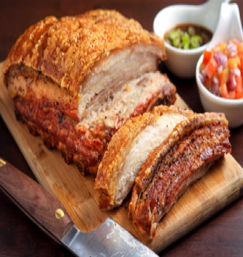 | Mock tails | £1.10  
Dauphinoise Potatoes | £2.40  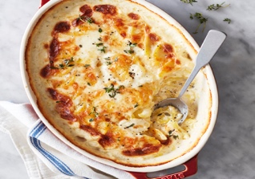 | Soft drinks | £1.85  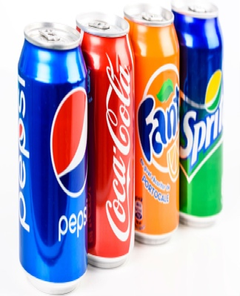
Cider jus & Crackling roast turkey | £1.10  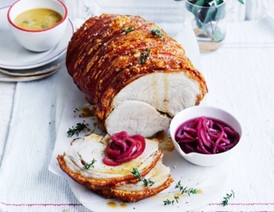 | Seasonal fruit juice | 2.85  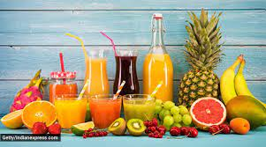
sage & onion stuffing | £4.40  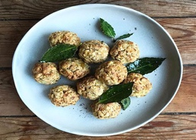
roast potatoes and gravy Braised Shoulder of Lamb Stew | £2.85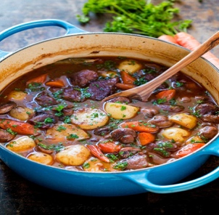
mashed potatoes pan seared Salmon Fillet | £3.75  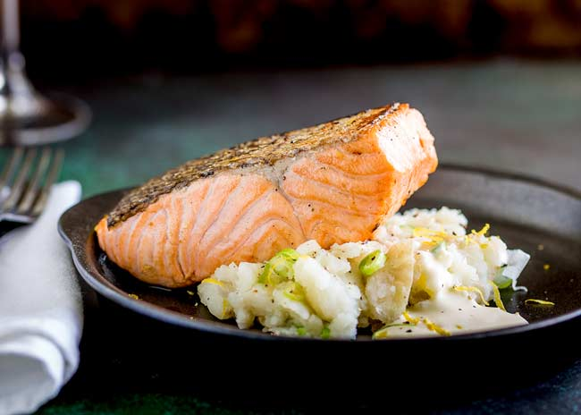
crushed new potatoes & Velouté cream sauce | £4.45  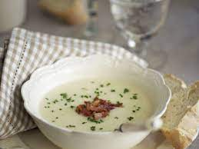
Creamy wild mushroom Stroganoff Pancakes | £3.20  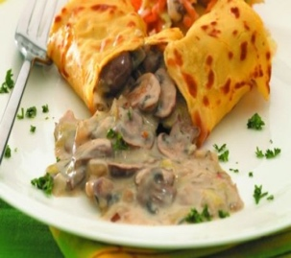
Fries Seasonal Vegetables. | £2.20  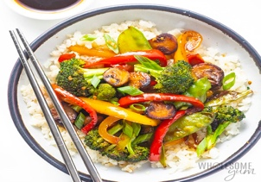
.Eat healthy and stay happy

Information required on the menu
On the menu of hotel Trinity for Christmas party, it is necessary to mention that whether the food is vegetarian or non-vegetarian so that people do not feel confusion while having look over the menu. Vegetarian menu can be pinpointed through green colour circle and non-vegetarian menu can be pinpointed through red colour circle.

Availability
The menu is available on pre order basis within hotel of Trinity on Christmas so that preparation team has proper time to arrange the meal into appropriate terms

Offers/discounts to encourage more bookings
As this Christmas party of hotel Trinity is mainly based on the children and the theme is also related to it so it’s very important that to offer something discount into proper manner. According to this party, discounts have been given when people come specially with more than one children so that they can make this occasion more special and thoughtful as well. They can also offer certain gifts for children and a chocolate package in order to make the offer more reasonable and amazing as well.
It has been concluded that menu planning is a very important step where it is necessary to take care about each and every aspect of menu into result oriented terms. It has been determined that within the menu three courses mainly included in it which is starters, main course and desserts. It has been observed that it is necessary to have appropriate price for it so that people can afford it into result oriented terms. So, in the overall manner, it is very important to consider each and every aspect food and beverage into serious terms with right kind of approach.

REFERENCES
Books and Journals
Bujisic and et.al., 2018. BEVQUAL: a tool for measuring performance quality in beverage operations. Journal of Foodservice Business Research, 21(5), pp.570-589.
Chen, X. and Voigt, T., 2020. Implementation of the Manufacturing Execution System in the food and beverage industry. Journal of Food Engineering, 278, p.109932.
Cousins and et.al., 2019. Food and beverage operations and management.
Davis and et.al., 2018. Food and beverage management. Routledge.
Dopson, L. R. and Hayes, D. K., 2019. Food and beverage cost control. John Wiley & Sons.
Montgomery and et.al., 2019. Big Data and the transformation of food and beverage marketing: undermining efforts to reduce obesity?. Critical Public Health, 29(1), pp.110-117.
Ramdhani and et.al., 2021. Decision Support System of Food and Beverage Franchise Business. In Proceedings of the International Conference on Industrial Engineering and Operations Management Monterrey (pp. 3120-3130).
Zuercher, J. L. and Lutz, N., 2018. Food security and the on-campus student: Assessment of meal plan use. Journal of Nutrition Education and Behaviour, 50(7), p.S124.

