Report: Feasibility Plan For International Meeting.

Sarah Ali 2119052, BMIH6007
Lecturer: Philippa Fitzgerald
Title: Love Dairy and Vegetables
Pages 1-15

Executive Summary:

Darlington's population serves a diverse range of world cuisine and is a thriving cultural town. In recent years, the planned relocation of 'Rishi Sunak's treasury offices to the Darlington town centre' from London has boosted Darlington's growth (Census, 2021). Families have relocated to Darlington for jobs in the treasury, primarily from the South. This event ‘Love Dairy and Vegetables,’ will be hosted at the ‘Darlington Hopetown Railway,’ Tickets will be available to purchase through ‘Event Master’ online digital tickets at a maximum capped number of availabilities of five hundred attendees. Many food initiatives open every other month, attracting visitors, companies in the Northeast of England, and new settlers. (event-bright, 2023). The success of this event is down to reaching out to local businesses in Darlington, into buying sustainable produces by local farmers and allotments. Introducing a wealth of new technology to follow suppliers, in influencing how sustainable buying, is effective for the locals.

Table of Contents
Contents
Executive Summary: 2
1 Table of Contents 3
3 Introduction 4
4 Aims and objectives 4
4.1 Mission Statement 4
4.2 Goals 4
4.3 Venue 4

5 Vision 6
6 Sustainable purchasing food 7
7 Consultation 7
8 SWOT 7
9 Pestel 8
10 Feasibility 9

11 Factors 10
11.1 Strategic Planning Functions 10
12 Plans 10

Introduction

The events point is to use information collected, to execute a successful and sustainable event on buying from local producers, of fruit and vegetables. Farmers products is managed by ‘MICE’ implementing to act on views and voices any change needed-(Quinn, B. 2013).

Aims and objectives
Public event caped at 500 due to area of scope managed by rules and regulations. The objective is to host a farmers’ market, and local suppliers of fruit and vegetables, in and surrounding Darlington and to be more ethical in buying produces and open future potential growth of the industry. The events success is managed by producing and encouraging healthier choices to have a positive impact on local economic growth (Wallace& Michopoulou, 2021).

Mission Statement
To build and engage in awareness of sustainable and economical buying from local farmers and allotments by hosting an event providing opportunity to the public, local business, council, and hospitality industry to build relationship between, the local farmers and allotments in and around Darlington. This is to take steps in helping the economy and environment.
- Aim- For everyone to buy locally sourced produces, supporting the farmers market and allotments around Darlington.
- Objectives- Achieve digital inventory by local suppliers and farmers. Sustainable farm succession, awareness on impacts of wastage, wellbeing, maintain standards.

Goals
To deliver the event of awareness to understand nutritious ingredients that is sustainable buying. Help the local farmers with the growth and rejuvenise existence for the farmers produces and locally sourced ingredients. The use of digital technology to maintain supply and demand. Events all over the world are heading to agricultural growth and to “Amplify the impact of philanthropic and investment communities in support of sustainable and agricultural systems,” education and support is important, (Sustainable Agriculture, 2024).

Venue
The venue of choice is ‘Hopetown Railway’ Darlington’s newest centre of attraction for visitors, families, and hosting events. With policies and health safety for public safety provided at the venue and core amnesties such as catering, meeting rooms, digital equipment, volunteer packages provided with ‘Darlington green volunteer groups,’ (DBC- Rangers, 2023). Central to public foot path makes this venue an opportunity to host with no other event in this criterion being held. This entire project is funded by the-
- Darlington Borough Council
- Tees Valley
- Heritage Fund
- Arts Council England
- Historic England
- Railway Heritage Trust

323,000 sq. feet
6000,000 play parks
3.6 million investments
35 million funded.

“This £35 million scheme is funded by Darlington Borough Council, Tees Valley Combined Authority, the National Lottery Heritage Fund, Arts Council England, Historic England, and Erail Heritage Trust”.

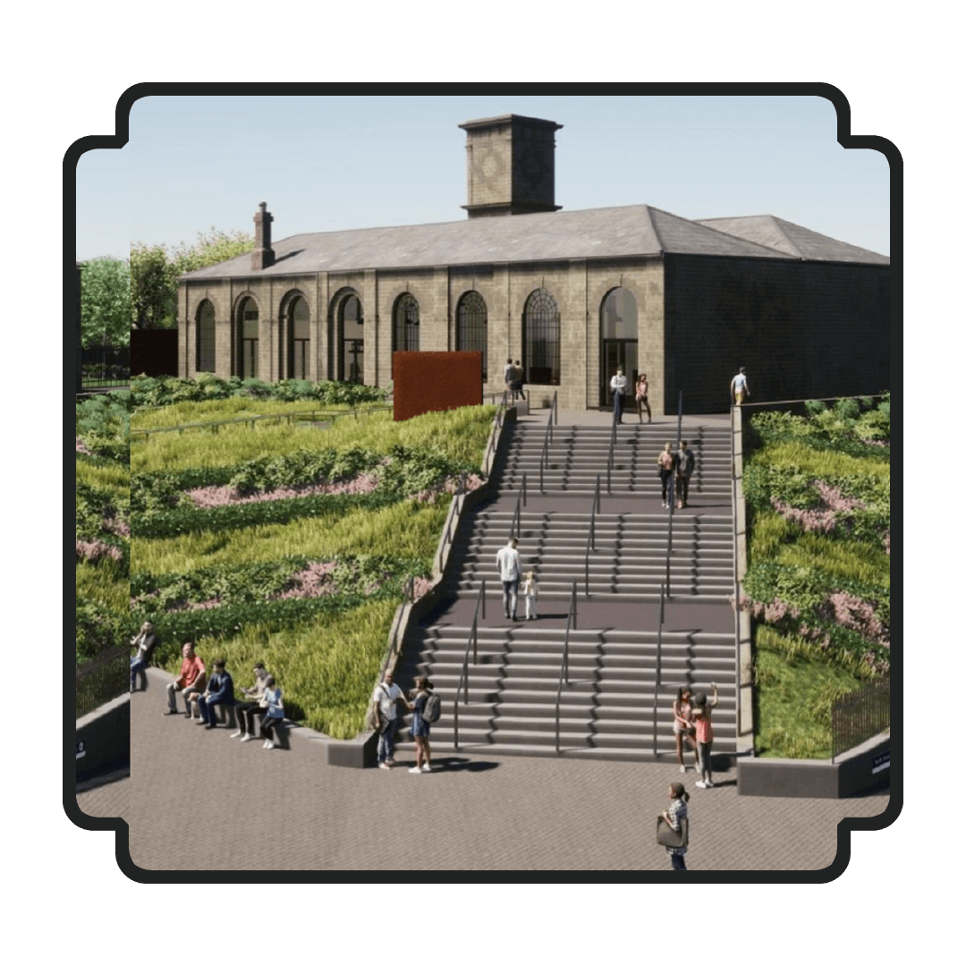
(Hopetown Railway 2024)

MICE destinations Lee and Black mentions in 2005, describe the factors that influence why certain locations are chosen over others have long sparked study interest. The venue chosen determines the amount of people who choose to attend the event, which has a significant impact on the meeting's success, (Quinn, B. 2013).

Vision
Define terms to reach the vision and measure success with collaboration using MICE industry to impact the outcome of the event in high numbers to determine the growth of the event for future directions. (Quinn, B. 2013).

- Stakeholders- to be informed to the lead up of the event and measures of outcomes.
- local business hubs – of the digital app A.I to use of availability of produces and products and information on nutrients, harvest time, cost saving areas.
- communities – Views to exchange across what is needed to keep interest,
- Volunteers – Strategy to develop the event.
Events concept is to increase of sustainable purchases made locally from allotments and farmers markets. Darlington's cultivation facilities and nearby villages, which were popular in the 1980’s, are fading. Farmers markets and allotments are examples of ways to help the local economy flourish sustainably. Farmers' awareness and targeted promotion to their surrounds is vital (Yoon, T. & Wang, S. 2023). The event is titled 'Love Dairy and Veg'. Tickets will be sold at a fee through the 'Eventbrite' internet platform. 100% of the profits will be donated to the National Farmers Union Darlington.

Sustainable purchasing food

Yale states, “A sustainable practice can continue indefinitely without degrading the systems on which it depends,” (Sustainable food, 2023). A core value to enhance into the local buyers and suppliers to keep alive sustainable buying from farmers and allotments.

- Organic
- Fruits and vegetables
- Dairy
- Eggs
- Poultry
- Dry goods, oils, spices
- Coffee, tea, chocolate

Darlington’s cultural growth and popularity in the growing cuisines of a variety of cultural restaurants and food establishment include, German, Mexican, Spanish, French, English, Indian, Bengali, Chinese, Thai. A source for foodie’s states how Darlington has seen an uprise in continues new food ventures, so posts are always being refreshed as they try different venues, and Darlington a foodie town has an array of venues on the radar. (Jelvin. E, 2023).

Culture in the united kingdom has a trend of worlds cuisines which is very present in the heart of Darlington with trends of teas and cultural food and the basic cuisines of a British fish and chips cuisines currently the market has approach to have sustainability in making and sourcing products locally. (Torkildsen G. p24 2005).

Consultation
- Public
- Dates
- Announcements
- Future Goals
- Challenges to consider is the footfall of numbers of a rising incident, Caterers, to convince financers and investors.

SWOT

- Strength
Reduction in C02 emission’s, sustainable buying, Awareness of farmers and green growers of the food industry. The directions to achieve a better circular economy.
- Weakness
Buying less means more trips to go shopping and time is important. Credibility. Using digital technology, updating training on rules and regulations. Understanding A.I. Waste Management control.
- Opportunities
Saving on Carbon Emissions, Recycling, Ethical sourcing, Educating to economic growth, Farmers Markets to sustain supply and demand.
- Threats
Farmers and business consumers reacting to change. Other events applying for funding at similar time. Wastage, Competition arising locally.

Pestel

Political- Leadership of the direction to execute the event.
Economical- According to Darlington Borough Council (DBC, 2019), a motion was passed for, DBC to ‘reach net zero carbon emission by 2050’. Through the art of using, MICE industry this even will provide an overview to all involved through innovation of Zoom.
Social- Event, festivals, and activities are attracting people into the area a key part of social context, and growth having positive and negative impacts is expected in events small or large scale. As mentioned in the events management, ‘events as activities that can have a variety of economic effects for host communities, attract key stakeholders and growth.’ (Quinn, B. 2013, p18-22). Economic Impact
Technology Use of A.I and Apps social groups to keep upto date on fresh produce availability could save on traveling to suppliers who cannot meet demand, also suppliers who might have extra availability of produces could be made into a solution for a better circular economy of growth. Ahead with automated forecasts of orders (Lecture, Fitzgerald, P. 2024).
Environment Help economic growth in a sustainable manner.

Legal Factors covered by Darling Borough Council (DBC, 2024), aspects of Insurance and public liability of all areas of damage and claims.

Feasibility

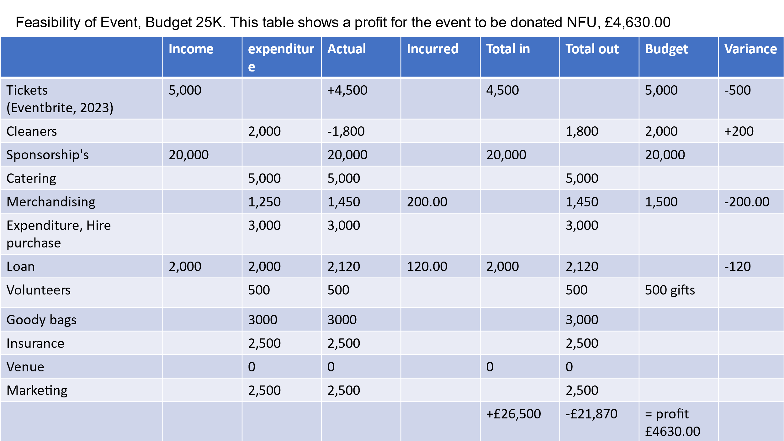

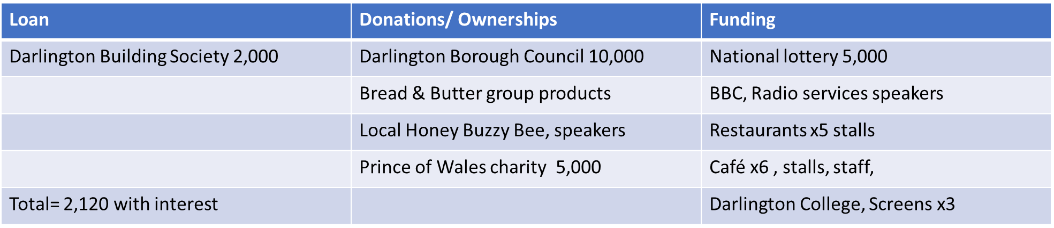

- S- Successful event site evaluation. Resources catering and premises.
- M- Analyse data of records of attendees, invites, communication with stakeholders.
- A – Achieved by understanding consumer needs and sustainability. Guest speakers to speak about importance of carbon footprint, use of local volunteers, funds and grants available for community public event.
- R- Relevant to the event guest speakers
- T – target to achieve guest and supplier satisfaction and profitably demands. A questionnaire link to all members attended to measure the outcome of the event, the success, and any failures to consider for future events.
(Forte village, Magazine. 2023).

Factors
A structure of this event being the first to highlight at Darlington Hopetown Railway.
Venue – Success of event steps to follow-
- Identify structure of events cycle
- Timing of events start to finish and breaks.
- Resources

Strategic Planning Functions

The impact of the organised event is themed on sustainable buying from Farmers markets locally addressing cost and wastage. Supply and demand of products to be productive on available A.I platforms to reach out to businesses, or consumers a solution to avoid wastage. Bowdin mentions “when staging an event, the major artistic and creative decisions to be made is that of determining what the theme is to be.”
(Bowdin, Chapter 6. 2011).

Plans

Historic- Outdoor and indoor space, Darlington Hopetown Railway, (Council, D.B., p4, 2022)
Traders- communities, businesses small or big.
This is an opportunity for markets to be more popular and can grow bigger with locals buying more fresh or dried.
- A rainbow of ranges of availability of the vast amount of fresh and dehydrated fruits and vegetable.
- Topic on what can be achieved with ingredients that are near to end of life such as making soups, dehydrate in summer for garnishes used in drinks and much more (Five Archers Allotments, 2023).
- Darlington population according to Census, “107,800 in 2021”, (Census, 2022).
- The plan of communications to reach sponsors, stakeholders, employees, suppliers, volunteers, using plans, policy, and MICE industry management.
- ‘Love Dairy and Vegetables’ event is to attract local hoteliers, restaurants, cafes, shops.
- The event will display small stalls offering a taste of the fresh, dried, frozen produces available seasonal and out of season dried fruits.
- Topic on show will be fruit and veg and locally sourced dairy and packaging that is addressing how to adapt to a circular approach and be sustainable using A.I, Apps to keep a track of suppliers demands. (Ali. S. 2119052, 2024, Power-point)
Recommendations
Managing the event to reflect activities impact upon the environment surrounding the Hopetown Railway, available are walking paths and cycle lanes. All roads to be closed for the event and notice to be given to Darlington Borough Council to action on date. “Online tools designed to track emissions and waste,” In managing the ‘Love Dairy and Vegetables,’ event external factors would be severe rainfall causing flooding in area of footpath. Promote healthy walking and cycling will produce low emissions, (Sage, chapter 34. 2011).

References

Ali Sarah, PowerPoint 2024, Assignment 1. Available on Moodle

Bowdin, G.A.J. (2011) Events management. 3rd ed. Oxford: Elsevier Butterworth- Heinemann.
Council, D.B., (2022). A Conservation Management Plan for Darlington Rail Heritage Quarter. Available at, https://www.sdr1825.org.uk/wp-content/uploads/2022/09/Rail-Heritage- Quarter-Conservation-Management-Plan-Final-Low-Res.pdf , (Accessed 25th January 2024)
Climate Change (DBC, 2019), Sustainability Change available at https://www.darlington.gov.uk/climate-change-and-sustainability/climate-change/ (Accessed 24th January 2024)
Darlington population change, Census 2021-ONS, Available at https://www.ons..gov.uk/visualisations/censuspopulationchange/E06000005/ (Accessed 31st January 2024)
DBC, Green Rangers Volunteering (2023), Available at:, https://www.darlington.gov.uk/climate-change-and-sustainability/green- volunteers/volunteering-with-darlingtons-ranger-team/, (Accessed 1st March 2024)
Fortville Magazine.fortevillageresort.om (2021), Available at https://magazine.fortevillageresort.com. (Accessed 20th February 2024).
Ely Jelvin, (2023). Available at https://elyjelvin.medium.com/. (Accessed 18th, 29th February 2024)
Eventbrite discover events in Darlington, (2023). Available at https://www.Eventbrite.co.uk (Accessed 1st February 2024).
Fitzgerald Philipa (2024). Available at Teams 22nd, 12:59 January 2024 Lecture Teams, Digital Strategies.
Five Archers Allotments (2023) Facebook. Available at: https://www.facebook.com/groups/173779139734590/?locale=en_GB (Accessed 25th January 2024)
Hopetown Darlington, (2024). Available at: https://www.head-of-steam.co.uk/future- plans/news-0and-updates/next-stop-hopetown-darlington/ (Accessed February 2024)
Quinn, B. 2013. MICE/MEEC. In: Key Concepts in Event Management, The SAGE Key Concepts Series. London: SAGE Publications Ltd. pp. 72-75
Available at: <https://doi.org/10.4135/9781473914742> [Accessed 25 Feb 2024].
Sage 2011, Available at: Chapter 34, https://sk-sagepub-com.ezproxy.uwtsd.ac.uk/books/key-concepts-in-event-management/n33.xml.
Seyfang, G. (2007), Growing sustainable consumption communities. Available at: Google
scholar, www.emeraldinsight.com/0144-333x.htm. Vol 27, p27.
DOI 10.1108/01443330710741066. (Accessed 15th February 2024).
Sustainable Agriculture, Available at: https://www.agandfoodfunders.org/events/.
(Accessed 15th February 2024).
Sustainable-Food, Available at: https://www.sare.org/wp-content/uploads/Sustainable-Food- Purchasing-Guide.pdf. (Accessed 28th February 2024).
Torkildsen George, Leisure and Recreation Management, 5th Edition by Routledge USA, ISBN 0-203-35100-2 (OEB Forbat)
Wallace, K & Michopoulou E. (2022) Event Management 27 (4). Available at: DOI:10.3727/152599522X16419948695143. (Accessed 25th February 2024).
Yoon, T. & Wang, S. (2023), "How Important Is Stakeholder Collaboration in the MICE Industry: Antecedents and Outcomes of Supply Chain Integration", Sustainability, vol. 15, no. 20, pp. 14966.

4.4 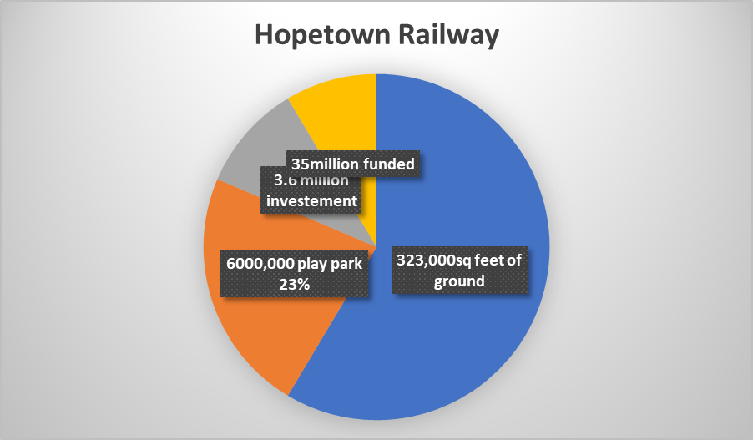

4.5
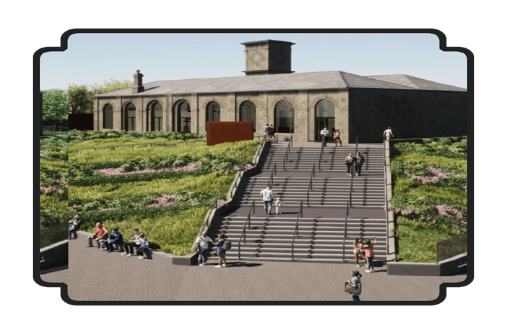

10.1
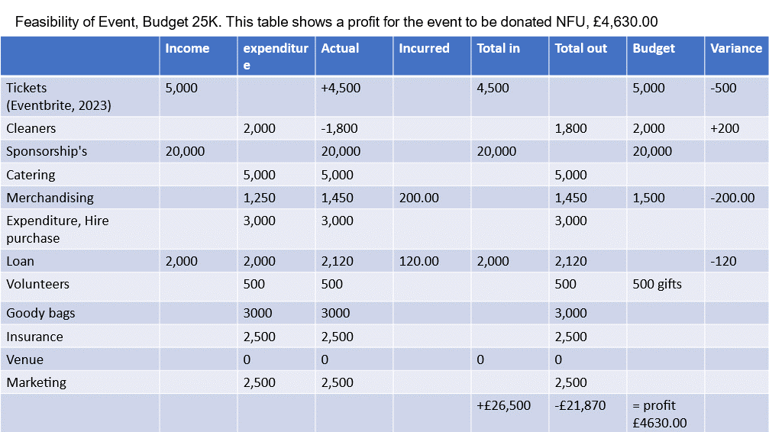

10.2


