Module LCLM_6001 Strategic Management for Business
Individual Report

Student Name: Claudia Piscorean
Student ID: 2316909
Lecturer Name: Dr. Faizu Edu

Table of Contents

Introduction
Overview of the organisation
Current strategic direction and goals of the company
Environmental scan to analyse the company’s competitive positioning
Stakeholder analysis
Key strategic recommendations accounting for the the challenges SMEs encounter to implement strategic direction
Conclusion
References List

- Introduction
The process of strategic management involves balancing the internal processes of a business with the evolving conditions in the external business environment to achieve long-term growth. In the present study, the strategic management principles are applied to the functionality of the UK-based SME Lucocoa Chocolates. The company’s business environment analysis is carried out using external and internal environment tools. Subsequently, the strategic suggestions for the company are developed using a range of strategy development models, which suggest that the company needs to adopt “hybrid” and “market penetration” strategy within its view. Similarly, the Mendelow’s matrix assists in informing the communication and strategy planning practice of the firm.
Strategic management concerns with the practice of organising, coordinating, and effectively utilising the resources of a business to improve its competitiveness within a market. As stated by Rêgo et al. (2022, p. 3220), the process of strategic management involves analysis of the external and internal business environment to gather relevant information about the business which informs the subsequent decision-making process. The present study involves analysis of the business case of Lucocoa Chocolate, a SME based in the UK to analyse its business environment and provide insights that inform its strategic decision-making process.

Overview of the organisation
Lucocoa Chocolates is recognised as London’s first Bean to Bar Chocolate Maker whose founder Amarchi Clarke recognises herself as a chocolate activist and crusader. The company offers unique chocolates that challenge the prevalent notions of traditional chocolate tastes (Lucocoa Chocolate, 2025). The business is a factor in the sustainable practices of development that evidences in its support towards advocacy and implementation of fair, ethical, and sustainable practices within the cocoa industry.
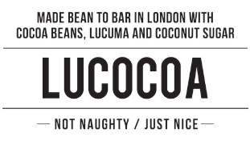

Products and services offered
The business takes three days to prepare its chocolates as adequate time is taken to understand the beans. Lucocoa Chocolates’ dark chocolate is not bitter, milk chocolate is not too sweet, and its white chocolate is made out of chocolate, which is different from traditional tastes. The products offered by the company are all hand made using traditional methods and does not include refined sugar, rather is made out of coconut sugar that does not spike blood sugar levels similar to refined sugar (Lucocoa Chocolate, 2025). The company’s major products include chocolate bars of distinct flavours, Haiti hot chocolate jar, brownies made without gluten and giant bourbon biscuits.

Business model(s) and its uniqueness
The business model of Lucocoa Chocolates reflects a business-to-consumer or B2C approach within its view. The products are offered on select retail channels and through online channels to cater to its niche market that values natural ingredients that are sustainable, ethically sourced and maintain transparent supply chain lines (Lucocoa Chocolate, 2025). The unique positioning of the business reflects in its traditional approach of hand-made chocolates and use of natural ingredients even replacing refined sugar with coconut sugar. The company’s compliance with Fair Trade and Rainforest Alliance Standards provides it with a unique advantage in terms of providing farmers with more than the required fair pay. Its value chain asserts sustainable alignment through ethical souring of cocoa beans and ensuring child and slave labour practices are not practised among supply partners.

Current strategic direction and goals of the company
Vision
The vision of Lucocoa chocolate is to transform the taste experience for chocolate consumers across the UK by offering them with innovative and unique beans to bar products.
Mission
The mission of Lucocoa chocolate is to become a reliable, quality and artisanal brand of chocolates, which echoes ethical and sustainable practices in its business practices.
Objectives
The key business objectives of Lucocoa chocolate are:
- To develop consumer trust to boost its revenue growth within the cocoa industry
- To collaboratively participate with suppliers across the cocoa industry to foster sustainability and develop impactful solutions that transform the industry

Environmental scan to analyse the company’s competitive positioning
Internal environment
SWOT analysis
Strengths | In house hand-made artisanal chocolate products ensuring quality consistency  Sustainable inclination across the supply chain and production processes
Weaknesses | High costs of operations and longer duration of production are key challenges faced by the firm  Limited retail outreach and distribution outlook
Opportunities | Positive compound-annual-growth rate or CAGR of the confectionery market in the UK at 5.60% for the period between 2025 and 2030 (Alda, 2025).  Capitalising on the increased adoption of sustainable trends among consumers in the UK
Threats | Competition threats from major industry players like Mondelez  Inadequacy to maintain profitability and sustainability in the long-term

Value Chain analysis
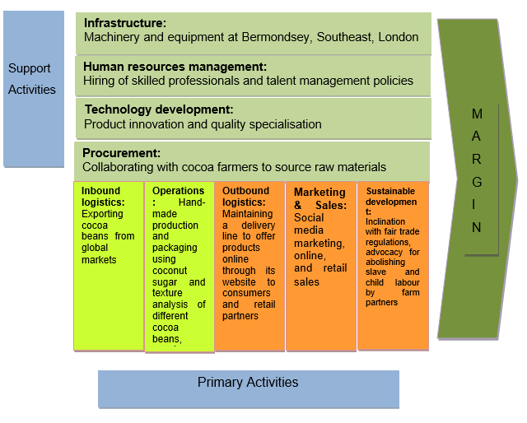

The above figure illustrates the value chain analysis of Lucocoa Chocolates illustrating the various primary and support activities that the company carries out to generate profit margins. As stated by Iftikhar et al., (2023, p. 1579), value chain analysis of a business refers to the process of evaluation of each of the activities within a company’s value chain process to understand the areas that need improvement. The company’s value chain represents efficient alignment of primary activities, which relate to inbound and outbound logistics, operations, marketing and sales and sustainable development. Subsequently, the support activities of the business identify as investments made in terms of infrastructure, HRM, technology development and procurement that enable it to meet its business objectives.
Support activities
Infrastructure: Machinery, and equipment at Bermondsey, Southeast, London
Human resources management: Hiring of skilled professionals and talent management policies
Technology development: Product innovation and quality specialisation
Procurement: Collaborating with cocoa farmers to source raw materials
Primary activities
Inbound logistics: Exporting cocoa beans from global markets
Operations: Hand-made production and packaging using coconut sugar and texture analysis of different cocoa beans, supply chain management
Outbound logistics: Maintaining a delivery line to offer products online through its website to consumers and retail partners
Marketing & Sales: Social media marketing, online, and retail sales
Sustainable development: Inclination with fair trade regulations, advocacy for abolishing slave and child labour by farm partners

External environment

PESTEL Analysis
Factors | Description | Analysis
Political | Stable political environment in the UK  Exit from EU led to loss of international trade leverage | Positive: A stable political environment in the UK supports policy continuity, which is necessary to support business planning in the near-term.  Negative: UK’s exit from the EU has affected the country’s advantage of international trade deals, which has affected supply chain continuity.
Economic | Moderate inflation rate at 3.8% in 2025  Low rate of GDP growth at 1.1% | Positive: A moderate inflation rate is beneficial in keeping bank interest rates low ensuring reduced operational costs.  Negative: A low GDP rate affects UK economic activity and results in poor demand within the region.
Social | High literacy rate  Evolving nature of consumer trends | Positive: A high literacy rate ensures that the consumers are aware about market trends and sustainability, which enables them to make informed decisions.  Negative: The evolving nature of consumer trends affects marketing strategy of the business requiring the organisation to alter its business and communication consistently (Mintel, 2024).
Technological | High R&D to GDP ratio at 2.90% (data.worldbank.org, 2022)  Low pace of technological developments adoption in the confectionery markets | Positive: A high R&D to GDP ratio indicates governments push towards innovation and digital transformation, which positively influences business development.  Negative: The low pace of digital transformation of the confectionery markets in the UK can lead to reduced innovation and stagnation in product variability.
Legal | Compliance with food safety, labelling and export regulations for cocoa beans  National Minimum Wage Act, 2018 | Positive: The export regulations outline strict and transparent measures of product labelling and quality checking which strengthens the ethical business supplier approach of Lucocoa Chocolates.  Negative: The minimum wage act affects the company in sourcing and retaining talented professionals as wage benchmarks do not reflect the rising costs of living (Collings et al., 2021, p. 378).
Environmental | Sustainable inclination of government policies  Transition towards green energy usage requires high investments | Positive: A higher push by the UK government towards sustainable policies across the business value chain aligns with the strategic process of Lucocoa Chocolates.  Negative: A shift towards adoption of green energy within production practices requires the firm to make extensive investments which might not be feasible given lack of adequate financial resources.

Porter’s Five Forces
Forces | Degree of impact | Analysis
Bargaining power of suppliers | Moderate | The suppliers of cocoa beans to Lucocoa Chocolates have moderate power since the company provides them with a higher pay than Fair Trade and rainforest Alliance standards requirements. However, since quality, raw materials are difficult to find and the suppliers have a higher degree of advantage in terms of selecting their buyers.
Bargaining power of buyers | Low | Limited presence of sustainable and artisanal chocolate brands in the UK market restricts the buyer advantage.
Threat of new entrants | Moderate | Low cost of investments in the industry creates scope for new entrants, however quality specialisation and competition threats reduces their growth advantage.
Threat of substitutes | Low | High investment requirements for R&D to develop a substitute of chocolate reduce the interest appetite of large-scale firms.
Industry rivalry | High | Presence of high competition from international brands like Mondelez that have economies of scale and global operations advantage (Mintel, 2024).

Available strategic growth choices for SMEs
Proposal of a new strategy
Porter’s Generic Strategies
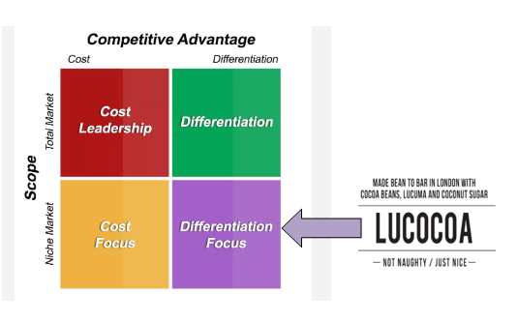

The relative position of a firm within the industry defines whether the company’s profitability is below or above average. As mentioned by Elsworth (2023), the porter’s generic strategy model includes strategic dimensions that businesses can align with for improving their competitive benchmarks within their industry. Lucocoa Chocolate's approach of business is built on its unique product offerings, which challenge the traditional chocolate tastes and notions. Its production line is also distinct from competitors as the company uses a hand-made traditional approach against mass factory production, while a specific emphasis on sustainable value chain entails the company with differentiation attributes against its competitors. The aforementioned approaches enable the company to cater to the niche consumer base that values sustainability, ethical and transparent business processes and favours traditional methods over mass production. Hence, the business approach reflects resemblance with the differentiation focus of the porter’s generic strategy model. The strategic position of the businesses builds upon targeting the niche market through its unique value chain approaches.

Ansoff’s Matrix
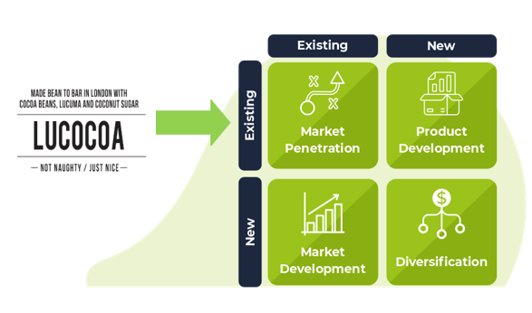

The Ansoff’s matrix tool entails a product or market expansion grid and is beneficial in identifying the strategic planning objectives of a business. As asserted by Zugay and Zakaria (2023), the approaches listed in the matrix help businesses identify their market position and plan business strategic development accordingly by complying with the relevant expansion outlook. At Lucocoa Chocolates, the company’s strategic position reflects an outlook of existing products, but differentiation created through production practices and taste cues. In order to support the company’s revenue growth objective, it is essential that the business deploy the market penetration approach within its expansion outlook. This can provide the company with a clear direction to gain an enhanced consumer base in the UK confectionery market for its artisanal and sustainable chocolate products. It further enables the company to establish strong brand awareness and recognition in the UK market to compete against established large firms like Mondelez.

Bowman’s Strategic Clock
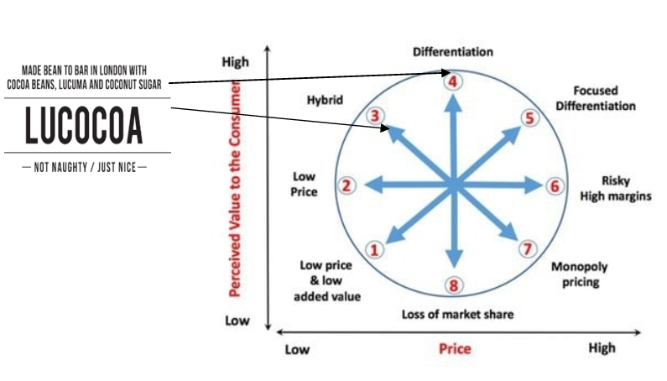

The application of Bowman’s strategic clock to the context of Lucocoa Chocolates can support the business in aligning its strategic options to meet consumer value propositions. As mentioned by Lynch (2021), the strategic clock framework includes distinct strategies that inform the business management about the perceived value by the consumer and the strategic onset required to materialise maximum competitive advantage. The hybrid strategy within the framework can offer businesses with maximum competitive advantage through low-cost alignment and consistent nature of product quality and created value (Ditkaew, 2023, p. 15). The concerned approach enables the business to maintain differentiation within its approach as well as align with the low-cost objective to increase its market expanse. The selected strategy enables the company to maintain the differentiated value proposition of its products among the consumers and thus cater to their preferences.
Proposed strategy
The application of the distinct models illustrates the various strategic options that the company has to cater to its market needs of strategic growth. It is suggested that the business should adhere to the “hybrid approach” that combines differentiation and low-price to align its value proposition and pricing outlook. In addition, “market penetration strategy” to cater to its enhanced consumer base and revenue growth in the UK markets. The former strategy empowers the business to align its business processes with the evolving consumer needs and generate brand awareness that sustains its long-term growth outlook. Subsequently, the latter strategy is aimed at catering to revenue and competitive benchmark improvement of the firm within the UK’s confectionery market.

Explanation of the proposed strategy’s alignment with sustainable strategy for the long-term
Lucocoa’s strategic approach requires the firm to build upon the merits of differentiation, to combine a low-price outlook and reflect hybrid strategy inclination. According to Abbas, J. and Kumari (2023, p. 434), the process of building long-term strategy requires incorporation of sustainable principles within its view, which rests on the merits of resourceful planning while considering its environmental impact. In order to strengthen its positioning in the competitive environment, adherence to market penetration strategy is also proven beneficial as it provides the company with a higher access to the UK markets through improvement in brand awareness and recognition. The suggested measures of strategy development for the company build upon the company’s core values of sustainability where it is to capitalise on the increasing trend of ethical and sustainable purchase behaviour among the UK consumers. The business through the application of differentiation metric can ensure that its unique production and procurement merits that rely on sustainable methods of collaborating with farmers to reduce slave and child labour positively shapes consumer purchase behaviours (SDG 12). The hybrid approach further enables the company to maintain a low-price for its products ensuring enhanced accessibility across consumer groups and alignment with the “sustainable development goals (SDG)” of Zero Hunger (SDG 2). The implementation of market penetration strategy is driven by the sustainable intent of advocating responsible consumption and production (SDG 12) through increased consumer awareness and transformation of the confectionery industry towards sustainable practices.

Stakeholder analysis
Mendelow’s Matrix
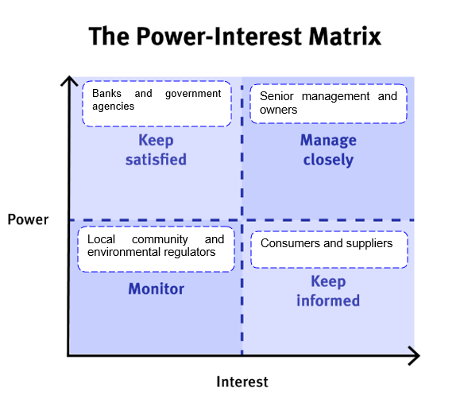

According to Mints and Kamyshnykova (2021, p. 394), the stakeholder matrix details the variance in degree of influence and power of different stakeholders within an organisation to define relevant engagement approaches with them.
High power, high interest: Senior management and owner of Lucocoa Chocolate have high power and interest in the company’s functioning and decision-making. The concerned stakeholders need to be managed closely, and active participation sought in the strategic decision-making process of the firm.
High power, low interest: Banks and government agencies have high power to influence the company’s functionality but have little interests in the way it is managed. The banking institutions serve the finance needs of the firm, and the government agencies audit its quality and sustainable alignment, requiring the management to keep them satisfied.
Low power, high interests: The consumers and suppliers of Lucocoa Chocolate have limited influence over the company’s decision-making practices; however, they have active interests in its strategic outlook and need to be informed regularly. The suppliers need to align their cocoa beans production, management, and export standards to meet the firm’s inherent requirements, while consumers define their purchase behaviour based on the marketing or product decisions taken by the firm.
Low power, low interest: The local community and environmental regulators have low interests and low power over the business practices of Lucocoa Chocolates. However, they need to be monitored to strengthen the company's perceived value among customers and improve brand reputation.
RACI
The application of RACI matrix details the distinct influence and power levels of varied stakeholders within the firm and the role that they can play in implementation of the strategic activities.
Activities | Operations manager | Marketing and resource manager | Finance manager | Procurement manager | Sustainability lead
Production pace improvement | Responsible | Informed | Accountable | Informed | Communicated
Marketing and communications planning | Accountable | Responsible | Communicated | Informed | Communicated
Hiring and retention of talented professionals | Accountable | Communicated | Informed | Communicated | Responsible
Advocating of sustainability across value chain and consumer behaviour | Communicated | Accountable | Accountable | Informed | Responsible

Identification of the most suitable, feasible and acceptable strategic option/options
The below table ranks the distinct strategic options based on their priorities by accounting for their suitable, feasible and acceptable attributes.
Activities | Suitability (out of 5) | Feasibility (out of 5) | Acceptable (out of 5) | Total (out of 15)
Production pace improvement | 3 | 2 | 2 | 7
Marketing and communications planning | 4 | 5 | 5 | 14
Hiring and retention of talented professionals | 4 | 3 | 3 | 10
Advocating of sustainability across value chain and consumer behaviour | 4 | 4 | 4 | 12

Key strategic recommendations accounting for the the challenges SMEs encounter to implement strategic direction
The strategic analysis of the business using distinct tools and frameworks helps to identify the key challenges that the firm is facing within its view. Addressing these challenges is necessary to support the strategic growth of the firm and improve its competitive positioning. The key challenges faced by the firm relate to limited market outreach, distribution, and slow pace of production. In order to address these challenges, the following strategies can be adopted by the firm’s management.

Implementation of digital marketing strategies
Digital marketing strategies include use of social media marketing, website, and search-engine marketing to enhance the company’s outreach among the consumers (Rêgo et al., 2022, p. 3198). It enables the firm to achieve market penetration in the UK markets building upon the merits of brand awareness and consumer engagement.
Partnering with e-commerce partners
The approach helps the company to collaborate with e-commerce panthers to enhance its market penetration and consumer accessibility to gain higher competitive benchmarks in the industry.
In-house training of employees to scale production coupled with digital transformation
The application of these strategic directions helps the firm align with the hybrid approach of maintaining differentiation and lowering its products costs to align with consumer preferences. Digital transformation supports efficient production planning to reduce costs, while in-house employee training ensures long-term vision to prepare future leaders that have similar vision.

Conclusion
The study has discussed the strategic recommendations to support the firm’s future developments and execution by accounting for the challenges that Lucocoa Chocolates can face within its strategic pursuits. It delves upon the analysis of external and internal business environments of the company to identify the prevalent market trends and eminent challenges that the firm faces. Subsequently, using the strategic development models it is suggested that the firm needs to adhere to a “hybrid approach” (differentiation and low-price) along with “market penetration" outlook to meet its strategic objectives. The application of Mendelow’s’ matrix assists in identification of the influence and power degree of distinct stakeholders to plan communication and engagement accordingly during the strategy development process.
- References List
Abbas, J. and Kumari, K. (2023) ‘Examining the relationship between total quality management and knowledge management and their impact on organizational performance: a dimensional analysis’, Journal of Economic and Administrative Sciences, 39(2), pp. 426–451. Available at: https://www.emerald.com/insight/content/doi/10.1108/jeas-03-2021-0046/full/html
Alda, M. (2025) Confectionery – United Kingdom | Statista Market Forecast. Statista. Available at: https://www.statista.com/outlook/cmo/food/confectionery-snacks/confectionery/united-kingdom?srsltid=AfmBOop4pOtZxRgcf0czHZfnlgC44nFwA5EN72kpzZBJCn_t3qZQcPAj (Accessed: 23 November 2025).
Collings, D.G., McMackin, J., Nyberg, A.J. and Wright, P.M. (2021) ‘Strategic human resource management and COVID‐19: Emerging challenges and research opportunities’, Journal of Management Studies, 58(5), p. 1378. Available at: https://pmc.ncbi.nlm.nih.gov/articles/PMC8013558/
data.worldbank.org (2022) Research and development expenditure (% of GDP) – United Kingdom | Data. Available at: https://data.worldbank.org/indicator/GB.XPD.RSDV.GD.ZS?locations=GB (Accessed: 22 November 2025).
Ditkaew, K. (2023) ‘Strategic management accounting on competitive advantage’, International Journal of Asian Business and Information Management (IJABIM), 14(1), pp. 1–17. Available at: https://www.igi-global.com/article/strategic-management-accounting-on-competitive-advantage/321193
Elsworth, T. (2023) Understanding strategic analysis: a simple guide to choosing, developing and implementing business strategy. Routledge.
Iftikhar, A., Purvis, L., Giannoccaro, I. and Wang, Y. (2023) ‘The impact of supply chain complexities on supply chain resilience: the mediating effect of big data analytics’, Production Planning & Control, 34(16), pp. 1562–1582. Available at: https://www.tandfonline.com/doi/abs/10.1080/09537287.2022.2032450
Lucocoa Chocolate (2025) Lucocoa Chocolate. Available at: https://www.lucocoachocolate.com/aboutus (Accessed: 23 November 2025).
Lynch, R. (2021) Strategic management. Sage.
Mintel (2024) UK Chocolate Confectionery Market Report 2021 | Mintel.com. Mintel Store. Available at: https://store.mintel.com/report/uk-chocolate-confectionery-market-report (Accessed: 23 November 2025).
Mints, A. and Kamyshnykova, E. (2021) ‘Fuzzy methods of stakeholder prioritisation in the context of stakeholder management’, International Journal of Learning and Change, 13(4–5), pp. 372–398. Available at: https://www.inderscienceonline.com/doi/abs/10.1504/IJLC.2021.116673
Rêgo, B.S., Jayantilal, S., Ferreira, J.J. and Carayannis, E.G. (2022) ‘Digital transformation and strategic management: A systematic review of the literature’, Journal of the Knowledge Economy, 13(4), pp. 3195–3222. Available at: https://link.springer.com/article/10.1007/s13132-021-00853-3
Zugay, B. and Zakaria, R. (2023) Ansoff matrix. SAGE Publications, Inc.

