

LCMB7024 MARKETING MANAGEMENT

Assessment 2: Portfolio: Brand Extension

Student name: Patel Ketankumar Rameshchandra
Student ID: 2421691
Lecturer’s Name : Laila Mazuz
Word count: 2,533
Date of submition : 26th april 2025

Table of Contents
1. Introduction to the brand and rationale for extension 3
Brief background of Organisation, current product offerings, and market gaps identification 3
Rationale for the brand extension 3
2. New brand extension for Aston Martin in order to sell DBX SUV in Nepal 4
Product description 4
Market demand assessment 4
Innovation and value proposition 4
Risk analysis and mitigation strategies 5
3. Segmentation, Targeting, and Positioning (STP) for new brand extension 6
Segmentation 6
Targeting 7
Positioning 8
4. Customer Persona development 9
5. 7P marketing mix strategy for brand extension 11
Product 11
Price 11
Promotion 11
Place 12
Process 12
People 12
Physical evidence 12
6. Conclusion 13
Summary of the findings 13
Recommendations 13
7. References 15

1. Introduction to the brand and rationale for extension

Brief background of Organisation, current product offerings, and market gaps identification
Aston Martin, founded in 1913 by Lionel Martin and Robert Bamford, is a renowned British luxury sports car manufacturer known for its blend of high performance and elegant design. It has established a distinguished reputation, simply because of the brand's longstanding status as James Bond's preferred vehicle and its connection to motorsport. Today, Aston Martin offers a range of premium vehicles, including the Vantage, DB11, and many others. DBX, starting at around 160,000 GBP and is specifically targeted at well-to-do women, has greatly expanded Aston Martin's customers beyond the men typically known to purchase its sports cars (The Guardian, 2021). However, in response to changing customer preferences for environmentally friendly and cutting-edge mobility solutions, Aston Martin is quantifying potential expansion for sustainable vehicles. All these aspects have further made Aston Martin to also develop its significance in Asia countries other than Europe and North America.

Rationale for the brand extension
Aston Martin’s brand extension into high-end lifestyle products and electric mobility aligns seamlessly with its mission to deliver beauty, craft, and performance, further reaching new customer segments beyond traditional ventures. Additionally, the vision of Aston Martin is to become the most coveted, ultra-luxury British brand in the world by producing the most exquisitely captivating performance vehicles (Aston Martin, 2025). This extension strategy enhances its competitive advantage by diversifying revenue streams and strengthening brand loyalty in an evolving luxury market. For instance, Ferrari has leased its name to a wide variety of goods for 20 years, with the automobile brand serving as its main selling factor in Saudi Arabia (ET Brand Equity, 2021). Therefore, Aston Martin believes that a well-considered brand expansion enhances its history while allowing it to adjust to contemporary premium lifestyle trends and environmentally friendly innovation.

2. New brand extension for Aston Martin in order to sell DBX SUV in Nepal

Product description
The introduction of Aston Martin DBX SUV (Sport Utility Vehicle) has suggested a bold extension of the iconic British automotive brand in the world of luxury as well as utility, followed by managing the performance of SUVs. A combination of elegance, versatility, and power has been proposed by the DBX SUV, making it dynamic performance relevant with adequate craftsmanship. However, a range of innovative materials and an industry first application of a fabric made from 80% wool has made an attractive choice for consumers to own Aston Martin DBX (Aston Martin, 2020). An all-wheel drive capability and luxurious interior with its sophisticated design have therefore made the DBX to offer refined driving experience in Nepal’s diverse terrains, further managing tastes of drivers.

Market demand assessment
Nepal has been identified as an emerging luxury market, especially for automotive brands to acknowledge the promising opportunity of the drivers to combine luxury and utility. However, the National Population and Housing Census 2021 data shows that only 3.1% of Nepali families own a four-wheeler, whereas 27.3% own a two-wheeler (Nepal Drives, 2023). Even though few people in Nepal own cars overall, the country's elite are becoming more and more interested in luxury SUVs, especially in Kathmandu and Pokhara. Growth of urbanisation, followed by rising disposable income and a growing desire for high-end automobiles are also contributing to the ultra-luxury market's gradual rise. It is ideal for Aston Martin to acknowledge a carefully positioned brand extension with DBX SUV, especially to enter in this aspirational lifestyle shift.

Innovation and value proposition
Aston Martin can position itself as a symbol of performance, luxury, and exclusivity in Nepal to extend its business with DBX SUV, while tailoring its innovation and design. The DBX can accommodate Nepal's distinct terrain and aspirational customers requiring both tough practicality and sophistication by fusing all-terrain capabilities with a sophisticated British personality. Aston Martin’s innovation within manufacturing bases in Warwickshire and St Athan, Wales have also been provided with the King’s Award for Enterprise, especially for creating decorative patterns in DBX car interiors (Warwickshire County Council, 2024). As cars are often attached as an aspirational product in Nepal, the unique design of DBX can be reinforced with a competitive value proposition based on elegance and heritage.
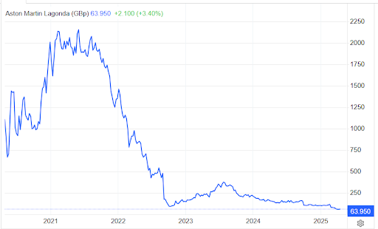
Figure 1: Stock Prices of Aston Martin (in GBP)
(Source: Trading Economics, 2025)
Aston Martin has a strategic opportunity to rebuild market confidence and create demand in emerging luxury markets such as Nepal, despite interpreting recent financial fluctuations. The company can draw in high-end Nepali consumers looking for distinction and dignity by launching with a localised campaign to highlight restricted availability, customisation, and specialised after-sales services. The last 12 months have caused Aston Martin to document its price fall by more than 57%, suggesting a prediction to be priced at 62.87 GBP by the end of 2025 (Trading Economics, 2025). Additionally, by allowing for competitive introductory offers without diminishing brand equity, this pricing trend may further promote strategic entrance.

Risk analysis and mitigation strategies
Expanding Aston Martin’s DBX SUV into the Nepalese market entails unique risks, including limited infrastructure, low brand awareness, and regulatory challenges. Conversely, Aston Martin can involve mitigation strategies by conducting thorough market research, thus lobbying for favorable policies, and investing in local partnerships to streamline operations. As per Tóth et al. (2024), in addition to forming strategic alliances with electric vehicle manufacturers, Aston Martin Plc has leveraged advanced digital technologies to enhance the customer experience. This includes an integration of personalised digital interfaces, further making it an offer for connected car services. Additionally, Aston Martin can lead to a regional service network and training courses for regional technicians to mitigate logistical risks and guarantee after-sale assistance and brand loyalty.

3. Segmentation, Targeting, and Positioning (STP) for new brand extension

Segmentation
Aston Martin has taken effective segmentation for exploring a brand extension into the Nepalese market, especially to attract affluent individuals with a taste for luxury and performance. Aston Martin, upon understanding the global website visits, have stated the audience comprises more than 71% of males and 28% female, mostly from 25-34 age groups (SimilarWeb, 2025). This data has identified geographic segmentation as to target urban areas like Kathmandu, making the Aston Martin to be more appreciated as a luxury brand. Additionally, the focus on high-net-worth individuals can be identified demographically, typically professionals and entrepreneurs aged 25 to 44 for valuing status symbols and performance vehicles.
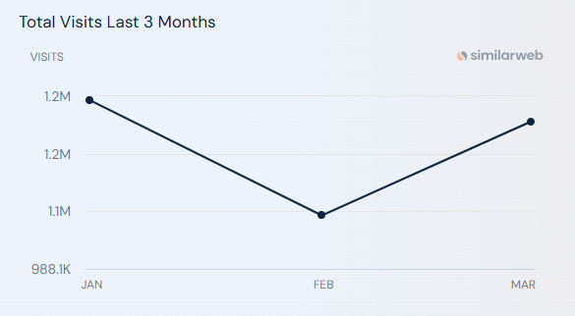
Figure 2: Total visits of astonmartin.com in 3 months
(Source: SimilarWeb, 2025)
Psychographic segmentation will further refine the audience by focusing on aspirational product management, taking Aston Martin into account. Customers are 50% more inclined to spend extra for genuine brands and 59% more likely to promote them, according to a Harvard Business Review study (Forbes, 2024). These potential consumers can also align brand-consciousness with Aston Martin’s legacy of elegance and innovation respectively.

Targeting
The target towards Nepalese customers for a new brand extension of Aston Martin can take market segmentation as an obligatory measure for managing exclusivity, premium quality, and status. Aston Martin as the luxury automotive brand can identify high-net-worth individuals, business elites, and luxury car enthusiasts in urban areas, taking income level, lifestyle, and aspirational value into consideration. However, by 2029, the market is anticipated to reach a volume of 137.4 million USD, with revenue estimated to rise at a CAGR of 0.48% annually (CAGR 2025-2029) (Statista, 2025). Targeting of Aston Martin with DBX can also prioritise affluent millennials and Gen X professionals with growing purchasing power. As suggested by Kohut (2024), in order to improve authenticity and increase viewer engagement, brands concentrate on strategic product placement agreements that match content and target audience. It seems that these consumers are increasingly influenced by global luxury trends and digital media. Therefore, Aston Martin can focus over building relevance and prestige within Nepal’s emerging luxury segment.

Positioning
Aston Martin is known for positioning itself as a symbol of status and innovation, offering a luxury experience unlike any local or regional competitor. An exploitation of numerous business tools, including the unique selling point have proven ideal for business strategy formulation, especially for crafting target markets with intended products (Wan et al., 2023). The positioning measures can therefore be recognised by interpreting other automobile competitors in Nepal that can also be taken in the following approach.
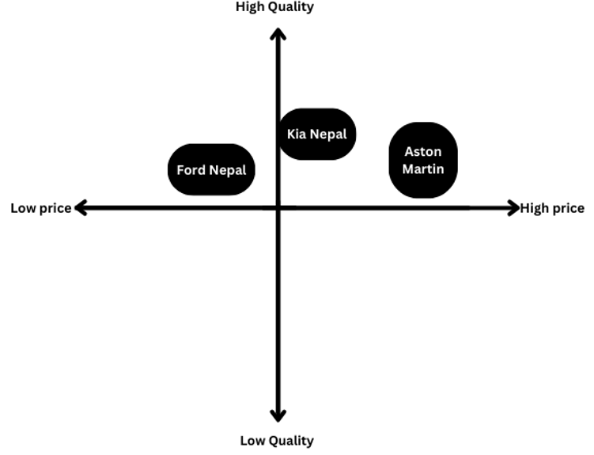
Figure 3: Positioning map of Automobile companies in Nepal
(Source: Self-developed)
The aforementioned picture of perceptual map has therefore placed Aston Martin in the high-price and high-quality quadrant, making it distinct from Ford Nepal and Kia Nepal. Aston Martin has emphasised 14% increment in wholesale volume in the 3rd quarter of 2024, thus reflecting DB12’s growth and production with acknowledgement of sequential increase (Aston Martin, 2024). This further helped in signalling strategic expansion of Aston Martin backed by performance success. Additionally, the company has positioned itself with ist alignment around premium identity, thus differentiating it from mass-market competitors like Ford and Kia.

4. Customer Persona development
Factors | Justification
Demographics |   Name: Ravi Shrestha  Age: 29  Gender: Male  Location: Kathmandu, Nepal  Income: more than 10 million NPR annually (business owner of a family enterprise)  Education: Master’s Degree in Business and International Studies  Marital Status: Single
Profile and story | - A second-generation entrepreneur, Ravi actively invests in tech companies while overseeing his family's export company.  - Educated abroad, he returned to Nepal to build a legacy grounded in modern sophistication and national pride.  - He frequently visits high-end social clubs, portraying a lifestyle of ambition, travel, and luxury.
Motivation | - Seeking to express his identity through exclusive and refined choices  - Taking value for craftsmanship, performance, and brand prestige
Goals | - To be perceived as a forward-thinking, stylish trendsetter  - To own rare and globally recognized luxury assets  - To network with like-minded elites and build a legacy
Pain-points | - Limited access to luxury services and support infrastructure in Nepal  - High import duties and taxation on luxury vehicles  - Lack of official brand presence and tailored experiences locally
Table 1: Customer persona
(Source: Self-developed)
The aforementioned customer persona has taken the example of Ravi Shrestha, a 29-year-old second-generation entrepreneur from Kathmandu to acknowledge Aston Martin’s brand expansion in Nepal. Ravi, earning over 10 million NPR a year, is a representative of Nepal's new generation of wealthy, international business leaders, further blending his knowledge of Business and International Studies with traditional family business values. Business success is also highly dependent on intense competition within a market, thus acknowledging attraction, management, and retention possible for talented and skilled employees (Operti et al., 2021). Therefore, the customer has adopted for valuing exclusivity, craftsmanship, innovation, and performance. However, pain-points have also been identified here with Nepal’s high import taxes, limited luxury infrastructure, and lack of local brand presence. All these aspects are enough to acknowledge the company to establish itself in Nepal.

5. 7P marketing mix strategy for brand extension
The 7P marketing mix has collectively been used for service marketing, making “product, price, place, promotion, people, process, and physical evidence” to be essential for acknowledging organisational activities (Jain et al., 2022). Every component of the 7P model is essential to building Aston Martin's distinctive brand identity in Nepal while taking into account local consumer trends and market conditions.

Product
The DBX707 of Aston Martin has unmatched power, breathtaking performance, and luxurious comfort, making it drive like no other luxury SUV (Aston Martin, 2025). As the brand’s flagship SUV, it symbolizes both capability and craftsmanship that can attract Nepal’s growing affluent class.

Price
Based on the research by Subrahmanyam and Arif (2022), the premium pricing approach purposefully sets high prices to give the impression of superior value, increasing customer satisfaction and loyalty. Premium pricing can therefore align with the brand's global image, thus enhancing customer loyalty through status-driven purchases.

Promotion
One of the main components of Aston Martin's marketing strategy has been found to be exclusivity, that allows the company to highlight the skill going into constructing each car (Medium, 2023). In Nepal, Aston Martin's promotional approach can leverage invitation-only events, followed by private test drives, and collaborations with luxury lifestyle brands.

Place
The “place” strategy for Aston Martin in Nepal requires careful planning to ensure selective distribution, like establishing a flagship showroom in Kathmandu to provide optimal visibility to the target audience. The showroom can also be responsible for reflecting the brand’s identity with architectural elegance and personalised service, thus integrating local luxury lifestyle establishments.

Process
Certain characteristics, such as authenticity, exclusivity, hedonism, and artistic expression, can possibly help in setting luxury brands apart from other types of brands.(Javornik et al., 2021). Furthermore, Aston Martin can implement a customized sales and after-sales experience, such as allowing customers for personalisation of vehicles with exclusive design options.

People
Aston Martin’s mission, vision, and values can also collectively become ideal for the organisation to ensure authenticity in talent development, taking both local and global experts for strategic direction (Knowles and Mainiero, 2023). Brand integrity can also be reinforced with encouragement of high customer engagement standards, thus making local professionals possible for integrating international specialists to acknowledge consistency in customer experience.

Physical evidence
Physical evidence has further referred to the tangible cues that reinforce brand credibility, making Aston Martin to include showroom ambiance, vehicle presentation, brand merchandise, and luxury marketing materials. High end design elements can manage physical manifestation of Aston Martin’s brand promise, whereas retail space development in Nepal with international standards can reflect the brand’s commitment to quality.

6. Conclusion

Summary of the findings
It can be summarised that Aston Martin’s strategic extension in Nepal by launching its DBX SUV has identified a compelling opportunity to align heritage with innovation in luxury car market. The brand’s evolution from high-performance vehicles to lifestyle symbols reinforces its mission to deliver exclusivity, elegance, and cutting-edge mobility. DBX can also be the luxury product of Aston Martin bridge the gap between functionality and prestige, supporting Aston Martin’s global vision to attract Nepal’s well-to-do customers. The adoption of a robust 7P marketing mix can further make the brand for addressing market-specific challenges while enhancing consumer appeal through personalised experiences, premium pricing, and exclusive distribution. However, customer persona adoption here has suggested the cultural relevance and market readiness for ultra-luxury vehicles as well, allowing Aston Martin to diversify revenue streams. A detailed understanding of strategic partnerships, targeted positioning, and value-driven innovation have suggested Aston Martin’s potential in Nepal, especially to market SUV with adequate utility in hilly regions. Infrastructural and regulatory risks have also been managed by Aston Martin to further strengthen brand equity, especially in an unexplored yet high-growth market like Nepal.

Recommendations
- Enhancing the customer experience, boosting sales, and enhancing brand image are all reasons for acknowledging car showroom lighting and displaying importance in the automotive industry (Jain et al., 2023). However, a flagship showroom can be established by Aston Martin in Kathmandu to showcase the DBX SUV, ensuring it reflects the brand’s luxury through architecture, ambiance, and premium service.
- Collaborative partnerships of international car brands with local service providers can also be helpful for strategic movements of business, thus mitigating possible business complexities in new countries and markets (Kukkamalla et al., 2021).
- The company can offer personalised after-sales services and customisation options to maintain brand integrity and customer satisfaction, further acknowledging brand collaborations to create aspiration and appeal.

7. References
Aston Martin, (2020). ASTON MARTIN UNVEILS DBX: AN SUV WITH THE SOUL OF A SPORTS CAR. Available at: https://www.astonmartin.com/en/our-world/news/2020/7/23/aston-martin-unveils-dbx-an-suv-with-the-soul-of-a-sports-car (Accessed: 18 April 2025)
Aston Martin, (2024). Q3 2024 Results. Available at: https://www.astonmartin.com/-/media/corporate/documents/2024-results/aston-martin-lagonda-q3-2024-results.pdf?rev=c7ef5c7d72604f5a885ad5bf82365ff6 (Accessed: 18 April 2025)
Aston Martin, (2025). About Us. Available at: https://www.astonmartin.com/en/corporate/about-us (Accessed: 18 April 2025)
Aston Martin, (2025). THE NEW POWER WITHIN DBX707. Available at: https://www.astonmartin.com/en/models/dbx707 (Accessed: 18 April 2025)
ET Brand Equity, (2021). Ferrari's ambitious attempt to transform car brand into a luxe lifestyle name. Available at: https://brandequity.economictimes.indiatimes.com/news/business-of-brands/ferraris-ambitious-attempt-to-transform-car-brand-into-a-luxe-lifestyle-name/83625247 (Accessed: 18 April 2025)
Forbes, (2024). Aston Martin: From Prestige To Profit Warnings—The 2024 Reality Check. Available at: https://www.forbes.com/sites/jeetendrsehdev/2024/11/27/aston-martin-from-prestige-to-profit-warnings-the-2024-reality-check/ (Accessed: 18 April 2025)
Jain, K., Chauhan, S. and Sharma, N., (2023). REVIEW OF DISPLAY DESIGN ASPECTS IN CAR SHOWROOMS INFLUENCING CUSTOMERS INTEREST. ShodhKosh: Journal of Visual and Performing Arts, 4(2 ECVPAMIAP), pp.73-85.
Jain, R., Jain, S. and Jain, S., (2022). Analyzing and exploring the effectiveness of each element of 7Ps of marketing mix. International Journal of All Research Education and Scientific Methods (IJARESM), 10(1), pp.2455-6211.
Javornik, A., Duffy, K., Rokka, J., Scholz, J., Nobbs, K., Motala, A. and Goldenberg, A., (2021). Strategic approaches to augmented reality deployment by luxury brands. Journal of Business Research, 136, pp.284-292.
Knowles, J. and Mainiero, L., (2021). Authentic talent development in women leaders who opted out: Discovering authenticity, balance, and challenge through the kaleidoscope career model. Administrative Sciences, 11(2), p.60.
Kohut, M., (2024). Product Placement in the Marketing Communications System. Економіка розвитку систем, 6(1), pp.112-118.
Kukkamalla, P.K., Bikfalvi, A. and Arbussa, A., (2021). Collaborative partnerships in the automotive industry: key motives and resource integration strategy. International journal of business innovation and research, 24(4), pp.571-592.
Medium, (2023). Aston Martin: The Art of Elegance and Exclusivity in Marketing. Available at: https://medium.com/@david_6844/aston-martin-the-art-of-elegance-and-exclusivity-in-marketing-2ff5d4d66c95 (Accessed: 18 April 2025)
Nepal Drives, (2023). Only 3.1% Nepalese Families Own Cars, 27.3% Own Two-Wheelers, 12th National Census Finds. Available at: https://www.nepaldrives.com/only-3-1-nepalese-families-own-cars-27-3-own-two-wheelers-census-finds (Accessed: 18 April 2025)
Operti, E., Sgourev, S.V. and Lampronti, S.Y., (2021). Choose your enemies well: Mapping, managing, and leveraging rivalry. California Management Review, 64(1), pp.29-46.
SimilarWeb, (2025). astonmartin.com Website Analysis for March 2025. Available at: https://www.similarweb.com/website/astonmartin.com/#geography (Accessed: 18 April 2025)
Statista, (2025). Passenger Cars - Nepal. Available at: https://www.statista.com/outlook/mmo/passenger-cars/nepal (Accessed: 18 April 2025)
Subrahmanyam, S. and Arif, S.A.F., (2022). PREMIUM PRICING STRATEGY AND CUSTOMER RETENTION-AN ANALYSIS. International Journal of Early Childhood Special Education, 14(3).
The Guardian, (2021). Aston Martin’s new SUV aimed at women fails to put brakes on losses. Available at: https://www.theguardian.com/business/2021/nov/04/aston-martins-new-suv-aimed-at-wealthy-women-fails-to-put-brakes-on-losses (Accessed: 18 April 2025)
Tóth, Á., Suta, A., Szauter, F. and Lukács, E., (2024). Quantitative analysis of green investments in European automotive companies: a digital reporting analysis. Clean Technologies and Environmental Policy, pp.1-13.
Trading Economics, (2025). Aston Martin Lagonda | AML. Available at: https://tradingeconomics.com/aml:ln (Accessed: 18 April 2025)
Wan, X., Sun, R., Nakhost, H., Dai, H., Eisenschlos, J.M., Arik, S.O. and Pfister, T., (2023). Universal self-adaptive prompting. arXiv preprint arXiv:2305.14926.
Warwickshire County Council, (2024). Aston Martin honoured with King’s Award for Enterprise in Innovation. Available at: https://www.warwickshire.gov.uk/news/article/5458/aston-martin-honoured-with-king-s-award-for-enterprise-in-innovation (Accessed: 18 April 2025)

