PROBLEM
ANALYSIS AND SOLUTION
DEVELOPMENT

Module Name: Analysing and Solving Problems
Module Code: ACCA 4019
Student Name: Kateryna Kondrashova
Student ID: 2321546
Group:1
Lecturer’s Name: Fahad Ahmed

Table of Contents
Introduction 3
1. Deconstruct the Problem 4
1.1 MoSCoW Technique Requirements 4
1.2 Constraints 5
1.3 Variables Identification 5
2. Proposed Solution 6
2.1 Assumptions 6
2.2 Flowchart 6
2.3 Flowchart Explanation 7
3. Reflection and Justification 10
3.1 Abstract thinking 10
3.2 Sub-dividing 10
3.3 Justification of solution 10
3.4 Limitation 10
Conclusion 12
References 13
Appendices 14
Appendix A 14
Appendix B 14

Introduction
This assessment examines the problem of optimising classroom allocation in a college. The primary objective is to develop a structured solution using abstract thinking and problem-solving techniques. The work focuses on the ability to evaluate the problem, identify requirements and constraints, and develop a logical, comprehensive solution. The work will also demonstrate skills in creating and using a flowchart to propose solutions to all assigned tasks.

Deconstruct the Problem
A local college has encountered a problem with the inefficient allocation of classrooms among groups, specifically mismatches in capacity, location, and timetabling. This problem arises from a lack of a systematic approach to organisation, planning and monitoring. As a result, classrooms are used inefficiently, scheduling conflicts arise and the effectiveness of the teaching process is reduced.
Timetable creation is a common problem for educational institutions and is described in detail in the source [1].
This problem can be broken down into several parts, such as:
- Classroom capacity management. Classrooms should be assigned according to group size to ensure efficient use of space.
- Classroom location management. Classrooms should be located as close as possible to minimise the time spent by students and staff moving between classrooms.
- Schedule management. To minimise scheduling conflicts, classrooms should be assigned to available time slots.

MoSCoW Technique Requirements
The MoSCoW technique is a prioritisation method that allows for a clear definition of the importance of each feature and requirement. This ensures that more important tasks and subtasks are completed more quickly and to a higher standard [2].
Must have
- Each session must be allocated to a classroom.
- Each session has a fixed start and end time.
- A single group may only have one session at a time.
- A single classroom may only accommodate one group at a time.
- The capacity of the classroom must be equal to or greater than the size of the group.
- Room assignment information must be updated immediately after assignment.
Should have
- The classrooms where lessons take place should be located close to one another as possible or in the same.
Could have
- Automatic notifications to lecturers and students regarding changes to the timetable.
- Lecturers’ and students’ preferences.
Won’t have
- Display of the timetable on the campus map.

Constraints
A constraint is a rule or condition that defines the limits of the decisions made [3].
Constraints depend on the problem and available resources [1].
- The number of groups and available classrooms is limited.
- Classroom size is limited by its capacity.
- Class times are fixed and cannot be changed.
- A group of students cannot attend several classes at the same time.

Variables Identification
Variables: | Description:
groupSize | Number of students per group.
totalRooms | Total number of classrooms available in the college
roomCapacity | The maximum number of students the classroom can accommodate.
roomAvailability1 | Shows whether the classroom is available in the first time slot (morning time).
roomAvailability2 | Shows whether the classroom is available in the second time slot (daytime).
assignedRoom1 | Classroom that has been allocated to the first session.
assignedRoom2 | Classroom that has been allocated to the second session.
Decision variables describe the quantities that the decision makers would like to determine [3].
All of the components listed are interrelated and require a comprehensive approach
to resolve the issue effectively.

Proposed Solution
A flowchart is a graphical representation of a process, showing the various steps that occur as the process or task progresses.
It organises the tasks in chronological order and identifies them by type, such as process, decision, data, etc. using standard symbols (such as rectangles, diamonds and other), with arrows between them indicating the order in which the steps are completed [4].

Assumptions
In the context of a flowchart, assumptions are conditions that are taken as true without the need for proof [5]. They help to simplify the problem-solving process by establishing certain conditions and boundaries.
- All classrooms are initially available before scheduling begins.
- Each group is treated separately, one at a time.
- One group has two classes per day, meaning it occupies two fixed time slots (morning and afternoon).
- Classrooms are numbered in order of increasing capacity.

Flowchart
The completed flowchart is presented in Figure 1.
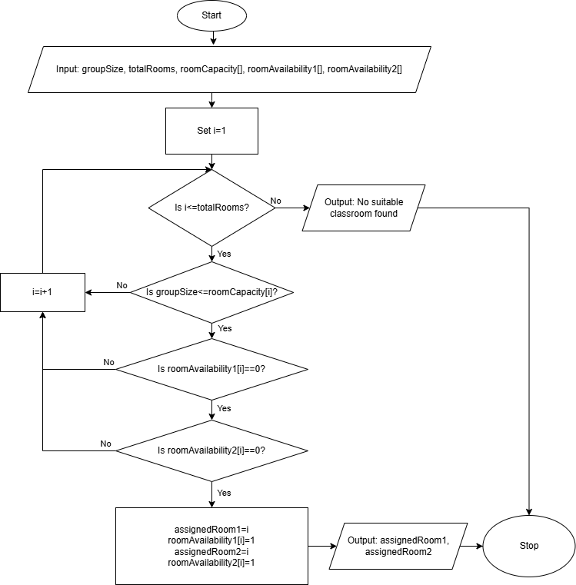
Figure 1. Flowchart (Personal Collection)

Additionally, the algorithm was implemented in pseudocode (see Appendix A) and in EduBlocks (see Appendix B).

Flowchart Explanation
Overview of the Solution
The proposed solution is an algorithm designed to simplify the process of allocating classrooms to groups. The algorithm takes into account factors such as availability, capacity and location. A classroom is only allocated to a group if all conditions are met. If no suitable option is available, the algorithm checks the next classroom for compliance. The algorithm stops when a suitable option is found or when all available classrooms have been exhausted.
How the Flowchart Works
First, the algorithm requests input data using the parallelogram symbol (input). It was decided to use arrays for certain variables to store the characteristics and availability of classrooms.
Next, the algorithm proceeds to the rectangle symbol (process). This specifies that the array index “i” has been set to the value “1”. “i” corresponds to the classroom number.
After this, the diamond symbol (decision) is triggered, which checks the loop condition: whether the index “i” exceeds the total number of classrooms (“Is i <= totalRooms?”). This means that the system has a fixed number of classrooms in the college, and when this number is exhausted, the algorithm must stop rather than select a new, non-existent classroom. This ensures the reliability of the system.
The next step is to determine whether the group size is less than or equal to the classroom capacity (“Is groupSize<=roomCapacity[i]?”). This step also has a diamond symbol. If the condition is not met, the process moves on to the next classroom (“i=i+1”).
If it does, the availability of the specific classroom in the first time slot is checked (“Is roomAvailability1[i]==0?”) (diamond). If it is not available, the algorithm moves on to the next classroom, and the check is repeated. If it is available, the availability of the same classroom in the second time slot is then checked (“Is roomAvailability2[i]==0?”) (diamond). If not, the process moves on to the next classroom. If so, this classroom is assigned to the first and second lessons (“assignedRoom1=i, assignedRoom2=i”), and the classroom becomes unavailable for other bookings (“roomAvailability1[i]=1, roomAvailability2[i]=1”).
Key Decision Points
- Whether the classroom capacity is sufficient (groupSize ≤ roomCapacity[i]).
This is an important condition, as failure to meet it will disrupt the teaching process. If a small classroom is allocated to a large group, it will not be possible to hold the session.
- Whether the classroom is available at the required time slots (1,2).
This condition ensures that there are no scheduling conflicts. It prevents two groups from being scheduled in the same classroom in the same time slot.
- Whether to continue searching or assign the room.
This allows the algorithm to explore all possible classroom options and ensures that the most suitable one is selected.
How it meets the requirements
This approach ensures efficient use of space by properly sorting classrooms (in ascending order) and sequentially matching classroom size to classroom capacity.
Prevents scheduling conflicts by using the roomAvailability variable with time slots. A classroom cannot be assigned to more than one group at a time.
Minimises travel time for students in the same group between classrooms by assigning the same classroom to multiple time slots within a single day.

Reflection and Justification

Abstract thinking
Abstract thinking is the ability to understand and separate context from content, whilst insignificant details are disregarded [6].
In this work, key details were identified as variables, such as group size, classroom capacity, accessibility and time slots. This allowed the principles for solving the problem of classroom allocation to be defined and simplified.

Sub-dividing
The division of the problem into subcategories has been demonstrated to facilitate management and enhance the comprehensibility of the underlying logic. Initially, the primary issues were identified. Then, each issue was considered in turn. In this work, the algorithm first checks the capacity of the classrooms and then their availability across two time slots. This approach simplifies the structure of the solution.

Justification of solution
Using a loop structure ensures accurate and reliable checking of all classrooms, preventing eligible rooms from being missed.
Using separate IF conditions make the logic easier to read and reduces the risk of errors. This approach was chosen rather than combining all the conditions into one complex statement.
Dividing room availability into two-time intervals (roomAvailability1[], roomAvailability2[]) instead of using a more complex two-dimensional array. This simplified the model and made it more understandable.
In the "Is groupSize <=roomCapacity[i]?" diamond, the "<=" operator was used instead of ">" because it was necessary to identify eligible classrooms based on capacity, rather than identifying capacity mismatches. This would have made the logic more intuitive.

Limitation
However, this solution does have some limitations.
It requires that each group always have two classes per day. The required number of classes per day is usually assigned individually to each group. Furthermore, classrooms are not always sorted according to their capacity.
An important aspect is also missing: teacher assignments, and therefore no verification of their availability during specific time slots.
This means that this solution is not entirely suitable for real-life situations, but it is applicable to a simplified model.

Conclusion
The proposed flowchart-based solution demonstrates a step-by-step algorithm for efficient classroom assignment based on group size, classroom capacity, availability, and location. The solution minimises the time students and staff spend travelling between classrooms and eliminates scheduling conflicts. Breaking down the scenario into smaller components has allowed for a better understanding of the problem. The priorities, constraints, and assumptions used in developing the algorithm help simplify the solution and establish its logical structure.

References

[1] | Xin Gu, Muralee Krish, Shaleeza Sohail, Sweta Thakur, Fariza Sabrina, Zongwen Fan, “From Integer Programming to Machine Learning: A Technical Review on Solving University Timetabling Problems,” Computation, vol. 13, no. 1, p. Art. no. 10, 2025.
[2] | Prajval Mohan; Pranav Narayan; Mythili Thirugnanam; Supratim Sarkar, “XPS-MoSCoW: A Prioritization-Based Hybrid Agile Model of SCRUM and Extreme Programming,” International Journal of Software Innovation, vol. 10, no. 1, pp. 1-15, 2022.
[3] | P. A. Jensen, “Terminology,” The University of Texas, 2004. [Online]. Available: https://utw11041.utweb.utexas.edu/ORMM/models/unit/linear/subunits/terminology/index.html. [Accessed 21 March 2026].
[4] | T. E. o. E. Britannica, “Flowchart,” Encyclopaedia Britannica, [Online]. Available: https://www.britannica.com/money/flowchart. [Accessed 09 April 2026].
[5] | C. U. Press, “Assumption,” Cambridge Dictionary, 2026. [Online]. Available: https://dictionary.cambridge.org/us/dictionary/english/assumption. [Accessed 09 April 2026].
[6] | S. K. Reed, Cognitive Skills You Need for the 21st Century, Oxford, UK: Oxford University Press, 2020.
[7] | Bryan Alexander Ulate-Caballero; Allan Berrocal-Rojas; Jeisson Hidalgo-Céspedes, “Concurrent and Distributed Pseudocode: A Systematic Literature Review,” in Proceedings of the XLVII Latin American Computing Conference (CLEI 2021), Cartago, Costa Rica, 2021.
[8] | EduBlocks, “EduBlocks,” Anaconda Inc., 2025. [Online]. Available: https://edublocks.org/. [Accessed 17 April 2026].

Appendices

Appendix A
Pseudocode is a valuable resource used in programming, software development and scientific reports for designing algorithmic solutions, as it is easy to write, understand and modify [7].
- Start
- Input: groupSize, totalRooms, roomCapacity[], roomAvailability1[], roomAvailability2[]
- Set i = 1
- WHILE i <= totalRooms
- IF groupSize <= roomCapacity[i] THEN
- IF roomAvailability1[i] == 0 THEN
- IF roomAvailability2[i] == 0 THEN
- Set assignedRoom1 = i
- roomAvailability1[i] = 1
- assignedRoom2 = i
- roomAvailability2[i] = 1
- Output: assignedRoom1, assignedRoom2
- STOP
- END IF
- END IF
- END IF
- Set i = i + 1 // if room is not suitable or not available, check next room
- END WHILE
- Output: No suitable classroom found
- STOP

Appendix B
EduBlocks is a free tool that helps anyone who wants to learn to code in text-based languages such as Python or HTML, using a familiar system of drag-and-drop blocks [8].
In addition to the work already completed, an attempt was made to convert the flowchart into EduBlocks. This was done to demonstrate a basic understanding of how algorithms and programme logic work.
However, the implementation principle in the flowchart and pseudocode differs from that in EduBlocks.
1. An additional loop was added for inputting and populating the arrays (roomCapacity, roomAvailability1, roomAvailability2). This sequentially populates the lists with data for all rooms before executing the main search algorithm. In the flowchart and pseudocode, the input is presented in an abbreviated form- as a single input.
2. In the pseudocode, the element count starts at 1, whereas in EduBlocks (as in Python) list indexing starts at 0. Therefore, i = 1 has been changed to i = 0, and i <= totalRooms has been changed to i < totalRooms accordingly. This was done to ensure that the loop correctly iterates over all elements of the list and does not go beyond its bounds.
The program code is presented in Figure 2.
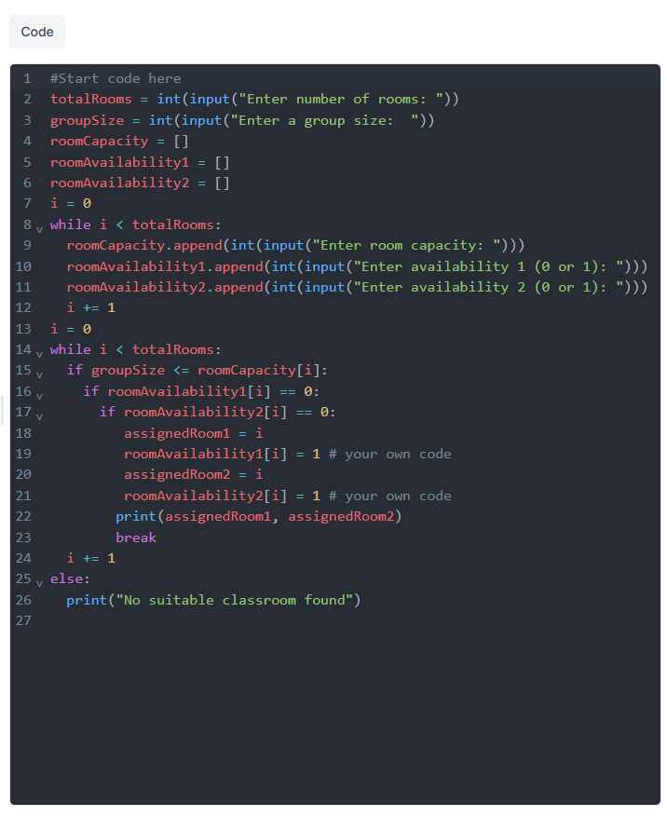
Figure 2. EduBlocks program code (Personal Collection)
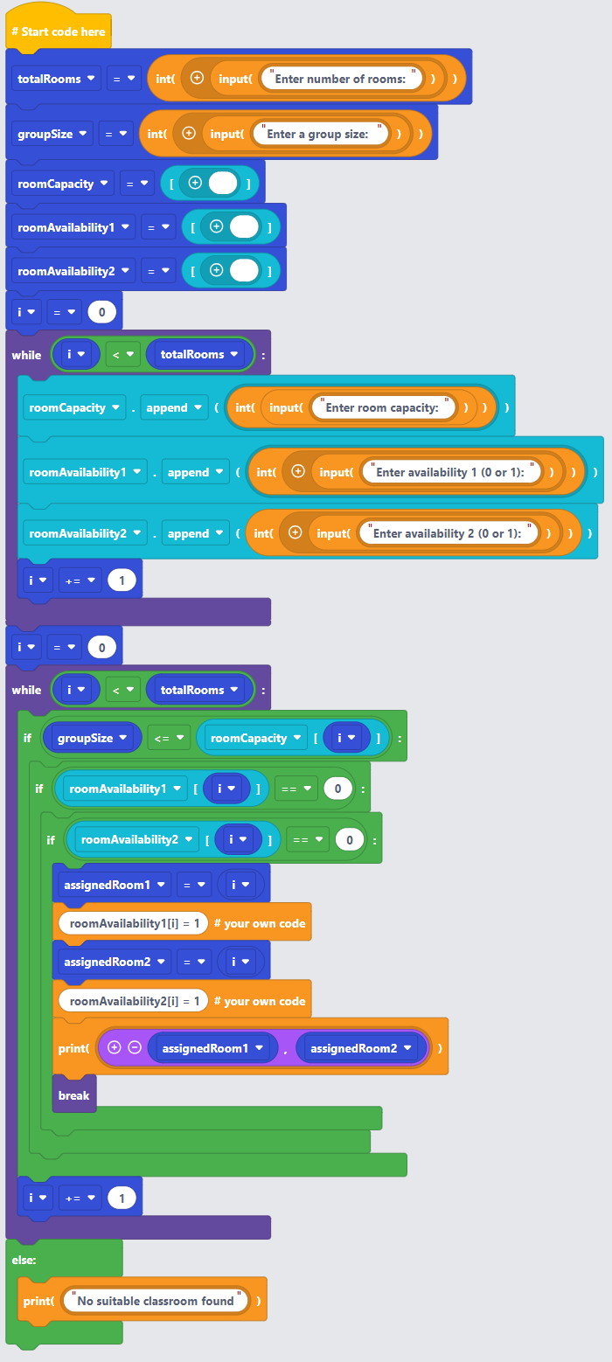
The algorithm in block form is presented in Figure 3.

Figure 3: Block view in EduBlocks (Personal Collection)

