

Providing Viable Solutions for Electrical Vehicle Charging in Social Housing

Karl Jones

MSc Property and Facilities Management
M7X01817

March 2021

Submitted in partial fulfilment of the requirements for the degree of Master of Science - Property and Facilities Management

Researcher: Karl Jones
Researcher Student Number: 133718

This research was undertaken under the auspices of the University of Wales: Trinity Saint David and Submitted in partial fulfilment of the requirements for the degree of M.Sc. in Property and Facilities Management, March 2021

Dissertation Tutor: Dr Deborah Hughes

Word Count: 15,000 +/- 10%
Dissertation Word Count: 14,002

Author’s Declaration
I declare that the work in this dissertation was carried out in accordance with the regulations of the University of Wales, Trinity Saint David. The work is original except where indicated by special references in the text and no part of the dissertation has been submitted for any other degree.
Any views expressed in the dissertation are those of the author and in no way represent those of the University of Wales, Trinity Saint David.
The dissertation has not been presented to any other University for examination either in the United Kingdom or overseas.
I hereby give permission for my work, if accepted, to be available for photocopying and inter-library loan, and for the title and summary to be made available to outside organisations.
Signed ………………………………………………………………………………………………………….
Date ……………………………………………………………………………………………………………..

DECLARATION SHEET – this sheet MUST be signed and included within the MSc dissertation

This work has not previously been accepted in substance for any degree and is not being concurrently submitted in candidature for any degree.

Signed ...................................................................... (candidate)

Date ........................................................................

STATEMENT 1
This dissertation is the result of my own investigations, except where otherwise stated. Where correction services have been used, the extent and nature of the correction is clearly marked in a footnote(s).
Other sources are acknowledged by footnotes giving explicit references. A bibliography is appended.
Signed ..................................................................... (candidate)

Date ........................................................................

STATEMENT 2
I hereby give consent for my dissertation, if accepted, to be available for photocopying and for inter-library loan, and for the title and summary to be made available to outside organisations.
Signed ..................................................................... (candidate)

Date ........................................................................
NB: Candidates on whose behalf a bar on access has been approved by the University, should use the following version of Statement 2:
I hereby give consent for my dissertation, if accepted, to be available for photocopying and for inter-library loans after expiry of a bar on access approved by the University of Wales on the special recommendation of the Member Institution concerned.
Signed ..................................................................... (candidate)

Date ........................................................................

Acknowledgements

The author wishes to give thanks to all those who have assisted and contributed between September 2020 and March 2021 in which the following dissertation was compiled.
I would like to express my gratitude to my dissertation tutor Deborah Hughes who was always available with her support and guidance through this research.
I wish to give thanks to my wife for her encouragement during the past year and for support in all my absence hours.
Finally a special thanks to the individuals who took time out of their busy schedules to participate in my research by answering questionnaires and taking part in interviews.

Abstract

The UK government has made it clear that it wants driving an electric vehicle to be convenient for people all over the country, and that local authorities have a key role to play. Wales is significantly behind the rest of the UK when it comes to providing charging points and there has been a drastic increase in the use of electric vehicles, and this trend is likely to continue in an upward trajectory, it’s important for registered social landlords to plan for charging facilities for electric vehicles. The aim of this research was to determine viable options for electrical vehicle charging for social housing tenants in the Neath Port Talbot and Swansea boroughs.
The Researcher employed a mixed method approach in the form of a literature review and collecting both qualitative and quantitative data through tenants of social housing and industry professionals. This data was then analysed and conclusions drawn.
The main findings of this research were that the most suitable charging solution would be slow chargers at the tenant’s home, RSL’s in general have not considered how this will be achieved in their existing stock. The researcher has made recommendations to install “passive provision” during planned maintenance works where off road parking is available. Communal car parks and sheltered housing complexes should be utilised for properties where designated off road parking is unavailable within the next 3-7 years. Not having suitable convenient charging is a barrier to EV uptake so RSL’s should considering acting to ensure charging is easily accessible.

Contents
Acknowledgements iii
Abstract iv
List of Figures viii
List of Tables ix
List of Abbreviations ix
1. Introduction 1
1.1 Introduction 1
1.2 Aims and Objectives 2
1.2.1 Aim 2
1.2.2 Objectives 2
1.3 Summary 2
2. Literature Review 3
2.1 Introduction 3
2.2 Increase in Electrical Vehicles 5
2.2.3 Company cars 6
2.3 Types of charge points 6
2.3.1 Demand on the grid 8
2.3.2 Home charge points 9
2.4 Existing Restrictions for flats/ no off road parking 10
2.5 Social housing 13
2.5.1 Fleet Vehicles 14
2.6 No action 14
2.7 Future Proofing for tenants needs 15
2.7.1 Resilience of stock 16
2.8 Demographic of early adopters 16
2.9 Conclusion 17
3. Research Methodology 19
3.1 Introduction 19
3.2 Research Design 19
3.3 Primary and secondary data 20
3.3.1 Literature review 20
3.3.2 Qualitative data 20
3.3.3 Quantitative Data 21
3.3.4 Pilot study 23
3.4 Data analysis 23
3.4.1 Reliable, Valid and Consistent data 24
3.5 Ethical Considerations 24
3.6 Limitations 25
3.7 Summary 25
4. Results 27
4.1 Questionnaires 27
4.1.1 Tenant questionnaire results 27
4.1.2 Overview of questionnaires 32
4.2 Semi-structured Interviews with RSL managers 32
4.2.1 RSL Manager Interview Results 32
4.2.2 Overview of interviews 37
5. Discussion 39
5.1 Introduction 39
5.2 Increase in Electrical Vehicles 39
5.3 Types of charge points 40
5.3.1 Infrastructure and Grid capabilities 41
5.4 Future proofing 42
5.4.1 No Action 43
5.4.2 Barriers to EV uptake 43
5.4.3 No off-road parking 46
5.5 Demographic of early adopters 47
5.6 Conclusion 49
6. Conclusion and Recommendations 51
6.1 Introduction 51
6.2 A need for electrical vehicle charging points, along with types and locations 51
6.3 Timescales that charge points will be needed for social housing tenants in South West Wales and potential implications if housing providers do not act 52
6.4 Options which could accommodate tenants with both off road parking and those with no dedicated off-street parking and fleet vehicles 52
6.5 Differences in tenant’s needs and housing associations plans 53
6.6 Summary 53
6.7 Critique 54
6.8 Future Research 54
List of References 55
Appendices 1
Appendix A: Tenant Questionnaire Blank 2
Appendix B: Semi Structured Interview Pilot Blank 3
Appendix C1: Interview Pilot 1 4
Appendix C2: Interview Pilot 2 5
Appendix D: Semi Structured Interview Blank 6
Appendix E: Review of tenant questionnaires 7
Appendix F: Results from Tenant Questionnaires 8
Appendix G1: Interview Respondent 1 9
Appendix G2: Interview Respondent 2 10
Appendix G3: Interview Respondent 3 11
Appendix G4: Interview Respondent 4 12
Appendix G5: Interview Respondent 5 13
Appendix G6: Interview Respondent 6 14
Appendix G7: Interview Respondent 7 15
Appendix G8: Interview Respondent 8 16

List of Figures

Figure 1- Number of charge points per region (House of Commons, 2019) 10
Figure 2- Increase in electric vehicles in the UK. (Society of Motor Manufacturers, 2019) 11
Figure 3- Electricity Demand and Charging Demand. (Rietmann, Hügler, Lieven, 2020). 14
Figure 4- Charging Behaviour Groups. Hardman, S. et al (2018) 15
Figure 5- Length of Social Housing Tenancies (Ministry of Housing, Communities and Local Government, 2018) 17
Figure 6- Age of EV owners in Germany Plötz, Patrick & Schneider, Uta & Globisch, Joachim & Dütschke, Elisabeth. (2014). 20
Figure 7– Age Category of tenant respondents 27
Figure 8– Gender of tenant respondents 28
Figure 9– Gender of tenant respondents 28
Figure 10- When are you considering upgrading your car? 29
Figure 11- When buying your next vehicle how likely is it going to be an electric vehicle? 29
Figure 12- How likely would it be that you'd need to be able to charge it overnight? 30
Figure 13- If you did not have access to charge the vehicle overnight how likely is it to put you off purchasing an electric vehicle? 30
Figure 14- Would you need to gain permission from your landlord to install your own electrical vehicle charging point? 31
Figure 15- Of those who answered likely or very likely to their next car purchase being electric/ when are you considering upgrading your car 37
Figure 16- Of those who answered likely or very likely to their next car purchase being electric /need to charge overnight 38
Figure 17- Of those who answered likely or very likely to their next car purchase being electric / would no overnight charging access put you off 39
Figure 18- Of those who answered likely or very likely to their next car purchase being electric / would you need to gain permission for electrical works 40
Figure 19- Of those who answered likely or very likely to their next car purchase being electric / do you have off-road parking 41
Figure 20- How likely is it going to be an electric vehicle? By age 42
Figure 21- How likely is it to be an electric vehicle? By gender 43

List of Tables

Table 1- Results from question 7 of interviews 32

List of Abbreviations

EV Electrical Vehicle
RSL Registered Social Landlord

1. Introduction

Introduction

Ambitious targets have been set by the United Nations and the UK Government alike to achieve a reduction in greenhouse gasses. The UK Government has made it clear that it wants driving an electric vehicle to be convenient for people all over the country, and that local authorities have a key role to play. The Government hasn’t offered any practical solutions on how and where to install these, especially around large scale retrofit to social housing properties.
The aim of this research will be achieved by using the data gathered from secondary and primary sources which will be compared and analysed. In order to meet the aim the Researcher will focus on addressing the objectives by gathering data from a variety of sources and executed in the form of a literature review and primary research, involving a series questionnaires and interviews. The two forms of data collection techniques include primary and secondary research. Secondary sources were available for the research and proved to be an excellent source of data providing readily available information.
The structure of the research will be first to understand the general areas of the topics and provide the reader with a clear background to electrical vehicle charging and the demand for it, along with other areas relevant to this research including social housing and future proofing. This will be followed by collecting the primary research which will include questionnaires and interviews. The discussion chapter will provide in-depth analysis of the data collected whilst comparing it to secondary data. Finally this research will be concluded and recommendations made.

1.2 Aims and Objectives

1.2.1 Aim

There is a notable national need to provide suitable charging facilities for electrical vehicles, the aim of this research is to determine viable options for electrical vehicle charging for social housing tenants in the Neath Port Talbot and Swansea boroughs.

1.2.2 Objectives

- Identify a need for electrical vehicle charging points, along with types and locations.
- Identify timescales that charge points will be needed for social housing tenants in the Neath Port Talbot and Swansea boroughs and potential implications if housing providers do not act.
- Identify options which could accommodate tenants with both off road parking and those with no dedicated off-street parking and fleet vehicles.
- Identify differences in tenant’s needs and registered social landlords plans.

1.3 Summary

The aim of the research is to determine viable options for electrical vehicle charging for social housing tenants in the Neath Port Talbot and Swansea boroughs. The Researcher will first review existing literature available which is relevant to meeting the objectives.

2. Literature Review

2.1 Introduction

In 2015, “The 2030 Agenda for Sustainable Development” was accepted by all United Nations Member States which provides “a blueprint for peace and prosperity for people and the planet, now and into the future.” Tackling climate change and working to preserving the oceans and forests are a major focus in the goals so energy management and reducing the use of fossil will play a role in meeting the goals set (United Nations, 2015). In May 2019, the Committee’s Net Zero highlighted the need to reduce greenhouse gas emissions in the UK effectively to zero by 2050 to meet the targets set by the government. The UK is the first major economy to legislate this target, with the Intergovernmental Panel on Climate Change (IPCC) in last year’s Report stating 1.5°C increase of global warming (Committee on Climate Change, 2019).

As set out by the UK Government (2018) in the “The Road to Zero: Next steps towards cleaner road transport and delivering our Industrial Strategy” they plan to end the sale of new conventional petrol and diesel cars and vans by 2040. Prime Minister Boris Johnson further reduced this target to 2035 in February 2020 and also included hybrid vehicles in this (UK Government, 2020).
The Department for Transport plan to meet this ambitious target by a variety of methods including;
- Grants for plug-in cars, vans, taxis and motorcycles which will continue to play a role beyond 2020
- A £400 million investment in charging infrastructure
- Ensuring uniformed charge points are easily accessed and used across the UK.
- All new built homes are electric vehicle ready by having a charge point available.
(UK Government, 2018)

Although this Act addresses new build properties it does not do anything to combat the 29million existing homes in the UK (Committee on Climate Change, 2019).
Another act which highlights the anticipated increase in electrical vehicles and their charge points is the Automated and Electric Vehicles Act quoting “This act will ensure that the UK’s infrastructure and insurance system is ready for the biggest transport revolution in a century.” (Automated and Electric Vehicles Act, 2018)

The UK Government has made it clear that it wants driving an electric vehicle to be convenient for people all over the country, and that local authorities have a key role to play. A letter was sent to local authorities across the country, urging them to take advantage of funding on offer to build up their electric car charging infrastructure and to increase local access to charge points for drivers (UK Government, 2019). Although the Researcher feels it has offered no real practical solutions on how and where to install these.

The table below produced by the UK Government shows that Wales is significantly behind the rest of the UK when it comes to providing charging points.
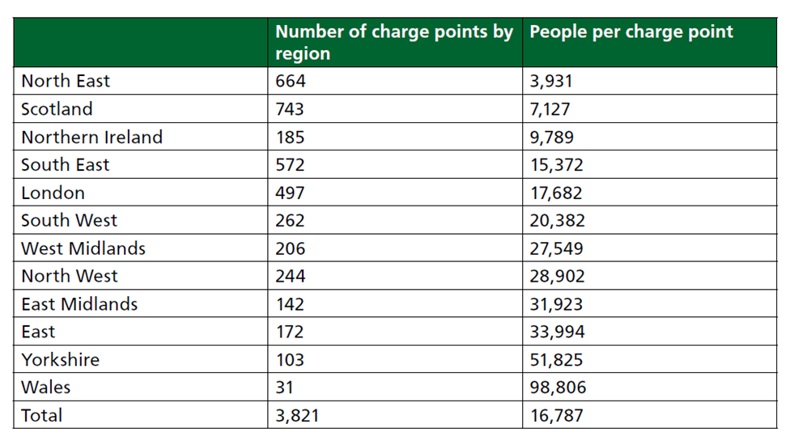
Figure 1- Number of charge points per region (House of Commons, 2019)

2.2 Increase in Electrical Vehicles

There has been a drastic increase in the electrical vehicles purchased in the UK between 2011 and 2018 as seen in figure 2, with information taken from The Society of Motor Manufacturers and Traders (SMMT) this highlights the need for suitable sufficient charging points.
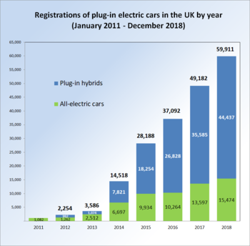
Figure 2- Increase in electric vehicles in the UK. (Society of Motor Manufacturers, 2019)
In the first 8 months 2019 the all-electric car sales where already ahead of the total of 2018 by a total of 17,393 registered between January 2019 and August 2019 showing the increasing trend. This figure was dwarfed in the 2020 with 44,708 in the first 8 months of the year alone (SMMT, 2020).
In the study “Forecasting the trajectory of electric vehicle sales” by Rietmann, Nele, Hügler, Beatrice & Lieven, Theo, (2020) in which a growth model was produced to predict long term growth of electrical vehicles in 26 countries, real data was used of sales between 2010 and 2018. It was forecasted that Electrical vehicles will own 42.5% of the car sales market worldwide by 2035. This will equate to 440 million sales.

2.2.3 Company cars

In 2019 the UK government (2019) announced that the ‘benefit in kind’ Tax, which is charged paid by employees with a company car, will be reduced to 0% in the tax year 2020/21. Following this they would then increase to 1% for 2021/22 and 2% for 2022/23 for electric vehicles. These reductions in tax rates will ensure it’s more attractive for employees to choose an electric car over conventional fossil fuel power vehicles. This means that sales are likely to soar as employees switch to the 0% tax 0% emission models and in turn means that the second-hand market for EVs will increase in two to three years’ time when companies upgrade their fleet. (Cirell, S. 2020).

2.3 Types of charge points

The growing use of electric vehicles is adding new challenges to electrical supply grid as different chargers require varying levels of power demand. In basic terms there are 3 main forms of chargers to charge electrical vehicles.
Standard- Is classed as a “slow charging unit” meaning it usually takes six to twelve hours so mainly used for overnight home charging. Typically around using 3kW giving an EV around 15 miles per hour on charge. 3-pin plug chargers with an EVSE cable also fall into this category using 2.3kW which provides up to 8 miles of range per hour, these should be used predominantly as a backup charging option, as they are not designed to withstand the necessary charging loads and should not be used long term and should only be used as a last resort reported the National Inspection Council for Electrical Installation (NICEIC, 2019)
Fast- Uses a dedicated charger unit with built in control and monitoring. Classed as “fast chargers” typically capable of charging EV’s in 3-4 hours. Normally requiring a 40A dedicated supply from the consumer unit and some may require a 3 phase supply (NICEIC, 2019).
Rapid- Normally large floor mounted specific points used at service stations, public car parks, large companies etc. It provides a DC charge of up to 50kw to the vehicle proving rapid charging. This level of power enables an EV to reach 80% charge in 30 minutes (Vidanalage, I. 2017).

A technical report carried out by the National Inspection Council for Electrical Installation Contracting states that standard and fast chargers are considered to be the most suitable for domestic/ light commercial use. Although if an EV on board charging unit only allows a charge of up to 3.6kw it would not be damaged by using a 7kW charger (NICEIC, 2019).
Research done by Kelly, N, Samuel, A and Hand, J (2015) highlighted an issue with fast charging units in the UK housing stock, this was amplified when combined with electric heating as it produces excessive loads on the electrical demand characteristics. The most successful strategy found for minimising the impact of electrification on the mean daily peak electrical demand was slow vehicle charging for a domestic dwelling. This was backed up by Erotokritos, X, Charalampos, M and Cipcigan, L (2015) with a data driven impact survey on the electrical supply network suggesting that either slow chargers should be utilised or investment was needed on a different management solution. Due to the lack of real charging data this was only a data modelling approach. As this was only a data driven approach it is not clear how the network grid will cope until the predicted demand happens and real data is collected.

Pod Point, who are one of UK's leading providers of electric vehicle charging, also raises concerns over the capabilities of the nation electricity grid. They have reported that as electric cars become more widely introduced it will increase the demand of power needed from the grid. A lot of drivers start charging their vehicles when they arrive home after work and that demand on the grid surges around 18:00 and peaks around 20:00 according to research undertaken by the company. Unmanaged this could cause power spikes that can put too much load on the local networks. To minimise this a study was undertaken by Pod Point who collected data from over 10,000 of their customers which highlighted that drivers only use their chargers 25% of the time that their vehicles are parked at home and that drivers on average charge their car every third day. To combat this high demand time smart chargers can be introduced, these work by having a built in auto power balancing function which adjusts the rate of charge to avoid overloading the electrical supply. These smart chargers can also avoid overloading the individual property electrical installation too by adjusting charging time when other high demand appliances are being used such as cookers and showers. (Pod Point, 2019).
This suggests that by using smart chargers it would be possible to install 7kW charging points to the majority of domestic homes although does not take into consideration the demand on the main distribution grid.

2.3.1 Demand on the grid

With greater numbers of EV’s expected in the coming years, large numbers of vehicles charging at the same time in the same area could impact the local electricity supply network. On a regional scale charging a large number of EV’s at the same time could cause peak power demand events reported Aveklouris, A, et al (2017) in Electric vehicle charging: A queueing approach. With uncontrolled charging owners are likely to charge their EVs when they arrive at work, in pubic locations in the evening, and when they arrive home in the evening or night-time. It is estimated that the power demand for EV charges in 2035 will be 76.3 TWh which is 22.9% of the total electricity production of 2017/18 in the UK. The joint largest percentage in the world as shown in the table below taken from “Forecasting the trajectory of electric vehicle sales and the consequences for worldwide CO2 emissions” (Rietmann, N. Hügler,B. Lieven, T, 2020).

Electricity Demand and Charging Demand
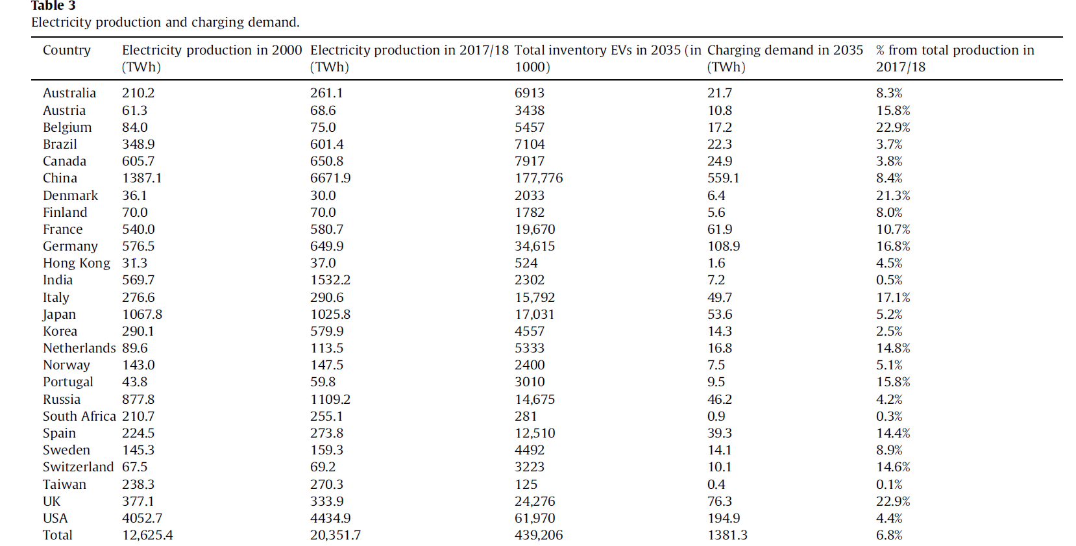

Figure 3- Electricity Demand and Charging Demand. (Rietmann, Hügler, Lieven, 2020).

To allow large scale EV chargers on local distribution networks it will be essential to introduce load shifting strategies in order to prevent overload of the electric grids during evening peak hours, when most EV drivers come home and plug their vehicles to charge. Forecasting the trajectory of electric vehicle sales and the consequences for worldwide CO2 emissions (Rietmann, Hügler. Lieven. 2020). The Researcher feels that large scale landlords have an opportunity to assist with this.

2.3.2 Home charge points

The Road to Zero paper recognised the need for the transition to electric vehicles to be supported by new infrastructure, meaning providing charging stations (UK Government, 2018). Cirell, S. (2020) reported that the most convenient and cost effective charging is done at the home of EV owners and is where up to 80% of EV charging takes place, providing there is a drive or space off road. Hardman, S. et al (2018) also found owners relied heavily on home charging, with more than half of them only using home chargers. The study found that 86% of EV owners relied on home charging in some form. With long range vehicles set to become increasingly more common place in the future as battery technology improves, Hardmans study found that owners of the EV’s with a longer range are more inclined to charge at home. This may have implications for the future development of non-home charging infrastructure as the longer range vehicles may have a reduced or different need for the infrastructure and further highlights the need for suitable home charging.

The research undertaken by Weiss, J., Hledik B., Lueken R and Lee, T. (2017) found that virtually all owners of electric vehicles prefer charging at home overnight for convenience, in the UK market. This method of charging was preferred over using public charging points or even charging at their workplace. This was backed up by Grote, M. et al (2019) in “Locating residential on-street electric vehicle charging infrastructure: A practical methodology”, where it was reported that if EVs are to penetrate widely into the large market of domestic vehicles sales, prospective EV owners will likely require the ability to charge at home. This will be straight forward to achieve where the resident has off-street parking facilities.

Despite this research some industry professionals are still not convinced. Julie Alexander the technical and innovation director for Places for People, which manages nearly 200,000 homes in the UK says “There’s a lot of different options available to developers. Some are modelled on particular user behaviour. Will people want to charge at home, on the street or en route? This is not properly understood yet.” (Alexander, J. 2019). Alexander goes on to state the challenge for developers and property managers is planning an environmental sustainability strategy in this changing landscape.

2.4 Existing Restrictions for flats/ no off road parking

A practical methodology produced by Grote, M. et al (2019) to determine suitable locations for Local Government Agencies to install initial on-street residential charging points to help remove barriers to EV uptake. The study analysed readily available census and parking data to identify the geographical overlaps between areas where residents where most likely to be electrical vehicle users and areas where there is a high reliance on residential on-street parking. Similar methods were used by Campbell, A., Ryley, T and Thring, R. (2012) in the study “Identifying the early adopters of alternative fuel vehicles: A case study of Birmingham, United Kingdom”. Although this study identified the potential early adopters of EV’s it did not go as far as indenting the correlation with lack of off-street parking for residents.
The study “Charging demand analysis framework for electric vehicles” considering the bounded rationality behaviour of users Hardman, S. et al, (2018) highlights the importance of having an integrated infrastructure as nearly half of owners relied on additional forms of charging from home charging as seen in the graph below.

Hardman Graph- Charging Behaviour Groups
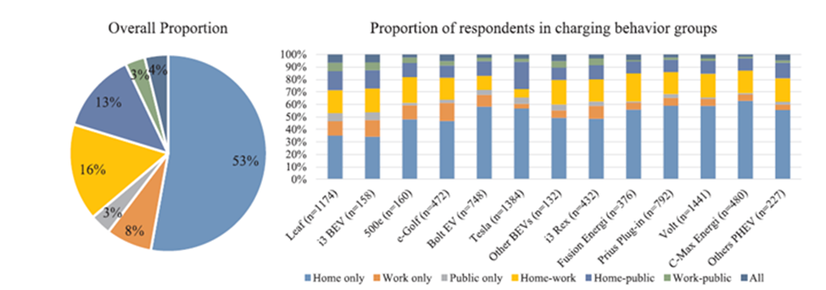

Figure 4- Charging Behaviour Groups. Hardman, S. et al (2018)

The results from a simulation model in the study “Adoption barriers for electric vehicles: Experiences from early adopters in Sweden” (Vassileva, Iana & Campillo, Javier, 2017) suggested that in order to achieve a sustainable use of EVs, national and local governments should focus on providing support for the planning of location of charging stations in densely populated areas. This should be slow charging stations located in parking garages and areas close to the driver’s homes where the cars can be left charging at night as confirmed in earlier studies which researched EV owners prefer to charge overnight.

This method just looked at the generic population as it was for government funded charging infrastructure, the research that will be undertaken for this paper is similar but this exact method is not suitable due to it not being specific to social housing tenants.

Suitable convenient charging has been highlighted as a barrier to EV uptake in other studies by Wikström, Martina, Hansson, Lisa & Alvfor (2016) and O'Neill, Eoin et al., (2019). The UK government have made it clear that it had no intention of operating a charging network and saw this as industry-led challenge, although a number of local councils have taken steps to reduce these barriers and a number of charging networks have been established across the country by numerous different companies. An example of this is Westminster Council who partnered with Siemens Ltd to convert 24 lampposts into EV charging points using existing city infrastructure along Sutherland Avenue which is nearly 1km in length in the city of London (Westminster Council, 2020). Lamppost charging is seen as a solution for EV charging for owners that do not have designated off road parking, although it has been reported that significant drawback of this method is the need to connect your own charging cable every time (Kane, M. 2020).

Although the government is not intending to operate a charging network it has brought in legislation to govern the systems, the Automatic Vehicles Act 2018 was introduced to ensure that all publicly accessible charge points are easily accessible to the majority of the public. Requirements like having a generic connections of socket outlets for public charge points and requiring operators of publicly accessible charge points to ensure consumers can use them without the need to utilise many different methods of access, payments like smart phone, SMS text, subscription and card payment are encouraged. This act also makes it mandatory for all new public charge points to have “smart” capabilities, which can shift the time of day the EV charges to help reduce and manage the impact of EVs on the electricity network grid. This will also help owners maximise the use of clean, renewable electricity (UK Government, 2018).

Guo, Chunlin, Yang, Jingjing & Yang, Lin (2018) further highlight that inadequate charging infrastructure is one of the key factors that restrict the development of uptake in EVs, the paper highlights the challenges in planning for an EV charging network for cities which will need to be large scale and geographically spread. It proposes to determine the optical locations for charge points by studying fuel sales and demand for EV’s in areas of a city. Although this study is aimed at city wide solutions with a tight land supply the researcher feels it could have some relevance to a large social housing provider.

The research undertaken by Weiss, J., Hledik B., Lueken R and Lee, T. (2017) highlighted that the provision of EV charging infrastructure produces a barrier to the purchase of EVs and restricts residents with no off-street parking in being able to purchase them. With 98% of social housing tenants staying in the same properties for less than 10 years the researcher feels the need for the social housing provider to take ownership of the provision of EVC points.


Figure 5- Length of Social Housing Tenancies (Ministry of Housing, Communities and Local Government, 2018)

2.5 Social housing

Although currently the demand for electric vehicles for residents living in social housing is relatively low as described in the article “Are social landlords responding to the electric vehicle challenge?” by stating “Demand for electric cars among residents of affordable homes is currently low. But as they become cheaper to buy and the infrastructure improves, this could change.” (Buchanan, B 2019)
The researcher feels there could be potential for growth. A study was carried out looking at the experiences from early adopters in Sweden and found that 41% of consumers that bought an electric vehicle in Norway stated that saving money was the main reason for them to choose purchasing an electric vehicle (Vassileva, Iana & Campillo, Javier, 2017). With social housing tenants generally being on a lower income an electrical vehicle could prove attractive.

2.5.1 Fleet Vehicles

Social housing providers have already started the transition to EV’s for their fleet, an example would be Beyond Housing where in 2018 took the decision to replace some of their 160 tradition diesel powered vehicles with electric vehicles, by incorporating these electric cars and vans within the new fleet it provided them with reduced running costs and helped the environment at the same time. While undergoing this change the provision for electric vehicle charging in the local area was highlighted as being poor, especially the infrastructure. The decision was made to purchase and install an EV charging system at the housing associations head office, not only to support its new fleet vehicles, but to also contribute to increased provision in the local area. The availability of the newly installed charging points allowed employees and visitors who already have their own electric vehicles to top up their batteries whilst at work stated Chris Walker the head of business intelligence at the housing association (Morgan, S. 2019).

2.6 No action

Faulty electrical work carried out by “do it yourself” enthusiasts was on average causing 10 deaths, 750 serious injuries and 12,500 fires each year on which prompted the government to introduce Part P of the building regulations in 2005. Although these numbers have slightly dropped since the regulation was brought in it highlights the dangers of substandard electrical installations (The Institution of Engineering and Technology, 2018). This raises safety and security concerns for the Researcher as a resident without dedicated off street parking may run the charging cable crossing the public footpath from property to the electric vehicle. A survey undertaken by Electrical Safety First questioned 1,500 electric vehicle owners of which 75% responded by saying they have used a domestic extension lead to supply the vehicle and even using multiple extension leads plugged into one another to reach their car, not only introducing electrical safety concerns by also trip hazards (Smithers, R. 2019).

2.7 Future Proofing for tenants needs

Certain Councils in the UK are concerned over future retrofitting charge points, “We want to future proof new developments” “We need to have the infrastructure in place as it’s difficult to retrofit developments.” explains Gary Sumner the cabinet minister for strategic planning at Swindon Borough Council (Sumner, G, 2019). Julie Alexander, the technical and innovation director for Places for People, further highlights the logistical issues with installing EV infrastructure to existing developments. Council’s throughout the UK have taken it further with Leeds City Council now requiring all new homes to have one charging point per parking space (Buchanan, B 2019).

Roders, M (2015) explains that future-proofing can be an innovative concept that encourages multidisciplinary thinking and a systems approach in the energy design. He highlighted in the paper “Assessment of the likelihood of implementation strategies for climate change adaptation measures in Dutch social housing”, that if a tenant specifically requests an adaptation, the housing association would be in a win-win situation and it suggests that policy should be in place that allows housing associations to recognise the value of these requests from tenants who are willing to contribute to the realisation of a resilient future proofed dwelling. The research suggests that by putting the tenant in a central position in the decision making seemed promising, however due to the high turnover rate in social housing it could be put long term strategies at risk, since the current occupant decides on measures that may have an influence on the future quality, vulnerability and value of the dwelling. Wang et al (2018) highlights the importance of properly planning for charging facilities for electric vehicles and goes as far as saying these plans should be modelled to ensure the effeteness of the planning scheme.

Local planning authorities have also been realising the importance of future proofing homes, in Swindon they have just introduced planning rules in which all new detached homes must have an EV smart charger to regulate charging time and speed on the network. New flat developments with parking must have 30% of spaces with a charger and a further 30% with the cabling infrastructure (Buchanan, B 2019).
Cabling infrastructure would be classed as a “Passive provision” of charging infrastructure which the Pod Point in their residential paper defined this as “the network of cables and power supply necessary so that at a future date a socket can be added easily”. This would enable future EV owners to easily connect a charger with the full installation (Pod Point, 2019).

2.7.1 Resilience of stock

To ensure the resilience of stock a long-term, planning based strategies assessed for a range of possible future scenario is essential. Thornbush, Golubchikov, Bouzarovski (2013) states in “Sustainable cities targeted by combined mitigation–adaptation efforts for future-proofing”, when carrying out upgrades the paper suggests to take the opportunity to rather than just returning to a pre-existing state, transforming it into a new state that is more sustainable in the current environment. A dilapidated and inefficient capital stock such as poorly maintained engineering systems and under-developed services can leave cities badly exposed. Although the paper was aimed at cities the Researcher can see a crossover to a large social housing stock. To ensure resilience it should be purposefully and progressively incorporated into all capital investment decisions while under taking maintenance work.

2.8 Demographic of early adopters

The study into the demographic of early adopters in Sweden concluded that over 80% were male and fell into the category of middle aged (Vassileva, Iana & Campillo, Javier, 2017), this was backed by Hardman, S. Eric Shiu, E. Steinberger-Wilckens, R (2016) who found that EVs are most popular with people who are around middle aged. Interestingly the study undertaken in Sweden found that nearly half of EV owners with only one car in the household lived in an apartment or flat.

Age of EV owners in Germany
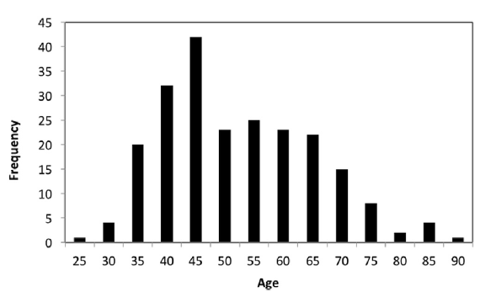
Figure 6- Age of EV owners in Germany Plötz, Patrick & Schneider, Uta & Globisch, Joachim & Dütschke, Elisabeth. (2014).
A study on early adopters in Germany found the same demographic, middle aged men. This study also reported that the inhabitants of major cities where less likley to purchase an EV over those living outside thought to be due to that they would not benefit from the economic benefits as much (Plötz, Schneider, Uta & Globisch & Dütschke 2014).

2.9 Conclusion

Tackling climate change and working to preserving the oceans and forests are a major focus around the globe and an integral part of the goals set in The 2030 Agenda for Sustainable Development, so energy management and reducing the use of fossil will play a role in meeting these goals. This literature review has shown that The UK government has made it clear that it wants driving an electric vehicle to be convenient for people all over the country, and that local authorities have a key role to play, going as far as to send a letter to local authorities across the country, urging them to increase local access to charge points for drivers. It has been highlighted that Wales is significantly behind the rest of the UK when it comes to providing charging points. With a drastic increase in the use of electric vehicles and the research highlighting that this trend is likely to continue in an upward trajectory especially with the introduction of the new tax benefit associated with an EV company car.

Existing studies found that virtually all owners of electric vehicles prefer charging at home overnight in the UK with residents of flats and apartments stating that the provision of EVC infrastructure produces a barrier to the purchase of EVs and restricts residents with no off-street parking in being able to purchase them. This raises safety and security concerns for the researcher as a resident without dedicated off street parking may run the charging cable crossing the public footpath from property to the electric vehicle.

Some Social housing landlords throughout the UK have already started switching their fleet to EV and the researcher feels that there is potential growth for social housing tenants as a study looking at the experiences from early adopters in Sweden and found that 41% of consumers that bought an electric vehicle in Norway stated that saving money was the main reason.

Research undertaken as part of this literature review highlights the importance of properly planning for charging facilities for electric vehicles and taking opportunity to future proof as part of any upgrade works is favourable due to the issues with retrofitting.

3. Research Methodology

3.1 Introduction

This chapter justifies the chosen methods of the research and describes why the Researcher believes these methods are the most appropriate to achieve the aims and objectives. The research methodology chapter begins by detailing the mixed method approach. This chapter defines how the data will be researched, collected and goes on to explain the processes used to analyse this data. The Researcher explains how the data collected will be verified and ensure consistency throughout. Ethical considerations are taken into account and any limitations of the methods details at the end of this chapter.

3.2 Research Design

Research for this paper was accumulated via a mixed method approach from a variety of sources and executed in the form of a literature review and primary research collected via questionnaires and interviews incorporating both quantitative and qualitative data.

A mixed method approach described by Johnson (2016) as being the third major research method. Whereas quantitative and qualitative data can stand alone in a research method, mixed method combines the two methods in a single study. Research undertaken by McKim (2017) claimed mixed methods research provides a more balanced perspective. The Researcher feels that by using this method to undertake this study it gave a better understanding of the issue by analysing different opinions and highlighting possible issues from the social housing industry, this could then be compared against the general needs and possible future needs of tenants, highlighting gaps between the two.

A case study was considered by trialling different options and locations but due to financial restrictions of this research it was not feasible.

3.3 Primary and secondary data

Primary and secondary data was collected as part of this research paper. Secondary data was reviewed in the form of literature review to gather information on the wider subject’s associated with EVC and social housing. The literature review failed to address the need to retro fit to a large social housing stock nor did it discuss future proofing such stock when undertaking planned maintenance works. Primary data was then collected by the Researcher via questionnaires and interviews.

3.3.1 Literature review

Existing research was critically evaluated to further gain an understanding of the theoretical and research issues surrounding electrical vehicle charging, social housing and management planning. A large proportion of the literature review of this available secondary data comprised of a combination of trade magazines / journals, newspapers, government publications and the internet, further case studies were analysed to determine whether any are transferable to meet the objectives of this research. There was limited recent information from text books on the use of EVC, however the vast amount of journal and articles compensated and provided more up to date insight on this topic area.

3.3.2 Qualitative data

Qualitative method of research is used to understand people's beliefs, experiences, attitudes, behaviour. It was important for the Researcher to understand these with regards to the RSL managers. It provided the Researcher with descriptive data rather than numerical data. This method is not only about “what” people think but also “why” they think it and reasons why. The data can be collected via different routes including one-on-one interview, focus groups, ethnographic research, case study research, process of observation. (Parahoo, 2005).

3.3.2.1 Semi Structured Interviews

Conducting semi structured interviews was decided upon by the researcher to collect qualitative data from industry professionals. Individual interviews were carried out via the telephone. This was a conversational method and invited opportunities for the respondents to give more in depth details.

Interviews were conducted with 8 industry professionals which included Head of Capital Investment, Head of Business intelligence, Director of Assets, Operations Manager, Senior Maintenance Supervisor, Building Surveying Manager, Planned Projects Manager and a Compliance Manager to gain the qualitative data.
This method provided a great opportunity to gather precise data on an insight to industry professional’s opinions and perceptions and identify any barriers. This also gave the Researcher an opportunity to ask follow on questions when they felt that not enough information was provided or there was an opportunity to gain a further understanding on the subject as discussed by Parahoo, (2005).

The researcher would have preferred to carry out face to face interviews to give a better opportunity to read the body language of the respondents and match the responses but due to COVID 19 restrictions phone or zoom interviews were conducted. A disadvantage of using interviews to collect this qualitative data was that it was time consuming and often difficult to arrange time with respondents.

3.3.3 Quantitative Data

Quantitative method of research involves collecting and analysing numerical data. It can be used to find patterns and averages, make predictions, test causal relationships, and provide results giving an over view to wider populations. Main ways in which results can be collected are via an experiment, surveys, observation or secondary research. Data from large samples can be processed through quantitative data analysis which would enable the Researcher to analyse using reliable and consistent procedures (Bhandari, 2020).

3.3.3.1 Questionnaires

To gather information on tenant’s attitudes and future plans for EV’s answers were obtained through closed-ended questions with multiple choice answer options. These were analysed using quantitative methods. Consideration was given to some disadvantages of questionnaires like selection of random answer choices by respondents without properly reading the question and that respondents are unable to express their additional thoughts about the matter due to the absence of a relevant question. The researcher decided a closed-ended questionnaire would be most suited to this research as it increased speed of data collection over other methods like interviews as discussed by Joyner, L. Rouse, W and Glatthorn (2013) in “Writing the winning thesis or dissertation; a step-by-step guide”. Interviews were considered for this but due to time constraints and the impossibility of limited returns it was decided questionnaires should provide the best results.

It was decided that the method of collecting answers to the questionnaires would be telephone calls to tenants living in RSL properties throughout Neath, Port Talbot and Swansea. Although more of a time consuming task it often provides a better return rate, another advantage of the telephone questionnaire is that it could be completed during the short amount of time (Laurel, B. 2003). The Researcher made contact with RSL’s who agreed to complete the questionnaire with tenants during routine calls to arrange appointments for major work upgrades, this way it meant that the respondents were already on the phone so response rates would be high. 88 respondents were targeted at random for the questionnaires.

Eight closed questions were asked and the Likert scale was used to measure attitudes by asking respondents to give either a positive, neutral or negative response to a statement. A five point scale was used to gauge agreement, importance or likelihood. As a universal method of collecting data it meant it was easy for the RSL tenants to understand them. It also provided clear data for the Researcher to draw conclusions, reports, results and graphs from the responses.

3.3.4 Pilot study

A pilot questionnaire and semi structured interview were produced and trailed to highlight any weaknesses in them. Five questionnaires and two interviews were completed under this pilot study where feedback was gained on wording, ease of understanding and responses were assessed by the Researcher for usefulness to the aims and objectives of this study. Slight changes were made to both the questionnaire and interviews following the pilot. The wording was altered to question 6 to include “If you were to have an electric car” to help the respondents better understand the question. When undertaking the pilot interview the Researcher was given additional information on question 7 when asking about the current planned maintenance programmes. The Researcher decided to add an additional part to the question enquiring about the timescales of these programmes.

3.4 Data analysis

When analysing the quantitative data a four step approach described by Bhatia, M. (2018) set out below are the steps that were taken:

- Data validation took place by checking the questionnaires were undertaken as agreed, including checking the questions were answered and questionnaires filled in correctly. 10% of questionnaires were random sampled by the Researcher with follow up calls to the respondents.
- Basic data checks including checking for any blank cells and outlying responses which could affect the accuracy of data.
- Coding the data by simplifying it, assessment will be made to decide whether the data needs to be grouped in larger groups than collected in the Likert scale.
- A descriptive analysis of the data was then undertaken. The results were put into percentages for ease of understanding. Graphs have been produced for a visual representation of the data. A summary of the data collected was then compiled.

The qualitative data was analysed by a similar method to that described by Silverman, D. (2001) which is set out below:

- Familiarisation with the data collected by reading and looking for basic patterns in the data, this will also transcribing the data.
- Revisiting the research objectives to determine which can be answered through this qualitative data.
- Identifying broad ideas and concepts that have arising from the responses and grouping them into codes.
- The Researcher then identified the most common responses and identified any patterns that have emerged.

Narrative analysis of both the quantitative data for the questionnaires, qualitative data from the semi-structured interviews and literature was undertaken to highlight any gaps or alignments between tenant’s expectations and RSL’s plans for EVC. The Researcher then addressed the objectives of this study with this analysis.

3.4.1 Reliable, Valid and Consistent data

Reliability refers to how consistently a method measures something. If the same result can be consistently achieved by using the same methods under the same circumstances, the measurement is considered reliable. By using well-known methods like the Likert scale and semi structured interviews the results could be reproduced when this research is repeated under the same conditions.

By checking how well the results correspond to establish theories against the literature review was assessed to determine how valid the results were.

3.5 Ethical Considerations

Kjellström, S Ross, S N and Fridlund, B (2010) highlighted the importance of ethical considerations in the journal publication “Research ethics in dissertations: ethical issues and complexity of reasoning” and that these should be emphasised when undertaken research. The Researcher ensured respondents from both the questionnaires and interviews were informed prior of the purpose of the study, the methods being used and possible uses of the data which was collected. The questionnaires and interviews were designed so that harm or distress could not be caused to the respondents. All participants of this study did so entirely voluntarily and were informed that they were able to withdraw at any time. Data was collected without names being added, codes like “Respondent 1” was used to protect the anonymity and confidentiality of participants.

The researcher maintained integrity in all aspects of the research.

3.6 Limitations

To improve this research site visits should be carried out to interview tenants living in properties where EV charge points have already been installed, such as recent developments to determine if any are currently being used or plans to use them in the future. This research would have also benefited from speaking to the RSL’s around budgets for suggested options as part of this research to determine their feasibility.

To further improve this study a larger scope of people should answer questionnaires and be interviewed to obtain a more conclusive view on people’s opinions. The sample size was not large enough to gain a conclusive overview of the opinions towards electrical vehicles due to time restrictions and the accessibility to these individuals. Although the sample size was small it did give a good indication of the attitudes towards electrical vehicles and the charging needs in the Neath Port Talbot and Swansea Borough.

3.7 Summary

Qualitative and quantitative data were collected through both questionnaires and interviews. This mixed method approach gave the researcher a balanced perspective. The Researcher felt that by using this mixed method it gave a better understanding of the issues around electric vehicle charging making it easier to meet the aims and objectives of this research. A pilot study highlighted where the Researcher needed to make some slight improvements to help the respondents better understand what was being asked. The data collected was structured in form of a closed ended multiply choice questions to collect quantitative data and semi structured interviews to collect qualitative data. This data was then analysed following recognised techniques whilst following ethical considerations throughout.

4. Results

4.1 Questionnaires

In total 52 questionnaires were undertaken over the telephone. 88 tenants we asked to participate in the question of which 36 declined to take part giving a success rate of 59%. Eight questions were asked and the respondents were asked to answer via a choice of multiple choice answers. The data produced by these questionnaire has been summarised below and then discussed in a percentage format. A full table of the results from these questionnaires can be found in Appendix F.

4.1.1 Tenant questionnaire results

Question one asked the respondents their age. A spread of ages answered, though more 18 to 30 are represented than 51 to 60 year olds.
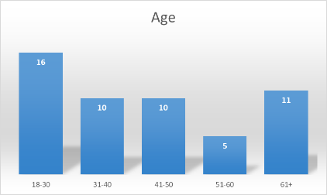
Figure 7– Age Category of tenant respondents

Question two asked the respondents their gender, a balance response was received. None of the respondents classed themselves as "other" or preferred not to say.
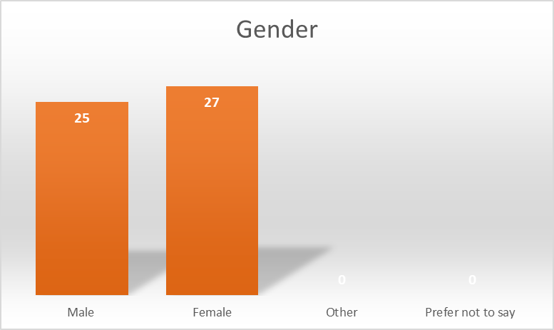
Figure 8– Gender of tenant respondents
Question three asked the respondents if they had access to off-road parking. 46 answered that they did and 6 did not.
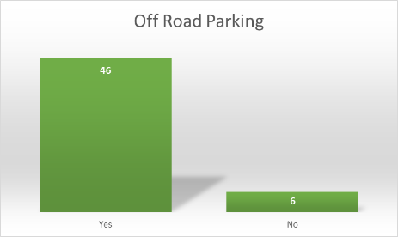
Figure 9– Access to off-road parking
Question four asked the respondents when they were considering upgrading their car. 4-7 years was the most popular answer with 19 respondents choosing this option. 7 respondents do not own a car so were not asked to participate further.
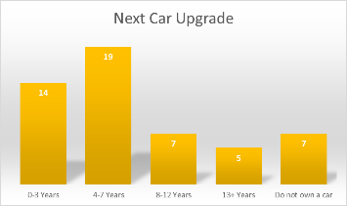
Figure 10- When are you considering upgrading your car?
Question five asked the respondents how likely it would be that their next car is an electric vehicle. The most common answer was "unlikely" with 23 out of the 45 respondents who owned a car choosing this option.
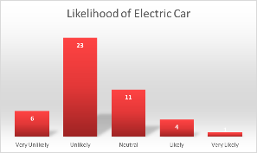
Figure 11- When buying your next vehicle how likely is it going to be an electric vehicle?
Question six asked how likely it would be that the respondents would need to charge an electric vehicle overnight at home. The most common answer was "likely" with 16 choosing this followed by "neutral" and "very likely" both with 10. "Unlikely" was chosen 7 times with "very unlikely" being chosen by 2 respondents.
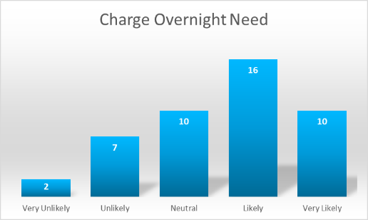
Figure 12- How likely would it be that you'd need to be able to charge it overnight?
Question seven asked the respondents if they did not have access to overnight charging would it put them off purchasing an electric vehicle. "Likely" was the most common answer with 17 respondents choosing this option followed by "very likely" (12), Neutral (11), "very unlikely" (3) and "unlikely" (2)
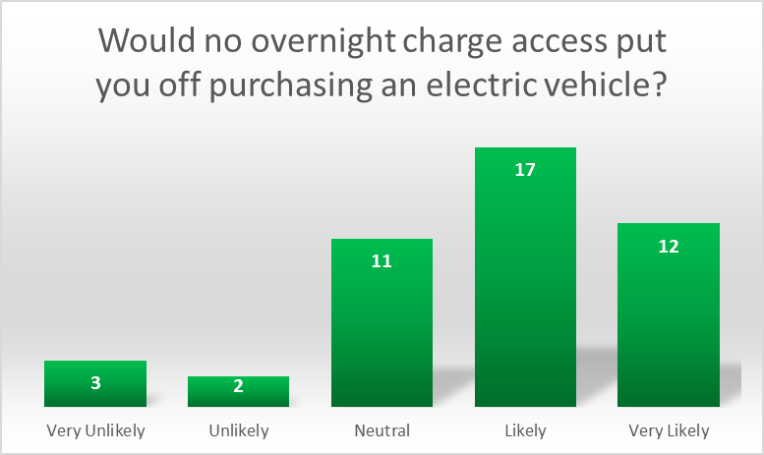
Figure 13- If you did not have access to charge the vehicle overnight how likely is it to put you off purchasing an electric vehicle?
Question eight asked the respondents if they needed to gain permission from their landlord to install their own charging point for an electric vehicle. 31 of the respondents answered "yes", 12 answered "no" and 3 were "unsure".
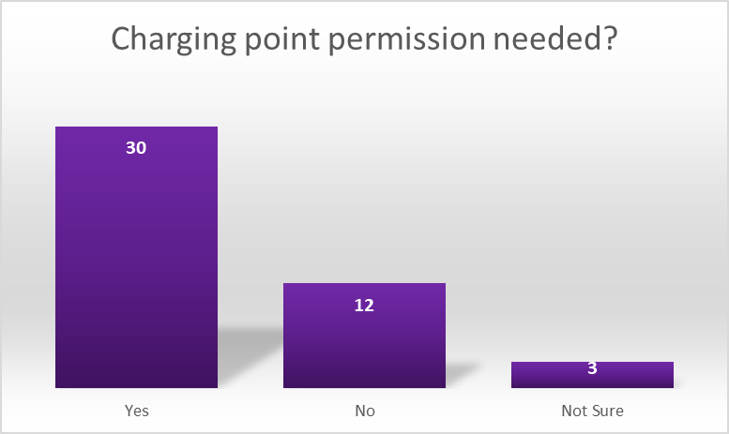
Figure 14- Would you need to gain permission from your landlord to install your own electrical vehicle charging point?

4.1.2 Overview of questionnaires

The success rate of tenants willing to participate was 59% with a total of 52 completed questionnaires. Six (12%) of these questionnaires were verified by the researcher via a telephone conversation with the tenant respondents, the Researcher found no discrepancies. 48% respondents were male and 52% of respondents were female providing a balanced mix of genders. 88% had access to off-road parking with the remaining 11% who did not.
13% did not own a car so were not asked to participate further in the questionnaire. The researcher still included these in the percentages for the remaining questions as they felt it was relevant to the understanding how many tenants EV charging would be relevant to.
Further analysis of the questions can be found in appendix E

4.2 Semi-structured Interviews with RSL managers

In total eight semi structured interviews were undertaken by the Researcher which included professionals across three RSL’s who had properties in the Neath Port Talbot and Swansea boroughs.
The questions which were asked in the interviews can be found in appendix D along with the full transcripts from the interviews which are in appendix G. The responses to the interview questions have been summarised below.

4.2.1 RSL Manager Interview Results

The first six questions asked to industry professionals in the semi structured interview were to gain an understanding of their background and demographic. The first question asked interviewees about their age category, out of the eight questioned four were aged 51-60, two were aged 41-50 and a further two were aged 31-40. No respondents fell into the age groups 18-30 or 61+.
The second question asked the gender of the interviewee, seven were male and one was female.
The third question asked what their role was in the organisation they worked, there was a range of roles which were Head of Capital Investment, Head of Business intelligence, Director of Assets, Operations Manager, Senior Maintenance Supervisor, Building Surveying Manager, Planned Projects Manager and a Compliance Manager.
Question four asked how long each respondent had spent working within the housing or construction industry, five respondents had been in the industry for more than 20 years, two serving 10-19 and one 3-5 years.

Question five asked the size of the housing stock which the respondent worked for, this ranged from 3,000 units to 13,000 units.

The type of their stock was then asked about in question six, all respondents had a mix of property types including houses and flats. Respondents 1, 2, 3 and 8 also had sheltered housing schemes catering for older people in their stock too. Respondent 4 also had responsibility for a small number of commercial properties including shops.

Question seven asked the interviewees if they currently ran a planned maintenance programme which included upgrading electrical installations and what cycle timescales intervals these were done at. Out of eight respondents seven declared that they had a planned electrical installation renewal programme. Four respondents stated that the life span of an installation was between 20 and 25 years. Two respondents did not have a planned renewal programme, instead upgrade works to the installation were undertaken every 5 years when the property undergoes an electrical condition report. One of these did undertake a rewiring programme but there was no set renewal period. One respondent answered 15 year cycle and one respondent stated that their organisation ran a 30 year cycle for complete renewal of the electrical installation. Five out of the eight respondents told the researcher that electrical upgrades were undertaken as part of and kitchen or bathroom refurbishment programme. All eight respondents carried out upgrade works to the electrical installations in their properties to varying degrees of extent and time frames but overall the majority ran a cyclical electrical upgrade programme between 15-30 years. The ones that didn’t still carried out upgrade works namely when the electrical condition reports were carried out at a five yearly interval. Results from question seven have been set out in the table below.

Results to question 7
 | Full Rewires | Partial upgrades with Kitchen upgrades | Remedial works with testing | None
Respondent 1 | x | x
Respondent 2 | x | x
Respondent 3 | x | x | x
Respondent 4 | x |  | x
Respondent 5 | x | x
Respondent 6 | x
Respondent 7 |  |  | x
Respondent 8 |  | x | x

Table 1-Results from question 7 of interviews

Question eight asked whether the respondent’s organisations require the tenants to gain permission to undertake electrical work in the property. All eight required tenants to gain permission from the organisation, in addition to this respondents 4 and 8 also required an electrical test certificate on completion of the works to be sent to them. Respondent 8, a Compliance Manager, stated a qualified electrician must undertake the works and that once complete an electrical inspector would visit to ensure the works were carried out correctly. Overwhelmingly permission needed to be sought from the landlord to undertake electrical works to the property with two respondents going a step further and requiring certification to cover the works.

Question nine asked if consideration had been given to how their tenants will charge their electrical vehicles including properties that did not have dedicated off street parking. Respondents seven and eight had not given any consideration and indicated that it would be the tenant’s responsibility to install one if they wished. The remaining six respondents had all mentioned that consideration had been afforded to installing circuits to new build properties with respondent 2 also stating that they have install a small number of charge point outlets too, the remaining five had just installed circuits in preparation only. Respondent 3 stated that the tenants without designated parking would have some sort of communal charging facility, they went on to say that all of their flats and sheltered complex’s had communal parking spaces where it would be feasible to install points. Respondent 2 stated that consideration had begun for the properties with off-parking as the organisation were looking at the feasibility of using an electrical vehicle battery as battery storage for the solar PV on the property. Out of the eight respondents only two had started to consider options for tenants to charge electric vehicles in existing stock six respondents 1, 4, 5, 6, 7 and 8 had not considered how their tenants will charge an electric vehicle. . The general consensus was that allowances where being made for new developments but no real consideration has been afforded to retrofitting to their existing stock.

Question ten asked the respondents if their organisation have, or are considering, electrical fleet vehicles for their staff and if so to what timescales where they looking at. Five out of the eight questioned already had a small number of fleet vehicles. Respondents 1,2,3 and 4 all had around five fleet cars already in ownership of their organisations with respondent 6 stating they currently have ”a small fleet”. Respondent 2 stated that they are looking to increase this number after a successful roll out which being planned for the next 12 months. Respondents 3, 4 and 6 all mentioned that vans where the next step in the electrical vehicle transition. Respondents 3 and 6 went further by saying that by 2030 all their fleet vehicles will be electric. Respondent 3 added that range of the work vans would be an issue as their organisation covers a large geographical area. Of the three respondents who did not currently have any electric vehicles two, respondents 5 and 8, were considering them, with respondent 5 looking to purchase a small fleet, and 8 had a trail planned which has been put on hold due to the COVID 19 pandemic. Respondents 7 did not have any electric vehicles nor did they have any plans for them either. The general consensus was that there is a transition happening to electrical fleet vehicles for the housing associations with seven out of eight respondents either having electric vehicles or were planning to have them.

The last question, question eleven, asked the participants if they anticipated any issues around Electrical Vehicle charging points for their organisations.
Respondent one raised a concern over the charge points for company vehicles, saying that they would need to be kept at the head office meaning some staff would have to travel to the office to travel back to site, this did not make sense logically to the respondent. Respondent one had five fleet vehicles currently at the organisation.

Respondent two questioned whether the grid would be able to cope with the amount of charge points needed for their tenants especially if they are all charging at the same time in a local area. They also brought up that careful consideration would be needed on where to locate charge points for both tenants and fleet vehicles, respondent two had also mentioned previously that they were considering battery storage for the PV.

Respondent three could see lots of issues around the charge points. The biggest one for them was how they will charge their electric vans for tradesman. Ideally they would want the staff to be able to charge these vehicles at home as a lot of staff need the vehicle with them at all times for out of hour calls. Range of the vehicles was raised as a concern for fleet vehicles in the interview as the organisation covered a large geographical area.

Respondent four raised concerns over potential supply chain issues and labour shortages, questioning if there is a sudden increase in demand who would install the charge points. They indicated that it may cause an increase in DIY works and unqualified electricians carrying out installation works. Their organisation required electrical certification on completion of any electrical work by their tenants.

Respondent five answered with concerns over the charging of their fleet vehicles, they did not have much space in their main office for a large fleet of vehicles to be able to charge. They mentioned earlier in the interview that they did not currently have any electrical fleet vehicles.

Respondent six stated that electrical charging points have been installed at their main office, however as the electrical fleet grows there would be a greater demand on these charging points especially as most of the fleet will be utilised around the same working hours suggesting that they would have to cap the number of vehicles at a certain point. They went on to say that at present the likelihood of their properties needing to include a charge point is low but recognised that demand will increase and consideration will have to be made to make provisions for points as part of a cyclical electric renewal programme verses retrofit costs. Respondent 6 finished by warning that as this is a new technology there is a limit to how far forward you should project your programme.

Respondent seven had not thought of any potential issues and they would be led by the government and any funding that would be provided. Respondent 7 had not given any consideration to electrical vehicles at all nor did they have any plans to purchase fleet vehicles.

Respondent eight could see a potential issue with tenants or unregistered installers installing their own charge points. Their biggest was concern was around ensuring that these points were installed safely and correctly so that the properties were protected. Respondent 8 also required a qualified electrician, test certification on completion and an inspection from the Housing Associations electrical inspector on completion of any electrical work requested by their tenants.

A range of anticipated issues were brought up, the main points being how organisations were going to charge their fleet vehicles including space at the office and logistical planning for staff to retrieve the vehicles. The electrical supply grid and its ability to cope with the excess demand was also raised as a concern, as was a skills shortage and potentially dangerous DIY work.

4.2.2 Overview of interviews

A range of roles within the registered social landlord maintenance sector were interviewed as part of this research with varying levels of housing stock. All respondents had a mix of property types including houses and flats. All respondents carried out some kind of electrical upgrade works to in their properties to varying degrees but overall the majority ran a cyclical electrical rewiring programme. When undertaking electrical work to their properties tenants had to gain permission from the association to carry these out. Overall the consensus was that allowances were being made for new developments but no meaningful consideration has been given to retrofitting to the existing stock. The interviews highlighted that there is a transition happening to electrical fleet vehicles for the RSL’s with seven out of eight respondents either having electric vehicles or were planning to introduce them.

A range of anticipated issue were brought up, the main points being how organisations were going to charge their fleet vehicles including space at the office and logistical planning for staff to retrieve the vehicles. The electrical supply grid and its ability to cope with the excess demand was also raised as a concern, as was a skills shortage and potentially dangerous DIY work. These results will be discussed and further analysed in the next chapter.

5. Discussion

5.1 Introduction

The objective of the questionnaire and interviews was to gather data from the tenant questionnaires that could be analysed and then compared with opinions of RSL managers to highlight any gaps or alignments between tenant’s expectations and RSL’s plans for EVC. Data collected from both the questionnaires and semi structured interviews was also analysed and compared with secondary data reviewed in the literature review on types and locations of charge points, timescales that charge points will be needed for social housing tenants in the Neath Port Talbot and Swansea boroughs and implications if housing providers do not act and potential options which could accommodate tenants with both off road parking and those with no dedicated off-street parking and fleet vehicles.

5.2 Increase in Electrical Vehicles

As part of the literature review it was highlighted that there has been a significant increase in the demand for electric vehicles, as seen in figure 2 early in this research. Both the questionnaires and interviews also highlighted a demand for electric vehicles with 5 (10%) of respondents of the questionnaires stating their next car is “likely” or “very likely” to be an electric vehicle. Three of these were planning to purchase within the next 7 years as seen in figure 15 below. The general consensus was that there is a transition happening to electrical fleet vehicles for the RSL’s with seven out of eight respondents either having electric vehicles or were planning to have them. This was also highlighted in the literature review with Beyond Housing replacing 160 of their fleet vehicles with EV’s and by Cirell (2020) writing that sales are likely to soar as employees switch to the 0% tax 0% emission models since the UK Government announced that the ‘benefit in kind’ Tax, which is a charged paid by employees with a company car, will be reduced to 0% in the tax year 2020/21. Two of the respondents of the interview said that by 2030 all their fleet vehicles will be electric, again predicting the electrical vehicle market will continue to growing rapidly.
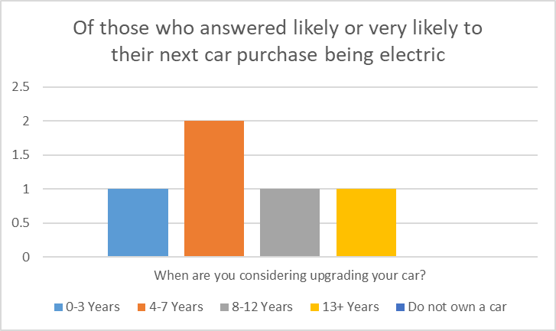
Figure 15- Of those who answered likely or very likely to their next car purchase being electric/ when are you considering upgrading your car

5.3 Types of charge points

As shown in figure 12 half of the tenants asked said that it would be “likely” or “very likely” they would need to charge an electric vehicle overnight at home. The Researcher further analysed this data by comparing it to the five respondents who were likely or very likely to purchase an electric car next, as shown in figure 16 60% would need the ability to charge their vehicle overnight at home. This, although slightly less, falls in line with the research undertaken by Weiss, J., Hledik B., Lueken R and Lee, T. (2017) which found that virtually all owners of Electric Vehicles prefer charging at home overnight in the UK for their convenience.
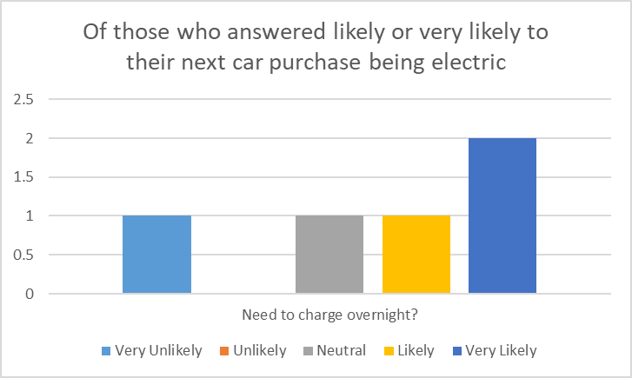
Figure 16- Of those who answered likely or very likely to their next car purchase being electric /need to charge overnight

56% of tenants even stating that if they did not have access to overnight charging it would be “likely” or “very likely” to actually put them off purchasing an electric car, again agreeing with Wikström, Martina, Hansson, Lisa & Alvfor (2016) and O'Neill, Eoin et al., (2019) where it was reported that suitable convenient charging was highlighted as a barrier to EV uptake.
Another point which needs consideration is a concern raised by respondent 3, how they will charge their electric vans for tradesman. Ideally they would want the staff to be able to charge these vehicles at home as a lot of staff need the vehicle with them at all times for out of hour calls, this would mean possibly installing charge points for staff at their homes and introducing the issue of who would pay the electricity.

5.3.1 Infrastructure and Grid capabilities

Research done by Kelly, N., Samuel, A and Hand, J. (2015) highlighted an issue with fast charging units in the UK housing stock, this was amplified when combined with electric heating as it produces excessive loads on the electrical demand characteristics, this was backed by Erotokritos, X., Charalampos, M and Cipcigan, L (2015) suggesting that slow chargers should be utilised. Concerns were also raised over grid and loading capabilities by two of the respondents from the interviews. Respondent 2 raised concerns over whether the grid would be able to cope with the amount of charge points needed for their tenants especially if they are all charging at the same time in a local area. Respondent 6 concerns were more aimed at the charging on their fleet vehicles, having already had charge points installed at their head office they understood there would be a “cap” on the number of charge points the main supply could handle, the respondent understood this would be amplified by the fact that as most of the fleet would be utilising these points the same working hours. Slow chargers installed at homes seems to be a viable option to eliminate these issues.

5.4 Future proofing

Roders, M (2015) explained that future-proofing can be an innovative concept and in the literature review it was highlighted that in his paper that if a tenant specifically requests an adaptation, the RSL’s would be in a win-win situation and it suggests that policy should be in place that allows RSL’s to recognise the value of these requests from tenants and should be willing to contribute to the realisation of a resilient future proofed dwelling. Wang et al (2018) highlighted in the literature review the importance of properly planning for charging facilities for electric vehicles. With six respondents having not considered how their tenants will charge an electric vehicle in their existing stock the general consensus was that allowances were only being made for new developments. Local planning authorities appear to be focusing also on just new developments, in Swindon as reported by Buchanan, B (2019) they have just introduced planning rules in which all new detached homes must have a EV smart charger to regulate charging time and speed on the network along with new flat developments with parking must have spaces with a charger and a further spaces with the cabling infrastructure.
To ensure the resilience of stock a long-term planning based strategies assessments under a range of possible future scenarios is essential, explains Thornbush, M. Golubchikov, O. Bouzarovski, S. (2013) when carrying out upgrades the paper suggests to take the opportunity to rather than just returning to a pre-existing state, transforming it into a new state that is more sustainable in the current environment. To ensure resilience it should be purposefully and progressively incorporated into all capital investment decisions while undertaking maintenance work. The Researcher has noted that from the interviews all eight respondents carried out upgrade works to the electrical installations in their properties to varying degrees of extent and time frames but overall the majority ran a cyclical electrical upgrade programme between 15-30 years. The ones that didn’t still carried out upgrade works namely when the electrical condition reports were carried out at a five yearly interval. Interestingly none took this opportunity to consider electric vehicle charging as the majority did on their new developments. The Researcher feels this could be a missed opportunity to install cabling infrastructure as a “passive provision” of charging infrastructure this would enable future EV owners to easily connect a charger with the full installation. This highlights a lack of future proofing currently being afforded by the RSL’s to the Researcher.

5.4.1 No Action

It was highlighted in the literature review that the government wants driving an electric vehicle to be convenient for people all over the country, and that local authorities had a key role to play in achieving this, with no real consideration being afforded to retrofitting to the existing stock of the RSL managers this could become a real issue. Referring back to figure 15, 6% of RSL tenants could be requiring EV charge points within the next 7 years so action will be needed in the short term to meet this long term goal set by UK Government of making driving an electric vehicle to be convenient for people all over the country.

5.4.2 Barriers to EV uptake

The Researcher further investigated the five tenants planning on purchasing an EV with four of them being put off purchasing one if they did not have access to overnight charging as seen in figure 17. This followed the general consensus of all tenant respondents as seen in figure 13 in the results chapter.
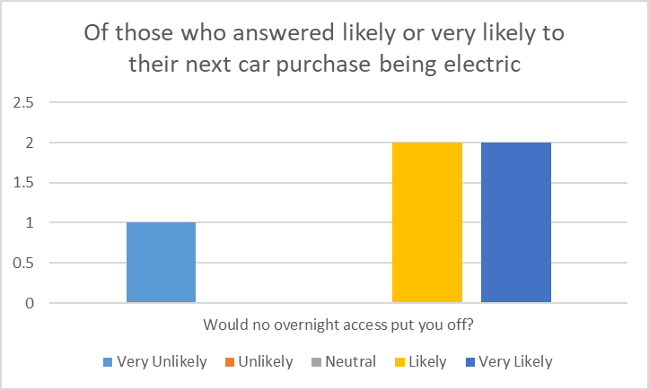
Figure 17- Of those who answered likely or very likely to their next car purchase being electric / would no overnight charging access put you off

RSL’s could potentially be restricting the uptake of EV’s by taking no action as this research has shown that it would put potentially users off by not having an overnight charging facility. The Researcher feels that this no action also has the potential to put tenants off renting a property from the RSL or leaving to move to a property with a charging facility, further research would be required to prove or disprove this theory.

This inaction could also create safety issues for RSL’s. Respondent 4 and 8 were the most concerned over taking no action with both raising safety concerns that it may cause an increase in DIY works and unqualified electricians carrying out installation works. As highlighted in the literature review faulty electrical work carried out by “do it yourself” enthusiasts caused deaths, injuries and fires highlighting the dangers of substandard electrical installations. (The Institution of Engineering and Technology, 2018).

A survey undertaken by Electrical Safety First reviewed earlier in this research (Smithers, R. 2019) found that 75% of EV owners had used a domestic extension lead to supply the vehicle and even using multiple extension leads plugged into one another to reach their car, not only introducing electrical safety concerns by also trip hazards This raises safety and security concerns for the Researcher as a resident without dedicated off street parking may run the charging cable crossing the public footpath from the property to the electric vehicle. The Researcher believes not addressing existing stock could lead to rushed installations without the proper planning and even dangerous DIY electrical works.

Interestingly out of the five respondents that were likely or very likely their next car would be electric, two of them (40%) did not think they would need permission to install their own charge point as shown in figure 18.

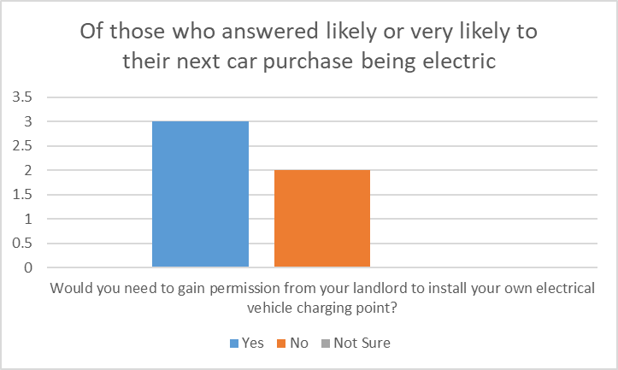
Figure 18- Of those who answered likely or very likely to their next car purchase being electric / would you need to gain permission for electrical works.

This followed in the same direction as what all the tenants answered as seen in figure 14 with 21% of tenants questioned saying they did not require to seek permission and 6% were unsure. This contradicts results from the interviews with HA managers. All 8 (100%) stating that permission was required for tenants to undertake any sort of electrical work to their properties.

5.4.3 No off-road parking

Further analysis was undertaken of the five respondents likely or very likely to purchase an electric car next.
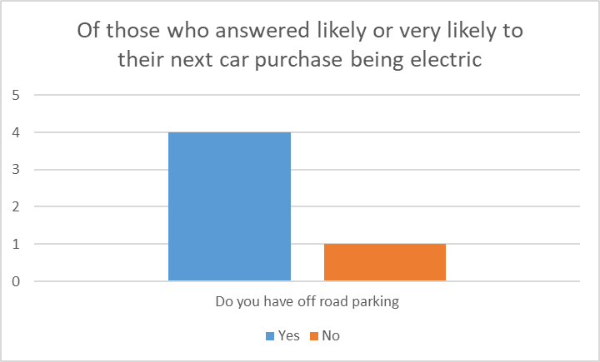
Figure 19- Of those who answered likely or very likely to their next car purchase being electric / do you have off-road parking.

Of the five tenant respondents one did not have off-road parking, this respondent would have to either run an extension lead to supply the vehicle which could potentially cause a safety issue as described previously, or find another property that did have off-road parking or the facility to charge their new vehicle. Either option would cause a risk to the RSL, either safety or the risk of losing a tenant. With 11.5% respondents of the tenant questionnaire not having access to off-road parking, as seen in figure 9, it is a small minority of tenants the Researcher feels it is an issue that needs addressing as combined with the possible safety concerns and the need to charge fleet vehicles it could become an increasing issue for RSL’s.

Two of the RSL manager respondents had started to consider how they will address this issue, respondent 3 stated that the tenants without designated parking would have some sort of communal charging facility, they went on to say that all of their flats and sheltered complex’s had communal parking spaces where it would be feasible to install points. The Researcher feels that these points could be used for the RSL’s fleet vehicles too as the general consensus was that there is a transition happening to electrical fleet vehicles for the RSL’s with seven out of eight respondents either having electric vehicles or where planning to have them. It could also alleviate a number of concerns raised by interview respondents including logistically problems of keeping vehicles at head office, as well as employees needed the vehicles for out of hours calls restricting them to leave vehicles a head office location. This was a big concern for respondent 1 who was working in an organisation covering a large geographical area. Space and grid demand concerns were also raised over keeping and charging fleet vehicles at a head office location, by providing these communal charge points the Researcher feels that some of these concerns could be addressed.

By installing charging points to properties without off road parking such as flats would also provide charging provision in the local area as Beyond Housing have done with their head office after discovering charging provision was inadequate in the local area (Morgan, S. 2019).
The study “Charging demand analysis framework for electric vehicles” (Hardman, S. et al, 2018) further highlights the importance of having an integrated infrastructure as nearly half of owners relied on additional forms of charging from home charging. Vassileva, Iana & Campillo, Javier (2017) suggested that in order to achieve a sustainable use of EVs, national and local governments should focus on providing support for the planning of location of charging stations in densely populated areas. This should be slow charging stations located in parking garages and areas close to the driver’s homes. As seen in figure 1 of this paper Wales is significantly behind the rest of the UK when it comes to providing charging points so would it again provide a good opportunity for RSL’s in South Wales to help with government targets. By the RSL’s taking ownership of charging needs it could also give them control of large spikes in demand on the electricity grid, this was highlighted as a concern in the literature review.

5.5 Demographic of early adopters

The study into the demographic of early adopters in Sweden concluded that over 80% were male and fell into the category of middle aged (Vassileva, Iana & Campillo, Javier, 2017), this was backed by Hardman, Eric Shiu,, Steinberger-Wilckens (2016) who found that EVs are most popular with people who are around middle aged. The research undertaken on tenants found that the category 31-40 were most likely to purchase an electric vehicle with four out of five respondents likely to purchase an EV as seen in figure 20, although did not highlight any in the category 41-50, which did not correlate to the literature review perfectly. The research highlighted that males were more likely to purchase an EV over females with 80% on those likely to purchase an EV being male as seen in figure 21, therefore agreeing with research undertaken by Vassileva, Iana & Campillo, Javier (2017). Generally the demographic of EV adopters found in this research agreed with that reviewed in the literature review.

The oldest respondent of the interviews, respondent 7, who was in the 61+ category, was the least enthusiastic about electric vehicle charging, this could be a “set in ways” mind-set as the other, slightly younger, respondents were more enthusiastic about the concept. This particular age group were also less inclined to be purchasing an electric vehicle with all respondents in this age group either answering “unlikely” or “very unlikely” to the question “When buying your next vehicle how likely is it going to be an electric vehicle?” as seen in figure 20.
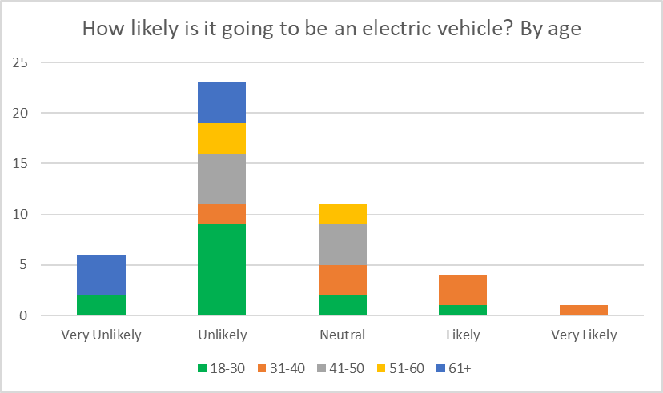
Figure 20- How likely is it going to be an electric vehicle? By age
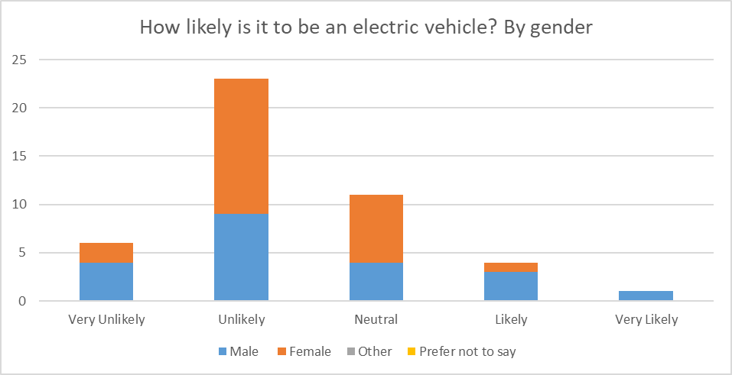
Figure 21- How likely is it to be an electric vehicle? By gender

5.6 Conclusion

Both the primary and secondary data of this research has highlighted an increase in EV’s and a higher demand forecast for their usage over the coming years. The general consensus is that the RSL’s fleet will become more electrified which will contribute to the demand and charging needs. It’s been confirmed that the need to be able to charge an EV overnight is considerable with tenants and it would prove a barrier to purchasing an EV to most respondents. It has also been highlighted overnight charging would be preferred with some fleet vehicles but this would need further research. Slow chargers at home seems to be a viable option to eliminate issues around infrastructure capabilities. Currently RSL’s are allowing for EV charging points in new build developments but generally there is no consideration being giving to existing stock which has highlighted a lack future proofing being afforded by the RSL’s to the Researcher. By taking no action to address the need for EV charging points RSL’s could be providing a barrier to the uptake of EV’s and introducing safety risks to the organisations. There is a notable gap in understanding on the tenant’s part to that of the RSL’s management when it comes to carrying out electrical work within the properties which could be a further risk to the organisation. A challenge for organisations will be providing charging facilities for properties that do not have off-road parking. Flats and sheltered complexes of the RSL’s that have communal parking spaces where it would be feasible to install points could provide space to install communal charge points not only to provide for the tenants of the local area but to be used as a facility for fleet vehicles to charge. By carrying out this it would also alleviate demand on infrastructure and the grid at the head office locations. It’s been highlighted that there is a demographic of early adopters of EV which could be utilised by RSL to prioritise installations for charge points following data research of age groups and gender.

6. Conclusion and Recommendations

6.1 Introduction

The aim of this research was to identify a need to provide suitable charging facilities for electrical vehicles and to determine viable options for Electrical Vehicle Charging for social housing tenants in the Neath Port Talbot and Swansea boroughs.
In order to achieve this aim it was split up into objectives, which were answered by collecting primary and secondary data executed in the form of a literature review and the primary research collected via questionnaires and interviews incorporating both quantitative and qualitative data. The literature review provided valuable information and data but did not go as far as addressing the objectives.

6.2 A need for electrical vehicle charging points, along with types and locations

This research has identified a need for EV charge points in social housing, although currently demand is low with only 2% of respondents of the questionnaires considering an electric vehicle in the next 3 years. This demand is forecast to grow in the coming years with 10% of respondents likely to purchase an EV when they next upgrade. This increase was highlighted in detail as part of the literature review by Rietmann, Nele, Hügler, Beatrice & Lieven, Theo, (2020) who forecasted that electrical vehicles will own 42.5% of the car sales market worldwide by 2035. Government schemes such as reducing tax on EV company cars was also reviewed, again forecasting an increased uptake. Data from the interviews highlighted a need for charge points for fleet vehicles of RSL’s, seven out of eight respondents either had electric vehicles or where planning to acquire them. The general consensus form both the primary and secondary data was that the preferred charging method is slow charging over night at home.

6.3 Timescales that charge points will be needed for social housing tenants in South West Wales and potential implications if housing providers do not act

This research highlighted that potentially 6% of RSL tenants would need charging facilities within the next 7 years, with over half of tenant respondents saying it would put them off purchasing an EV if they did not have provision for charging at home. It’s also been highlighted that not having suitable convenient charging was as a barrier to EV uptake. In-action from RSL’s would not only potentially put tenants off choosing an organisations property but restrict EV uptake forming a barrier to Government targets. It could also introduce a safety issue for RSL’s with the possibility of tenants installing their own provisions which was a big concern highlighted from RSL managers in the interviews.

6.4 Options which could accommodate tenants with both off road parking and those with no dedicated off-street parking and fleet vehicles

The research brought to light that although the vast majority of RSL’s undertook planned upgrade work on electrical installations, none took the opportunity to consider electric vehicle charging as they did on their new developments. The Researcher feels that by installing the cabling infrastructure as a “passive provision” during planned maintenance works would enable future tenants, that own EV’s, to easily connect a charger. This highlights a lack of future proofing being afforded by the RSL’s to the Researcher.
Properties with no off-road parking, although more problematic, are in the minority but a solution should still be sought by RSL’s. Both the primary and secondary data collected highlighted a need for provision. The Researcher feels that charging provision should be installed at communal car parks and sheltered housing complexes for RSL tenants, this would be a viable solution for not only tenants of the properties but also those in the local area with no off-road parking. This solution would also provide a facility for the RSL’s expanding fleet vehicles, by reducing the need for staff to travel to head offices and alleviating demand on the electrical grid at head office locations. These concerns were raised by RSL managers. By providing these communal charge points it would eliminate some of the barriers associated with EV uptake. Tenants and staff could operate these points utilising payment methods via smart phone, SMS text, subscription and card payment which are all being encourage by the UK government as reviewed in the literature review. The Automatic Vehicles Act 2018 (UK Government, 2018) makes it mandatory for all new public charge points to have “smart” capabilities, although these would not be classed as “public” RSL’s should consider these as they provide benefits like shifting the time of day the EV charges to help reduce and manage the impact of EVs on the electricity network grid. This will also help owners maximise the use of clean, renewable electricity (UK Government, 2018).

6.5 Differences in tenant’s needs and housing associations plans

It has been highlighted as part of this research that the demand for EV charging facilities is going to grow in the coming years and that generally there is no consideration being giving to existing stock within the RSL’s interviewed, the Researcher has made recommendations on how this gap can be addressed.
Another area where there was a notable gap was around carrying out electrical work within the properties. There appears to be a lack of understanding on the tenant’s part around whether permission is needed to undertake electrical work to the properties. Further research is needed as it was not the intention to gather this information as part of this research but it has highlighted a possible risk to the RSL’s.

6.6 Summary

The most suitable charging solution would be slow chargers at the tenant’s home, RSL’s in general have not considered how this will be achieved in their existing stock. The Researcher has made recommendations to install “passive provision” during planned maintenance works where off road parking is available. Communal car parks and sheltered housing complexes should be utilised for properties where designated off road parking is unavailable within the next 3-7 years. Not having suitable convenient charging is a barrier to EV uptake so RSL’s should consider acting to ensure charging is easily accessible.

6.7 Critique

Electrical vehicle technology is rapidly changing, especially around batteries and the charging of them. Different charging options may come to fruition such as super-fast charging stations and on-road charging in the near future which may reduce the need to charge overnight drastically. Battery performance for EV’s is also improving which may reduce the need to charge vehicles as often, these points could have an effect on respondents answers in the future. Any research undertaken follow the methods used in this research should take this into consideration.

6.8 Future Research

The Researcher feels that further research could be carried out on tenants living in properties where EV charge points have already been installed such as recent new-build developments to determine if any are currently being used or if there are plans to use them in the future. This could provide further evidence to enable RSL’s to follow the recommendations of this study.
The gap highlighted between tenants and RSL managers with regards to permission to undertake electrical work to properties should be further examined to understand why this didn’t align. The Researcher feels that this subject has the potential to be a great risk to RSL’s.

List of References

Alexander, J. (2019). Are social landlords responding to the electric vehicle challenge? Available: https://www.insidehousing.co.uk/insight/insight/are-social-landlords-responding-to-the-electric-vehicle-challenge-62652. Last accessed 1st October 2020.
Allan, AJ, Randy, LJ, (2005) Writing the Winning Thesis or Dissertation. A Step-by-Step Guide, Corwin Press, California
Automated and Electric Vehicles Act 2018 (c.1). London: UK Parliament
Aveklouris, A, Nakahira, Y, Vlasiou, M & Zwart, AP (2017), 'Electric vehicle charging: A queueing approach', Performance Evaluation Review, vol. 45, no. 2, pp. 33-35. https://doi.org/10.1145/3152042.3152054
Bhandari, P. (2020) An introduction to quantitative research. Available: https://www.scribbr.com/methodology/quantitative-research/. Last accessed 15th Nov 2020.
Bhatia, M. (2018). Your Guide to Qualitative and Quantitative Data Analysis Methods. Available: https://humansofdata.atlan.com/2018/09/qualitative-quantitative-data-analysis-methods/. Last accessed 15th Nov 2020.
Buchanan, B. (2019). Are social landlords responding to the electric vehicle challenge? Available: https://www.insidehousing.co.uk/insight/insight/are-social-landlords-responding-to-the-electric-vehicle-challenge-62652. Last accessed 1st October 2020.
Campbell, A., Ryley, T and Thring, R. (2012). Identifying the early adopters of alternative fuel vehicles: A case study of Birmingham, United Kingdom Transportation Research Part A: Policy and Practice. 46 (8) p1318-1327.
Cirell, S. (2020). The future of transport – building EV growth into the energy network. Available: https://airqualitynews.com/2020/05/21/the-future-of-transport-building-ev-growth-into-the-energy-network/. Last accessed 5th Oct 2020.
Committee on Climate Change, (2019). Reducing UK emissions – 2019 Progress Report to Parliament. London: Committee on Climate Change. Available: https://www.theccc.org.uk/publication/reducing-uk-emissions-2019-progress-report-to-parliament. Last accessed 7th January 2020.
Committee on Climate Change, (2019). UK housing: Fit for the future? London: Committee on Climate Change. Available at: https://www.theccc.org.uk/wp-content/uploads/2019/02/UK-housing-Fit-for-the-future-CCC-2019.pdf Last accessed 13th December 2019.
Erotokritos, X., Charalampos, M and Cipcigan, L (2015). A data-driven approach for characterising the charging demand of electric vehicles: A UK case study. Energy and Buildings. 162 (7), p763 - 771.
G. Wang et al., (2018) "Robust Planning of Electric Vehicle Charging Facilities With an Advanced Evaluation Method," in IEEE Transactions on Industrial Informatics, vol. 14, no. 3, pp. 866-876.
Georgiadou, MC, Hacking, T and Guthrie P (2012). Future-proofed energy design for dwellings: Case studies from England and application to the Code for Sustainable Homes. Building Services Engineering Research and Technology. 34 (1), p9 – 22.
Grote, M., Preston, J., Cherrett, T and Tuck N (2019). Locating residential on-street electric vehicle charging infrastructure: A practical methodology. Transportation Research Part D: Transport and Environment. 74 (2), p15 - 27.
Guo, Chunlin, Yang, Jingjing & Yang, Lin, (2018). Planning of Electric Vehicle Charging Infrastructure for Urban Areas with Tight Land Supply. Energies (Basel), 11(9), p.2314.
Hardman, S. Eric Shiu, E. Steinberger-Wilckens, R. (2016). Comparing high-end and low-end early adopters of battery electric vehicles. Transportation Research Part A: Policy and Practice. 88 (3), p.40-57
Johnson, R. Burke, Onwuegbuzie, Anthony J and Turner, Lisa A. (2016). Toward a Definition of Mixed Methods Research. Journal of mixed methods research. 1 (2), p112-113.
Joyner, L. Rouse, W and Glatthorn, A. (2013) Writing the winning thesis or dissertation; a step-by-step guide, 3d ed. Reference and Research Book News; Portland. 28 (2).
Kane, M. (2020). UK’s First Residential Avenue Fully Converted To Lamppost Charging. Available: https://insideevs.com/news/405122/uk-converted-lamppost-charging/. Last accessed 28th Sept 2020.
Kelly, N. Samuel, A and Hand, J. (2015). Testing integrated electric vehicle charging and domestic heating strategies for future UK housing. Energy and Buildings. 105 (3), p377 - 392.
Kjellström, S Ross, S N and Fridlund, B (2010) Research ethics in dissertations: ethical issues and complexity of reasoning. Journal of medical ethics, 36(7), pp.425–430
Laurel, B., (2003) Design research: methods and perspectives, Cambridge, Mass. ; London: MIT Press.
Lewes District Council, (2018). Electric Vehicle Charging Points- Technical Guidance Note. Available: https://www.lewes-eastbourne.gov.uk/_resources/assets/inline/full/0/275421.pdf. Last accessed 11th December 2019
McKim, C. A. (2017) The Value of Mixed Methods Research: A Mixed Methods Study, Journal of Mixed Methods Research, 11 (2), p202–222.
Ministry of Housing, Communities and Local Government. (2018). Social Housing Lettings. Available: https://assets.publishing.service.gov.uk/government/uploads/system/uploads/attachment_data/file/759738/Social_Housing_Lettings_April2017_to_March2018_England.pdf. Last accessed 2th January 2020.
Morgan, S. (2019). Charging begins at home. Available: https://electricalreview.co.uk/2019/06/13/charging-begins-at-home/. Last accessed 27th Sept 2020.
NICEIC, (2019). Electrical vehicle charging- all you need to know Available: https://www.niceic.com/medialib/www.niceic.com/PDF/NICEIC-Electric-Vehicle-Charging-brochure.pdf. Last accessed 20th December 2019.
O'Neill, Eoin et al., (2019). Barriers to electric vehicle uptake in Ireland: Perspectives of car-dealers and policy-makers. Case studies on transport policy, 7(1), pp.118–127.
Parahoo, K. (2005) The essential guide to doing research The essential guide to doing research Sage. Nurse researcher, 12(4), p.90–91.
Plötz, Patrick & Schneider, Uta & Globisch, Joachim & Dütschke, Elisabeth. (2014). Who will buy electric vehicles? Identifying early adopters in Germany. Transportation Research Part A: Policy and Practice.
Pod Point. (2019). Residential charging white paper. Available: https://pod-point.com/solutions/business/residential-charging. Last accessed 24th Sept 2020.
Rietmann, N. Hügler,B. Lieven, T. (2020). Forecasting the trajectory of electric vehicle sales and the consequences for worldwide CO2 emissions. Journal of Cleaner Production. 261 (121038),
Roders, M. (2015). Assessment of the likelihood of implementation strategies for climate change adaptation measures in Dutch social housing. Building and Environment 83, p168 – 176.
Silverman, D., 2001. Interpreting qualitative data : methods for analysing talk, text and interaction 2nd ed., London: SAGE.
Smithers, R. (2019). Electric vehicle drivers at risk by charging from home mains supply. Available: https://www.theguardian.com/technology/2019/may/30/electric-vehicle-drivers-at-risk-by-charging-from-home-mains-supply. Last accessed 1st Oct 2020.
SMMT. (2020). SMMT Vehicle Data. Available: https://www.smmt.co.uk/vehicle-data/. Last accessed 28th Sept 2020.
Society of Motor Manufacturers (2019) Increase in electric vehicles in the UK.. EV registrations. Available: https://www.smmt.co.uk/2019/01/december-ev-registrations-2/. Last accessed 5th December 2019.
Sumner, G, (2019). Are social landlords responding to the electric vehicle challenge. Available: https://www.insidehousing.co.uk/insight/insight/are-social-landlords-responding-to-the-electric-vehicle-challenge-62652. Last accessed 1st October 2020.
T., Witkamp, B., (2018). A review of consumer preferences of and interactions with electric vehicle charging infrastructure. Transp. Res. Part D Transp. Environ. 62, 508–523. https://doi.org/10.1016/j.trd.2018.04.002.
The Institution of Engineering and Technology and BSI (2018). Requirements for Electrical Installations BS7671:2018. London: The Institution of Engineering and Technology
The Institution of Engineering and Technology. (2018). Part P Building Regulations. Available: https://electrical.theiet.org/bs-7671/building-regulations/part-p-england-and-wales/. Last accessed 27th Sept 2020.
The Office for Low Emission Vehicles. (2019). Electric Vehicle Homecharge Scheme. Available: https://www.gov.uk/government/publications/customer-guidance-electric-vehicle-homecharge-scheme. Last accessed 13th December 2019.
UK Government, (2018). The Road to Zero Next steps towards cleaner road transport and delivering our Industrial Strategy London: UK Government. Available at: https://assets.publishing.service.gov.uk/government/uploads/system/uploads/attachment_data/file/739460/road-to-zero.pdf Last accessed 7th January 2020.
UK Government, (2019). New ‘league table’ reveals electric car charging availability across UK as Transport Secretary calls on local authorities to do more. Available: https://www.gov.uk/government/news/new-league-table-reveals-electric-car-charging-availability-across-uk-as-transport-secretary-calls-on-local-authorities-to-do-more. Last accessed 12th December.
UK Government. (2019). Expenses and benefits electric company cars. Available: https://www.gov.uk/expenses-and-benefits-electric-company-cars/y. Last accessed 26th Sept 2020
UK Government. (2020). PM launches UN Climate Summit in the UK. Available: https://www.gov.uk/government/news/pm-launches-un-climate-summit-in-the-uk. Last accessed 28th Sept 2020.
United Nations, (2015). Sustainable Development Goals. Available: https://sustainabledevelopment.un.org/#. Last accessed 7th January 2020.
Vassileva, Iana & Campillo, Javier, (2017). Adoption barriers for electric vehicles: Experiences from early adopters in Sweden. Energy (Oxford), 120, pp.632–641.
Vidanalage, I,. Venkatesh, B., Torquato, R and Freitas, W. (2017). Scheduling of electrical vehicle charging for a charging facility with single charger. IEEE. 1 (3), p11-15
Weiss, J., Hledik B., Lueken R and Lee, T. 2017. The electrification accelerator: Understanding the implications of autonomous vehicles for electric utilities. The Electricity Journal. 30 (10), p50 - 57.
Welsh Housing Quarterly, (2019). Tai Tarian to be carbon neutral by 2030. Available: https://whq.org.uk/2019/11/13/tai-tarian-to-be-carbon-neutral-by-2030/. Last accessed 20th December 2019.
Westminster Council. (2020). Electric vehicles. Available: https://www.westminster.gov.uk/electric-vehicles. Last accessed 28th Sept 2020.
Wikström, Martina, Hansson, Lisa & Alvfors, Per, (2016). Investigating barriers for plug-in electric vehicle deployment in fleets. Transportation research. Part D, Transport and environment, 49, pp.59–67.

Appendices
List of Appendices
Appendix A: Tenant Questionnaire Blank 2
Appendix B: Semi Structured Interview Pilot Blank 3
Appendix C1: Interview Pilot 1 4
Appendix C2: Interview Pilot 2 5
Appendix D: Semi Structured Interview Blank 6
Appendix E: Review of tenant questionnaires 7
Appendix F: Results from Tenant Questionnaires 8
Appendix G1: Interview Respondent 1 9
Appendix G2: Interview Respondent 2 10
Appendix G3: Interview Respondent 3 11
Appendix G4: Interview Respondent 4 12
Appendix G5: Interview Respondent 5 13
Appendix G6: Interview Respondent 6 14
Appendix G7: Interview Respondent 7 15
Appendix G8: Interview Respondent 8 16

Appendix A: Tenant Questionnaire Blank

Appendix B: Semi Structured Interview Pilot Blank

Appendix C1: Interview Pilot 1

Appendix C2: Interview Pilot 2

Appendix D: Semi Structured Interview Blank

Appendix E: Review of tenant questionnaires

Out of the 52 tenants 10% suggested that it was “likely” (8%) or “very likely” (2%) that their next vehicle would be an electric one. 58% said it was “unlikely” (45%) or “very unlikely” (13%) that their next vehicle would be electric with 21% of respondents selecting “neutral”. Half of the respondents (50%) said that it would be “very likely” (19%) or “Likely” (31%) they would need to charge an electric vehicle overnight at home. 19% chose “neutral” to this question with 17% saying it would be “unlikely” (13%) or “very unlikely” (4%) they would need to charge overnight at home.56% of respondents stated that if they did not have access to overnight charging it would be “Likely” (33%) or “Very Likely” (23% ) to put them off purchasing an electric car. 21% chose the “neutral” answer with 10% saying it would be “unlikely” (6%) or “very unlikely” (4%) to put them off. 60% said that they would need to gain permission from their landlord to carry out electrical work to their property and 21% said they did not need permission. 6% or respondents were “unsure” if they needed permission to carry out electrical works to the property.

Appendix F: Results from Tenant Questionnaires

Appendix G1: Interview Respondent 1

Appendix G2: Interview Respondent 2

Appendix G3: Interview Respondent 3

Appendix G4: Interview Respondent 4

Appendix G5: Interview Respondent 5

Appendix G6: Interview Respondent 6

Appendix G7: Interview Respondent 7

Appendix G8: Interview Respondent 8

