Gibbs Model of Reflection

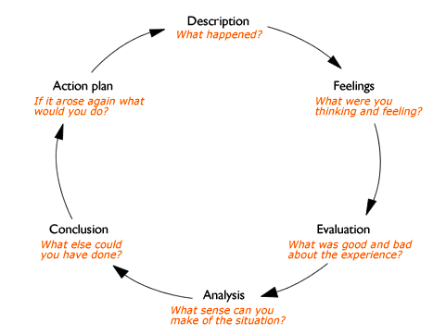
The topic which I chose to research was child labour in relation to fashion retail store, H&M. I was first tasked with creating a poster based on the issue along with a poster defence, where I defended my use of imagery, wording and presentation. I then had to discuss corporate social responsibility, linking the issue to numerous theoretical models and making reference to various stakeholders that would be affected by this issue.
I feel like the research conducted allowed me to successfully assess H&M’s stance towards child labour, while also teaching me more about the issues faced by large retailers across the world.
When producing this report, I particularly enjoyed designing and creating the poster, while researching an issue as important as child labour gave me great insight into the issues faced by both large companies and exploited workers. As there was so much information available, I sometimes struggled to stick to the permitted word count.
Throughout my research, I have learnt that there are arguments both for and against corporate social responsibility from a business perspective, relationships with stakeholders should be valued as they have a very high influence on the company, and I have also learned that there are different levels of expectation from society when it comes to CSR as discussed in Carroll’s CSR pyramid.
During this report, I could have researched other companies that carry out child labour and use them as comparison against H&M. I could have also attempted to research the history of the issue to establish if there has been an improvement. If the opportunity arose, with a larger word count, I can implement this in the future.

