
University of Wales Trinity Saint David
School of Computing
Programming 2
Kieran John Ayres (P149775)
Mike Dacey/Dr Tim Bashford
29/03/2018
Programming 2/ ACCA4006

Introduction
This assignment will cover a variation of topics, the first section of this assignment will be a brief report on a problem-solving technique and how you would apply that approach when programming, part b, there will be an analysis of code where there will be some testing going into the data to determine what the problem is and how someone would fix it. The final part of the assignment there will be three different exercises for different programs, in the report there will be screenshots and reason for use of technique.

Section 1
Each time a programmer is given a task to complete, there are things they have to do to deal with this problem, there are ways that they can approach this. Firstly, the programmer would read through the task at hand. They would read through this thoroughly and as many times as appropriate to understand what they have to do, to do this, after roughly the third reading they would make notes on the document to get an idea of where they could start.

An approach that they could use is to use functions, so there would be a group of files, in the header file you would have all the necessary links to the other files in the project and you would have the function code in the “.h” file and then the lists of function instructions e.g. “void AddTwoNumbers(int num1, int num2)”. By doing a long list of functions the programmer in question is capable to break down the application into as many small problems as they feel is necessary because that way they can simplify the program. An example of this happening is shown below, the program is broken down into smaller problems which eventually will come together to complete the application, so it will run smoothly.

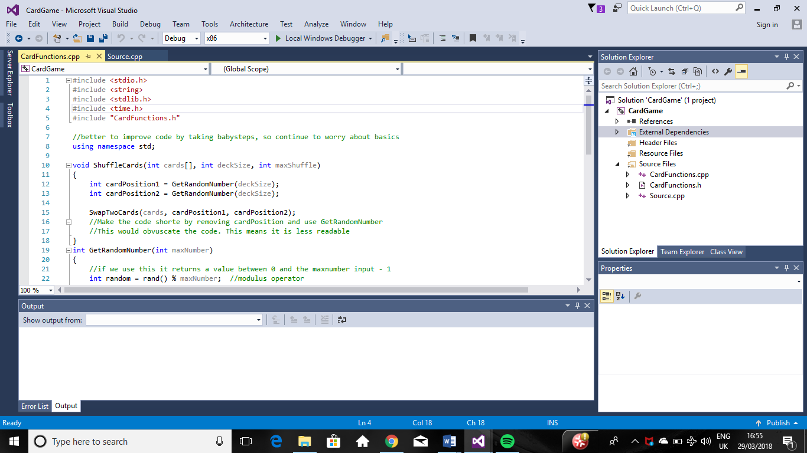
The perks of using functions to shorten your program is maintainability, so by it having this it’s broken down into smaller steps it means the steps are much easier to go back to and make change to, each function is named accordingly so they would be easy to find rather than reading through endless lines of code which could take hours to find. The code will have better understandability, so a lot of functions are simple to understand as they have names that associate to what that function is built to do, e.g. “AddTwoNumbers” is a self-explanatory function so in theory, if you followed this rule for the application then it will be easier to understand as the code will have simplicity. By having broken down small functions in your coding, then there’s chance they can be reused in other programs that the person has built so it has given it reusability. By having the code broken down into functions gives it good debuggability as you smaller functions are easier to debug rather than long complex piles of code. It also gives it good code regression. According to source [1], code regression is when there is changes to the program, but they test the new program to see if the older programming previously done still works.

Section 2
In this section there will be testing going into the code that was provided in the appendix. There will be a group of tests that deal with different parts of the code, this will show where things could be improved and then there will be some improvements shown where necessary.

Test 1
## | Input to Quit
Description |  | You can only type in “YES” to close the program. What is causing this is on the code the only option to quit is the “YES” so the programmer would need to add more.
 |  | Test Steps :
1 | Fix code accordingly, type “yes”
2 | Type “Y”
3 | Type “Quit”

Response |  | Code should quit as expected
Status |  |  | Date |  |  | Description
Pass |  |  | Date 29/03/18 Time  21:00 |  |  | Code passed as expected

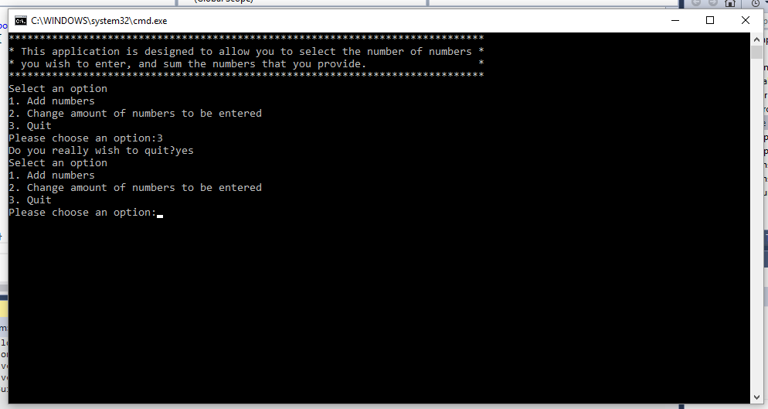
This is a screenshot to show the code before being changed so different input options could close the program.
This is the program after the appropriate fixes had been made.
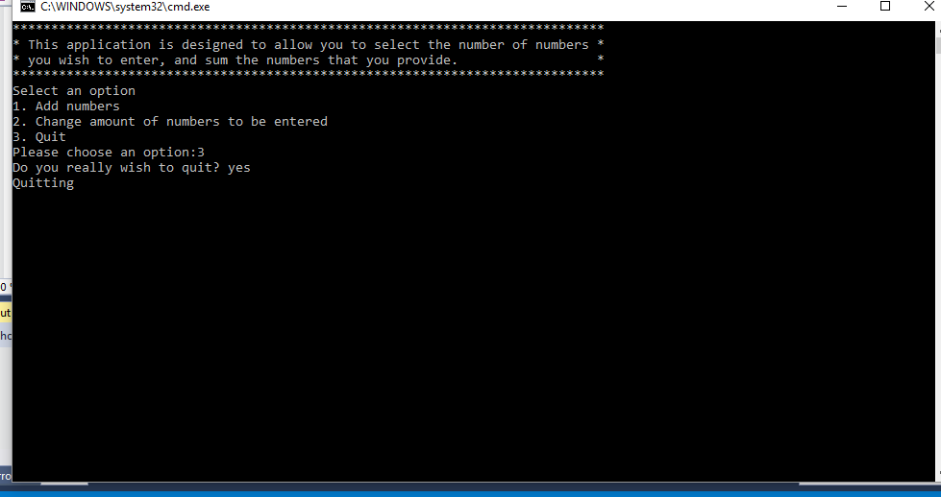
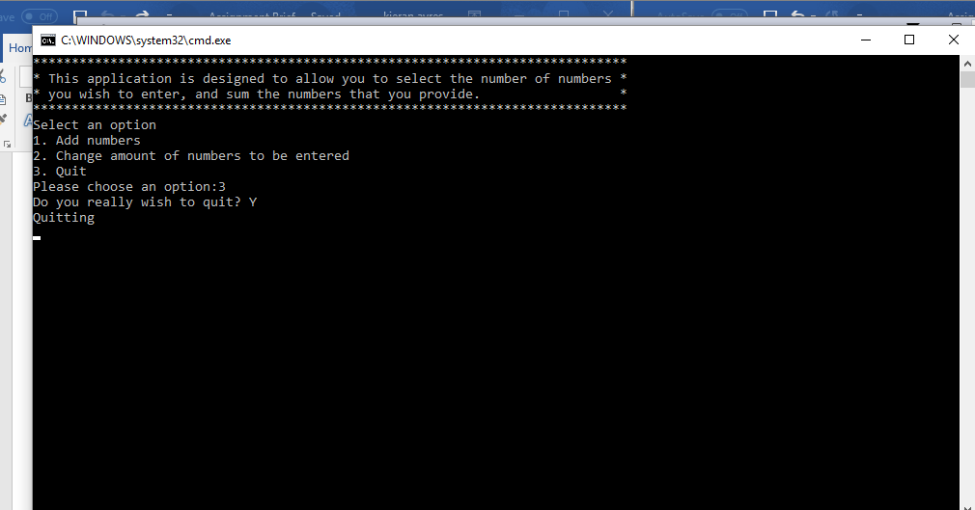
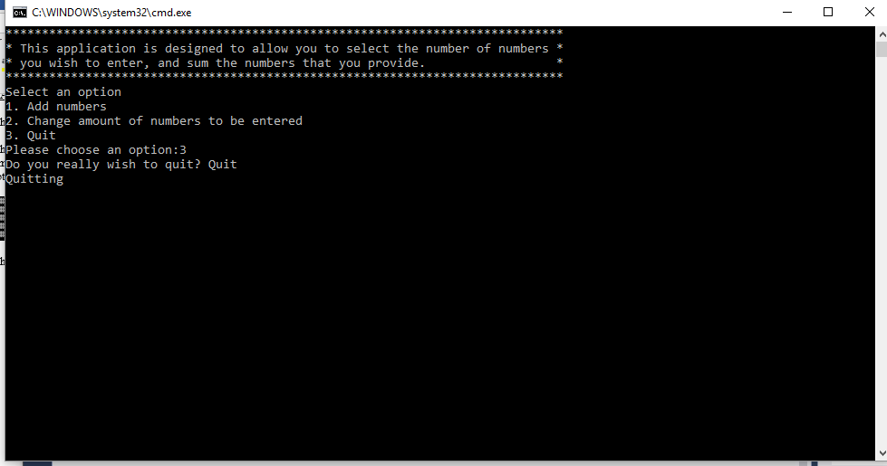
## | Option 1
Description |  | Check the Program moves onto option 1, and the numbers add correctly
 |  | Test Steps :
1 | Type in “1”
2 | Input numbers
3 | Displays Correctly

Response |  | Code should quit as expected
Status |  |  | Date |  |  | Description
Pass |  |  | Date 29/03/18 Time  21:30 |  |  | Program passed as expected

A screenshot to show this
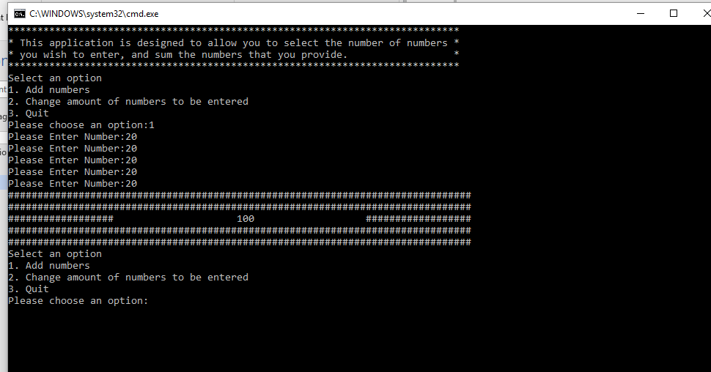

## | Display Difficulties
Description |  | The program shows one more hash than it needs to, as seen in the assignment brief.
 |  | Test Steps :
1 | Run Program
2 | Input numbers
3 | Displays Correctly

Response |  | Code should display as expected
Status |  |  | Date |  |  | Description
Pass |  |  | Date 29/03/18 Time  21:55 |  |  | Program passed as expected

Screenshot of the code with a two-digit number, a three-digit number and a four-digit number
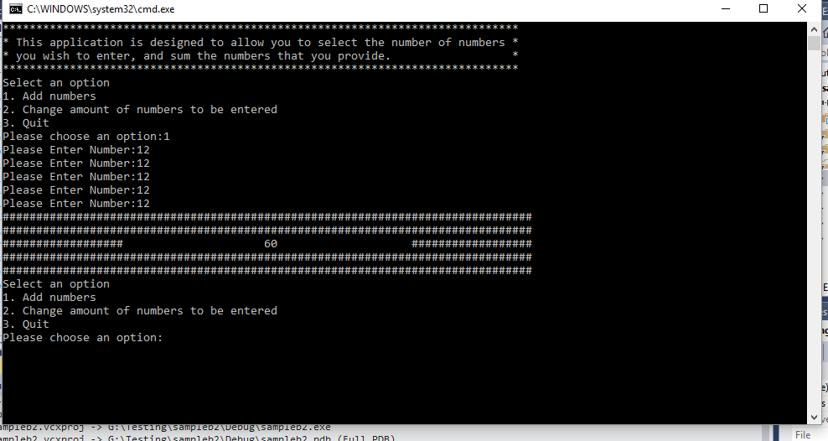
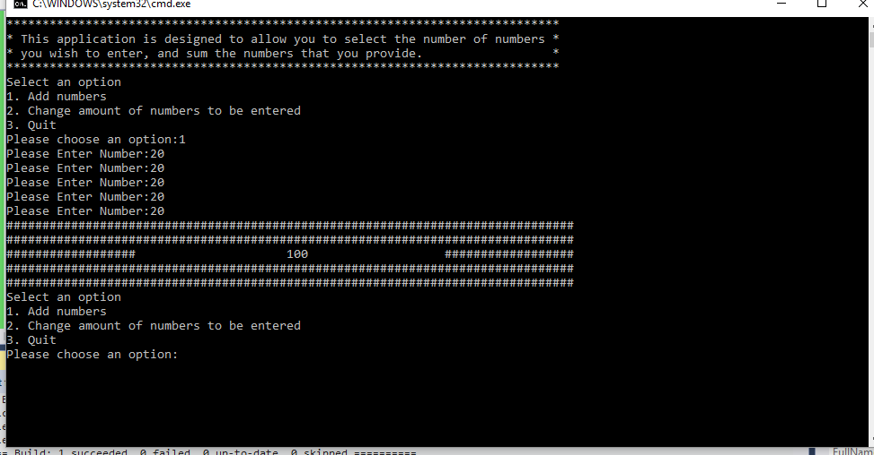
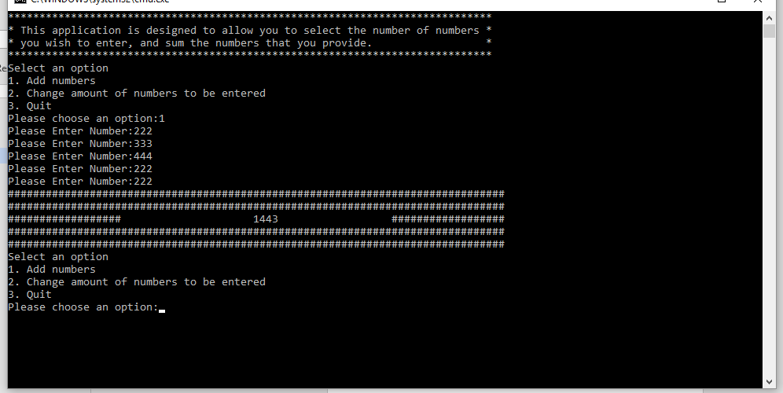

## | Option 2
Description |  | Check the Program moves onto option 2 and then can successfully change the numbers to enter for option 1
 |  | Test Steps :
1 | Type in “2” and enter number
2 | Input numbers into option 2
3 | Displays Correctly

Response |  | Code should pass as expected
Status |  |  | Date |  |  | Description
Pass |  |  | Date 29/03/18 Time  22:05 |  |  | Program passed as expected

Screenshot to show option two working
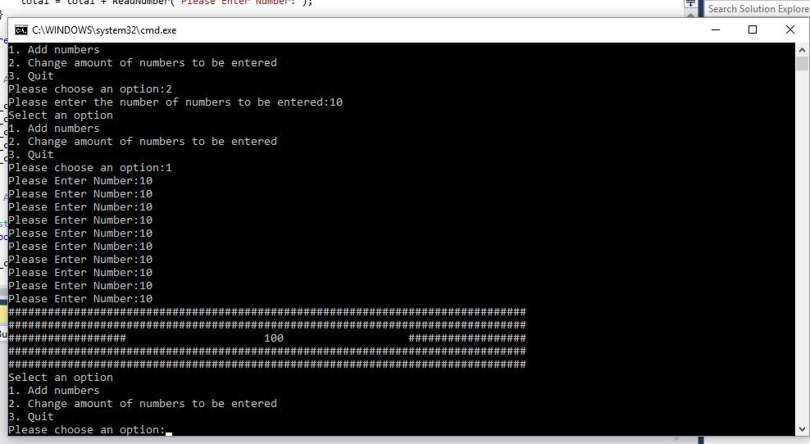
## | Option 3
Description |  | Check the Program moves onto option 3 and then quits successfully
 |  | Test Steps :
1 | Type in “3” and enter number
2 | Input “YES”
3 | Quits Correctly

Response |  | Code should pass as expected
Status |  |  | Date |  |  | Description
Pass |  |  | Date 29/03/18 Time  22:15 |  |  | Program quits as expected
Screenshot to show the test working.
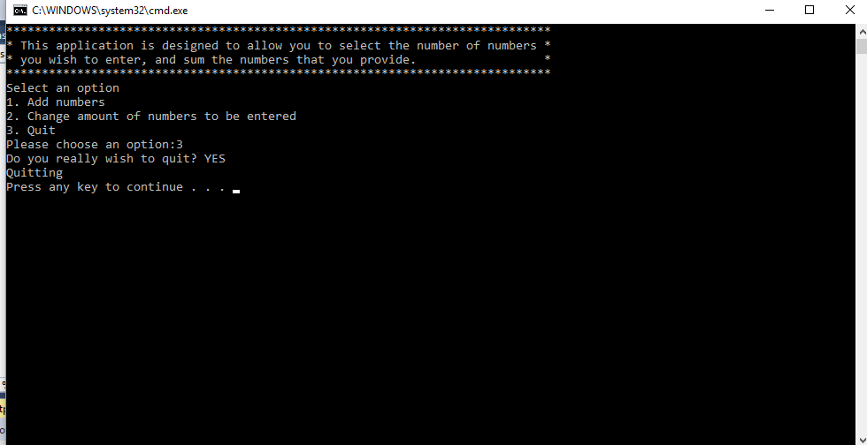
## | Entering other numbers
Description |  | Inputting larger numbers than “3” into the options menu
 |  | Test Steps :
1 | Type in “4”
2 | Type in “6”
3 | Type in “9”

Response |  | Code should pass as expected
Status |  |  | Date |  |  | Description
Pass |  |  | Date 29/03/18 Time  22:30 |  |  | Program goes as expected

Screenshot of the test
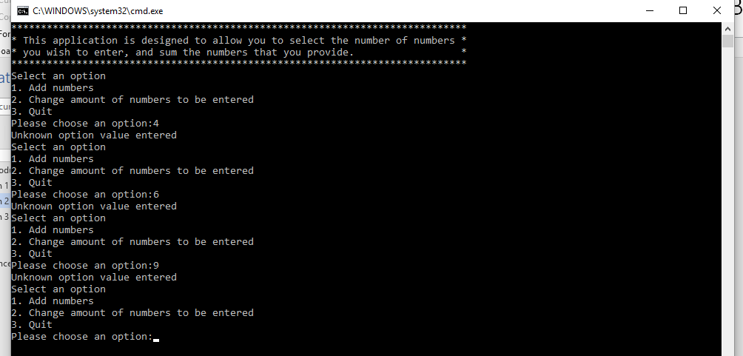

Section 3

Exercise 1
For exercise 1, there is a list of problems that need to be identified. In this, the program in question is to be a console application game that requests players to guess numbers, these numbers need to be between -20 and 20. The program would generate this itself. The player is aloud 5 guesses and then it loses. The game would be built to give help to the player every time they get an answer wrong.
The problems of the possible broken-down problems are listed from easiest to hardest to follows:
- Input a number
- Display “You Won” or “You Lost”
- Quitting the game
- Display whether the number is negative or positive
- Create a counting loop for 5 times so the game can run
- If statements to say whether their guess was right or wrong
- If statements to then give hints as to whether they are close or not
- Entering a value which; isn’t in the range, is a special character or is a letter, the game takes a life away.
- Using SRAND to randomly generate numbers

References

[1] http://searchsoftwarequality.techtarget.com/definition/regression-testing

