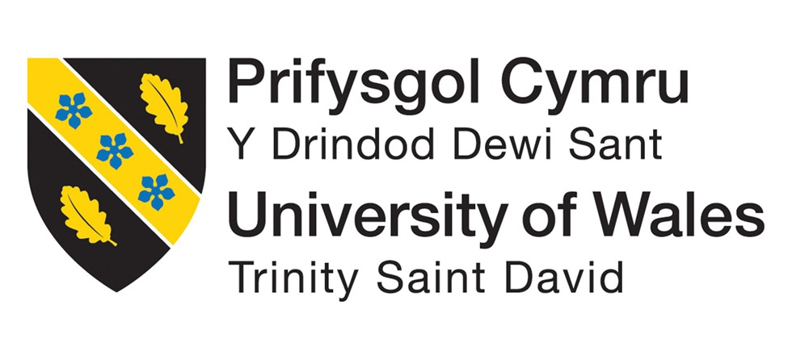

Master of Business Administration

Student Name : Patel Maitri Kaushikbhai
Student ID : 2418456
Module Name : Marketing Management
Module Code : LCMB7024
Word Count : 2500
Lecturer Name : Tushara Balendran
Submission Date : 28th April 2025

ASSESSMENT 2: PORTFOLIO: BRAND EXTENSION

Table of Contents
Introduction 2
Background of the Company 2
1. A new brand extension for Unilever: "Sustainable Living Solutions for Urban Environments" 4
2. Segmentation, Targeting and Positioning for the new service offered by Unilever 5
3. Detailed customer's personal profile for the new brand extension 9
4. Marketing Mix Strategies 11
Conclusion 14
Reference List 16

Introduction
The purpose of this assignment is to explore the development of a strategic brand extension for an organisation with existing products or services from which they want to branch out for their brand. In this assignment, the discussion has been done based on introducing the process of how to identify the viable brand extension opportunities, taking market trends, brand synergy and the growth opportunity into consideration. The discussion covered the practical steps of creating a successful brand extension using real-life cases such as Starbucks, Nike, LEGO, Patagonia, IKEA, Disney, Samsung, Unilever, Toyota, and LVMH.
The process is to analyse the current product or service offering, determine the market gap, create an innovative extension consistent with the brand’s core values. In this regard, the discussion is to study different segmentation, targeting and positioning strategies to effectively reach the target audience. Additionally, in this assignment, a rogue inferno of new detailed new customer personas and map comprehensive marketing mix methods using instruments such as 7Ps or marketing mix. The purpose of this assignment is to emphasize the strategic thinking needed to extend the reach of a brand as well as generate new ground for growth in the current highly fluid market.

Background of the Company
The Unilever company is a multinational consumer goods company headquartered in the city of London, England and Rotterdam, the Netherlands (Baragiola and Mauri, 2021). Diversified top line of brands, and founded in 1930 as a merger of the British soap maker Lever Brothers and the Dutch margarine producer Margarine Unie, with Unilever a global giant.

Figure 1: Companies Associated with Unilever
(Source: Lieu et al. 2021)
Other important categories of products that Unilever is in the business of manufacturing include
- Beauty & Wellbeing: The top of the line comes from that section and is among skincare, haircare, and personal care products (Islam, 2022).
- Personal Care: Providing products like deodorants, soaps, and oral care.
- Home Care: Focusing on cleaning products and laundry detergents.
- Product categories: Foods that include a variety of condiments, soups, meal solutions, etc.
- Ice cream: A home to iconic ice cream brands that are relished in the world over.
Unilever is committed to sustainable growth through its sustainable growth business philosophy with strong commitment to reduce its environmental impact and to encourage social responsibility. With its wide spread and various product lineup, the company is a major feature in the global consumer goods market.

1. A new brand extension for Unilever: "Sustainable Living Solutions for Urban Environments"
Such an approach would involve offering integrated solutions to the ‘sustainable living in densely populated urban areas’ problem.
Examples:
- Community-based composting and recycling programs.
- Vertical farming systems for urban food production.
- Water purification and conservation systems for urban households.
- Electric scooter sharing can be considered as a sustainable solution to improve pollution in urban cities (Popova and Zagulova, 2022).
- Forming partnerships with city governments to carry out sustainable infrastructure.
Reason: The problem matches Unilever’s ambitions of social progress, given the growing need of city sustainability solutions, and introduces new business opportunities.
Developing its portfolio of solutions to address problems creeping into Unilever's traditional product-centric stance, a new strategic evolution of 'Sustainable Living Solutions for Urban Environments' is presented by Unilever. Being aware of the growing issues surrounding urban sustainability, this extension offers full, integrated solutions by benefiting from Unilever’s worldwide reach and brand awareness (Sarbazvatan, 2022). In such densely populated metropolitan cities, availability of the resource, pollution and waste management are major issues which need creative resolutions.
Beyond the simple sale of ecofriendly products, this initiative is bigger, it’s moving on to create the entire sustainable ecosystem. The practice of community-based composting and recycling programs enables a circular economy by decreasing the waste and encouraging community involvement through the practice of segregating waste at the source (Majka, 2024). Vertical farming systems address food security and provide a reduction in long distance transportation of food resulting in corresponding reductions to the carbon footprint of food (Akintuyi, 2024). An entire water purification and conservation system supplies essences alongside minimizing environmental impact. Electric scooter shares and other sustainable urban mobility solutions can contribute to making our cities more human-friendly and less car dependent, better away from congestion and suddenly find more space for bicycles.
This is also the key to partnerships among city governments to implement large sustainable infrastructure projects. By doing this, Unilever can tap into its considerable expertise of resources to achieve tangible, lasting change (Lieu et al. 2021). Unilever addresses the multifaceted challenge of urban sustainability and consequently, reinforces its brand reputation and opens new revenue streams in a market which is growing dramatically. It is a perfect extension to Unilever’s commitment to sustainable living through its proactive approach to environmental and social responsibility.

2. Segmentation, Targeting and Positioning for the new service offered by Unilever
Among its ‘Sustainable Living Solutions’ Unilever’s focus is addressing urban sustainability issues. This means, urban demographics, psychographics and behaviour need to be considered in segmentation.
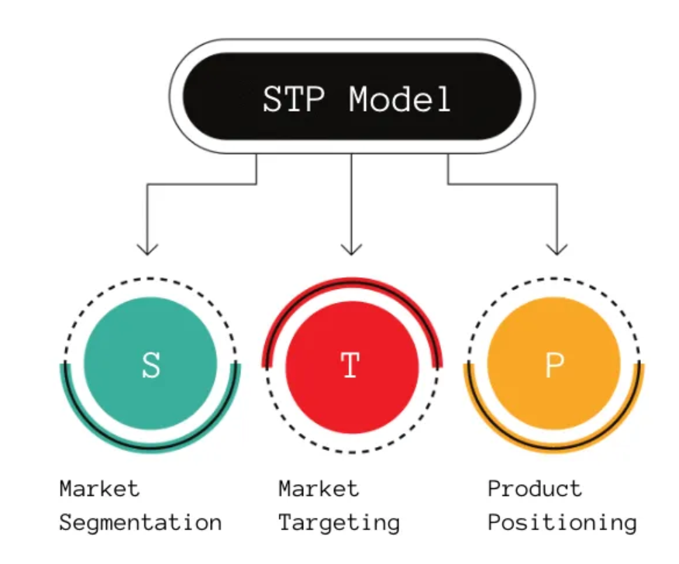
Figure 2: STP Model
(Source: Nygaard, 2024)
Demographic: Demographic categorisation based on age, Millennials and Gen Z who are more environmentally conscious, income (middle to upper middle class and willing to invest in sustainable solutions), family size (families looking for healthier living environments), location (hyper dense areas full of pollution and resource scarcity).
Psychographic: Values (environmental consciousness, health consciousness, community oriented), lifestyle (urban dwellers, active participant in sustainable initiatives) as well as attitudes (open to new technologies, willing to adopt sustainable practices) are psychographic (Nygaard, 2024).
Behavioural: Resource consumption patterns (resource exploiting the use), purchasing habits (favouring green purchases) and engagement with sustainability efforts (Involvement in recycling programs; support for local environmental groups, etc.).
Targeting:
The main audience is segmented and the following is based on various factors.
- Middle- to upper-middle-class families residing in dense urban cities focus on the environment while living healthy (Sengupta, 2024). It is willing to invest in solving problems that reduce their environmental footprint and also create a better life for themselves.
- Young professionals, millennials who live in cities, are willing to live green by embracing sustainability in cities. They are tech savvy and not averse to new features.
- Forward Thinking Urban Communities include community groups and local organisations that are already working to help make their neighbourhoods more sustainable. They want to access partnerships as well as resources to bring sustainable initiatives online.
Positioning:
Urban sustainability needs to be treated as a marketing opportunity and Unilever should take the opportunity to position its ‘Sustainable Living Solutions’ as a trusted comprehensive provider of innovative and effective solutions. The positioning should emphasize:
Convenience and Accessibility: Making sustainable living easy and accessible for urban dwellers (Wyrwa et al. 2023).
Results: They aim to impact and affect the quality of life and reduce the environmental impact.
Community and Collaboration: Fostering a sense of community and collaboration among urban residents.
Innovation and Technology: Utilizing cutting-edge technologies and innovative solutions.
Platform: It leverages Unilever’s solid brand reputation for quality and sustainability.
Segment | Demographic | Psychographic | Behavioural | Targeting Priority
Urban Eco-Conscious Families | Middle to upper-middle class, families, urban residents | Environmental and health conscious, community oriented | Eco-friendly purchasing, active in recycling | High
Sustainable Urban Professionals | Young professionals, millennials, urban residents | Passionate about sustainability, tech-savvy | Seeks eco-alternatives, utilises sustainable transportation | High
Forward Thinking Urban Communities | Community groups, local organisations | Community driven, environmentally aware | Participation in local initiatives, seeking partnerships | Medium
Table 1: Discussion of STP Model
(Source: Created by the learner)
Explanation:
Below are the key characteristics of each segment presented in the table. Being an urban eco-conscious family, they are a high priority due to their commitment to invest in green solutions and their big role in the household consumption (Ocansey and Siakwa, 2021). In line with demographical status such as their family status and their income, there is a very great potential in adopting Unilever’s offerings. Their psychographic profile shows they are the people who are very devoted to Ecological and health values, and their behavioural patterns show they are very much involved in sustainable practices.
They are of high priority because they represent one of a growing number of individuals who are environmentally conscious, known as Sustainable Urban Professionals. It is important to mention that because they are tech-savvy and are open to innovative solutions, they are the perfect adopters of Unilever’s smart and efficient products. Their behaviour reflects the preference for transportation in sustainability and for eco-friendly products, which perfectly coincides with the proposed solutions by Unilever.
Although forward-thinking urban communities are only a medium priority, they are important because they help amplify the impact Unilever can have. These are catalysts of change, which bring about the adoption of the sustainable practices at the community level. Unilever can further work with these groups without the need to establish their networks and leverage their established ones and expertise as well, creating a ripple effect which permeates way beyond individual households. This takes away demand for the products of competitors, which eventually builds brand loyalty and generates positive public relations for Unilever.

3. Detailed customer's personal profile for the new brand extension
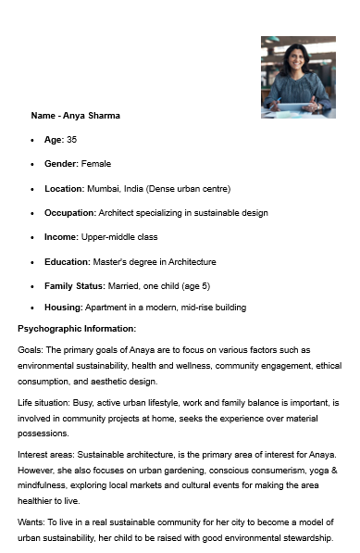
Figure 3: Personal Details
(Source: Created by the learner)
Further Psychographic Information:
Proactive on environment concerning the potential impact of our action on environmental issues; believes that the sole individual action can lead to change; open to adopting new technologies that integrate green solutions; sceptical about greenwashing.
The following describes their personality: Driven, organized, creative, empathetic, and a very strong person for positive change.
Environmental Blogs and Social Media: Consistent minions of environmental blogs and social media accounts, podcasts on sustainability and urban living, design and lifestyle magazines, use smart home tech.
Reasons: She wants to live healthy lives, a healthy and sustainable environment not only for her family but also for her city in general, to help a greener city, she wants to get rid of her environmental footprints and motivate others to adopt sustainable practices.
Balancing the convenience with the sustainability: how to make the purchase decisions in such a way that you did not undermine the quality of your life while keeping true to your principles; finding reliable and trustworthy sustainable products and services; finding efficient ways to plan for the children of the future and educating them about environmental responsibility.
Detailed Profile:
Anya Sharma, an architect based in the centre of Mumbai is a very dynamic and forward-thinking one. No matter the industry, her values are deep and part of her work: she’s all about designing sustainable, eco-friendly urban space. She is worried about the environmental conditions of her city and is determined to do her best.
Being a mother, she works to provide a healthy and sustainable place for a family to live. She has cognisance of her consumption and looks for the eco-friendly alternative in her household. Ananya is an urban gardener, who turned her balcony into a mini oasis. Besides this, she takes part in initiatives in her local community like recycling programs and urban cleaning drives to the best of her ability.
Anaya believes in tech and smart home technology, monitors and optimizes her energy and water consumption. She is well educated on environmental matters and is well informed about the best contemporary green innovations. Additionally, she is a discerning consumer who investigates products or services before making a purchase.
It is a challenging task for her to maintain her hectic professional and family life in this modern world while fulfilling her responsibility to sustainability. Often she can’t find convenient and reliable sustainable solutions in the urban environment. Greenwashing also worries Anya, and brands are transparent to her.
Anya is attracted to brands that respect her values and walk the talk for sustainability. She loves brands that will provide innovative and effective solutions and that will empower individuals to contribute to a change. Unilever’s “Sustainable Living Solutions” would be an ideal customer for her because she is searching for complete solutions to the problems of urban sustainability. Specifically, she would regard community-based initiatives, innovative technologies and trusted partnerships.

4. Marketing Mix Strategies
Unilever also has to develop a very robust marketing mix strategy that will help it effectively launch and promote “Sustainable Living Solutions.” Since the 7Ps framework fits well into the service providing nature of this extension, it is best to consider.
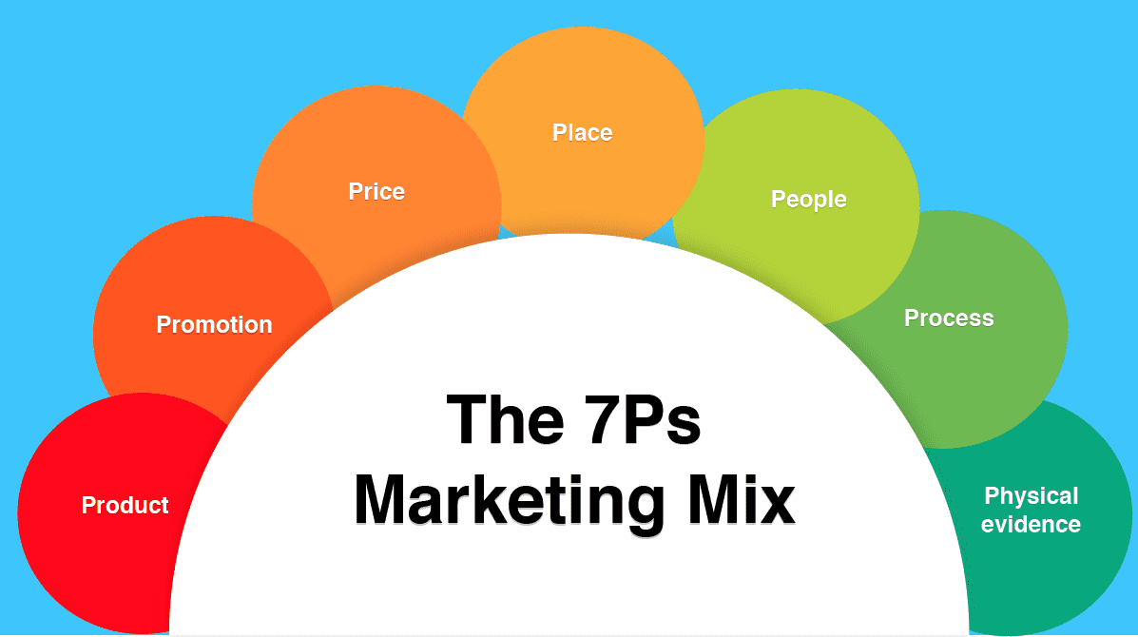
Figure 4: 7Ps Marketing Mix Model
(Source: Agyapong, 2024)
1. Product (Solutions):
- It will offer a detailed portfolio of integrated solutions in the urban sustainability area. This includes:
- Composting, recycling, and urban gardening initiatives are community-based programs (Nurhasanah and Akbar, 2022).
- Technology-driven solutions: Smart home energy and water management systems, air quality monitoring.
- Personalized sustainability plans, waste reduction strategies come under consulting and advisory services.
- Eco-friendly cleaning supplies, Urban farming kits are all examples of sustainable product subscriptions.
- Partnerships: Collaborations with local businesses, community organisations, and city governments.
The concern is for solutions that are integrated, easy and effective for the urban living Diversity.
2. Price:
- It is recommended that value-based pricing is adopted.
- Subscription services that are priced on a tiered basis according to income levels as per different packages (Frohmann, 2023).
- Community participation and early discount/ incentive.
- Searching for partnerships with local governments to subsidise some of the solutions over other things for poor communities.
- The long-term cost savings associated with going environmentally friendly.
3. Place (Distribution):
- One needs to develop a multi-channel distribution strategy.
- User friendly website and mobile application designed for information access, subscription of services, and account management.
- Awareness creating and on-site demonstrations through community centers and pop up events (Williams, 2022).
- Sustainable product and urban gardening supply distribution partnerships with local retailers.
- For consulting services, and large projects where you need a community which is not currently there.
4. Promotion:
- A multi-faceted promotional strategy needs to be worked out.
- Social media campaigns: Targeting specific ads, informative content, and video that is entertaining to the viewers (Zheng et al. 2022).
- A partnership with environmental influencers, press releases with community initiatives, and participation in sustainability events.
- Educational Seminars & Workshops: Interaction & Educational Demonstrations.
- Influencer partnerships: To build authentic content.
- Sustainable urban living, United Nations agencies: Educational campaigns about the benefits of such urban living.
5. People:
- It is important to mention that key personnel are highly trained and passionate.
- Sustainability consultants with expertise in urban planning and environmental science (Hepburn et al. 2021).
- Community outreach specialists with strong communication and interpersonal skills.
- Technical support teams for smart home systems and digital platforms.
- To emphasize building a team made up of an array of urban communities.
6. Process:
- It is necessary to have a streamlined and user-friendly process.
- Easy online registration and subscription management.
- Efficient scheduling and delivery of services.
- Transparent and accessible customer support.
- Feedback mechanisms that support the delivery of service.
- Using data analytics to make the most of an individual’s data to offer personalized recommendations.
7. Physical Evidence:
- Tangible things that offer reassurances to the brand’s commitment to being sustainable:
- Eco-friendly packaging and branding materials (Jain and Hudnurkar, 2022).
- Demonstration centers showcasing sustainable solutions.
- Physical representation of the brand’s impact played out in the form of community gardens and recycling station.
- Well-designed digital platforms to respond to people easily.
- Some certifications and awards relating to Unilever’s sustainability.

Conclusion
This assignment investigated the strategic creation of brand extensions adopting established organisations, more specifically Unilever’s ‘Sustainable Living Solutions for Urban Environments.’ Our research started by looking at what services and products Unilever, a household name, offers and also market opportunities, identifying how Unilever is transitioning to being a comprehensive urban sustainability solutions provider. therefore, moved on to segmentation, targeting, and positioning and came up with a strategy that covered how to reach eco-conscious urban families, professionals, and communities.
Anya Sharma drew out a detailed customer persona of the demographics and psychographics for the target audience. The 7Ps of the product, price, place, promotion, people, process and physical evidence that were necessary for the marketing mix strategy for the successful implementation of this work. This detailed analysis and strategy have been created to show how the brand can reach further, serve the needs of society, and foster sustainable growth.

Reference List
Agyapong, G.K., 2024. Contemporary Marketing Practices in Africa: Challenges and Success Factors. In Business Success in Africa: Academic and Managerial Insights (pp. 165-180). Cham: Springer Nature Switzerland.
Akintuyi, O.B., 2024. Vertical farming in urban environments: a review of architectural integration and food security. Open Access Research Journal of Biology and Pharmacy, 10(2), pp.114-126.
Baragiola, G. and Mauri, M., 2021. SDGs and the private sector: Unilever and P&G case studies.
Frohmann, F., 2023. Pricing Process Part 3: Structure (3b: Price Models). In Digital Pricing: A Guide to Strategic Pricing for the Digital Economy (pp. 179-216). Cham: Springer International Publishing.
Hepburn, C., Qi, Y., Stern, N., Ward, B., Xie, C. and Zenghelis, D., 2021. Towards carbon neutrality and China's 14th Five-Year Plan: Clean energy transition, sustainable urban development, and investment priorities. Environmental Science and Ecotechnology, 8, p.100130.
Islam, M.D., 2022. Project Apollo Unilever Frontliners Academy. Department of Business and Technology Management (BTM), Islamic University of Technology (IUT), Board Bazar, Gazipur-1704, Bangladesh.
Jain, P. and Hudnurkar, M., 2022. Sustainable packaging in the FMCG industry. Cleaner and Responsible Consumption, 7, p.100075.
Lieu, P.T.H., Arunjit, N., Buapradabkul, S. and Nathaniel, D., 2021. Unilever Company Strategic Business Analysis.
Lieu, P.T.H., Arunjit, N., Buapradabkul, S. and Nathaniel, D., 2021. Unilever Company Strategic Business Analysis.
Majka, M., 2024. The Strategic Role of Knowledge Management in Modern Organizations. Saatavilla, 1, p.2024.
Nurhasanah, D. and Akbar, Y.G.S., 2022. Stakeholder mapping in the Climate Village Program in DKI Jakarta. JPPUMA: Jurnal Ilmu Pemerintahan dan Sosial Politik UMA (Journal of Governance and Political UMA), 10(2), pp.149-158.
Nygaard, A., 2024. Green Segmentation, Targeting, and Strategic Positioning. In Green Marketing and Entrepreneurship (pp. 137-153). Cham: Springer International Publishing.
Ocansey, T.S. and Siakwa, E.N., 2021. Eco-Conscious Community Development in Non-Formal Education. IBE on Curriculum, Learning, and Assessment, p.219.
Popova, Y. and Zagulova, D., 2022, April. Aspects of e-scooter sharing in the Smart City. In Informatics (Vol. 9, No. 2, p. 36). MDPI.
Sarbazvatan, S., 2022. From the fair trade concept to a symbiotic sustainability business model: the case of Unilever and the Lipton-Rainforest Alliance partnership. International Journal of Competitiveness, 2(3), pp.189-211.
Sengupta, U., 2024. Housing Quality, Affordability, and the Middle Class in Urban India. In Urban Dynamics, Environment and Health: An International Perspective (pp. 377-390). Singapore: Springer Nature Singapore.
Williams, J., 2022. Challenges to implementing circular development–lessons from London. International Journal of Urban Sustainable Development, 14(1), pp.287-303.
Wyrwa, J., Barska, A., Jędrzejczak-Gas, J. and Kononowicz, K., 2023. Sustainable Consumption in the Behavior of Young Consumers. European Journal of Sustainable Development, 12(3), pp.349-349.
Zheng, S., Cui, J., Sun, C., Li, J., Li, B. and Guan, W., 2022. The effects of the type of information played in environmentally themed short videos on social media on people’s willingness to protect the environment. International Journal of Environmental Research and Public Health, 19(15), p.9520.

