Programming II
  - semester 2
  - TUTOR: Mike dacey
  - module no. acca4006

Introduction
In this report for the first half I have been told select a technique, how I apply it when I develop the code and benefits of adopting this approach such as subdividing each problem into functions. In Part A I will be explain why I will be using functions.

Part a
I will be using functions because the development is easy, this is because your work can be shared with different project members, the implementation is parallel. This also makes program testing easy to locate and confine a faulty function for more examination.
On another hand code sharing becomes easy and is possible to do , this is because any function can be used by different programs , which means C++ programmer will be allowed to use function done by other users . This stops you from starting from the beginning. Functions also increase program readability, this makes it possible because there is a design which can be called ‘stepwise refinement’ this is used to solve problems that are broken down. With this style, there is high level judgement for overall problems, this is solved with each fact that is lower functions that is addressed later. With the amount of source from the program, it can be reduced by using functions at convenient places.
Functions also facilitate the factoring of code, this is because in all C++ programs it depends on a main function which summons other functions. Which helps each of them having a well-defined functionality. Another positive fact about functions is that you don’t have to type up the same block of codes. This is helpful when you are using few locations; this is good for long complicated programmers that you are creating

Definition of Function
Function is a scheduled set of instruction or code, which carries out a specific task that is prepared independently. When a program passes control to the function, this function will carry out the task given which then returns the instruction. Specifically a function will have a set of code, that gets along and works on many inputs, which most of them are variables, this will then make great results that changes to variables values. This can also be based on the inputs.
Functions although they are good to use there can also be disadvantages. This is because it is not the greatest choice for implementation, because when you add a user function this makes the code fast ‘which is written in C++ other than scripting language’.

Below I will be showing an example of a function being used in C++, I will be describing a user defined function. Two integers combine to make a function ‘add()’ to add integers and display sum in main () function.
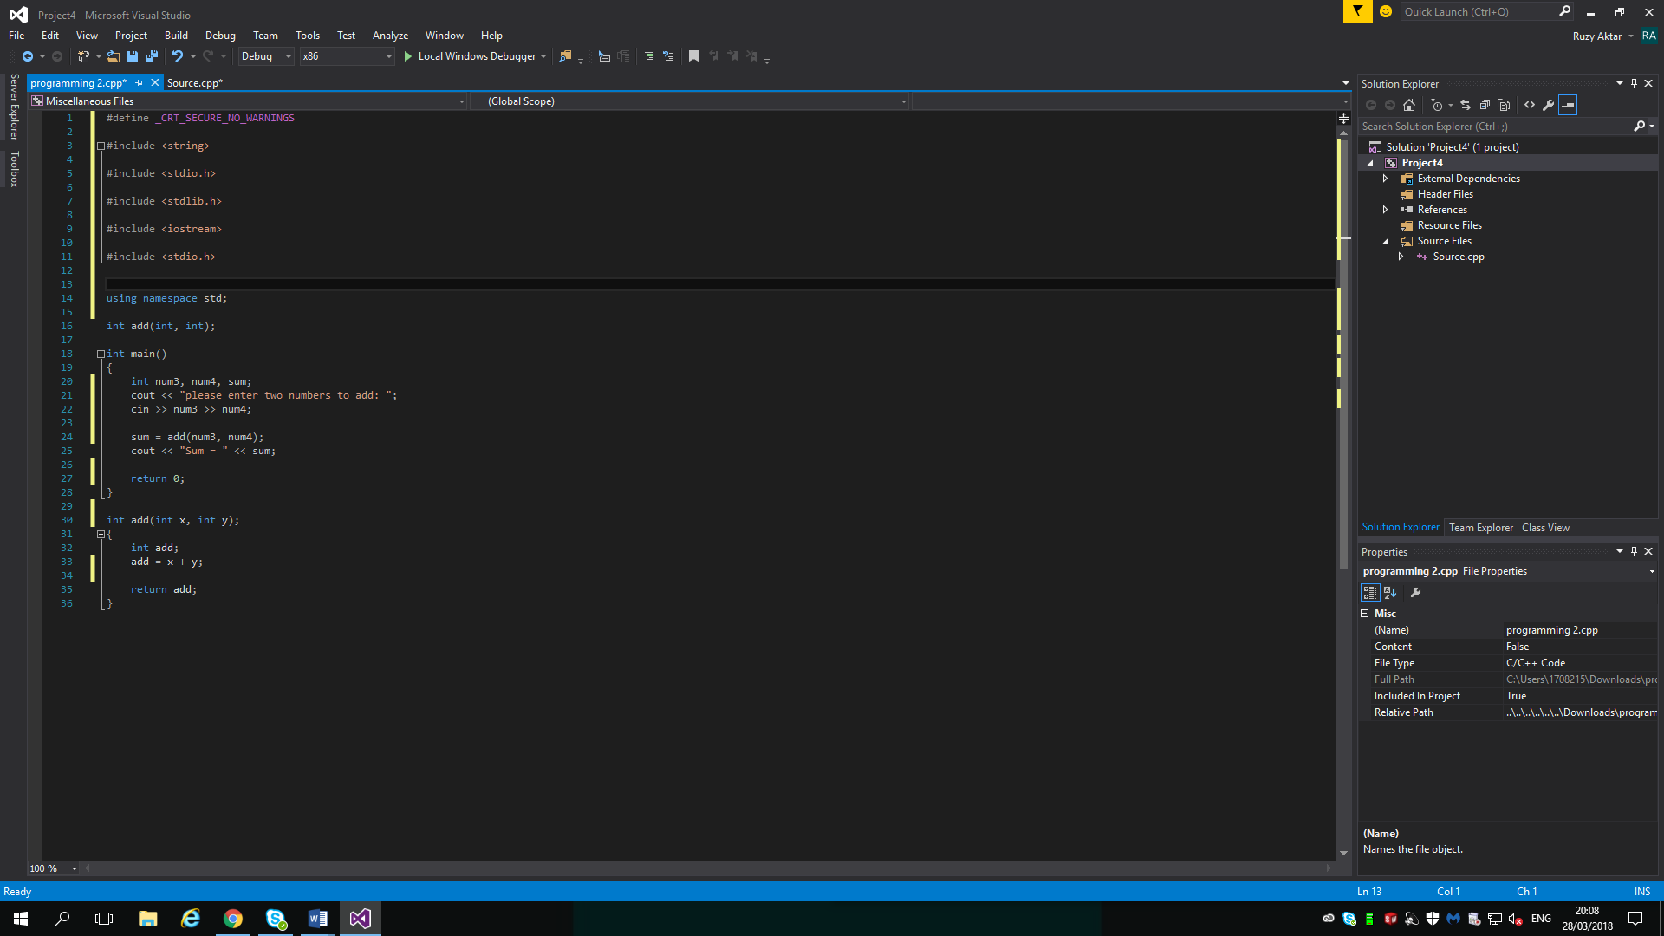

User defined function gets defined after main() then this function compiler will show errors. This is only because compiler is oblivious of user defined function types. This is disagreements passed down to function and return type.
When using C++ a function prototype is declaring a function that doesn’t have a body to give compiler any information regarding the user defined function.
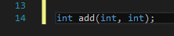
An example of a prototype function.

As you can see above here I have no body of function in prototype. However as you can tell there’s only return type of argument but there is no argument. On the other hand you can declare function prototype.

As you can see it is not crucial to write down arguments
So overall here I am trying to explain it isn’t essential to define prototype if user defined function happens before the Main() function.

Function Cell
To eliminate the codes of the function body, the user defined function would need to be called up. In the program that I have provided above here is a screenshot of a part of it explain the program.

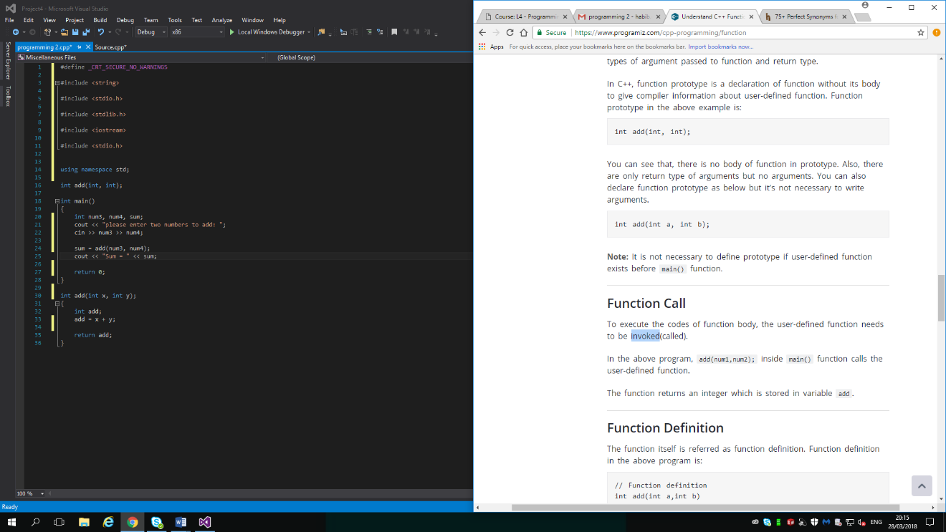
So inside Main () function calls the user defined function, the function then will go back to integer where it is then kept in variable add

Function Definition
When a function is called, control is put through to the main statement of the function body. So the other statements in function body will get eliminated continuously. When every single code inside the function definition is eliminated, the control of program passes through to the calling program.

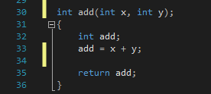

Passing arguments to functions
When it comes to programming argument usually assigns to the data that has gone through to a function this happens when it is calling it. Above where I have provided a screenshot of an example, there are two variables called num3 and num4 which developed through to function during function call. The arguments are actually known as arguments.
Below here I have an example of this. In the program the two arguments are of ‘int’ type. However this isn’t essential to have the arguments of the similar type.
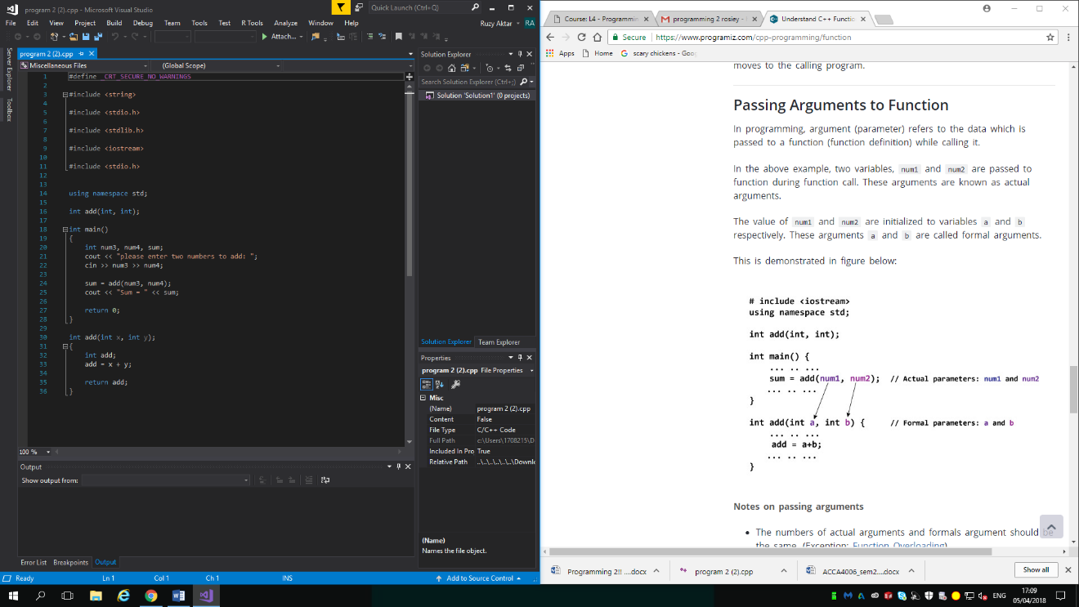

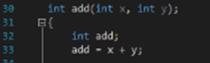

When it comes to arguments/ formal arguments numbers should always be the same. But this doesn’t include function overloading. A first argument needs to always be the same and meet the type of first formal argument. This means the second argument would need to meet the second type of formal argument, this then goes on etc.
You can add default arguments to the function, such as values this is then labelled as default arguments. However depending on how you would like to figure out the issue, you can assign a function that isn’t passing any argument. So the numbers of an argument moved to a function this then is how you would decide to solve it.

Return statement
In programming a function is able to return a single value to the calling program by using the return statement.

So the program that I have used above, the value that I have ‘add’ returns from user defined to the calling programming and this is done by return add;
Below here I have an example of a working return statement.

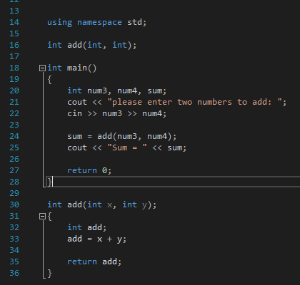

Here the value add is inside user defined function which is returned to the calling function. This value is then kept secure to a variable sum. If you can see the returned variable e.g. add is of the type int and the sum is again of int type. However on the program also return type of function is defined in function delarator int add (int x, int y). But the int before add (int x, int y). Means the function should return a value int.
If there is no value returned to the calling function then, void should be used.

PART B (TESTING)
In this part of the report I will be running some programs that I have been given. I will be providing evidence of the tests that I will be running by giving screenshots.
So the program code that I have been given should allow the user to enter a set of numbers given and calculate their sum. But the amount of numbers to be entered can also be set by the user itself. However once the total is calculated the total is displayed within a number of hashed lines.

But in this program there are 3 problems, I will be trying to enter text instead of numbers. As well as that the program asks the user if they wish to quit, but the only input value that can be entered is “YES”. I will be trying to enter another variation such as “Yes”, “yes”,”y” and so on. On the other hand the display of the total is broken when the value being displayed is more than one digit. Here is an example
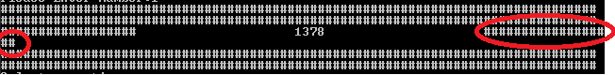

As you can notice here, the hash lines have wrapped and damaged the display that should have turned out like this instead.
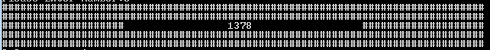

Now in this report I will be describing these problems that I have above and explain in detail what is affecting the problem. I will now create some tests to provoke these problems and provide evidence for this. I will be using a table to do this.
No1 | Entering text instead of numbers
Description |  | User inputs text instead of a number to see if a message displaying an error appears.
 |  | Test Steps :
1 | Start the program up
2 | Input text as an option
3 | Run program by pressing enter

Response |  | Once the user enters text instead of a number as an option, the program should have displayed error message saying that option doesn’t exist.
Status |  |  | Date |  |  | Description
Pass |  |  | Date 27/03/18  Time: 10.00 |  |  | Test passed, program displays error message

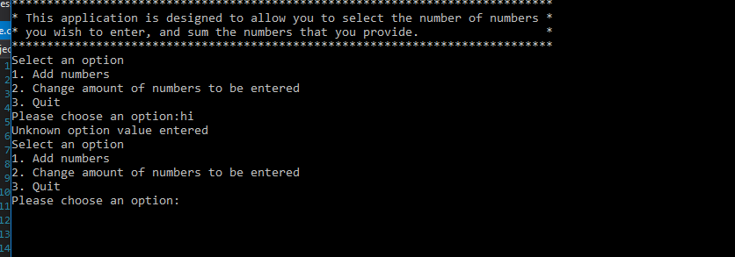

No.2 | To exit the program input variations
Description |  | User inputs “Yes”, “yes”, “y”, etc. to leave the program
 |  | Test Steps :
1 | Input 3 for option 3 to exit the program
2 | Error message appears, asking if the user would like to exit the program.
3 | yes is entered by the user,

Response |  | Once user enters a variation, program should exit and close down.
Status |  |  | Date |  |  | Description
Fail |  |  | Date: 27/03/18 Time 11:15am |  |  | Once the user had entered yes , the program did not display an error message instead , it kept telling them to chose an option . so it would not exit

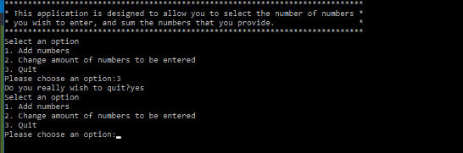

No.3 | Entering the total that is displayed
Description |  | The user inputs a number into option 1, then inputs another number into option 1 again. And presses enter to display the total of the sum.
 |  | Test Steps :
1 | User choses option 1.
2 | Enters a number twice.
3 | User presses enter
4 | Both numbers then get added up
5 | Program then displays total of sum.

Response |  | The total of the numbers entered is displayed in the centre of multiple hash symbols.
Status |  |  | Date |  |  | Description
Fail |  |  | Date: 27/03/18  Time: 12:00pm |  |  | This had failed because the numbers entered were a double digit number which caused the hash symbols to add an extra hash in the third row towards the end.
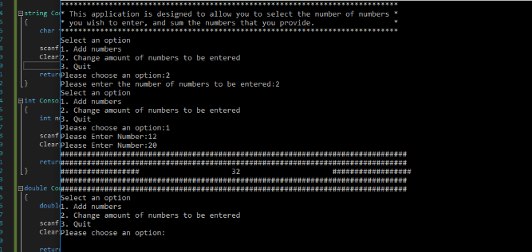

If the number the user enters is 9 or less the lines of hash will not be broken. Below here I have a screenshot proving this.

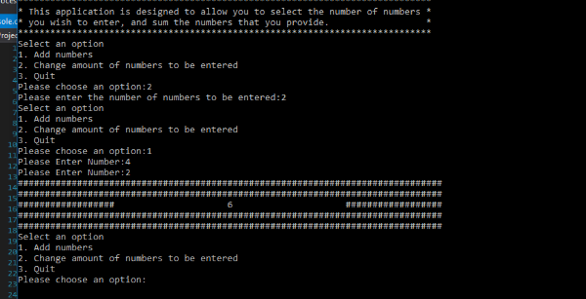

Part c implementation
In this part of the assignment I have been given a game to solve the problems. I will need to arrange them from easiest to hardest for the user. in the game the user has to guess number between -20 and +20 that the program elects in secret. They user has 5 attempts to guess this number or they will lose the game. This game gives there player a new hint every time they fail.

- If the display message such as “You won” or “you lost” doesn’t appear.
- Input a number.
- 5 attempts only.
- Timer not showing up. This is because if the timer doesn’t show up then they will lose their turn and putting in an attempt.
- If you cannot enter a value which is not a number but is considered as a guess them play can lose an attempt if they put in a decimal.
- If you do not figure out it’s just for whole numbers and find it difficult to input a number.
- Running out of guess’s

http://solvedbcaassignment.blogspot.co.uk/2013/02/define-functions-write-advantages-and.html

https://www.programiz.com/cpp-programming/function

