DS 1 Template

My Screenshots/Photos
- Please add 4–6 screenshots or photos of your digital life.
- You can use your phone or laptop.
- For each screenshot, write one or two sentences explaining what it shows.

Screenshot/Photo 1
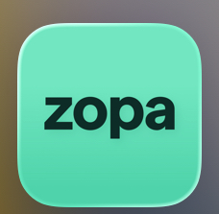
This is a mobile banking app used to access my daily finances.
This digital tool can used to send money to friends and family.

Screenshot/Photo 2

Ringo is a mobile parking application used as a frequent digital tool.
This digital tool is used to pay for parking in most major cities within the United Kingdom.

Screenshot/Photo 3

Instagram is a social media platform used for social networking, sharing photos and videos.
This digital tool is essential for online content creators and can be very beneficial for self - employed.

Screenshot/Photo 4
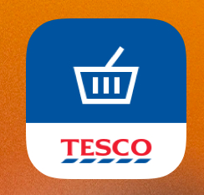
Tesco shopping app, used for essential grocery shopping .
This app is a digital tool used for me to access shopping to buy groceries and can be used to access my instore discount club card.

Screenshot/Photo 5

Booking.com app is a digital tool used to book accommodation. domestic or overseas.
This digital tool can also be used to rent a car and book a flight worldwide.

Screenshot/Photo 6
[Insert Photo/Screenshot below]

[Write what this shows of your digital life]

My Short Reflection
- Write 5–8 simple sentences about your digital life.
- You can use the sentence starters below if helpful.
Digital skills are important to be because I use many digital tools throughout the day.
I can use the digital skills from this module to help me gain more knowledge and understanding of the digital world, in my personal life, university and business.
I feel confident when I am using my digital tools to access the digital world.
I use digital tools to communicate, use appliances and many more tasks.
The digital skills I use in everyday life will be improved when I finish this module.
I hope this module will help me use my digital skill effortlessly.

Sentence starters
- I use digital tools to …
- I feel confident when I …
- I want to improve …
- I often use these tools: …
- I sometimes feel nervous about …
- I hope this module will help me …
- Digital skills are important for me because …
You can write more if you want.

Submission Checklist
Before you submit, please check:
​​​ ☒ I added 4–6 screenshots
☒ I wrote short sentences for each screenshot
☒ I wrote my short reflection
☒ My work is my own
☒ My file opens correctly
​​☒ My file opens correctly

