Leading and Implementing Workplace Change
BMSW6103

Student Name: Costel-Alexandru Crap
Student ID: 2132995
Teacher Name: Nadeem Mirza
Executive Summary
There is an argument that cultural diversity influences leadership and team performance in an organisation, especially in the retail sector. This report focuses on Wizz Air and analyses the effect of cultural diversity. An overview of Wizz Air’s organisational tradition is provided to supply context to the analysis, including its assets and liabilities, such as operational advantage and consumer dedication, as well as a lack of innovation and the manifestation of a managerial hierarchy. The paper thus breaks down how those cultural components influence change within the organisation in terms of change management to suit future business environment needs. This looks at the impact of organisational culture on decision-making, change, and organisational issues in embracing the digital age and sustaining change.
The report also presents recommendations for integrating the suggestions into the vision and strategic initiatives at the organisation, including recognising employees’ involvement in decision-making, focusing on innovative ways and cultural sensitivity for improving the team and leadership behaviour and outcomes at Wizz Air. They focus on management and leadership growth and shift whereby the airline will be well placed to face the competitive and diverse market.
In conclusion, the report suggests that change management is a critical factor in the vision strategy, and culture alignment enables the organisation to employ a more flexible workforce that will produce outcomes relevant to future needs.

Table of Contents
1. Introduction 6
2. Current State of Wizz Air 6
2.1 Overview of Wizz Air 6
2.2 Challenges Faced by Wizz Air 7
3. Analysis of External Environment and Recent Changes 8
3.1 Impact of Digital Disruption 8
3.2 Economic Uncertainty and Industry Challenges 9
4. Critical Evaluation of Change Management Models 12
4.1 Overview of Change Management Models 12
4.2 Application to Wizz Air 13
4.3 Proposed Change Management Model 15
5. Organisational Culture and Its Impact 16
5.1 Overview of Wizz Air’s Organisational Culture 16
5.2 Impact of Culture on Change Management 17
5.3 Recommendations for Cultural Alignment 18
6. Change Management Plan 19
6.1 Proposed Change 19
6.2 Financial Plan 20
6.3 Communication Plan 21
6.4 Evaluation Plan 22
7. Conclusion 23
References 25

List of Figures
Figure 1: Values of Wizz Air 7
Figure 2: IOT In Aviation From 2019 Forecasted Upto 2032 9
Figure 3: Fluctuating Aviation Fuel Price From 2016-2022 10
Figure 4: Sustainability Insights of Wizz Air 11

List of Tables
Table 1: Financial Plan 20
Table 2: Communication Plan 21
Table 3: Evaluation Plan 23

1. Introduction
Wizz Air Airlines is one of the most popular in the UK, with excellent performance and covering many European countries and areas beyond this continent. However, the airline has a strong market positioning and faces many challenges given the continually shifting nature of business environments. Today’s global economic instabilities, post-Brexit regulatory shifts, fast-forward technologies, and rising rivals call for adequate leadership in change management.
This report seeks to present a well-coordinated change management plan for Wizz Air that adopts best practices and opportunities within existing internal problems and external environmental factors. Consequently, the report identifies Wizz Air’s strengths and weaknesses in the established organisational culture and practices. It develops a change management plan to give the organisation a sustainable competitive advantage.
Starting with an evaluation of the airline's condition, volition, and jurisdiction, the research examines its external environment, discusses various change management models related to the airline, and outlines a strategic plan for its future sustainability.

2. Current State of Wizz Air

2.1 Overview of Wizz Air
Wizz Air was established in 2003 and has quickly become one of the fastest-growing low-cost airlines in Europe, with a significant market share in the UK (Wizz Air, 2024a). The airborne company's dense schedule allows it to perform flights in more than fifty countries, and CALC is focused on meeting the needs of large and small communities. Wizz Air's efficient business model does not include extra services to compromise ticket prices. It also adapts advanced methods of managing the aircraft fleet to reduce costs.
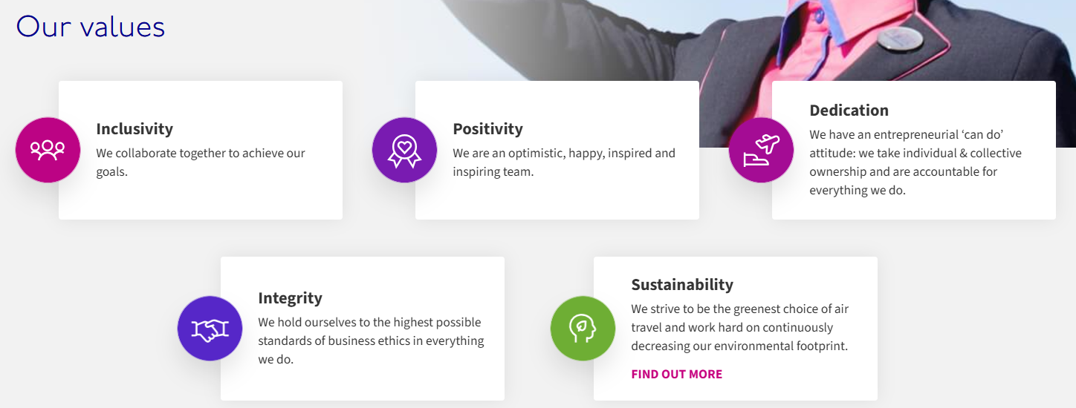

Figure 1: Values of Wizz Air
(Source: Wizz Air, 2024a)
Wizz Air’s mission is to provide customers with affordable and sustainable air travel. It has strategically invested in newer, fuel-efficient aircraft to reduce carbon emissions and align with global sustainability goals. Additionally, the company has focused on digitalisation, enhancing its online booking systems and mobile applications. However, these strengths are juxtaposed with challenges that require adaptive change management to maintain its competitive edge.

2.2 Challenges Faced by Wizz Air
Internal Challenges
Wizz Air has faced criticism for employee relations, including disputes over working conditions and compensation, leading to occasional operational disruptions (Beresnevicius, 2020). While driving profitability, the high-pressure, cost-driven culture also risks workforce morale and productivity. Concerns about staff burnout, particularly within cabin crew and ground staff, have led to high turnover rates. Additionally, the airline has been slow to implement digital tools for predictive maintenance and data analytics, limiting operational efficiency (Stanton et al., 2023). Digitalisation, particularly in fleet management and real-time data analysis, has not been fully integrated, hindering proactive decision-making and customer satisfaction.
External Challenges
The post-Brexit regulatory landscape has introduced complexities, including restrictions on intra-European Union operations, forcing Wizz Air to adapt its fleet allocation and flight schedules (Norton Rose Fulbright, 2016). The uncertainty surrounding post-Brexit rules continues to challenge long-term planning. Rising operational costs due to inflation, fluctuating fuel prices, and increased environmental taxes have impacted profitability. Airlines must become greener to comply with government requirements and satisfy customers (Ryley, Baumeister and Coulter, 2020). Wizz Air needs investment in carbon emission restrictions, fuel-efficient technologies, and carbon offsetting.
Competition on price from low-cost carriers such as Ryanair and EasyJet, adopting aggressive growth plans and cost-cutting measures (Cifuentes-Faura and Faura-Martínez, 2021), will also put increased pressure on Wizz Air. It puts more pressure on Wizz Air to keep fares low but not cut down on service. Wizz Air rarely uses personalised marketing because its competitors employ digital marketing and customer loyalty programs.
For Wizz Air to overcome these challenges and maintain (or increase) market share in the long run, they will need a robust change management strategy. Top executives must embrace technology, improve employee relations, and prioritise sustainability to lead.

3. Analysis of External Environment and Recent Changes

3.1 Impact of Digital Disruption
According to Hassan, Santos and Vink (2021), the airline industry has undergone significant digital disruption in recent years, with technology playing a central role in enhancing customer experiences and improving operational efficiency. As seen in the image below, one of the critical drivers of growth in the global Aviation Market is supposed to register a CAGR of 22.7% in terms of technological advancements in adapting Wireless Network Technologies (Emergen Research, 2023). Wizz Air has made strides in digital innovation, particularly its user-friendly online booking system and mobile app, improving customer engagement and convenience. However, compared to its competitors, Wizz Air still lags in areas like AI-powered customer service and advanced data analytics for route optimisation and pricing strategy.
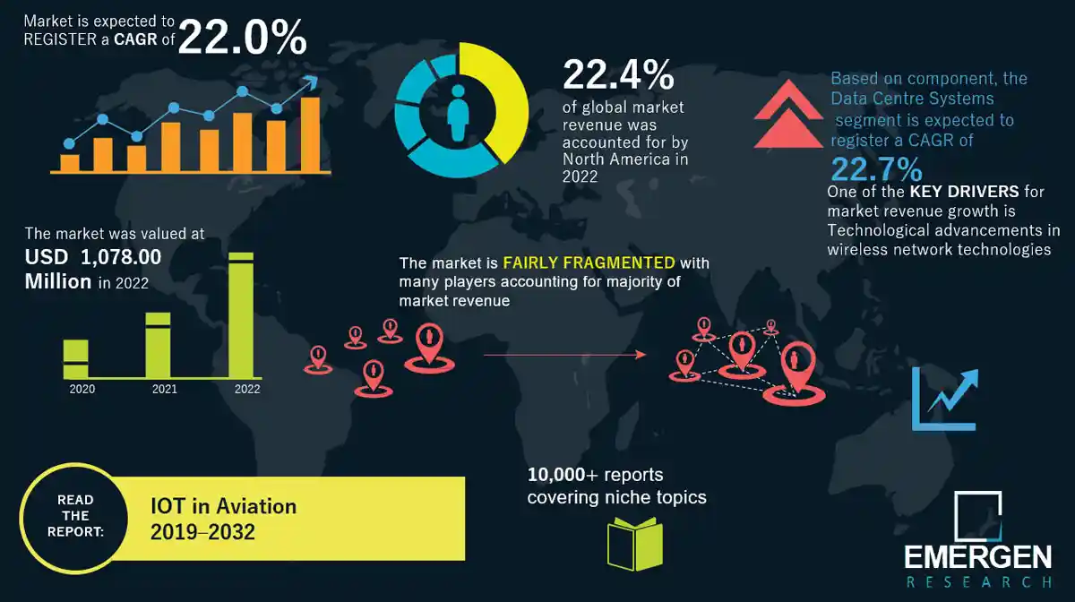

Figure 2: IOT In Aviation From 2019 Forecasted Upto 2032
(Source: Emergen Research, 2023)
Competitors like Ryanair have heavily invested in artificial intelligence (AI) for customer support and big data for dynamic pricing and personalised offers (Tian et al., 2021). Wizz Air has yet to fully leverage such technologies, which could provide insights into customer preferences for targeted marketing and route planning. The airline's lack of improvement in efficiency regarding ticketing, maintenance records and overall transparency stems from the lack of investment in blockchain technology (Tsiakalos, 2024).
It is recognised that the outbreak of COVID-19 facilitated the use of digital innovations, mainly in performing health checks and touchless registration (Amankwah-Amoah, 2021). As in the rest of this paper, Wizz Air has done some of these things but is not entirely in tune with them. To maintain its competitiveness, Wizz Air must adopt a more significant strategic concern with the digital domain, including AI, blockchain, and improving customers’ experiences; however, they all raise data security/privacy and regulation problems.

3.2 Economic Uncertainty and Industry Challenges
According to Ahmed et al. (2023), the UK airline industry has suffered badly through economic risks in the last few years due to Brexit, escalating fuel prices, and inflation. Brexit continues to introduce processes regarding rules in aviation agreements, and the ease of obtaining permission and licenses has become cumbersome. Such disruptions have grossed changes in the aircraft industry, including Wizz Air, and drastically changed their business models and operations to accommodate new policies. Moreover, new tendencies in EU consumers’ behaviour and restrictions on their possibility to travel after Brexit also affected flight demand.
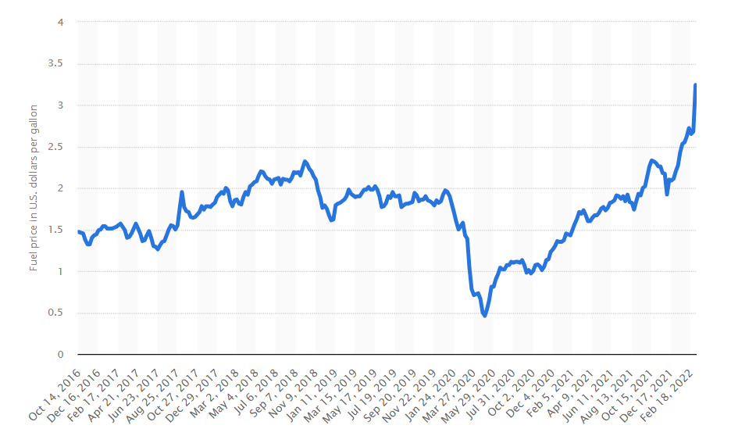

Figure 3: Fluctuating Aviation Fuel Price From 2016-2022
(Source: Statista, 2024)
This is because fuel prices, which form a significant part of airline costs, as was shown in the above graph, affected Wizz Air's cost structure (Statista, 2024). Despite the efforts to have the newest generation of planes with efficient fuel consumption, aspects like a high global fuel price remain unpredictable. This has, however, been compounded by inflationary pressures, which have put pressure on maintenance costs, labour costs, and service charges, hence the profit margins.
They also argued that sustainability in the aviation sector is another external challenge that avails a working theory developed by Lai et al. (2022). Current and potential legal regulations and rising consumer awareness pressure airlines to decrease their emissions. The UK government has set several environmental standards that airline companies must fulfil, thus leading Wizz Air to embrace more stringent policies. Competitors like EasyJet and British Airways have already implemented carbon offsetting schemes, setting benchmarks that Wizz Air must meet to remain competitive in an environmentally conscious market (Baumeister, 2020).
These external pressures emphasise the need for Wizz Air to strategically adapt its business model to navigate economic uncertainty and ensure long-term operational resilience.
3.3 Recent Organisational Changes
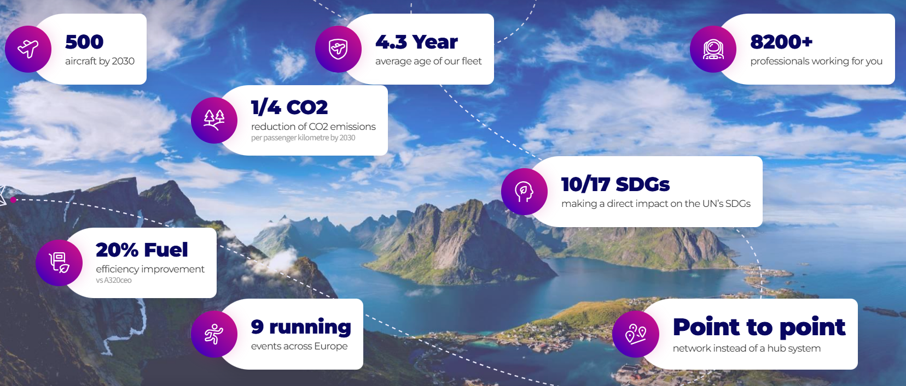

Figure 4: Sustainability Insights of Wizz Air
(Source: Wizz Air, 2024b)
In recent years, Wizz Air has implemented several organisational changes to improve efficiency and maintain competitiveness. A significant change has been its fleet expansion, including adding newer, more fuel-efficient aircraft like the Airbus A321neo. This move has reduced the airline's environmental impact and lowered operational costs, as seen in the image above, aligning with the growing aviation sustainability demand (Wizz Air, 2024b).
Wizz Air has also streamlined its route network, focusing on more profitable markets while discontinuing underperforming routes (Ex-Yu Aviation News, 2024). This shift supports its low-cost model and optimises revenue. However, this requires careful planning to avoid neglecting underserved regions, as losing market presence could lead to customer dissatisfaction, which is possible because of the 44% drop in profits so far (Smith, 2024).
On the digital front, the airline upgraded its online booking platform with features like dynamic pricing, personalised offers, and real-time feedback tools. While these improvements have enhanced customer experience, they remain incremental and lack the transformative impact needed to keep up with digital disruption. Wizz Air has recently partnered with Striim to improve its operations using real-time data analytics (Striim, 2024).
Overall, these recent changes demonstrate Wizz Air’s willingness to adapt. However, to stay competitive, a more comprehensive, long-term change management plan is needed to address broader industry challenges.

4. Critical Evaluation of Change Management Models

4.1 Overview of Change Management Models
Various change management models enable people to implement changes in an organisation correctly. Three widely recognised models applicable to Wizz Air are:
- Lewin’s Change Management Model
Developed by Kurt Lewin, this model emphasises three stages: Only three models that have been widely practised are Unfreeze, Change, and Refreeze, as suggested by (Harrison et al., 2021).
- Unfreeze: Make the organisation ready for change by raising awareness of difficulties and the need to alter something.
- Change: Deliver the intended change to stakeholders and educate them on its effect.
- Refreeze: Sustain the change and make it part of the organisational culture. The allocated model is genuinely reasonable, although accused of being rigid for quickly altering conditions such as those in aviation.
Although easy to understand, Lewin’s model might not capture specific key issues characteristic of dynamic industries such as aviation.
- Kotter’s 8-Step Process
On the contrary, writing is based on steps, including creating a sense of urgency, assembling a coalition, and navigating new approaches to the culture by John Kotter (Lovelace and Dyck, 2020). These are bigger pictures; due to this, they include vision clarification, communication, and Short-term success.
- Strengths: Comprehensive and people-oriented.
- Weaknesses: Time-intensive and challenging in dynamic settings like Wizz Air.
Wizz Air's structured steps, like forming coalitions and quick wins, correspond to combating industry disruptions and technological advancements.
- McKinsey’s 7-S Framework
This model examines seven interdependent elements: strategy of choice, structure, systems, shared values, corporate style, staff make-up, and skill levels (Lugonja, 2020). It focuses on ensuring that these components are correctly positioned to facilitate change.
- Strengths: Holistic and adaptable.
- Weaknesses: Complex and requires significant resource investment.
By aligning corporate objectives and field capacities, they help Wizz Air achieve a solid strategic fit, especially in sustainability and technology transitions.
While each model is informative, a more focused solution is needed for Wizz Air, which operates in a dynamic competitive environment.

4.2 Application to Wizz Air
Applying the selected models to Wizz Air offers actionable strategies for managing change:
1. Lewin’s Change Management Model
- Unfreeze:
The problem for Wizz Air is that it needs to start the change process by identifying external factors, such as the industry's digital disruption or the necessity to meet sustainability demands. This is achieved by generating a sense of imminence from quantitative customer information on customer preferences and competitor analysis. Contingent about their stake and transparent clarification of threats, such as a few green projects, enhance commitment.
- Change:
Wizz Air can dedicate its resources to implementing digital tools like artificial intelligence, intelligent maintenance, and customer relations programs (Sadhu et al., 2024). Training lowers resistance, and communication drives change. In this phase, effective leadership, particularly a collaborative workforce, keeps the workers motivated.
- Refreeze:
Change must become part of the organisation's culture. The essential requirements are performance targets, policies supporting new behaviour, and appreciation of conversion activities. This means that proper periodic assessments using the KPIs achieved keep improving the company’s operations and satisfying the long-term goals (Malarvizhi and Raji, 2024).
While operating as a functional model for facilitating structured change, the Lewin model may need some modification when applied to the constantly evolving aviation industry.
2. Kotter’s 8-Step Process
- Creating Urgency: Emphasise threats like increasing competition and environmental regulations to prompt immediate action.
- Building a Coalition: Form a team of leaders and experts in sustainability and digital transformation to drive change.
- Developing and Communicating a Vision: Create a vision statement, such as “Leading Europe’s sustainable and innovative low-cost aviation market.” This vision can be disseminated through digital and in-person communication channels.
- Empowering Action and Short-Term Wins: Implement visible, quick wins such as AI-based maintenance tools and an initial carbon offset program (Sridhar and Bell, 2022). These demonstrate progress, boosting employee and customer confidence.
- Anchoring Changes: Train programs and conduct regular evaluations to institutionalise sustainability and innovative technology. Integrate these ideas into Wizz Air's operations and acknowledge staff.
So, Kotter’s approach is comprehensive but requires time and resources, and critical import areas are prioritised.
3. McKinsey’s 7-S Framework
- Strategy: Align digital innovation with sustainability targets to meet regulatory demands and customer expectations.
- Structure: Streamline reporting structures to enable agility and faster decision-making.
- Systems: Introduce advanced IT systems for efficient operations and real-time analytics.
- Shared Values: Promote customer-centric and eco-friendly values as core organisational beliefs.
- Style: Emphasise participative leadership to foster collaboration across teams.
- Staff: Invest in employee upskilling for digital and green technologies.
- Skills: Develop technical expertise in AI, data analytics, and environmental compliance (Solaimani, 2024).
McKinsey’s holistic process will result in comprehensive alignment but demands intense coordination between all elements.
By combining the benefits of the models discussed, Wizz Air may create a balanced approach that supports current operations and fulfils long-term goals.

4.3 Proposed Change Management Model
To move forward and tackle current challenges, Wizz Air needs a tailored change management model combining Lewin’s, Kotter’s, and McKinsey’s frameworks:
1. Preparation Phase (Unfreeze + Creating Urgency)
- Perform a situational analysis to identify critical drivers of change; digital disruption and sustainability requirements are good candidates.
- Show competitive benchmarking data and regulatory pressures to stakeholders to drive urgency.
- Form a guiding coalition of leadership and external experts to provide strategic direction.
- Craft a vision aligning with Wizz Air’s goals, such as: “Becoming Europe’s leader in sustainable, innovative budget aviation.”
2. Implementation Phase (Change + Kotter’s Middle Steps)
- Start by introducing AI-driven tools for operations such as maintenance and customer service.
- Make it a point that when a new system arrives, employees are completely arm-ready and know what to do with it.
- Start off with short-term wins, like a carbon offset program. Progress or actions like these reinforce the change’s validity and show progress has been made.
- Provide regular updates to stakeholders through digital means and town hall meetings, keeping them updated on changes as they are automated.
3. Consolidation Phase (Refreeze + Anchoring Changes)
- Revised policies, continuous monitoring and employee incentives toward adaptation to changes are institutionalised.
- Keep communicating every day and have regular performance evaluations.
- Track progress utilising KPIs to refine strategies or maintain alignment with larger objectives.
However, it is a hybrid model, allowing for the benefits of existing frameworks while meeting Wizz Air's requirements. Therefore, such a model allows the organisation to redeem itself from external challenges and be a leader in innovative and sustainable aviation practices.

5. Organisational Culture and Its Impact

5.1 Overview of Wizz Air’s Organisational Culture
Organisational culture means that Wizz Air is successfully focused on cost leadership, innovation, and customer orientation, which is perfectly suitable for the company as it is one of the largest LCCs in Europe. Key cultural aspects include:
1. Leadership: Wizz Air has strong, directive leadership that targets operational top performance and business expansion (Wizz Air, 2024b). Though helpful for exercising cost control, this method sometimes hinders decentralised decision-making.
2. Innovation: The airline recognises the use of technology, as seen through utilising the latest fleets and electronic bookings (Striim, 2024). This culture fosters competitiveness but must be sustained by constant resource application to ensure competitiveness drowns out rivals.
3. Employee Engagement: Wizz Air completes employee training and offers employees opportunities to advance in their careers. However, the airline industry's demanding nature occasionally results in high turnover, challenging long-term retention.
4. Communication: Internal communication focuses on clarity and efficiency, which are essential for maintaining smooth operations. However, cultural gaps across geographies may hinder alignment during large-scale changes.
Cultural Strengths:
- Commitment to innovation ensures adaptability to technological advancements.
- Strong operational focus sustains competitiveness in the low-cost market.
Cultural Weaknesses:
- A cost-centric mindset may slow the adoption of high-investment sustainability initiatives.
- Limited participative decision-making may affect employee buy-in during change programs.
Wizz Air’s culture provides a solid foundation for innovation but requires refinement to support transformative changes effectively.

5.2 Impact of Culture on Change Management
Culture is critical in determining how an organisation understands and manages a change. At Wizz Air, the current organisational culture supports and fragments change management.
Cultural Barriers
One cog restraining factor concerns cost aspects, which tend to prioritise the curvature of cost lines in the short run. This approach could negatively affect the implementation of disruptive change, for example, advanced technology or environmental programs for which massive capital outlay is needed (Turskis and Šniokienė, 2024). Further, Wizz Air’s hierarchical structural integration stipulates top-level control, thereby excluding the employees from decision-making, reducing innovation and their commitment to the changes.
Cultural Enablers
However, there are several cultural assets which Wizz Air must initiate change: The organisation is innovation-oriented, which will help it incorporate AI-driven analytics and environmentally friendly practices (Elbroumi et al., 2025). Such commitment to innovation also improves accommodation to the digital and environmental challenges in the aviation sector. On the one hand, operational discipline allows Wizz Air to maintain strict discipline in the change implementation process. On the other hand, a customer-oriented approach, which is in line with the organisational culture of Wizz Air, allows the company to change and align with meeting customers’ needs, including an increased focus on digital convenience and sustainability.
Adaptability and Responsiveness
However, the company requires better improvisation skills, as in the case of Wizz Air. The constantly evolving technological advancement and higher expectations of shareholders and stakeholders due to rising regulatory standards for sustainability create a need for a more flexible process (Roman and Talavera, 2024). Considering these findings, it becomes clear that Wizz Air needs to develop and strengthen its change management processes to make employees at all levels understand that change is imperative and should be embraced and provide the necessary agility to confront market and regulatory change. Through cost-sensitivity and creativity, Wizz Air can bypass cultural restraints and socialise its workforce to adhere to new change throughout the increasing years of its triumph.

5.3 Recommendations for Cultural Alignment
To ensure that Wizz Air’s culture aligns with its strategic change objectives, the following recommendations are offered to enhance its ability to navigate future challenges and foster sustainable growth.
1. Enhance Participative Leadership: Introducing participatory decision-making practices is critical in aligning the culture with change (Ropp and Belt, 2020). Encouraging employee involvement through initiatives like employee forums and cross-functional teams will increase engagement, foster creativity, and promote a culture of innovation. When employees at all levels contribute to decision-making, they feel valued and are more likely to embrace change initiatives, improving the success rate of those initiatives.
2. Strengthen Change Communication: Effective communication is critical to managing change across a culturally diverse organisation (Alkan and Sunar, 2024). Wizz Air should develop tailored communication strategies to address cultural differences in its various regions. Using digital tools, feedback sessions, and regular updates will ensure transparency, helping employees understand the implementation's purpose and benefits.
3. Embed Sustainability into Core Values: Given the increasing focus on environmental concerns, sustainability should become Wizz Air's next value, along with cost tendency. By focusing on long-term goals, the company will achieve financial solidity and ecological friendliness (Elavarasan et al., 2022). Biological incentives for employees engaged in sustainable activities can support this change in organisational culture.
4. Promote Training for Cultural Adaptability: The enhanced training interventions mean raising HR's adaptability level to changes in digital processes and management of sustainability concepts (Wahdiniawati and Sarinastiti, 2023). These programs should also reflect Wizz Air's diversity by preparing employees for changes that would allow the organisation to adapt to international challenges.
5. Foster Flexibility in Decision-Making: Based on these findings, a more sensitive decision-making approach must be facilitated so that the organisation can quickly address changes occurring in the market and regulation (Valarezo et al., 2021). Therefore, more decision-making and control should be delegated to the various teams to make the organisation more competitive.
When adopted, these measures will enable Wizz Air to establish a pro-change work culture that can support strategic initiatives in a highly innovative and competitive operational environment.

6. Change Management Plan

6.1 Proposed Change
The desired change in the strategy for Wizz Air involves connecting digital globalisation and sustainable management plan strategies. People worldwide have become more concerned about the environment in recent years, and the airline industry has become highly dependent on technology, so Wizz Air has changed its operating model through digitalisation. This initiative can be associated with Wizz Air cost reduction, customer-oriented improvement, and carbon emission decrease strategies. Safety is also covered under the digital transformation, which involves embracing Artificial Intelligence and Automation to enhance service delivery. Its sustainable focus is mainly on minimising carbon emissions, adopting sustainable fuel, and optimising the fleet.
Several problems explain this change. Wizz Air is currently experiencing increasing environmental requirements and the necessity of better operational performance. The airline industry is experiencing global pressure to cut emissions; Wizz Air’s competitors have already invested in green technologies. In addition, details of digital applications reveal better customer relations and compelling operation systems, which are essential strategies for Wizz Air's competitive advantage. With these implemented changes, Wizz Air will rise to the standards of sustainable change within the air travel industry and set the bar.

6.2 Financial Plan
The financial plan for the proposed changes involves estimating the budget, identifying funding sources, and evaluating financial risks.
Financial Element | Details | Estimated Costs
Budget Estimate | Initial investment in digital transformation, AI systems, and sustainable fuel adoption. | £100 million
Funding Sources | Internal funds, debt financing, and possible government grants for sustainability. | £70 million (internal), £30 million (debt)
Financial Risks | Delays in technology integration and regulatory changes affecting the sustainability initiatives. | Medium to high-risk
Cost-Benefit Analysis | Expected returns from improved efficiency, customer retention, and fuel savings. | Positive ROI expected by Q3 2025

Table 1: Financial Plan
(Source: Self-Developed)
A proposed budget estimate estimates the total funding required for these two activities, internet strategy and sustainability, at £100 million. This comprises £70 million from retained earnings and £30 million from debt funds. From the preceding, one can appease that government grants will likely continue to be a source of additional funding. Wizz Air concentrates explicitly on sustainability, particularly with the rising global consciousness of sustainable aviation.
The financial risks relevant to the plan are related to postponing technology implementation and fuel price volatility, which affect sustainable practices. But the advantages lie much higher than these disadvantages. There are predictions that digital transformation will lead to better total costs as digital technology is expected to eliminate operational overheads. Furthermore, increasing sustainable fuel usage and optimising fleet management will help cut fuel usage costs. It can, therefore, give high returns on investment and ROI. The positive ROI expected will be seen by the third quarter of 2025/2016 through enhanced efficiency and customer satisfaction. The company has a sound financial plan: investments in digital tools and sustainability make comprehensible long-term savings for the company.

6.3 Communication Plan
An effective communication plan is critical to the success of Wizz Air's change initiatives. It ensures that all stakeholders are aligned and engaged throughout the process.
Communication Strategy | Details | Frequency
Internal Communication | Regular updates for employees via town halls, emails, and intranet. | Monthly
External Communication | Press releases, social media campaigns, and partnerships with eco-friendly organisations. | Quarterly
Stakeholder Engagement | Stakeholder meetings, focus groups, and surveys for feedback. | Bi-monthly
Feedback Mechanisms | Digital platforms and surveys for employees and customers. | Continuous

Table 2: Communication Plan
(Source: Self-Developed)
It is agreed that the internal communication plan regarding change management will include town hall meetings and e-mail communication once a month to ensure that all employees are informed of the subject change management initiatives, their importance, and the time frame within which these changes will occur. This will enhance transparency while at the same time calling for the employees’ support of the change process.
In this case, to the outside world, Wizz Air will use channels such as its website, press releases, and social media platforms to relay information to customers and the public regarding the company's sustainability and digital enhancements. Wizz Air may develop a positive brand image through close interaction with eco-conscious customers.
Frequent focus groups and surveys will be conducted to engage the stakeholders and capture what customers, employees, and investors will likely say about the proposed innovation. Such feedback will help modify the change process interventions to reflect the audience’s expectations. The Communication Plan will hence be evaluated for its effectiveness in real-time by key stakeholders and end users through the assorted digital platforms.
Incorporation of these communication approaches provides stakeholder engagement not only with change information but also with the change process, which improves the odds of implementation.

6.4 Evaluation Plan
Therefore, the evaluation plan will seek to measure the success of the change process by benchmarking performance against certain specified KPIs and comparing performance against the short-term and long-term change goals.
Evaluation Element | Details | Timeline
Short-Term KPIs | Improvement in operational efficiency, digital engagement, and fuel savings. | Q3 2024-Q2 2025
Long-Term KPIs | Customer retention, reduction in carbon footprint, and return on investment (ROI). | End of 2025
Monitoring Methods | Monthly performance reviews, quarterly financial audits, and customer feedback surveys. | Continuous
Adjustments | Modify operational processes based on feedback from evaluations. | Ongoing

Table 3: Evaluation Plan
(Source: Self-developed)
Specific short-term KPIs for Wizz Air include reduced operating costs, greater use of digital technologies, and fuel efficiency, which will be recorded from Q3 2024 to Q2 2025. These indicators will assist in evaluating the short-run potential of digital transformation and sustainability initiatives.
Long-term KPIs will comprise customer retention rates, reduced carbon emissions, and return on investment. These measures will help us understand the combined effect of change initiatives on Wizz Air's positioning and profitability by the end of 2025.
Accounting tools, including monthly performance appraisals, quarterly financial check-ups and client feedback questionnaires, shall be practical tools to ensure the realisation of the laid down objectives (Thumburu, 2022). Hence, the plan will be adjusted in response to the feedback to make the strategies and processes suitable for the situation. Constant surveillance will be conducted to guarantee that the changes suit Wizz Air’s general strategic plan.

7. Conclusion
To this end, analysing Wizz Air’s organisational culture provides emerging and potentiated information on leadership and team performance regarding its strengths and weaknesses. This emphasis on productivity and cost containment has well-placed the airline within the low-cost airline industry subsector. But it has done this at the cost of not being able to invest in value creation and transformation projects, some of them relevant to factors such as sustainability, Digital advancements, etc.
The firm lacks procedural flexibility, which has affected its ability to translate strategic initiatives into practice due to its top-down approach and resistance to change. Employees' non-involvement in decision-making has caused the failure to respond to change and adopt new practices. Hence, the company's culture must change to adapt to the unpredictable and constantly developing market.
Implementing the best practices of empowering employees, creating and promoting an innovative cultural mindset, and instituting company cultural values in line with long-term strategic accoutrements can result in better change management of Wizz Air, leadership growth, and team growth. These adjustments will prove effective in helping the company understand how it can effectively operate in the new, more intensified global airline market.

References
Ahmed, R., Chen, X.H., Kumpamool, C. and Nguyen, D.T., 2023. Inflation, oil prices, and economic activity in recent crisis: Evidence from the UK. Energy Economics, 126, p.106918.
Alkan, A.D. and Sunar, O.N., 2024. Human Resources Management in the Civil Aviation Sector: A General Overview. Strategic Management and Policy in the Global Aviation Industry, pp.1-15.
Amankwah-Amoah, J., 2021. COVID‐19 pandemic and innovation activities in the global airline industry: A review. Environment International, 156, p.106719.
Baumeister, S., 2020. We are mitigating the climate change impacts of aviation through behavioural change. Transportation Research Procedia, 48, pp.2006-2017.
Beresnevicius, R., 2020. ‘Wizz Air criticized for labor and safety malpractices’ [Online] Available at: https://www.aerotime.aero/articles/25514-wizz-air-labor-safety-criticism [Accessed on: 21 Nov 2024]
Cifuentes-Faura, J. and Faura-Martínez, U., 2021. Situation of European airlines caused by COVID-19: restrictions, government subsidies and future prospects. Aviation, 25(4), pp.232-240.
Elavarasan, R.M., Pugazhendhi, R., Irfan, M., Mihet-Popa, L., Khan, I.A. and Campana, P.E., 2022. State-of-the-art sustainable approaches for deeper decarbonization in Europe–An endowment to climate neutral vision. Renewable and Sustainable Energy Reviews, 159, p.112204.
Elbroumi, S., Idrissi, M.A., Chaaouan, M. and Eddahmouny, H., 2025. Exploring Trends, Perspectives, and Challenges of Artificial Intelligence in Sustainable Mobility: A Systematic Review. Utilizing Technology to Manage Territories, pp.207-238.
Emergen Research, 2023. ‘Internet of Things in Aviation Market, By Component (Communication Service, Data Centre Systems, IT Services & Software), By Application (Ground Operations, Asset Management), By End-use (Airline, Airport, MROs), By Region Forecast to 2032’ [Online] Available at: https://www.emergenresearch.com/industry-report/internet-of-things-in-aviation-market [Accessed on: 21 Nov 2024]
Ex-Yu Aviation News, 2024. ‘Wizz Air returning to growth on most EX-YU markets this winter’ [Online] Available at: https://www.exyuaviation.com/2024/10/wizz-air-returning-to-growth-on-most-ex.html [Accessed on: 21 Nov 2024]
Harrison, R., Fischer, S., Walpola, R.L., Chauhan, A., Babalola, T., Mears, S. and Le-Dao, H., 2021. Where do models for change management, improvement and implementation meet? A systematic review of the applications of change management models in healthcare. Journal of healthcare leadership, pp.85-108.
Hassan, L.K., Santos, B.F. and Vink, J., 2021. Airline disruption management: A literature review and practical challenges. Computers & Operations Research, 127, p.105137.
Lai, Y.Y., Christley, E., Kulanovic, A., Teng, C.C., Björklund, A., Nordensvärd, J., Karakaya, E. and Urban, F., 2022. Analysing the opportunities and challenges for mitigating the climate impact of aviation: A narrative review. Renewable and Sustainable Energy Reviews, 156, p.111972.
Lovelace, K.J. and Dyck, L.R., 2020. Experiencing organizational change through the change management simulation: Power and influence. Management teaching review, 5(1), pp.70-81.
Lugonja, D., 2020. Change Management as a Support to the Organizations' Digital Transformation-State of the Art. In Central European Conference on Information and Intelligent Systems (pp. 167-174). Faculty of Organization and Informatics Varazdin.
Malarvizhi, S. and Raji, V., 2024, February. Reviewing the Landscape: A Literature-based Exploration of Sustainable HR Practices and Key Performance Indicators (KPIs) in Green HRM for Assessing Organizational Sustainability. In 3rd International Conference on Reinventing Business Practices, Start-ups and Sustainability (ICRBSS 2023) (pp. 580-588). Atlantis Press.
Norton Rose Fulbright, 2016. ‘Airline regulation: What you need to know with Brexit approaching’ [Online] Available at: https://www.nortonrosefulbright.com/en/knowledge/publications/e31eb55d/airline-regulation---what-you-need-to-know-with-brexit-approaching [Accessed on: 21 Nov 2024]
Roman, W. and Talavera, G., 2024. Emerging Technologies for Enhancing Organizational Resilience in the Global Air Transport Sector.
Ropp, T.D. and Belt, S.M., 2020, June. Individual resilience as a competency for aviation professionals: A review of the literature. In 2020 ASEE Virtual Annual Conference Content Access.
Ryley, T., Baumeister, S. and Coulter, L., 2020. Climate change influences on aviation: A literature review. Transport Policy, 92, pp.55-64.
Sadhu, A.K.R., Parfenov, M., Saripov, D., Muravev, M. and Sadhu, A.K.R., 2024. Enhancing Customer Service Automation and User Satisfaction: An Exploration of AI-powered Chatbot Implementation within Customer Relationship Management Systems. Journal of Computational Intelligence and Robotics, 4(1), pp.103-123.
Smith, G., 2024. ‘Is the Profit Party Over? Wizz Air Reports 44% Drop in Earnings as Aircraft Groundings Bite’ [Online] Available at: https://skift.com/2024/08/01/wizz-air-reports-drop-in-earnings-as-aircraft-groundings-bite/ [Accessed on: 21 Nov 2024]
Solaimani, S., 2024. From Compliance to Capability: On the Role of Data and Technology in Environment, Social, and Governance. Sustainability, 16(14), p.6061.
Sridhar, B. and Bell, D., 2022. Sustainable aviation operations and the role of information technology and data science: background, current status and future directions. In AIAA Aviation 2022 Forum (p. 3705).
Stanton, I., Munir, K., Ikram, A. and El‐Bakry, M., 2023. Predictive maintenance analytics and implementation for aircraft: Challenges and opportunities. Systems Engineering, 26(2), pp.216-237.
Statista, 2024. ‘Average weekly jet fuel price from October 2016 to March 2022(in U.S. dollars per gallon)’ [Online] Available at: https://www.statista.com/statistics/526660/aviation-fuel-cost-comparison-across-regions/ [Accessed on: 21 Nov 2024]
Striim, 2024. ‘Wizz Air and Striim partnership will streamline mission-critical operations with real-time data pipelines’ [Online] Available at: https://www.striim.com/press/wizz-air-and-striim-partnership-will-streamline-mission-critical-operations-with-real-time-data-pipelines/ [Accessed on: 21 Nov 2024]
Thumburu, S.K.R., 2022. Post-Migration Analysis: Ensuring EDI System Performance. Journal of Innovative Technologies, 5(1).
Tian, H., Presa-Reyes, M., Tao, Y., Wang, T., Pouyanfar, S., Miguel, A., Luis, S., Shyu, M.L., Chen, S.C. and Iyengar, S.S., 2021. Data analytics for air travel data: a survey and new perspectives. ACM Computing Surveys (CSUR), 54(8), pp.1-35.
Tsiakalos, S., 2024. Enhancing Organizational Resilience in the Air Transport Industry Through Adopting Emerging Technologies: A Case Study of the Middle Eastern Airlines.
Turskis, Z. and Šniokienė, V., 2024. IoT-Driven Transformation of Circular Economy Efficiency: An Overview. Mathematical and Computational Applications, 29(4), p.49.
Valarezo, O., Gómez, T., Chaves-Avila, J.P., Lind, L., Correa, M., Ulrich Ziegler, D. and Escobar, R., 2021. Analysis of new flexibility market models in Europe. Energies, 14(12), p.3521.
Wahdiniawati, S.A. and Sarinastiti, N., 2023. Employee Development: Analysis Organization Culture, Competence and Mentoring: A Literature Review. International Journal of Business and Applied Economics, 2(2), pp.295-308.
Wizz Air, 2024a. ‘About Us: Wizz Air’ [Online] Available at: https://wizzair.com/en-gb/information-and-services/about-us/about-wizz [Accessed on: 21 Nov 2024]
Wizz Air, 2024b. ‘Wizz Cares: Welcome to the Wizz Air Sustainability site!’ [Online] Available at: https://wizzair.com/en-gb/information-and-services/about-us/sustainability [Accessed on: 21 Nov 2024]
Zarzycka, E., Krasodomska, J. and Dobija, D., 2021. Stakeholder engagement in corporate social practices and non-financial disclosures: a systematic literature review. Central European Management Journal, 29, pp.112-135.

