Supporting your discussion with theory, practice and evidence from literature, critically reflect on how you would support an individual learner whose progress is being affected by specific barriers to his/ her learning during one particular transition period (horizontal or vertical). The response should include: 1.A written reflection. (3,500 words) 2.A one-page profile of the pupil and a support plan that outlines the provision, the role of key stakeholders in the transition process and any evaluation strategies. (1,500 words)

This assignment aims to critically analyse and reflect on how classroom strategies support a learner with additional learning needs (ALN) during a vertical transition. The learner being discussed is Leo, a 10-year-old boy in a year 6 class (his name has been changed following the BERA guidelines 2018). He is currently working on progression step 2 and will soon be progressing to comprehensive school. He lives with his mother, step-father and three sisters. Leo has no contact with his biological father due to domestic violence in the home environment in previous years, which he was witness to and has resulted in Leo suffering from physical and mental health problems. Leo has additional learning needs that affects how well he performs within the classroom. A learner with increased learning needs encounters obstacles to learning that are noticeably worse than those experienced by most other students their age (Welsh Government, 2022). Leo was diagnosed with ADHD (attention- deficit hyperactivity disorder) when he was 8 years old and has recently been diagnosed with ASC (Autistic spectrum condition). These are barriers to Leo’s learning in the classroom which significantly affect his child development. Yet, an essential component of a learner’s educational development is classroom progression (Black and Wiliam, 1998). Leo’s diagnose of ADHD and more recently ASC reveals that he will undoubtedly have demanding needs in the classroom which should certainly be supported appropriately to allow him to improve in his learning and development.

Anything that could impede a student from participating completely in the process of learning is called a learning barrier (Ispring, 2023). Leo's primary academic obstacle is ADHD, which has an adverse effect on him every day in the classroom. This barrier provides Leo with heightened sensory processing, low self-belief and confidence, which triggers off embarrassment and lower academic results due to being overwhelmed. This might be as a result of his capacity for concentration, attentiveness, or effort in the assigned work (Nemours Kids Health, 2020). Leo gets triggered easily due to low-self-esteem and confidence in his work, which causes him to act out aggressively with other pupils. Pupils fear that they have answers wrong in class and why away from challenges to avoid embarrassment. The role of the practitioner is to help them overcome their fears and explore the problem for real learning (Holt, 1964).

Students with ADHD may find it difficult to balance both school and home life because of challenges with executive function, which can cause anxiety and low self-esteem in the classroom (Muinios, 2022). Learners like Leo who lack confidence in their abilities in the classroom are less likely to participate in learning or take necessary risks for academic advancement (American Psychological Association, 2023). According to Carl Rogers (1951), learners who have a solid sense of who they are more likely to be more self-assured and proficient at handling challenges (First Discoverers, 2018). He believes that self-concept has three components; self-image, self-esteem and the ideal self (Geller, 1982). This suggests that Leo is unable to see the positive in his abilities and becomes overwhelmed when he faces a harder task to complete. On account of this, to ensure Leo is able to develop in his academic achievement, it is essential that he is supported appropriately with his additional learning needs.

Vertical transitions also constitute a major change to a learner’s routine and these transitions may affect Leo’s academic progress due to a large change in environment (Rhondda Cynon Taff, 2022). A child with ADHD and ASC may find new environments overwhelming and confusing leading to a flight or fight response. All of our biological systems are engaged during these reactions to keep us alive in what we perceive to be a perilous circumstance (Brain and Spine, 2019). In the classroom, Leo finds it difficult to regulate his emotions leading him to choose a fight response. Therefore, it is crucial that classroom strategy techniques are in place to ensure Leo is supported during his vertical transition to the comprehensive school. Vygotsky (1962) created the zone of proximal development which refers to the difference between what a learner can do without help and what they can achieve with support (Allal and Ducrey, 2000). This theory is crucial in Leo’s development, with extra support and knowledge, his progress could potentially increase.

The classroom strategies that will be implemented in Leo’s last term of year 6 are ‘visual timetables’, ‘golden 7 minutes’ and organised meetings with teachers from Leo’s comprehensive school. These strategies will most definitely enable Leo to feel prepared and supported in his transition to comprehensive school, as it shall allow him to have a few familiar faces, to feel safe in the new school, time to express emotions, practice of reading and understanding of a timetable for various lessons.

A vertical transition like moving from a primary school to a secondary school may be challenging for numerous learners in education. This type of transition creates increased levels of anxiety and stress in young people as they are facing new environments which may be seen as a threat to them (Freud, 2020). Some children may become attached to environments and people that they feel safe around as they have been in those environments for numerous years. Bowlby’s attachment theory (1969) states that children are biologically wired to form attachments as a survival strategy (Main, 2023). Ainsworth (1971) agrees with this theory by saying the attachment styles are based on learners’ early interactions with caregivers which form a continuum of emotion regulation (Ainsworth, 1978). By changing Leo’s learning environment, he could possibly struggle to accept new teachers resulting in him paying no attention and avoid applying himself within the classroom. This may possibly lead to a form of resistance, distraction and meltdowns due to being overwhelmed by his emotions (Every day health, 2022). Michael Rosenthal, a clinical neuropsychologist says that children with ADHD have a tougher time managing their emotions (Child Mind Institute, 2023). This implies the need for the ‘golden 7 minute’ strategy that is being implemented into Leo’s plan.

Good teaching and learning underpin a good curriculum, allowing students to advance in meaningful ways (Welsh Government, 2022). The stake holders have a significant effect on a child’s education (Watts, 2019). Therefore, it is essential that key leaders in education support learners appropriately for their individual needs. Stakeholder engagement is the deliberate process of developing a strategy plan to make sure the organization's or school community's ethos fulfils the needs of the learners (Engagement in education, 2020). Sir Al Aynsley-Green 2017 states that neutering children should be everyone’s business. Instead of focusing only on academic success, education must also instil fundamental values, expectations, and abilities. (RSA, 2010). This is related to the holistic approach to education. This method focuses on educating students to handle any obstacles they may face in life and in their academic careers, while emphasising wholeness and attempting to avoid neglecting any significant components of the human experience (Sirous et al, 2012). Holistic education incorporates a diverse set of philosophical perspectives and pedagogical practices (P.J, 2014). Pedagogy is incorporated into the Welsh Curriculum as schools should consider the pedagogical approaches to support learners in realising the four purposes. The curriculum design is underpinned by twelve pedagogical principles, which state what good teaching and learning should include (Welsh Government, 2023). This highlights how crucial it is for Leo and the two schools to collaborate closely in order to provide him with the best opportunity of succeeding within the classroom.

The United Nations Convention on the rights of the child (UNCRC) say that every child in Wales has the right to education and to be happy (Welsh Government, 2022). The right to education is very important for a child’s development and economic growth (UNICEF, 2023).
However, it is perceivable that every child has different opportunities and challenges in their education due to having different needs. It is paramount in the Welsh Curriculum that education is inclusive for all learners. The practise of inclusion allows all students to take advantage of shared opportunities in ways that are appropriate for their needs. This guarantees their complete integration into the school community (Welsh Government, 2016). Diversity and the unique contributions that each learner brings to the classroom are valued in inclusive education. It provides all children with a sense of safety and belonging (Open society foundations, 2019). Many students with ADHD can learn more effectively by being inclusive of learners with additional learning requirements and understanding coupled with the desire to modify teaching and learning practises (ADHD foundation, 2018).

Adapting teaching and learning is significant for Leo’s progress and development within the classroom. During Leo’s last term in the year 6 class, he will be following a support plan that include strategies to support him with his individual needs (ADHD). This support plan will follow through to the teachers in the comprehensive school to ensure consistency with Leo’s support.
There will be three different strategies in place (as seen on support plan), which have been implemented according to Leo’s struggles with emotional regulation, frustration and feeling safe in an environment. Strategies assist learners in beginning to grasp the learning process and assisting pupils in avoiding areas of weakness and performing at the level at which they are capable. Strategies encourage flexible thinking and teach pupils the value of adapting their methods to different challenges (Edthena, 2020). Evidently, it is critical for teachers to recognise and satisfy the requirements of each pupil because it allows them to focus their energies beyond routine teaching to successful education that is helpful and respectful of each learner (IQualifyUK, 2020).

The first strategy that Leo will encounter is ‘golden 7-minutes’. This is an activity that will occur every morning that Leo attends school to help regulate his emotions. The exercise should be short and intense to have better results than longer durations of exercises with less impact (Raising an extraordinary person, 2017). This strategy is following Seligman’s positive psychology theory. The PERMA model is Seligman’s (2011) framework for understanding and measuring well-being. It is broken down into five key elements; positive emotions, engagement, relationships, meaning and accomplishment (Sutton, 2016). During these sessions Leo’s aim is to identify emotions, build trust and accomplish positive regulations.

Leo finds it difficult to express and identify his own emotions which causes him to become distressed and overwhelmed. When these feelings occur, he shuts himself away from learning which damages his progress in the classroom. Emotion control is critical because emotions influence how we think and feel. Our thoughts and feelings impact our behaviour and help us select how to respond to a circumstance and what actions to take (NHS camhs, 2022). By allowing Leo 7 minutes every morning to understand and express his emotions he will benefit greatly in his confidence and self-esteem. Having good emotional self-regulation means Leo can then embrace a way to respond that has the least negative consequences (MedicalNewsToday, 2022). Emotional well-being is fundamental in the Welsh curriculum as it is embedded within the four purposes; healthy, confident individuals (Twinkl, 2023). As a result, it is critical to focus on Leo's emotional well-being given that it is important to a learner's progress and performance. Good levels of well-being enable students to take charge of their own life and development (Welsh Government, 2022).

The sessions will be carried out by Leo’s trusted adult. This is extremely important to ensure Leo becomes able to feel safe and secure to allow him to be confident and comfortable enough to express his emotions. Due to the trauma that occurred from Leo’s father it is essential that Leo has a sense of belonging with someone with whom he knows well. When learners develop a close relationship with an adult they trust, they are more likely to finish tasks, remain calm in the face of problems, exhibit enthusiasm in learning, and participate in activities (Horn, 2020). The learning support assistant (LSA) of the year 6 class will be assigned as Leo’s trusted adult. The LSA will facilitate different activities each week during the golden 7 minutes to engage Leo accordingly. The sessions shall take place in a quiet room outside of the classroom, to avoid embarrassment. This is essential to Leo’s support as shame is associated with attention deficit disorder (ADHD) (Hallowell, 2022). Every morning Leo will attend the quiet room before registration. During the sessions, the LSA and Leo will have informal conversations regarding emotions, hobbies, interests and friendships. By supporting Leo with regulating his emotions, he will develop skills he can use in adulthood (Source Kids, 2023). There will be a diary to record Leo’s emotions every day. This diary should most definitely be shared with the comprehensive school to ensure that the teachers are kept updated with Leos progress.

This technique, on the other hand, may have certain limits. When self-regulation fails, learners can become overwhelmed by instant temptations or impulses. Self-regulation is a skill that pupils learn over time, while pupils who have difficulty determining what will help them calm down may avoid attempting in the first place. This is because they find it difficult to be adaptable when things change and may react with irritated outbursts (Morin, 2020). Furthermore, by asking Leo to speak about his emotions may cause him to have a negative reaction due to trauma in the household from his biological father. Therefore, it is crucial that Leo is not forced to speak about anything sensitive and if so the information is safeguarded correctly. Trauma can have a long-term impact on the ability to regulate emotions which can cause children to lose their temper (Dvir, Ford, Hill and Frazier, 2014). To overcome this, it is crucial that the LSA allows Leo to speak about his emotions at his own pace. He should be reassured continuously to enable Leo to not feel afraid to speak about his feelings. This may be a long process but it is essential that patience is at the heart of this strategy.

The second strategy implemented is visual timetables. The timetables may include photographs or symbols to visually show Leo’s schedule over a certain period of time (NHS Wales, 2020). A visual timetable gives the school day a clear external shape and may be physiologically calming for students. The application of a visual timetable routine can enhance safety and predictability (Hume, 2023). The visual learning style is referred to as the spatial learning style. This is a way of learning in which information is associated with images (Visual Learning Style, 2020).

Leo will make use of a visual timetable everyday while in his last term of year 6, to help him to be prepared when transitioning into comprehensive school. It is important for Leo to use a visual timetable as they help pupils with ADHD to understand and prioritize their tasks and it assists them to be prepared for upcoming lessons. This can reduce anxiety and stress as the learners can see what they need to do and when appropriate (Kaczegowicz, 2023). Reducing anxiety levels for Leo is crucial in increasing his self-esteem within the classroom. Therefore, this strategy is of high significance to the support and progress of Leo.

Leo will be given a visual timetable each day with photographs of each lesson in order to display to him clearly what lessons he will have on that day. This will take the pressure off verbal language skills and allow time for Leo to process the information (NHS Wales, 2020). The visual schedule will also enable pupils with ADHD to become independent of adult prompts and instructions (Mesibov, Shea, & Schopler, 2005). When Leo transitions to year 7 he will be more independent when moving from class to class, so allowing time to practice reading these timetables will enable him to receive consistency within a routine.

Although the visual timetables are useful in Leo’s development, there are some limitations. Creating a visual timetable each day in school can become extremely costly. Printing out symbols and pictures is more expensive that other communication techniques used in the classroom (Javatpoint, 2021).
To overcome this, the timetable could possibly be digital on a laptop or iPad utilised within) the classroom. This shall be easily accessed by Leo and it can be easily edited by teachers without any expense. Another limitation may be that the timetable may not be easy to read. Sometimes information that is visual can be presented in a complicated way and it becomes more challenging to interpret (Javatpoint, 2021). A solution to this can be to ensure each picture clearly indicates every lesson. To ensure Leo is fully aware and understands it would be beneficial to arrange a meeting with him to look over the pictures, or agree for Leo to select his own which would undoubtedly ensure that it turns out to be more relatable for him.

The final strategy to support Leo through his transition is extra meetings with the year 7 teachers. It will be beneficial for Leo to have extra transition days with a buddy, where he will spend time with his teachers in year 7. This will allow Leo to have familiarity when he leaves primary school, which may make him feel more safe and secure. The feeling of safety is important for learners with ADHD as if they do not feel safe they are unable to pay attention or feel comfortable being who they are (Goldrich, 2022). The enhanced transition is also helpful for Leo’s mum who may be concerned about the impact of the changes in Leo’s education (Estyn, 2019). Additionally, the teachers are able to meet Leo and build a relationship with him. This is crucial for the teachers as it will enable them to support Leo appropriately when he arrives at their school. They will be able to identify Leo’s needs and behaviour (Estyn, 2019).

Transitions for learners with ADHD are stressful and overwhelming. Therefore, having extra transitions day will ease Leo into the new routine of school. These days will be planned effectively, to mentally prepare Leo for the events in the day (Sinfield, 2019). During the visits, Leo and a buddy can visit the school and look around each classroom meeting different teachers. Leo will also have the opportunity to go on a school bus with adult support so he can feel comfortable in a different environment. By having these visits and opportunities can allow Leo to feel more comfortable the first time he arrives on his own (Mulhern, 2022). A study published in the European Journal of Social Psychology claimed that it takes about two months to adapt to a new environment and get used to the behaviours and routine (Eleven Recruiting, 2022).

This method is crucial for Leo as he ought to have established a positive relationship with his new teachers by the time he leaves his present school. He should be more assured about his transfer now that he knows what provisions are in place for him (Estyn, 2019). However, there may possibly be some limitations to this strategy. It may be difficult to find the staff for the transition days as they will be teaching classes.
The transition will consist of support staff from primary accompanying Leo along and the teachers in the comprehensive school. Therefore, to find time that is suitable for all members may be hard. A solution to this problem may be to ensure that the days are planned in advance and are organised effectively around the teacher’s schedule. Both schools should communicate effectively with each other to ensure that the transition runs smoothly without any disturbances. This will allow Leo to have the best opportunity possible to help with his development.

To conclude, by implementing strategies into Leos support plan, it provides the best opportunity for him to progress and succeed in education. Progression is at the heart of the welsh curriculum design and is embedded throughout the four purposes and pedagogical principles (Welsh Government, 2020). The strategies introduced to Leo will allow him to control his emotions, have consistency and familiarity and feel a sense of belonging. These are essential for a child with additional learning needs as this can create positive feelings of connections between their communities, Wales and the wider world (Welsh Government, 2023). As a professional practitioner I will apply my skills and knowledge to real life practice. As having experience in recent protests for ‘Reform of the additional learning needs code of Wales 2021’, I believe it is highly significant for all teachers in Wales to receive compulsory specialist training for children with additional learning needs. Additionally, in my future practice, I will ensure to provide an inclusive quality classroom for my learners. This will be through the work of professional standards for teaching and leadership; collaboration, leadership and pedagogy. This will ensure that I secure the best outcomes for learners and advance their learning through using opportunities to work productively with all partners in professional effectiveness (Welsh Government, 2019).

Part 2

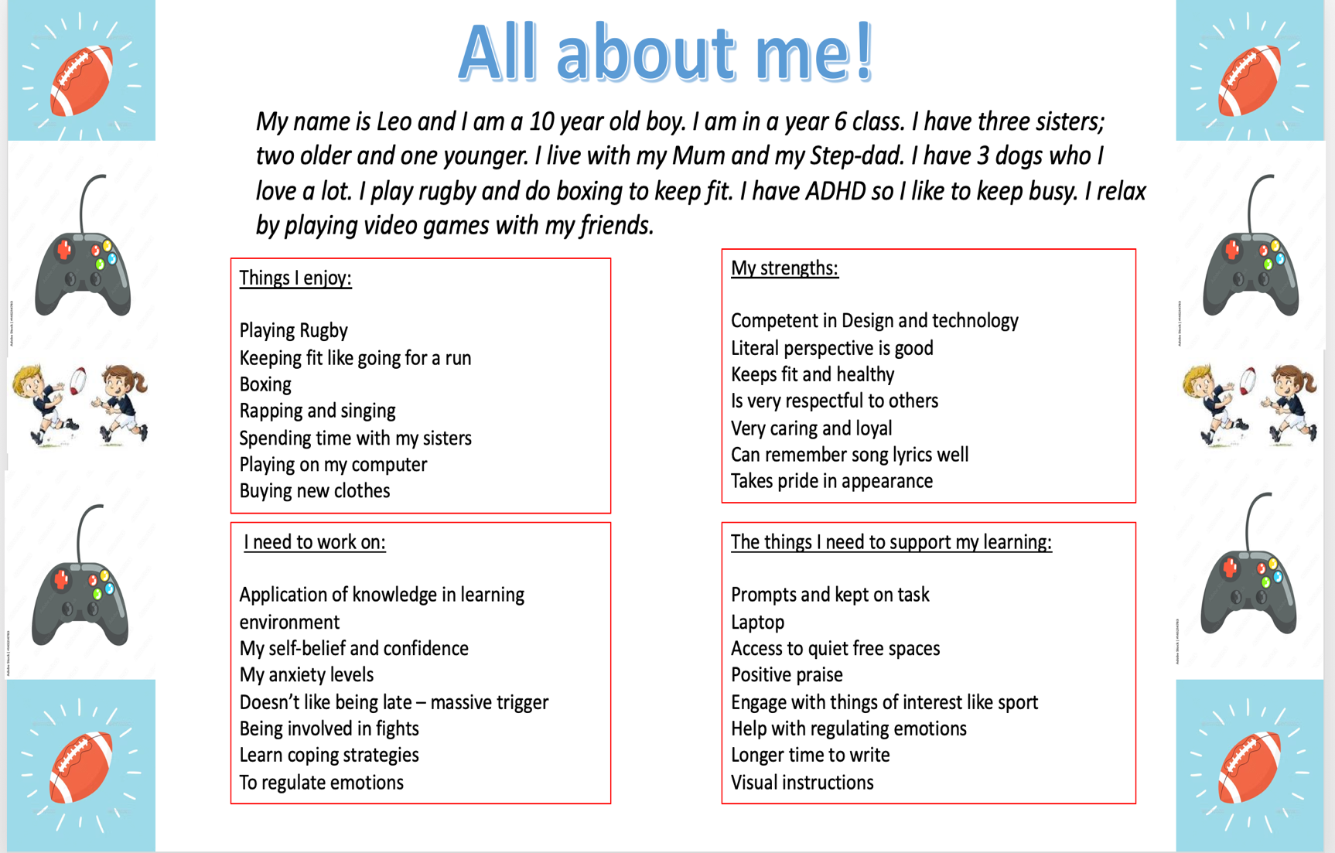

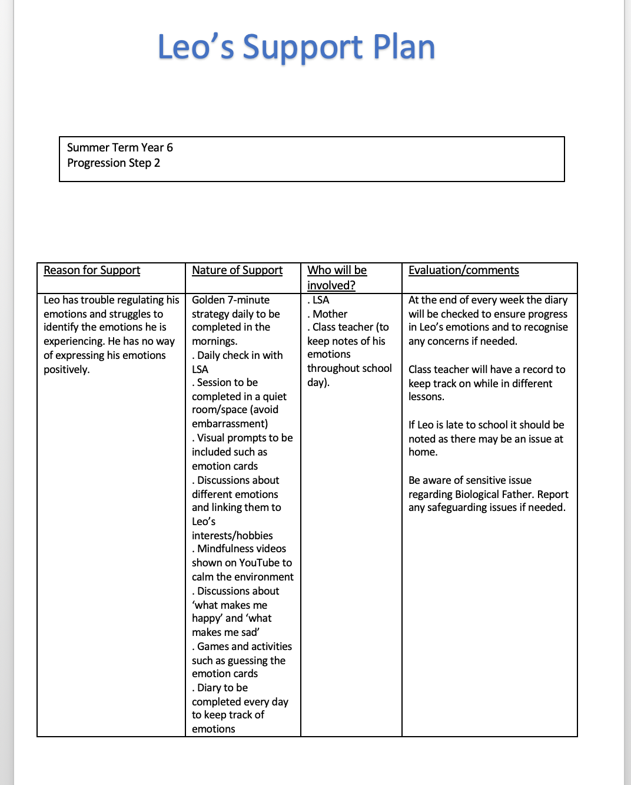

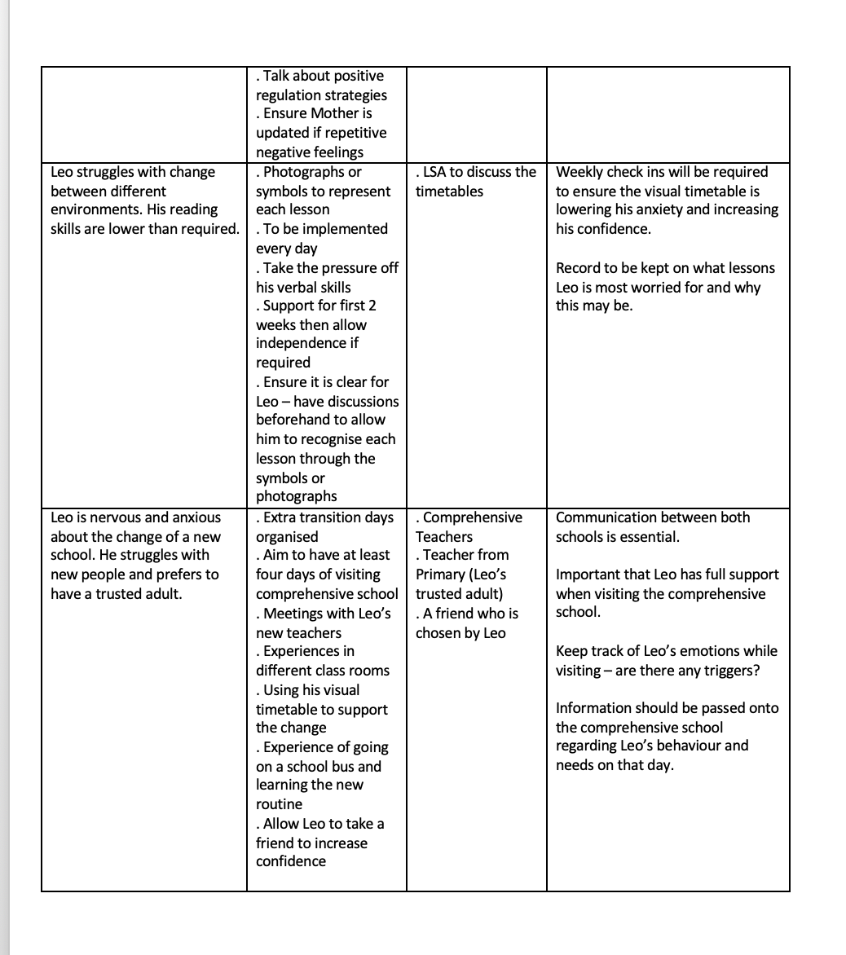

Reference list
Ainsworth, M.D.S. (1978). The Bowlby-Ainsworth attachment theory. Behavioral and Brain Sciences, [online] 1(03), p.436. doi: https://doi.org/10.1017/s0140525x00075828.
Allal, L. and Pelgrims Ducrey, G. (2000). Assessment of—or in—the zone of proximal development. Learning and Instruction, 10(2), pp.137–152. doi: https://doi.org/10.1016/s0959-4752(99)00025-0.
American Psychological Association (2021). Students Experiencing Low Self-esteem or Low Perceptions of Competence. [online] Apa.org. Available at: https://www.apa.org/ed/schools/primer/self-esteem#:~:text=Self%2Desteem%20and%20perceived%20competence.
Bedosky, L. (2022). Emotional Meltdowns: Why They Happen, How to Prevent Them | Everyday Health. [online] EverydayHealth.com. Available at: https://www.everydayhealth.com/wellness/united-states-of-stress/emotional-meltdowns-why-they-happen-how-prevent-them/.
BERA (2018). Ethical Guidelines for Educational Research, fourth edition (2018). [online] Bera.ac.uk. Available at: https://www.bera.ac.uk/publication/ethical-guidelines-for-educational-research-2018.
Black, P. and Wiliam, D. (2016). Inside the black box: Raising standards through classroom assessment - kappanonline.org. [online] kappanonline.org. Available at: https://kappanonline.org/inside-the-black-box-raising-standards-through-classroom-assessment/.
Brain and Spine (2019). What Happens During Fight or Flight Response. [online] Cleveland Clinic. Available at: https://health.clevelandclinic.org/what-happens-to-your-body-during-the-fight-or-flight-response/#:~:text=.
Broadbent, K. (2021). 4 Different Learning Styles: The VARK Theory. [online] Melioeducation.com. Available at: https://www.melioeducation.com/blog/vark-different-learning-styles/.
Camhs NHS (2021). Emotional Regulation: What is it? [online] Rdash.nhs.uk. Available at: https://www.rdash.nhs.uk/publications/camhs-emotion-regulation-what-is-it/.
Child Mind Institute (2023). Why Do Kids Have Trouble With Transitions? [online] Child Mind Institute. Available at: https://childmind.org/article/why-do-kids-have-trouble-with-transitions/#:~:text=Difficulty%20with%20transitions%20can%20manifest.
Dvir, Y., Ford, J.D., Hill, M. and Frazier, J.A. (2014). Childhood Maltreatment, Emotional Dysregulation, and Psychiatric Comorbidities. Harvard Review of Psychiatry, [online] 22(3), pp.149–161. doi: https://doi.org/10.1097/hrp.0000000000000014.
Edthena (2020). Why Student-Centered, Independent Learning is Important When Distance Teaching - Edthena. [online] Why student-centred independent Learning is Important when distance teaching. Available at: https://www.edthena.com/student-centered-independent-learning/#:~:text=This%20naturally%20creates%20flexibility%20for.
Engagement Education (2023). Making Individuals Matter. [online] Engagement in Education. Available at: http://www.engagementineducation.co.uk/stakeholder-engagement.
Estyn (2019). Supporting pupils with additional needs through change | Estyn. [online] www.estyn.gov.wales. Available at: https://www.estyn.gov.wales/effective-practice/supporting-pupils-additional-needs-through-change [Accessed 6 Nov. 2023].
First Discovers (2018). Child Development Theories: Carl Rogers. [online] First Discoverers. Available at: https://www.firstdiscoverers.co.uk/child-development-theories-carl-rogers/.
Freud, A. (2020). Transitions : Mentally Healthy Schools. [online] Mentallyhealthyschools.org.uk. Available at: https://mentallyhealthyschools.org.uk/risks-and-protective-factors/school-based-risk-factors/transitions/.
Geller, L. (1982). The Failure of Self-Actualization Theory. Journal of Humanistic Psychology, 22(2), pp.56–73. doi: https://doi.org/10.1177/0022167882222004.
Goldrich, C. (2022). How to Create a Successful Student-Teacher Relationship. [online] www.additudemag.com. Available at: https://www.additudemag.com/trust-student-teacher-relationship/#:~:text=Feeling%20safe%20and%20secure%20at.
Hallowell, E. (2022). Shame and ADHD: Understanding & Managing Negative Emotions. [online] www.additudemag.com. Available at: https://www.additudemag.com/slideshows/overcoming-adhd-and-shame/#:~:text=You%20may%20even%20feel%20like.
Hasan, S. (2020). ADHD and School (for Parents) - Nemours KidsHealth. [online] kidshealth.org. Available at: https://kidshealth.org/en/parents/adhd-school.html#:~:text=ADHD%20can%20affect%20a%20student.
he's-extraordinary (2017). HIIT for Kids - Improve Emotional Regulation In Just 7 Minutes Per Day. [online] Raising An Extraordinary Person. Available at: https://hes-extraordinary.com/improve-emotional-regulation-just-7-minutes-per-day.
Holt, J. (1995). How children fail. Reading, Ma. Addison-Wesley Publishing.
Horn, M. (2020). Trusted Adults And Their Importance On Teens. [online] Spark their Future. Available at: https://www.sparktheirfuture.qld.edu.au/trusted-adults/#:~:text=Research%20has%20found%20that%20young.
Hume, K. (2023a). Structured Teaching Strategies: A Series Article 2: Visual Schedules in the School Setting. [online] Available at: https://www.iidc.indiana.edu/doc/resources/structured-teaching-strategies-visual-schedules.pdf.
Hume, K. (2023b). Visual Schedules in the School Setting | Reading Rockets. [online] www.readingrockets.org. Available at: https://www.readingrockets.org/topics/autism-spectrum-disorder/articles/visual-schedules-school-setting#:~:text=A%20visual%20schedule%20provides%20a.
iQualifyuk (2023). Why is it important to identify and meet individual learner needs when teaching? – iQualify UK – Modern British Qualification. [online] Why is it important to identify and meet individual learner needs when teaching? Available at: https://iqualifyuk.com/why-is-it-important-to-identify-and-meet-individual-learner-needs-when-teaching/#:~:text=Evidently%2C%20it%20is%20paramount%20that.
Java Point (2023). Advantages and Disadvantages of Visual Communication - Javatpoint. [online] www.javatpoint.com. Available at: https://www.javatpoint.com/advantages-and-disadvantages-of-visual-communication.
John, P.J (2014). Holistic Approach in Education-An Overview. International Journal of Research in Social Sciences, [online] 7(4), pp.346–353. Available at: https://www.indianjournals.com/ijor.aspx?target=ijor:ijrss&volume=7&issue=4&article=026.
Kaczegowicz, C. (2023). Visual Aids: A Vital Tool for Students with ADHD. [online] Medium. Available at: https://medium.com/@ckaczeducation/visual-aids-a-vital-tool-for-students-with-adhd-bbf3a9eb5b25#:~:text=Visual%20schedules%2C%20such%20as%20visual.
Mahmoudi, Sirous|Jafari, Ebrahim|Nasrabadi, Hasan Ali|Liaghatdar, Mohmmd Javad (2012). Holistic Education: An Approach for 21 Century. International Education Studies, [online] 5(2), pp.178–186. Available at: https://eric.ed.gov/?id=EJ1066819.
Main, P. (2023). Bowlby’s attachment theory. [online] www.structural-learning.com. Available at: https://www.structural-learning.com/post/bowlbys-attachment-theory#:~:text=This%20theory%20proposes%20that%20the.
Morin, A. (2023). Self-Regulation Skills. [online] www.understood.org. Available at: https://www.understood.org/en/articles/trouble-with-self-regulation-what-you-need-to-know.
NHS Wales (2023). NEURODEVELOPMENTAL TEAM Visual Timetables What is a visual timetable? Why use a visual timetable? [online] Available at: https://bcuhb.nhs.wales/services/hospital-services/neurodevelopmental/documents/visual-timetable/#:~:text=A%20visual%20timetable%20shows%20what.
Open Society Foundations (2019). The Power of Letting Children Learn Together. [online] www.opensocietyfoundations.org. Available at: https://www.opensocietyfoundations.org/explainers/value-inclusive-education#:~:text=Inclusive%20education%20values%20diversity%20and.
Ph.D, J.S. (2016). Martin Seligman’s Positive Psychology Theory. [online] PositivePsychology.com. Available at: https://positivepsychology.com/positive-psychology-theory/#:~:text=Seligman.
Psych Central (2022). ADHD Struggles: 8 Obstacles and How to Overcome Them. [online] Psych Central. Available at: https://psychcentral.com/adhd/adhd-struggles-coping-tips.
Recruiting (2022). 6 Tips on How to Adapt to a New Work Environment - Eleven Recruiting - IT Recruiting, IT Staffing and IT Jobs. [online] Eleven Recruiting. Available at: https://elevenrecruiting.com/how-to-adapt-to-a-new-work-environment/#:~:text=to%20your%20organization.-.
Rhondda Cynon Taf (2023). Transition information for Early Years | Rhondda Cynon Taf County Borough Council. [online] www.rctcbc.gov.uk. Available at: https://www.rctcbc.gov.uk/EN/Resident/SchoolsandLearning/AccessandInclusiontoEducation/WorkinginPartnershipwithParents/SchoolTransitionAdvice/TransitioninformationforEarlyYears.aspx#:~:text=Vertical%20transitions%20are%20transitions%20which.
Sinfield, J. (2019). Transitions When You Have ADHD - Untapped Brilliance | Adult ADHD Coach | Jacqueline Sinfield. [online] Untapped Brilliance. Available at: https://untappedbrilliance.com/adhd_and_transitions/.
Sir Al Aynsley-Green (2010). Should the Nurture of Children be Everybody’s Business? [online] The RSA. Available at: https://www.thersa.org/video/events/2010/06/should-the-nurture-of-children-be-everybodys-business [Accessed 25 Oct. 2023].
Source Kids (2019). Emotional regulation: how children learn to manage their feelings & how you can help. [online] Source Kids. Available at: https://www.sourcekids.com.au/emotional-regulation-how-children-learn-to-manage-their-feelings-how-you-can-help/#:~:text=Emotional%20regulation%20is%20essential%20to.
Springer (2023). European Journal of Psychology of Education. [online] Springer. Available at: https://www.springer.com/journal/10212.
Twinkl (2023). Four purposes of the curriculum . [online] Twinkl.co.uk. Available at: https://www.twinkl.co.uk/resources/foundation-phase-welsh-primary-resources-classroom-management/curriculum-for-wales-cymru-wales/four-purposes-of-the-curriculum-curriculum-for-wales-cymru-wales.
UNICEF (2023). The Right to Education - UNICEF UK. [online] Rights Respecting Schools Award. Available at: https://www.unicef.org.uk/rights-respecting-schools/the-rrsa/the-right-to-education/#:~:text=The%20Right%20to%20an%20Education.
Veazey, K. (2022). Emotional self-regulation: Importance, problems, and strategies. [online] www.medicalnewstoday.com. Available at: https://www.medicalnewstoday.com/articles/emotional-self-regulation#summary.
Visual Learning Style: Definition & Characteristics Video (2020). Visual Learning Style: Definition & Characteristics - Video & Lesson Transcript | Study.com. [online] Study.com. Available at: https://study.com/academy/lesson/visual-learning-style-definition-characteristics.html#:~:text=The%20visual%20learning%20style%2C%20often.
Watts, S. (2019). What Is a Stakeholder in Education? - Definition & Examples - Video & Lesson Transcript | Study.com. [online] Study.com. Available at: https://study.com/academy/lesson/what-is-a-stakeholder-in-education-definition-examples.html.
Welsh Goverment (2023a). Children’s rights in Wales. [online] GOV.WALES. Available at: https://www.gov.wales/childrens-rights-in-wales#:~:text=Children%20and%20young%20people%20aged.
Welsh Goverment (2023b). Developing a vision for curriculum design - Hwb. [online] hwb.gov.wales. Available at: https://hwb.gov.wales/curriculum-for-wales/designing-your-curriculum/developing-a-vision-for-curriculum-design#:~:text=Curriculum- [Accessed 6 Nov. 2023].
Welsh Goverment (2023c). Enabling learning - Hwb. [online] hwb.gov.wales. Available at: https://hwb.gov.wales/curriculum-for-wales/designing-your-curriculum/enabling-learning#:~:text=A%20strong%20sense%20of%20belonging.
Welsh Goverment (2023d). Inclusion and pupil support: guidance for schools and local authorities. [online] GOV.WALES. Available at: https://www.gov.wales/inclusion-and-pupil-support-guidance-schools-and-local-authorities.

Welsh Goverment (2023e). Learners’ well-being, equity and inclusion - Hwb. [online] hwb.gov.wales. Available at: https://hwb.gov.wales/evaluation-improvement-and-accountability/the-national-resource-evaluation-and-improvement/learners-well-being-equity-and-inclusion.
Welsh Government (2019). Professional Standards for Teaching and Leadership. [online] Available at: https://hwb.gov.wales/api/storage/19bc948b-8a3f-41e0-944a-7bf2cadf7d18/professional-standards-for-teaching-and-leadership-interactive-pdf-for-pc.pdf.
Welsh Government (2020). The additional learning needs transformation programme: frequently asked questions [HTML]. [online] GOV.WALES. Available at: https://www.gov.wales/additional-learning-needs-transformation-programme-frequently-asked-questions-html.
www.rtor.org, G.A. for (2021). How to Adjust to a New Environment as a Person with Anxiety. [online] Dealing with anxiety of a new envrionment. Available at: https://www.rtor.org/2021/07/30/how-to-adjust-to-a-new-environment-as-a-person-with-anxiety/.

