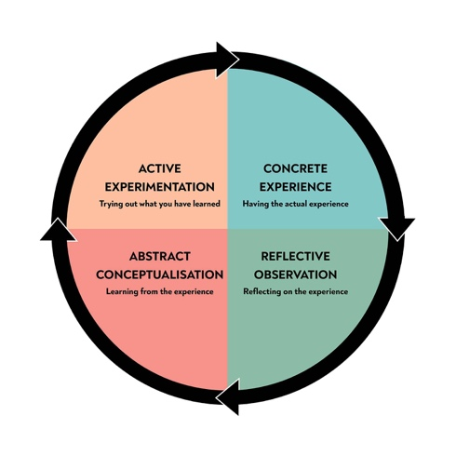
What is reflection and reflective practice?
Within early years it is important to understand both what reflection and reflective practice mean and how they are portrayed within the early years sector. As an early year practitioner it is fundamental to become a reflective thinker and how it can be effectively used within practice.

What is reflection? Brock 2015 argues that reflection is an activity that is already ingrained into our lives already in many forms and is important in the 21st century within educational and employment workforce. Where reflective evaluations are undergone in the forms of reflective portfolios and learning journals where employers and student’s performances are personally reflected upon in order to promote their professional practice. Hargreaves and Page (2013) suggest that reflection as a whole is greatly promoted for effective development, with regards both to academic and employment grounds it helps encourage professional codes. Furthermore being reflective as a practitioner is argued to lead to better learning styles, understanding and gives practitioners positive opportunities to learn, develop and improve.
Both reflection and reflective practice are key values of early years professionals and are regarded as vital for academic progression and professional training. It is important that childcare and early years professionals are able to actively use personal reflection within practice and personal life in order to become more articulate in all areas of life. This as a result will develop their educational aims and outcomes alongside positively developing their own personal skills.
Reflective practice is regarded as an ongoing cycle that is important within the early years sector, for practitioners it is the process in which they take the time to stop, think, challenge and in result make changes to their practice in order to get a better and more depth understanding of the sector and their performances helping to advance both their early years skills and the outcomes for children through their learning and development.
The importance and significance of reflective practice within the early years sector
Bronwen Middleton Student: 2217677 Module: ECEY4002/Cç

Reflection within early years settings

Reflection is vital for early years professionals especially directly within their careers. It enables them to understand their practise, self-evaluate and be aware of needs to improve or seek academic and professional development. Being able to effectively reflect as a practitioner is important in not only benefitting career opportunities and improving personal skills but also being able to give children and young people the best start in life and equipping them with the right recourses and care in order for them to be able to achieve the greatest outcomes. Ensuring that as the professional practitioner you give every child the best opportunities to thrive. This is argued to be successful if practitioners are able to use reflection and reflective practise constructively.

Within the early years sector to be able to undergo successful reflection it is important to have good rapports and bonds with fellow colleagues in order to be able to work effectively as team. Being a team player alongside promoting good communication skills is vital in ensuring that reflection can be undergone successfully within the workplace. Furthermore having good rapports with not only the children but also their families is regarded as vital to enable early years educators to be good professional practitioners. This all sits alongside using reflection effectively, by being able to take a step back from individual practise it enables practitioners to self-evaluate and make positive changes to their work that will benefit those within the early years settings.
Paige- Smith (2011) argues that within early years settings there are a number of different aspects of practice that can be reflected upon. Which can be actively developed, changed and positively challenged. This involves working with parents, inclusive education, and other professionals. By working together it enables practitioners to share skills and opinions leading to problem solving, discovering solutions and both giving and receiving effective constructive feedback which is suggested to when working together positively links different approaches to children’s learning and development alongside their well-being. it also helps improve and develop provisions for children through practitioners accepting and understanding how to go about changing ways of teaching and improving skills for future benefits. Furthermore Paige- Smith (2011) suggests that a shared understanding of reflection within practice amongst the community of practitioners helps to develop skills of understanding and how to adapt and link theory to practice, in order to develop and improve skills within the early years workforce.

Schon(1983) writes about the importance of reflection in allowing practitioners to spend vital time exploring both group actions and individual practice. As a result, it helps practitioners to question and raise new ideas regarding continuous provision for children. Which leads to practitioners together making positive changes and adaptions to help and support each individual child within their care.
Importance of reflection within professional practice

Siolta (2006) suggests that practising in a professional manner requires individuals to have the correct skills, knowledge, values and attitudes that are appropriate and responsible for their role within early years. it is argued to be success alongside practitioners being able to regularly reflect upon their own practice and engage in ongoing, supportive and positive professional development. As a practitioner within the early years sector it is important to portray professionalism. This role comes with many skills, one in which is being reflective within a professional manner. Brock (2015) proclaims that the role of a professional practitioner carries different challenges not only with regards to the aspects of upholding the quality of provision, understanding every child’s individual needs and being able to work alongside other practitioners. However being a professional practitioner presents individual challenges with regards to reflection and reflective practice. Therefore being a successful reflective thinker requires practitioners to address those questions that have a purpose within developing your practice. As practitioners gradually develop their professional thinking and create professional knowledge it in result will help them to practically apply this knowledge and understanding to their practice. Which not only benefits their educational understanding and skill sets but also positively impacts on the wellbeing and education of each and every child within their care.
Additionally it is important for practitioners to use the outcomes of reflective learning to adapt and develop skills including having appropriate training and making changes when appropriate, being able to self evaluate as a practitioner is a vital quality of the professional practitioner.

When using reflective learning within professional practice it opens many doors for good personal development which then leads to better work ethics and practitioners being able to better the outcomes and experiences of all children within their care, truly making a positive difference to both their personal and educational development. This can be seen to be adapted through the on going care children receive within their early years settings, being able to plan activities and undergo observations with children is another way of using reflective practice effectively. Practitioners reflecting on the adult lead activities they set out and making changes that will benefit the educational outcomes for the children is a fundamental aspect of professional practice.
Simple Psychology.org (2013)

§
Different models and theories of reflection

Within the early years sector it is key to understand the many different models and theories that are linked to reflective practice and how they can be positively linked to practice. These theories help and guide practitioners in how to use reflective learning and gives strategies to implement within their roles.
Each theory and model have their own ideas and outcomes however they are relatively linked and all understand and show the importance of reflection within the early years.
Firstly the Gibbs reflective cycle is one of the most known and commonly used cycles within the early years sector. The reflective cycle was created and developed by Graham Gibbs in 1988 to give solid structure to learning from experiences which can be adapted in many different situations. The model provides a framework for examining experiences and given its cycle layout argues that it can be repeated many times over. Allowing practitioners to learn from experiences that either went well or did not go so well, being able to make constructive outcomes from both and understanding that as a practitioner we can gain knowledge and understanding from negative experiences as well as positive helps to create the all rounded professional practitioner.

The cycle covers six stages these include:
- The description of the experience
- Feelings and thoughts regarding the experience
- Evaluation of the experience, both negative and positive.
- Analysis to make an understanding of the situation
- Conclusion regarding what has been learned from the initial experience and how things can be changed and adapted going forward.
- The end action plan for how to deal with similar situations going
- forward and how changes can be implemented.

The Gibbs model is a good way of understanding and working through
experiences with many different practitioners and agencies. Gibbs
originally advocated its use in repeat situations and can be adapted
effectively. It helps practitioners to reflect on experiences in depth leading to them
being able to plan for each possible outcomes.

Another reflective model that is widely used within early years is Kolb’s learning styles and the experimental learning cycle. Although this is a much smaller model it is still as effective as Gibbs cycles. David Kolb published his experimental learning cycle in 1984, he argues that learning involves the acquisition of different abstract concepts that can be flexibly applied in a range of situations. He suggests that new concepts come directly from new experiences being provided so that practitioners are able to continuously learn and adapt.

“Learning is the process whereby knowledge is created through the transformation of experience” (Kolb, 1984 p.38)

Kolb’s theories combine a four stage learning cycle alongside four learning styles and is argued to provide a powerful foundation for learning and development within the early years. it is the ideal process where knowledge is created through different experiences. Kolb’s theories and cycles have positively influenced the work of teachers, early years practitioners and even worldwide. It is regarded as a key aspect of training within many workplaces.
The core of Kolb’s experimental learning theory includes the four stages alongside the four learning styles and as practitioners go through the different stages it enables them to convert experiences into key knowledge.
The experimental learning cycle helps practitioners to understand four key aspects that are important within the early years especially with regards to reflective learning, these are experiencing, reflecting, thinking and acting.
He describes the four stages as the concrete experience, the abstract conceptualisation, reflective observation and the active experimentation. Together these aspects help and assist practitioners in transforming their learning and knowledge to benefit both themselves and others with regards to early years.

Furthermore Kolb’s learning theories can be used effectively within early years practice in many forms and can actively help practitioners to learn new things from experiences and question their own knowledge. This can be undergone through trail and error as practitioners experiment and reflect throughout practice in order to reach desired conclusions.

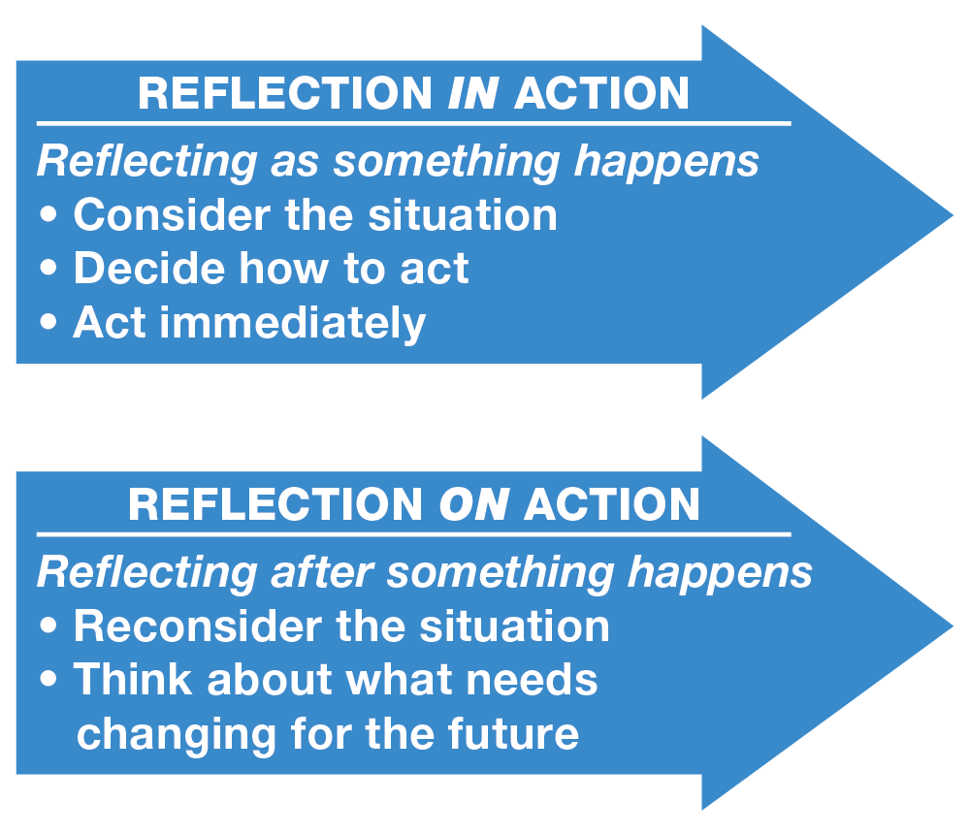
Schons theory on reflection

Schons (1991) created his reflection in action and reflection on action model which provides additional understanding with regards to making a distinction between reflection during an event and the reflection that comes after the event. Reflection in action is regarded as reflection that is undergone as the experience is happening whereas reflection on the experience is the reflection that occurs after the experience, both as important as each other for effective learning.
His model is particularly important for the professional practitioner within practical situations in early years. it helps practitioners to think on the spot and try new experiences in order to make all round improvements.
Reflective learning can come from negative experiences
as well, where things may have not gone to plan
therefore lessons can be learnt and provision can
be adapted. Using Schons framework allows
practitioners to capture the important aspects
of reflective practice.

Nasser Al-Amrani (2021)
Conclusion

As an early years practitioner it is important to understand the different concepts of reflection and reflective learning and how it benefits many areas within early years not just learning and development. To be able to give the most effective care for those within early years settings it is essential for practitioners to seek to constantly improve provision in order to improve and advance the outcomes of children and young people. This is done effectively through important training and reflective skills both individually and within a team. Ensuring that theories and models are adapted to practice within the setting will lead to being almost sure that positive outcomes will be seen and new goals will be met with productivity.
How does reflective practice improve the quality in early years care?

Reflective practice is a fundamental aspect of learning and development within the early years and helps aid the professional practitioner in gaining new skills and continuously improve the outcomes of children and young people. Being able to reflect from experiences within the workplace and come to good conclusions that lead to positive outcomes is important within early years setting, it helps practitioners to plan effectively for children within their care and provide them with the right adult led and continuous provision that not only each and every child will thrive from but also gain developmentally.
It also helps practitioners to gain new skills and learn from constructive criticism as the outcomes of experiences and reflecting on them. For example a practitioner undergoing an observed adult led activity can led to understanding both positive and negatives from the observation and helps build skills within practitioners that enables them to think about their own performances and how they are able to improve in order to excel within their position with the early years sector.

Crowes Associates Ltd (no date)

Reference List
Bronwen Middleton Student: 2217677 Module: ECEY4002/Cç

Hargreaves, J. and Page, L. (2013) Reflective Practice. 1st ed. Oxford: Polity press

Paige-Smith, A. and Craft, A. (2011) Developing reflective practice in the early years. 2nd ed. Berkshire: Open university press

Brock, A. (2014) The early years reflective practice handbook. Oxfordshire: Routledge.

Schon, D,A. (1983) The reflective practitioner: how professionals think in action. Newyork: Basic books.

Gibbs, G. (1988) Learning by doing: a guide to teaching and learning methods. Further education unit. Oxford: Oxford polytechnic

Simple Psychology (2017) The experiemential learning cycle [online image] Available at: https://www.simplepsychology.org/learning-kolb.html (Accessed: 22 October 2022)

Crowes Assosiates Ltd (no date) Gibbs reflective cycle [online image] Available at: https://www.crowes-assosiates.co.uk/coaching-tools/gibbs-reflective-cycle.pdf (Accessed: 23 October 2022)

L&D, Learning theory (2021) What is Kolb’s experimental learning theory. [blog] 2 Nov. Available at: https://www.growthengineering.co.uk/kolb-experimental-learning-theory/ (Accessed: 22 October 2022)

Open Library (2021) Reflective practice in early years education. [online image] Available at: https://ecampusontario.pressbooks.pub/reflectivepracticeinearlyyears/chapter/3-3-donald-schon/ (Accessed: 22 October 2022)

Schon, D,A. (1991) Reflective writing. Available at: https://libguides.hull.ac.uk/reflectivewrititng/schon. (Accessed: 24 October 2022)

Kolb, D. (1984) Experimential learning: experience as the source of learning and development. New jersey: Prentice- Hall.

Siolta (2006) The national quality framework for early childhood education. Dublin: CECDE

