ACDB5002 Electronics 1

Designing an Automatic Traffic Light Controller for a T- Junction Road.

Charles, 2420823

Embedded Electronic Systems
Contents
Abstract (130) 3
I Introduction 3
II Understanding traffic light systems 3
III System outline 5
A Regulatory considerations 5
B System design 7
IV Circuit design and simulation 9
A Components 9
B Pin selection 11
C Proteus simulation 12
C Breadboard prototype 14
V System code 16
A Control Strategy and Program Structure 16
B Functional Design 17
C Detailed Code Analysis and Execution 18
VI Firmware testing 26
VII Potential design changes 27
VIII Conclusion 28
References 29
Appendices 31
Appendix A: System requirements 31
Appendix B: Firmware 31

Abstract (130)
This report presents the design and implementation of a fixed-timing traffic light control system for a T-junction using a PIC microcontroller to provide predictable and safe traffic management. The system was developed to meet specific functional requirements, including a 40-second countdown cycle displayed on 7-segment displays, defined phases for each vehicular direction and dedicated pedestrian crossings. Relevant UK regulations and guidance were reviewed to inform the design.
The circuit was simulated using appropriate discrete components in Proteus 9, followed by a breadboard prototype, for validating design choices. The control firmware was programmed in CCS C with a structured approach to replicate the required system behaviour.
The final system demonstrates practical skills, techniques and applying embedded systems principles within given constraints. Limitations and potential improvements are identified and considered throughout, allowing further development.

I Introduction
This report presents the design and implementation of a traffic light system, utilising a PIC microcontroller at a T-junction. Traffic lights are a critical part of maintaining road safety and improving efficiency, being an important application of embedded systems within modern infrastructure.
This report explores relevant regulations and guidance on timings, alongside common control methods and system considerations to ensure predictable and reliable operation whilst prioritising safety.
The aim of this project is to develop a functional prototype using discrete components, to meet specific design requirements in Appendix A. These include a 40-second countdown displayed on 7-segment displays, three vehicular traffic phases and a dedicated pedestrian crossing phase.
The system is programmed in C, compiled with CCS C, simulated in Proteus 9 and tested on a breadboard prototype.

II Understanding traffic light systems
For single junction controllers, three primary strategies are commonly used: Fixed timing (FT), Vehicle Actuated (VA) and Microprocessor Optimised Vehicle Actuated (MOVA). [1] [2] [3] [4, pp. para 9.3.1, 9.3.9]. These strategies vary in complexity, efficiency, and their ability to adapt to real-time conditions, dictating where these are best appropriate.
Standard terminology used to describe the structure and operation of traffic lights is summarised in Table IITable I], providing a foundation for analysing and comparing strategies in Table I.
Table I
Relevant terms used for traffic light systems
Term | Definition
Phase | Each individual direction within the junction that can be controlled. These are labelled alphabetically. [4, para 6.3.2]
Stage | A stage starts when any green light illuminates after being off. These are numbered. [5, p. 1]
Interstage | An interstage starts when a green light is extinguished, and ends when the next green light illuminates. These are numbered based off the previous and next stage. [5, p. 1]

Table II
Categories of traffic light controller
 | Description | Efficiency | Complexity | Cost
Fixed Timing | Follows a pre-determined order of operations for the timings of lights which is constantly repeated. | Medium:  Each stage and interstage has predetermined times, independent of traffic conditions at the junction. | Low:  The program can be hard coded since no response to inputs or outside events are required. | Medium:  Compared to other management systems like roundabouts, traffic lights are expensive to install and have ongoing costs.
Vehicle Actuated (VA) | Sensors, such as inductive loops or cameras, are installed to detect vehicles on each approach, influencing priority and phase selection. Timings can be extended up to pre-defined limits. | Medium/high:  Approaches with no vehicles can be skipped. Approaches with more vehicles can be given priority for longer, reducing stationary time per vehicle. | Medium:  Sensors require wiring into the microcontroller adding complexity to the circuit. A larger program is required for monitoring and acting upon detections. | Medium/High:  Includes the cost of fixed timing as well as sensors and more computing overheads, increasing installation and operating costs.
MOVA | Similarly to VA, MOVA uses a larger quantity of sensors which provides the ability to count vehicles entering and leaving intersections, monitoring speed and positions of vehicles. Timing can be adjusted actively to best benefit the situation present at the junction. | High:  The system can dynamically adapt to current conditions, allocating green to the highest demand and optimising signal change times. This increases throughput and reduces wait times by analysing vehicles positions, arrival rates and approximate speeds. | High:  A minimum of two sensors per lane is typically required, increasing data collection and processing by the controller. Requires a larger and more complex software code to operate. | High:  Additional computing resources and infrastructure increase costs further compared to VA.

A fixed timing control method was selected due to its simplicity to implement within a microcontroller-based system. VA and MOVA rely on sensors for dynamic timing, which is not compatible with the fixed time constraints explored in chapter III system outline. These methods would introduce additional complexity without functional benefits.
Although fixed timing lacks adaptability and may reduce efficiency, it’s most appropriate for this application, providing predictable and deterministic operation. Fixed timing provides the best demonstration for embedded systems within traffic lights with sequential logic with minimal complexity for the projects requirements.

III System outline
System requirements are defined prior to designing to guide both component selection and architecture design. Within embedded systems, this ensures that functionality and constraints are all translated into design decisions.
Requirements for this task can be split into design specific requirements, provided in appendix A and regulatory considerations.

A Regulatory considerations
UK traffic light regulations are governed primarily from the requirements of the Traffic Light Signals Regulations [6] and the Traffic Signals Manual Chapter 6, Traffic Control [4]. Whilst full real-world compliance is not required, these provide essential constraints which should be considered, which have already considered previous research on safety requirements and system behaviour. The key considerations relevant for this project are summarised in Table III, which directly inform predictable behaviour.
Table III
Considerations for the junction control based upon requirements
Reference | Description | Requirement
SI 2016/362  Sch 14 pt 1 para 4 (2) | Order of illumination | - Red  - Red and amber  - Green  - Amber
SI 2016/362  Sch 14 pt 1 para 4 (3) | Duration of red and amber | 2 seconds (± ¼ second)
SI 2016/362  Sch 14 pt 1 para 4 (4) | Duration of only amber | 3 seconds (± ¼ second)
SI 2016/362  Sch 14 pt 1 para 5 | Meaning behind each light combination. | Each combination of lights has a specific meaning. No other combination is allowed.
SI 2016/362  Sch 14 pt 1 para 10  (Sch 14 pt 2 para 11) | Wait light | Wait is only illuminated (in white or yellow) when an input for the pedestrians has been activated and not acted upon.
Derived from:  SI 2016/362  Sch 14 Pt 2 para 10 | Timer Display | The timer display must:  Match the phase timing and represent the time remaining.  Always decrease by one.  Only displayed during the relevant phase.
Traffic Signs Manual, Ch 6, para 3.1.1 and 3.4.3. | Number of signal heads | For vehicular traffic, a minimum of 2 heads are required.  “There will always be circumstances where extra signal heads are required.”
Traffic Signs Manual, Ch 6, para 3.5.4. | Filter arrows | When a filter arrow is used, there must be no conflicting movement/active collision points and drivers have exclusive right of way.
Traffic Signs Manual, Ch 6, para 6.5 through 6.13 | Recommended periods of time for stages | The recommended time for inter-green periods should be calculated.**  Recommended minimum green time is 7s.
Traffic Signs Manual, Ch 6, para 11.7.6 and table 11-1. | Recommended pedestrian cycle timings | Invitation to cross: 6-12 seconds.  Black out to continue crossing: 3-15 seconds.  All red: 1-3 seconds.

B System design
Traffic light-controlled T junctions have many strategies for operation based on generic and local requirements. Two common approaches were considered where safety is directly controlled by the system and not driver assessments of the junction.
Method one assigns each vehicular approach a dedicated phase. This approach is common as there is only one state per approach, and the simplest for vehicles.
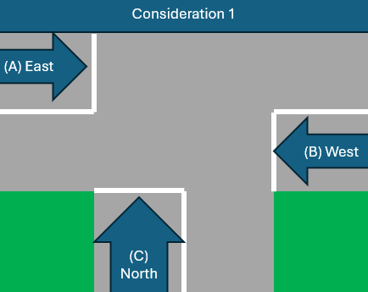
Fig. 1 Image showing approaches into a T-junction.
Method two allows movement which avoids conflict points with the prioritised phase explored in method one to operate simultaneously. This improves efficiency, increasing throughput however requires careful consideration to avoid unsafe combinations.
Introducing additional green lights increases system complexity, and increases the risk of driver misinterpretations, reducing safety.
Conflict points occur where traffic movements intersect within the junction, creating potential collision risks. For example, a north-bound vehicle turning right does not conflict with west-bound traffic turning left but would with other westbound and eastbound movements.

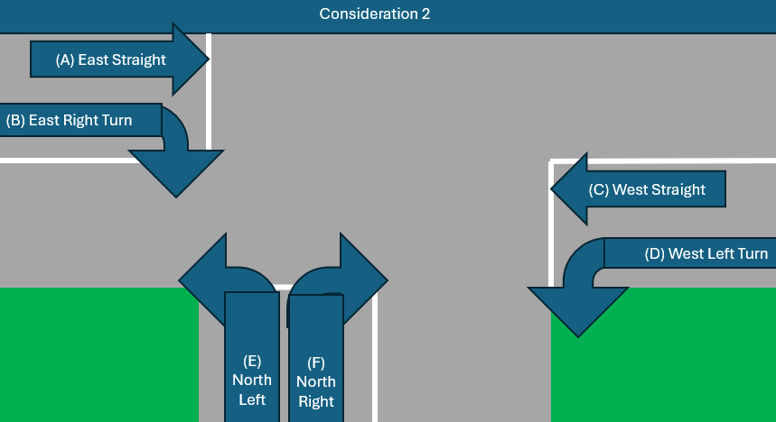
Fig. 2 Picture showing possible exits from a T-junction
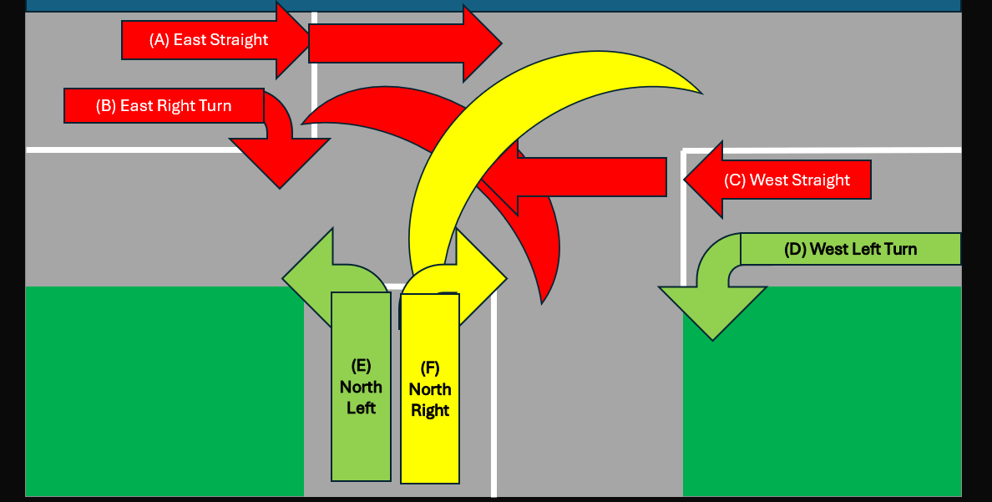
Fig. 3 Image showing directions which create a conflict point with right turning traffic from the minor road
Figure 1 demonstrates the timings for the first two considerations based on the timings for each direction within Table IV based on the findings from Table III .
Table IV
Phases within a cycle of the junction traffic lights program.
Prioritised phase | Action
1: East Traffic (Main Road) | Time displayed: 40 to 31 seconds.
2: West Traffic (Main Road) | Time displayed: 30 to 21 seconds.
3: North Traffic (Minor Road) | Time displayed: 20 to 11 seconds.
4: Pedestrian cycle | Time displayed: 10 to 0 seconds.

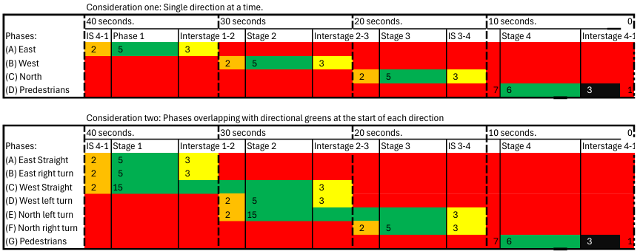
Fig. 4 Picture showing phases and stages of potential designs
For simplicity of the system design and maximum safety, the first method was selected. This ensures that every output is directly controlled from the PIC, due to running out of digital pins. Additional pins can be acquired through analogue pin configuration, or an I/O extender.

IV Circuit design and simulation

A Components
PIC16F877A
The widely used PIC16F877A [7] was selected because of its programmability and ability to control the entire system. There are sufficient I/O pins for the current design and includes built in features such as timers and interrupts. It has also successfully been used in similar circuits [8].

20MHz crystal oscillator
A 20MHz crystal oscillator was chosen for the external clock being a standard operating frequency [7, p. 3] providing simplicity, reliability and sufficient instruction cycles for the task. The crystals load capacitors were not calculated for a perfect 20MHz, since the timing is not operationally critical.

Common anode 7-segment display
Common anode displays source power from a rail, through the LED segments, towards ground. In this circuit ground is the PIC I/O pins. These were chosen over common cathode due to current limitations on the microcontroller, mentioned in the PIC16F877A datasheet [7]. By sinking current for the displays, this reduces stress on the PIC whilst avoiding limits, improving reliability. Common anode requires inverting the output logic passed to the pins.

LEDs and traffic lights
LEDs are used in the prototype, replacing traffic light heads due to their simplicity, availability and ease of use. They function the same while operating at low power allowing direct control from the PIC rather than a separate power source. They can be replaced with higher current draw elements by incorporating switching devices such as transistors or FETs, turning the output into a bias data line.

Resistors and resistor network
Resistors limit current flow and protect components that don’t self-regulate current, such as LEDs. By limiting current, resistors prevent damage due to overcurrent to other components.
In a system ready for implementation, each component would have a resistor calculated for consistent brightness through the system. For this proof of concept, the same resistor value reduces complexity whilst achieving the aims of the task, provided it is calculated properly to ensure safe operation.
20mA is considered the maximum current to operate LEDs safely. The forward voltage drop (V_{f}) of red LEDs is commonly 1.2V, yellow are around 1.8V and greens are 2.2V.
The minimum resistor value to use in series with LEDs can be calculated by
$$R_{min}=\frac{V_{max}}{ I_{max}}=\frac{V_{s}-V_{f}}{I_{max}}$$

$$R_{min}=\frac{5V-1.2V}{20mA}=\frac{3.8V}{0.02A}=190Ω$$

190Ω Is the minimum resistance that is considered safe with the LEDs in this design. 220Ω is typically used as a current limiting value for LEDs when connected to a 5V supply. This ensures current is safely limited while ensuring sufficient brightness across the range of colours and voltage drops of different LEDs. The current flowing can be calculated by
$$Imax=\frac{Vmax}{R}$$
The current flowing through red LEDs with the lowest forward voltage drop is therefore:
$$\frac{5V-1.2V}{220Ω}=\frac{3.8V}{220Ω}= 17.3mA$$
And for green LEDs the current flow is:
$$\frac{5V-2.2V}{220Ω}=\frac{2.8V}{220Ω}= 12.7mA$$
A resistor network combines multiple resistors into a single package, reducing complexity, wiring and component count.

Microcontroller outputs
In typical embedded designs utilising microcontrollers, output pins are treated as signal lines rather that sourcing or sinking current. Higher current load are driven through bias components such as transistors or FETS, preventing the microcontroller from sourcing too much current.
The prototype uses low current components within the capabilities of the PIC, and proteus does not simulate current limits, so this design is safe to operate without the additional components.

B Pin selection
Assigning the PIC pins to the correct components is crucial to ensure the most efficient layout of the board, optimising the potential software implementations and minimising additional components available within the PIC. The configuration in Table V justifies the allocation in the current design.
Table V
Pin selection on the PIC16F877A
PIC16F877A Pins | Component | Justification
RB0 | Button | Utilises the external interrupt capability, providing an immediate response, avoiding continuous pulling.
RC0-RC6 and  RD0-RD6 | 7-seg displays | Grouping the display pins to the same port simplifies the design, and allows simpler code within the firmware.
RB1-RB3, RB4-RB6, RE0-RE2 | Vehicular heads | Grouping vehicular approach heads together on the same port reduces complexity.
RA0-RA1 | Pedestrian red and green | Grouping pedestrian heads together on the same port reduces complexity.
RB7 | Pedestrians wait light | RB7 is the most suitable remaining pin. The remaining port A pin default to analogue operation, and the empty 7-seg display pins are overwritten in the correct code implementation for simplicity.

C Proteus simulation
The circuit design was simulated and tested using in Proteus 9 to validate the chosen design, and components functioned as expected, along with the timing. The justifications for the components used in the simulation, are listed in Table VI.
Table VI
Components used
Component | Proteus part used | Description
Microcontroller (µC) | PIC16F877A | Central processing unit, controlling operations and sequences.
Crystal oscillator | Generic crystal | Generates a clock signal for the PIC, required for timing operations within the controller.
Capacitors | Generic capacitor | Used to store energy, alongside the crystal to ensure consistency.
Resistor | Generic resistor | Limits current and provides voltage drops, protecting components.
Resistor network | RES16DIPIS | 8 parallel resistors in a single package, simplifying the circuit.
Traffic lights | Traffic Lights | Represents traffic signal heads with the 3 colour outputs in one device.
LED | Active LED | Visual representation of other outputs for heads.
7-segment display | 7-segment-common-anode display | Displays the countdown 40-0 using 0-9 on each component.
Button | Generic button | Used as an input to change the operation of the system.
The simulation prioritised a clear and intuitive layout, representing a realistic implementation. The microcontroller and its supporting components were grouped together, with connecting nodes to junction components.
The junction was visually represented on top of an image designed on a T-Junction, with the component’s placement on each road segment. The placement is not optimal due to component size restraints, and wire nodes in proteus not showing above images.
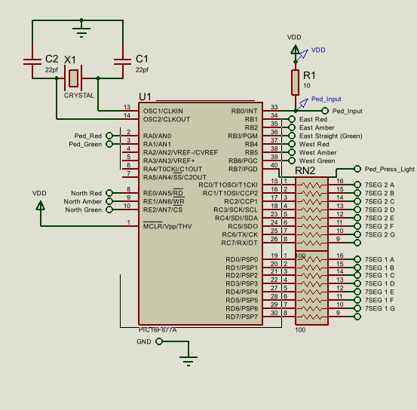
Fig. 5 Picture of the microcontroller and surrounding components within Proteus 9
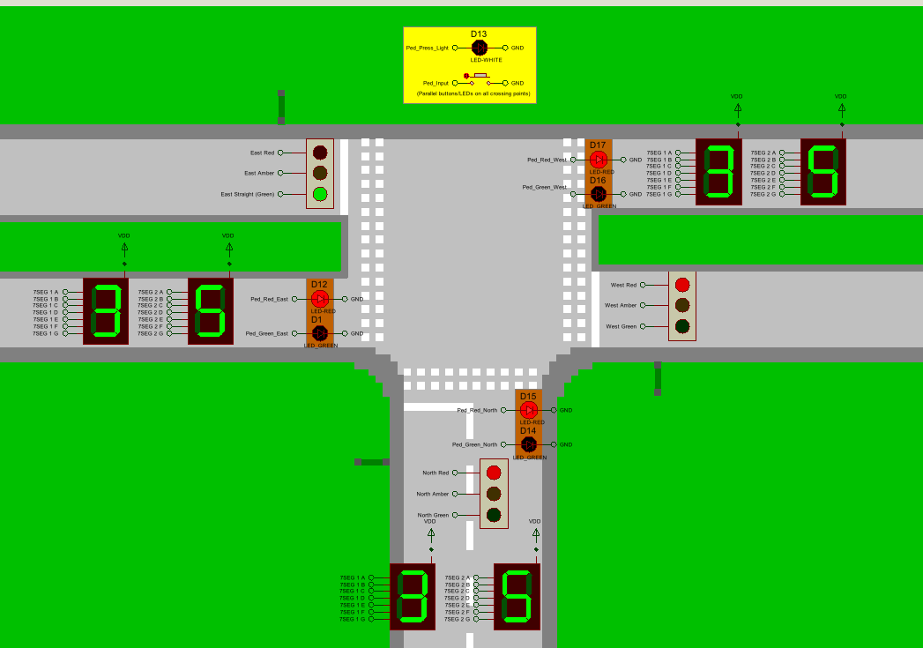
Fig. 6 Picture showing the junction layout of the simulation.

Several issues were encountered within the simulation, primarily due to incorrect circuit layouts, and incorrect component values. Sometimes the HEX file would be dropped from the PIC within the simulation, requiring it to be re-loaded.

C Breadboard prototype
The breadboard prototype was programmed through a PICKIT 3 programmer and MPLAB IPE V6.15. The purpose is to demonstrate the concept, rather than the full design or a system ready for implementation.
Figures 7-10 show the breadboard layout, with the PIC centrally positioned with surrounding components positioned based on their pin location. This maintains a relatively organised breadboard which minimises crossing wires where possible. Due to the port C and D pins being split, it can’t be entirely eliminated.
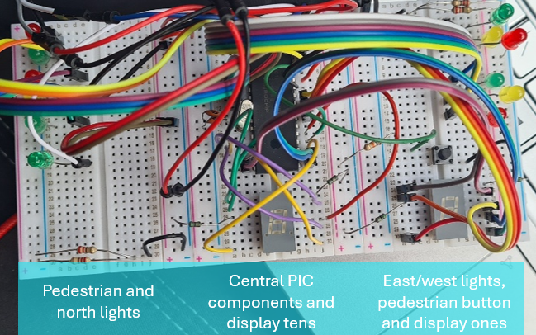
Fig. 7 Picture of the prototype
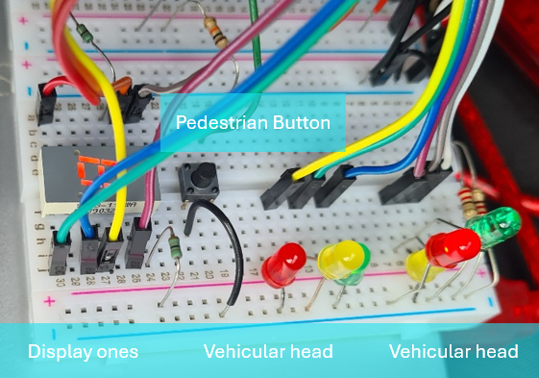
Fig. 8 Picture of the prototypes right side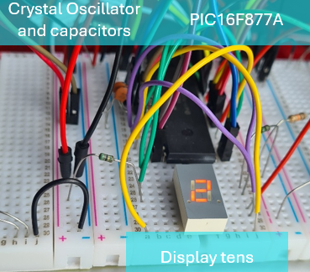
Fig. 9 Close up image of the prototypes central section

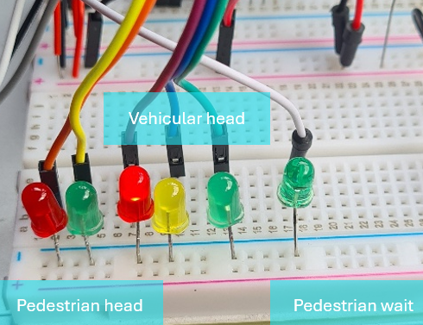
Fig. 10 Picture of the prototypes left side
The prototypes right side features the east and west vehicular heads, the pedestrian button, and the ones digit 7-seg display. The push button is positioned for accessibility from the side, with wires arranged to avoid obstructing the button.
The prototypes left side features the north and pedestrian lights interfaced on ports A and E. The pedestrian wait light was routed across from the right side to align with the pedestrian head lights, improving monitoring during verification without observing the entire board.
The current distribution of LEDs results in two or three lights illuminated per side at any time. Safe current limiting can be achieved with two, 220Ω resistors in parallel. When the third LED is illuminated, a reduction in brightness occurs, which is considered acceptable for the proof of concept as explained in chapter IV.

V System code

A Control Strategy and Program Structure
The firmware was written in C, and complied using CCS C. Because compiler implementations vary, portable code improves reliability and maintainability, ensuring consistent behaviour across systems.
Various program structures were considered for implementing the system control firmware, and are shown in Table VII.

Table VII
Control strategies comparisons
Design approach | Description | Advantages | Disadvantages
Nested for loops | Outer loops control timed tasks such as changing lights, with inner loops controlling repetitive tasks such as updating displays. | Simple to implement and understand. Suitable for small systems. | Blocking structures reduce responsiveness. Timing is dependent on execution speed. Difficult to expand upon, requiring code re-writes.
Parameter driven | The system dynamically determines the outputs based on configuration variables. | Extremely flexible with modifications like timing made by changing variables and not logic. | Highly complex code reducing readability, whilst making implementation and debugging harder.
State machine | The system transitions through pre-determined states representing the traffic light stages. | Simple to understand, reflecting visible output conditions. States can easily be skipped. Works well with interrupts. | Requires careful considerations to avoid soft-locks or invalid transitions.

A state machine was selected as it provides a visibly clear structure representing the traffic light sequence. This method maintains responsiveness by avoiding blocking code when implemented correctly, supporting real-time responsiveness with or without interrupt driven inputs. The relatively small system design allows for exhaustively testing the system and all states to ensure correct operation.

B Functional Design

Unlike tradition state machines implementations where time is reset changing state, this implementation uses a single global time variable. This approach simplifies updating displays, debugging, and state referencing, with all timing reliant on a single value. This reduces the number of calculations required for multiple variables, whilst simplifying debugging for looking at one value when the issue is reliant on another.
A lower power sleep() function was initially considered to reduce power consumption of the PIC between required operations. This introduces many problems which involve disabling features such as Timer 1, used for timing, response times are increased, and debugging is complicated. Given the safety priority, and traffic lights often powered from mains, continuous function was considered more appropriate.

C Detailed Code Analysis and Execution

This section analysis the firmware implantation, alongside supporting flowcharts. The firmware is structed with four main sections; Setup and definitions, function declarations, the function initialisation and the main execution loop.

The first line imports the PIC16F877A header files. This requires the fuses, which are configuration bits settings for the PIC operation. A clock speed is also defined. The rest of the setup is summarised in Table VIII.

Table VIII
Sections of setup
Section | Purpose
Pin definitions | Uses #define to assign suitable names to pins based on their function, improving readability and ease of future modifications.
Bitflags | Used as inputs for multiple functions, simplifying the code and improving readability.
Enums | Represents state names using descriptive names rather than numbers, improving readability.
Time | Global time variable created, initialising at 27, to account for startup time, with a maximum time set at 40 seconds.
Arrays | Creates an array called seg which holds the values to output for the numbers 0-9, which is passed to the 7-seg ports.
Flags | One flag is made to keep track of whether the pedestrian button has been activated and not yet acted upon.

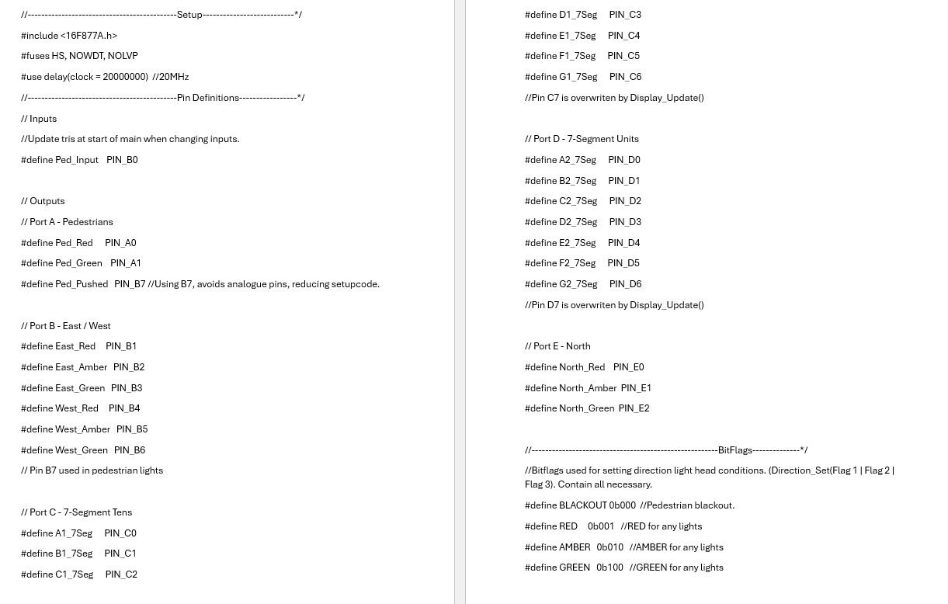
Fig. 11 PIC setup and definitions used in the code
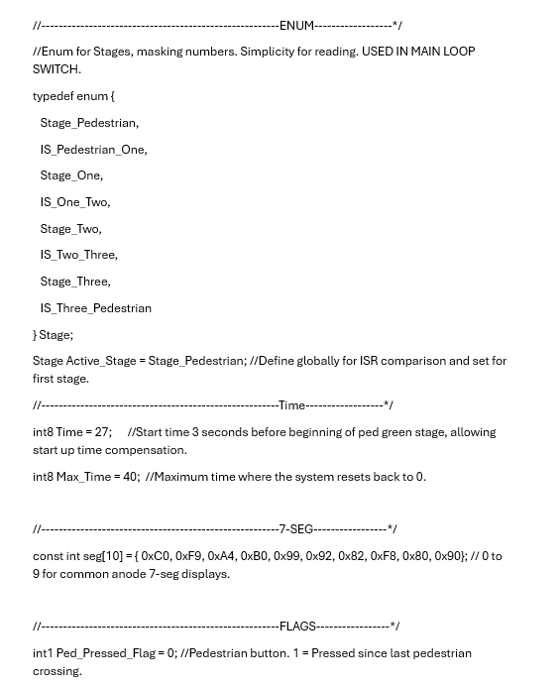
Fig. 12 Remaining global variables setup

Interrupt Functions
The external Interrupt on RB0 is triggered by a high to low transition on the pin, triggered by the button. If the system is not in the pedestrian stage, the flag is raised to mark the button being pressed and not acted up, with the wait light illuminated.
Timer 1 is used for marking every second, triggering every tenth of a second, and marking an interrupt. After 10 interrupts, time is incremented by one second, and reset if above 40.
Timer one is used as an interrupt to keep track of one second. The interrupt fires every tenth of a second, and increments the overflow count by 1. On the tenth overflow, the count is reset and time incremented. If time is equal to the maximum value set previously, then time is reset to 0.
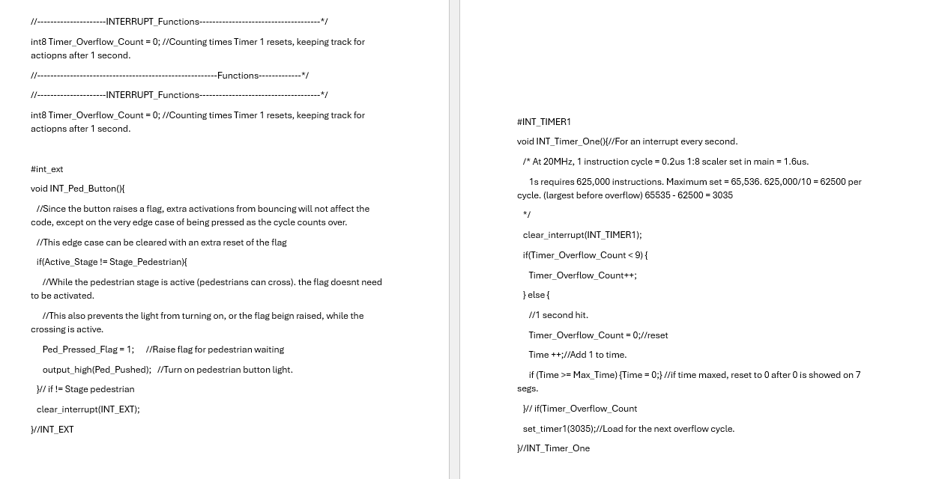
Fig. 13 Interrupt functions
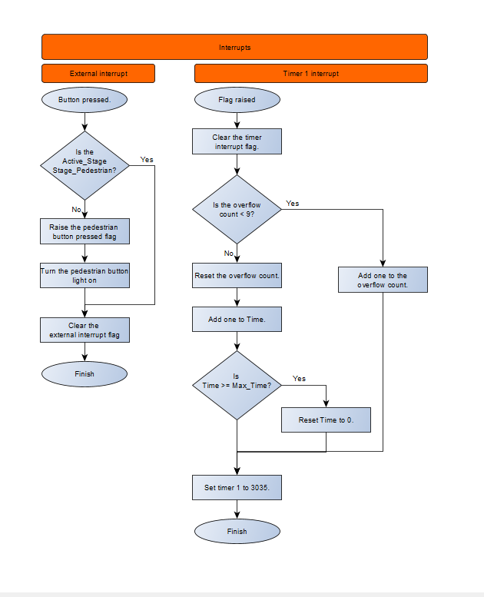
Fig. 14 Flowchart showing the flow of the interrupts
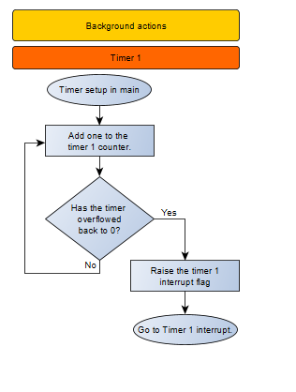
Fig. 15 Picture depicting the flow of timer ones background actions.

Callable functions
Each traffic head approach has its own function. These use bitflags to determine which outputs should be enabled. All the outputs for that direction are turned off and selectively turned on through bitwise operations. The pedestrian function operates similarly, however when blackout is passed, all lights remain off.
The button check function acts as a backup to the interrupt function, ensuring reliable operation in the event of the interrupt function failing.
The display update function controls the 7-segment display outputs by calculating the number required for that time, and then passing the value from the array to display the chosen number on the display.


Fig. 16 Standard, callable functions
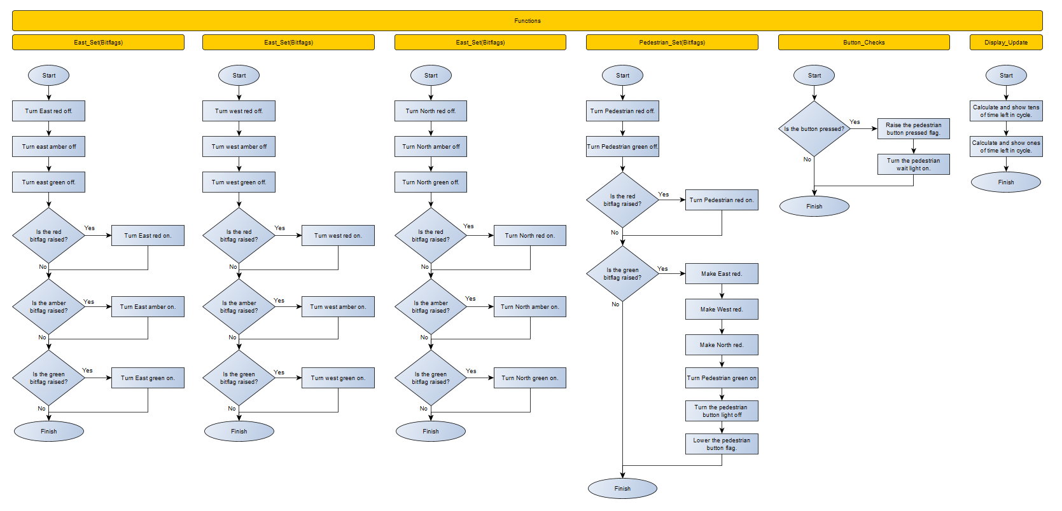
Fig. 17 Flowcharts showing the callable functions from the main function.

Main function setup
The main function begins by configuring I/O directions, with RB0 as an interrupt and all others as an output. Unused pins being set as outputs prevents signals reaching these pins from affecting the microcontroller and reducing reliability. Every output is disabled to ensure a known state, and then the 7-segment pins are turned on, clearing the display.
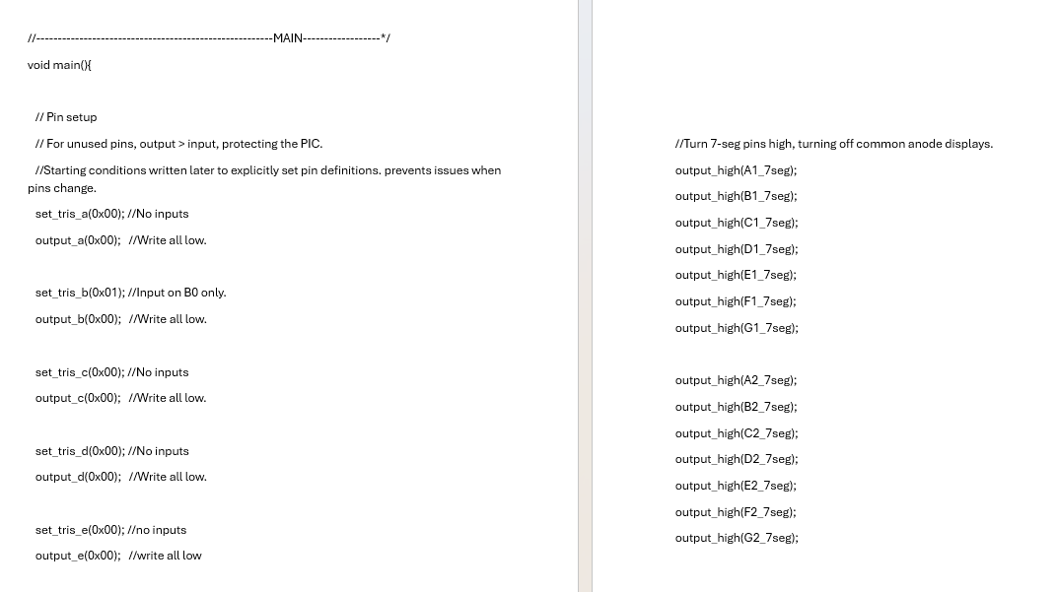
Fig. 18 Initial pin states

The interrupts utilised are then enabled and configures as required. The external interrupt fired on a falling edge and Timer1 enabled with the pre-scalers required to reach 0.1s interruptions.
The intersection is brough under control by transitioning all vehicular directions to amber, then red for a controlled stop. The system then enters the pedestrian stage, where the pedestrian green is turned on. This ensures pedestrians are prioritised whilst minimising the potential for a collision.
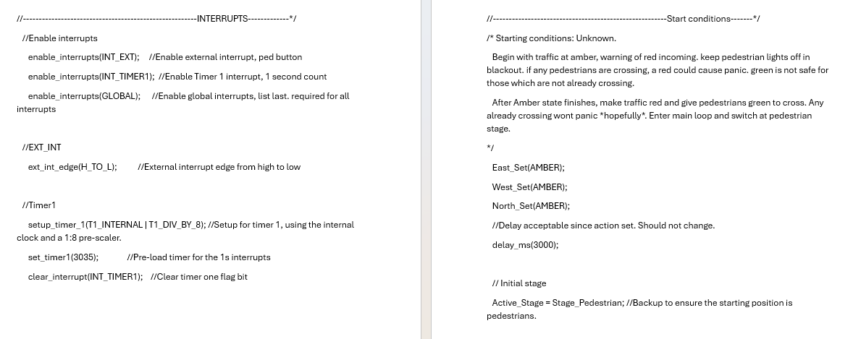
Fig. 19 Main function setup code
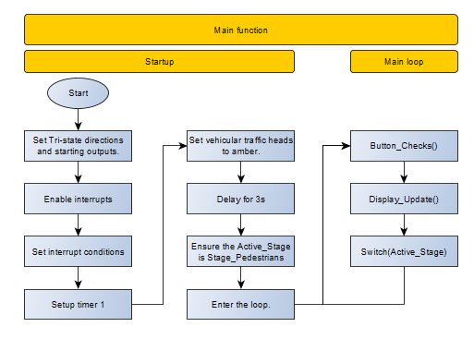
Fig. 20 Picture depicting the flow of the main function.

Main Function loop
The main loop continuously performs a button check, updating the display, and running the state switch. In a larger system, it may be better to run the switch and update displays only when time increments to prevent checks running behind, however since their operation time is minimal, it doesn’t cause an issue in the current implementation.
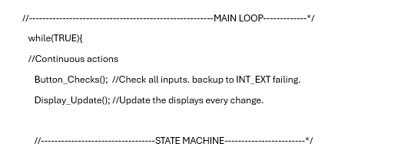
Fig. 21 Main loop code before the switch.
The state machine is implemented through a switch statement, where each stage and interstage is given. A time check is completed to ensure the correct output for the current time. If the switch manages to escape from the pre-defined states, a default case resets the microcontroller, rather than staying stuck or re-entering at the incorrect state.
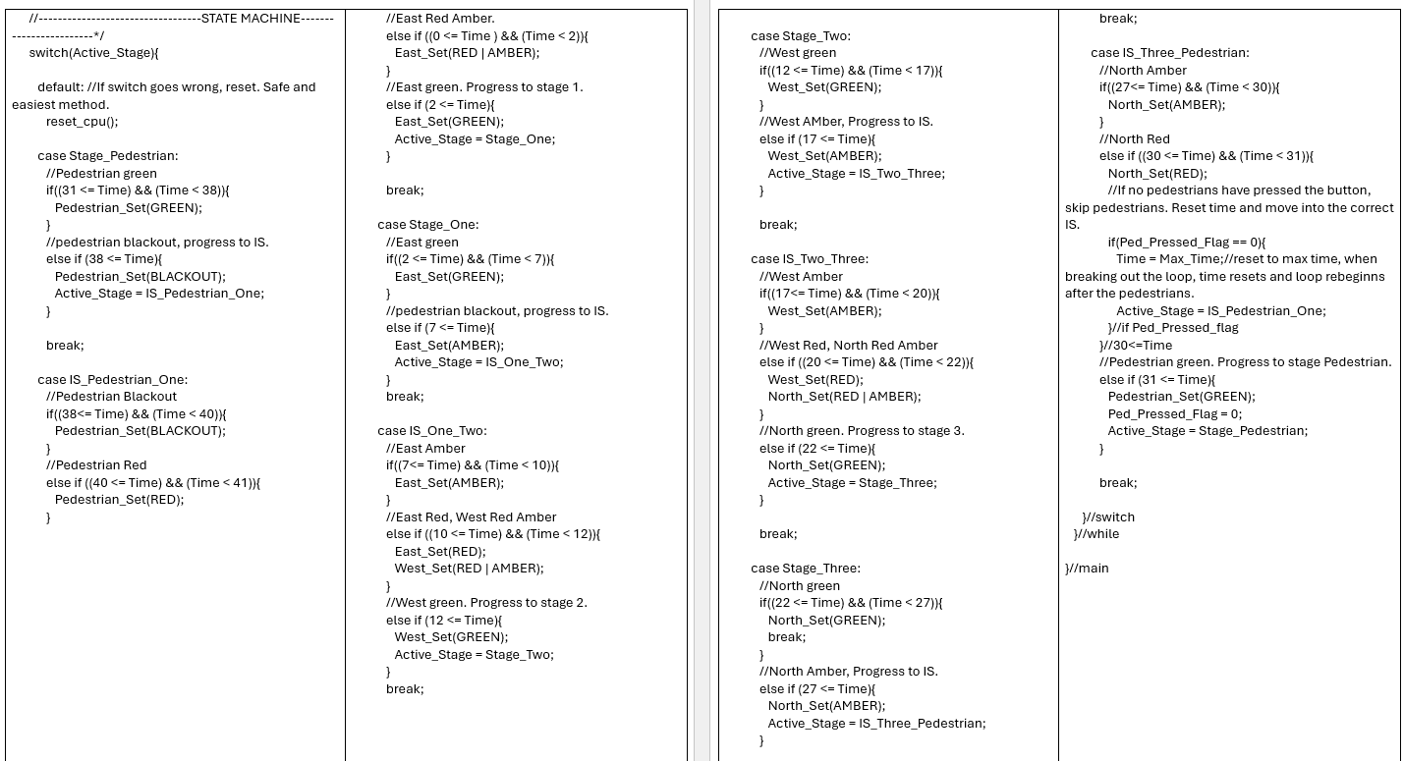
Fig. 22 State machine code
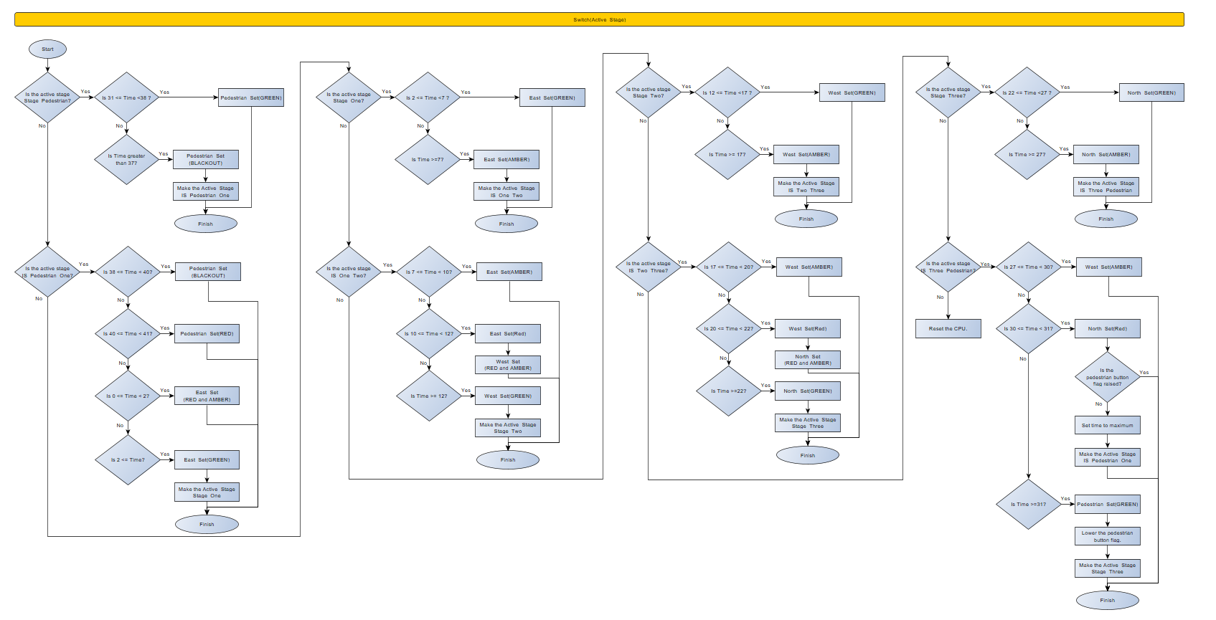
Fig. 23 Flowchart showing the operation of the switch statement

VI Firmware testing
Firmware testing was completed across the simulation and prototype, to ensure the operation was consistent throughout.
Prototype resetting
Although starting the same, the prototype reset after 5 seconds. This was due to having no current limiting resistors. Rather than a resistor on all segments, a resistor was put on the common anode pins. Assuming the segments have a forwards voltage drop of 1.2V being red, the lowest resistance needed is:
$$R=\frac{V}{I}=\frac{5V- 1.2V}{100mA}=\frac{3.8V}{0.1A}=38Ω$$
A 51Ω resistor was used to reduce the current further to ensure any variability in the voltage does not force the port to sink more current than capable.
7-segment displays swapped
The displays were also showing time backwards. Instead of re-defining the pins, making 14 changes, outputting to ports C and C were swapped in the display update function.
Incorrect time reset
The displays showed time resetting at 1, rather than 0. By changing the time reset comparison from < to >= corrected when time was reset, with the circuit functioning as intended.

VII Potential design changes
Many changed could be made depending on the circumstances of the T-Junction.
- Implement medians for pedestrians to cross to. Pedestrians no longer need to interact with the main system, and can be given a green light whenever the cars in one direction have a red light, however, may be impacted if suggestion 2 is implemented.
- Left/Right turning green arrows. If space allows for dedicated turning lanes, throughput on the junction would be improved. This is best used with medians for pedestrians; however separate buttons would be needed to disable turning arrows to allow pedestrians to cross that section.
- Junction to Junction or emergency vehicle interactions have not been considered. In large built-up areas, Junctions will act in chains to provide vehicles in the main direction a constant green light through. This would require adding a communication method. Emergency vehicles often also interact with junctions to receive priority. [9] [10]
- Update display currently writes to a port, enforcing 8 pins to be used. This could be changed to take the array value, and using bitflags, turn each pin on or off individually. This method allows the displays to be connected to any output pin, rather than forced to use the same pin order on the same port.

VIII Conclusion
This project successfully demonstrated the ability to design and implement a traffic light system using a PIC microcontroller. The system met the core objectives of three vehicular heads and pedestrian lights, with each having 10 seconds per cycle. 7-segment displays show the countdown time until 0 as wanted by the task requirements.
Proper research showed that although the task requirements couldn’t directly meet regulatory requirements, they could be made close. Designing adaptability into the design means this can easily be modified to meet the requirements over other implementations which are hard coded to run within simpler implementations.
Using a state machine provided a clear and structured methods for controlling the system whilst replicating the visual operation, ensuring predictable operation and production. Using the simulation within Proteus 9 validated the overall design with the breadboard prototype demonstrating the feasibility of the implementation, using a simpler version of the full simulated design. Both designs allowed the sequence, timings and behaviour to be validated.
Throughout potential improvements and changes to the design have been considered, with the designs chosen allowing these modifications to be made without the requirements for large re-designs.
Overall, the system provides reliable operation, with considerations to prioritise safety throughout and being suitable for a T-junction as tasked, but adaptable for other junction designs.

References

[1] | “Dynamic traffic controls,” Shropshire Council, [Online]. Available: https://next.shropshire.gov.uk/roads-and-highways/traffic-management/traffic-signals/dynamic-traffic-controls/. [Accessed 24 03 2025].
[2] | Department for Transport, “The "MOVA" signal control system,” 03 1997. [Online]. Available: https://tsrgd.co.uk/pdf/tal/1997/tal-3-97.pdf. [Accessed 24 03 2025].
[3] | M. M. A. Milisia, “COMPARISON OF FIXED-TIME VS. ACTUATED TRAFFIC SIGNALS: EFFICIENCY AND CHALLENGES,” 06 2025. [Online]. Available: https://journalcea.com/wp-content/uploads/1_Jun-2025.pdf. [Accessed 24 03 2026].
[4] | Department for Transport, “Traffic Signals Manual Chapter 6,” 2019. [Online]. Available: https://assets.publishing.service.gov.uk/government/uploads/system/uploads/attachment_data/file/851465/dft-traffic-signs-manual-chapter-6.pdf. [Accessed 25 03 2025].
[5] | Department for Transport, “TRAFFIC ADVISORY LEAFLET 1/06 part 4 of 4,” 03 2006. [Online]. Available: https://tsrgd.co.uk/pdf/tal/2006/tal-1-06_4.pdf. [Accessed 25 03 2025].
[6] | UK Government, “The Traffic Signs Regulations and General Directions 2016,” 2016. [Online]. Available: https://www.legislation.gov.uk/uksi/2016/362/schedule/14/part/1/made?view=plain. [Accessed 02 03 2026].
[7] | Microchip, “PIC16F87XA Datasheet,” 28 07 2003. [Online]. Available: https://ww1.microchip.com/downloads/en/devicedoc/39582b.pdf. [Accessed 02 12 2025].
[8] | I. Ayyub, “Automatic traffic light using PIC16F877A Microcontroller,” 21 06 2018. [Online]. Available: https://pic-microcontroller.com/automatic-traffic-light-using-pic16f877a-microcontroller/. [Accessed 26 03 2025].
[9] | MioVision, “Miovision Opticom™ Emergency Vehicle Preemption,” 2026. [Online]. Available: https://miovision.com/opticom/emergency-vehicle-preemption/. [Accessed 04 03 2026].
[10] | V. Paruchuri, “Adaptive Preemption of Traffic for Emergency Vehicles,” IEEE, Cambridge, 2016.

Appendices

Appendix A: System requirements
Design a traffic light control system for a T-Junction. This system design aims to enhance traffic management efficiency while prioritizing safety, making it suitable for a T-Junction.
- Install three traffic signal lights on each side of the road for comprehensive traffic management.
- Include a set of 7-segment displays on each side to count down from 40 to 0 seconds.
- Configure the system to change traffic signals every 10 seconds for predictable and smooth traffic flow.
- Reserve the final 10 seconds of the signal cycle for a dedicated pedestrian crossing phase. Install LEDs to display Pedestrian Green and Red signals.
- During the pedestrian crossing phase, program the traffic signals to either turn off or display a red signal for all three roads, ensuring pedestrian safety.

Appendix B: Firmware
/*
2420823 for ACDB5002. 2026AD
Switch based control for T-Junction traffic lights.
Based on PIC16F877A, using 20MHz clock.
Pin RB0 used as pedestrian interrupt button.
Timer1 interrupt used for timing, totalling 1s actions.
*/

//--------------------------------------------Setup---------------------------*/
#include <16F877A.h>
#fuses HS, NOWDT, NOLVP
#use delay(clock = 20000000) //20MHz

//--------------------------------------------Pin Definitions-----------------*/
// Inputs
//Update tris at start of main when changing inputs.
#define Ped_Input PIN_B0

// Outputs
// Port A - Pedestrians
#define Ped_Red PIN_A0
#define Ped_Green PIN_A1
#define Ped_Pushed PIN_B7 //Using B7, avoids analogue pins, reducing setupcode.

// Port B - East / West
#define East_Red PIN_B1
#define East_Amber PIN_B2
#define East_Green PIN_B3
#define West_Red PIN_B4
#define West_Amber PIN_B5
#define West_Green PIN_B6
// Pin B7 used in pedestrian lights

// Port C - 7-Segment Tens
#define A1_7Seg PIN_C0
#define B1_7Seg PIN_C1
#define C1_7Seg PIN_C2
#define D1_7Seg PIN_C3
#define E1_7Seg PIN_C4
#define F1_7Seg PIN_C5
#define G1_7Seg PIN_C6
//Pin C7 is overwriten by Display_Update()

// Port D - 7-Segment Units
#define A2_7Seg PIN_D0
#define B2_7Seg PIN_D1
#define C2_7Seg PIN_D2
#define D2_7Seg PIN_D3
#define E2_7Seg PIN_D4
#define F2_7Seg PIN_D5
#define G2_7Seg PIN_D6
//Pin D7 is overwriten by Display_Update()

// Port E - North
#define North_Red PIN_E0
#define North_Amber PIN_E1
#define North_Green PIN_E2

//-------------------------------------------------------BitFlags--------------*/
//Bitflags used for setting direction light head conditions. (Direction_Set(Flag 1 | Flag 2 | Flag 3). Contain all necessary.
#define BLACKOUT 0b000 //Pedestrian blackout.
#define RED 0b001 //RED for any lights
#define AMBER 0b010 //AMBER for any lights
#define GREEN 0b100 //GREEN for any lights

//-------------------------------------------------------ENUM------------------*/
//Enum for Stages, masking numbers. Simplicity for reading. USED IN MAIN LOOP SWITCH.
typedef enum {
Stage_Pedestrian,
IS_Pedestrian_One,
Stage_One,
IS_One_Two,
Stage_Two,
IS_Two_Three,
Stage_Three,
IS_Three_Pedestrian
} Stage;
Stage Active_Stage = Stage_Pedestrian; //Define globally for ISR comparison and set for first stage.
//-------------------------------------------------------Time------------------*/
int8 Time = 27; //Start time 3 seconds before beginning of ped green stage, allowing start up time compensation.
int8 Max_Time = 40; //Maximum time where the system resets back to 0.

//-------------------------------------------------------7-SEG-----------------*/
const int seg[10] = { 0xC0, 0xF9, 0xA4, 0xB0, 0x99, 0x92, 0x82, 0xF8, 0x80, 0x90}; // 0 to 9 for common anode 7-seg displays.

//-------------------------------------------------------FLAGS-----------------*/
int1 Ped_Pressed_Flag = 0; //Pedestrian button. 1 = Pressed since last pedestrian crossing.
//-------------------------------------------------------Functions-------------*/
//---------------------INTERRUPT_Functions-------------------------------------*/
int8 Timer_Overflow_Count = 0; //Counting times Timer 1 resets, keeping track for actiopns after 1 second.

#int_ext
void INT_Ped_Button(){
//Since the button raises a flag, extra activations from bouncing will not affect the code, except on the very edge case of being pressed as the cycle counts over.
//This edge case can be cleared with an extra reset of the flag
if(Active_Stage != Stage_Pedestrian){
//While the pedestrian stage is active (pedestrians can cross). the flag doesnt need to be activated.
//This also prevents the light from turning on, or the flag beign raised, while the crossing is active.
Ped_Pressed_Flag = 1; //Raise flag for pedestrian waiting
output_high(Ped_Pushed); //Turn on pedestrian button light.
}// if != Stage pedestrian
clear_interrupt(INT_EXT);
}//INT_EXT

#INT_TIMER1
void INT_Timer_One(){//For an interrupt every second.
/* At 20MHz, 1 instruction cycle = 0.2us 1:8 scaler set in main = 1.6us.
1s requires 625,000 instructions. Maximum set = 65,536. 625,000/10 = 62500 per cycle. (largest before overflow) 65535 - 62500 = 3035
*/
clear_interrupt(INT_TIMER1);
if(Timer_Overflow_Count < 9) {
Timer_Overflow_Count++;
} else {
//1 second hit.
Timer_Overflow_Count = 0;//reset
Time ++;//Add 1 to time.
if (Time >= Max_Time) {Time = 0;} //if time maxed, reset to 0 after 0 is showed on 7 segs.
}// if(Timer_Overflow_Count
set_timer1(3035);//Load for the next overflow cycle.
}//INT_Timer_One

//-------------------------------Functions-------------------------------------*/
/*Direction_Set(INPUT)
Each direction has its own function to set the outputs for each traffic head.
Inputs are the colour to be shown on the head, using RED | AMBER | GREEN and BLACKOUT (Pedestrian only)
All lights are turned off, and then those required are turned back on. (Red turning off and back on is unnoticeable to human eye).
*/
void East_Set(int8 Light_Colour){
output_low(East_Red);
output_low(East_Amber);
output_low(East_Green);

if (Light_Colour & RED) {output_high(East_Red);}
if (Light_Colour & AMBER) {output_high(East_Amber);}
if (Light_Colour & GREEN) {output_high(East_Green);}
}//East_Set

void West_Set(int8 Light_Colour){
output_low(West_Red);
output_low(West_Amber);
output_low(West_Green);

if (Light_Colour & RED) {output_high(West_Red);}
if (Light_Colour & AMBER) {output_high(West_Amber);}
if (Light_Colour & GREEN) {output_high(West_Green);}
}//West_Set

void North_Set(int8 Light_Colour){
output_low(North_Red);
output_low(North_Amber);
output_low(North_Green);

if (Light_Colour & RED) {output_high(North_Red);}
if (Light_Colour & AMBER) {output_high(North_Amber);}
if (Light_Colour & GREEN) {output_high(North_Green);}
}//North_Set

void Pedestrian_Set(int8 Pedestrian_Colour){
output_low(Ped_Red);
output_low(Ped_Green);

if (Pedestrian_Colour & RED) {output_high(Ped_Red);}
//BLACKOUT turns all off, done at the start so does not need to be defined.
if (Pedestrian_Colour & GREEN) {
//Ensure all vehicular traffic is off.
East_Set(RED);
West_Set(RED);
North_Set(RED);
output_high(Ped_Green);
output_low(Ped_Pushed);
Ped_Pressed_Flag = 0; //Clear flag.
}//Green
}//Pedestrian_Set

void Button_Checks(){
//should be handled by ISR INT_EXT, however not functioning reliably on PIC testing with. Functioned correctly on different pic.
//Since only raising same flag, for same action, does not cause conflict, so SHOULD NOT cause issues.
if(input(Ped_Input) == 0){ //If the pull-up button is pressed.
if(Active_Stage != Stage_Pedestrian){
//While the pedestrian stage is active (pedestrians can cross). the flag doesnt need to be activated.
//This also prevents the light from turning on, or the flag beign raised, while the crossing is active.
Ped_Pressed_Flag = 1; //Raise flag for pedestrian waiting
output_high(Ped_Pushed); //Turn on pedestrian button light.
}// if != Stage pedestrian
};//Input
}//Button_Checks
void Display_Update(){ //Flip displays
output_c(seg[(Max_Time - Time)/10]);//output division of 10 for time
output_d(seg[(Max_Time - Time)%10]);//output ones of time.
}//Display_Update
//-------------------------------------------------------MAIN------------------*/
void main(){

// Pin setup
// For unused pins, output > input, protecting the PIC.
//Starting conditions written later to explicitly set pin definitions. prevents issues when pins change.
set_tris_a(0x00); //No inputs
output_a(0x00); //Write all low.

set_tris_b(0x01); //Input on B0 only.
output_b(0x00); //Write all low.

set_tris_c(0x00); //No inputs
output_c(0x00); //Write all low.

set_tris_d(0x00); //No inputs
output_d(0x00); //Write all low.

set_tris_e(0x00); //no inputs
output_e(0x00); //write all low

//Turn 7-seg pins high, turning off common anode displays.
output_high(A1_7seg);
output_high(B1_7seg);
output_high(C1_7seg);
output_high(D1_7seg);
output_high(E1_7seg);
output_high(F1_7seg);
output_high(G1_7seg);

output_high(A2_7seg);
output_high(B2_7seg);
output_high(C2_7seg);
output_high(D2_7seg);
output_high(E2_7seg);
output_high(F2_7seg);
output_high(G2_7seg);
//-------------------------------------------------------INTERRUPTS-------------*/
//Enable interrupts
enable_interrupts(INT_EXT); //Enable external interrupt, ped button
enable_interrupts(INT_TIMER1); //Enable Timer 1 interrupt, 1 second count
enable_interrupts(GLOBAL); //Enable global interrupts, list last. required for all interrupts

//EXT_INT
ext_int_edge(H_TO_L); //External interrupt edge from high to low

//Timer1
setup_timer_1(T1_INTERNAL | T1_DIV_BY_8); //Setup for timer 1, using the internal clock and a 1:8 pre-scaler.
set_timer1(3035); //Pre-load timer for the 1s interrupts
clear_interrupt(INT_TIMER1); //Clear timer one flag bit

//-------------------------------------------------------Start conditions-------*/
/* Starting conditions: Unknown.
Begin with traffic at amber, warning of red incoming. keep pedestrian lights off in blackout. if any pedestrians are crossing, a red could cause panic. green is not safe for those which are not already crossing.
After Amber state finishes, make traffic red and give pedestrians green to cross. Any already crossing wont panic *hopefully*. Enter main loop and switch at pedestrian stage.
*/
East_Set(AMBER);
West_Set(AMBER);
North_Set(AMBER);
//Delay acceptable since action set. Should not change.
delay_ms(3000);

// Initial stage
Active_Stage = Stage_Pedestrian; //Backup to ensure the starting position is pedestrians.

//-------------------------------------------------------MAIN LOOP-------------*/
while(TRUE){
//Continuous actions
Button_Checks(); //Check all inputs. backup to INT_EXT failing.
Display_Update(); //Update the displays every change.

//----------------------------------STATE MACHINE------------------------*/
/*Switch constantly running.
Time comparisons if ((Start <= time) && (Time < when next stage starts))
breaks; in every if statement since tasks complete for time value.
*/
switch(Active_Stage){

default: //If switch goes wrong, reset. Safe and easiest method.
reset_cpu();

case Stage_Pedestrian:
//Pedestrian green
if((31 <= Time) && (Time < 38)){
Pedestrian_Set(GREEN);
}
//pedestrian blackout, progress to IS.
else if (38 <= Time){
Pedestrian_Set(BLACKOUT);
Active_Stage = IS_Pedestrian_One;
}

break;

case IS_Pedestrian_One:
//Pedestrian Blackout
if((38<= Time) && (Time < 40)){
Pedestrian_Set(BLACKOUT);
}
//Pedestrian Red
else if ((40 <= Time) && (Time < 41)){
Pedestrian_Set(RED);
}
//East Red Amber.
else if ((0 <= Time ) && (Time < 2)){
East_Set(RED | AMBER);
}
//East green. Progress to stage 1.
else if (2 <= Time){
East_Set(GREEN);
Active_Stage = Stage_One;
}

break;

case Stage_One:
//East green
if((2 <= Time) && (Time < 7)){
East_Set(GREEN);
}
//pedestrian blackout, progress to IS.
else if (7 <= Time){
East_Set(AMBER);
Active_Stage = IS_One_Two;
}
break;

case IS_One_Two:
//East Amber
if((7<= Time) && (Time < 10)){
East_Set(AMBER);
}
//East Red, West Red Amber
else if ((10 <= Time) && (Time < 12)){
East_Set(RED);
West_Set(RED | AMBER);
}
//West green. Progress to stage 2.
else if (12 <= Time){
West_Set(GREEN);
Active_Stage = Stage_Two;
}

break;

case Stage_Two:
//West green
if((12 <= Time) && (Time < 17)){
West_Set(GREEN);
}
//West AMber, Progress to IS.
else if (17 <= Time){
West_Set(AMBER);
Active_Stage = IS_Two_Three;
}

break;

case IS_Two_Three:
//West Amber
if((17<= Time) && (Time < 20)){
West_Set(AMBER);
}
//West Red, North Red Amber
else if ((20 <= Time) && (Time < 22)){
West_Set(RED);
North_Set(RED | AMBER);
}
//North green. Progress to stage 3.
else if (22 <= Time){
North_Set(GREEN);
Active_Stage = Stage_Three;
}

break;

case Stage_Three:
//North green
if((22 <= Time) && (Time < 27)){
North_Set(GREEN);
break;
}
//North Amber, Progress to IS.
else if (27 <= Time){
North_Set(AMBER);
Active_Stage = IS_Three_Pedestrian;
}

break;

case IS_Three_Pedestrian:
//North Amber
if((27<= Time) && (Time < 30)){
North_Set(AMBER);
}
//North Red
else if ((30 <= Time) && (Time < 31)){
North_Set(RED);
//If no pedestrians have pressed the button, skip pedestrians. Reset time and move into the correct IS.
if(Ped_Pressed_Flag == 0){
Time = Max_Time;//reset to max time, when breaking out the loop, time resets and loop rebeginns after the pedestrians.
Active_Stage = IS_Pedestrian_One;
}//if Ped_Pressed_flag
}//30<=Time
//Pedestrian green. Progress to stage Pedestrian.
else if (31 <= Time){
Pedestrian_Set(GREEN);
Ped_Pressed_Flag = 0;
Active_Stage = Stage_Pedestrian;
}

break;
}//switch
}//while
}//main

