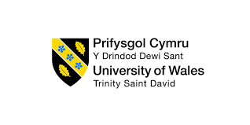

Program: BA (Hons) Developing Leadership and Management

Module: Managing Projects in Organisations

Module code: BMSW5009_SWAN

Lecturer: Giulia Chifari

Assignment Title: Written report & Reflective blogs

Student Name: Maia vashakmadze

Student Number: 1816795

Submission deadline: 03rd July, by 11:59pm.

Contents

Executive Summary 3
1. Introduction 4
2. Findings 4
2.1 Critical discussion of project management tools and techniques in general 4
2.2 Critical discussion of how those tools were used in the project 6
2.3 Communication and Stakeholders 8
3. Conclusion 9
4. Future Improvement 10
References 12

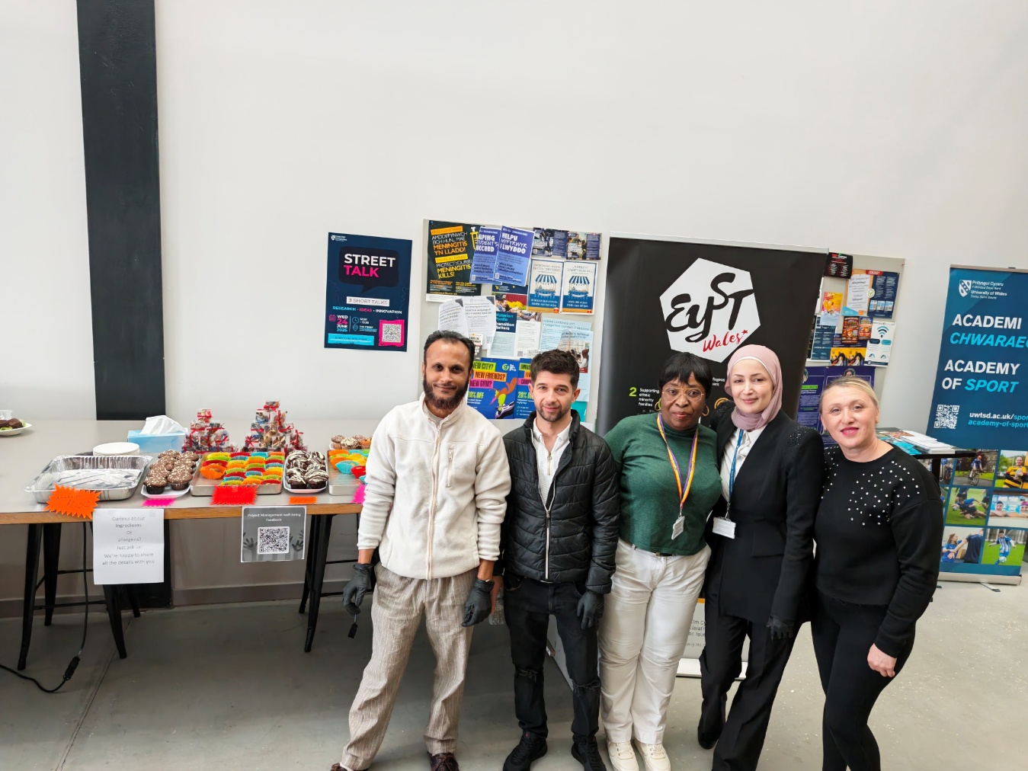

Executive Summary

This report looks at our group project: organising a fundraising and well-being event at UWTSD to support the charity EYST. We planned and ran the event to raise money, bring people together, and encourage well-being among students and staff. The report follows the full project journey from the first ideas and planning, through to delivery and final evaluation.
We used standard project management tools and methods, including the Work Breakdown Structure (WBS), Gantt chart, stakeholder analysis and risk management. These helped us stay organised, meet deadlines and work well as a team. We also worked closely with everyone involved from the university operations team to the charity and students to make sure the event met everyone’s needs.
Overall, the project was a success. We raised £115 for EYST, had around 40 attendees, and received very positive feedback. We also learned a great deal about how to manage projects in practice. This report explains what worked well, what challenges we faced, and what we would do differently next time to make future projects even better.

Introduction

Our team took on this project as part of our Managing Projects in the Organisation module. The main aim was to organise an event that would raise funds for a local charity, while also promoting well-being, kindness and inclusion within our university community. We chose to support EYST (Ethnic Youth Support Trust), a charity that helps young people from diverse backgrounds to achieve their potential.
We set out with four clear objectives: To raise money for EYST through selling food and taking donations; to get students and staff involved and bring people together; to encourage positive mental health and well-being through activities, and finally, to put into practice the project management methods we have learned during the module.
From the start, we understood that a project is not just about doing tasks. It is a structured process with clear stages, decisions, responsibilities and results (Successful Project Management, 2026). We followed the full project lifecycle (Eadie et al., 2013), starting with defining what we wanted to do, planning every step, putting the plan into action, checking progress, and finally closing the project and reviewing how it went.
This report explains how we managed each stage. It looks at the tools and methods we used, how we worked with people involved in the project, what went well, what we found difficult, and what we would recommend for anyone running similar projects in future.

2. Findings

2.1 Critical discussion of project management tools and techniques in general
Project management tools and techniques are there to help teams plan, organise and control work, so that projects are finished on time, within budget, and to the right standard (Project Management, 2026). They are not just paperwork, they are practical ways to make sure everyone knows what to do, when to do it, and how everything fits together. Below I discuss the main tools we learned about, their benefits, and also their limits.
According to Zecheru and Olaru (2016) and Alexandru (2026), the Work Breakdown Structure (WBS) is one of the most useful planning tools because it breaks complex projects into smaller, manageable components. It takes the whole project and breaks it down into smaller, more manageable pieces. Instead of seeing one big job, you see all the separate tasks that make it up. This makes it much easier to assign work to people, estimate how long things will take, and make sure nothing important is missed. The main strength of the WBS is that it brings clarity and structure. However, it can take time to put together, and if you break things down too much, it can become too detailed and hard to follow. It works best when you keep it simple and focused on what is actually needed (Olaru, 2016).
Geraldi and Lechter (2012) state that the Gantt chart is the most common way to show a project plan over time. It is a visual timeline that shows each task, when it starts and finishes, and how tasks link to each other. It helps you see the order of work, work out which tasks must be finished before others can start, and check if you are on schedule. The big advantage is that it is easy to understand immediately, even for people who do not know much about project management. However, Gantt charts can become out of date very quickly if they are not updated regularly and they do not always show resource usage or cost in detail (Green, 2024).
Another important framework is the Iron Triangle, also called the Project Management Triangle (Pollack et al., 2018). This shows the three main limits of any project: time, cost and scope (or quality). The idea is that you cannot change one without affecting the others. For example, if you want to finish sooner, you may need more money or have to reduce what you deliver. If you want to do more work, you will need more time or money. This is a very useful way to test if a project is realistic. It helps you make decisions and balance what you want to do with what is possible. The downside is that it is quite simple, and does not cover other important things like people, risk or quality in detail but it is still a great starting point.
Risk management is another key technique. This means thinking ahead about what could go wrong and putting plans in place to stop it happening or to reduce the damage if it does (Berg, 2010). Good risk management saves time and trouble later on. It turns unexpected problems into things you have already thought about and prepared for. The only difficulty is that you cannot predict every risk, and it takes time to analyse and plan for them.
Stakeholder analysis is about identifying everyone who has an interest in or influence over the project and determining how best to engage with them (Aleksandra, 2022). This is important because people can make or break a project. If you understand what different people want and how much power they have, you can keep them happy and get their support. Without this, you might face delays or opposition. The challenge is that people’s interests can change, and you must keep checking and adjusting your approach (Aleksandra, 2022).
Overall, these tools are not perfect, and they do not guarantee success on their own. But when used properly and combined with good communication and teamwork, they offer a much better chance of delivering a project that works. They turn ideas into clear plans and help you stay in control all the way through.

2.2 Critical discussion of how those tools were used in the project

In our event project, we used several project management tools and techniques to help us plan, organise and deliver the event successfully. These tools were useful because they gave us a clear structure to follow and helped us manage different aspects of the project. This section discusses how they were used, what worked well and some of the limitations we experienced.
The first tool we used was the Iron Triangle. This helped us assess whether the event was realistic by focusing on time, cost and scope. We had around six weeks to plan the event while also managing our university work, so time was limited. Our budget was very small and mainly covered ingredients: therefore, to keep the project manageable, we limited the scope to a food sale and wellbeing corner. Using the Iron Triangle helped us balance these three constraints and avoid taking on more than we could realistically achieve (Asana, 2025). It was useful for making decisions and setting clear boundaries for the project. However, it did not help us deal with unexpected issues such as changes in student availability or other factors outside our control.
We also created a Work Breakdown Structure (WBS). This involved breaking the project into smaller tasks, from obtaining approval from the university to closing the project after the event. The WBS helped us identify everything that needed to be completed and assign responsibilities to team members. This made the project easier to manage and reduced the risk of forgetting important tasks. It also helped everyone understand their role within the team. One limitation was that new tasks appeared as the project developed, meaning the WBS had to be updated. Despite this, it remained a valuable planning tool throughout the project (Atlassian, 2024).
After completing the WBS, we developed a Gantt chart (Gantt Chart with Dependencies Templates, 2023). This allowed us to place tasks on a timeline and see when activities needed to be completed. It also helped us identify dependencies between tasks. For example, we could not begin promoting the event until university approval had been received. The Gantt chart gave us a clear overview of the project and helped us monitor progress (Clayton, 2019). We reviewed it regularly and used it to identify any delays. Although some team members found it more difficult to understand than a simple task list, it was effective for keeping the project on schedule (Green, 2024).
Risk management was another important technique used during the project. We identified possible risks, including allergic reactions to food, delays in approval, low attendance and bad weather. We then planned actions to reduce the likelihood or impact of these risks. Food was clearly labelled with allergen information; approval was requested early and the event was held indoors to avoid weather-related problems. This process increased our confidence and helped us feel prepared. As no major problems occurred during the event, the risk management approach proved effective (Berg, 2010).
We also carried out a stakeholder analysis to identify the people and groups affected by the project. This included students, university staff, the charity and the project team. Understanding their interests helped us make decisions that supported the success of the event (Aleksandra, 2022).
Overall, these tools were extremely useful and played a major role in helping us deliver the event successfully. While they required time to create and update, they improved organisation, communication and planning. Although some challenges arose during the project, the tools helped us manage them effectively and provided a clear framework for achieving our objectives.

2.3 Communication and Stakeholders

Stakeholders are the people and groups who are involved in, affected by, or able to influence a project (Tristancho, 2025). For our event, these included internal stakeholders such as our team, the university operations team, and university staff, as well as external stakeholders including EYST, students, event attendees, and volunteers.
From the beginning, we recognised that effective communication was just as important as planning. Even with a strong project plan, poor communication could have led to misunderstandings, delays, or a lack of support. To manage this, we carried out a stakeholder analysis to identify key stakeholders, assess their level of influence and interest, and determine the most appropriate methods of communication (Tristancho, 2025).
The university operations team had significant influence over the project because their approval was required before the event could take place. We maintained regular contact through formal emails, submitted all required documentation promptly, and ensured that we followed university procedures. This helped us gain approval efficiently.
Students were our main audience, so we used social media, posters, Facebook, on the university HWB, LinkedIn and face-to-face conversations to promote the event and encourage participation (Hansen, 2025). We also designed activities that would appeal to them, including a wellbeing corner where attendees could share positive messages.
Within the team, communication was maintained through weekly meetings and WhatsApp messages. This ensured that everyone remained informed, supported, and involved. Overall, the project demonstrated that successful communication is essential for building relationships, meeting stakeholder needs, and achieving shared goals (Hansen, 2025).

3. Conclusion

This project was a very valuable experience, and it showed us clearly what project management is really about. We learned that a project is not just a list of jobs to do; it is a structured process with clear stages, decisions and responsibilities (Successful Project Management, 2026). Tools and techniques helped us manage the project effectively and contributed to successful project delivery, which reflects Horton’s (2025) view that structured project management practices support positive project outcomes.
We achieved everything we set out to do. We organised a safe, enjoyable event, raised £115 for EYST, brought people together, and promoted well-being. We also applied all the tools and techniques we learned: the Iron Triangle, WBS, Gantt chart, risk management and stakeholder analysis. Each one helped us in different ways, and together they gave us control and confidence.
We also learned that tools are only part of the story. Good communication, teamwork, leadership and flexibility are just as important. We faced challenges especially around the timing of the event, when many students had already finished their studies, but we managed them well because we were prepared and worked together (Poláková et al., 2023).
Overall, the project was a success. It bridged the gap between what we learn in the classroom and how things work in real life. We now understand much better how to plan, manage and deliver a project, and this experience demonstrated how classroom learning can be applied to real-world situations while developing skills that will be valuable in our future careers (Dr. Tharankumar Thinakaran, 2025).

4. Future Improvement

Although the project was successful, there are several ways it could be improved in future. One key lesson is that timing matters. Holding the event in June meant fewer students were available, so running it earlier in the term, such as February or March, would likely increase attendance and fundraising. Promotion could also be strengthened by using more channels, including student societies, university newsletters and class announcements. Involving EYST earlier would have been helpful because the organisation offers a range of support services and community programmes that could have provided useful ideas, contacts and publicity opportunities (EYST, 2023). In addition, the project plan would benefit from greater flexibility, with extra time built in to manage delays and reduce pressure. More frequent short reviews would also help keep everyone organised and focused. Finally, gathering feedback during the event, rather than only afterwards, would allow immediate improvements to the experience (MeetingPulse, 2022). Overall, these changes would make the project more effective, enjoyable and successful next time.
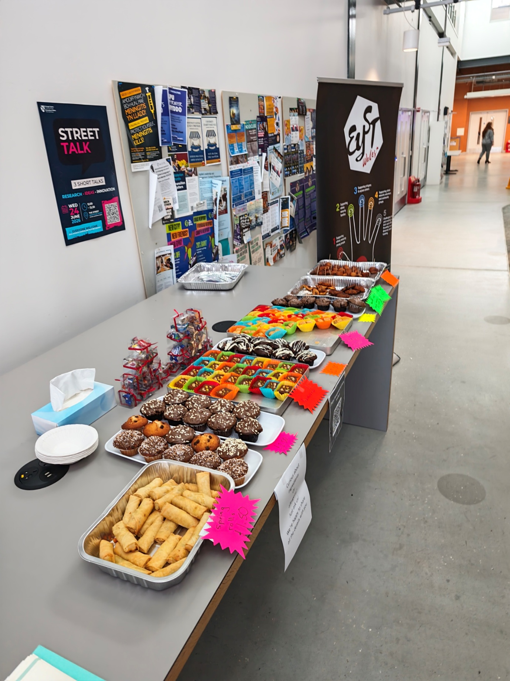

References

Aleksandra (2022) What is Stakeholder Management, Institute of Project Management. Available at: https://instituteprojectmanagement.com/blog/what-is-stakeholder-management/ (Accessed: 19 June 2026).
Alexandru, I. (2026) L2_WBS_CriticalPath.pdf, Scribd. Available at: https://www.scribd.com/document/403981522/L2-WBS-CriticalPath-pdf (Accessed: 23 June 2026).
Asana (2025) The Project Management Triangle: What It Is and How to Use It, Asana. Available at: https://asana.com/resources/project-management-triangle (Accessed: 19 June 2026).
Atlassian (2024) Work Breakdown Structure in Project Management | The Workstream. Available at: https://www.atlassian.com/work-management/project-management/work-breakdown-structure (Accessed: 23 June 2026).
Berg, H.-P. (2010) ‘Risk management: procedures, methods and experiences’, Reliability: Theory & Applications, 5(2), pp. 17-25. Available at: https://cyberleninka.ru/article/n/risk-management-procedures-methods-and-experiences (Accessed: 19 June 2026).
Clayton, M. (2019) Project Management in Under 5: What is a Gantt Chart? [Online video]. Available at: https://www.youtube.com/watch?v=fB0wsdmV3Sw (Accessed: 19 June 2026).
Eadie, R. et al. (2013) ‘BIM implementation throughout the UK construction project lifecycle: An analysis’, Automation in Construction, 36, pp. 145–151. Available at: https://doi.org/10.1016/j.autcon.2013.09.001 (Accessed: 19 June 2026).
EYST (2023) What We Offer. Available at: [INSERT URL HERE] (Accessed: 23 June 2026).
Gantt Chart With Dependencies Templates (2023) Smartsheet. Available at: https://www.smartsheet.com/content/gantt-chart-templates-dependencies (Accessed: 23 June 2026).
Geraldi, J. and Lechter, T. (2012) ‘Gantt Charts Revisited: A Critical Analysis of Its Roots and Implications to the Management of Projects Today’, International Journal of Managing Projects in Business, 5(4), pp. 578–594. Available at: https://doi.org/10.1108/17538371211268889 (Accessed: 19 June 2026).
Green, J. (2024) The Benefits and Advantages of Using Gantt Charts in Project Management, Magnetic.app. Available at: https://www.magnetic.app/blog/advantages-of-using-gantt-charts-in-project-management (Accessed: 23 June 2026).
Hansen, L. (2025) Mastering Stakeholder Communication: A Project Manager’s Key to Success, GBI Biomanufacturing. Available at: https://www.gbibio.com/mastering-stakeholder-communication-a-project-managers-key-to-success/ (Accessed: 23 June 2026).
Horton, R. (2025) Transformation vs Project Delivery - How They Complement Each Other, LinkedIn. Available at: https://www.linkedin.com/posts/rhys-horton-ba74381a_remoterecruiting-projectmanagement-projectmanager-activity-7300318767559913472-gF7v/ (Accessed: 23 June 2026).
MeetingPulse (2022) Event Planning: Collecting Feedback Before, During, After, MeetingPulse. Available at: https://meetingpulse.net/blog/3-critical-stages-of-live-event-feedback/ (Accessed: 23 June 2026).
Poláková, M. et al. (2023) ‘Soft skills and their importance in the labour market under the conditions of industry 5.0’, Heliyon, 9(8), e18670. Available at: https://doi.org/10.1016/j.heliyon.2023.e18670 (Accessed: 23 June 2026).
Pollack, J., Helm, J. and Adler, D. (2018) ‘What Is the Iron triangle, and How Has It changed?’, International Journal of Managing Projects in Business, 11(2), pp. 527–547. Available at: https://doi.org/10.1108/IJMPB-09-2017-0107 (Accessed: 19 June 2026).
Project Management (2026) Google Books. Available at: https://books.google.co.uk/books?id=uJgYAgAAQBAJ (Accessed: 19 June 2026).
Successful Project Management (2026) Google Books. Available at: https://books.google.co.zm/books?id=YSFHAAAAQBAJ (Accessed: 23 June 2026).
Thinakaran, T. (2025) Most students believe classroom learning ends with exams. But in reality, what truly matters is how knowledge is applied, LinkedIn. Available at: https://www.linkedin.com/pulse/power-projects-turning-classroom-learning-real-world-thinakaran-czfkc/ (Accessed: 23 June 2026).
Zecheru, V. and Olaru, B.G. (2016) Work Breakdown Structure (WBS) in Project Management. [Provide publisher or URL if available].

