

“ A report on various “AON – HEWITT” Model method implement for developing an effective engagement strategy LIDL”

Student Name :- Patel Manthan Sureshbhai
Student Id :- 2241308
Programme :- MBA- Master Of Business Administration
Module :- Human Resource Management
Module Code :- LCMB7000
Lecturer Name :- Mohamed Asim
Date :- 23/08/2023
PERFORMANCE MANAGEMENT AND RECOGNITION :-
- Lidl Stiftung & Co. KG, a renowned retail company, is already considering the AON-Hewitt model for its robust Performance Management and Recognition system, as the model emphasizes a comprehensive approach to employee evaluation and acknowledgment, aiming to drive excellence and align individual goals with organizational objectives; the process commences with clear goal setting, where managers and employees collaboratively define SMART (Specific, Measurable, Achievable, Relevant, and Time-bound) objectives.
- Regular check-ins are held to provide continuous feedback and ensure employees stay on track. Managers are additionally endeavouring to identify any potential roadblocks and offer support for improvement, at the end of the performance period, a thorough appraisal is conducted, considering both qualitative and quantitative metrics; furthermore high-performing employees are recognized through various channels, such as monetary incentives, public praise, and career advancement opportunities, this encourages a culture of excellence, engagement, and retention, fostering the growth and success of both Lidl and its workforce.
CAREER PATHING AND DEVELOPMENT :-
- Lidl Stiftung & Co. KG is to be strategically aligned with the AON-Hewitt model, ensuring employees' growth and organizational success, the model emphasizes comprehensive approaches to talent management, identifying strengths, and fostering long-term career progression, Lidl believes in empowering its workforce by providing diverse learning opportunities, skill-building workshops, and mentoring programs; with the AON-Hewitt model's guidance, development plans can be customized for each employee focusing on their unique aspirations and competencies, regular feedback and performance assessments will then enable continuous improvement and alignment with company goals, through a transparent and merit-based approach a culture of internal mobility it will come to be, promoting employee retention and loyalty.
- In conclusion, by adopting the AON-Hewitt model, Lidl Stiftung & Co. KG cultivates a workforce that is motivated, skilled, and poised for future leadership roles, driving the company's sustained success in the dynamic market landscape.

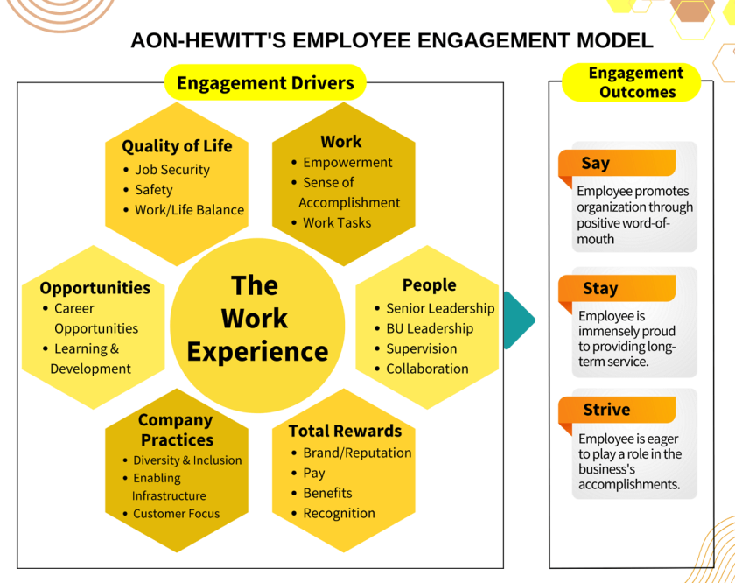
Figure 1: AON-Hewitt’s Employee Engagement Model
Source: Getbravo

ENHANCING ORGANIZATIONAL CULTURE :-
- Lidl Stiftung & Co. KG, being a lead retail company, understands the importance of a strong organizational culture in driving success and fostering employee engagement, to enhance their culture, they have adopted the AON-Hewitt Model, a well-established framework that emphasizes key factors for positive workplace transformation; firstly, Lidl focuses on Leadership Alignment, ensuring that leaders exemplify the desired values and behaviours, secondly, they prioritize Employee Value Proposition, creating a compelling work environment that attracts and retains top talent, thirdly, the company promotes Employee Well-being, nurturing a healthy and productive workforce. Lastly, Lidl emphasizes Performance Culture, recognizing and rewarding outstanding contributions, by embracing the AON-Hewitt Model, Lidl cultivates a thriving and cohesive organizational culture that drives sustained growth and success.

EMPLOYEE WELLNESS AND WELL-BEING :-
- Lidl uses the Aon-Hewitt concept to give employee wellness first priority. Programmes for physical, mental, and emotional wellness are encouraged. A supportive workplace is created via flexible work schedules and stress-reduction programmes, which improve work-life balance (Avey et al., 2010).
COMMUNICATION AND TRANSPARENCY :-
- In the context of "Communication and Transparency" within the AON-Hewitt model, Lidl Stiftung & Co. KG has exemplified a commendable approach, emphasizing open channels of communication, the company fosters an environment where employees feel heard and valued, regular town hall meetings and transparent updates from top management ensure that crucial information flows seamlessly throughout the organization and towards the community; moreover, Lidl Stiftung & Co. KG actively promotes feedback mechanisms, encouraging employees to express their ideas and concerns freely, this commitment to transparency cultivates a culture of trust and collaboration, leading to improved employee engagement and overall organizational success.
- By upholding the principles of the AON-Hewitt model, Lidl Stiftung & Co. KG demonstrates their dedication to effective communication and transparency, establishing a foundation for a thriving and cohesive workforce.
EMPLOYEE FEEDBACK AND CONTINUOUS IMPROVEMENT :-
- In the context of Lidl Stiftung & Co. KG, the AON-Hewitt model plays an essential role in establishing a culture of employee feedback and continuous improvement, this model emphasizes the importance of creating a feedback-rich environment where employees feel comfortable sharing their thoughts, concerns, and suggestions openly, Lidl actively encourages two-way feedback mechanisms, enabling employees to provide insights on processes, work dynamics, and company policies; regular performance evaluations, facilitated by the AON-Hewitt model, allow managers to identify individual strengths and areas for growth, through actively engaging with employee feedback, Lidl cultivates a sense of ownership and empowerment among its workforce, leading to enhanced collaboration and innovation.
- Through this model, Lidl generates continuous improvement by using feedback as a catalyst for positive change and growth, creating a more agile and adaptive organization.

- CONCLUSION :-

- In conclusion, implementing an effective employee engagement strategy is essential for Lidl to maintain a competitive edge and achieve sustainable success. By adopting the AON-Hewitt model and focusing on leadership, performance, career development, and culture, Lidl can create an environment where employees are engaged, motivated, and committed to the company's mission. Let us work together to build a workplace that fosters excellence, innovation, and growth for both the organization and its valued employees. Thank you for your attention, and I am now open to any questions or discussions you may have.

- REFERENCES :-

- Hewitt, C.C.U.A., Analyzing Employee Engagement Improvement in CV. Crisbar Using AON Hewitt and Deloitte Model.
- Avey, J.B., Luthans, F., Smith, R.M. and Palmer, N.F. (2010). Impact of positive psychological capital on employee well-being over time. Journal of Occupational Health Psychology, [online] 15(1), pp.17–28. doi:https://doi.org/10.1037/a0016998.
- Schein, E.H. (1990). Career anchors and job/role planning : the links between career pathing and career development. RePEc: Research Papers in Economics.
- Schneier, C.E. (1989). Capitalizing on Performance Management, Recognition, and Rewards Systems. Compensation & Benefits Review, 21(2), pp.20–30. doi:https://doi.org/10.1177/088636878902100203.
- Assen, M.F. van (2020). Training, employee involvement and continuous improvement – the moderating effect of a common improvement method. Production Planning & Control, [online] 32(2), pp.1–13. doi:https://doi.org/10.1080/09537287.2020.1716405.
- ‌Yue, C.A., Men, L.R. and Ferguson, M.A. (2019). Bridging transformational leadership, transparent communication, and employee openness to change: The mediating role of trust. Public Relations Review, [online] 45(3). doi:https://doi.org/10.1016/j.pubrev.2019.04.012.

