Activity 2 and 4

Activity 2

The HR Role is built around integrity, transparency, and trust. People professionals need to champion ethical practices and work with the wider business to ensure the best possible outcomes for all. HR professionals should role model ethical practice.

Making difficult decisions quickly and under pressure is a risk factor for unethical behavior. Individuals must take an ethical approach for the best possible outcome. Business are under pressure and will be likely to be publicly scrutinised and called out when they behave unethically. Social wellbeing is a focus. HR professionals need support from leaders to create practices that support their workforces especially in unprecedented times (CIPD, 2020)

An open culture improves morale. Good relationships with customers lead to an ethical reputation. Ethical companies outperform their piers financially in the long term (CIPD, 2020). The success of organisations relies on trustful relationships with employees, suppliers, customers, and community.

The ‘say/do gap’ can cause serious risk when leaders say one thing but do another. This is detrimental and can cause employees to be disengaged. HR professionals play a part in ensuring an organisaitons ethical values and expectations are set out to enable employees to reflect this in their behaviors.

The CIPD Profession Map has been designed to guide the HR professional in relation to activities, knowledge and behaviors needed for success. The map has four bands. These bands define the contribution that professionals make at every stage of their HR career in these areas; -

- The relationship that the HR professional has with a client
- The fucus of the activities performed by the HR professional
- Where HR professionals spend their time
- What services they provide to clients
- How their contribution and success is measured

Band One – Supports colleagues with administration process. Effectively managers information and data and is customer orientated.

Band Two – Advises on and/or manages HR related issues relating to an individual or a team. Has a clear understanding of the evaluation process and the solutions available.

Band Three – Leads a professional area activity as a consultant or partner. Addresses key HR challenges at an organisational level for the medium and long- term.

Band Four – Leads and manages a professional area(s) and/or the organisation. Responsible for developing and delivering organisational and HR strategies.

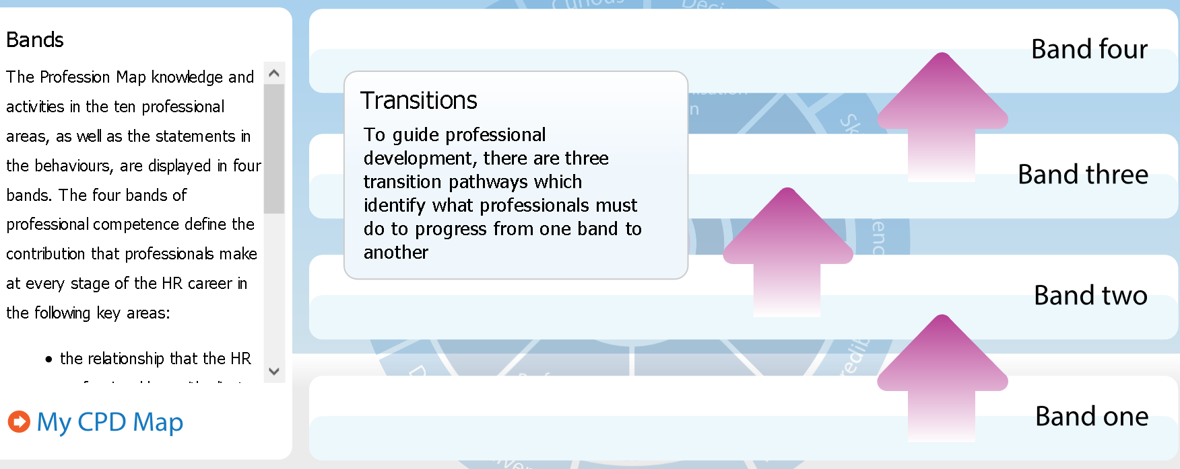

A ‘professional’ is someone who carries out their job to a high standard. HR is not one dimensional. There are many elements that can be summerised to concentrate on as the ‘four concentric circles of HR professionalism’: - (Taylor and Woodhams, 2017).

- Managing Self – Managing your own skills, knowledge, and behaviors.
- Managing in Groups/Teams – To be able to network in tams or groups, working with other HR professionals to solve problems.
- Managing Upwards – To be able to work with senior professionals within organisations. To be able to integrate specific strategies and plans with the wider organisational strategies.
- Managing across the organisation – To be able to set plans in motion across the organisation. To be able to influence and communicate to Line Managers. Promoting benefits that can arise from successful integrated HR activity.

The CIPD Profession Map states that there are ten professional areas set out in four bands of competence. These set out activities and knowledge for each area. Insights, strategy, and solution sit at the heart of the Map. There are Eight areas that identify what activities and knowledge needed to provide specialists HR support.

The Eight areas of behavior within the CIPD Profession Map detail how to carry out activities and/or make contributions for success. Each behavior has been described within the four bands of competence. Within each behavior there is a contra-indicator illustration of negative manifestations. This will enable everyone to identify what good looks like and recognise the behaviors that are hindering development. The eight behaviors are -

- Driven to Deliver - Demonstrates determination, resourcefulness, and purpose to deliver the best results for the organisation.
- Courage to Challenge - Shows courage and confidence to speak up skillfully, challenging others even when confronted with resistance or unfamiliar circumstances
- Role Model - Consistently leads by example. Acts with integrity, impartiality, and independence, balancing personal, organisation and legal parameters.
- Curious - Is future-focused, inquisitive, and open-minded; seeks out evolving and innovative ways to add value to the organisation.
- Decisive thinker - Demonstrates the ability to analyse and understand data and information quickly. Uses information, insights, and knowledge in a structured way to identify options, make recommendations and make robust, defendable decisions.
- Skilled influencer - Demonstrates the ability to influence to gain the necessary commitment and support from diverse stakeholders in pursuit of organisation value.
- Personally credible - Builds and delivers professionalism through combining commercial and HR expertise to bring value to the organisation, stakeholders and peers.
- Collaborative - Works effectively and inclusively with a range of people, both within and outside of the organisation.

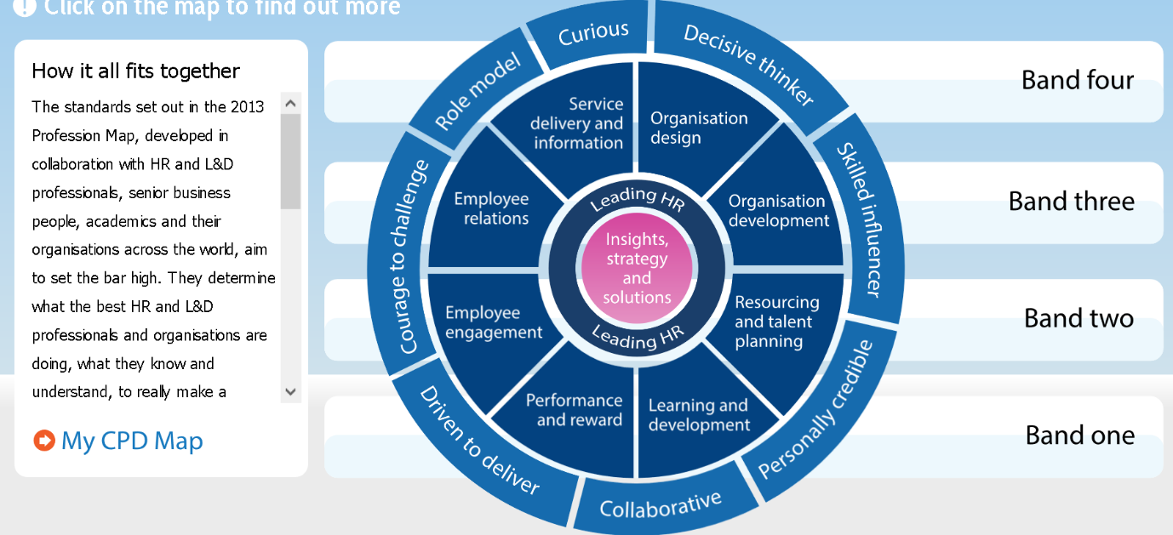

The behaviors set out from the Profession Map are essential to a HR Professional as it provides the individual ‘with the strongest foundation yet for effective decision making’. The behaviors outline ‘what it takes to be an effective People Professional in an uncertain world of work’ (salestrainingint.com, 2020). I believe the CIPD Profession Map is a continuous ongoing development tool which can be used in all stages of professionalism during a career. It provides the tools to improve personal challenges and/or provide you with knowledge and strategies to influence constructively and confidently. In an ever-changing high-pressured environment, the behaviors set out in the CIPD Profession Map, including the self-reflection tool keep values at the heart of any decision making and strive to encourage the practice of ethical principles. This will encourage the Professional to behave, act and champion better working environments.
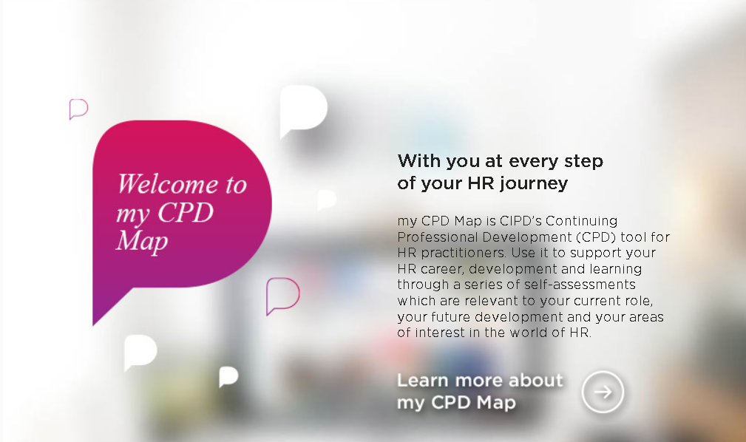
(Screenshot of PDP tool, 2020)
References

CIPD Profession Map available at; -
https://www.cipd.co.uk/learn/career/profession-map

Corona virus and the workforce – doing the right thing, available at: -
https://www.cipd.co.uk/news-views/changing-work-views/future-work/thought-pieces/coronavirus-workforce-crisis

CIPD 8 behaviors of the successful HR professional available at; -
https://www.salestrainingint.com/wp-content/uploads/2019/02/CIPD-8-behaviours-of-the-successful-HR-professional1.pdf

Taylor, s. (2017) 'chapter 4', in Perkins, G. (ed.) Studying Human Resource Management. Great Briton: CIPD, Pg. 75-78.

Word count - 953

Activity 4 – 1082 words.
Group dynamics is a set of behavioural and psychological processes that occur within a social group or between groups. It refers to the "nature of groups, the laws of their development, and their interrelations with individuals, other groups, and larger institutions" (Cartwright and Zander, 1968).
Group leaders and team members can contribute to a negative group dynamic (Mindtools, 2020)
- Weak leadership: when a team lacks a strong leader, a more dominant member of the group can often take charge. This may lead to a lack of direction, or a focus on the wrong priorities.
- Excessive deference to authority: this can happen when people want to be seen to agree with a leader, and therefore hold back from expressing their own opinions.
- Blocking: this happens when team members behave in a way that disrupts the flow of information in the group such as:
  - The aggressor: this person often disagrees with others or is inappropriately outspoken.
  - The negator: this group member is often critical of others' ideas.
  - The withdrawer: this person does not participate in the discussion.
  - The recognition seeker: this group member is boastful or dominates the session.
  - The joker: this person introduces humour at inappropriate times.
Free riding: some group members may make no contribution and leave other colleagues to do all the work. Free riders may work hard on their own but limit their contributions in group situations; this is known as "social loafing."
Evaluation apprehension: team members' perceptions can also create a negative group dynamic. Evaluation apprehension happens when people feel that they are being judged excessively harshly by other group members, and they hold back their opinions as a result.
To strengthen your team's dynamics, these strategies may be useful.
- Know your team.
- Tackle problems quickly with good feedback.
- Define roles and responsibilities.
- Break down barriers.
- Focus on communication.
- Pay attention.
Keep in mind that observing how your group interacts is an important part of your role as a leader. Many of the behaviours that lead to poor dynamics can be overcome if you catch them early enough (mindtools, 2020).
Psychologist Bruce Tuckman developed a model that is widely used. It describes elements of group dynamics. There are five stages in the model. The first four were written and developed in 1965 with the fifth being added in 1977 (toggl.com, 2020). The example of the stages is described below; -
Forming Stage
A newly introduced team, everyone is overly polite and pleasant. Most members are excited to start something new. The first meeting format could be.
- Member’s skills, background, and interests
- Project goals
- Timeline
- Ground rules
- Individual roles
When the group familiarise themselves, roles and responsibilities will begin to form. It is crucial for team members to develop relationships and understand what part each person plays for clear understanding going forward.
At this stage, the team is more likely to get to know each other and productivity would be low.
Storming Stage
In the storming stage, the reality and realisation of completing the task at hand has now become clear. The initial feelings of excitement and the need to be polite have likely worn off, this can be interpreted as the Danger Zone” (Tesco, 2013)
Personalities may clash. Members may disagree over how to complete a task or voice their concerns if they feel that someone is not contributing enough. Sometimes, the Group Leader is questioned over their leadership style.
It is important to remember that this is normal and most groups experience conflict. It is important to ensure all members of the team/group understand that this behaviour/feeling is normal.
Some teams try to avoid conflict stage at whatever cost. This avoidance usually makes the problem grow until it is unmanageable. Best practice is to recognise conflicts and resolve them as soon as they arise.
Norming Stage
People start to appreciate their team/group members’ strengths. The group starts to settle. All members are contributing and working unitedly.
Storming sometimes overlaps with norming. As new tasks arise, groups may still experience a few conflicts. It can be easier to address this if you have dealt with minor conflicts at the previous stage.
Performing Stage
Members are confident, motivated, and familiar with the project and their team. The team will most likely operate without supervision. Everyone is like minded and driving towards the goal set at the beginning.
The performing stage is what all groups strive to reach. Some fail to overcome conflict and cannot work together and do not make it to this stage.
Adjourning Stage/Mourning
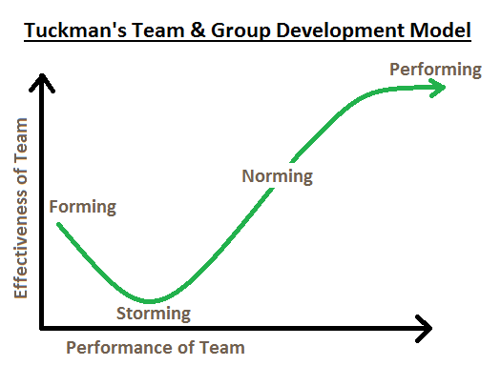
Tuckman added a fifth stage called adjourning in 1977. When a project ends, the team disbands. It can also be known as mourning. Members grow close and feel a loss when the experience is over.

I have worked with a successful team within Morrisons delivering a ‘Service Success’ presentation aimed at Customer Service Managers from 24 Stores. I quickly realised when preparing for the presentation that leading a group of professionals to the same goal was going to have characteristics of the Bruce Tuckman model.
Forming - I led a team of 4 People Managers. We met to discuss the aim and to delegate roles and responsibilities that the individuals were to have. Each Manager contributed and delivered a different part during the presentation.
Storming – One People Manager was not happy with their role, we discussed what the reasons for this were. We came to a compromise within the group and negotiated a different role. The pressures of the time constraint contributed to the storming stage. This was resolved with a clear time scale for each module.
Norming – We met to confirm the content of the presentation and were happy with the content that each member had contributed.
Performing – A video link meeting was held to share content for the final draft of presentation. The presentation was successfully delivered on time.
Adjourning – The presentation was a success; the team were happy with the result. There was sadness that the project had ended when the team disbanded to enable them to focus on other projects within the business.
Recognising Group Dynamics and Group Behaviours will strengthen and benefit any organisation. Organisational politics are a natural result of the fact that people think differently and want to act differently (Hrmars, 2020). It is important to point out at every stage that this process is ‘normal’. The HR professional is integral to this. Coaching /guiding and formal training is an imperative role within the business and will contribute to drive success throughout.

References

Effect of Organizational Politics on Organizational Goals and Objectives, Available at;-
https://hrmars.com/papers_submitted/1877/Effect_of_Organizational_Politics_on_Organizational_Goals_and_Objectives.pdf

Improving Group Dynamics available at; -
https://www.mindtools.com/pages/article/improving-group-dynamics.htm

Five Stages of Team Development -Understanding team development process Available at;-https://toggl.com/track/stages-of-team-development/

Group Dynamics: it’s characteristics, stages, types, and other Details | Management available at; -
https://www.yourarticlelibrary.com/management/group-dynamics-its-characteristics-stages-types-and-other-details-management/5363

