2020
Managing Projects in the Organisation

Dr Paul Jenkins BMSW5104
Syeda Aysha Khanom (1814416)
Table of Contents

Introduction ………………………………………………………………2
Techniques and Tools used for Project Management ……………………2
Work Breakdown Structure…………………………………..3
Gantt Chart …………………………………………………...3
Critical Path Method (CPM)………………………………….3
Program Evaluation and Review Technique……………......3/4
Implementation of Project Mansion House……………………………….4
Gantt Chart…………………………………………………...4
Project Plan…………………………………………………………….....5
Project Appraisal Technique.………………………….…6/7/8
Stakeholders………………………………………………….8
Communication Management………………………………..9
Risk Analysis………………………………………….9/10/11
Snagging List……………………………………………….12
Evaluation of Project Mansion House………………………………..12/13
Self-Development Plan……………………….………………………13/14
SMART Objectives………………………………………….15
Project Closure Analysis…………………………………………………15
Conclusion……………………………………………………………….16
References…………………………………………………………….16/17
Appendix…………………………………………………………………17

Introduction
Project Management is a procedure, where a Project Manager; is leading a team to complete and achieve goals and meet targets all within a specified time. In this assignment I will be writing a report and producing a Project Management plan for opening a new Convenience store in Sainsbury’s (Project Mansion House). I will examine and implement the relevant theories and models required to make the plan successful and ensure all the procedures are completed within the required time scales.
Sainsbury’s is a Supermarket, which has been retailing food for last 150 years. The company has grown and currently growing rapidly; where the opening of new stores is vital to keep the revenue coming in and the business growing in the food retail industry.
According to Meredith et al (2017), project management provides a robust foundation of using a managerial approach to both fundamental concepts and practices in real life. To build a successful Project, it is important to have a strong Project Manager, who will lead by an example and complete the project without any problems. They need to be pro-active and constantly make decisions, take control and ownership of their actions. They need to delegate all necessary jobs to the relevant department. Keep reviewing the process to ensure they are communicating well with the team and motivate the team to achieve the goals at the optimum level and of the highest standards.
A Project Scope is required to be constructed right at the beginning of the project, where it highlights the resources required for the project, how much labor will be needed, the roles people will play and the time limit they have to complete their jobs are some of the elements required for a project to succeed. Planning a successful Project requires the use of tools and techniques correctly, this will enable me to see which technique will be best suitable for the New store opening.

Techniques and Tools used for Project Management
Project Management Tools and Techniques (PMTT) are used for preparing schedules, controlling them and having a work breakdown structure to plan the project and ensure all points are covered in terms of cost, time and what goals are to be achieved by the deadline. Technique is the process, in which certain things are completed and tools are the methods they use to complete that process. According to Rad and Levin (2006), Project Managers who wish to spend their resources competently and have a strategic plan, are required to use the full range of project management functions. This is used through Management tools and techniques to execute projects successfully.
To ensure Project Mansion House is completed successfully, it is important to plan the journey and highlight all actions, resources, labor that will be required for this project. The types of tools and techniques for Project Management are the following:
Work Breakdown Structure: According to Jung and Woo (2004) a flexible work breakdown structure (WBS) improves the overhead attempt by reducing the amount of data to be controlled. This tool is a deliverable-oriented structure that allows you to reach your objectives and outlines the scope of the project. I have produced a Work Breakdown structure below to outline all the deliverables required for Project Mansion House, along with all the tasks required to be completed within the time scale and added the review times for each department.
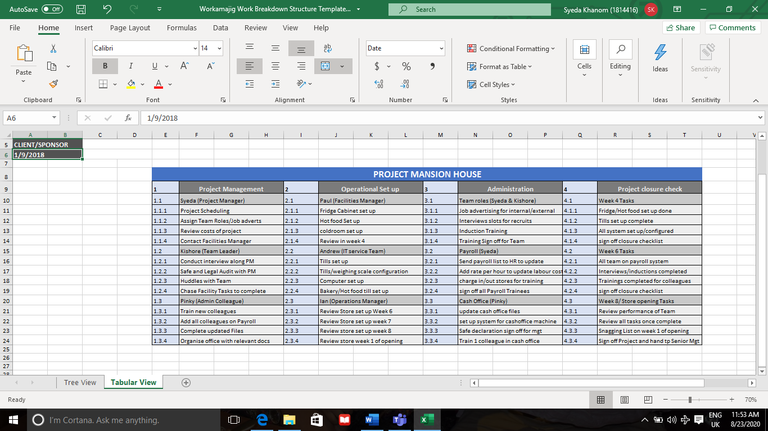
Fig 1: Work Breakdown Structure created by (Author)
Gantt Charts: Gantt Charts are used to help managers structure their tasks and events, once tasks are listed it will enable them to see the duration of time required to complete certain jobs within their time frame. This technique will help to highlight all the essential steps to follow and fulfill to reach the required results.
Critical Path Method (CPM): CPM is the tool, which lists all the characteristics in technical order from start to finish like a graph; dealing with planning, scheduling, organizing activities which are defined. It deals with time and cost of the project ensuring to meet the target at the lowest cost with least time. This tool may be used in Opening the new store at Sainsburys, to ensure all characteristics are listed from start to finish however for some reason if there is a technical error on the system the tool will not work for the project.
Program Evaluation and Review Technique (PERT): PERT is the technique used to outline any uncertain activities within the project. This technique plans and controls time, whereas CPM is used to control Time and cost. CPM and PERT are used in conjunction where both methods work along with each other to give reliable results.
PERT is mostly used for research and development projects and CPM is more activity based and used for construction-based projects, however if the techniques are used for projects where PERT is used on its own that is not relevant to research and development then it may not be as reliable, reason for this may be that PERT chart does not estimate time or cost of historic events and only reflect on input by participants in time order, which will not give accurate results for any project that is not relevant to research and development. Using both PERT and CPM together will be a big cost to any project. Taking time and cost into consideration I decided to conduct a Gantt chart to establish the tasks and procedure required to follow and complete each phase of Project Mansion House.
Implementation of Project Mansion House
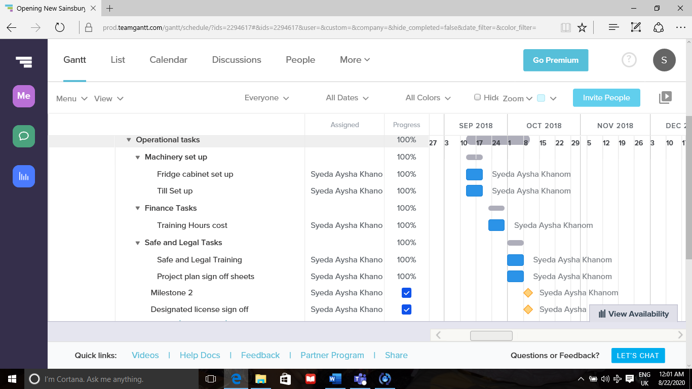
After planning the PMTT, the next step was to implement these tools and techniques within our Project. To ensure this is done correctly we had to prepare a Project plan to set the goals and organize the team in their roles and ensure they were aware of the activities they will be carrying out. Resources will need to be put in at this point and will also have to be controlled by the Project manager (PM). Below is a copy of the Gantt Chart I conducted which enabled me to specify where to put the right people, in the right place at the right time.
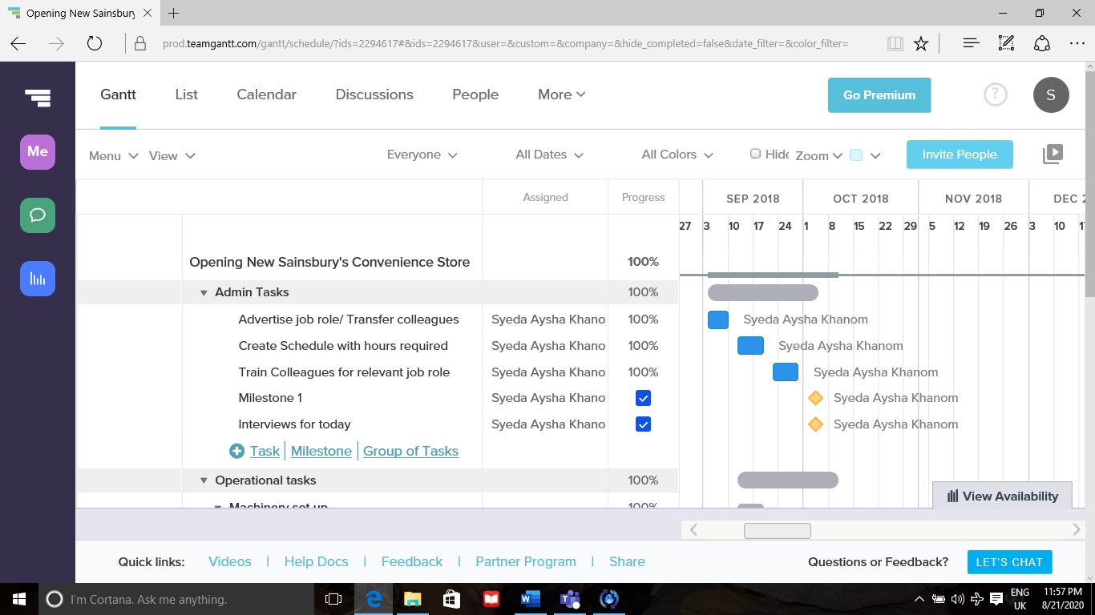
Fig 2: Gantt Chart completed by (Author)

Project Mansion House was a 2-month project (September 2018- November 2018), where all phases had to be completed on time. The Gantt chart highlighted all-important tasks, completed in the first 4 weeks for the project to go smooth. Activities were spread out in phases where the first phase was based on Administration. The first phase of opening a retail store is ensuring we have the right people for the roles; therefore, the first step was to advertise jobs for internal and external candidates. Project scheduling is also vital to ensure activities are being planned accordingly, this helped to set realistic costs and timescales for each activity and outlined relevant use of candidates for each activity. 8 out of the 10 tasks have been completed 100% without any problems however Designated License holder training needed follow ups and chasing of senior management for sign off. This was completed just before week 4 finished opposing to week 2 when it was initially scheduled to be completed. Interviews was highlighted as a milestone, as it did not have a duration for completion and was ongoing throughout the 4 weeks. This had a negative effect on the project, interviews could not be scheduled at one time as recruitment and transfers were coming through continuously in that period. Plans had to be rearranged to fit interview slots during some days, this had an impact on productivity and cost on labor as well.
Sainsbury’s has strong visions and values for their colleagues and customers, their vision is to be the best retailer where people love to work and shop (Ormerod., 1996). Sainsbury’s have strong tools and techniques that is used within the organization to ensure trainings are conducted of the highest standards and colleagues are getting the best tools for their training.
Project Plan
Project Initiation Document (PID) outlines the overall measures of a project plan, which was used for the project plan. The team can go back and relate to the PID at a later stage of the project as/when required. This approach consists of the project scope and collaboration, which was used as a guideline for stakeholders. The key steps in the project initiation are shown on my project Plan below.
Create Business Plan | Identify Stakeholders | Outline Project  Scope | Goals and Objectives | Assignment of Jobs | Carry out Risk Assessment
Open a New Convenience store.  Next to Train Station  No competition nearby  Hot Food available  Weekly Sales 65-70k approx | Customers  Shareholders  Community  Suppliers  Employees  Distributors | 1 PM and 1 Team leader  Schedule for colleague hours required  Advertise job roles for internal and external candidates.  Set up operation tasks  Send colleagues for relevant training. | Open store in 2 months  Safe and legal training refresh for PM and TL  Designated premises license course booking.  Conduct Interviews  Delegate key responsible colleagues training  Allocate Labours hours designated for project  Review meeting with Area Manager to discuss final stages of store opening | Project Manager to handle all legal document sign off.  IT to complete till set up.  Fridge cabinet log in via Facilities manager  Team Leader to carry out admin training i.e Payroll, Induction, relevant training completion.  Cash office colleague to do cash document audit and update all files for store.  Bakery/ Hot food colleague to carry out relevant training. | Risk assessment to be carried out on week 6 after all installation and training is complete to outline any risks.  Snagging List to be conducted on first week of store opening to check any technical or operational errors before project completion sign off.
Fig 2: Project Management Plan created by (Author)
I used the Project initiation document to implement my Project plan. Once the Business Plan has been given the green signal and signed off by senior management. It was important to start the phases straight away, as there were no room for error due to time scale being tight.
Project Appraisal Technique:
A project appraisal technique is used by organizations to assess the feasibility of the project before committing to any resources etc. Businesses use this technique to choose the best project to achieve their goals. In project Mansion House a project appraisal was used to assess the financial appraisal, as well as the Economic appraisal, Social appraisal, Marketing appraisal, Technical Appraisal. Financial appraisal was used to ensure the project did not overspend and costs were kept with in limit, below I have formed a table which outlines all the costs and tasks required to complete in Project Mansion House.
Phase 1 of Plan: Week 1 -4 (3rd September – 1st October 2018)
Deliverables/Tasks | Cost of Task | Task assigned to | Date completed
Project Scheduling:  Hours for labor in total for 4 weeks: (8hr shifts)  Designated Premises  Licence Training for Team Leader 1 day course.  Admin: files x12  Stationary (pens, erasers,notepads etc)  Fridge Cabinet Set up total 8 cabinets.  Till Set up total 6 tills  Bakery till  Hot Food Scale | Rate per hour: 8.50  TL RPH 9.50  WK1: 1x8.50=340  1x9.50=380  Total: Week 1= 720  WK2: 5x8.50=1,700  1x9.50=380  Total: Week 2= 2080  WK3: 8x8.50=2720  1x9.50= 380  Total: Week 3= 3100  WK4: 12x8.50=4080  1x9.50=380  Total: Week 4= 4460  Total for Labour in 4 weeks: 10,360  35  12x1.50=18  50  8x720=10,320  6x499=2994  1x399=399  1x399=399  Total for operation in 4 Weeks = 14,112  Total for Phase1= 24,575 | Syeda (PM)  Kishore (TL)  Pinky (Admin)  Ian (Operation Mgr)  Ian (Operation Mgr) | 05/09/18  12/09/18  19/09/19  26/09/18  06/09/18  06/09/18  08/10/18  26/09/18  27/09/18  27/09/18

Phase 2 of Plan: Week 5-8 (02nd October – 30th October 2018)
Deliverables/Tasks | Cost of Task | Task assigned to | Date completed
Project Scheduling:  Hours for labor in total for 4 weeks: (8hr shifts) | Rate per hour = 8.50  TL RPH = 9.50  WK5: 5x8.50=1700  1x9.50=380  Total: Week 5= 2080  WK6: 1x8.50=340  1x9.50=380  Total: Week 6= 720  WK7: 2x8.50=680  1x9.50=380  Total: Week 7=1060  WK8: 5x8.50=1700  1x9.50=380  Total: Week 8=2080  Total for Labour in 4 Weeks= 5,940 | Syeda (PM) | 04/1018  11/10/18  18/10/18  25/10/18

Phase 3 of Plan: Week 1 of store opening (31st October-6th Nov 2018)
Deliverables/Tasks | Cost of Task | Task assigned to | Date completed
Snagging List:  Make a list of Areas that need improving,  Any Facilitiy issues to fix (broken socket, wall signage etc.)  Risk Assessment Audit  Project Closure Report  And sign off | N/A | Syeda (PM)  Syeda & Store Manager (SM)  Syeda & SM | 4th Nov 2018  5th Nov 2018  6th Nov 2018

I have calculated the total cost for the project in the first 4 weeks. This was the time where all the expenditure was made to kick start the Project. In Phase 2 there were not any operational cost just Labor cost of new starters and colleague training. Phase3 was for admin checks before the final closure report was checked and the project was signed off.
Stakeholders
Stakeholders are the people who have an attraction within the organisation, these people may have invested within the business and may determine the outcome of business decisions (Savage et al, 1991). Stakeholders for project Mansion House have been listed on the plan. These stakeholders are those who will have an impact and involvement in the process of the store opening. They will receive weekly updates from the Project Manager regarding the progress of Project Mansion House. A Stakeholder Analysis Communication Report will be conducted to outline this information.
Stakeholders | Type of Document | Person to contact | Date sent
Employees | Colleague journal | Project Manager | End of each week
Customers | Letter (noticeboard) | Project Manager | End of each week
Suppliers | E-mail | Project Manager | End of each week
Distributers | E-mail | Project Manager | End of each week
Share holders | Shareholder journal | Project Manager | End of each week
Community | Letter (noticeboard) | Project Manager | End of each week
Fig 3: Stakeholder Analysis Communication Report created by (Author)
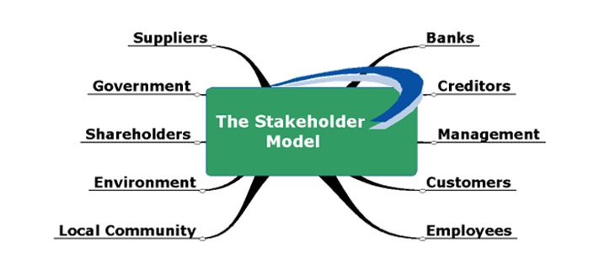
Fig 4: The Stakeholder Model sourced: Kourteli (2000) cited from http://www.dissertationhomework.com/essays/business/business-environment-sainsburry-nhs

Communication Management
To lead a successful project, it is important for the project manager to have great communication skills, they are the main point of contact for the project. The project plan should be communicated with all relevant individuals who are associated with the project.There are many types of communication which is required to be carried out in a project:
Face to face communication: PM’s should always have positive body language and eye contact; they should communicate in a soft tone to ensure all jobs are being completed without immense pressure.
Weekly Stakeholders Analysis Report: conducted by the PM in a weekly basis to communicate with the stakeholders and update them on the progress of the project.
Weekly progress update via Team huddles: Communication session of discussing the project plan and what changes are required to be dealt with if there are any.
It is essential that all the communication channels i.e Stakeholders are receiving information in a timely manner.

Risk Analysis
Risk analysis concerns itself with the quantity of risks (Vose, 2008),once the Project has come to an end it is essential to carry out a Risk audit to check and see if there are any points/issues which require immediate action or which may need attention in a few weeks of Store Trading.

Hazards | Who could be harmed and how? | Existing control measures | Current risk rating (consider likelihood and severity) | Completion date for actions required | Person responsible | New risk rating (additional controls in place)
Mechanical  Crushing and cutting points on machines i.e bakery slicer, mechanical lifting and handling of bailer machine | Bakery Colleagues may be harmed if slicer is left open.  Colleagues using bailing machine for cardboard. | Slicer always placed in designated place  Bailer machine to be used after delivery completed | AMBER  GREEN | 13/11/18 | Asif (Bakery colleague) | RED (High Risk)  Slicer was outside whole day, it should always be out of sight when not in use
Electrical  Electrical Panel | All Colleagues if panel is not kept clear from combustibles. | Electrical panel should always be kept clear | RED | 13/11/18 | Lawrence (SM) | RED (HIGH RISK)  Electric Panel covered with combustible and not bailed after delivery .ALWAYS keep the electric panel clear!
Fire & explosion  Fire call points and fire exits.  Emergency File updated? | All colleagues/ customers if fire exits are blocked during an emergency | Fire Exits are kept clear  All calling points responded during fire test.  Emergency File all updated | GREEN  GREEN  GREEN |  |  | GREEN (LOW RISK)
Thermal  Hot Food Department | Hot Food colleagues/customers if turbo serve is not switched off and they burn their hands. | Hot Food Turbo serve is switched off when not in use. | GREEN |  |  | GREEN (LOW RISK)
General work environment  Adverse Weather conditions | All colleagues/  Customers might slip when it’s raining outside. | Caution signs put out when its raining outside | GREEN |  |  | GREEN (LOW RISK)
Lifting/handling  handling Pallets on shopfloor. | Colleagues  /Customers if pallets are pushed instead of being pulled could hurt someone. | Pallets are being pulled correctly on the shop floor | GREEN |  |  | GREEN (LOW RISK)
Stress  Any pregnant colleagues/ colleagues with stress? | No colleagues with stress | Separate risk conducted for colleagues who are pregnant | GREEN |  |  | GREEN (LOW RISK)
Other  Insufficient training and information, first-aid facilities, missing occupational health provision. | All colleagues | All Training are complete | GREEN |  |  | GREEN (LOW RISK)
Date and Assessor’s signature: | 6th Nov 2018  Syeda Khanom (Project Manager) |  |  | 6th Nov 2018  Lawrence Monk (Store Manager)
Fig 5: Risk Assessment created by (Author)
After completing the risk assessment there were 2 points of action for the store to take into consideration, these actions were required to be completed within a week. A re-audit took place in 7 days. Most of the sections were GREEN, as the store had just opened therefore all training and checks were done during project closure report.

Snagging List
Snagging lists are conducted after the completion of the project, in the first week of opening the store the Project Manager is required to walk around the store and make a list of any miscellaneous jobs that require attention and need to be completed instantly.
Hazard | Action required | Action Completed by | Date Completed
Bakery wall plug needs to be tightened.  Till 4 weighing scale not working.  Safe limit Document missing from Safe.  Payroll File Missing Contents page inside. | Facilities manager to screw the wall plug tight  IT colleague to configure the tills and check scale.  Print off new page and stick inside Safe.  Print off page from the system and stick inside. | Paul (FM Manager)  Andrew (IT Team)  Syeda (PM)  Pinky (Admin) | 06/11/2018  06/11/2018  06/11/2018  06/11/2018
Fig 6: Snagging List created by (Author)
Evaluation of Project Mansion House
According to Munns and Bjeirmi (1996), the distinction between the project and project management demonstrates how the appreciation of both delivers higher project success. Overall, the project ran smoothly with most tasks being completed on a timely manner, however there were some operational tasks, which were not completed according to time scales but did complete before the store opened. Due to having tight time frame of 8 weeks opposed to 12 weeks, which was normally granted for a New Convenience store opening; all tasks were briefed and submitted from day 1. Tasks that were down to facilities manager ( third party) were done in 3 phases, as first the Fridge cabinet had to be measured and parts had to be ordered, after the parts were ordered the team had to regularly chase the facilities manager for update, as that was one of the longest jobs and had to be completed accordingly or the store would have had issues while opening if fridge cabinets were out of order. Once the parts arrived 2 parts arrived of the wrong measurements which delayed in the cabinets getting fixed on time. The part was reordered, and we waited a further 7 days to get the cabinet up and running. Once the cabinet was turned on, they were left running for 2 days to check the consistency of the temperature. We ensured the cabinets were running properly for the chilled food to stay within required temperature, which was between 0-8’c. During this time, all temperature probes were tested to make sure they were working for both cold cabinet and hot food cabinet. Interviews also had a bad impact on productivity, transfer colleagues and new recruits were not able to come in at the same time and had to be interviewed at different times, which caused a minor delay in the project.
After completing the project, a feedback survey was completed by the team to give feedback on the Project managers performance (Questionnaire attached on Appendix). The form was handed out to all colleagues from the team, who were part of the project from the beginning. After conducting the survey all the results were put together to form a development plan going forward on how to improve my skills, as a Project Manager for upcoming projects, the results are the following:
- All colleagues were briefed on their role that they had within the project.
- Weekly updates were given during huddles and ad-hoc team meetings however 2 missed the updates, as they were on a course and were not updated at a later stage.
- All colleagues apart from Team leader did their allocated hours weekly, in 2 instance the team leader stayed behind to complete some admin.
- All colleagues apart from the Team Leader were doing their delegated tasks.
- All colleagues had a meeting, some had a brief review and key responsible colleagues i.e. bakery/hot food colleagues had a more detailed in-depth review.
- Team Leader conducted Safe and Legal training with colleagues and Project Manager conducted safe and legal audit with colleagues from key roles, i.e cash office colleague.
- Project manager was happy to help however during one incident project manager was at a meeting and was not available, therefore colleague requested help from Team Leader.
- Project Manager always communicated changes and updates constantly to ensure colleagues were aware of what was happening with in the project.
- Overall colleagues were happy with the way the Project Manager managed this project and how the team was motivated to complete tasks. They were engaged throughout the project and if at any point they needed assistance they were supported by the management team whether it was myself or the Team Leader. According to this feedback I believe my main Strength during this project has been my communication with my Team, I have always kept them in the loop and managed to boost their morale during the project therefore, they were all happy with my management skills but as they suggested there is always room for improvement to get better at the role. A few points of concern were mentioned in the questionnaire, which need to be forwarded to the self-development plan.
I will conduct a Self-Development Plan to outline areas, where I need to develop and improve my ways of working to become a better manager and be able to manage projects in a better way next time. According to Ramaditya (2020), to increase involvement at work, the employees have to develop motivation themselves by enabling conversations and contribution between employees to change their self- development behaviors.
Self-Development Plan
Development  Objective | Development  Action | Any Support required? | Development  Duration | Completion date/signoff
Weekly updates to be given to all colleagues | -Have a daily huddle every morning before all tasks start and motivate team to do the best job.  -listen to any queries any team member may have and act accordingly. - All colleagues will be updated on a daily and weekly form as there is constant information updated to team. | Team Leader to carry out a huddle once a week. | 1 week | S.A.Khanom  21/11/2018
Project Scheduling and allocate hours accordingly. | Ensure all colleagues on next project are strictly doing allocated hours and not more. | Team should finish shift and leave after reporting to me for the day. | 3 Months | S.A.Khanom  31/01/2019
Delegate relevant tasks to relevant colleagues | Team Leader only to complete job delegated. Constantly keep reviewing colleague roles. | Team Leader only support Colleagues if authorized by PM | 3 Months | S.A.Khanom  31/01/2019
Conduct In depth Colleague reviews | During Project duration all colleagues to receive feedback on a daily basis and a depth review in last week of project to give clear perspective of their performance through the process. | Colleagues to book in review times in advance to avoid disappointment. | 3 Months | S.A.Khanom  31/01/2019
Safe and legal audit to be conducted accordingly. | Safe and legal audit to be conducted with as many colleagues as possible therefore colleagues are aware of safe and legal training as well as gain better understanding of store trading. | Colleagues to come across if they are interested in taking part in safe and legal audits or any other audits aswell. | 3 Months | S.A.Khanom  31/01/2019
Fig 7: Self-Development Plan created by (Author) actions taken from questionnaire (Attached in Appendix).
A Self -development action plan was produced, actions had to be completed and signed off within 3 months of Plan. After looking into the plan I realized my strength is also my weakness, I communicated well to the team throughout the project however, I also forgot to communicate to few colleagues during few opportunities when they were not available and due to the rush and tight schedules, it was easy to forget miscellaneous points if I was not reminded. There are perceptions and visions of development these contrast with the liberal trends in development thinking (Rahman, 1993).
SMART Objectives:
SMART Objectives are goals set, which are measurable and achievable. Following on from the Self- Development plan I have conducted SMART Objectives to achieve the plan quickly and reasonably.
Specific Objective: Communicate the importance of cost within a project and how colleagues can save cost by doing only allocated hours during the project.
Measurable Objective: Colleagues to be given daily feedback and all performance reviews to be Completed by end of week 7 of any project.
Achievable Objective: All colleagues to only do delegated tasks so that all goals are achieved on time by the end of the project.
Relevant Objective: All colleagues to conduct Safe and Legal Audit with PM, to ensure they gain better understanding of Legal Trading Standards in retail stores.
Time Bound Objectives: Team should get a daily 10min huddle to be updated with all relevant changes and how project is getting on so far. These 10 min huddles will save any sort of training or colleague meeting later on, as colleagues are aware of what is required off them and any questions would be answered within the huddle, so there should be no confusion later on and time will be saved.

Project Closure Analysis:
A winning project is the one that has been effectively closed (Sarfraz, 2009), Project closure is the handover process when the Project manager does the final audit walk with the Senior Managers and Store Manager and signs the project off once all the deliverables have been achieved.
Final Project Scope Analysis: All deliverables and costs have been achieved according to the Project Plan and Work Breakdown Structure; these have also been signed off by me.
Action Plan: A development plan has been conducted after the completion of the project; this is required to be completed within 3 months.
Admin: All training is signed off and updated recently.
Stakeholder Analysis: All stakeholders who were part of the project have been updated with all important information and have received relevant documents regarding the project.
All the sections have now been completed regarding Project Mansion House and I can confirm that I have completed and signed off all the follow ups and reviews for colleague performances.
Handover sign off: Syeda Aysha Khanom (PM) Date: 06/11/2018
Lawrence Monk (SM) Date: 06/11/2018

Conclusion
In conclusion it is evident that New Store opening requires attention to detail when it comes to appointing the right team for the project. Having a detailed plan in the beginning allows you to allocate the right people in the right place at the right time. It gives the scope to understand where the cost will go in the project. If you have experienced people in the team then you will save cost on training and can use that towards a more advanced technology. There is immense stress and pressure in store openings especially when the time scale is tight, this instantly is a disadvantage with time, as normally stores have 12 weeks to open and Project Mansion House had 8 weeks due to being a smaller store in size compared to others. It still required the same jobs and tasks to be completed however, that was the main challenge in this project and it was accomplished with high work ethic and a team who strived for success and reached the goal with high standard. A great Well done to Project Mansion house for successfully completing this project.
References

- Gantt Chart ., 2020 available on https://prod.teamgantt.com/gantt/schedule/?ids=2294617#&ids=2294617&user=&custom=&company=&hide_completed=false&date_filter=&color_filter= (accessed on 21st Aug 2020)
- Jung, Y. and Woo, S., 2004. Flexible work breakdown structure for integrated cost and schedule control. Journal of construction engineering and management, 130(5),pp.616-625.
- Meredith, J.R., Shafer, S.M. and Mantel Jr, S.J., 2017. Project Management: A Strategic Managerial Approach. John Wiley and Sons.
- Munns, A.K. and Bjeirmi, B.F., 1996. The role of project management in achieving project success. International journal of project management, 14(2), pp.81-87
- Ormerod, R.J., 1996. Information systems strategy development at Sainsbury’s supermarkets using “soft” OR. Interfaces, 26(1), pp.102-130.
- Rad, P.F. and Levin, G., 2006. Project portfolio management tools and techniques. www. iil.com/publishing.
- Rahman, M.A., 1993. People’s Self-development. Perspectives on Participatory Action Research, pp.315-335.
- Ramaditya, M., 2020. Does teamwork, career development, self development influence work involvement? Journal of Socioeconomics and Development, 3(2), pp.1-11.
- Sarfraz, F., 2009, August. Managing for a successful project closure. In PICMET’09-2009 Portland International Conference on Management of Engineering & Technology (pp. 1392-1395). IEEE.
- Savage, G.T., Nix, T.W., Whitehead, C.J. and Blair, J.D., 1991. Strategies for assessing and managing organizational stakeholders. Academy of management perspectives, 5(2), pp. 61-75.
- Sourced: Kourteli., 2000. Stakeholder Model http://www.dissertationhomework.com/essays/business/business-environment-sainsburry-nhs (accessed on 21st Aug 2020).
- Vose D., 2008. Risk analysis: a quantitative guide. John Wiley & Sons.
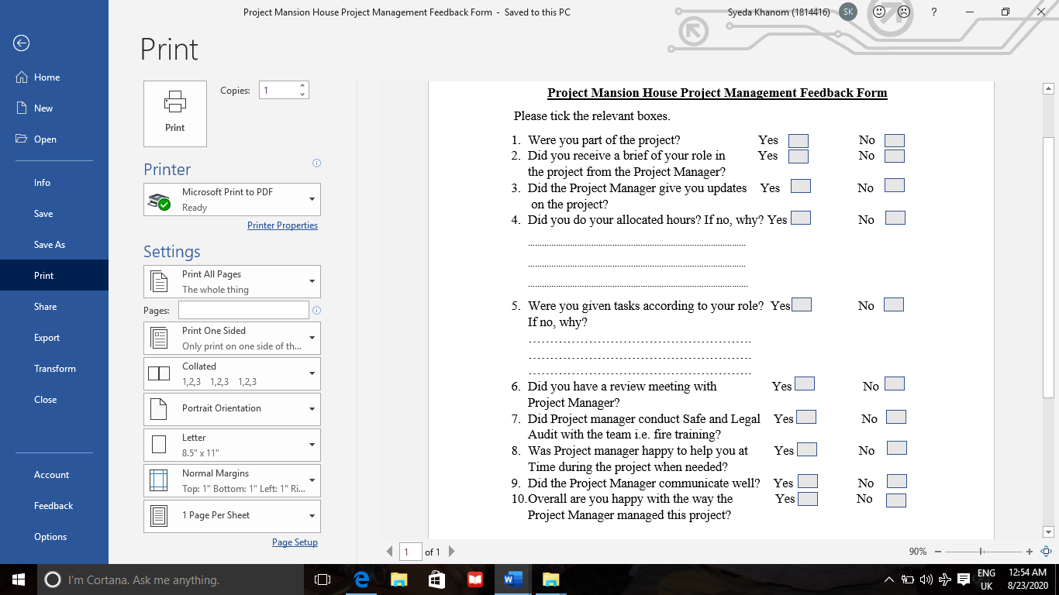
Appendix
Fig 8: Feedback form completed by Project Team, Created by (Author)

