Benjamin Woodhead (P151944)
Bwoodhead.151944@student.uwtsd.ac.uk
Abstract
A description and analysis of Non-Destructive Testing and the various techniques used within the field. The advantages and disadvantages of each technique are assessed, as well as how these affect their deployment by inspection teams. This is then applied to the field of stress analysis, and how NDT techniques can be used to help inspection teams.
NDT Techniques and applications
Advanced Stress Analysis & FEA Coursework

Contents
Introduction 1
Ultrasonics 3
Magnetic Flux Leakage 7
Visual Inspection 10
Bibliography 11

Introduction
Non-Destructive Testing is using the process of using various methods to detect defects in a material before they become hazardous points of potential failure. These defects can appear at any point within the manufacturing and service life cycle of the part, such as (Hull & John, 1988);
- In the raw materials:
  - Stress cracking – hairline cracks due to excess stress as part of the formation process
  - Porosity – air pockets forming during production
  - Slag inclusions – inclusions of undesired materials within the main material
  - Segregation – delamination of the material layers
- During manufacture:
  - Machining defects – scoring, chipping or chattering of the material after machining
  - Heat treatment defects – warping or necking of the part after heat treating
  - Welding defects – overheating/burning during welding
  - Residual stress cracking – stress defects from raw material propagating due to manufacturing stresses
- Assembly defects:
  - Incorrectly assembled/missing parts
  - Additional welding defects
  - Assembly stress cracking – stresses due to incorrect assembly such as over-torquing of components
- Service life defects:
  - Fatigue
  - Corrosion
  - Wear
  - Creep
  - Thermal instability
By detecting these defects either at the point of manufacture or during the service life of the part, potential failures can be identified and rectified before they cause harm or damage to person or property. There are many techniques used within the field of NDT such as eddy current analysis, Alternating Current Field Measurement (ACFM) and vacuum leakage testing, but this report will focus on ultrasonics, Magnetic Flux Leakage (MFL) and visual inspection. There are advantages and disadvantages to all three, but each of them is an important tool for an NDT inspection team. It should be noted that while these three techniques are separate, they are often overlapping and used in a complementary manner by an inspection team to provide a complete overview of the state of an asset. The main benefit of all these techniques over classic destructive testing methods is that the inspected part is not damaged in any way and can be immediately returned to service if it passes inspection. This saves a large amount of time and cost for asset owners as they do not lose an asset in the testing process, and can plan any required repairs that may help to extend the asset past its initial expected service life.

Ultrasonics
Ultrasonic flaw detection is a method based upon using high-frequency sound energy to examine inspection surfaces and take thickness measurements of the material (NDT Resource Centre, 2019). The technique involves using a UT transducer to produce sound waves that are pulsed in to the surface via a couplant, and then measuring the time it takes for these signals to be reflected back from the closest surface – the front wall – and the furthest surface – the back wall – to the transducer (NDT Resource Centre, 2019). By knowing the acoustic velocity of the inspection material and these two time delays, the instrument can calculate the remaining wall thickness of the material – if this thickness deviates from the given nominal thickness of the material, then a defect can be detected and accurately sized (Drury, 2004). This can either be performed by a single or double crystal transducer for spot readings, giving a thickness reading a specific point the diameter of the sound wave, or by a linear array probe for a reading across the width of the probe. This latter technique is commonly referred to as ‘phased array UT’, but the linear array is simply a number of single point transducers linked together to cover a larger area, as one group of transducers within the probe will project the signal that can then be detected by all of the transducers on the array (Kenny, 2019). Both of these techniques will detect material defects on both the top and bottom surface of the material, as well as any internal defects, although it will not tell the operator upon which surface the defect is located as it simply measures the remaining wall thickness. The technique is suitable for a large array of material thicknesses, as a transducer with a given frequency can be chosen depending on the thickness of the material to be inspected – typically a 10MHz probe will be chosen for materials between 0 and 6mm thick, a 5MHz probe for materials between 6 and 30mm and a 2.5MHz probe is suited to materials over 30mm thick. As a general rule, the thicker the material, the lower the frequency of the required sound wave required to penetrate the material (Kenny, 2019). One of the key benefits of UT inspection is that because it can detect top and bottom side defects, the operator rarely has to empty the inspection vessel or gain inside access in order to perform the inspection, which reduces time and cost for the asset owner as well as increasing safety for the NDT operator. This will become more appealing to asset owners as the Non-Intrusive Inspection recommended practices are trying to phase out all intrusive techniques by 2025 (Eddyfi Technologies, 2018).
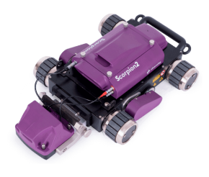
Figure 1 - Silverwing Scorpion2 crawler system with Twin-Crystal UT probe
Additionally, UT techniques require very little surface preparation to perform a scan as they do not require the surface to be fully cleaned before inspection unlike other techniques such as MFL, again saving time and expense for the asset owner (NDT Resource Centre, 2019). However, coatings and claddings on the inspection surface can cause problems – if the coating is a uniform material density and thickness such as an epoxy resin, then there is no problem other than allowing for the additional thickness, but if the material is sound absorbing or porous such as a rubber or cork then the sound waves are attenuated by this material and unable to properly penetrate the inspection surface below. The adhesion of this material must also be considered, as if any air pockets have formed between the coating and the surface then this will have the same attenuation problem due to the lower acoustic velocity of the air (Parramore, 2019).
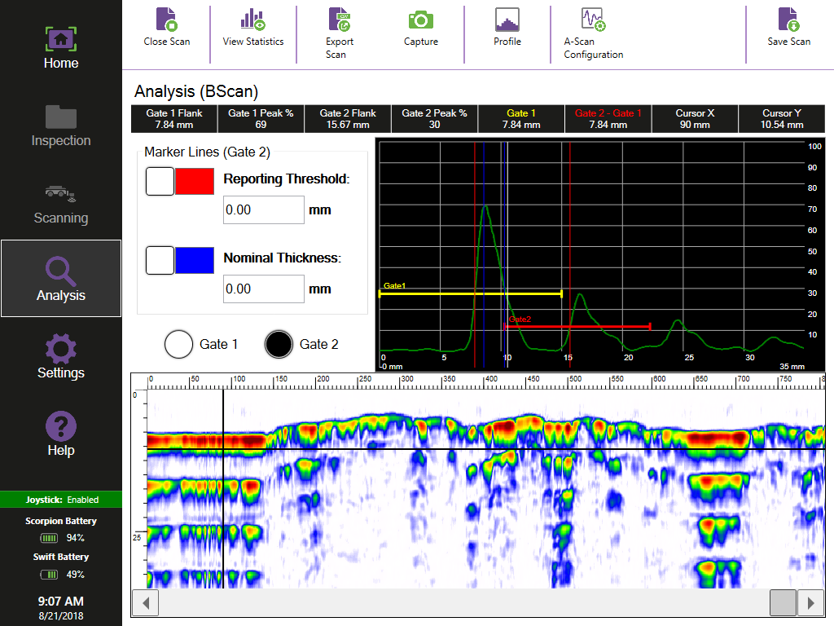
Figure 2 - example data from Scorpion2 system, showing both A-Scan and B-Scan
Another problem facing UT inspection is its requirement for the transducer to be perfectly parallel – ‘normal’ – to the inspection surface. When using hand-held probes this can make the inspection very operator-dependent for its results, meaning extensive training is required for UT operators to be able to gain reliable results (NDT Resource Centre, 2019). This also means it is difficult to inspect rough, irregularly shaped or very small surfaces as the signal is liable to be lost. However, this problem with normalisation can be overcome with mechanical deployment systems that automatically normalise the probe to the surface, such as found on the RMS and R-Scan Array systems from Eddyfi UK (Eddyfi UK, 2019). By using these systems, the inspection is less reliant on the ability of the UT operator to capture data to produce a reliable scan. It should be noted however, that linear defects that run parallel to the signal path are very unlikely to be detected with a single-crystal transducer, so either a twin-crystal or linear array probe is recommended (NDT Resource Centre, 2019). There is also a trade-off to be made when using single-point scanning probes, as the resolution of the scan map must be selected – because the probe only inspects a single point on the inspection surface, it would take an extraordinarily long time to scan the entirety of the asset which would in turn be very expensive. Typically, an asset owner will provide the inspection team with a minimum coverage requirement based upon the service life of the asset, the time available to the team and the legislation in place for that given area. This resolution is then generally set between 1x1mm and 5x5mm – for a 1x1mm scan the transducer would take a reading, move across 1mm and take another reading and completing the scan width in this way before moving up the inspection surface 1mm and repeating. This method is obviously prone to miss small diameter defects, which could be a serious problem if one of these defects has penetrated deep into the material. Because of this, the phased array probe configuration has a large advantage, because it can complete a high-resolution scan much faster than a single-point transducer can (Kenny, 2019).
UT is also heavily reliant on a probe couplant material for its signal quality, in order to prevent having to pass through air that will heavily impede the sound waves. This is typically done with some kind of couplant gel, a continuous water supply or a specially formulated rubber. While this is only a small caveat, it does mean that operators do have to consider this during the inspection and should this couplant be lost during a scan the signals will no longer provide accurate measurement data. The data provided comes in the form of an A-Scan, a B-Scan and a C-Scan; the A-Scan shows the raw amplitude data of the signal at that specific point, the B-Scan shows the profile view of the surface with the location and depth of any defects along that scan line and the C-Scan (if available) maps this data in to a plan-view of the entire inspection area, again showing the location and severity of any defects (Kenny, 2019).
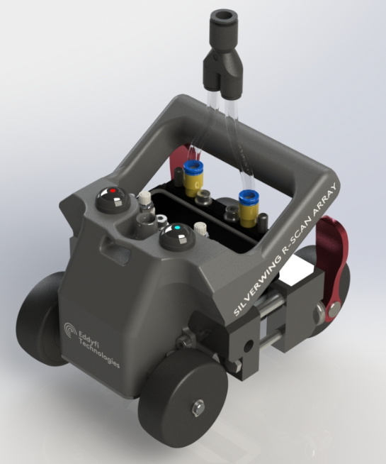
Figure 3 - Silverwing R-Scan Array phased array UT scanner
Ultrasonic testing, whether in single crystal or phased array arrangement, is typically used for the inspection of Above-ground Storage Tanks (AST’s), pipework, vessels and ship hulls. While these jobs can be performed with a manually-operated handheld scanning system, it is more common now to employ some sort of automated scanning robot as this reduces the need for rope-access or scaffolding which take time to install and induce a greater health and safety risk to the operator.
In terms of stress analysis, ultrasonics can be used to inspect a wide array of materials, from metals to polymers to carbon fibre. It can be used to detect stress cracks and fractures from overloading of a part, fatigue cracking and necking from a part past its expected service life and corrosion defects that could potentially result in failure due to material loss. A major benefit of UT over magnet-based techniques such as MFL is that it can be used on a wide range of materials, so it is also commonly used to detect delamination of carbon fibre parts under excessive load (Parramore, 2019).
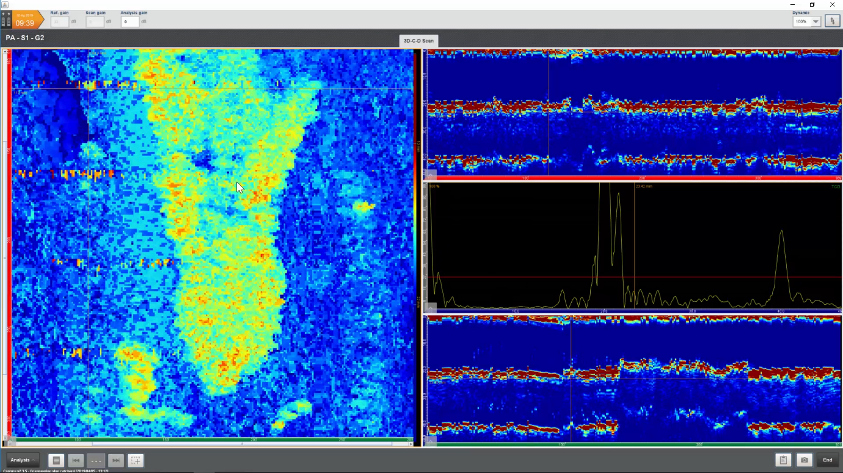
Figure 4 - example data from R-Scan Array showing A-Scan, B-Scan and C-Scan

Magnetic Flux Leakage
Magnetic Flux Leakage (MFL) is a technique based upon using high strength magnets to detect flux leakages from a target inspection surface. By saturating this surface with magnetic flux, a scanning system can use Hall-effect sensors to detect changes in this field that will occur in the presence of a surface defect. This can be done because the material loss defects will create ‘waves’ in the magnetic field as the remaining material cannot fully absorb this additional flux – this leakage is also closely correlated to the volumetric size of the defect, meaning that these signals from the sensors can be used to accurately size the defects (Pearson, 2014). However, the saturation level of the surface can have adverse effects on this sizing if not properly allowed for – if the surface is under-saturated, the flux that should leak from the defect can be absorbed by the surrounding under-saturated material and cause the defect to be under sized by the instrument. Inversely, if the material is over-saturated then there will be excess leaking field even without a defect, so when a defect is present the signal amplitude will be greater than it should be causing the instrument to over-size the defect. Both over and under saturation can be adjusted for, but it is dependent on the operator to correctly input the nominal thickness and corresponding scanner calibration (Boat, 2019). The material properties of the inspection surface will also affect the scanner’s ability to saturate a plate, as while low-carbon steel is typically used, higher grade steels are harder to saturate. The material’s exposure to contained product can also affect the saturation ability as hydrogen attack can affect the material’s magnetic flux capacity, again causing defect sizing problems.
However a key benefit of MFL is that it can detect both top and bottom side defects, and when combined with a Surface Topology Air-gap Reluctance Sensor (STARS) it can be used to differentiate between the two (Eddyfi Technologies, 2019). This helps operators in locating the defects and plan potential repairs accordingly. Another issue with MFL is that defect geometry has a significant impact on the way the flux leaks from the inspection surface, meaning that a defect can potentially be sized differently depending on the direction of scan (MFE Enterprises, 2019). This is because of the ‘sea wall’ effect, where a flat bottom lake-type defect with a sharp wall angle will cause the flux to project further from the surface than a similarly sized pit-type defect with a shallower exit angle. Because of this it is often prudent to scan defects measured over a given size in multiple directions to confirm that this reading is correct (Boat, 2019).
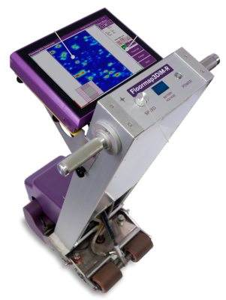
Figure 5 – Silverwing Floormap3DMi-R tank floor scanner
MFL is typically used on surfaces between 3 and 16mm thick – this upper limit is not so much set by the principles of the technique, but the mechanical requirements to scan plates significantly thicker than this. Because of the large required magnet strength to scan greater than 16mm, the mass of the scanner becomes too great and unwieldy to be safely operated by a user. Also the dangers of operating such powerful magnets become greater without some method of disengaging them, as the strength poses significant trap hazards to the operator (Boat, 2019). However, because of the size of these required magnet bridges, large areas can inspected much faster than if a UT-based system was used, and because there are no resolution limitations a scanned surface could potentially have 100% coverage – this is why MFL systems are typically used to inspect tank floor bottoms and perform longitudinal inspections of pipework (MFE Enterprises, 2019). For tank floor inspection this does require an operator to enter the inspection tank, which means removing the asset from service as the contained product must be removed at cost to the asset owner. Another complication for MFL floor scanning is that the inspection surface must be suitably cleaned and prepared for the inspection; an excess of dirt and debris can cause a large amount of signal noise during the scan, potentially causing defects to be missed or incorrectly sized. If this debris is ferrous, it also gets attracted to the magnet bridge of the scanner causing potential jams in the rolling or encoder mechanisms (MFE Enterprises, 2019). This is because the magnet bridge must be very close to the inspection surface, typically 2-4mm, because of the exponential drop-off of magnet strength with lift-off from the surface. This also causes issues due to undulating plates, which can occur either when the plates are manufactured or if they warp over time. These undulations can either cause the system to ‘ground out’ on a bowed plate or lose magnet strength when passing over a sagging plate. The former can potentially damage the unit when being forcibly pushed across the bow, and the latter can potentially affect scan signals due to increase magnet lift-off (MFE Enterprises, 2019). Another aspect of tank geometry that can also affect the quality of the scan is the presence of obstacles such as stanchions, pipework and tank curvature; because MFL floor scanners are quite large, they have a large ‘dead zone’. This is the distance from the magnet bridge to the out limits of the scanner body, and it prevents the scanner from being able to collect data near these obstacles and against the tank walls. There is also limited steering ability on most MFL floor scanners, meaning that full coverage of annular plates around the edges of circular tanks is also a challenge. So while 100% tank coverage is theoretically possible, it is rarely achievable and so less unwieldy techniques such as UT are commonly used as backup techniques during MFL inspections.
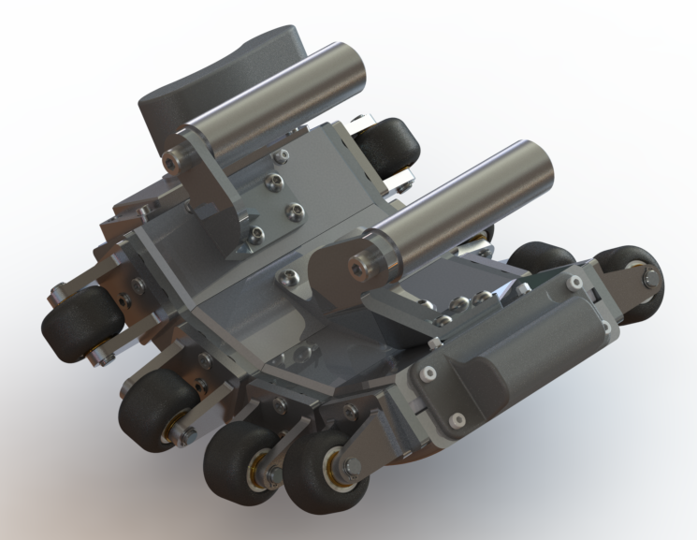
Figure 6 – Silverwing Elite Pipescan MFL pipe scanner - 12.3" configuration
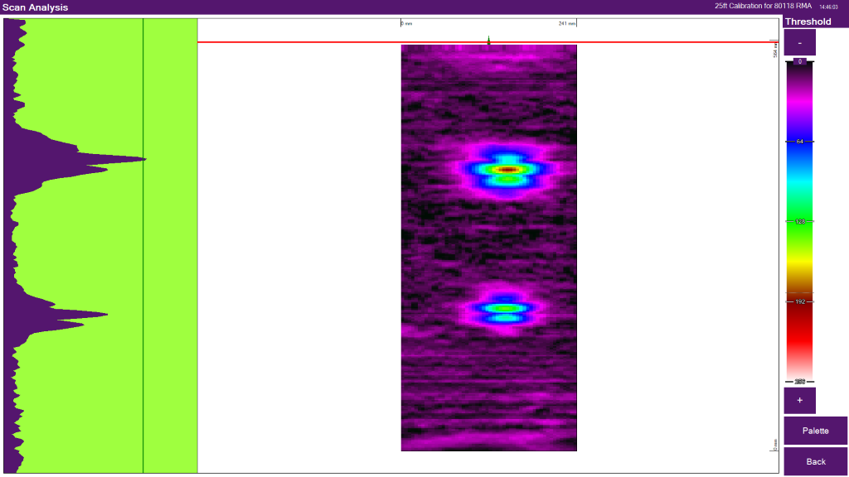
Figure 7 - example data set from Elite Pipescan showing 40% and 60% defects
The main limitation for MFL as part of a stress analysis system is that it can only be used on ferrous materials due to the use of magnetic flux as the detection method. The MFL technique is not proficient at detecting hairline stress or fatigue cracks as the magnetic flux can simply cross the small gap without creating a leaking field to be detected (Boat, 2019). However, its ability to accurately locate and size corrosion defects makes it a vital tool in the inspection of storage tanks and pipework systems designed to hold and transport corrosive product such as crude oil - by locating and sizing these defects asset owners can plan repairs accordingly, extending the lifespan of the assets rather than having to replace them. Because of the prevalence of low-carbon steel in the production of these assets, this is a key tool for NDT in the oil and gas industry.

Visual Inspection
Visual inspection is often the first process a new part will go through at the start of its life cycle. Machined parts are liable to machining defects, and it is standard machinist practice to visually check for any potential defects that may inhibit the part from properly performing its function at the point of manufacture. Depending on the complexity and final purpose of the part this may be simply performed with the naked eye, or with some sort of optical magnification system – stereo microscopes are the most suitable, with an amplification range of x5 to x75 to detect defects not visible to the naked eye, and rigid or flexible optical probes that can be inserted into the part to inspect the internal surfaces. While these internal surfaces can potentially be inspected, optical inspection is limited to the surface immediately in front of the sensor as it possesses no means of penetrating the material to detect internal or back-surface defects. (Hull & John, 1988). An optical probe typically consists of the objective lens that captures data from the inspection surface, a viewing port/visual display to supply the data to the operator and a form of light source used to illuminate the surface in low-light conditions (Hull & John, 1988). Fibre optics have provided significant advancement in the technique, as they can be used to provide a flexible light source integrated within the probe to remove the need for bulky lamps that could potentially restrict access within the part cavity (Hull & John, 1988).
The benefit of visual inspection in most cases is the ease and cost of the technique. Through minimal training operators can be taught how to detect and identify defects with either no equipment or relatively low-cost tools, which is an acceptable level of inspection for low-risk industries. For service-life specialist NDT inspection companies, visual inspection can still be a key tool – unlike ultrasonics or electrical detection methods, visual inspection can use fibre optic cabling for its signal transmission, which is much less susceptible to signal degradation and background noise. This means visual inspection systems can operate to much greater lengths than others, with cables able to stretch to kilometres rather than tens of metres. This is a huge advantage for the inspection of long-range pipework, where visual inspection crawlers are at the forefront of the industry. The lack of susceptibility to signal interference also makes the technique useful in the area of nuclear inspection, where stored nuclear waste could potentially be leaking radiation that would render electrical signal-based techniques useless. The technique can also operate in much dirtier environments, as while this will obviously make defects harder to see it will not actually stop the equipment from operating, so visual inspection crawlers are often used for applications such as waste pipes. The small size and flexibility of optical probes also means that the technique can be used in areas that would limit the capability of other larger systems, so optical inspection is often used for the inspection of engine internals and other complex mechanical systems (Hull & John, 1988). In terms of stress analysis, this makes visual inspection a useful tool for detecting stress cracking, scoring and larger areas of corrosion - however this capability is always limited by the quality of the image and ability of the operator to spot defects.
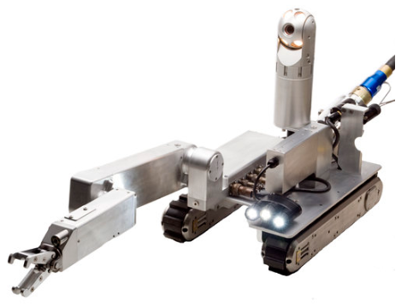
Figure 8 - Inuktun VT450 crawler system

Bibliography
Anderson, M., Kass, D., & Nelligan, M. (2010). Phased Array Testing: Basic Theory for Industrial Applications. Waltham, MA: Olympus NDT.
Boat, M. (2019, October 29). MFL Technique Principles. (B. Woodhead, Interviewer)
Chen, C. (2007). Ultrasonic and Advanced Methods for Non-Destructive Testing and Material Characterisation. Singapore: World Scientific Publishing Co. .
Drury, J. C. (2004). Ultrasonic Flaw Detection for Technicians, 3rd Edition. Swansea: Silverwing Ltd.
Eddyfi Technologies. (2018). Non-Intrusive Inspection - Vessels, Pressure Systems and Associated Pipework. Quebec: Eddyfi Technologies.
Eddyfi Technologies. (2019). Floormap MFL Tank Bottom Inspection. Retrieved from Eddyfi Technologies: https://eddyfi.com/en/product/floormap-mfl-tank-bottom-inspection
Eddyfi UK. (2019). RMS PA Phased Array Corrosion Mapping. Retrieved from Eddyfi: https://eddyfi.com/en/product/rms-pa-phased-array-corrosion-mapping
Hull, B., & John, V. (1988). Non-Destructive Testing. London: Macmillan Education.
Kenny, S. (2019, October 24). UT Inspection Technique. (B. Woodhead, Interviewer)
MFE Enterprises. (2019). What is MFL? Retrieved from MFE Enterprises: http://www.mfeenterprises.com/what-is-mfl
Moore, H. D. (1981). Materials and Processes for NDT Technology. Columbus, OH: The American Society for Non-destructive Testing.
NDT Resource Centre. (2019). Basc Principles of Ultrasonic Testing. Retrieved from nde-ed.org: https://www.nde-ed.org/EducationResources/CommunityCollege/Ultrasonics/Introduction/description.htm
Parramore, M. (2019, October 28). UT Inspection Through Coatings. (B. Woodhead, Interviewer)
Pearson, N. (2014). Band-limitations and non-linearities of magnetic flux. Swansea: Swansea University.

