Report

Understand and solving the problem of profit decline for TM Lewin

Module: Problem Solving and Decision Making
Module Code: BMSW4004
Lecturer Name: Chijioke Uba
Student name and number:
Mihaita Robert Nedelea: 2129063

Contents

Introduction 3
Profit Decline Nature 4
Profit Decline Impact at TM Lewin and its employees 4
Identification of causes of Profit Decline in TM Lewin 5
Identifying external causes of Profit decline at TM Lewin using PESTEL Analysis 6
Cause and effect of Declining Profitability at TM Lewin using Fishbone Diagram 6
Identification of possible solutions 7
Grid Analysis 8
Plan for implementing solution, Monitoring and Evaluation 9
Action Plan 10
Monitoring Plan 11
Evaluation 11
Conclusion 12
References 13

Introduction

Problem solving is an analytical technique used to identify potential solutions to a given circumstance. Making choices is an essential stage in problem solving. The process of fixing problems is complicated and involves making decisions along the way.
A decision is a selection that is made based on one's own judgement. For managers and leaders in particular, the capacity to make wise judgments is essential. You could have to decide on several options during the problem-solving process. Obviously, choosing which course of action to take requires the use of decision-making skills by leaders and managers. To remedy the problem, they will also need to validate and start new actions.
Problem solving is a process, but decision making is an action based on insights gained throughout the problem-solving process. This is the main difference between problem solving and decision making. Even though they are not the same, many people conflate problem solving and decision making.
Although the capacity for problem-solving and decision-making go hand in hand, success in either does not imply success in the other. Those in management and leadership roles must understand the differences between the two and work to continuously improve their respective skill sets.


Profit Decline Nature

TM Lewin, founded in 1898, was a formalwear staple specialising in shirts. However, due to work-from-home orders and the cancellation of social events during the Covid crisis, formalwear sales plummeted as consumers adopted loungewear.
Along with the store closures, the company reduced its employment and is now thought to employ fewer than 100 individuals.
The Covid problem had a significant impact on the company's falling profitability.
The company's profitability has fallen due to supply chain challenges, rising inflation, and the cost of living, all of which have an impact on customer purchasing.

Profit Decline Impact at TM Lewin and its employees

Since calling in administrators in June 2020, the company, which had 150 stores prior to the epidemic, has only maintained an online store.
More than 600 staff were laid off because of the administration, resulting in the closure of all 150 stores.
One of the most hit retail industries during the pandemic was men's clothing, especially formalwear, as the demand for suits and formal tailoring was decreased by work-from-home rules and event restrictions. The pandemic has unfortunately had a terrible effect on this well-known British brand, despite the Company undergoing significant reorganisation at the beginning of the outbreak. Undoubtedly, the organization's profits will decline due to issues with the supply chain, inflation, and the current cost-of-living pressure on consumer purchasing.

Identification of causes of Profit Decline in TM Lewin

To be resolved, any problem's causes must be identified.
PESTEL Analysis and the Fishbone Diagram will assist me in determining the primary causes of the TM Lewin company's deteriorating profitability.
A PESTEL Analysis examines an organization's primary external factors: political, economic, social, technical, environmental, and legal. It can be used to help senior managers make strategic decisions in several settings.

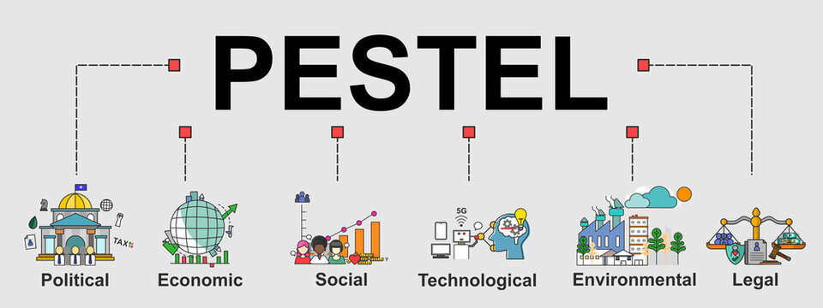

A fishbone diagram is a cause-and-effect discovery technique that helps identify the root causes of process defects, variations, or failures. In other words, it helps in the analysis of the underlying causes that might have an impact on subsequent levels. One of the key methods in root cause analysis is the fishbone diagram, sometimes called an Ishikawa diagram or a cause-and-effect study.
As the name suggests, a fishbone diagram is a picture of a fish's skeleton. The fish's head, which is facing right, represents the fundamental issue, and the skeleton's bones, which branch off the rear to indicate the principal causes and the root causes, respectively. These factors look like the fish skeleton's bones. The fishbone structure can branch off to as many levels as necessary to identify the underlying causes of the problem. I will evaluate the two models to determine the causes of TM Lewin's deteriorating profitability.
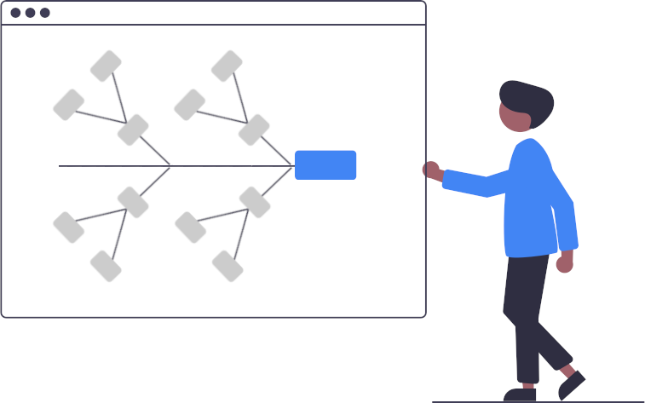

Identifying external causes of Profit decline at TM Lewin using PESTEL Analysis

Political | Economic | Social | Technological
- Lockdown legislation  - Brexit  - Tax | - Covid pandemic  - Raising inflation  - Cost increases  - Exchange rates | - Consumer buying habits  - Language | - Internet  - Online shopping

Cause and effect of Declining Profitability at TM Lewin using Fishbone Diagram

Identification of possible solutions

After carrying out of PESTLE Analysis and Fishbone Diagram, I identified the following major causes from my point of view:
- Cost increases
- Energy cost increases
- Consumer buying habits change

The following solutions target these main causes:
- Online shopping
- New products

Grid Analysis

Grid analysis is a technique for concept analysis and decision-making that rates the ideas according to several weighted criteria. Each suggestion is compared to each criterion, and a score is assigned according to how well it satisfied that requirement. The importance of each criterion to the decision-maker is then considered when determining its weight. A ranked list of concepts is created as a result.

The important benefit of employing grid analysis for decision-making and idea evaluation is that it increases objectivity. By employing a set of criteria with separate weights, the decision-maker can inject some logic into the process and, as a result, more easily justify their decision to others if necessary.

Next, I'll utilise Grid Analysis to guide me in selecting one strategy to put into practise to increase TM Lewin's profit.

Factors  Weights | Cost increases  5 | Energy price increases  4 | Consumer buying habits change  3 | Total
Online  shopping | 3  15 | 1  4 | 2  6 | 25
New products | 2  10 | 1  4 | 3  9 | 23

The Online shopping, which obtained the highest score after the Grid Analysis, will be used for implementing the solution.

Plan for implementing solution, Monitoring and Evaluation

Action Plan
An action plan is a comprehensive outline of the tasks and materials needed to finish a project or achieve a goal. Think of it as a list of tasks that must be completed in order to achieve the intended goals or as a visual countdown to project completion.
Monitoring
Monitoring is characterised as a continuous role that uses systematic data collection on designated indicators to inform management and key stakeholders of an ongoing development intervention about the level of success and achievement of goals as well as progress in the utilisation of allocated resources.
Evaluation
Evaluation is the process of determining the value or significance of a development activity, policy, or programme to assess the applicability of goals, the effectiveness of the planning and implementation, the efficiency or resource utilisation, and the sustainability of results. The results of an evaluation should (enable) the incorporation of learned lessons into the selection of partners and donors.
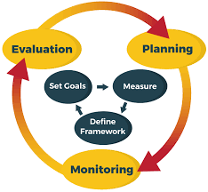

The first stage in implementing a solution is to develop an Action Plan. An Action Plan outlines the steps to be followed prior to implementing the chosen solution.
Solution to implement: Online store
Outcome: Profit increase on TM Lewin

Action Plan

Action  (What) | Description  (How) | Timeframe  (When) | Staff responsible  (Who)
Determine the customer's needs | Knowing who their customers are and responding to their individual needs and desires is critical. | 17/10/2022-  24/10/2022 | Sales Manager
Define the business model for Online | Use their newfound knowledge about their consumers and items to identify their revenue sources. | 25/10/2022-  01/11/2022 | Sales Manager
Determine the most effective e-commerce / IT model | Choose to buy the software, or have it hosted depending on the size of their business, their budget, and how hands-on their want to be. | 02/11/2022-  09/11/2022 | IT Manager
Develop a chat | Adding and maintaining a chat section on their website | 10/11/2022-  17/11/2022 | It Manager
Develop customer feedback | Customers must have access to a feedback page where they may express their thoughts on the things they have purchased. | 18/11/2022-  25/11/2022 | Sales Manager

Monitoring Plan

Action | Description | Timeframe | Staff responsible
Click rate on the store's online page | The number of visitors on the site is important to monitor | Daily | Marketing Manager
The number of online buyers | The number of online buyers need to be counting | Daily | Sales Manager
Feedback | To ask satisfied customers to write reviews for the ordered products | Daily | Marketing Manager
Purchase time | Monitoring the purchase time for products | Daily | Marketing Manager

Evaluation

Key performance indicators, or KPIs, assist business owners and managers in measuring and tracking performance against specified corporate goals and objectives. They concentrate on the factors that are important when making strategic decisions and contribute to the company's growth and development.

The problem identified | Profit decrease on TM Lewin
The chosen solution | Online store
Outcome | Profit increase on TM Lewin

Indicators:
- the number of orders received is an important KPI
- the purchase time is the time required for a customer to buy products from the online store.
- average time for customer support agents to resolve a complaint
- the number of customers who return to the online store to make another purchase.

Conclusion

All commercial endeavours have profit as their primary objective. If a firm is not lucrative, it will eventually fail. Analysing current and past profitability and projecting future profitability are so crucial.
Profitability is calculated using income and expenses. Money generated by a business's operations is known as income. For instance, the production and sale of crops and livestock results in income. On the other hand, money entering the business because of activities like borrowing money does not result in revenue. The corporation and the lender are just exchanging cash to raise money for business expenses or asset purchases.

References

Adair, J.E. (2019) Decision making and problem solving: break through barriers and banish uncertainty at work. Fourth edition. London: Kogan Page

Crowley, P.H. and Zentall, T.R. (2013) Comparative decision-making. Edited by P.H. Crowley and T.R. Zentall. New York: Oxford University Press.
Desai, M.S. and Johnson, R.A. (2013) ‘Using a fishbone diagram to develop change management strategies to achieve first-year student persistence’, S.A.M. advanced management journal (1984), 78(2), p. 51
‘PESTLE analysis’ (2016) A Dictionary of Business and Management. 6th edn. Oxford University

Pressman, A. (2019) Design thinking: a guide to creative problem solving for everyone. New York: Routledge.

Straus, D. (2002) How to make collaboration work powerful ways to build consensus, solve problems, and make decisions. 1st edition. San Francisco: Berrett-Koehler.

Sutherland, J. and Canwell, D. (1997) Planning and decision making. London: Pitman. Press.
Vroom, V.H. and Yetton, P.W. (1973) Leadership and decision-making. Pittsburg, Pennsylvania: University of Pittsburg Press.

Watson, G., Reissner, S. and Watson, G. (Gillian E. (2010) Developing skills for business leadership. London: Chartered Institute of Personnel and Development.

Wickelgren, W.A. (1974) How to solve problems: elements of a theory of problems and problem solving. San Francisco: W. H. Freeman and Company.

https://www.theguardian.com/business/2022/mar/17/tm-lewin-calls-in-administrators-for-second-time-in-two-years
https://scholar.google.com

