

Student name: Ndeye Bop
Student ID: 2419596

Module name: Introduction to Physiology
Module code: BMHP5023
Lecturer name: Shaila Hussain

Assessment:

Contents
1. Introduction 3
Types of Diabetes 3
Endocrine System and the Pancreas 4
2. Blood Sugar Regulation 5
3. Cellular Metabolism 7
4. Recording and Tracking Blood Sugar Levels for Type 2 Diabetes 8
Importance of Monitoring Blood Glucose 9
5. Recommendations 10
Healthy Diet 10
Regular Physical Activity 10
Weight Management 11
Smoking Cessation 11
Diabetes Education 11
6. Conclusion 11

1. Introduction
Diabetes mellitus is a chronic metabolic condition in which blood glucose levels become abnormally high due to problems with insulin production, insulin action, or a combination of both. It is recognised as a major global health issue, affecting hundreds of millions of people across the world. The World Health Organization reports that the prevalence of diabetes has risen sharply in recent decades, influenced by factors such as increasingly sedentary lifestyles, an ageing population and rising rates of obesity.
The case scenario focuses on an individual with Type 2 diabetes who requires support from healthcare professionals in a general practice setting. The aim is to help the patient understand their condition and develop the skills needed to manage blood glucose levels effectively. This report explains the physiological mechanisms involved in diabetes and evaluates the importance of monitoring blood sugar levels and adopting lifestyle changes as part of effective disease management.
Diabetes is closely connected to the endocrine system, which comprises glands that release hormones directly into the bloodstream to regulate essential bodily functions. The pancreas plays a central role in regulating blood glucose, functioning as a key endocrine organ. It releases the hormones insulin and glucagon, which work in opposition to maintain glucose levels within a normal range. When this regulatory system becomes impaired, diabetes can occur.

Types of Diabetes
There are three primary forms of diabetes.
Type 1 diabetes is an autoimmune disorder in which the body’s immune system mistakenly targets and destroys the pancreatic beta cells responsible for producing insulin. As a result, individuals with Type 1 diabetes cannot make insulin and must rely on lifelong insulin replacement therapy.
Type 2 diabetes is the most common form and develops when the body becomes resistant to insulin or when the pancreas does not produce enough insulin to meet the body’s needs. This type is strongly linked to lifestyle factors such as excess body weight, poor diet and low levels of physical activity.
Gestational diabetes develops during pregnancy when hormonal shifts reduce the effectiveness of insulin. Although it typically disappears after the baby is born, it significantly increases the mother’s likelihood of developing Type 2 diabetes later in life.
Several risk factors contribute to the development of Type 2 diabetes. These include obesity, physical inactivity, an unhealthy diet, smoking, increasing age, family history and certain ethnic backgrounds. If not managed effectively, diabetes can lead to serious complications such as cardiovascular disease, kidney damage, nerve problems and vision loss.

Endocrine System and the Pancreas

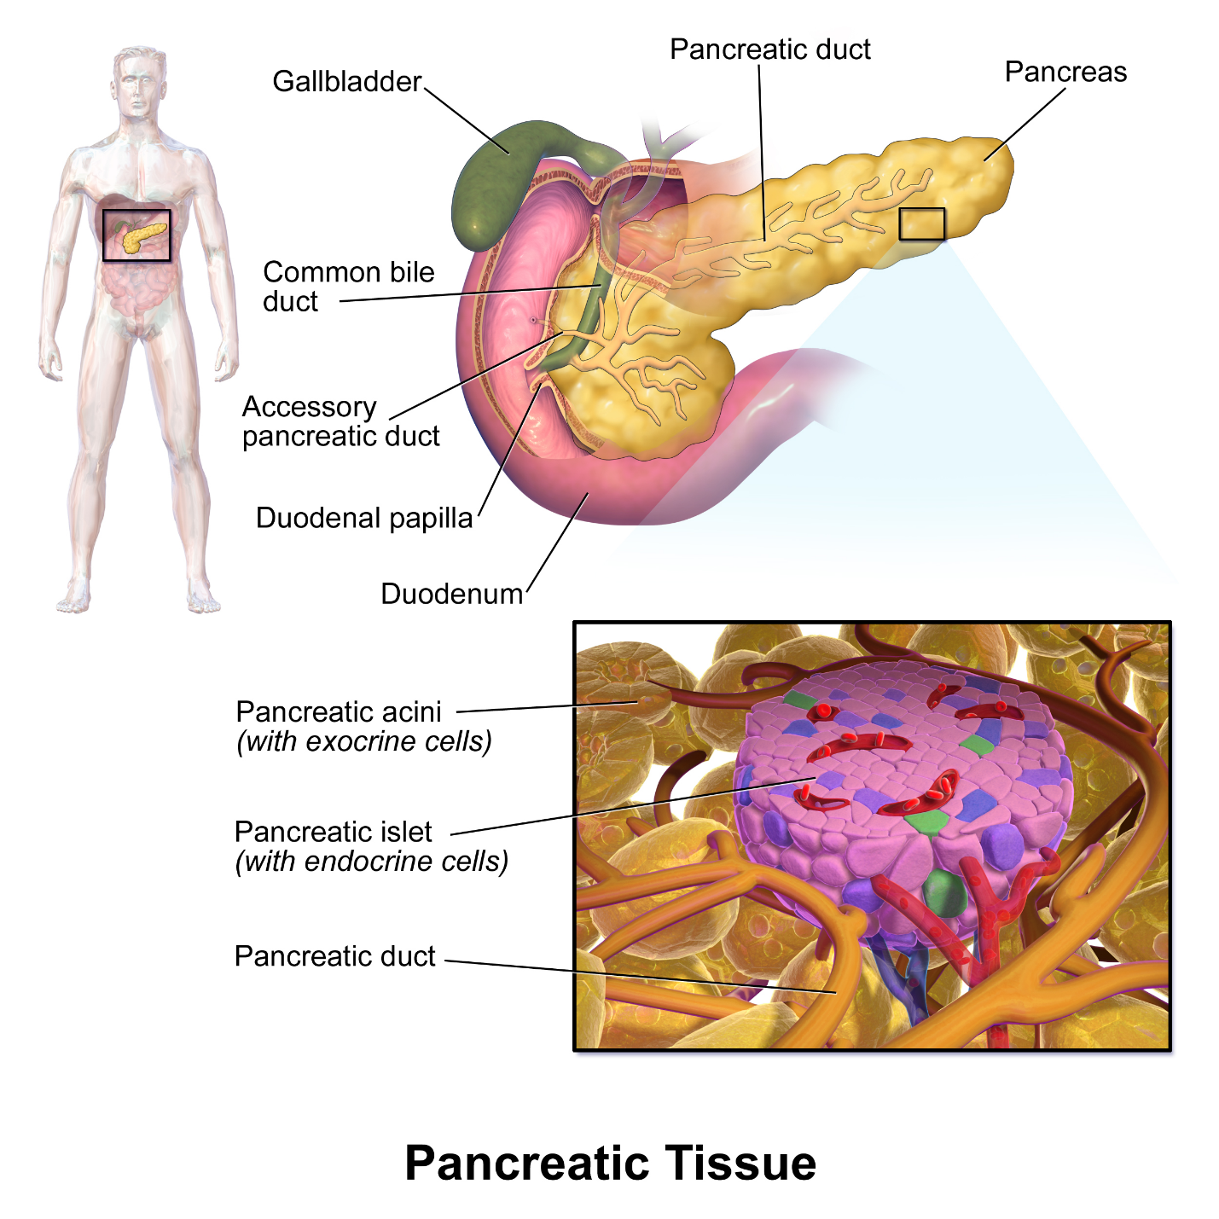
Figure 1: Structure of the pancreas and pancreatic islets showing insulin-producing beta cells within the endocrine pancreas (Encyclopaedia Britannica, 2023).

The pancreas contains specialised groups of endocrine cells called the Islets of Langerhans. These cells secrete hormones that are essential for maintaining stable blood glucose levels. Within the islets, beta cells are responsible for producing insulin, while alpha cells release glucagon.
These two hormones work in opposition to one another to maintain glucose homeostasis and ensure that the body has a steady and balanced supply of energy (Encyclopaedia Britannica).

2. Blood Sugar Regulation
Blood glucose regulation is essential for maintaining homeostasis. In healthy individuals, glucose levels are kept within a narrow range, usually between 4 and 7 mmol per litre, to support normal cellular function (Silverthorn, 2019). Blood glucose regulation is primarily controlled by the hormone’s insulin and glucagon, both of which are produced in the pancreas.
When blood glucose levels rise, most notably after eating, beta cells release insulin. This hormone allows glucose to move into body cells, particularly those in muscle and adipose tissue, where it can be used for energy or stored as glycogen in the liver and muscles (Tortora and Derrickson, 2021). Insulin also acts to suppress glucose production in the liver.
Glucagon, produced by alpha cells, is released when blood sugar decreases during fasting or physical activity. It acts on the liver to break down glycogen into glucose and promotes the formation of new glucose from non‑carbohydrate sources (OpenStax, 2020). These actions raise blood glucose levels.
Insulin and glucagon operate through a negative feedback system. When glucose rises, insulin lowers it; when glucose falls, glucagon restores it. This balance ensures a steady supply of energy.

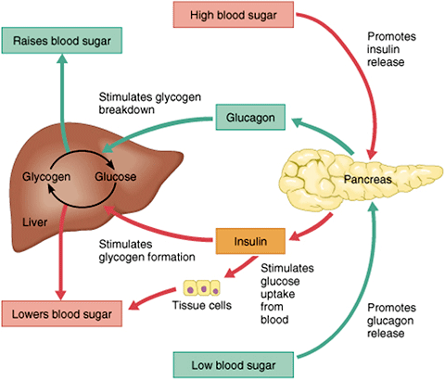
Figure 2: Regulation of blood glucose levels through insulin and glucagon (OpenStax, 2020).
After meals, insulin promotes glucose uptake and glycogen storage. During low glucose states, glucagon stimulates glycogen breakdown and glucose release. This regulation maintains energy availability.
In Type 2 diabetes, the regulatory process is impaired because the body develops insulin resistance, meaning cells is unable to respond to insulin. As a result, glucose remains in the bloodstream, leading to sustained hyperglycaemia (DeFronzo et al., 2015). Persistently elevated glucose levels gradually damage blood vessels and various organs.
Over time, chronic hyperglycaemia heightens the risk of cardiovascular disease, kidney impairment, neuropathy and visual complications, largely due to inflammation and oxidative stress (NHS, 2023).
Effective blood glucose regulation is therefore essential for preventing complications and supporting long‑term health. Understanding the roles of insulin and glucagon provides a foundation for diabetes management and highlights the need for strategies that improve insulin sensitivity and glycaemic control.

3. Cellular Metabolism
Cells require a constant supply of energy to support essential functions such as growth, repair, movement and the maintenance of homeostasis. This energy is produced through cellular metabolism, which involves biochemical reactions that convert nutrients into usable energy. The main process responsible for this is cellular respiration (Campbell et al., 2021; Hall, 2021).
Respiration at the cellular level involves the breakdown of glucose with oxygen, resulting in adenosine triphosphate (ATP), which is the cell’s main source of energy. The overall reaction is:
Glucose + Oxygen → Carbon dioxide + Water + Energy (ATP)
This process occurs in three stages.
Glycolysis takes place in the cytoplasm, where a single glucose molecule is disintegrated into two molecules of pyruvate. This anaerobic stage generates ATP along with reduced electron carriers (Tortora and Derrickson, 2021).
The Krebs cycle, which occurs in the mitochondria, further breaks down pyruvate. It releases carbon dioxide and generates high‑energy electron carriers needed for the final stage (Silverthorn, 2019).
The electron transport chain, also in the mitochondria, requires oxygen. Electrons move through protein complexes, producing increased amounts of ATP via oxidative phosphorylation. Oxygen acts as the final electron acceptor and forms water (Hall, 2021).
Together, these stages allow glucose to serve as the main fuel for energy production.
In diabetes, this process becomes disrupted. Insufficient insulin or insulin resistance prevents glucose from entering cells effectively. Despite high blood glucose levels, cells experience an energy shortage, highlighting the essential role of insulin in normal metabolism (DeFronzo et al., 2015).
In compensation, the body starts to break down fats and proteins for energy, to produce ketone bodies. Excessive ketone production can lead to diabetic ketoacidosis. Poor glucose utilisation also contributes to symptoms such as fatigue, unintended weight loss and muscle weakness (NHS, 2023).
Understanding cellular metabolism helps explain the physiological effects of diabetes and reinforces the importance of maintaining good glycaemic control to prevent complications and support overall health.

4. Recording and Tracking Blood Sugar Levels for Type 2 Diabetes
Monitoring blood glucose levels is a core component of diabetes self‑management. Individuals with Type 2 diabetes are often encouraged to measure their blood sugar regularly using a glucometer or a continuous glucose monitoring system. Keeping a record of these readings enables both patients and healthcare professionals to observe patterns and assess how lifestyle, for example, diet, exercise and drugs affect blood glucose control.
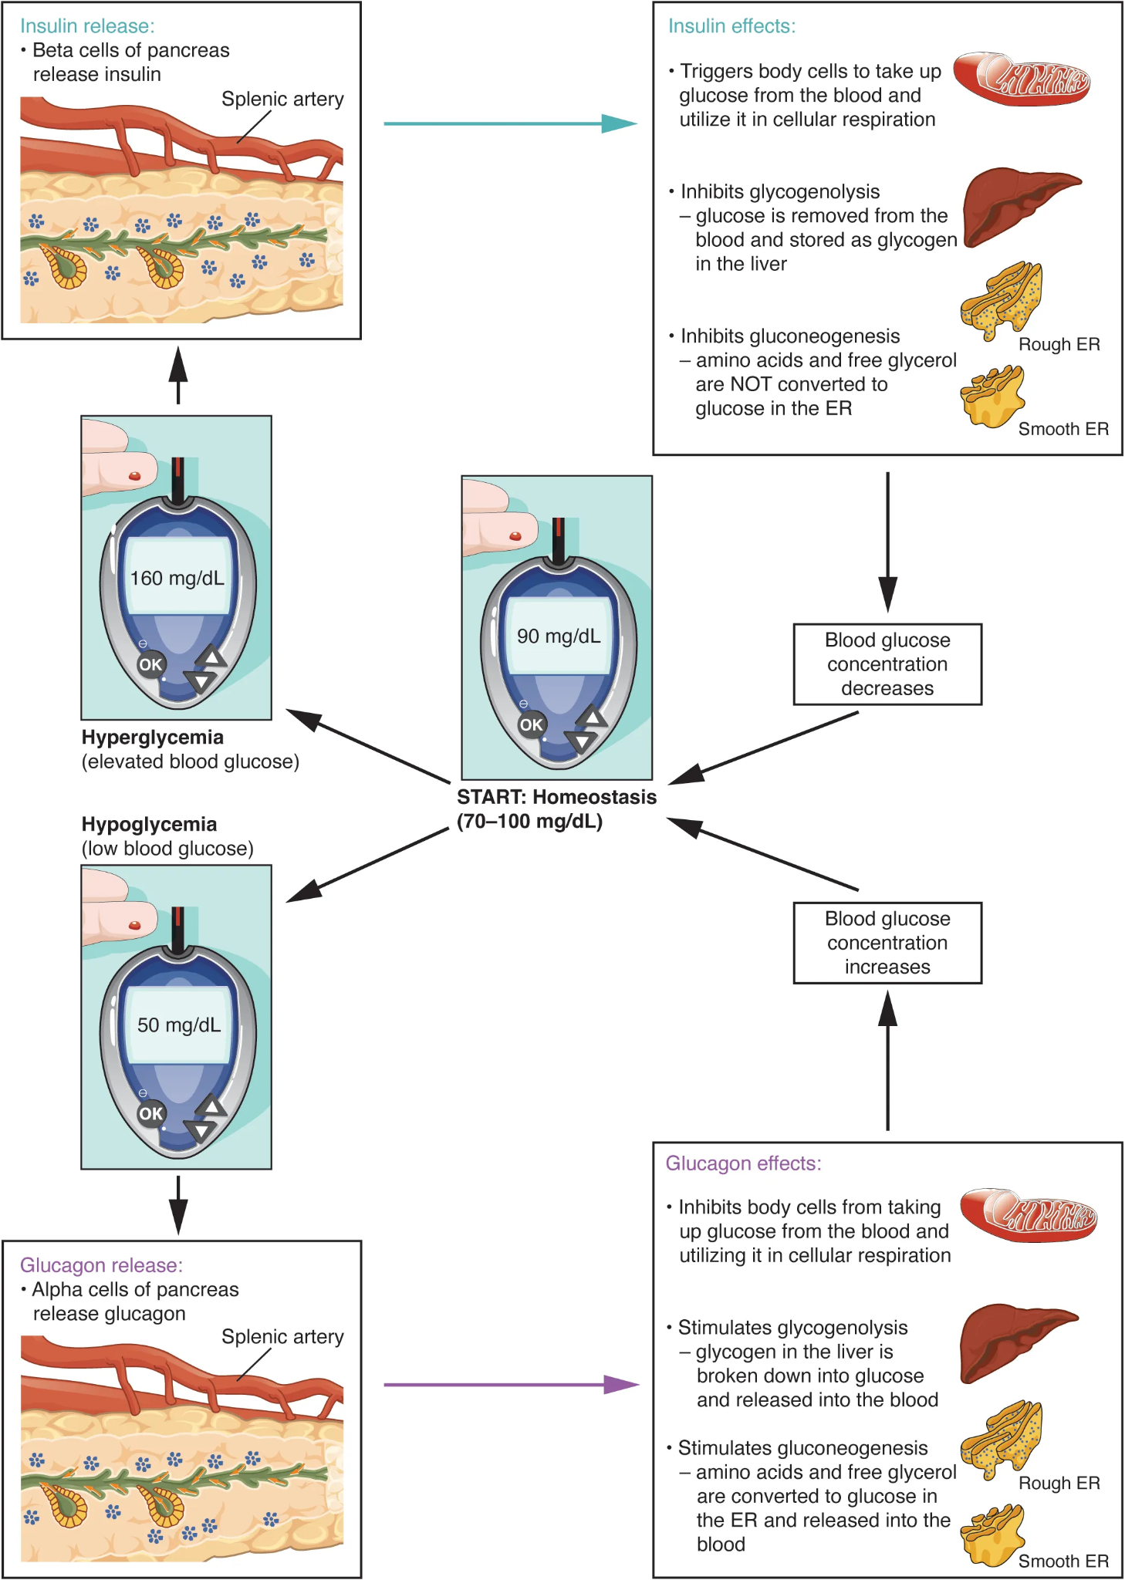
Figure 3 Regulation of Blood Glucose Levels

Importance of Monitoring Blood Sugar
Early detection of abnormal glucose levels
Regular monitoring allows early identification of hyperglycaemia and hypoglycaemia, which supports timely intervention and reduces the risk of acute complications.
Evaluation of treatment effectiveness
Healthcare professionals rely on recorded glucose readings to determine whether prescribed medications or insulin therapy are achieving the desired effect. This information helps guide adjustments to treatment plans.
Understanding lifestyle impacts
Tracking blood glucose levels helps individuals recognise how specific foods, exercise routines or periods of stress affect their glucose control. This awareness supports informed decision making and encourages healthier habits.
Prevention of complications
Maintaining stable blood sugar levels significantly lowers the risk of long‑term complications, for example, cardiovascular disease, neuropathy and kidney impairment. Frequent monitoring plays an important role in preventing these outcomes.
Without regular monitoring, individuals may experience prolonged periods of hyperglycaemia without realising it. This can lead to serious health consequences, including diabetic ketoacidosis, organ damage and increased hospital admissions. Monitoring therefore, acts as both a preventive measure and a tool for early intervention.
According to Diabetes UK, self‑monitoring empowers individuals to take an active role in managing their condition. It supports greater independence, improves confidence in decision-making and contributes to better overall health outcomes.

5. Recommendations
Managing Type 2 diabetes effectively requires coordinated management that combines medical treatment, lifestyle changes and health promotion. Healthcare professionals support individuals through education, behavioural guidance and regular monitoring to help them manage their condition safely and confidently.

Healthy Diet
Maintaining steady blood glucose levels relies heavily on a balanced diet. People are advised to prioritise high fibre foods, for example, whole grains, vegetables, fruits and legumes, while reducing their intake of processed foods, sugary beverages and foods rich in saturated fats. Managing portion sizes and monitoring carbohydrate intake are key strategies for avoiding rapid spikes in blood glucose.

Regular Physical Activity
Physical activity improves insulin sensitivity and supports better glucose use. The National Institute for Health and Care Excellence recommends at least 150 minutes of moderate‑intensity activity each week. Exercises such as brisk walking, cycling or aerobics contribute to improving metabolic health.

Managing Weight
To achieve and maintain a healthy weight can significantly improve insulin sensitivity and reduce the risk of diabetes and its complications. Healthcare professionals can offer advice on healthy eating, physical activity and behaviour change to support weight management.

Smoking Cessation
Smoking increases cardiovascular disease risks and other complications linked to diabetes. Individuals should be encouraged to stop smoking and be offered access to cessation services, which may include counselling or nicotine replacement therapy.

Diabetes Education
Structured diabetes education programmes help people with Diabetes to acquire the knowledge they need to manage their condition. Such programmes often cover blood glucose monitoring, medication use, healthy eating and physical activity, supporting informed decision making and greater independence.

6. Conclusion
Diabetes mellitus is a multifaceted metabolic disease that impairs the body’s ability to control blood glucose effectively. The endocrine system, particularly the pancreas, plays a vital role in sustaining glucose control through the secretion of insulin and glucagon. When these regulatory processes fail, as occurs in diabetes, the body can no longer maintain normal glucose homeostasis.
This report has explored the physiological processes involved in blood glucose regulation and highlighted the importance of cellular metabolism in generating energy from glucose and oxygen. It has also examined how disturbances in these processes lead to the development and progression of diabetes.
Regular monitoring and recording of blood glucose levels form an important part of effective diabetes management. Self‑monitoring enables individuals to recognise abnormal glucose levels, assess how well treatments are working and make informed decisions about their lifestyle and daily routines.
Also, evidence shows that lifestyle management, such as healthy eating, regular exercise, smoking cessation and weight management play a vital role in improving health outcomes for people living with Type 2 diabetes. These strategies help enhance insulin sensitivity, support glycaemic control and reduce the risk of long‑term complications.
Through access to structured education, supportive healthcare services and a commitment to proactive self‑management, individuals with diabetes can manage their condition and significantly decrease the possibility of developing complications.

References
American Diabetes Association (2024) Standards of Care in Diabetes 2024. Diabetes Care.
Betts, J.G., Young, K.A., Wise, J.A., Johnson, E., Poe, B., Kruse, D.H., Korol, O., Johnson, J.E., Womble, M. and DeSaix, P. (2022) Anatomy and Physiology 2e. Houston, Texas: OpenStax. Available at: https://openstax.org/books/anatomy-and-physiology-2e/pages/17-9-the-endocrine-pancreas (Accessed: 2 April 2026). (OpenStax)
Campbell, N. et al. (2021) Campbell Biology. 12th edn. Pearson.
Colberg, S.R. et al. (2016) ‘Physical activity/exercise and diabetes’, Diabetes Care, 39(11), pp. 2065–2079.
DeFronzo, R.A. et al. (2015) ‘Type 2 diabetes mellitus’, Nature Reviews Disease Primers, 1, pp. 1–22.
Diabetes UK (2023) Managing diabetes. Available at: https://www.diabetes.org.uk (Accessed: 2 April 2026).
Dyson, P.A. et al. (2018) ‘Diabetes UK evidence-based nutrition guidelines’, Diabetic Medicine, 35(5), pp. 541–547.
Encyclopaedia Britannica (2023) Pancreas and Islets of Langerhans. Available at: https://www.britannica.com (Accessed: 2 April 2026).
Hall, J.E. (2021) Guyton and Hall Textbook of Medical Physiology. 14th edn. Elsevier.
International Diabetes Federation (2023) IDF Diabetes Atlas. 10th edn.
Lean, M.E.J. et al. (2018) ‘Primary care-led weight management for remission of type 2 diabetes’, The Lancet, 391(10120), pp. 541–551.
National Health Service (2023) Diabetes overview. Available at: https://www.nhs.uk (Accessed: 2 April 2026).
National Institute for Health and Care Excellence (2022) Type 2 diabetes in adults: management (NG28).
NHS England (2023) Type 2 Diabetes Prevention Programme.
OpenStax (2020) Anatomy and Physiology. Houston: OpenStax.
Silverthorn, D.U. (2019) Human Physiology: An Integrated Approach. 8th edn. Pearson.
Taylor, R. (2019) ‘Type 2 diabetes: etiology and reversibility’, Diabetes Care, 42(5), pp. 734–740.
Tortora, G.J. and Derrickson, B.H. (2021) Principles of Anatomy and Physiology. Wiley.
UK Prospective Diabetes Study (UKPDS Group) (1998) ‘Intensive blood-glucose control…’, The Lancet, 352(9131), pp. 837–853.
World Health Organization (2023) Diabetes. Available at: https://www.who.int (Accessed: 2 April 2026).
Zheng, Y. et al. (2018) ‘Global aetiology and epidemiology of type 2 diabetes’, Nature Reviews Endocrinology, 14(2), pp. 88–98.

