REPORT ON MANAGEMENT AND ORGANISATION BEHAVIOUR
Student Name: Marius-Ionut Hurmuzache
Student ID:2125248
Lecturer Name: Lan Zhang

Executive summary
This study on management and organisational behaviour has focused on Hyatt Hotel Groups organisational behaviour and management. In this aspect, the organisational structure, culture and other description of the organisation are described in this report. Different kinds of recent changes are included to see the effectiveness of the company are also described. Besides, there is inclusion of the managerial and leadership aspect for developing behavioural matter in the international business. The strategic direction and current organisational performances are also effective factor for the company and these factors are pointed out briefly in the report assessment. Some recommendations are also engaged in this work for developing better organisational behaviour of Hyatt.

Table of Contents
1.0 Introduction 4
2.0 Description and analysis 4
2.1 Organisational Structure, Culture and People 4
2.2 Organisation’s goal 6
2.3 Modification and changes along with their impact and management 7
2.4 Leadership’s roles and management 8
2.5 Behavioural approach to management 9
2.6 Strategic Direction and current business performance 10
3.0 Recommendation 12
4.0 Conclusion 13
References 14

1.0 Introduction
In the current era, the behaviour of organisations become more expanded to involve international settings as the organisations become global and embrace different cultures and nationalities. In this aspect, this report is going to focus on the organisational structure, performance, culture and others of Hyatt Hotel Group. This study is going to be the inclusion of the recent changes in the hotel group, leadership, strategic direction and others to understand the management and organisational behaviours.
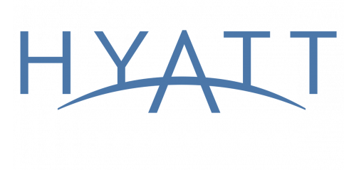
Figure 1: Hyatt Hotel Groups Logo
(Source: Hyatt, 2024)

2.0 Description and analysis

2.1 Organisational Structure, Culture and People
Organisational Structure is a pattern in which the organisation or a business group operates its functionalities to achieve its purposes. Depicting several channels of communication and authoritative processes among multiple sections of the business, the organisational structures would result in a successful decision-making process. Established in 1957 by Jay Pritzker it came into the international sector as a public company in 1968 (Hyatt, 20224). Hyatt Hotels group employs a hybrid or Matrix organizational structure, which is a combination of functional as well as service-based approaches (Organimi, 2024). This allows the business group to effectively oversee its various hotels and services while maintaining explicit commitments to the customers and accountability.
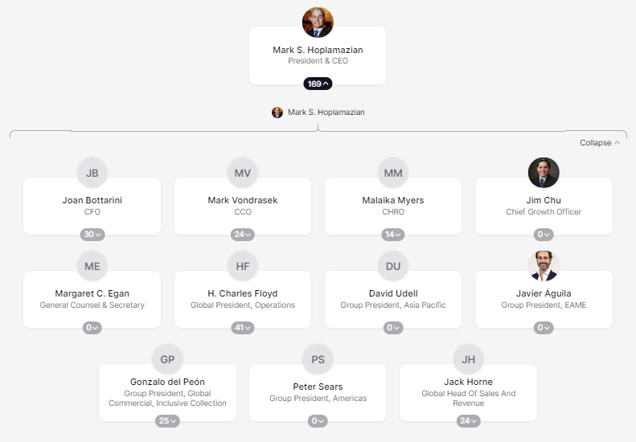
Figure 2: Organisational Chart of Hyatt
(Source: Theorg, 2024)
Hyatt's unique structure enables employees to collaborate across multiple teams and projects, enhancing efficiency and flexibility. The company also has a Board of Directors, responsible for overseeing corporate governance and supporting the regulatory, and ethical parameters. Hyatt, with its structured chain process, encompasses multiple business outlook units for different brands, including Grand Hyatt and Hyatt Regency (Hodcroft, 2020). In the supervision of this structure of the organisation, each brand operates autonomously, with its leadership taking direction.
Hyatt is dedicated to attracting and maintaining top talent in its cultural context. Hyatt believes in creating an inclusive work environment that allows colleagues to thrive and shine. Relations with each other, guests, and the community are highly valued, and these values are grounded in respect, integrity, and creativity. Hyatt's commitment to working with people has earned them a remarkable 100% ranking on the Human Rights Campaign (HRC) Foundation's Corporate federally-funded training program conceived for individuals with disabilities (JAQUEZ, 2021).

2.2 Organisation’s goal
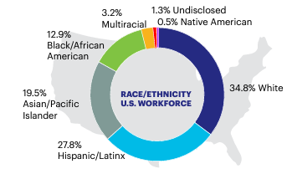
Figure 3: Ethnicity of Hyatt Group in Workforce
(Source: Hyatt, 2024)
Guided by their commitment to care for people, the Hyatt Hotel group seeks to make a difference in the lives of its employees. Some of their current objectives by 2025, are to double the representation of women and people of colour in key leadership roles, as well as doubling the number of Black leaders. This effort aims to counteract favouritism based on race and ethnicity.

2.3 Modification and changes along with their impact and management
Hyatt over recent years has taken several leads through the advancement of principalities. They have taken firm steps towards heightening diversity, equity, and inclusion (DE&I) within the organization and beyond. These include focusing on minority representation in the supply chain, introducing same-sex partner benefits, and signing a pledge for the CEO Action for Diversity & Inclusion Initiative. As depicted by Ruiz Molina et al. (2022), Hyatt’s moral approach to opening a global program to produce career opportunities for Opportunity Youth hey Launched RiseHY, which on the other hand, helped to ban hate groups from the hotel conveniences. Furthermore, the enhancement process for creating an inclusive workspace, including signed pledges in line with UN LGBTI standards (Lyons and Christiancy, 2020). In 2020, their amendment to the long-term executive process was comprehended by the ‘Change Starts Here’ program as part of their commitment to DE&I.
The World of Care platform initiated in 2021 is formulated to improve the Environmental, Social and Governance (ESG) approach in response to overall business practices. Hyatt's adoption of 100% renewable electricity at its owned hotels encourages suppliers to follow EcoVadis standards for sustainability (Hyatt, 2024). Their comprehensive and transparent approach includes stakeholder engagement and continuous improvement. They host a Global Wellness Week to promote employee well-being and align activities with the UN Sustainable Development Goals to ensure a broader positive impact. Besides, the hotel group’s commitment to employees' well-being aims to develop programmes and policies to improve health and other aspects. This approach is stimulated by the engagement of maintaining a standard work-life balance.
With a clear understanding of the subject matter and potential direction, the hotel group’s recent initiatives have been well managed. The proactive stance of the hotel group towards developing employees’ well-being and DE&I have provided insights into the progress toward the aim of the company alongside maintaining their stakeholders and every engaged individual’s satisfaction.

2.4 Leadership’s roles and management
The Hyatt Hotel Group is managed by a team of experienced professionals who hold various leadership roles including General Manager, Director of Sales and Marketing, and Director of Revenue Management among others. Hyatt Group's leadership and management structure are conceived to supervise the company's day-to-day operations in which the strategies would be directed. M.S. Hoplamazian, the current CEO of the group leads the groups by multiple executive authorities for managing operations in the sector of finance, operations, resourcing and so on. Overall, there is the inclusion of a servant leadership approach to prioritise the requirements of the guests and teams. This approach of style or leadership has made the hotel group unique from most of its competitors. Hyatt’s competitors such as Hilton Hotel engage in transformational leadership. On the other hand, Shangri-La Hotels is connected with a visionary leadership approach (Shangri-la, 2020).
The Board of Directors plays a crucial role in the management of the Hyatt hotel group. They offer guidance, oversight, and approval of significant decisions. Board members come from various backgrounds and perspectives, ensuring strong corporate governance. The hybrid organisational structure provides a clear vision of the objectives of the different boards and sections. Maintaining the organisational culture is another aspect of the organisation's leadership roles. Besides, ensuring of delivering developed service to the guest is another potential role of the leadership of the company. Cultivating a customer-centric approach is there to provide the best customer experience and this is done by the leaders in the hotel group.
Effective leadership and management are influenced by different variables in the Hyatt Hotel Group.
Innovation and creativity: Innovation and creativity embraced by the effective leaders in Hyatt are there to improve operational activities, improve guest experience.
Ethical leadership: The high standard of ethical leadership in Hyatt develops the trust and integrity of the employees and customers.
Cross-cultural dimensions: The leaders of the hotel group possess the competency of cross-culture for navigating diverse cross cultures, ensuring the services are shaped according to domestic preferences, and communicating with teams across the globe.
Emotional intelligence: Leaders with emotional intelligence understand the requirements of stakeholders. In Hyatt, the leaders foster the relationship with customers and employees to create a positive environment.
Empowerment and employee development: Leaders and managers in the hotel group focus on empowerment and employee development to create growth opportunities in the careers of their employees.

2.5 Behavioural approach to management
As opined by Mullins, (2020), The behavioural approach is correlated with the concept of the human relation movement and it aims to focus on multiple elements of human behaviours effectively in an organisational context. Hyatt becoming a global hospitality sector pays much attention towards customer satisfaction. According to Mullins and Dosser (2013), organisations can create an effective and engaging work environment by comprehending individual differences in behaviours.
Individual personality: Hyatt follows a reverse strategy to adapt to management styles to accommodate their managing style to a certain level of specifics of employees. The organisational culture emphasizes collaboration, innovation, and respect for its employees, which in turn results in increased employee engagement and improved performance. It made the employees more confident and valued to work in teams with people with custom cultures and geographics on the other hand diminishes discrimination..
Work pressure measurement: ensuing customer-centric thought process Hyatt balances work demands with reasonable wages to the staff to avoid excessive workloads. Recognizing the emotional and psychological conditions of workers managers with high emotional intelligence can navigate interpersonal relationships and create a more harmonious work environment (Hultman et al. 2021). Management should look upon the work group as a positive force which can be utilised productively.
Learning Approach: A line of open and transparent communication across the department can foster trust among the employees. The hotel group must provide training programs as per the specific requirements of the departments. A novice could lead to bad services and result to unsatisfied customers. These are effective for the newly appointed employees motivated and culturally attributive as well as supportive for their career growth.

2.6 Strategic Direction and current business performance
Hyatt Hotel Group's strategic direction focuses on driving asset-light growth, maximizing its core business, integrating new growth platforms, and optimizing capital deployment. The hotel group's franchising business model, where properties are taken off-balance sheet, consistently achieves revenue per available room and RevPAR (Hyatt, 2024).
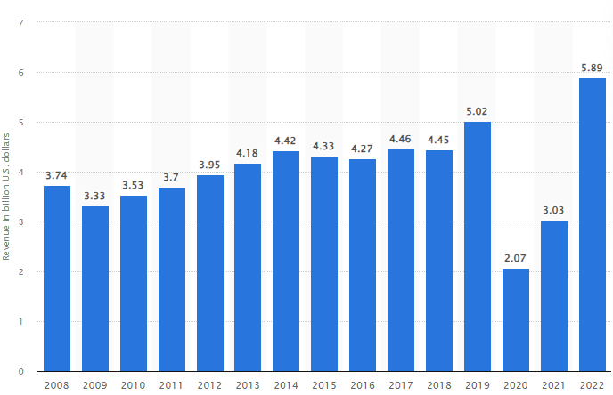
Figure 4: Revenue of Hyatt Hotels Group worldwide
(Source: Statista, 2024)
Business tycoon in the hotel industry Hyatt has made a profit of around $5.89 billion worldwide in 2022 and this justified the Royalty Relief approach that is evaluated for a hotel brand’s estimated strength and potential aspect of market position. Moreover, Hyatt primarily generates revenue through room bookings, food and beverage sales, and other ancillary services. Additionally, it profits from operating third-party agreements and owning other hotels. The company's strategy includes concentrating on luxury and lifestyle leisure while moving towards a more asset-light business model
Hyatt's present performance in terms of finance has significantly improved, resulting in high-profit margins and a robust capital structure. The company's outlook remains positive with consistent growth across all major segments. As per the overview of Boddy (2014), organizational structure, which incorporates elements of diversification, enables efficient management of its diverse hotel portfolio while maintaining clear communication channels. Furthermore, enhancing Hyatt's cultural understanding through collaborations with local bodies and incorporating seasonal functionalities can make its business practices more appealing to guests. In terms of economic market and stock valuation, Hyatt for the entire 2022 acquired around 4.32 million shares worth $369 million. In a certain comparison with s significant competitor, Hilton Worldwide, though surpassed Hyatt the trailing return was comparatively higher for this group. Among all of its inclusive strategies for seasonal growth, Hyatt aims to generate $750 million in free cash flow and achieve an 80% asset-light earnings mix by the end of 2025 (Hospitality-on, 2024).

3.0 Recommendation
There are some recommendations for Hyatt Hotel Group to improve their management and organisational behaviour.
Continuous improvement and feedback: The hotel group should improve their organisational behaviour and management practices by implementing the provisions for getting feedback from guests and employees.
Improving cross-cultural training: There are programmes of comprehensive training for cross-cultural working environments. These factors needs to be effective for understanding and respecting diverse behaviours, cultures, customs and others (Burhan et al. 2021).
Local adoption with global standardisation: Hotels of Hyatt Group should allow local norms and cultural preferences besides the establishment of global standards. It is one of the potential strategies for developing consistency in service standards while respecting the local customers.
Development in leadership: The inclusion of leadership development programmes for cultivating managers to adapt the diverse cultural environments can be effective for international business companies.

4.0 Conclusion
It can be concluded that management and organisational behaviour are crucial aspects for international business organisations such as Hyatt Hotel Group. The report has reflected the company’s goals, organisation structure, culture and others. The leadership and managerial variables of the company have been recognised as important factors for developing the behaviour of guests and employees of the company in the international market. Recent changes in the company have been pointed out in the report along with their impacts on the business and behavioural aspects. It has been found that the company’s strategic direction and current performances are potential and developing respectively. These factors provide insights into the future performance of the hotel group.

References
Boddy, D. (2014) Management: An Introduction (6th Ed), Harlow, Pearson
Burhan Ismael, N., Jabbar Othman, B., Gardi, B., Abdalla Hamza, P., Sorguli, S., Mahmood Aziz, H., Ali Ahmed, S., Sabir, B.Y., Ali, B.J. and Anwar, G., (2021). The role of training and development on organizational effectiveness. Ismael, NB, Othman, BJ, Gardi, B., Hamza, PA, Sorguli, S., Aziz, HM, Ahmed, SA, Sabir, BY, Ali, BJ, Anwar, G.(2021). The Role of Training and Development on Organizational effectiveness. International Journal of Engineering, Business and Management, 5(3), pp.15-24.
Hodcroft, E.B., (2020). Preliminary case report on the SARS-CoV-2 cluster in the UK, France, and Spain. Swiss medical weekly, 150(0910), pp.w20212-w20212.
Hospitality-on, (2023). Hyatt Investor Day highlights asset-light transformation and future growth expectations. Accessed from: https://hospitality-on.com/en/hospitality/hyatt-investor-day-highlights-asset-light-transformation-and-future-growth-expectations [Accessed on: 24th February, 2024]
Hultman, M., Papadopoulou, C., Oghazi, P. and Opoku, R., (2021). Branding the hotel industry: The effect of step-up versus step-down brand extensions. Journal of business research, 124, pp.560-570.
Hyatt, (2019). Hyatt Focused on Driving Asset-Light Growth. Accessed from: https://investors.hyatt.com/news/investor-news/news-details/2019/Hyatt-Focused-on-Driving-Asset-Light-Growth-03-05-2019/default.aspx [Accessed on: 24th February, 2024]
Hyatt, (2024), About. Accessed from: https://about.hyatt.com/en/hyatthistory.html [Accessed on: 24th February, 2024]
Hyatt, (2024). 2022 WOC Highlights. Accessed from: https://about.hyatt.com/content/dam/hyatt/woc/2022WOCHighlights.pdf [Accessed on: 24th February, 2024]
Hyatt, (2024). DEI Report. Accessed from: https://about.hyatt.com/content/dam/hyatt/woc/DEIReport.pdf [Accessed on: 24th February, 2024]
Hyatt, (2024). About. Accessed from: https://about.hyatt.com/en/hyatthistory.html [Accessed on: 24th February, 2024]
Hyatt, (2024). Diversity, equity and Inclusion. Accessed from: https://about.hyatt.com/en/world-of-care/caring-for-people/Diversity-equity-inclusion.html [Accessed on: 24th February, 2024]
Hyatt, (2024). LogosAccessed from: https://www.hyatt.com/ [Accessed on: 24th February, 2024]
JAQUEZ, D., (2021). AUTHENTICITY VERSUS EXPLOITATION: HOW CORPORATE AMERICA COMMUNICATES WITH LGBTQ+ AUDIENCES.
Lyons, A. and Christiancy, C., (2022). Reclaiming the human rights foundations of the UN standards of conduct for business on tackling discrimination against LGBTI people. Business and Human Rights Journal, 7(1), pp.134-156.
Mullins, L and Dosser, P., (2013) Hospitality Management and Organisational Behaviour (5th Ed) Harlow, Pearson.
Mullins, L., (2020) Organisational Behaviour in the Workplace (12th edition) Harlow:Pearson
Organimi, (2024), Organisational structure. Accessed from: https://www.organimi.com/organizational-structures/hyatt-hotels/ [Accessed on: 24th February, 2024]
Ruiz Molina, M.E., Belda-Miquel, S., Hytti, A. and Gil-Saura, I., (2022). Addressing sustainable food management in hotels: proposing a framework and examining hotel groups. British Food Journal, 124(2), pp.462-492.
Shangri-la, (2020). vVisionary Leadership. Accessed from: https://www.shangri-la.com/group/our-story/leadership-team#:~:text=Under%20our%20founder's%20visionary%20leadership,operate%20and%20make%20business%20decisions. [Accessed on: 24th February, 2024]
Statista, (2024). Revenue of Hyatt Hotels Corporation worldwide. Accessed from: https://www.statista.com/statistics/257362/revenue-of-the-hyatt-hotels-corporation/#:~:text=In%202022%2C%20hotel%20giant%20Hyatt,company's%20revenue%20peaked%20in%202022. [Accessed on: 24th February, 2024]
Theorg, (2024). Organisation chart. Accessed from: https://theorg.com/org/hyatt [Accessed on: 24th February, 2024]

