Architecture in my Hometown
I conﬁrm that I have not used any AI tools in the research and creation of this assignment. I conﬁrm that I have not presented any AI generated materials as my own work. I conﬁrm I have copies of my drafts, notes, and other resources I used, which I may be asked to provide in evidence.

Context and Historical Background of Swansea Civic Centre (1980’s) and Swansea Guild Hall (1930’s)

When looking into the history of Swansea Civic Centre and Swansa Guild Hall, it is clear that they both share many similarities that range from location, design, and use. Starting with orientation, they both sit within Swansea Bay; creating a civic authority in the area. Swansea Civic Centre (designed by J. Webb as county architect, and Charles W. Quick as the job architect) features a brutalist design, boldly constructed in concrete (English – Coflein 2021). The building was constructed in phases between 1979-1984 on reclaimed land (English – Coflein 2021). Standing metres from the sea, the scale and materiality of this building profoundly stands out within the bay landscape, creating a dominant and authoritative composition. The irregular ribbon-like layout of this building makes the interior layout unique, and it aimed to provide a hub for public services. The Swansea Guild Hall (designed by Sir Percy Thomas) features a neo classical / stripped classical-like style that follows a symmetric form. The Swansea Guild Hall was built in 1930-1934, and primarily served as an earlier civic centre, local government offices, and law courts (Archives - the Guildhall in Victoria Park – Swansea Council, 2024). The design features modern clean lines mixed with classical references illustrated by bold mass concrete.

In consideration of the plans of both Swansea Civic Centre and Swansea Guild Hall, it is visible that they both establish a governing structure with the use of formal entrances, public spaces, and hierarchy spaces deeper into the plans. Swansea Civic Centre operates at a bigger scale, with more complexity within the plan aiming to avoid massing (English – Coflein 2021). However, form still follows function within the spaces. Figure 1 illustrates the repeated use of structural bays within the interior, while also keeping the space open for natural light from the partly glass roof. One key benefit of this abstract plan is the limited use of internal rooms, leading to most spaces having access to natural light and ventilation; which are key aspects for office spaces (Figure 2). The layout follows key points such as, lift shafts and staircases to serve multiple floors, in addition to appropriate zoning of offices and public spaces. The key council octangle chamber sits above the entrance in a symbolic nature (Figure 3). The Swansea Guild Hall sits a lot more symmetrically compared to the Civic Centre, with 4 blocks surrounding internal courtyard (Figure 4). Figure 5 and Figure 5.5 highlights a rough bird's eye sketch and section, showing how each block has its own formal use in creating an organised layout and design, which is arguably a much more conventional layout compared to the Civic Centre. However, this meant an increased presence of internal rooms, contrasting the Swansea Civic Centre.

In terms of materiality, both buildings have similar outputs that show their authority as governing structures. The Swansea Civic Centre is mainly constructed with robust concrete, which helps to protect the structural elements from potential exposure to adverse weather conditions, due to its location on Swansea Bay. The bays along the design create a flow to the design, as illustrated in Figure 6, where glass windows and stone facades are used consistently across the horizontal axis of the building. The abundant use of windows allows plentiful natural light to enter spaces of the building. The limited number of internal rooms means that a lot of the interior will experience natural light, as shown in Figure 2. The interior materials are similar to the exterior concrete structure and theme that flows throughout the design. However, offices have a more discreet style in comparison to the public areas, as seen in Figure 7. Similarly, Swansea Guild Hall is constructed from Portland Stone. This gives it a bold, blocky style that can be perceived as grand. Unlike the Swansea Civic Centre, natural light appears to play a less crucial role in the spaces, due to the smaller windows that surround the design (Figure 9). However, features like large stained-glass windows in the Brangwyn Hall (Figure 8) and grand foyer windows are a notable feature that will interact with the lighting of the space. Interiors of the Guild Hall by Sir Percy Thomas have been termed “the finest of their period in Wales” (English – Coflein 2021). Both buildings illustrate the bold use of Concrete throughout, symbolizing authority through their designs. Moreover, the larger role of natural light in the Civic Centre is highlighted by its abundance of glass facades, which ultimately implies a modern shift in design between the construction of the two buildings.

The two buildings share a common use of governance and public functions. Swansea Civic Centre focuses on a mix of public functions, such as a library and advisory services, as well as administrate office spaces and chambers. As the offices are located further away from the main entrances and public spaces of the Civic Centre, noise concerns are reduced. The open space and public access of this building allow people to move freely throughout; significantly more so than the Swansea Guild Hall. This use of space successfully stands the test of time, as today, there remains minimal alteration to the building. In contrast, the Swansea Guild Hall offers reduced public access and amenities in comparison. The entrances are more formal, and zoning has clearly been separated between public and private access. However, it arguably has a larger range and availability of governing functions, such as office spaces, law courts, and previously, council chambers. The Guild Hall’s public functions are largely limited to ceremonial halls, for instance, the Brangwyn Hall. To summarise, both the Swansea Civic Centre and Guild Hall share very similar uses as prominent civic buildings within the community, however, it can be argued the Swansea Civic Centre is better aimed at the public while still maintaining its civic authority spaces.

In conclusion, both buildings show how civic spaces have changed over time. As discussed, the Swansea Guild Hall is more focused toward a bolder block-like design and carefully decorated interiors, including a bigger focus on government space utilisation compared to public spaces. In contrast, Swansea Civic Centre follows a more modern approach with increased considerations of natural lighting, while still having a bold brutalist design that implies power; as well as showing different uses of scale, plans and function that reflect the design. Overall, during this study, my research has allowed me better insight into the design choices that architects made during the construction of these buildings and has provided me with a deeper knowledge and understanding of architecture in my hometown.

Figures

Figure 1 (Self Took)
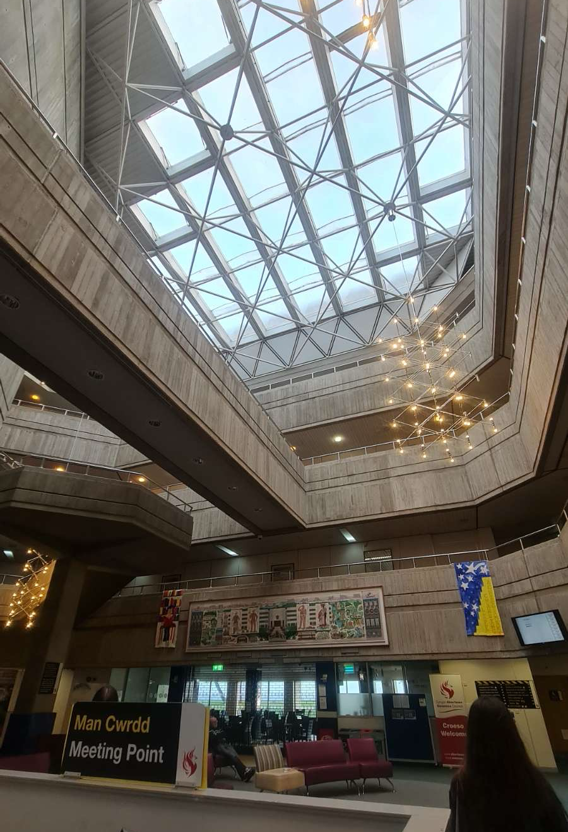
Figure 2 (English – Coflein 2021)
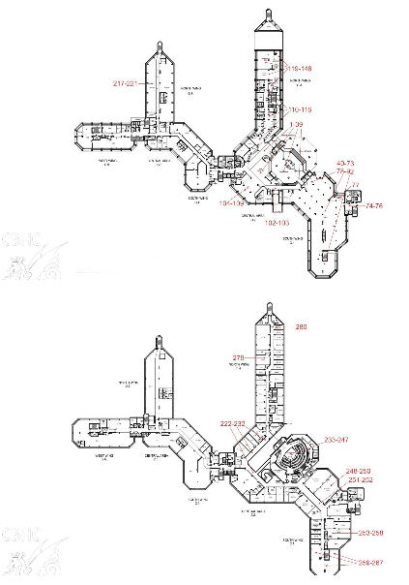

Figure 3 (Self Took)
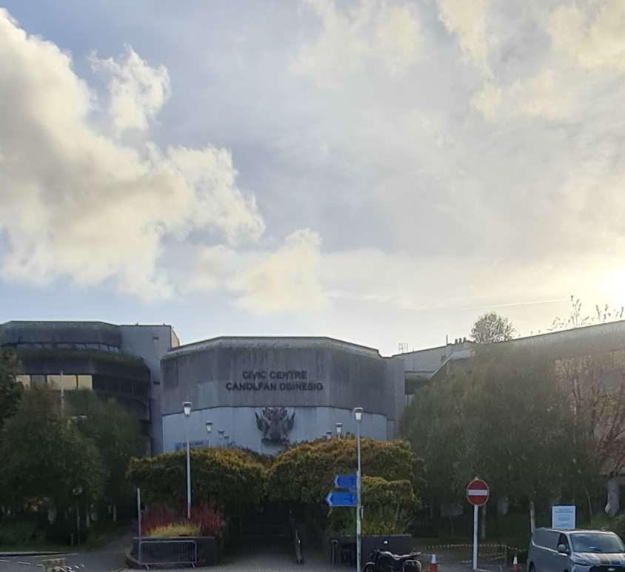

Figure 4 (English – Coflein 2021)
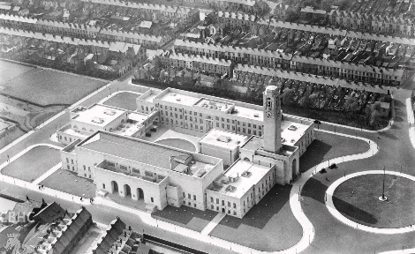

Figure 5 Self Drawn Sketch floor plan (British Listed Buildings, n.d.)
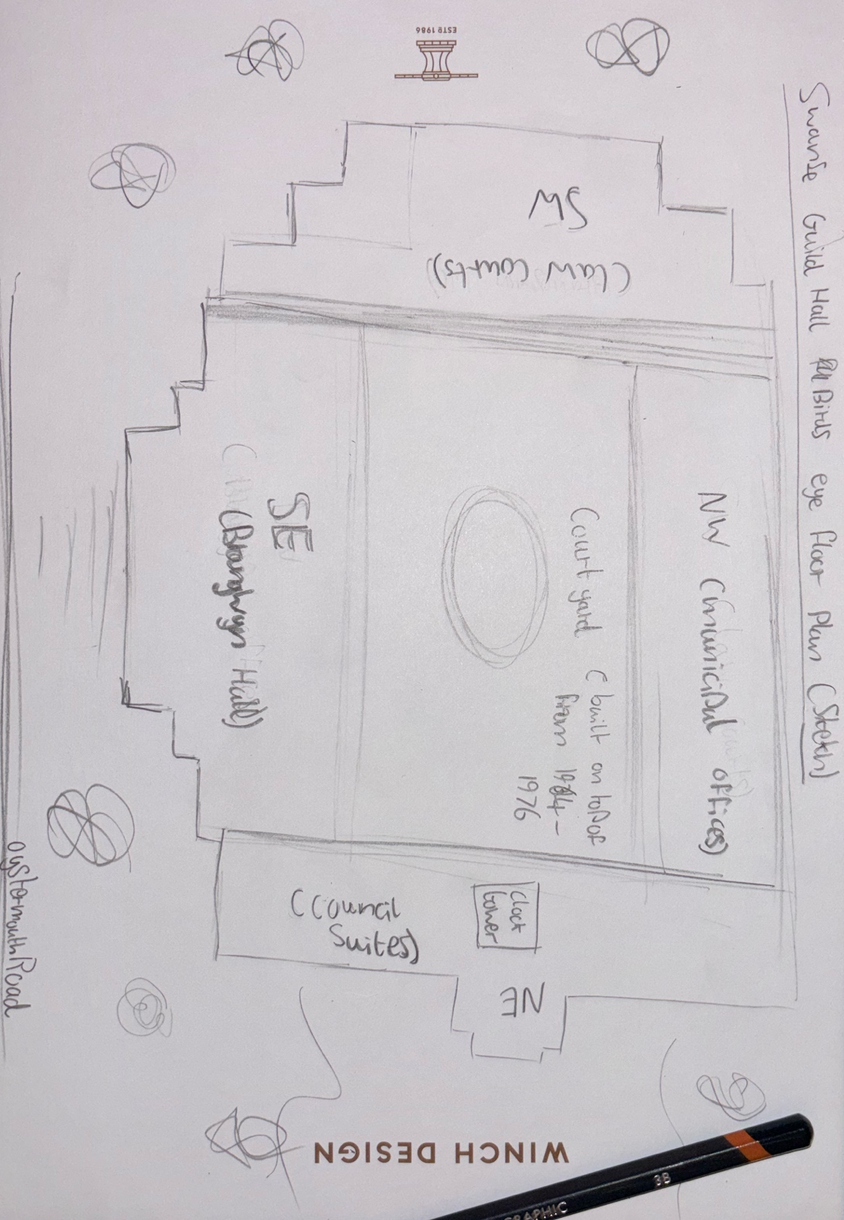

Figure 5.5 Self Drawn Sketch Section (British Listed Buildings, n.d.)
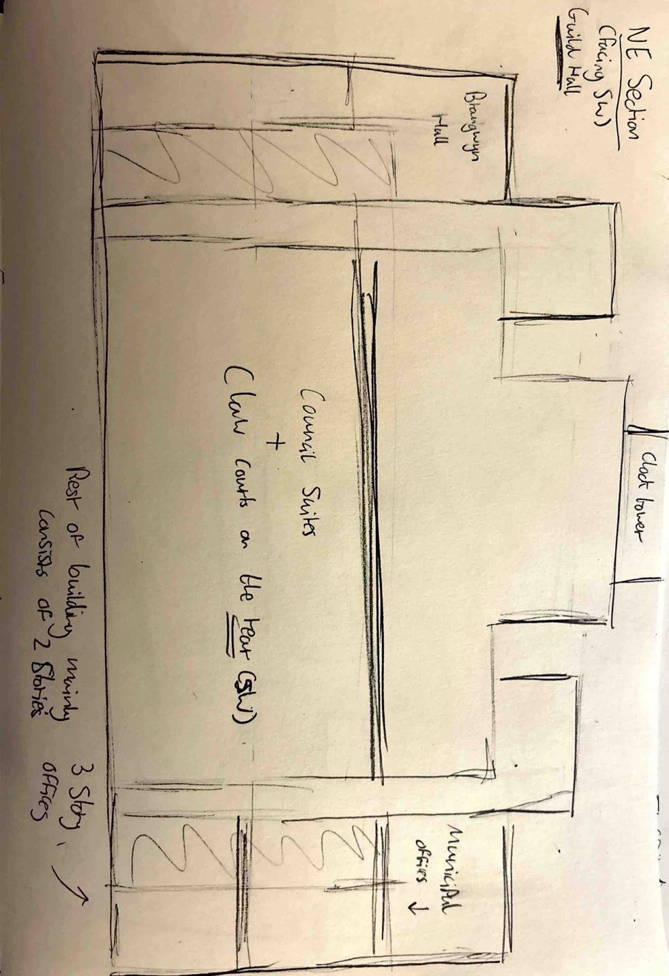

Figure 6 (English – Coflein 2021)
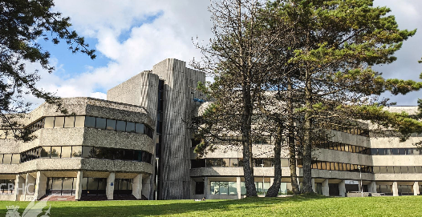

Figure 7 (English – Coflein 2021)
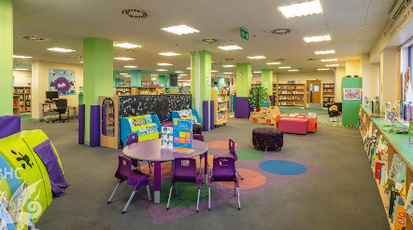

Figure 8 (Brangwyn Hall-Stained Glass | Art UK)
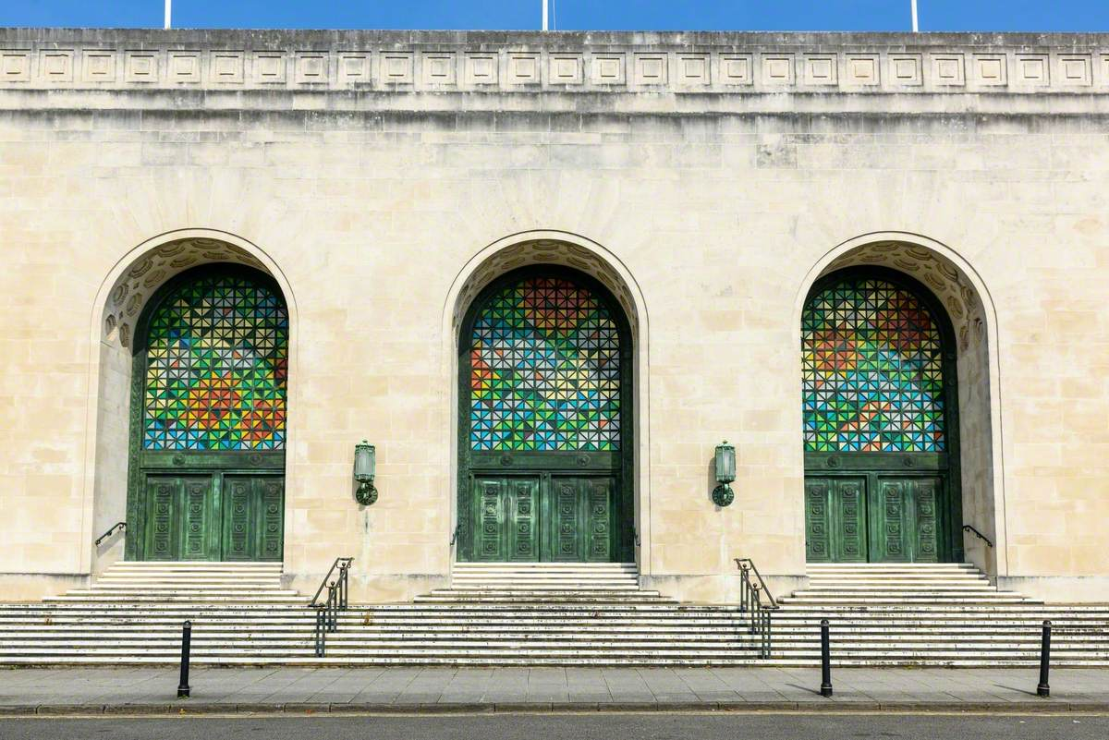
Figure 9 (Dreamstime, 2017)
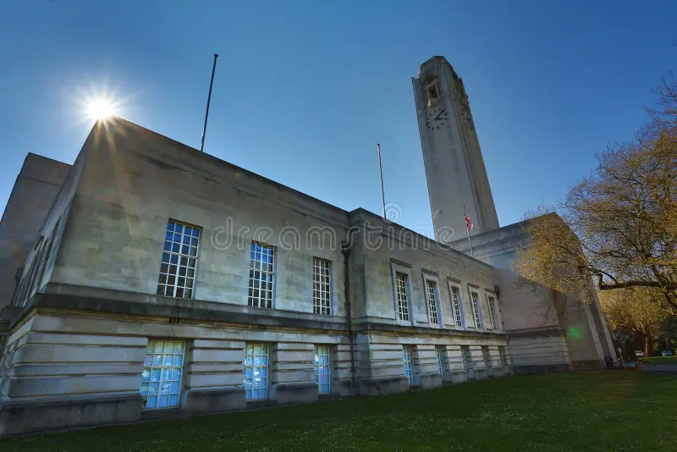
Bibliography

“Archives - the Guildhall in Victoria Park - Swansea.” Swansea, 2024, www.swansea.gov.uk/article/8020/Archives---The-Guildhall-in-Victoria-Park. Accessed 18 Jan. 2026.

“Brangwyn Hall-Stained Glass | Art UK.” Artuk.org, 2026, artuk.org/discover/artworks/brangwyn-hall-stained-glass-322596. Accessed 19 Jan. 2026.

Anon n.d. Swansea New Guildhall, Uplands, Swansea. Britishlistedbuildings.co.uk. [Online]. [Accessed 19 January 2026]. Available from: https://britishlistedbuildings.co.uk/300014594-swansea-new-guildhall-uplands.

“English – Coflein.” Coflein.gov.uk, 2021, coflein.gov.uk/en/site/300024. Accessed 17 Jan. 2026.

Stock, Swansea. “Guildhall Swansea Stock Photos - Free & Royalty-Free Stock Photos from Dreamstime.” Dreamstime, 2017, www.dreamstime.com/photos-images/guildhall-swansea.html. Accessed 19 Jan. 2026.

