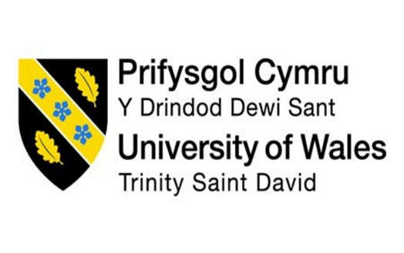

Discuss how the evolution of HRM facilitates the strategic development
of an international hotel brand through workforce planning, recruitment and selection

BMIH5005
Personnel Resourcing and Development
Scott James
Beatrice-Elia Gherasim
2241871

This essay will delve into the evolution of the human resource management (HRM) system and its strategic role in developing international hotel brands. It will focus on the planning, recruitment, and selection processes, using examples from the hotel sector to illustrate the main points. The carefully selected and rigorously applied theoretical concepts will be used to justify the findings. Ultimately, this essay aims to demonstrate the impact of strategic HRM planning and processes in understanding labour demand and setting goals for implementing relevant programs.
Marriott International, a beacon of success in the hotel industry, is an American multinational hotel brand that was founded on March 5, 1927, by the visionary minds of J. Willard Marriott and Alice Marriott. Their ambitious dream was to create the world's most beloved travel company, a goal they have undoubtedly achieved. Today, Marriott International is a global leader, offering travellers various services, from accommodation to flight, hotel, and car rental services.
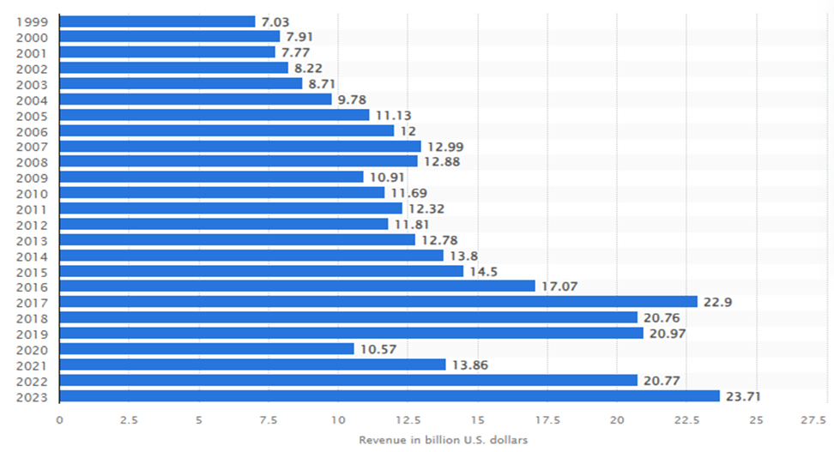
Figure 1: Annual revenue earning of Marriott International
(Source: Statista, 2024)

Statista (2024) reports that Marriott International's annual revenue was $13.86 billion in 2021. This figure witnessed a remarkable surge in the subsequent years, soaring to $20.77 billion and $23.71 billion, respectively. This impressive growth is a testament to the effectiveness of Marriott International's robust HRM system, bolstered by a formidable employee base of 411,000k in 2023, which has empowered the company to operate globally.
In the early 20th century, early personnel management was the primary responsibility of the HRM system. In this era, HRM's role was predominantly administrative. The critical focus of HRM was to perform essential duties such as payroll, record-keeping, screening CVs, and recruiting skilled employees. In this context, Shamaileh et al. (2022) have stated that the evolution of HRM contributed to achieving organisational strategic objectives and aided the employees in performing best in enhancing the efficiency of organisational performance. However, the 1980s marked a significant turning point in the evolution of HRM. In this period, HRM was going into the transition phase where the organisation began to realise the strategic planning of recruitment, selection and employee retention. This realisation and employee demand emphasised that the HRM system should go beyond administrative tasks and encompass a broad range of practical functions to steer corporate functions (Azmi, 2019). In the 21st century, the HRM system has grown by incorporating several trends in operations and functioning to streamline the recruitment and selection process to retain skilled employees and attract new talents easily. Looking ahead, the hotel industry will likely face new challenges in HRM, such as the increasing use of technology in recruitment and the need to adapt to changing workforce demographics. These trends will require HRM to continue evolving and adapting to ensure the strategic development of international hotel brands.
The strategic role of HR functions lies in restructuring a business's HR process and reshaping management practices to streamline strategic planning. As Mayhew (2019) referred to, the strategic role of HR functions emphasises the HR leaders' alignment between business strategy and HRM plans to steer the employee retention process, workplace safety strategy, and risk management. HRM has emphasised this in strengthening employee motivation, which is reflected in organisational performance development.
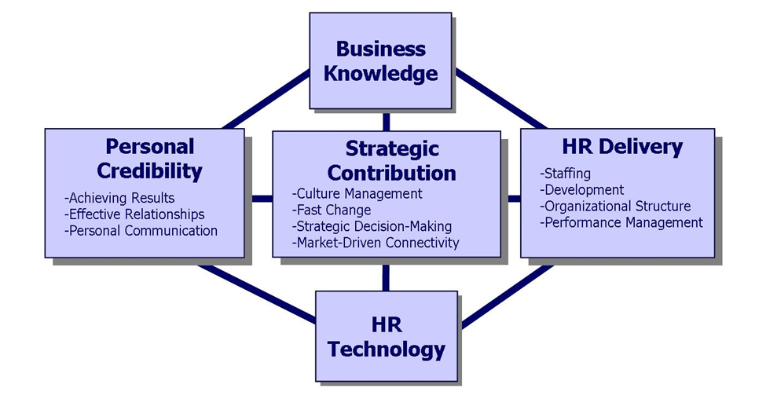
Figure 2: Strategic role of HR functions
(Source: Shrouf et al., 2020)

Furthermore, strategic HRM significantly influences employee performance and the strategic management approach to performance management (Shrouf et al., 2020). It has been further evaluated that strategic HRM influenced organisational productivity and contributed to cultural management. The development of strategic HRM has a profound impact on the HRM functionalities of international brands such as Marriott International. It has been obtained from the case study of Marriott-Careers (2023) that Marriott International embraced changes in the recruitment process by introducing a video conference where the HR leader asks some questions based on candidates' profiles and the job roles. Additionally, the hotel brand used advanced technology in HRM to streamline the recruitment and selection process, which depicted the impact of strategic planning on HRM functionalities.
Analysis and forecasting of labour market demand have been a core responsibility of the HRM system to manage the workforce and handle the labour relatively. However, the hotel industry faces unique challenges, such as high turnover rates and seasonal fluctuations in demand. As stated by Vankevich and Kalinouskaya (2021), analysis and forecast of labour demand have played a significant role in HRM in assessing the skills and competency of employees and facilitating the brands to make effective decisions. Additionally, it has been evaluated that labour market demand increased in nexus to the pandemic outbreak. It has been evident that nearly 2 billion workers have obtained informal employment globally, and 70% of employees belong to developing and low-income countries (World Economic Forum, 2023). This statistical evidence emphasised that the hotel industry should understand the actual scenario of the labour market and incorporate the necessary changes to improve the situation. By this, Marriott International employed diverse individuals to stimulate business performance and enhance organisational productivity. However, the law of labour supply functions in the labour market, which states that a higher price for labour leads to a higher quantity of supply and a lower price leads to a lower quantity supplied (Daily Times, 2022). Additionally, statistics of labour market demand and supply trends facilitated hotel brands to recruit individuals as per the labour market demand.
Goal setting has been a core part of strategic planning, and strategic HRM functions lead to steering employee performance through understanding their career goals and aligning them with the business objectives. Additionally, goals provided a direction to the organisation, enhanced team members’ understanding regarding their responsibilities, and fostered a sense of cohesion. As Hassanein and Özgit (2022) suggested, understanding key goals and responsibilities facilitated the employees to achieve 80% of business goals and relatively enhanced performance efficiency. However, Marriott International aimed to improve customers' travel experiences by offering unsurpassed vacation tours and stimulating leisure experiences. In this context, HRM integrated changes in operations by recruiting talented individuals with a sense and professional knowledge to assimilate customer needs.
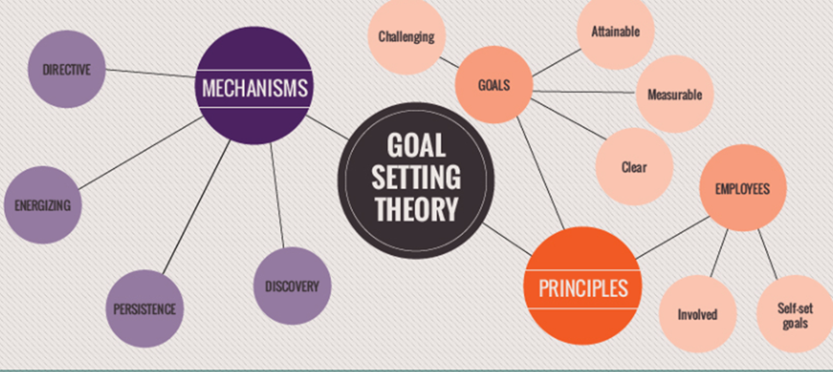
Figure 3: Goal setting theory
(Source: Tocino-Smith, 2019)
The theoretical overview of goal-setting theory describes the possible goals, but a lack of proper guidance makes it impossible to achieve them (Tocino-Smith, 2019). Additionally, HRM instructed the employees to analyse the principles of the organisation to perform best. By this, strategic planning lies in acknowledging employees' essential desires and demands before shaping the remuneration packages. According to The Human Capital Hub (2023) report, Marriott International offered paid time off to the employees on sick days, personal needs and relaxation. This has benefitted the renowned hotel brand to retain talented employees. Moreover, employees received a 50% discount on room booking and a 20% discount on hotel meals and beverages. These offers create interest among employees and build trust in the hotels.
HRM has fostered the responsibility of assessing business requirements, collaborated with finance departments to evaluate financial stability and then formed plans for implementing relevant programs into operations. Torrington et al. (2020) state that leaders need to assess the principles and aspects of HRM to implement further relevant practices and justify the practices through the lens of the theoretical overview of concepts. In relevance to this, hotel brands such as Marriott International acknowledge customer demand and identify the change needed to steer business performance. In this case, the report of Marriott-Programs (2023) has been analysed to understand the range of programs such as hotel internship programs, apprenticeships, and fellowship programs that the hotel brand offers employees to enhance their skill potential. These programs facilitated the workforce's collaboration with global leaders and emphasised engaging with senior Marriott executives to broaden their learning and knowledge. Moreover, employee performance evaluation involves obtaining feedback from the HR leaders regarding employee performance potential. Further, it would have been effective if Marriott International had used Key Performance Indicators (KPIs) to measure employee performance.
The strategic role of HRM emphasises that the organisation, especially the hotel brands, should reshape HR planning, recruitment, and selection processes by integrating advanced technologies into operations and functions. Noor Al-Jedaiah and Albdareen (2020) suggest that strategic HRM significantly enhances organisational excellence. Additionally, organisational excellence depends on HRM’s functions such as recruitment, training and career development practices. By this, Marriott International fostered a work-friendly culture to streamline the HR planning process. Chinnuswamy (2018) opined that Marriott integrated robust development into the HR planning process. This development process emphasised the HR leaders reviewing the career graph of existing employees and suggesting development plans for steering their career development. In this context, it has been stated that HR planning lies in enhancing employees' career growth and uplifting their skill potential through reviewing the performance of existing employees and acknowledging the difficulty faced in performing tasks.
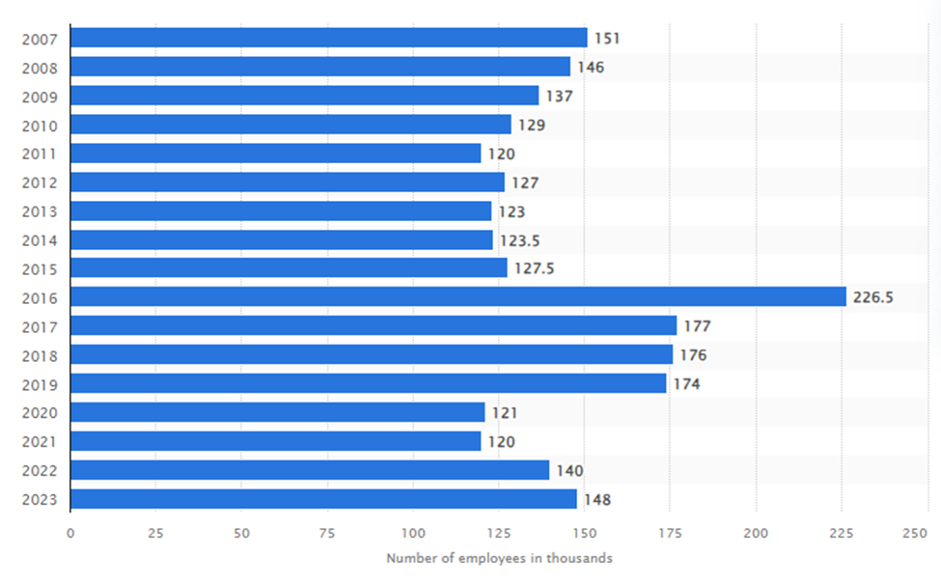
Figure 4: Number of employees of Marriott International
(Source: Statista, 2024)
The strategic functionalities of HRM depicted the initiation of using AI-generative tools in the recruitment process to screen candidates' profiles and select the talented ones in further stages. As suggested by Meister (2018), Marriott International integrated AI-based tools in talent management stages to assess employees' performance and analyse whether they are competent to serve the best hospitality services to customers. This strategic change facilitated Marriott International in retaining the talented workforce by guiding them through the best suggestions. Furthermore, the business development of Marriott International depends on the approach used in the selection process. However, the HR managers of Marriott Hotels aligned people's expectations and determination with the business goals to select reliable candidates and strengthen business outcomes. This has been reflected in the gradual enhancement of the number of employees. According to Statista's report (2024), the number of Marriott International employees was 120,000 in 2021, 140,000 in 2022, and 148,000 in 2023. This gradual enhancement of the number of employees showed that strategic HRM has a significant role in strategic planning, recruitment and selecting the best and most talented individuals to increase business potential.
The evolution of strategic HRM has begun to ease adjusting to the market demand and enhance business productivity to streamline business growth. It has been the same for the hotel industry, such as Marriott, to improve business growth within the hotel sector. In Enad Al-Qaralleh and Atan's (2021) view, knowledge-based HRM practices have contributed to organisational agility that steered the managerial approach to increase the brand's innovative performance. Market research and customer demand emphasised the hotel industry's introduction of ‘customised services' within all tour packages and other hotel services. In relevance to this, hotel brands have recruited personnel who have insight into the understanding of travellers' desires and expectations and provide the relevant services to enrich their purchase interest.
This has resulted in steering business growth adequately. According to the report of Marriott International (2024), Marriott International announced a signed agreement with HMI Hotel Group to rebrand the seven existing properties of HMI in five major cities across Japan. This strategic decision aids Marriott in providing the best hospitality services to local tourists in Japan. Business growth and expansion have put forth the hotel industry to enhance revenue earning and increase market share worldwide. As reported by Statista (2024), it is projected that the revenue of hotels will reach US$446.50 billion in 2024 worldwide, and it has been estimated that the annual growth rate would be 3.32% in 2028, which leveraged the hotel industry to increase market volume to US$508.90 billion.
In conclusion, the strategic role of HRM functions played a vital role in reshaping strategic planning and embracing changes in recruitment, selection, training and development programs. Additionally, understanding the forecast of labour market demand and supply facilitated the hotel brands in recruiting individuals per the market demand. Moreover, strategic HRM has been a significant aspect of setting goals, empowering the workforce to achieve the goals and streamlining performance growth relatively. Training and development programs aided Marriott’s employees in accelerating the performance graph and upscaling the skill potential. Moreover, it has been suggested that Marriott International should instruct the HR leaders to supervise employees’ performance in tasks to ease addressing the employees' hindrances in their work.

References
- Azmi, F.T. (2019) Strategic HR Evaluation, Cambridge University Press. Edited by F.T. Azmi. Cambridge: Cambridge University Press. Available at: https://www.cambridge.org/core/books/abs/strategic-human-resource-management/strategic-hr-evaluation/D93967A0963D787AFE35BBAF4A5B009D# (Accessed: 30/04/2024).
- Chinnuswamy, Y. (2018) How Marriott International puts people first, HRM Asia. Available at: https://hrmasia.com/how-marriott-international-is-putting-people-first/ (Accessed: 1/05/2024).
- Daily Times (2022). Higher Education Commission, Your Attention is Needed! [online] Available at: https://dailytimes.com.pk/898834/higher-education-commission-your-attention-is-needed/ (Accessed: 01/05/2024).
- Enad Al-Qaralleh, R. and Atan, T. (2021) ‘Impact of knowledge-based HRM, business analytics and agility on innovative performance: linear and FsQCA findings from the hotel industry’, Kybernetes, ahead-of-print(ahead-of-print). Available at: https://doi.org/10.1108/k-10-2020-0684 (Accessed: 02/05/2024)
- Hassanein, F. and Özgit, H. (2022) ‘Sustaining Human Resources through Talent Management Strategies and Employee Engagement in the Middle East Hotel Industry’, Sustainability, 14(22), p. 15365. Available at: https://doi.org/10.3390/su142215365 (Accessed: 29/04/2024).
- Marriott-Careers (2023) The Marriott Voyage Application & Interview Process: A Guide, Marriott Careers. Available at: https://careers.marriott.com/blog/voyage-application-process/ (Accessed: 01/05/2024).
- Marriott International (2024) Marriott International and HMI Hotel Group Announces a Multi-property Conversion Deal in Japan, Marriott International Newscenter (US). Available at: https://news.marriott.com/news/2024/04/17/marriott-international-and-hmi-hotel-group-announces-a-multi-property-conversion-deal-in-japan (Accessed: 01/05/2024).
- Marriott-Programs (2023) Early Careers, Marriott Careers. Available at: https://careers.marriott.com/career-paths/earlycareers/ (Accessed: 01/05/2024).
- Mayhew, R. (2019) The Strategic Role of Human Resource Managers, Chron.com. Available at: https://smallbusiness.chron.com/strategic-role-human-resource-managers-11782.html (Accessed: 01/05/2024).
- Meister, J. (2018) Future Of Work: How Using AI Creates An Enhanced Candidate And Employee Experience, Forbes. Available at: https://www.forbes.com/sites/jeannemeister/2018/04/10/future-of-work-how-using-artificial-intelligence-creates-a-best-in-class-employee-experience/?sh=5fbe2156620c (Accessed: 01/05/2024).
- Noor Al-Jedaiah, M. and Albdareen, R. (2020) ‘The effect of strategic human resources management (SHRM) on organisational excellence’, Problems and Perspectives in Management, 18(4), pp. 49–58. Available at: https://doi.org/10.21511/ppm.18(4).2020.05 (Accessed: 30/04/2024).
- Shamaileh, N. et al. (2022) ‘The effect of e-HRM on organisational performance and talent management: A strategic evolution perspective’, International Journal of Data and Network Science, 6(4), pp. 1043–1048. Available at: https://doi.org/10.5267/j.ijdns.2022.8.005 (Accessed: 30/04/2024).
- Shrouf, H. et al. (2020) ‘A study on the relationship between human resources and strategic performance: The mediating role of productivity’, Management Science Letters, 10(13), pp. 3189–3196. Available at: https://doi.org/10.5267/j.msl.2020.5.002 (Accessed: 29/04/2024)
- Statista (2024) Marriott International: revenue 2019, Statista. Available at: https://www.statista.com/statistics/266279/revenue-of-the-marriott-international-inc-hotel-chain/#:~:text=Global%20hotel%20giant%20Marriott%20International (Accessed: 01/05/2024).
- Statista (2024) Number of Marriott International employees worldwide from 2007 to 2023, Statista. Available at: https://www.statista.com/statistics/297269/number-of-marriott-international-employees-worldwide/ (Accessed: 01/05/2024).
- The Human Capital Hub (2023) Marriott Employee Benefits, Human Capital Hub. Available at: https://www.thehumancapitalhub.com/articles/marriott-employee-benefits (Accessed: 01/05/2024).
- Tocino-Smith, J. (2019) What is Locke’s Goal Setting Theory of Motivation? (Incl. Examples), PositivePsychology.com. Available at: https://positivepsychology.com/goal-setting-theory/ (Accessed: 29/04/2024).
- Torrington, D., Atkinson, C. and Taylor, S. (2020) Human Resource Management, www.pearson.com. Available at: https://www.pearson.com/en-gb/subject-catalog/p/human-resource-management/P200000005617/9781292261669 (Accessed: 02/05/2024).
- Vankevich, A. and Kalinouskaya, I. (2021) ‘Better understanding of the labour market using Big Data’, Ekonomia i Prawo, 20(3), pp. 677–692. Available at: https://doi.org/10.12775/eip.2021.040 (Accessed:29/04/2024).
- World Economic Forum (2023) The Future of Jobs Report 2023, World Economic Forum. Available at: https://www.weforum.org/publications/the-future-of-jobs-report-2023/in-full/1-introduction-the-global-labour-market-landscape-in-2023/ (Accessed: 01/05/2024).

