

Student name: Jeneba Echeverria Dominguez
Student ID: 2438504
Module name: Introduction to Health and Social Care
Module code: LCHS4008_LON
Lecturer name : Christofer
Content page

Dentistry Services ………………………………………………….. page 2
History Of NHS ……………………………………………………… page 3
References …………………………………………………………… page 4

Current function of Dentistry Services
NHS dentistry services help keep teeth and gums healthy, provide treatments like fillings, extractions, crowns, and emergency care, and replace missing teeth with dentures or bridges. They also offer free or cheaper care for children, elderly people, and low-income patients (NHS, 2024).
Dental history
When the NHS started in 1948, everyone could go to the dentist for free. Many people had teeth treated or pulled, and it was the first time a lot of people visited a dentist.
Because so many people went, the government started charging small fees for dentures and other treatments.
Later, dentists ran their own practices but still worked for the NHS. People now pay set prices for the care they need.
Today, NHS dental care is still cheap, but it can be hard to get an appointment in some places because there are not enough dentists.
The government is trying to make NHS dental care better and easier to see a dentist (NHS, 2024).

Dentistry services
Jeneba Echeverria Dominguez, Introduction to Health and Social Care , 2438504@student.uwstd.ac.uk.

Two challenges faced in Dentistry Services
Access to care: Due to a shortage of NHS dentists in some locations, many patients struggle to schedule an appointment.
Financial constraints make it hard to offer every treatment, and patients occasionally have to wait a long time or pay for their care (NHS Business Services Authority, 2025; British Dental Association, 2025).

Photo 2
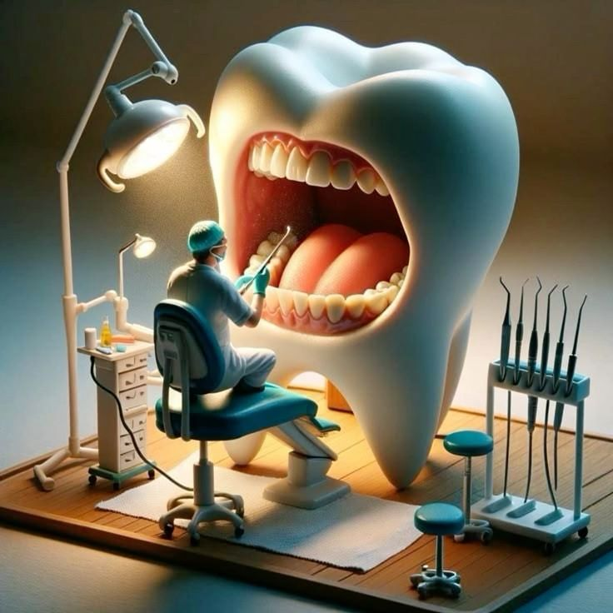
Explanation of Dentistry Services
The NHS offers dental care, including as examinations, fillings, extractions, crowns, and dentures, to maintain the health of teeth and gums. Although most people pay established fees, some patients, such as children or those with poor incomes, may receive care for free. Appointments can be difficult to get in some places, and NHS dentists operate their own practices while adhering to NHS regulations. The government is attempting to facilitate access to dental care (NHS, 2024; Department of Health and Social Care, 2024).

Photo 1
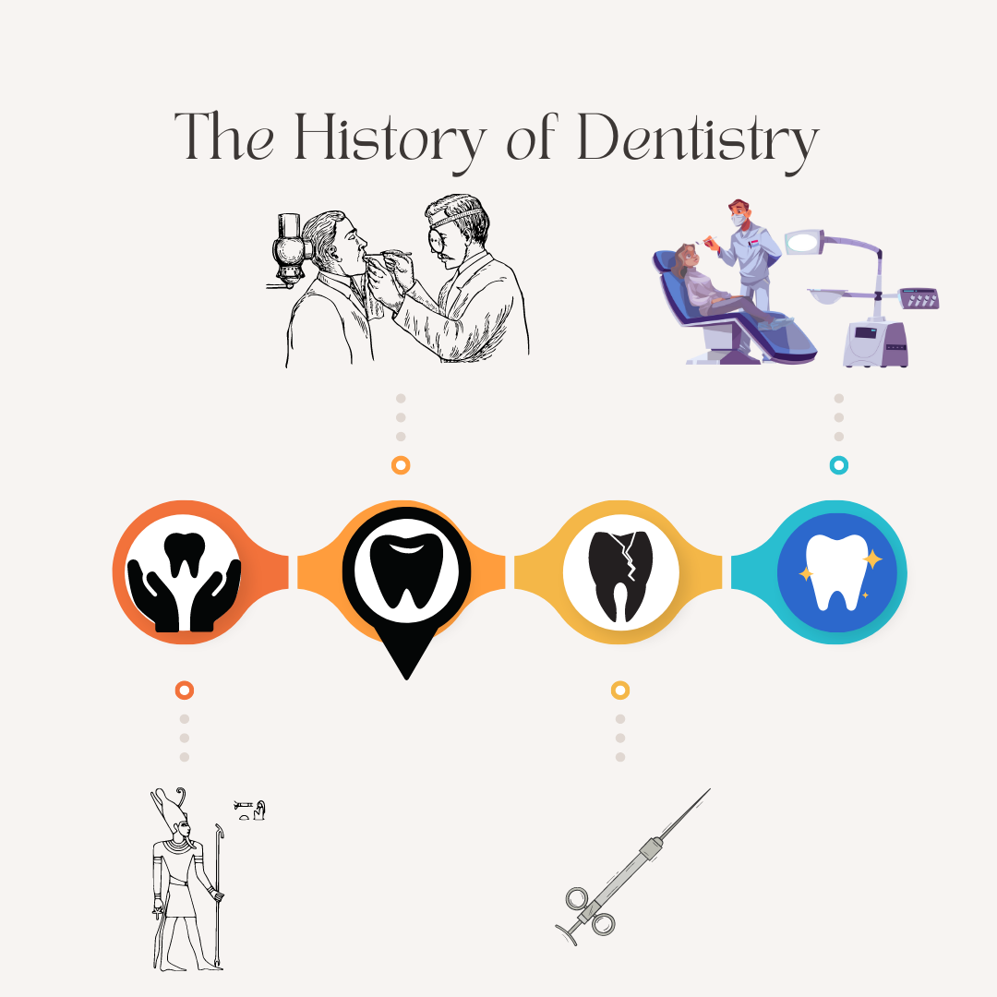
Element 2

Introduction
The National Health Service (NHS) was established in 1948 to provide free medical care to all citizens of the United Kingdom. It was designed to make it possible for everyone to visit a doctor, dentist, or hospital regardless of their financial situation.
The NHS now offers a wide range of services, including emergency care, treatments, and check-ups. While local NHS trusts oversee hospitals and clinics, doctors and dentists typically maintain their own practices while adhering to NHS regulations. Certain treatments may be somewhat expensive, but the majority of services are free. Patients with modest incomes, the elderly, and children frequently receive free care. The government works to make NHS services more user-friendly, however occasionally scheduling an appointment might be challenging due to a shortage ofIt was designed to make it possible for everyone to visit a doctor, dentist, or hospital regardless of their financial situation.
The NHS now offers a wide range of services, including emergency care, treatments, and check-ups.
During the second World War, British society faced five major social challenges identified by William Beveridge in his 1942 Social Insurance and Allied Services report Want, Disease, Ignorance, Squalor and Idleness (Beveridge, 1942). These five giants highlighted widespread proverty, poor health, inveryoadequate education, poor housing and unemployment. The war revealed deep inequalities in access to healthcare particularly between the rich and poor, creating a strong demand for a comprehensive welfare system.
This led to the creation of the National Health Services (NHS) in 1948 by the Labour government, led by Clement Attlee and Health Minister Aneurin Bevan. The NHS was built on three main ideas: everyone should be able to get healthcare (universal access) treatment should be free when people need it and care should be based on medical need not on how much money someone has (Department of health, 2015). These principles were meant to make society fairer and improve peoples health by giving everyone the same chance to receive good medical care.
However as the cost of running the NHS increased, some changes had to be made. In 1951 people began paying small fees for dental care and prescriptions to help cover expenses (Webster, 2002). Even with these changes, the NHS is still one of Britain most respected services and continues to represent Beveridge idea of a fair and caring society.
The essay discusses how William Beveridge "five giants" during World War II underlined the need for improved welfare and healthcare in Britain. This resulted in the establishment of the National Health Service in 1948, which was founded on universal access, free treatment, and care based on need. Despite subsequent costs for dental and prescription treatments, the NHS remains critical to social equality and well-being.

References
NHS (2024) Dental services. Available at: https://www.nhs.uk/nhs-services/dentists/ (Accessed: 2 November 2025).
Department of Health and Social Care (2024) Our plan to recover and reform NHS dentistry. Available at: https://www.gov.uk/government/publications/our-plan-to-recover-and-reform-nhs-dentistry (Accessed: 2 November 2025)
NHS Business Services Authority (2025) Dental statistics – England 2024/25. Available at: https://www.nhsbsa.nhs.uk/statistical-collections/dental-england/dental-statistics-england-202425 (Accessed: 5 November 2025).
NHS Business Services Authority (2025) Dental statistics – England 2024/25. Available at: https://www.nhsbsa.nhs.uk/statistical-collections/dental-england/dental-statistics-england-202425 (Accessed: 1 November 2025).
Beveridge, W. (1942) Social Insurance and Allied Services. London: His Majesty’s Stationery Office (HMSO). Available at: https://www.bl.uk/collection-items/beveridge-report (Accessed: 22 October 2025).
Department of Health (2015) The NHS Constitution for England. London: Department of Health. Available at: https://www.gov.uk/government/publications/the-nhs-constitution-for-england (Accessed: 22 October 2025).
Webster, C. (2002) The National Health Service: A Political History. 2nd ed. Oxford: Oxford University Press. Available at: https://global.oup.com/academic/product/the-national-health-service-9780199251104 (Accessed: 5 November 2025).

