

Module: Human Capital Management
Module code: LCMB7023

Assessment component 2

Student Name: Andrey Nieche

Table of Contents
Introduction 3
Retention Challenges: Beyond Turnover Statistics 4
Succession Planning Challenges: A Reactive System 6
Structural and Policy-Driven Root Causes 7
Leadership and Cultural Root Causes 8
Critical Application of HRM Theory 10
Recommendations 11
Conclusion 13
References 14



Introduction

One of the largest and most complicated public sector organisations in the world, with more than 1.3 million employees, is the UK National Health Service (NHS). Its labour force has been at the forefront of providing effective, safe and equitable healthcare services. The NHS now faces a serious workforce crisis marked by chronic staff shortages, high turnover, and growing inability to staff more and more key positions.
Succession and retention planning are thus not an operational issue but a strategic one. In the Human Capital Management (HCM) position, organisational continuity, organisational resilience, and institutional knowledge are all preserved through these functions. Both areas are historically undeveloped and not strategically ingrained in the NHS, but instead react to it.
More importantly, NHS workforce problems are never resolution-specific HR problems but are indicative of more systemic inefficiencies, such as funding constraints, policy inconsistencies, and leadership constraints. This presentation will critically assess the issue of retention and succession planning within the NHS, delve into the underlying factors of these problems, both within structural, cultural, and managerial aspects, and suggest empirically supported HRM interventions within the theoretical framework.

Retention Challenges: Beyond Turnover Statistics
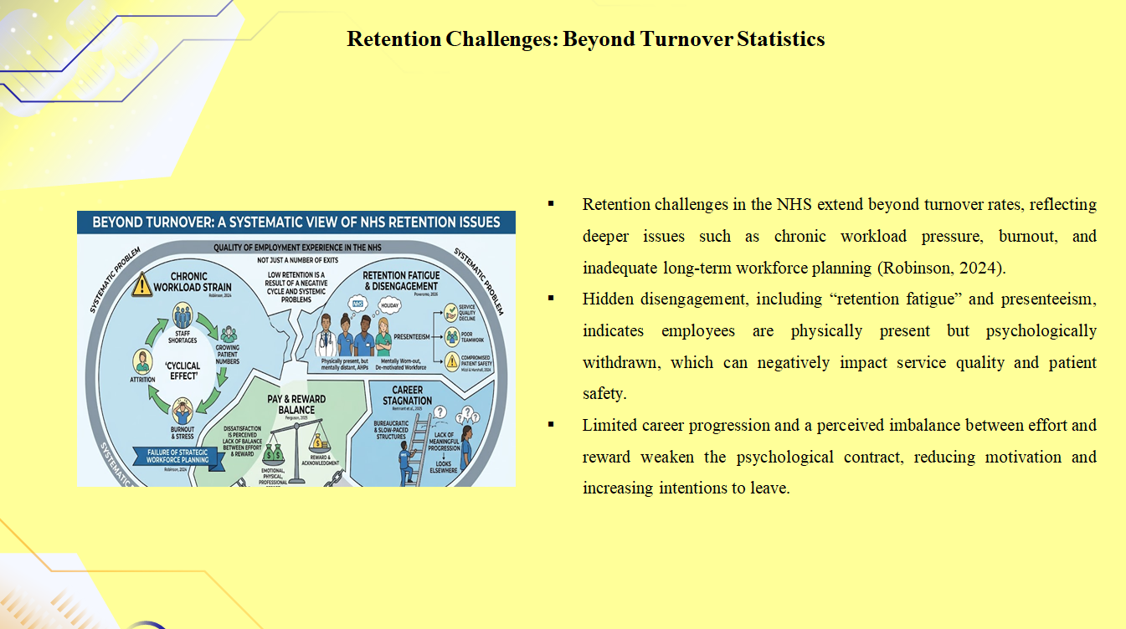
The turnover rates are often used to define the issues of retention in the NHS, but such a one-dimensional approach may simplify an extremely complicated and systematic problem. Although it remains clear that high rates of nurses leaving the organisation, junior doctors and allied health professionals are not only leaving the organisation, but the number of exits is not the root of the issue, but rather the quality of the employment experience in the NHS(Robinson, 2024).
Chronic workload strain is one of the gravest motivators of low retention, as it is caused by the ongoing staffing shortage and the growing number of patients. This provides a cyclical effect in that understaffing breeds higher work pressure, burnout, stress and emotional burnout, which further promotes attrition. More importantly, this call is not to be considered an operational issue but a failure of long-term strategic workforce planning(Poveromo, 2026). The lack of predictability to meet health care demand signifies flaws in the management of human capital.
The NHS experiences what can be referred to as "retention fatigue, in which employees stays in the organisation, but they are mentally on holiday? This has been associated with presenteeism and is an indication of a physically present but mentally worn-out and de-motivated workforce(Remnant et al., 2025). These less glaring forms of disengagement are of particular concern because they are not easily noticeable as compared to turnover, but could be very devastating to the service quality, teamwork, and patient safety.
Perceived lack of meaningful career progression is another important problem. Despite the presence of formal career structures in the NHS, they have often been criticised as bureaucratic, slow-paced and not very transparent. Consequently, workers might feel restricted by the position, and they can hardly grow in terms of their positions or expertise(Mizzi and Marshall, 2024). This stagnation is a demotivating factor, and it tends to make employees find other chances elsewhere, other than the organisation.
Lastly, pay is most commonly viewed as one of the key elements of retention, but pay is too reductionist to explain workforce exodus in terms of remuneration. Rather, the dissatisfaction can best be seen as a perceived lack of balance between effort and reward(Ferguson, 2025). There is often an advocacy among employees that the emotional, physical and professional needs of their jobs are not sufficiently acknowledged or compensated, and this causes a decline in the psychological contract and accelerated intent towards departure.

Succession Planning Challenges: A Reactive System
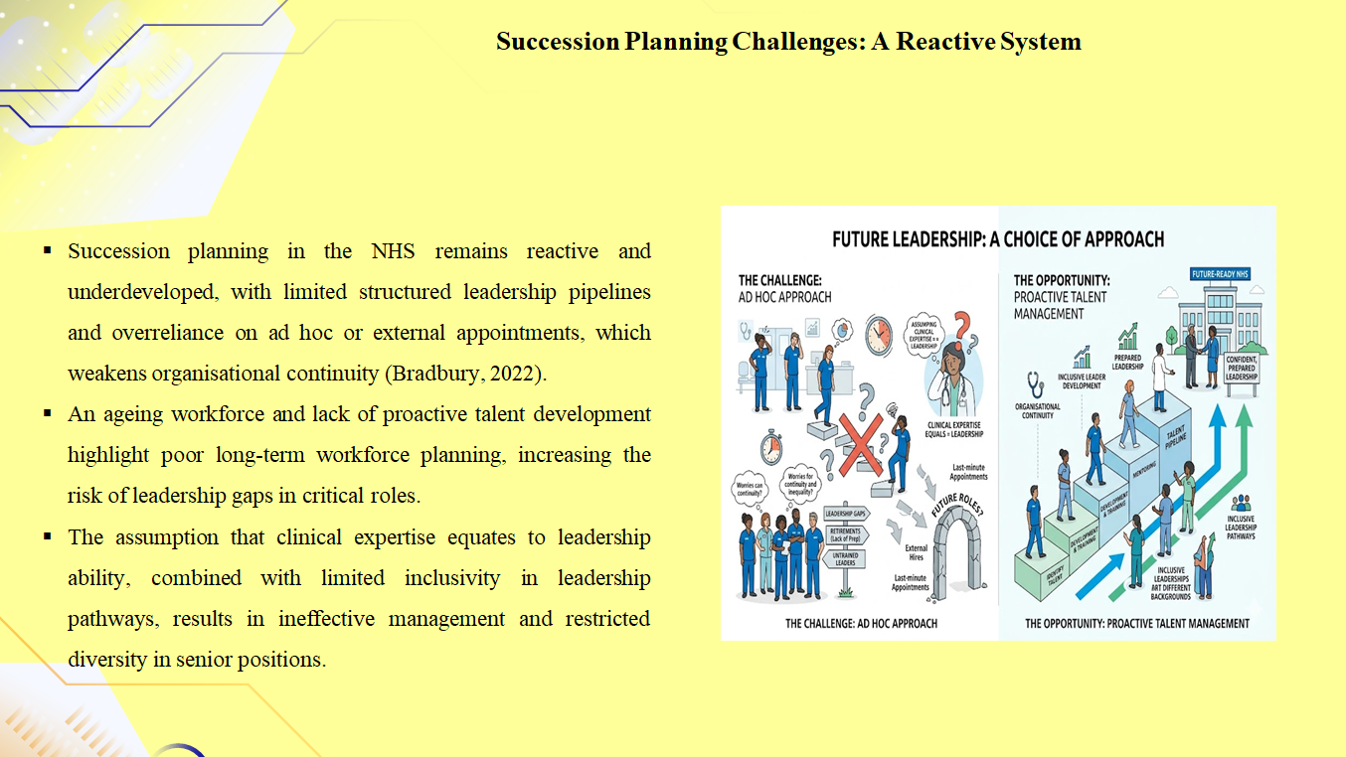
The NHS succession planning is still in its underdeveloped and reactive phases, especially in leadership and specialised clinical positions. As opposed to companies in the private sector, which tend to embrace proactive talent management plans, the NHS has been using informal and ad hoc methods of leadership succession in the past.
The lack of clearly defined leadership pipelines is one of the issues. Some of the top positions are appointed externally or are given in a hurry to internal candidates, but not achieved through a systematic process of talent development(Bradbury, 2022). This strategy sabotages organisational continuity and contributes to the possibility of gaps in leadership.
This difficulty is further complicated by the phenomenon of an ageing workforce. A large percentage of the ageing clinicians and managers are near retirement age, but there is no adequate effort in succession preparation. This means that there is a lack of foresight for the foreseeable workforce changes(Habib, 2026).
Also, the NHS includes a troublesome assumption according to which clinical expertise is inherently transformed into leadership competence. Consequently, people find themselves in management positions without proper leadership training, resulting in poor management practices.
More importantly, succession planning within the NHS is also not inclusive. The leadership lines are not always available to various groups of people, and thus, this hinders creativity and continues with the prevailing disparities in the organisation(AlDayel et al., 2025).
Altogether, the NHS succession planning is marked with a short-term approach, an inability to align strategies, and inadequate investment in leader development.

Structural and Policy-Driven Root Causes
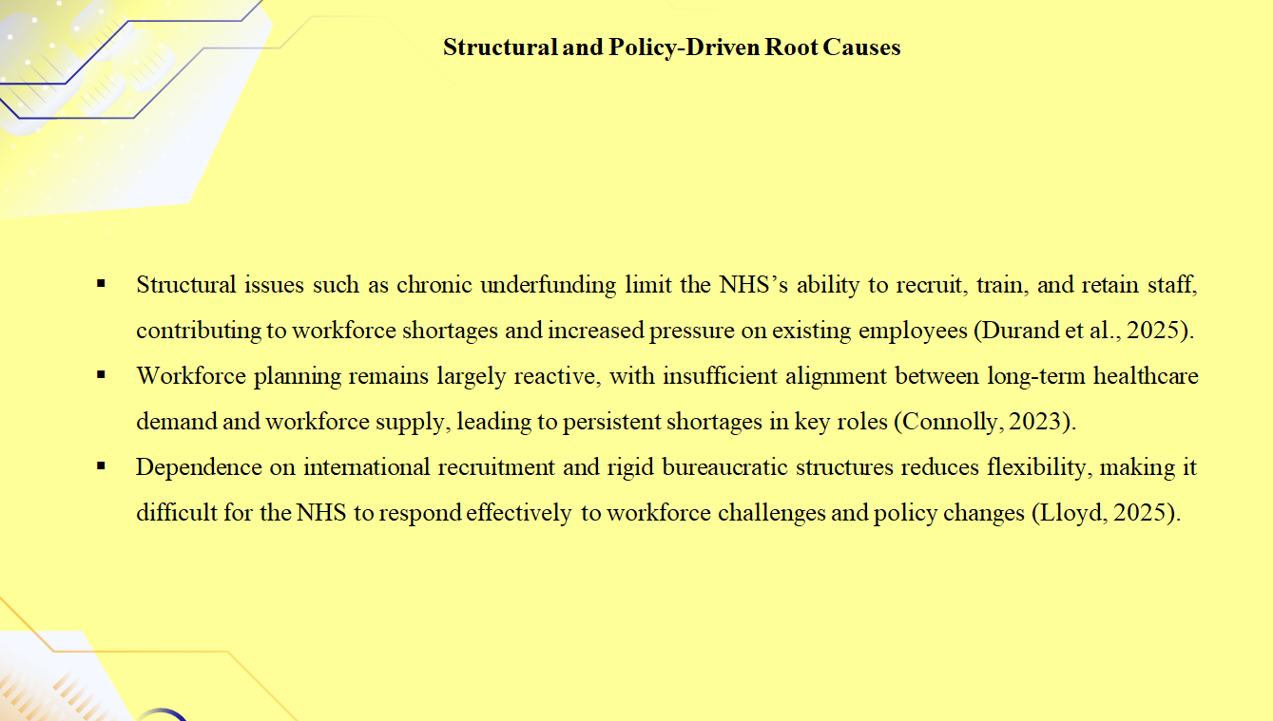
The retention and succession issues in the NHS cannot be entirely perceived without analysing the structural and policy-based sources of the problem. Chronic underfunding is one of the most critical parts that limit the capability of the organisation to recruit, train and effectively retain employees.
The workload and job satisfaction are haunted by a shortage of staff due to financial constraints. Yet, it is not a financial problem only, but represents a more general policy choice in terms of healthcare prioritisation and resource distribution(Durand et al., 2025).
The NHS has also had criticism regarding workforce planning as being a reactive process. In the past, the lack of a proper relationship between the supply of workforce and demand for long-term healthcare has been experienced(Connolly, 2023). As an illustration, lack of adequate investment in training programmes has led to the shortage of certain occupations that are in high demand in the job market, including nursing and general practice.
Complications in the workforce further apply to immigration policies. International recruitment has been a traditional ploy used by the NHS to fill staffing gaps; however, alterations in the immigration policy have derailed the approach(Lloyd, 2025). This demonstrates that the organisation is highly reliant on the labour market and does not rely on internal development of the workforce sustainably.
Also, the NHS has bureaucratic structures that restrict the flexibility of HR. The organisation lacks the capacity to work dynamically towards workforce challenges as decision-making processes are usually slow and centralised.

Leadership and Cultural Root Causes
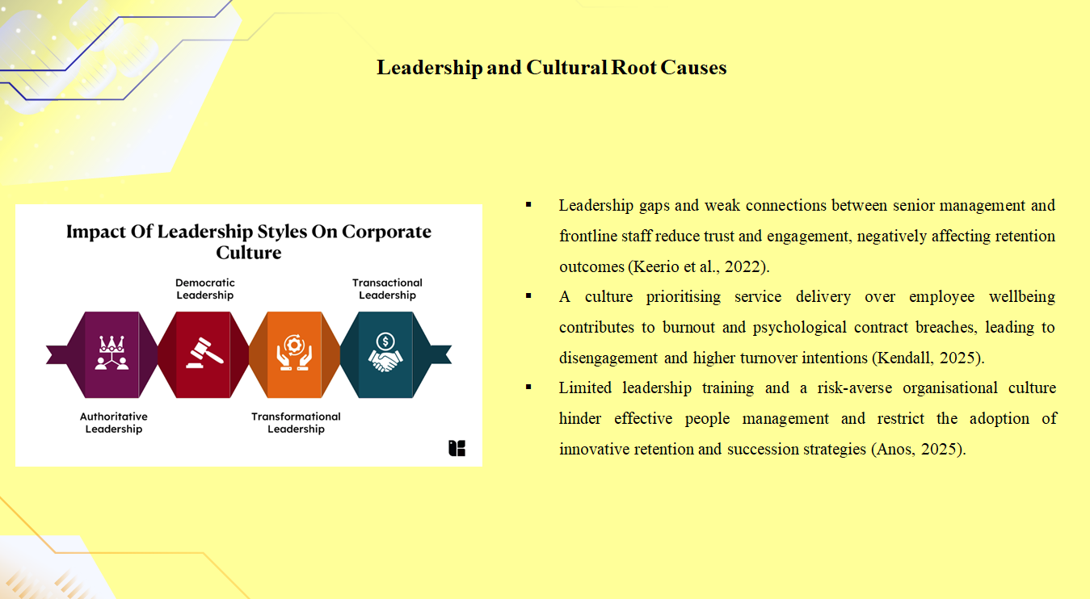
Structural factors are also important, but leadership and organisational culture are equally important in influencing retention and succession outcomes. Senior management and staff at the frontline are not connected in many NHS organisations, which undermine trust and engagement.
The NHS has long believed that service delivery is more important than employee welfare, culturally speaking. Although it represents a great dedication to the needs of the patient, it can frequently lead to disregard for the needs of the staff(Keerio et al., 2022). This disparity adds to burnout and dissatisfaction.
Violation of the psychological contract is typical between the organisation and its employees. Working in the NHS, employees could expect to get meaningful work, professional development, and support from the organisation. Disengagement and turnover occur due to unmet expectations (Kendall, 2025).
The other issue of interest is the ability to lead. Most managers do not have people management training, and this affects their ability to assist and inspire the teams that they lead. Weaknesses in leadership behaviours will just increase stress, demoralize, and increase the rate of attrition.
Moreover, the NHS culture may be risk-averse and change-avoidant, which inhibits HR practice innovation. This cultural tradition obstructs the usage of contemporary retention and succession practices(Anos, 2025).

Critical Application of HRM Theory
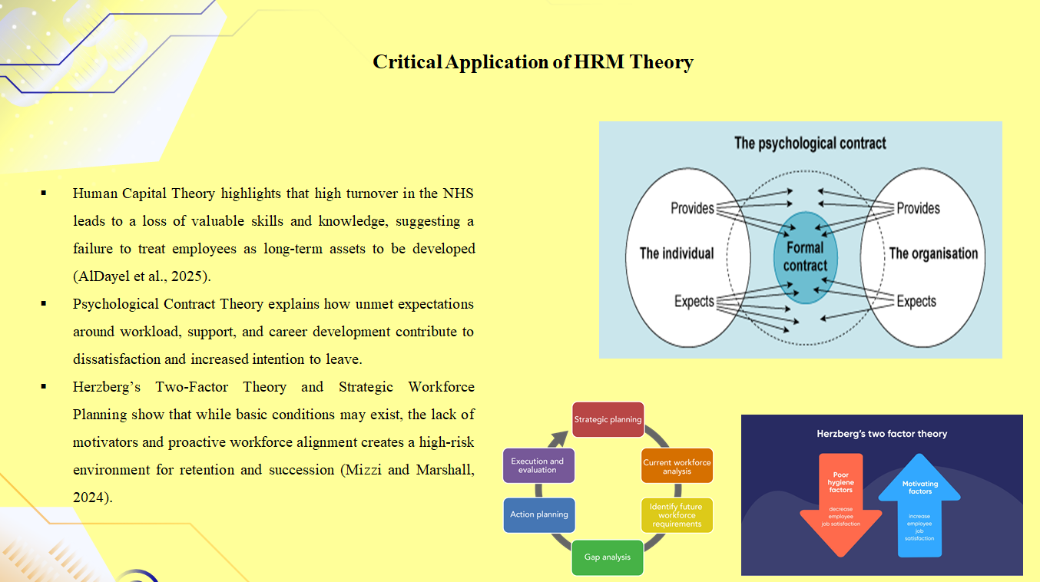
The application of the HRM theory gives a clearer insight into these challenges. Human Capital Theory places an emphasis on the employees being assets and their skills and knowledge contribute to organisational performance. High turnover in the NHS is a waste of human capital, and it lowers efficiency.
It seems that the NHS has assumed a consumptive strategy about human capital and employees are viewed as a resource to be exploited as opposed to an asset to develop. This is against the precepts of strategic HRM(AlDayel et al., 2025).
The Psychological Contract Theory emphasises the existence of mutual expectations between the employer and the employee. Violation of this contract in the NHS (e.g. unfulfilled promises in relation to workload, support and career advancement) contributes to dissatisfaction and departure.
The Two-Factor Theory, as put forward by Herzberg, also accounts for retention. The hygiene factors e.g. pay and working conditions are not enough, whereas the motivators like recognition and career development are mostly missing. This combined lack of sufficiency provides a turnover environment characterised by high risk(Mizzi and Marshall, 2024).
Lastly, Strategic Workforce Planning theory emphasises the strategy of balancing the workforce strategies to the organisational objectives. The reactive nature of workforce management practised by the NHS shows that the latter has not established the said principle effectively.

Recommendations
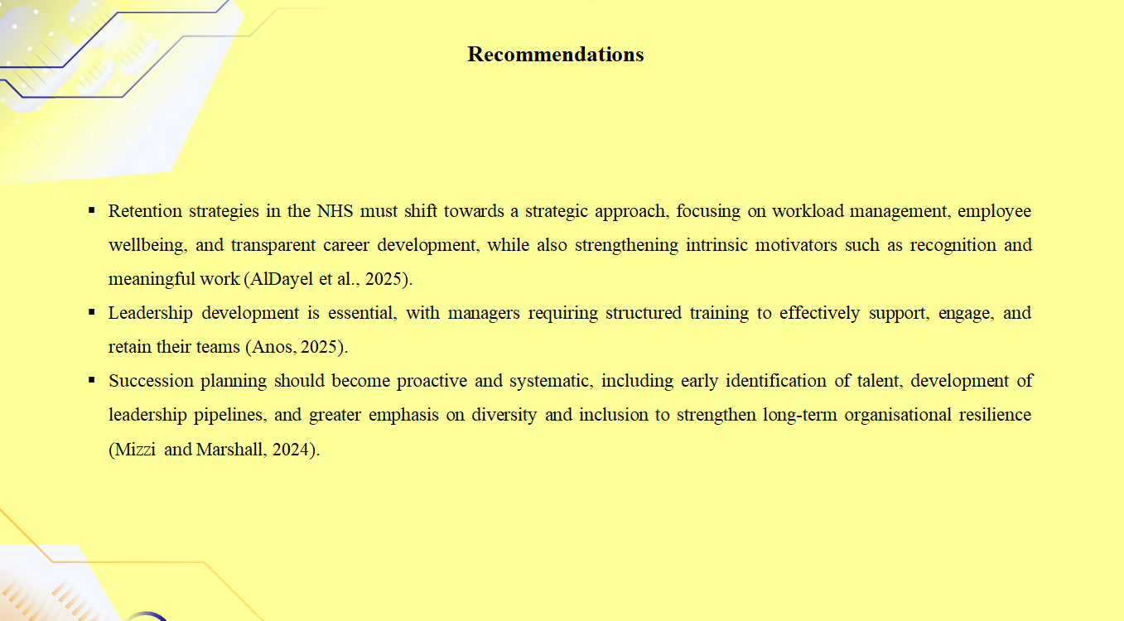
Rethinking Retention Strategies
To overcome retention issues in the NHS, a response to the problem should be changed to a strategic workforce management approach. To start with, there should be workload management. This involves scheduled staffing, better scheduling of the shifts, and the use of technology that decreases the administrative workload(Anos, 2025).
Second, employee well-being must not be viewed as an addition to the organisational strategy, but, instead, be integrated into it. This is achieved through the provision of mental health, fostering work-life balance and a supportive working environment.
Third, the career development pathways should undergo reorganisation to increase transparency and accessibility. The NHS ought to invest in lifelong learning, mentorship schemes, and articulate structures of progression.
Notably, the financial incentives should not apply in the retention strategies anymore. Although competitive remuneration is required, intrinsic factors must also be considered, i.e. recognition, autonomy and meaningful work(AlDayel et al., 2025).
Lastly, there should be the development of leadership. The managers should be prepared on how to engage, support and retain their teams. This necessitates an organised investment in the leadership training and development programmes.
Planning Succession Strategically
The NHS should be proactive and systematic in order to tackle the problems of succession planning. This involves ensuring that high-potential employees are identified at an early stage and are taken through systematic development opportunities(Mizzi and Marshall, 2024).
High-profile positions must have talent pipelines, which would mean that there are people who are talented enough to get the key positions. This is where long-term talent management is necessary against short-term recruitment.
The leadership development programmes must be restructured to emphasise the clinical and managerial competencies. This makes sure that the future leaders are in a position to accept the challenges of healthcare management.
Also, diversity and inclusion should be emphasised during succession planning. Widening access to leadership will increase innovation and decision-making within organisations(AlDayel et al., 2025).

Conclusion
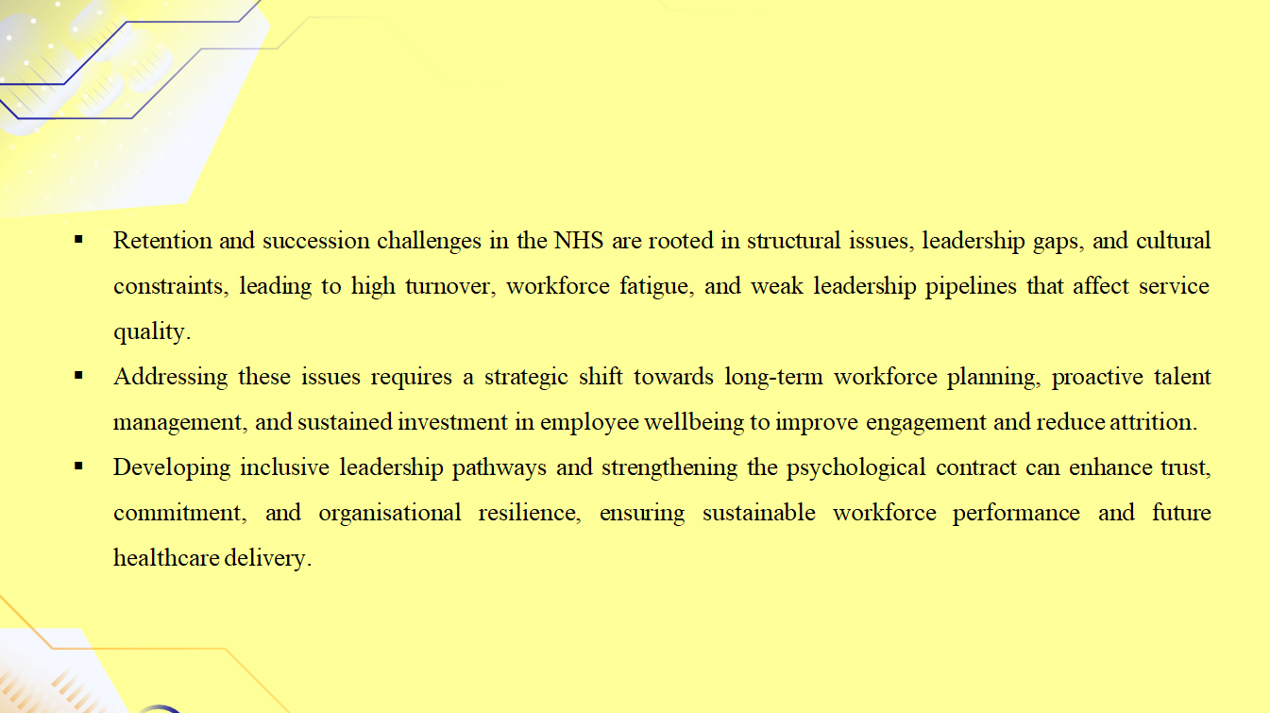
Issues of succession and retention in the NHS are more structural, including leadership deficiencies and cultural constraints, than a single HR issue. Reactively handling staff is evidenced by high staff turnover, chronic workforce fatigue and underdeveloped leadership pipelines. The problems undermine continuity of care, organisational performance, and the capacity to effectively respond to the increasing healthcare requirements. An effective change is hence required, which puts emphasis on long-term workforce planning, active talent management and strategic investment in employee wellbeing to lower attrition rates and boost employee engagement.
The same can be said about the establishment of inclusive leadership lines to identify and nurture high-potential staff in order to have a pool of future potential leadership. By streamlining the HR practice in the organisation and making the psychological contract stronger, the NHS can foster commitment, trust, and loyalty to the organisation. Improved retention and succession models will be one of the keys to maintaining the standards of services, keeping the ethical view of the workforce intact and looking at the issue of healthcare through the prism of the long-term perspective.

References
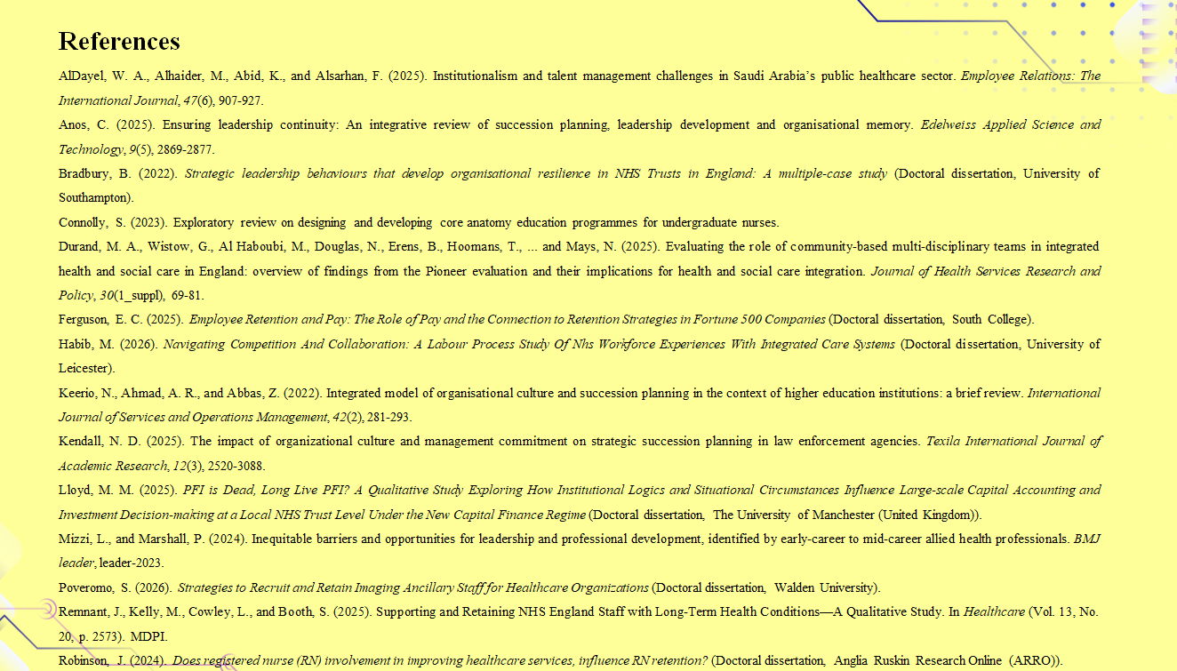
AlDayel, W. A., Alhaider, M., Abid, K., andAlsarhan, F. (2025). Institutionalism and talent management challenges in Saudi Arabia’s public healthcare sector. Employee Relations: The International Journal, 47(6), 907-927.
Anos, C. (2025). Ensuring leadership continuity: An integrative review of succession planning, leadership development and organisational memory. Edelweiss Applied Science and Technology, 9(5), 2869-2877.
Bradbury, B. (2022). Strategic leadership behaviours that develop organisational resilience in NHS Trusts in England: A multiple-case study (Doctoral dissertation, University of Southampton).
Connolly, S. (2023). Exploratory review on designing and developing core anatomy education programmes for undergraduate nurses.
Durand, M. A., Wistow, G., Al Haboubi, M., Douglas, N., Erens, B., Hoomans, T., ...and Mays, N. (2025). Evaluating the role of community-based multi-disciplinary teams in integrated health and social care in England: overview of findings from the Pioneer evaluation and their implications for health and social care integration. Journal of Health Services Research and Policy, 30(1_suppl), 69-81.
Ferguson, E. C. (2025). Employee Retention and Pay: The Role of Pay and the Connection to Retention Strategies in Fortune 500 Companies (Doctoral dissertation, South College).
Habib, M. (2026). Navigating Competition And Collaboration: A Labour Process Study Of Nhs Workforce Experiences With Integrated Care Systems (Doctoral dissertation, University of Leicester).
Keerio, N., Ahmad, A. R., and Abbas, Z. (2022). Integrated model of organisational culture and succession planning in the context of higher education institutions: a brief review. International Journal of Services and Operations Management, 42(2), 281-293.
Kendall, N. D. (2025). The impact of organizational culture and management commitment on strategic succession planning in law enforcement agencies. Texila International Journal of Academic Research, 12(3), 2520-3088.
Lloyd, M. M. (2025). PFI is Dead, Long Live PFI? A Qualitative Study Exploring How Institutional Logics and Situational Circumstances Influence Large-scale Capital Accounting and Investment Decision-making at a Local NHS Trust Level Under the New Capital Finance Regime (Doctoral dissertation, The University of Manchester (United Kingdom)).
Mizzi, L., and Marshall, P. (2024). Inequitable barriers and opportunities for leadership and professional development, identified by early-career to mid-career allied health professionals. BMJ leader, leader-2023.
Poveromo, S. (2026). Strategies to Recruit and Retain Imaging Ancillary Staff for Healthcare Organizations (Doctoral dissertation, Walden University).
Remnant, J., Kelly, M., Cowley, L., and Booth, S. (2025). Supporting and Retaining NHS England Staff with Long-Term Health Conditions—A Qualitative Study. In Healthcare (Vol. 13, No. 20, p. 2573).MDPI.
Robinson, J. (2024). Does registered nurse (RN) involvement in improving healthcare services, influence RN retention? (Doctoral dissertation, Anglia Ruskin Research Online (ARRO)).

