

Applied Leadership and Management in the Workplace Module Assignment Submission

Student Name: | Tomasz Paczkowski
Student Number: | 2018054
Module No: | BMSK4012
Module Title: | Enterprise and Intrapreneurship

Tomasz Paczkowski
Business Plan for breakfast bar.

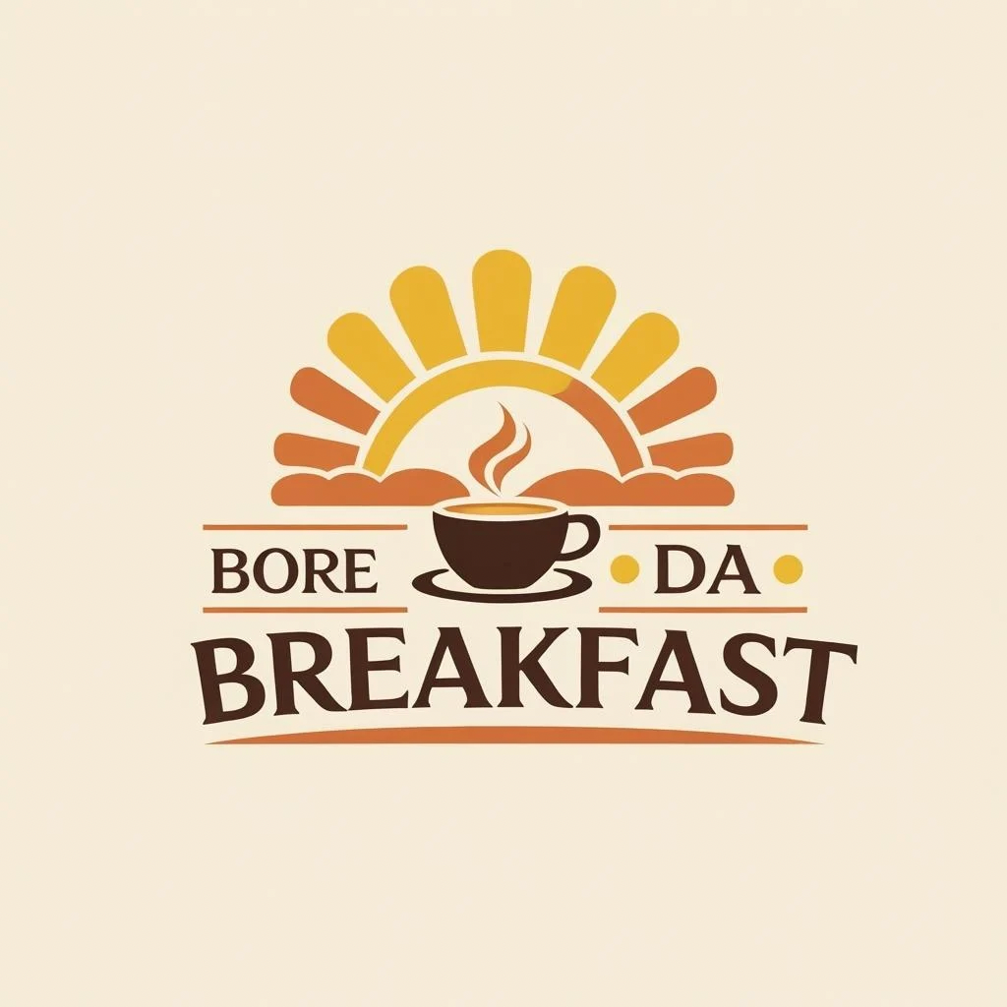

Table of Contents

- Executive Summary
1.1 Overview of Bore Da Breakfast
1.2 Unique Selling Point
1.3 Target Market
1.4 Financial Goals and Projections
- Introduction
2.1 Business Idea
2.2 Legal Status
2.3 Owner and Management Team
2.4 Product / Service Offering
- Financial Information
3.1 Revenue and Profit Projections
3.2 Monthly Profit & Loss Forecast
3.3 Break-even Analysis
3.4 Target Sales and Capacity
3.5 Sustainability Goals
- Marketing
4.1 Marketing Strategy
4.2 Unique Selling Point (USP)
4.3 PEST Analysis
4.4 SWOT Analysis
4.5 Competitor Analysis
4.6 Market Segment and Target Audience
4.7 Market Size and Reach
4.8 Marketing Objectives
- Revenue and Pricing Strategy
5.1 Pricing Approach
5.2 Example Menu Prices
5.3 Income Streams
5.4 Revenue by Stream
5.5 Pricing Flexibility
5.6 Adjustments and Inflation

- Operations
6.1 Location and Premises
6.2 Equipment Requirements
6.3 Staffing Plan
6.4 Suppliers
6.5 Daily Operations
6.6 Health, Safety, and Legal Compliance
- References

Executive Summary
Bore Da Breakfast is a modern, locally inspired breakfast café located in Swansea city centre, aiming to become the go-to destination for both residents and visitors seeking high-quality, freshly prepared morning meals. The business combines a warm, welcoming atmosphere with a menu that honours Welsh produce, including local free-range eggs, Welsh rarebit, traditional bara broth, and coffee.
Our unique selling point (USP) lies in blending traditional Welsh culinary elements with a modern café experience. We will offer dine-in and takeaway services to a wide range of customers — from morning travellers and students to tourists exploring Swansea Bay.
The business will operate as a sole partnership with the potential to transition to a private limited company (Ltd.) as the business grows. Within the first year, we aim to achieve a turnover of £120,000, based on realistic projections of serving 60–80 customers per day at an average spend of £5–£6.
Marketing efforts will focus on establishing a strong local existence through social media, partnerships with nearby businesses, and a loyalty program to attract repeat customers. With Swansea’s growing tourism sector and lively local community, Bore Da Breakfast is strategically positioned to make the most of both the breakfast and brunch trend, aiming for a break-even point within the first 6 months of operation.
In the long term, Bore Da Breakfast aims to become a recognized local brand with potential for expansion into multiple sites across South Wales. The business will reinvest profits into staff training, community partnerships, and menu development to ensure continued relevance and customer loyalty.

2. Introduction
Business Idea
Bore Da Breakfast is a locally owned breakfast café based in the heart of Swansea, UK. The business aims to offer a exceptional and true breakfast experience rooted in Welsh culture, focusing on high-quality, locally sourced ingredients and warm, friendly service. The café will serve traditional and modern breakfast, from full Welsh breakfasts and vegetarian options to grab-and-go items like breakfast baps, pastries and coffee. With increasing demand for early dining and open takeaway options, Bore Da Breakfast seeks to tap into a growing market of breakfast consumers in tourist-rich areas.
Legal Status
The business will be established as a partnership between the owners — Tomasz Paczkowski and Sylwia Paczkowska — under UK law. This structure allows for shared decision-making, joint liability, and flexible contributions to management and operations. A formal partnership agreement will be prepared to specify each partner's responsibilities, profit-sharing ratio, and conflict resolution procedures. As the business grows, the partners may look at transitioning to a private limited company (Ltd.) to enable expansion, protect personal assets, and attract future investment.
Owner and Management Team
The business will be owned and operated by Tomasz Paczkowski and Sylwia Paczkowska, who brings experience in kindness, business planning, and customer service. Initially, the owners will supervise all aspects of operations including sourcing, menu design, staff hiring, and customer service. As demand grows, additional staff will be recruited, including a full-time chef, part-time kitchen assistant, and two front-of-house employees. In the medium term, an operations manager will be appointed to support strategic planning and daily oversight.
Product / Service Offering
Bore Da Breakfast will offer:
- Full Welsh breakfasts (meat and vegetarian options)
- Breakfast baps, rolls, and toasties
- Pastries and baked goods (e.g., croissants, bara brith)
- Freshly brewed coffee and teas (including Welsh Brew Tea)
- Fresh juices and smoothies
- Weekend specials and limited-time seasonal menu
Both dine-in and takeaway services will be available. The café will be open 7 days a week from 7:30am to 2:30pm, capturing both early commuters and mid-morning brunch traffic.
3. Financial Information
3.1 Revenue and Profit Projections
Based on a 7-day-a-week operation (7:30am – 2:30pm), we project an average of 60–80 customers per day, with an average spend of £5.50 per person. That results in an estimated monthly turnover as follows:
Metric | Conservative Estimate | Ambitious Estimate
Avg. Daily Customers | 60 | 80
Avg. Spend per Customer | £5.50 | £5.50
Daily Revenue | £330 | £440
Monthly Revenue (30 days) | £9,900 | £13,200
Annual Revenue (12 months) | £118,800 | £158,400

3.2 Projected Monthly Profit & Loss (based on conservative estimates)
Item |  | Amount (£)
Monthly Revenue |  | 9,900
Expenses:
Rent |  | 1,200
Utilities (gas, water, elect) |  | 300
Ingredients / Supplies |  | 2,000
Staff Wages (2 PT + 1 chef) |  | 3,200
Insurance |  | 150
Marketing |  | 200
Miscellaneous |  | 250
Total Expenses |  | 7,300
Net Monthly Profit |  | 2,600
Net Annual Profit | 31,200

3.3 Break-Even Analysis
Fixed Monthly Costs: approx. £4,100
(includes rent, utilities, insurance, minimal staffing)
Contribution per Customer:
- Average sale: £5.50
- Variable costs per customer (ingredients + disposables): ~£2.00
- Contribution margin: £3.50
Break-Even Point:
- £4,100 / £3.50 = 1,172 customers/month
- That’s about 39 customers per day to break even
3.4 Target Sales and Capacity
Target | Figures
Break-even customers/day | 39
Comfortable living (target) | ~60 customers/day
Maximum capacity | 100 customers/day (seating + takeaway)
A sensitivity analysis indicates that if average customer spending falls to £5.00, monthly turnover will be reduced to £9,000, lowering net profit to approximately £1,800. Conversely, if average spend increases to £6.00 and footfall improves to 80 customers/day, monthly revenue could reach £14,400.

3.5 Sustainability Goal
To ensure long-term sustainability and growth, the business should aim for:
- Monthly net profit of £2,500–£3,000
- A 10% contingency fund on top of operational costs
- Ability to reinvest £500/month into equipment, training, or expansion

4. Marketing
4.1 Marketing Strategy
Bore Da Breakfast will use a local-first, community-driven marketing approach that blends traditional and digital strategies. Key tactics include:
- Social Media Campaigns: Instagram and Facebook for visual branding, daily specials, and customer engagement.
- Google Business Profile: For visibility in local searches (e.g., “breakfast near me”).
- Local Collaborations: Partnering with Swansea Uni societies, tourism boards, and nearby hotels or Airbnbs.
- Flyers & Launch Offers: Printed menus, loyalty cards, and “first coffee free” coupons at local events or campuses.
- Loyalty Program: A stamp card or digital system offering a free item after 8–10 visits.

4.2 Unique Selling Point (USP)
The café’s USP is its Welsh-inspired breakfast menu made with locally sourced ingredients in a cosy, welcoming environment. The name Bore Da Breakfast (meaning "Good Morning" in Welsh) itself communicates a cultural connection, giving it strong local character and identity.

4.3 PEST Analysis
Factor | Impact on Business
Political | Food safety and hygiene regulations; post-Brexit import considerations; UK small business grants available
Economic | Inflation affecting food costs and customer spending habits; rise in domestic tourism (more people eating out locally)
Social | Increased demand for handcrafted food; support for local businesses; rising vegetarian/vegan trends
Technological | Use of digital loyalty apps, delivery platforms (Just Eat, Deliveroo); social media marketing is essential

4.4 SWOT Analysis
Strengths | Weaknesses
Strong local identity and USP | New brand with no initial customer base
High-quality, locally sourced menu | Limited hours = limited daily revenue
Low start-up overheads (compact size) | No prior brand recognition

Opportunities | Threats

Partnering with local businesses and events | Local competition with more established cafés
Growing interest in breakfast/brunch scene | Rising costs of ingredients and wages

4.5 Competitor Analysis
Competitor | Strengths | Weaknesses
Café 1 | Waterside location, trendy vibe | Expensive; small menu
Café 2 | Trendy aesthetic, great coffee | Lacks traditional breakfast options
Café 3 | Chain reliability, loyalty app | Common offerings; not local
Bore Da Breakfast fills a gap by offering a traditional-yet-modern breakfast spot with local culture and accessible pricing.
Additional competitors in the area include independent cafés such as Café 4, which focuses on vegan options, and Café 5, known for its takeaway-friendly menu. While these offer strong competition, none of them focusing on a Welsh-specific breakfast characteristics, giving Bore Da Breakfast a clear positioning benefit.
Market breakdown will focus on three primary customer groups:
- Students (aged 18–25) looking for affordable, quick breakfast options.
- Young professionals (25–40) seeking premium takeaway coffee and healthy breakfast choices.
- Tourists and families (35+) interested in local experiences and traditional food.

4.6 Market Segment and Target Audience
- Students (Swansea University and UWTSD)
- Commuters (weekday early risers looking for takeaway)
- Tourists (visiting Swansea city and the Gower)
- Residents (families and weekend breakfast seekers)
Demographics: Ages 18–45, mid-income, trend-conscious, generally interested consumers who value quality, service, and local products.

4.7 Market Size and Reach
Swansea has a population of over 240,000, with over 20,000 students and thousands of tourists visiting each month (especially in spring and summer). Our residential area (within walking distance from the city centre) gives access to an estimated 5,000–10,000 potential weekly customers, of which we aim to capture 2–3% initially.

4.8 Marketing Objectives
- Attract 500 unique customers/month by month 3
- Grow Instagram following to 1,000 within 6 months
- Reach 30% repeat customer rate by end of Year 1
- Collaborate with 5+ local businesses within the first year
- Launch student discount scheme by month 2

5. Revenue and Pricing Strategy
5.1 Pricing Approach
Pricing at Bore Da Breakfast is designed to balance affordability with profitability. The strategy is based on:
- Cost-plus pricing: Prices are set by calculating the direct cost of ingredients and applying a markup of 150–250% depending on the item.
- Competitor benchmarking: Pricing is aligned with local competitors such as Coffee #1 and independent cafés but provides better value through portion size and local quality.
- Psychological pricing: Items are priced just below whole numbers (e.g., £4.95 instead of £5.00) to improve customer perception.

5.2 Example Menu Prices
Item | Price (£)
Full Welsh Breakfast | 8.95
Vegetarian Breakfast | 7.95
Bacon or Sausage Bap | 4.25
Croissant / Pastry | 2.20
Bara Brith Slice | 2.50
Cappuccino / Latte | 2.80
Welsh Brew Tea (pot) | 1.80
Orange Juice / Smoothie | 2.50

Average per customer spend: £5.50

5.3 Income Streams
Revenue Stream | Description | Est. Monthly Revenue
Dine-In Sales | Breakfasts, drinks, pastries | £6,000–£8,000
Takeaway Orders | Grab-and-go items, coffee, baps | £2,000–£3,000
Weekend Brunch Specials | Premium dishes, upsell items | £800–£1,000
Loyalty Programme Repeat Sales | Return customers + offers | Included above
Seasonal Specials / Events | Holiday menu items, themed days | £200–£500

5.4 Revenue by Stream Example
Based on the conservative estimate of £9,900/month:
Stream | Approx. % of Revenue | Value (£)
Dine-In | 65% | 6,435
Takeaway | 25% | 2,475
Specials / Seasonal | 10% | 990
Total | 100% | £9,900

5.5 Pricing Flexibility
- Off-Peak Offers: 10% off between 7:30–9:00am to drive early traffic.
- Student Discount: 15% off with valid student ID.
- Bundled Deals: Breakfast bap + coffee for £5.95, or brunch combo meals.

5.6 Adjustments and Inflation
Prices will be reviewed quarterly and adjusted based on:
- Ingredient cost fluctuations
- Customer feedback and sales data
- Competitor pricing trends

6. Operations
6.1 Location and Premises
Bore Da Breakfast will operate from a small, leased premises located near Swansea city centre, ideally within walking distance of key footfall areas like the train station, student accommodation, or the high street. The space will accommodate:
- Indoor seating for 20–25 customers
- A compact kitchen and prep area
- Takeaway counter with self-service station
- Accessible toilet facilities (as required by law)
Premises will be chosen for high foot traffic, morning sun exposure (to enhance ambience), and good visibility for branding.

6.2 Equipment Requirements
Equipment | Estimated Cost (£)
Commercial espresso machine | 2,000
Griddle / grill | 1,500
Refrigerator & freezer units | 1,200
Food prep counters + sink units | 800
Toasters, kettles, microwaves | 500
Crockery, utensils, glassware | 600
EPOS (till + software) system | 1,000
Seating, tables, and decor | 1,800
Total Setup Cost (Est.) | £9,400

Most equipment will be purchased outright or financed via small business loan schemes available for start-ups.

6.3 Staffing Plan
Initially, the café will be run by the two co-owners, with the following part-time staff:
Role | Hours per Week | Wage Rate (£) | Monthly Cost
1 Part-time Chef | 30 | 12.00 | ~£1,440
1 Kitchen Assistant | 20 | 10.50 | ~£840
2 Front-of-House (shared shifts) | 30 total | 10.50 | ~£1,260
Total Staff Cost (est.) |  |  | £3,540

6.4 Suppliers
Key suppliers will include:
- Local butchers and farm shops (eggs, meat, milk)
- Welsh bakeries for pastries and bara broth
- Coffee roasters (ideally local or regional)
- National wholesalers (for dry goods, cleaning supplies)
Importance will be placed on sourcing fresh, ethical, and local products to support regional business and strengthen the brand identity.

6.5 Daily Operations
- Opening Hours: 7:30am to 2:30pm, 7 days a week
- Preparation: Food prep begins at 6:30am
- Ordering System: In-person, phone-in orders, and possible integration with food delivery platforms (e.g. Just Eat)
- Service Time: 5–10 minutes per order for dine-in, 3–5 minutes for takeaway
- Payments Accepted: Card, cash, and digital (Apple Pay, Google Pay)
Daily responsibilities will include opening procedures, stock checks, cleaning schedules, staff rotation, and order logging. Weekly reviews will address stock, revenue, and customer feedback.

6.6 Health, Safety, and Legal Compliance
The café will comply with all UK legal and safety requirements, including:
- Food hygiene rating system (FSA) — goal: achieve a 5-star rating
- Risk Assessments (HACCP) to ensure food safety
- Employer’s liability insurance, public liability insurance, and food business registration
- Fire safety and equipment certification
- COSHH regulations for cleaning products
- Staff will receive Level 2 Food Hygiene Training before opening
Regular audits, staff refreshers, and professional pest control inspections will be scheduled to maintain compliance and public trust.
The café will use a digital point-of-sale (POS) system integrated with inventory management software to track sales trends, reduce waste, and reorder supplies efficiently.
Customer feedback will be collected through comment cards and online reviews, monitored weekly to identify trends or service issues. Positive reviews will be featured in social media content to build visibility.
Sustainability will be built into operations from the start, using recycle and ecofriendly takeaway container, reusable plates for dine-in customers, and sourcing from local producers to reduce transport emissions. Leftover food will be minimised through accurate prep forecasting and by partnering with local food-sharing apps, helping to reduce waste while inviting budget-aware customers.

7. References (APA 7th Edition Style)

British Business Bank. (2024). Business finance guide: A journey from start-up to growth. https://www.british-business-bank.co.uk/finance-hub/
Business Wales. (2023). Start a food business. Welsh Government. https://businesswales.gov.wales/foodanddrink/start-food-business
Food Standards Agency. (2023). Starting a food business: What you need to do. https://www.food.gov.uk/business-guidance/starting-a-food-business
HM Revenue & Customs. (2023). Self-employment and partnerships: What you need to know. https://www.gov.uk/set-up-business
Mintel. (2023). UK Foodservice Market Report: Breakfast & Brunch Trends. Mintel Group Ltd.
Office for National Statistics. (2024). UK consumer spending by category. https://www.ons.gov.uk
Swansea Council. (2023). Food business registration and safety. https://www.swansea.gov.uk/foodsafety
Statista. (2024). Average daily coffee consumption per person in the UK. https://www.statista.com
Visit Swansea Bay. (2023). Tourism and economic impact report. Swansea Council. https://www.visitswanseabay.com
Welsh Government. (2023). Supporting local food businesses and sustainability. https://gov.wales/local-food-strategy

