Skills for the Work Place
Module: ‘Critical Analysis of Management theories relevant to workplace’
Module code: BMSK5001

Student name: Musammot Sima (1705525)
Organisation: University of Wales Trinity Saint David
Lecturer: Shehla Khan
Submission date: 11th January 2019

Introduction:
In any organisation their main mission is to be the champion for customers, providing them with the best quality of products and for them to enjoy. Customers want great products with great value which they can purchase easily, and it is the organisations job to deliver them in the best and appropriate way. It is necessary for any organisation to have decent values, attitudes and beliefs in the workplace to get the best out of the employees.

Task a)
Critically analyse the impact of values, beliefs and attitudes in the workplace.
How beliefs, attitudes and values impact on own workplace behaviour is critically assessed using a relevant theoretical model(s) or technique(s) to make a detailed judgement.
Value:
Values of any organisation is the main code by which the company functions. While no organisation can control the activities of every member of staff. It defines the expectations and how to develop the procedures for any violations. Many companies have familiar areas of focus when it comes to values in workplace. This consists of honesty, respect caring and reliability. Values should be defining in an organisations mission statement or policies. Values connected to the attitudes of the organisation. Personal value should link into the organisations values. For example; when applying for a position it is necessary to investigate the organisations value to see if it matches your own values so then it benefits both the organisation and individual. (Leonard, 2018).
Attitude:
Attitude is a way how people express or applies their values towards their actions as well as a way of thinking or feeling about certain things with a certain state of mind at the time. Attitude in the workplace comes in four different headings;
- work situation; the attitude towards the actual job. For example; pay, co workers or working state etc.
- Personality; the way an employees attitude is in the first place. The right person whose attitudes fit in with the co-workers in the organisation is their main personality.
- Values; this is something that comes out whilst completing a job. The attitude towards the main standard of a job.
- Social Influences; this depends how the employees and managers attitudes are like. It is like comparing with others. So, if another worker is not working hard, it automatically comes in yourself that why should I work harder, this will cause the attitude as well as behaviour not working hard enough. (Myorganisationalbehaviour, 2011).
Belief:
Beliefs connects to the values as well as the attitudes. Beliefs are things that can be holding to be true. From beliefs comes attitudes. Beliefs are effective as they effect the attitude in yourself. Behind every step taken, decision making, or communication are beliefs. Some beliefs are more charges than others as they carry emotional content. Often this can be due to things not being completed to your own way. Some beliefs change due to circumstances and some good or bad beliefs stay to the mindset. (Tolle, 2011).
It is important to critical think whilst dealing with values, beliefs and attitudes in a workplace. Critical thinking is a skill to think clearly and reasonably. It concludes to engage in reflective and solo thinking. A good critical thinker can understand the reasonable connections between ideas, identity and evaluating arguments etc. there are different critical thinking methods which help to analyse situations. (Hancock, 2014).
Some are mentioned below:
To critically analyse Toulmin’s model will be applies. The Toulmin model is a six-part model of argument which was first introduced by a British philosopher Stephen Toulmin. It was first mentioned in his book – “The uses of Argument” (1958). This model is used as a tool for developing, analysing and categorizing arguments. This model consists of six components of arguments;
Claim: A statement that something is so.
Data: The backing for the claim.
Warrant: The link between the claim and the grounds.
Backing: Support for the warrant.
Modality: The degree of certainty employed in offering the argument.
Rebuttal: Exceptions to the initial claim. (Nordquist, 2018.)

There is another critical thinking model which is known is Pearson’s RED critical model. it layers a way for understanding how critical thinking works and especially for developing every important skill.
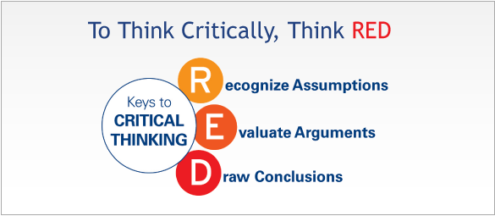

Recognising assumptions; this is a way to separate truths from opinions. Noticing assumptions helps to show any less information or unknown logic. When getting information together, it is necessary to listen to what people say in a situation, at this point it is important to know what your own assumptions are going to be; it might be a situation where a trusted employee is sharing reliable information, but it is necessary to see if there is back up to it.

Evaluate argument; the way to evaluate arguments consists of analysing information accurately, acknowledging the quality of the evidence and understanding how emotion is connected to the situation. Popole tend to rapidly conclude simply to avoid conflict but being able to persist calm and sort the argument with different position of help from people will draw more precise conclusions. There are many problems in workplace which cause conflict because emotion get in the way or sometimes only whatever is needed to be heard is heard. It is necessary to keep the conflict aside and to analyse information correctly and calmly.

Draw conclusions: people who enjoy the skill to draw conclusion can carry diverse knowledge together to get to the end which logically follow from enough evidence and do not unsuitably oversimplify beyond the evidence. They are known to have a good judgement as this lets them to make a quality decision. When thinking critically the actual situation is clear and by drawing to conclusion makes the tough decision easy to solve. (thinkwatson.com 2019).

Tesco’s value, attitudes and beliefs:

Values in a workplace are recognised at the helm of the organisation. The values of a business are the ethical code by which the business functions. it should be defining in an organisation by law, mission statement and policies. (Maund, 2018).
As looking into Tesco, they welcome everyone. This is a way of informing the employees and customers what they take on. They take equality, diversity and inclusion seriously. This indicates that whoever you are, wherever you work and whatever you do Tesco wants the employees to feel welcome. When an employee goes into work, they will find that there are many things in common with other colleagues, but perhaps there might be some differences as well. as there are different people working in the organisation, they tend to reflect to the community they serve including town, city, village and street. This concludes that every employee must be committed to treat each other with respect even where there might be different point of views or something that might not have been in their belief or value before. In fact, all employees are all unique with their own value, belief and attitudes. Even though they might differ but there are some differences that can be seen, and some others are hidden. There are certain examples which differ that can be seen; hair colour, age, gender, eye colour, ethnicity or some disabilities etc. now there are ways of differences which cant be seen, for example; religion, values, beliefs (including political beliefs), nationality, sexual orientation etc. the attitude towards all customers from the employees are always to be respectful to the customers as well as the colleagues. This means using the appropriate words both in person or online, for example; on website or any social networks. This is to be aware of not making anyone get offended or upset. It means taking an interest in other people so that they do not feel left out without asking any difficult questions and this also means allowing others to be themselves when they come to work in the company. (Tesco, 2019).
According to Murray, S. (2018), he mentioned on the journal.ie.com that a Tesco worker had been sent home because of how his beard looked. He then was awarded £2.5k following labour court hearing. Even though Tesco has always valued their staff as well as customers at some certain times things do change. The man had always maintained his beard by keeping it neat and tidy and according to Murray he should not have been suspended. The Tesco worker was alleged being bullied and harassed at work and even been sent home because of how is beard was. He resisted with the behaviour of the management team towards him as it was getting deteriorated over time even though he said he always kept his beard neat. He was suspended without being paid for four months over his beard. Tesco has always kept a respectful relationship with the employees as well as equality, diversity and inclusion seriously. the mans mother wrote to the CEO of Tesco on two occasions to complaining about how his son was being treated. The man’s union took the position that management “began a vendetta against him because he had a beard”, which ultimately resulted in the suspension.
According to the report from Murray, there was reference made to an alleged event where a manager poked the employee with his finger, as well as having his hours cut. In the report to the labour court there was a submission that a beard net was not provided and when he bought one himself, then he was not allowed to wear it. But according to Tesco’s response over a three-year working period the employee was asked to attend meetings to discuss his appearance, his performance, his work role, him leaving work early and his uniform as well as holidays but he would not attend the meetings. (Murray, 2018).
Following the letter from the man’s mother, the grievance procedure concluded the man’s beard “did warrant management taking issue with his appearance and they were entitled to discuss same with him but said this ongoing issue was made more difficult because the store was unable to order a beard net”. (Murray, 2018).
The employee appealed the result of the investigation personally and internally, but it was then found that he had been sent home because of his beard even though after all the bullying etc. according to Tesco his beard was not neat and with the expectation of the company. In the case before the Workplace Relations Commission, Tesco had submitted that it would take several measures to support the man in returning to work from sick leave. The WRC judge ruled; “in relation to the beard incident and being sent home I believe management could have managed this situation in a timelier manner and feel that sending him home without pay was a punitive action.” (Murray, 2018).
According to the court they even stated that the loss of earning was obvious, and they still recommend a compensation payment to the employee of £2,500. The most important statement by the adjudicator was the main aspect of this recommendation was that the employee aims to put this matter behind him and focus back in getting into work. The man subsequently referred the case to the Labour Court. It upheld the recommendations of the WRC adjudicator. It stated; the worker should actively and regularly communicate with the employers in relation to his return to his workplace and should also follow the policies and values in relation to holidays. It had been recommended that Tesco should pay the employee the sum of £2.500 compensations in recognition of the fact that the beard issue could have handled in a timelier fashion. (Murray, 2018).
In Tesco’s managements opinion they have experienced many different people with different commitments towards work. They might have different attitudes which can cause issues like this. As looking into Tesco, they welcome everyone. This is a way of informing the employees and customers what they take on. In my opinion there are both positive and negative sides to the values, beliefs and attitudes in the workplace from both sides the organisation and the employees. Certain rules from Tesco does make the employees work well and some make them change their attitude and not be interested in their work routine and role in the organisation. (Tesco, 2019).
Some employees do not prefer to share ideas and work with something new, so it is nice for them to work as an individual in their own space. In the above case the employee had not been attending meetings, so this had made issues and conflict between the management team and the individual. Employees should have the chance to show ideas or voice their opinion. By not doing so it can demotivate the employees in the long-term working process. The employees can even start to get annoyed at various rules and regulations with the risk of have a bad impact on the organisation as employees might start taking a stand and going on strike. Even in the above case by not talking with each other and not trying to sort out the issue of the beard the company had to make a compensation of £2.500 and it had demotivated the employee to continue with his work.
In general, it is therefore necessary that these types of organisations properly and carefully inform the employees well in advance about their system of working and requires them to work along. Only those who agree are suitable to work in such an environment. Tesco continues to hold its leadership position with high stage in the retail industry. The core competencies of Tesco have been aligned with the business environment, hence highlighting a bright positive future for the company. (Ivoryresearch.com, 2019).

Task b)
Identify a management theory relevant to your role and critically assess its impact on your own beliefs, attitudes and values.
There are many types of management theories available that shows how it is useful for an individual and different organisation. Here are a few mentioned that have been used in different organisations. For example; Max Weber’s, theory of management called bureaucratic theory, Elton Mayo’s Hawthorne theory and many more.
Management is the art, or science, of achieving goals through people. Through management theories it is proven that managers are expected to have greater productivity and continuously receiving improvement. Management is the process of designing and matching an environment in which all individuals, working in teams and efficiently fulfil selected goals. (Koontz, Heinz, 1990, p.4). Management can be expanded in different forms; firstly, as managers, people undertake the managerial function of planning, organising, leading and controlling. Secondly, management applies to any big or small organisation. Thirdly, management applies to managers to all organisational levels. Fourth, the main target for all managers is the same, to create and find out extra whilst managing any concern with productivity – this suggests efficiency. All managers refer to the development of bureaucracy that derives its necessities from the need for planned planning and monitoring the hard and large decision-making stages. (Olum, Dr. Y, 2004).
Elton Mayo:
TESCO
The behavioural theory is the Elton Mayo. The management theory is known as the Hawthorne theory. The Hawthorne studies attempted to determine the effects of lighting on worker productivity. Motivation have internal and external feature that stimulates desire and energy in employees to be constantly interested and focused to a job or to make the effort to achieve a goal. In the early 1930’s the theorist Elton Mayo suggested that motivation at work can be promoted by different factors like; greater communication, good teamwork, showing interest in others and ensuring the wellbeing of others etc. (Olum, Y, 2004).
Mayo (1933, 1945) pointed out that it was necessary to consider the whole person on the job, he believed that because there was a change in the routinization of tasks brought about by the industrial revolution had served to massively reduce the possibility of finding satisfaction in the task itself. Because of this change the employees would begin to seek satisfaction elsewhere. There was a critic thinking that failure to treat workers as human can to be regarded as the cause of low morale, poor management and confusion. (Steers, Porter, Bigley, 1976).

Taylor Fedrick:
TESCO
The first management theory is what is popularly referred to as Frederick Taylor’s Scientific Management. Frederick Taylor started the era of modern management. He believed that the workload should be equally shared between management and employees. Taylor’s strongest motive was to break a hard task into several steps and improving the performance of the sub tasks, however his stop watches measured time trails. There are many critics both historical and contemporary have stated out Taylors theory tend to dehumanise the employees.
There is a need to develop a science of work to replace the old rule method which is pay and other rewards linked to achieve the main goals. It measures the work performance of the staff and the management team. According to Taylor’s theory the employees are to be scientifically selected and developed, trained with first class training in certain specific task. The science of work in his theory is to work together to achieve the best results. Finally work and responsibilities should be divided between the workers and management together. (Olum, Dr. Y, 2004).
The theory to motivate shows Taylor said, “One that is motivated works purely for money”.
In Tesco they also have a certain similar link to Taylor’s theory as the organisation have an employee reward which provides the employees with a financial reward packaging to motivate them.
Tesco is the biggest British retailer and is the world’s biggest retailing outlet. The main reason for its growth is because of its workplace, it has a workforce of 552,004 employees. To maintain the growth of the organisation Tesco always must make sure that they have the right staff who are flexible, motivated and aware of the customer needs. Tesco focuses on two groups, their staff and customers to get the motivation by providing them rewards such as staff discount, flexible working etc. (UKessays.com 2017).

According to business case studies at Tesco the Mayo theory has been operating throughout the organisation. As communication is a very highly important factor in motivating employees. This could be undertaken through 1 to 1 meeting with managers and through newsletter and formal structure meetings such as appraisals. the Mayo theory undertakes as this helps the organisation keeping the employees motivated and focused on their job roles. (Businesscasestudies, 2019).

This is a section from Elton Mayo’s theory as Tesco always is up for motivating their staff. Tesco have different opportunities for their staff. For example; increasing pay, they support the varieties of lifestyle of which every individual that are employed by Tesco by using important benefits. For an example; Tesco’s staff may will to serve customers or improve their basic understanding and skills. (UKessays.com 2017).
There are many other factors that take place in motivating a person this can be personal or working lives. To understand the job satisfaction for the staff Tesco does create a good working environment. They expect their employees to feel valued and this then increases the communication and employees are then asked for feedback and their opinions. Tesco being a big organisation they input their time and money into training which follow ups Taylor’s theory and increases the development which enables the staff to understand and increase their skills. For example; at sports direct the organisation create a good working environment as there training provided for working in the till. There are co-workers helping each other to develop the understanding of the business.
As Tesco ask for feedback through surveys, the employees can put their own point of view out and this also provides the staff to get across their views on the job they do. This helps the organisation understand what is needed for the employees to stay motivated and ensuring that they are achieving job satisfaction. (UkEssays, 2017).

As mentioned above Tesco undertakes the management theories from Elton Mayo and Fedrick Taylor. This helps the staff to be motivated in workplace and it gives them the opportunity to communicate freely. According to Mayo’s theory Tesco uses his theory to motivate their employees by using the two-factor theory. For example; this can motivate and empower the employees by using a time-maintained communication method. This can be by giving the employees the right responsibilities which match to their values and beliefs. The great benefit of the management theory is that bigger organisations can become more structured as the employees and the management team will work more effectively.
Douglas McGregor:
AMAZON:
According to the author – (Hadas, 2015). Amazon is such a large organisation where the company would not have lived up to customers’ expectations without the people who love the culture of Amazon and those who tolerate it. However, the owner Bezos’s corporate style is basically an invitation to trouble. Amazon, he once said, is “friendly and intense, but if push comes to shove, we’ll settle for intense.” With that combination, a lot of shove is pretty much guaranteed.

Amazon follows the Douglas McGregor’s theory – The theory X and Y which was discovered in 1960. The good side of the theory is the Theory Y part and the main idea in this part is when the employees naturally want to be the best so that the managers can encourage them to use their skills to the fullest. But then the intense part of the theory is the Theory X. this is the part where there is an assumption that the workers naturally do less than they commit too, so then the managers need to be very careful with the employees with an extensive array of punishment and rewards. (Hadas, 2015)
A pure theory Y method can take place in special conditions, when all employees are dedicated to the given task. According to Reuters Breakingviews columnist unfortunately, Amazon vision does not justify an all Y management style. A retail revolution may have enough demand to keep some Amazon employees working happily through the night. The organisation needs more than friendly theory Y to build the empire. It is a typical organisation. Most management blend Y and X which consists of managers being friendly and supportive but to a certain extent. The workplace is strong but flexible when necessary. The amazon difference is to take both theories to their extreme. For theory Y a difference can, be by hiring and developing the best, never settle into a specific job so then employees can show their potential by changing roles. For theory X the employees should be constantly monitored and assessed. Not just paying a different amount is not the solution. (Hadas, 2015).

in general Amazon is such an organisation where there are lacking to motivate their employees to work harder rather than increasing the financial part is not the solution. They do not tend to change their staffs responsibilities and then the staff get demotivated to work harder. This can cause unnecessary conflict between employees and managers as the job might not be completed in the given time. There are many good and bad reviews on indeed.com where employees complain about the support and push needed from managers.
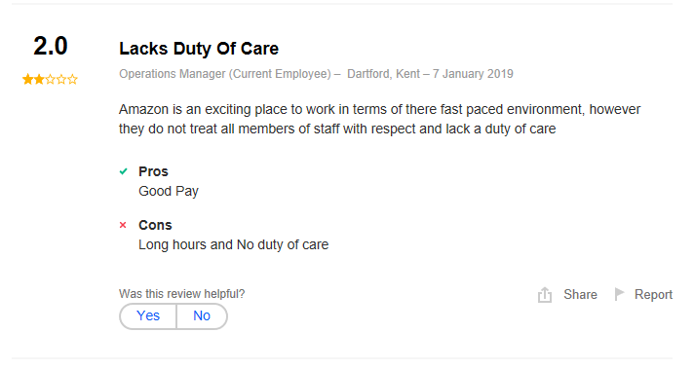 (indeed.com, 2019).
If amazon was to follow the management theory form Elton Mayo it would have helped the organisation in a large amount. This theory would have helped with motivation and communication. In Tesco’s they acknowledge Mayo’s theory and have found different solutions for the staff who are not committed to work. they give them the chance to give feedback to what they need and then managers also take that advice on board if possible. According to the review the managers do not treat everyone with the same value and belief in amazon which causes employees not to be interested in their work.
Max Weber:
AMAZON:
Max weber was unlikely the most leaders today. His most famous theory of management is called bureaucratic theory. This theory means a non-personal of organisation that follows a formal structure, where rules and ability are features of appropriate management practices. There are 10 elements in the definition of max’s bureaucracy theory.
"Precision, speed, unambiguity, knowledge of files, continuity, discretion, unity, strict subordination, reduction of friction and of material, and personal costs – these are raised to the optimum point in the strictly bureaucratic administration," said Weber. (Whimster, 2004).
Where his theory prioritises productivity, it is not essentially the best practice for leaders to undertake. Many of weber’s belief dishearten creativity and collaboration in the workplace and oppose flexibility and risk. There are mainly 4 goals to his theory;
- Clearly defined job roles
- Carefully record keeping
- Hiring based on specific qualifications
- Work appropriate relationships only. (Caramela, 2018).
The theory is displayed in the management in Amazon based on some of the current guidelines for employees. Firstly, bureaucracy is in the way that information is controlled with many management staff who have the authority to speak on behalf of the organisation meaning also that they have a lot of settlement to get any information about Amazon. The great benefit of the management theory is that organisations like amazon can be more structured and employees work more effectively. The stages from this theory makes it easier for management to keep control and make alterations when needed. Policies can be applied without fear. There is no discrimination. (UkEssays, 2017).
Even though amazon undertakes McGregor’s and Weber’s theory there are many reviews where it shows it is still not enough. If comparing with Tesco, amazon has negative reviews, and this is due to them not motivating and communicating with their employees good enough. Not giving them anything enough except for the pay. It is necessary for a workplace to be joyful as well as the management system. Comparing with Tesco they undertake Mayo and Taylor’s theory where motivation and working together as a team is priority. Communication is lacking key in amazon. They do not hold meetings like Tesco and this cause complaints which causes staff to resign. They should follow different management theories for the better for the organisation. This will be beneficial for both the staff and organisations.
Below there is a comparison of both amazon and Tesco with their reviews from the employees: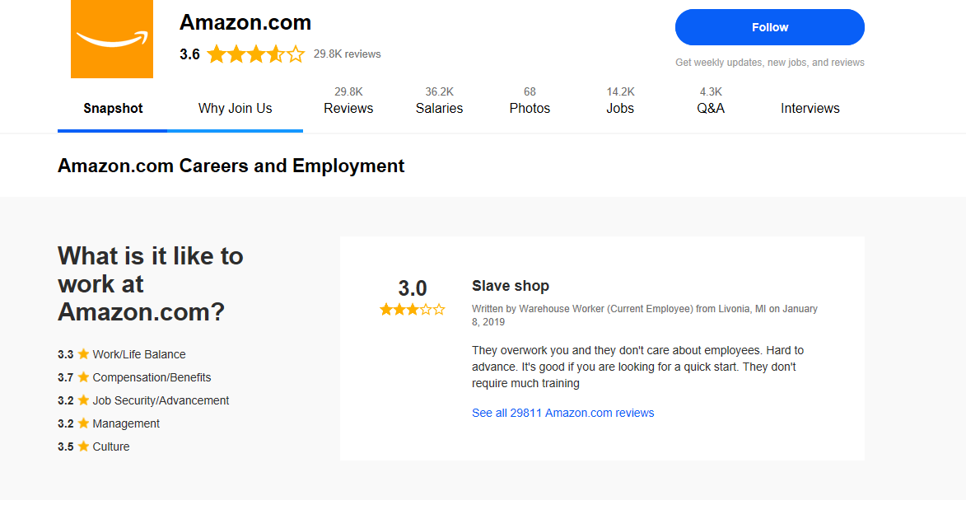
(indeed, 2019).
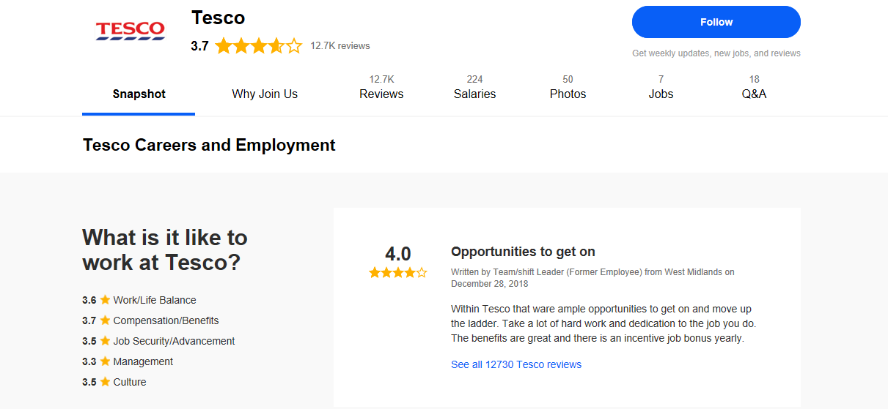
(indeed, 2019).

Conclusion:
Throughout this report, there is different management theories which might be old but still beneficial for the organisations to use and see how it is useful. There is some statements and case studies that show organisations do still need improvements and changes for the betterment not only for the employees but also for the organisation as well as the customers. These models have always had an impact on organisations as it shows how organisations and individuals can improve on their skills and knowledge as well as how to stay motivated in workplace. It shows how it is beneficial for the employer and employee’s.

Reference:
- (2011) Attitude, Available at: http://www.myorganisationalbehaviour.com/attitudes-and-behaviour-in-organisations/ (Accessed: 27th December 2018).
- (2019) Core Purpose and Values, Available at: https://www.tescoplc.com/about-us/core-purpose-and-values/ (Accessed: 2nd January 2019).
- (2019) Employee Reviews, Available at: https://www.indeed.co.uk/cmp/Amazon.com/reviews (Accessed: 6th January 2019).
- (2019) Motivational theory in practice at Tesco a Tesco case study, Available at: http://businesscasestudies.co.uk/tesco/motivational-theory-in-practice-at-tesco/the-mayo-effect.html (Accessed: 7th January 2019).
- (2019) Pearson's RED Critical Thinking Model, Available at: https://www.thinkwatson.com/the-red-model/red-critical-thinking-model (Accessed: 05th January 2019).
- (2019) Tesco supermarket: SWOT, PESTEL, Porter’s Five Forces and Value Chain, Available at: https://www.ivoryresearch.com/samples/business-essay-example-tesco-swot-pestel-porter-five-forces-and-value-chain-analysis/ (Accessed: 31st December 2018).
- Caramela, S. (2018) The management theory of Max Weber, Available at: https://www.business.com/articles/management-theory-of-max-weber/ (Accessed: 19th December 2018).
- Hadas, E. (2015) 'Amazon’s ultra-XY management style', Reuters Breakingviews, 19 August, p. 12.
- Hancock, L.C. (2014) Critical thinking; The Red Model, Available at: https://prezi.com/ppujkiwehfyj/critical-thinking-the-red-model/ (Accessed: 2nd January 2019).
- Indeed (2019) Amazon-Careers and Employment, Available at: https://www.indeed.com/cmp/Amazon.com (Accessed: 9th January 2019).
- Indeed (2019) Tesco-Careers and Employment, Available at: https://www.indeed.com/cmp/Tesco (Accessed: 9th January 2019).
- Koontz, H., Heinz, W. (1990) Essentials of Management, 5th edn., McGraw-Hill: .
- Leonard, K. (2018) Workplace Values & Ethics, Available at: https://smallbusiness.chron.com/workplace-values-ethics-4887.html (Accessed: 28th December 2018.).
- Maund, A. (2018) BA in Leadership and Management Skills for the Workplace Student Yearbook, 1st Year, British Library: Sage Publications.
- Murray, S. (2018) Tesco worker sent home, Available at: https://www.thejournal.ie/beard-tesco-worker-4392916-Dec2018/ (Accessed: 2nd January 2019).
- Nordquist, R. (2018) What Is the Toulmin Model of Argument?, Available at: https://www.thoughtco.com/toulmin-model-argument-1692474 (Accessed: 05th January 2019).
- Olum, Dr.Y. (2004) Modern Management Theories and Practices, Kenya School of Monetary Studies: Makerere University.
- Steers, R.M., Porter, L.W. and Bigley, G.A. (1976) Motivation and Leadership at Work, 6th edn., McGraw-Hill: The McGraw-Hill companies.
- Tolle, E. (2011) The Power of Beliefs at Work, Available at: https://intentionalworkplace.com/2011/05/20/the-power-of-beliefs-at-work/ (Accessed: 30th December 2018).
- UkEssays (2017) Amazon Management Structure, Available at: https://www.ukessays.com/essays/management/amazon-management-structure-6347.php (Accessed: 9th January 2019).
- UkEssays (2017) Tesco’s Management and Leadership Theories, Available at: https://www.ukessays.com/essays/management/tescos-management-and-leadership-theories-management-essay.php (Accessed: 7th January 2019).
- Whimster, S. (2004) The Essential Weber, London Metropolitan University: Max Weber Studies.

