AHHI5017 Contesting Conflict: Representations of War, 1789–Present
Week 10: The Vietnam War
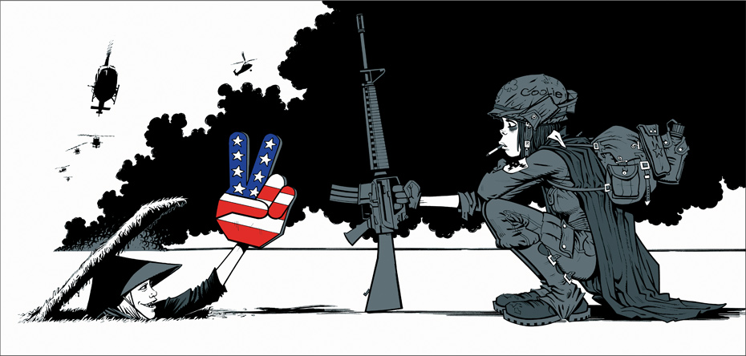
Jamie Hewlett, Big Sponge Finger (2003)
Lectures summary:
This week concentrates on representations of the war between the United States and Vietnam. The role of popular culture and media representations (popular music, film, television news) in structuring American memories of the war is discussed, with emphasis also placed on official commemorative practices. Where this week differs from prior discussions is with the admittance of alternative memories of the war. Students will examine how ‘the American War’ appears a much different conflict when viewed from a Vietnamese perspective.
Monday’s lecture explores the manner in which US military involvement has been remembered as a ‘different war’ in American culture, politics, society and history. This is done, first, through examinations of artistic representations of the war, and, secondly, through discussion of the different features of the Vietnam Veterans Memorial (VV), Washington DC. Here, debates elicited by Maya Lin’s memorial design will be foregrounded, with consideration also afforded to the statues which now accompany ‘The Wall’ at the VVM.
The Friday session too revolves around the notion of Vietnam as ‘a different war.’ This time, however, the lecture looks to assess the extent to which Vietnamese memories of the war differ from those in the United States (and the West more generally). The lecture aims to do two things: a) situate what Vietnamese people refer to (among other terms) as ‘the American War’ within a much longer historical context; and b) to situate contemporary Vietnamese cultural memory of the war within the social, political and economics of 21st-century Southeast Asia. With these overarching themes and concepts established, students will then interpret a variety of commemorative practices and institutions that exist in contemporary Vietnam: from war memorials and cemeteries to the War Remnants Museum and the Củ Chi tunnels in Ho Chi Minh City (formerly Saigon).

Preparing for the lectures:
Having viewed Platoon for Week 9 of the module, students have already had access to one example of a cultural representation of the Vietnam War in the United States. As such, students should be reasonably well-primed to tackle the assigned extracts from A Different War: Vietnam in Art before the Monday lecture (note: these are short chapters consisting mainly of pictures so should not me an onerous read). These extracts also introduce ideas pursued more comprehensively in Marita Sturken’s chapter ‘The Wall and the Screen Memory,’ which looks at the different features of the Vietnam Veterans Memorial, and how it has been interpreted by critics and the general public respectively.
The readings for Friday concentrate on a topic which is likely to be less familiar to students. The shorter James Tatum piece gives an overview of memory if the war in Vietnam itself and probably offers the easier starting point for students. The Christina Schwenkel article does something similar but in a more concentrated (and perhaps more densely academic) fashion. The questions below name the key memorial practices and institutions which will be discussed during the lecture.
It is hoped that these readings, allied to the lecture, will give students a rounded, introductory understanding of memories of the war in North America and Southeast Asia.

Required reading and other preparation:
Monday lecture
- Lucy R Lippard, A Different War: Vietnam in Art (Whatcom Museum of History and Art/Real Comet Press: Seattle, 1990), pp. 10–11, 88–118.
- Marita Sturken, ‘The Wall and the Screen Memory,’ Tangled Memories: The Vietnam War, the AIDS Epidemic, and the Politics of Remembering (University of California: London, 1997), pp. 44–84.
Background reading on Friday lecture themes:
- Christina Schwenkel, 'Recombinant History: Transnational Practices of Memory and Knowledge Production in Contemporary Vietnam,' Cultural Anthropology (Vol. 21, No. 1, February 2006), pp. 3–30.
- James Tatum, ‘An America War Experience,’ The Mourner's Song: War and Remembrance from the Iliad to Vietnam (University of Chicago: Chicago, 2003), pp. 22–32. Excerpt from University of Chicago Press: http://press.uchicago.edu/Misc/Chicago/789934chap1.html; accessed November 25 2015.

Questions to consider:
General
- What representations of the Vietnam War are you familiar with, and what are some of their key characteristics?

- What are some of the key features of how the Vietnam/American War has been represented and remembered in North America and South Asia respectively, and to what extent do they differ from one another?

Lippard, A Different War
- On what basis does Lippard base her assertion that the Vietnam War is considered ‘a different war’ in American politics, history and culture?

- What are some of the notable features of artistic representations of the Vietnam War in the United States, and to what extent do they support Lippard’s claims about its ‘different’ status in American politics, history and culture?

Sturken, ‘The Wall and the Screen Memory’
- How did domestic politics in the United States and wider geopolitics impinge on debates about the Vietnam Veterans Memorial Fund (VVMF)?
- What did discussions about the VVM ‘say’ about American society in the 1980s?

- What were the features of Maya Lin’s design for the Vietnam Veterans Memorial (VVM), and what are your opinions of the memorial?
- What sort of memorial would you say the VVM was/is?
- How does the VVM represent the war and those who died in it?
- Why did some veterans disapprove of Lin’s design?
- How were these objections phrased?
- In what ways would critics have preferred the war to be commemorated?
- What is your opinion of the VVM?

- What additions to the Vietnam Veterans Memorial have been made since the dedication of Maya Lin’s wall, and what are your opinions of them?

- What arguments does Sturken make about issues of race, class and gender in relation to the VVM?

- How else might the war have been memorialised besides the different components of the VVM?

Background reading:
Tatum, ‘An America War Experience,’ and Schwenkel, ‘Practices of Memory and Knowledge Production in Contemporary Vietnam'

- What do Tatum and Schwenkel have to say about the following memorial practices and institutions in contemporary Vietnam:
- Monuments to military battles and Vietnamese victories;
- Memorials to US defeats and atrocities;
- Physical reminders of the war in the rural landscape;
- Physical reminders of the war in the urban landscape;
- Cemeteries and graves dedicated to troops from northern and southern Vietnam;
- The War Remnants Museum, Ho Chi Minh City;
- The Cu Chi Tunnels and Ben Duoc Temple, Ho Chi Minh City?

- What do you understand by the terms ‘recombinant’ and ‘transnational’ used in the title to Schwenkel’s article, and why might they be important for understanding her arguments about contemporary memories of the Vietnam/American War?

