LCHS7009
POPULATION HEALTH AND
DIGITAL HEALTH PROMOTION
COMPONENT 1 | TWO BLOGS
Digital health promotion interventions:
critical evaluation and original design
Student name | Geetha Marimuthu
Student ID number | 2528691
Programme | MSc Public Health and Social Care in Practice
Module | LCHS7009 - Population Health and Digital Health Promotion
Lecturer | Dr Raheela Shaikh
Submission deadline | 23 October 2026
BLOG 1 | GDM-Health: existing digital intervention
BLOG 2 | GDM Compass: proposed digital intervention

BLOG 1 | EXISTING DIGITAL HEALTH PROMOTION TECHNOLOGY

Can GDM-Health improve gestational diabetes care? A critical evaluation
Existing intervention | Digital glucose monitoring in pregnancy
Why does this matter?
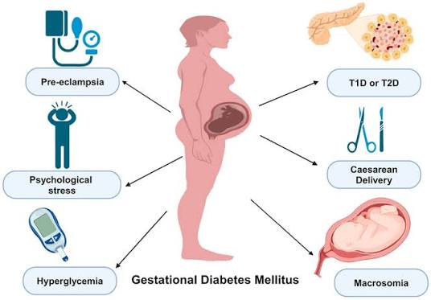
Figure 1: Maternal and fetal complications of gestational diabetes mellitus (GDM).
(Source: Mittal et al., 2025)
Gestational Diabetes Mellitus (GDM) is high blood glucose detected for the first time in pregnancy. NHS England estimates around 30,000 cases amongst 700,000 deliveries per year; 50% of affected mothers may develop type 2 diabetes within five years (NHS England, 2024). Efficient glucose management is essential since uncontrolled GDM poses risks to maternal and newborns' well-being (NICE, 2015).
How does GDm-Health function?
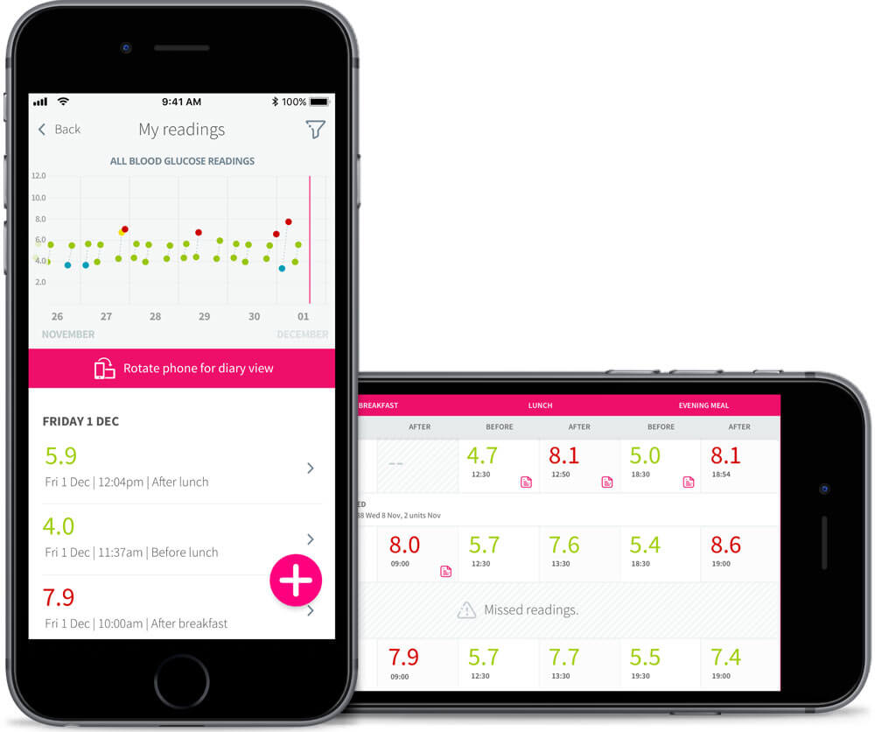
Figure 2: GDM-Health smartphone app and clinical dashboard for remote glucose monitoring.
Source: Building Better Healthcare (2018)

GDM-Health is a digital tool used in NHS pregnancy services. Women enter their glucose readings via an app on their smartphone, link to a compatible meter, leave notes and ask for a callback. Diabetes professionals assess the results remotely and respond when necessary (University of Oxford, n.d.). Frequent remote assessment might reduce travel burden and help to identify trends between consultations, assuming the staff has sufficient capacity to review and respond to the results.
What does the evidence say?
In a randomised trial in the UK, 203 participants used GDM-Health reported glucose levels more frequently and were more satisfied with the intervention than the control group. Still, there was no significant difference in glucose improvement. The rate of caesarean delivery was lower (26.7% vs. 46.1%), whereas other outcomes remained the same; this single-center trial could not prove the benefit in the whole (Mackillop et al., 2018). In a meta-analysis of 27 trials with 3,483 women, mobile-health interventions showed improved glucose control and self-management in general despite different interventions and poor methodological quality (Wei et al., 2023).
Critical judgment and next steps
The advantages include convenient reporting, visualization of the glucose levels and easy communication with the clinician. Still, access to smartphones, language barriers, digital literacy, technical issues and privacy concerns can prevent some users from using the tool. Review also found usability limitations and absence of emotional support (Safiee, Rough and Whitford, 2022). The service must offer translation services, allow alternative methods, protect personal data and maintain face-to-face maternity assessment. Additionally, it is crucial to provide the instruction about urgent glucose readings and assistance in seeking immediate help. The use of GDm-Health does not substitute professional decision-making and face-to-face consultations.
BLOG 1 | VISUAL EVIDENCE AND REFERENCES

GDm-Health: from home readings to clinical support
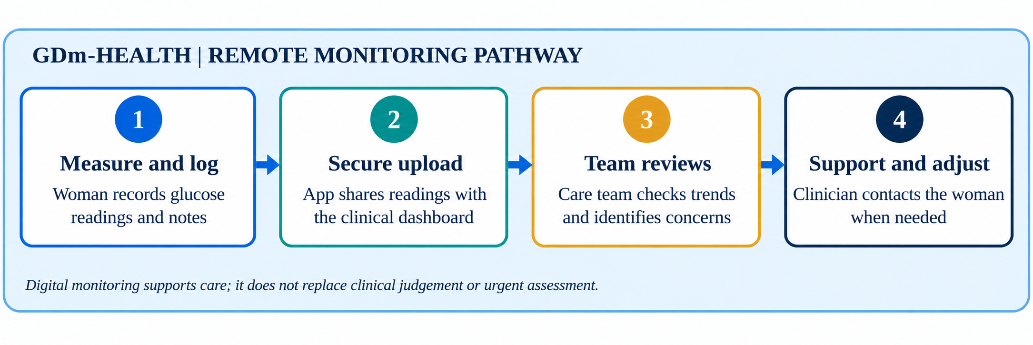
Figure 3. GDM-Health remote-monitoring pathway.
Source: Self-developed illustration, informed by University of Oxford (n.d.) and Mackillop et al. (2018).
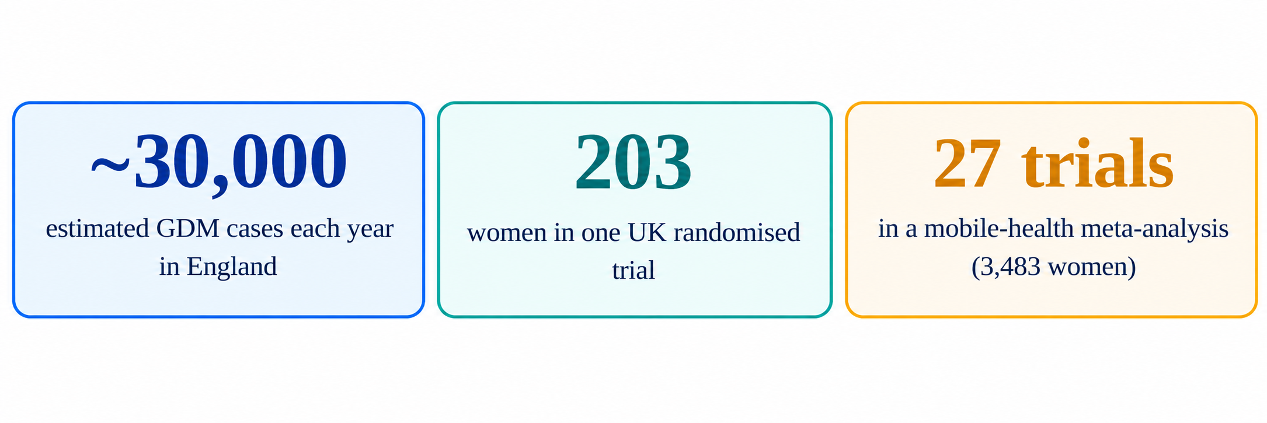
Figure 4. Evidence snapshot for gestational diabetes and digital monitoring.
Source: NHS England (2024), Mackillop et al. (2018) and Wei et al. (2023). The counts describe different sources and are not directly comparable measures of effectiveness.
Explore the technology: University of Oxford - GDm-Health case study
References - Blog 1
Building Better Healthcare (2018), Official launch of GDM-Health. https://buildingbetterhealthcare.com/official-launch-of-gdm-health-148302
Mackillop, L., Hirst, J.E., Bartlett, K.J., Birks, J.S., Clifton, L., Farmer, A.J., Gibson, O., Kenworthy, Y., Levy, J.C., Loerup, L., Rivero-Arias, O., Ming, W-K., Velardo, C. and Tarassenko, L. (2018) ‘Comparing the efficacy of a mobile phone-based blood glucose management system with standard clinic care in women with gestational diabetes: randomised controlled trial’, JMIR mHealth and uHealth, 6(3), e71. Available at: https://doi.org/10.2196/mhealth.9512.
Mittal, R., Prasad, K., Lemos, J.R.N., Arevalo, G. and Hirani, K. (2025) ‘Unveiling Gestational Diabetes: An Overview of Pathophysiology and Management’, International Journal of Molecular Sciences, 26(5), article 2320. Available at: https://doi.org/10.3390/ijms26052320.
National Institute for Health and Care Excellence (NICE) (2015) Diabetes in pregnancy: management from preconception to the postnatal period (NG3). Available at: https://www.nice.org.uk/guidance/ng3/chapter/Recommendations (Accessed: 21 October 2026).
NHS England (2024) ‘Healthier You NHS Diabetes Prevention Programme: Gestational Diabetes Mellitus (GDM)’. Available at: https://www.england.nhs.uk/long-read/healthier-you-nhs-diabetes-prevention-programme-gdm/ (Accessed: 21 October 2026).
Safiee, L., Rough, D.J. and Whitford, H. (2022) ‘Barriers to and facilitators of using eHealth to support gestational diabetes mellitus self-management: systematic literature review of perceptions of health care professionals and women with gestational diabetes mellitus’, Journal of Medical Internet Research, 24(10), e39689. Available at: https://doi.org/10.2196/39689.
University of Oxford, Institute of Biomedical Engineering (n.d.) ‘GDm-Health: Gestational Diabetes management system’. Available at: https://ibme.ox.ac.uk/case-study/gdm-health-gestational-diabetes-management-system/ (Accessed: 21 October 2026).
Wei, H.X., Yang, Y.L., Luo, T.Y. and Chen, W.Q. (2023) ‘Effectiveness of mobile health interventions for pregnant women with gestational diabetes mellitus: a systematic review and meta-analysis’, Journal of Obstetrics and Gynaecology, 43(2), 2245906. Available at: https://doi.org/10.1080/01443615.2023.2245906.

BLOG 2 | ORIGINAL PROPOSED DIGITAL HEALTH PROMOTION INTERVENTION

GDM Compass: designing a digital app to support women with gestational diabetes
Proposed intervention | Self-management during pregnancy and prevention after birth
Why create another app?
While gestational diabetes requires daily self-management through pregnancy, risks persist after giving birth. NHS England estimates 30,000 diagnoses per year; up to 50% of those women may develop type 2 diabetes within five years (NHS England, 2024). Support services should therefore bridge antenatal management and post-natal prevention. As pregnancy management lowers risks, bridging after birth is necessary to prevent long-term prevention being overlooked.
What is GDM Compass?
GDM Compass is a proposed app, co-designed by maternity teams and women living with the condition, which would include glucose diary and trend graph, simple guidelines on food and exercise, reminders for scheduled tests and appointments, and secure callback requests. The interface would display an individualised set of agreed-upon targets rather than general thresholds and interpret flags according to local clinical protocols. The app could also store user questions for the next appointment. In the post-natal period, reminders would guide follow-up testing and direct eligible patients to the NHS Diabetes Prevention Programme. This app does not diagnose issues or adjust medication recommendations; clinical decisions remain up to the healthcare team following NICE guidelines (NICE, 2015).
How will the app promote health?
According to the COM-B model, health-related behaviour can be explained through capability, opportunity and motivation (Michie, van Stralen and West, 2011). Lessons, translated into plain language, increase capability; difficulties with accessing data, use of optional SMS service and links to clinicians increase opportunities; self-determined goals and feedback may increase motivation. Reviews found digital interventions improved glucose outcomes, although effects differed, and apps should complement rather than substitute clinical services (Leblalta et al., 2022; Wei et al., 2023).
Risks and evaluation
Potential risks are related to digital exclusion, anxiety triggered by notifications and failure of privacy protections. Reviews noted usability, technical and emotional support barriers (Safiee, Rough and Whitford, 2022). Design and testing with various users, providing phone or paper option, limiting data collection and using clinician-approved notifications. Conduct a pilot of the app and assess glucose monitoring, post-natal testing, user experience and equality of reach. Impact of the app cannot yet be proved until evaluated.
BLOG 2 | DESIGN CONCEPT AND IMPLEMENTATION SAFEGUARDS

GDM Compass: proposed interface and user safeguards
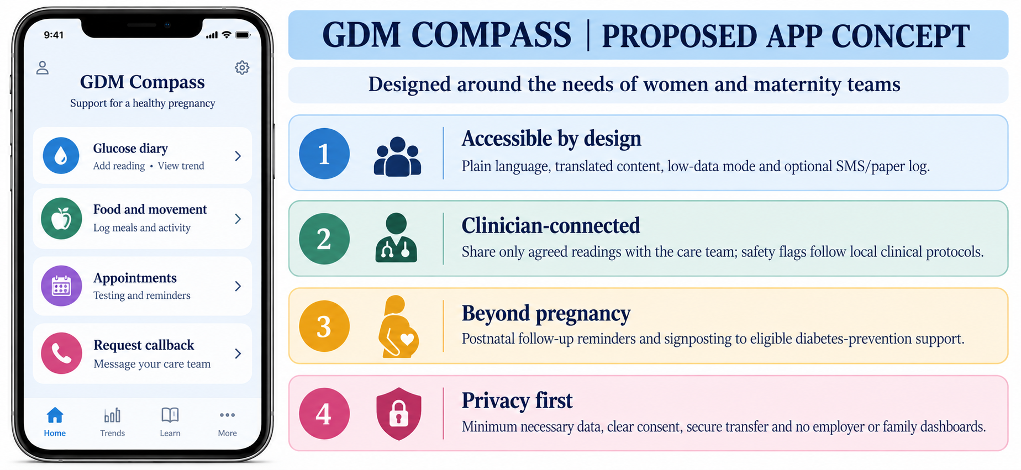
Figure 5. GDM Compass proposed user-facing concept interface.
Source: Self-developed illustration; proposed design only, not a live product.

Behaviour change model
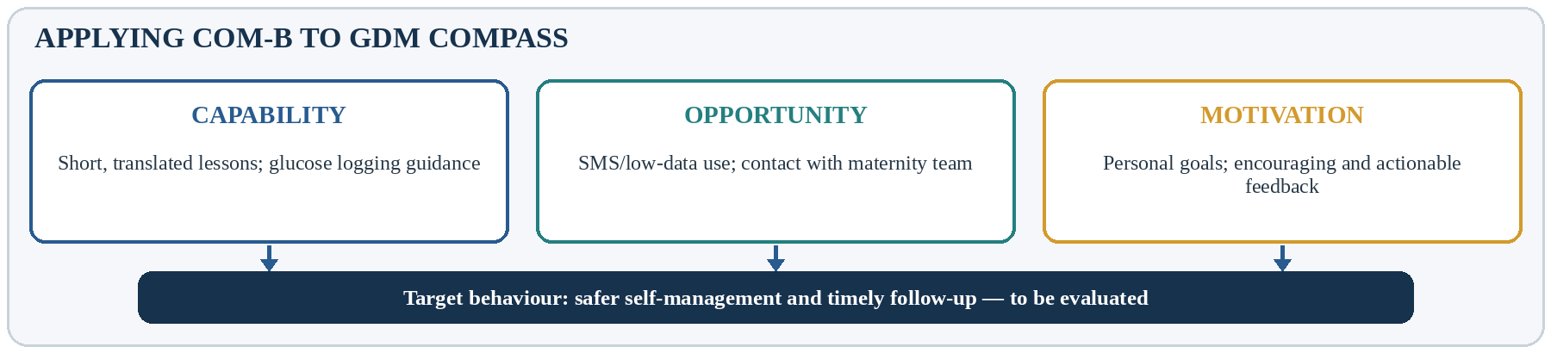
Figure 6. Applying COM-B to the proposed intervention.
Source: Self-developed, informed by Michie, van Stralen and West (2011).

Implementation risks and practical mitigations
Risk | Design response
Digital exclusion or language barriers | Translated plain-language content plus optional phone, SMS and paper routes.
Anxiety or unsafe self-adjustment | Supportive wording, clinician-approved alerts and no automated medication advice.
Privacy and trust | Clear consent, data minimisation, secure transfer and access limited to authorised care teams.

References - Blog 2
Leblalta, B., Kebaili, H., Sim, R. and Lee, S.W.H. (2022) ‘Digital health interventions for gestational diabetes mellitus: a systematic review and meta-analysis of randomised controlled trials’, PLOS Digital Health, 1(2), e0000015. Available at: https://doi.org/10.1371/journal.pdig.0000015.
Michie, S., van Stralen, M.M. and West, R. (2011) ‘The behaviour change wheel: a new method for characterising and designing behaviour change interventions’, Implementation Science, 6, 42. Available at: https://doi.org/10.1186/1748-5908-6-42.
National Institute for Health and Care Excellence (NICE) (2015) Diabetes in pregnancy: management from preconception to the postnatal period (NG3). Available at: https://www.nice.org.uk/guidance/ng3/chapter/Recommendations (Accessed: 21 October 2026).
NHS England (2024) ‘Healthier You NHS Diabetes Prevention Programme: Gestational Diabetes Mellitus (GDM)’. Available at: https://www.england.nhs.uk/long-read/healthier-you-nhs-diabetes-prevention-programme-gdm/ (Accessed: 21 October 2026).
Safiee, L., Rough, D.J. and Whitford, H. (2022) ‘Barriers to and facilitators of using eHealth to support gestational diabetes mellitus self-management: systematic literature review of perceptions of health care professionals and women with gestational diabetes mellitus’, Journal of Medical Internet Research, 24(10), e39689. Available at: https://doi.org/10.2196/39689.
Wei, H.X., Yang, Y.L., Luo, T.Y. and Chen, W.Q. (2023) ‘Effectiveness of mobile health interventions for pregnant women with gestational diabetes mellitus: a systematic review and meta-analysis’, Journal of Obstetrics and Gynaecology, 43(2), 2245906. Available at: https://doi.org/10.1080/01443615.2023.2245906.

