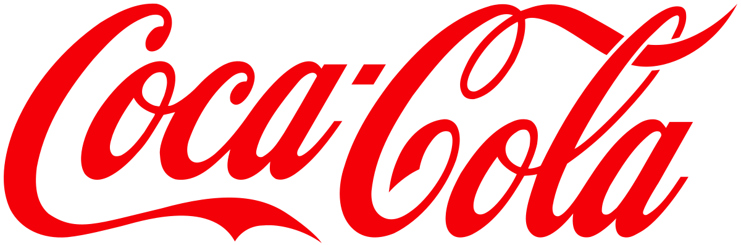
Coca-Cola Company
RED Critical Thinking Model
Cristina Sulugiuc | 2/24/20 | Developing Workplace Critical Thinking

Beliefs, attitudes and values

Specialists state that aligning individual’s and organization’s values can create a win-win situation for all concerned. By clarifying those notions, employees can feel worthy, satisfied and organizations are able to withstand periods of change due to a committed workforce. (Sullivan, Sullivan and Buffon, 2002, p.247)
In order to evaluate how values, beliefs and attitudes contribute to the success of a company, we will analyse the Coca Cola company through the RED Critical Thinking Model.
- Coca Cola’s beliefs, attitudes and values
In order, not just to survive, but to maintain its reputation as the world’s largest beverage business for more than 100 years, Coca-Cola developed a strong internal culture which is reflected in their core values. (Mission Statement Academy, 2019)
Diversity: As inclusive as our brands
Passion: Committed in heart and mind

Collaboration: Leverage collective genius
Leadership: The courage to shape a better future

Mission statement:
‘to refresh the world in mind, body, and spirit, to inspire moments of optimism and happiness through our brands and actions, and to create value and make a difference.’ (Coca-Cola, 2017)

Accountability: If it is to be, it's up to me
Integrity: Be real

Quality: What we do, we do well

R – One of the Coca-Cola core values is that they shape a better future, which is highlighted in the following statement: Leadership: The courage to shape a better future. (Coca-Cola, 2017)
E – In order to show its concern for the good of society and the development of a better future, Coca-Cola has created in Africa in 2015 and 2016 two youth-oriented programs in order to dissolve the issue regarding the youth unemployment rate in that area. The basis of these two programs (Youth Empower for Success and Coca Cola MENA Scholars Program) is the development of entrepreneurship skills. (Banks, 2016, p. 456)
More than that, to promote equal opportunities for women and men, Coca-Cola not only offered grants to more than 50% women registered in the MENA program to develop their own business plans, but also showed a 40% growth in the number of women occupying senior roles in the company in the last 7 years. Besides this, Coca-Cola has created opportunities for women outside the system by developing the program 5by20 which includes business skills training courses, loans financial services and assets and peer networks and mentoring. The magnitude of this programme can be reflected in the award of the Best Global Initiative for Women’s Economic Empowerment in 2013 at the Women in Leadership Economic Forum. (Banks, 2016, p.458)
On the other side, Coca Cola has faced a bad history with labour unions in the past and cannot be omitted. In 2012 the Namibian Food and Allied Workers’ Union went on strike for two weeks after Coca-Cola refused to pay a 1,745 Namibian dollar increase per month. The problem of the employees who worked in the company for over 10 years was that they were paid less than the newly recruited employees. As a result of this strike, Coca-Cola has agreed to pay an increase of 12.5%. (Schilmoeller, 2012)
Google has faced a similar situation in 2018 when its employees went on strike due to sexual misconduct allegations, thus questioning one of the company's values which is Integrity. (The Guardian, 2018) Considering that the company had a positive attitude towards this event and actually took into consideration employees’ improvement ideas, it means that they are really sticking to their values ​​and trying to improve the negative aspects.
D - Although this company has also faced negative aspects regarding working conditions, the low salary of the employees, it has managed to recover and inspire millions of people through the programs it commits for the benefit of the community and the creation of a better future.

References
1. Banks, H. (2016) ‘The business of peace: Coca-Cola’s contribution to stability, growth and optimism. ‘Business Horizons. 59 pp. 455-461
2.Coca-Cola. (2017) Mission, vision and values. Coca-Cola.co.uk.Available at: https://www.coca-cola.co.uk/about-us/mission-vision-and-values (Accessed on 19th February 2020)
3. Mission Statement Academy (2019) Coca Cola mission and vision statement analysis. Mission-statement.com. Available at: https://mission-statement.com/coca-cola/ (Accessed on 19th February 2020)
4. Schilmoeller, J. (2012) Labour Practices Questioned as Coca-Cola Workers Protest Unfair Policies Worldwide. Mintpressnews.com Available at: https://www.mintpressnews.com/labor-practices-questioned-as-coca-cola-workers-protest-unfair-policies-worldwide/31715/ (Accessed on 21st February 2020)
5. Sullivan, W., Sullivan, R., Buffon Barbara (2002) ‘Aligning individual and organisational values to support change’. Journal of change management, 2(3) pp. 247-254
6. The Guardian (2018) ‘Google walkout: global protests after sexual misconduct allegations’ TheGuardian.com. Available at: https://www.theguardian.com/technology/2018/nov/01/google-walkout-global-protests-employees-sexual-harassment-scandals (Accessed on 21st February 2020)

