Assessment Form

Module: BMPL4002 Preparing for Professional Policing
Student Number: Sophie Jones
Student Name:
Module Tutor (s): Kelly Andrews
Date:
Question | 1  Situation | 2  Task | 3.  Action | 4.  Result |  | Total Mark
1 | 4/5 | 3/5 | 10/15 | 5/5 |  | 22/30
2 | 1/5 | 3/5 | 10/15 | 3/5 |  | 20/30
3 | 4/5 | 4/5 | 11/15 | 3/5 |  | 22/30
Total Mark
64/90

Time: 13.35
Key
No Reference | Minimum | Satisfactory | Exceptional
0 | 0-4 | 5-10 | 11-15

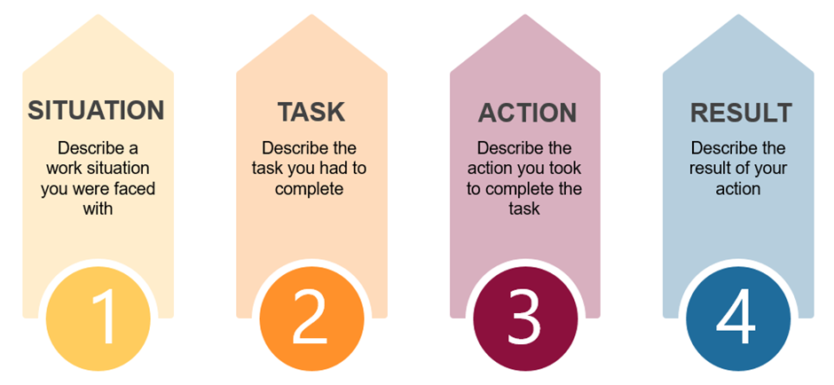

Question | Comments
1 | In my part time job as a support worker- I delivered support for six individuals in the house. We had one individual each, we had a meeting and discussed what the people wanted and looked at the pros and cons of each one, I spoke on behalf of my individual.  Actions worked out a date and time and sent out invites.  The day was successful, and my person was happy with everything we had organised.  We discussed how to manages all the family and friends, we organised everything.
2 | The situation was I was working for Iceland; I worked on Sundays in the evening, I used t scan all the stock to feed up into the managers computer. I had scanned everything, but I made a mistake and miss scanned a fridge, I realised what I had needed to do, I offered to stay behind and fix the problem, I learned from the experience, and I learned from the mistake.  The manager provided positive feedback. If I had not owned up it would have gone back to the manager as a stock loss this would have affected the company massively. I recounted the stock and counted everything twice and it was all resolved.
3 | The situation – special constable on duty with my shift, received a call about persons kicking off outside a nightclub. Attended the scene, lots of people there not happy.  I went to the person who looked to be in distress, I stood between him and his friend and reassured him, i assessed the situation and offered my support, I gave him open ended questions. Used active listening skills.  The situation calmed down and I spoke with the young man and got a lot of information from him.  He seemed happy.  .  Started strong with situation for each example, needed to be clearer with task and outline why certain decisions were made within actions, result highlighted but could have been more detailed on last question.

