The Influence of International Policy on Educational Outcomes for Females in Pakistan
“The sustainable Development Goals (SDGs) were adopted at the United Nations Assembly in 2015 articulating a global vision to stimulate activity over fifteen years for ‘humanity and the planet’. The STGs gave prominence to education, understood as lifelong process of learning.”
(McCowan and Unterhalter, 2022, p.1)
The STG are one of many universal policies that have been developed to encourage the ending of poverty and to recognise that this must be accomplished through “strategies that improve health and education, reduce inequality, and spur economic growth” (United Nations, 2015). Furthermore, the United Nations have set a deadline to accomplish these goals by 2030 (United Nations, 2015). This essay takes SDG goal 4 (SDG 4) as its focus - to “ensure inclusive and equitable quality education and promote lifelong learning opportunities for all” (United Nations, 2015) and will seek to discover if sufficient progress is being made. The significance of global education levels is made clear by The World Bank (2021), who state that “Education is a human right, a powerful driver of development, and one of the strongest instruments for reducing poverty and improving health, gender equality, peace, and stability” (World Bank, 2021, p.1). One will focus on the education system in Pakistan and critically examine the barriers to education that are faced by children and especially girls in the society. There will be a discussion of the relevant International and national policies such as the United Nation Convention on the Rights of the Child (1989) (UNCRC) that are in place to protect individuals right to education and these will be given context by applying Uri Bronfenbrenner’s Ecological Systems Theory (EST) (1979) (Bates, 2019). Further theoretical perspective will be achieved through referencing postcolonisation theories, as well as referring to Abraham Maslow’s (1943) hierarchy of needs (Bates, 2019) (Edwards, 2018).
A good place to start would be to critically discuss the role that the UNCRC (1989) plays in protecting the rights of every child and their educational wellbeing. One will also refer to Bronfenbrenner’s EST (1979) to add context. He understood that the child is surrounded by “communities, cultures and wider societies” (Gray and Macbain, 2015, p.121) that have influence over a child’s outcomes, and which can be perceived as layers of concentric circles (See Appendix 1) (Gray and Macbain, 2015) (Bates, 2019). The UNCRC (1989) is a set of universal rights specifically for every child and it demonstrates how all countries should implement these rights which encompass “civil, political, economic, social and cultural rights” (Collins and Foley, 2008, p.241). It has been ratified by 196 countries, that is all countries globally with the exception of the United States (Save the Children International, 2022). Article 28 of the UNCRC (1989) explicitly concerns rights around education, stating that:
“States Parties recognize the right of the child to education, and with a view to achieving this right progressively and on the basis of equal opportunity, they shall, in particular: (a) Make primary education compulsory and available free to all”
(Unicef, 2022, p.9).
In reality, children’s wellbeing and access to education in all countries is “policy -susceptible” (Callings and Fowley, 2008, p.4). To add context, Bronfenbrenner’s EST (1979) would class the UNCRC (1989) as belonging to the child’s macrosystem which would have significant effect on all other systems; bringing influence to bear on the governmental policies that hold sway over their ability to access education (Edwards, 2018). The UNCRC (1989) provides a framework to apply “international measurements and comparisons” (Collings and Fowley, 2008, p.4) which enables the assessment of a country’s strengths and weaknesses, and which provides a compelling means to argue for transformation (Collings and Fowley, 2008). For instance, the UNCRC (1989) has been utilised by the Welsh Government to initiate change within the educational system and forms the basis of the New Curriculum for Wales (2022) (WG, 2019). Its influence is also evident in The Constitution of the Islamic Republic of Pakistan (2012), of which Article 25(A) states that “the State will provide free and compulsory education to all children of the age of five to sixteen” (National Assembly of Pakistan, 2012, p.15). It further states that “there shall be no discrimination on the basis of sex” (National Assembly of Pakistan, 2012, p.15). Although sexual discrimination is mentioned in both the UNCRC (1989) and The Constitution of the Islamic Republic of Pakistan (2012), it does not have its own Article and therefore, one could argue that it has not been given enough prominence (Edwards, 2018) (Unicef, 2022) (National Assembly of Pakistan, 2012). This observation is also mirrored by the Oorganisation for Economic Cooperation and Development (OECD) report ‘Closing The Gap’ which “identifies (that) addressing gender inequality means ensuring gender equality in macro and meso level policy-making, education, employment and access to entrepreneurship” OECD (2012, cited in Edwards, 2018, p.108). However, this is not the case with the SDG (2015), which makes explicit note of feminist principles in Goal 5 (SDG 5), the aim of which is to “achieve gender equality and empower all women and girls” (United Nations, 2015).
From a less westernised perspective, Africa has produced their own child’s rights charter called The African Charter on the Rights and Welfare of the Child (ARCWC) (1990) (Edwards, 2018). Article 11 of which obligates the State ensure that “every child shall have the right to an education” (Au.Int., 2019, p.3). This mirrors the UNCRC, but the ARCWC goes further, clarifying that the government must “take special measures in respect of female, gifted and disadvantaged children” (Au.Int., 2019, p.3). Furthermore, Article 11 part 4 makes specific note of pregnant girls, stating that state parties should “ensure that children who become pregnant before completing their education shall have an opportunity to continue with their education” (Au.Int., 2019, p.3). Ekundayo (2015) suggests that this creates an “obligation on states to ensure that pregnant girls are allowed to continue with their education” (Ekundayo, 2015, p.150). In developing countries, there can be a culture of girls getting married younger; these ‘child brides’ are not such a significant concern in Western cultures as they are in Africa and other developing countries (Ghani, 2016). In Pakistan for instance, 3 % of girls are married before they are 15 rising to 21% before they are 18 (Ghani, 2016). Ekundayo, (2015) suggests that the ARCWC (1990) addresses the child’s right to a continued education by making it explicit in Article 11 (Ekundayo, 2015). Further criticism is made of the UNCRC (1989) by Edwards (2018) who draws attention to unrealistic expectations made by the UNCRC by assuming that “parents will priorities education over work and [it] does not recognise the decisions poor families must make around their children’s education and the need for survival” (Edwards, 2018, p. 69). Edwards further points out that these expectations are delivered through an “ethnocentric, Western First World perspective” (Edwards, 2018, p.69). Collins and Fowley (2015) indicate that if the UNCRC (1989) and other governmental policies do not reflect the reality of low-income countries then they lose their power to elicit change (Collins and Foley, 2015).
One is using Pakistan as a focus of this essay and therefore, it is important to have a broad understanding of the issues and struggles its inhabitants face. Situated in South Asia, Pakistan was born out of the end of the British rule over the sub-continent of India. In 1947 India was divided into two separate nations, Pakistan and India, with Pakistan to the west mostly Muslim and India to the east mostly Hindu (Asrar, 2019). The Indian sub-continent had been previously part of the British Empire for more than 200 years and since gaining its independence, has struggled to retain political stability and social development (Burki, 2022). Geographically and culturally Pakistan faces many challenges, with the foothills of the Himalayas on the north, it is two thirds’ mountain, while the south coast meets the Arabian sea (UNESCO, 2022) (Burki, 2022). Referred to as “the youngest country in the world” (Tiger et al, 2019, p.90), and the sixth most populated country on the planet, its population was estimated at 229,907.000 in 2021 (Britannica, 2022) (UNESCO, 2019) (Tiger et al, 2019).
British colonialism has had a lasting impact on Pakistan (Nadia and Faqiha, 2011). Under the ‘Raj’, the British exploited the Indian territory for their own interests, establishing the feudal system which persists in outlying, rural areas, causing poverty and confusion. (Nadia and Faqiha, 2011) (Tager et al, 2019). A continuing English ideology has caused the ethnic culture of Pakistan to be supressed and Pakistanis express a lack of confidence in their ability to govern (Nadia and Faqiha, 2011). One will use postcolonisation theory (as defined in Monica Edwards book, ‘Global Childhoods’) to understand the impact colonialism has had on Pakistan (Edwards, 2018). Postcolonisation theory derived from critical theories such as feminism, ethnography, post modernism and Marxism, “countries were managed by a system of hegemonic policies that served to legitimise Western control through subjugation” (Edwards, 2018, p,99). Pakistan is still a society divided, with English being cited as a co-official language (along with Urdu) (Haidar and Fang, 2019). This is not the case in other countries which were not colonised, an example of which is China, where English is classified as a taught second language (Haidar and Fang, 2019). Edwards (2018) suggests that “the imposition of Western languages, religion, political and economic processes positioned those under colonial rule as uncivilised, childlike, feminine and in need of saving” (Edwards, 2018, p.100). In fact, Pakistan re-entered the commonwealth again in 1989 after leaving in 1972 and there is still a persistent colonial mindset, although they re-entered under their own terms (Britannica, 2022) ) (Haidar and Fang, 2019). An example of the legacy of post colonisation can be seen in the use of English instruction in education, which is still held in the highest regard but is a dividing factor in society (Haidar and Fang, 2019). Other lasting impacts include the fact that; land holdings were segmented causing reduced crop yields; cultural industries were repressed and ruined; education was not made accessible; development of infrastructure such as railways was built in the British concern and not to benefit the Indian society; the new political system was not superior to the previous British one and lacked the personal component (Nadia and Faqiha, 2011). This reflects Bronfenbrenners EST, which suggests that historically, colonialism has impacted the chronosystem of Pakistan (Edwards, 2018). Its detrimental influence can be felt through all the economic, social, political and educational structures within the country (Edwards, 2018) (Bates, 2019).
The country still faces many challenges. It is rooted in inequality and poverty and has a quickly growing youth population (UNESCO, 2022). In fact, “Sixty percent of the population is younger than 30 years and nearly one-third is living in multidimensional poverty” (UNESCO, 2022, p. 9). Unesco (2022) states that “44% of children are out of education” (UNESCO, 2022, p.5) which translates to “an estimated 22.8 million children aged 5-16 out-of-school” (Unicef, 2022, p.1). Although, this is not the whole story, Unicef (2022) informs us that “disparities based on gender, socio-economic status, and geography are significant” (Unicef, 2022, p. 1). For example, 52 % of children (58 % girls) living in poverty in Sindh province do not attend education, this rises to 78 % of girls in Balochistan (Unicef, 2022).
Despite these concerning statistics, Pakistan spends only 2.5% of its GDP on education which has shown no lasting increase since 2013 and which falls way below the Education 2030 Framework for Actions goal of 4% to 6% (UNESCO, 2019). Tager et al (2019) states that this should be of great concern as “low female literacy trends affect inversely on growth and economic development” (Tager et al, 2019, p.1). Thus, it should be an urgent governmental priority to deliver quality education for females to enable “sustainable economic growth and development” for all (Tager et al, 2019, p.1).
There are many barriers to education experienced by children in Pakistan today (Unicef, 2022) (UNESCO, 2019). The UNESCO Pakistan Country Strategic Document 2018-2022 reports that causes for low enrolment and retention rates include:
“Teacher absenteeism, poor quality of education, distances that children, especially girls, have to travel to attend school, coupled with limited transportation options, as well as a lack of school WASH facilities, poverty and food insecurity”.
(UNESCO, 2019, p.12).
Such barriers include the distance that children must travel to school, especially girls and that most conservative rural communities “are unwilling to send their daughters to school if the facility is located too far from the village” (Hussain, 2020, p. 1) (UNESCO, 2019). Furthermore, lack of wash facilities is a barrier to adolescent girls due to menstruation concerns as well as the need for privacy and security within toilet facilities (UNICEF, 2022). The lack of a secure environment is addressed by Tager et al (2019) who also indicate that schools in all areas have damaged boundary walls, no proper transportation for girls, a deficit in female teachers and a lack of girl’s schools is also a factor (Tager et al, 2019). Adding to this are political and social insecurities which result in an un-willingness to allow girls to travel outside of their village (Tager et al, 2019). Geographical barriers are also present, for instance the province of Baluchistan encompasses a desert and mountainous region which renders the building of schools problematic (Tager et al, 2019). In this area “28% of its population is literate, with males at 39% and females at 16% (Tager et al, 2019, p.93).
It is clear that many schools have deficits in facilities, Abraham Maslow (1943) Hierarchy of needs theory informs us that all individuals have basic, physical needs which they require for survival and that these needs must be met before they can engage with higher level, intellectual needs such as education (Bates, 2019). These 5 basic, physical needs include the need for food, water, clothing, shelter, and sleep and children have their right to have these basic needs catered for in schools (Bates, 2019) (Tiger et al, 2019). However, Tiger et al (2019) inform us that almost every school situated in isolated regions have a deficit of these basic facilities (Tiger et al, 2019). From a rights-based approach, Article 24 states that “Governments must provide good quality health care, clean water, nutritious food, and a clean environment and education on health and well-being so that children can stay healthy” (Unicef, 2022, (B), p.1). Furthermore, this correlates with Bronfenbrenner’s EST (1979) indicating that if there are deficits within the mesosystem, such as unfit school facilities and a deficit of female staff then this directly impacts the child’s outcomes (Edwards, 2018) (Bates, 2019).
A further barrier to consider is the cultural and social taboos that persist, (Ahmad et al, 2014). It is considered against the teachings of the Islamic religion to co-educate girls and boys, even though many areas do not have girl’s schools (Ahamad et al, 2014). The deficit of co-educational opportunities has exacerbated the culture of patriarchal economic and political systems (Ahamad et al, 2014). The most extreme result of this culture is under Sharia law, who’s ‘anti woman agenda’ forbids girls to attend school and gain an education (Iodice, 2020). In fact, in 2012 in Swat province, a masked gunman boarded a school bus and shot Malala Yousafzai in the head for drawing attention to her plight and every girl’s right to an education (Iodice, 2020). After this horrific incident the international community condemned the action and there was great sympathy for Malala’s plight in Pakistan (Harris, 2016). A petition set up by Malala and her father was signed by over 2 million people which helped to secure the passing of the Right to Education Bill Article 25(A) within The Constitution of the Islamic Republic of Pakistan (2012) (UN, 2017). Also, on Malala’s 16th birthday she talked in front of the United Nations (Harris, 2016) staging the first ever youth takeover which included “more than 600 young leaders from around the world in support of universal education for all children” (Harris, 2016, p.2). This helped to bring about the historic UN summit that implemented the Sustainable Development Goals (UN, 2017). From a theoretical perspective, Bronfenbrenner’s EST (1979) informs us that a child’s exosystem incorporates a community’s values (Bates, 2019). Therefore, positive and inclusive values such as the SDG can empower individuals and enhance life outcomes (Edwards, 2018) (Bates, 2019). Additionally, international agencies such as the UN have utilised Malala’s narrative and the SDG to apply pressure to Pakistan’s macrosystem (its social and economic structures) which can promote social transformation (Edwards, 2018) (Bates, 2019).
Although all Pakistani children are impacted by barriers to education, the greatest impact is felt by girls (Unicef, 2019). As a strategy to bring about change, in 2000, the World Education Format adopted the Dakar Framework for Action, ‘Education for All’ (2000) (EFA). It laid out a framework of standards required by the international community regarding a rights-based approach to education for all (UNESCO, 2000). This was to be accomplished under the leadership of The United Nations Educational, Scientific and Cultural Organisation (UNESCO) which would “co-ordinate and mobilize all partners at national, regional and international levels” (UNESCO, 2000, p.3) and with particular prominence given to recognized areas of concern such as “education of girls and women” (UNESCO, 2000, p.3). UNESCO has strived to influence policy in Pakistan, to bring about a top-down change of culture by using international policies such as the SDG and UNCRC (1989) as targets (UNESCO, 2021). The Girls Right To Education Programme (GREP) was launched in 2015 and is backed by UNICEF’s Malala Fund for Girls’ Right to Education as well as the Pakistani Government (UNESCO, 2021). This multi, internationally funded program sought to boost the attendance of girls in education to 50000 by putting in place 2410, mostly female teachers, and by increasing “social mobilization and advocacy in marginalized communities” (UNESCO, 2021, p.1). GREP would focus on “education quality by improving school facilities and learning environments – activating parent-teacher committees (PTCs), school management committees” (UNESCO, 2021, p.1) These improvements to school staffing diversity and quality facilities enhanced the educational mesosystem resulting in girl friendly and supportive settings (Edwards, 2018). Governmental structures were improved by “boosting the capacity of district and provincial education officials to create an enabling environment for girls’ education” (UNESCO, 2021, p.1). However, this programme only had funding for 3 years which was not sufficient to meet the UNs SDG 4 of ‘all children in education by 2030’ (UN, 2015). This is evident from data collected by UNESCO (2019) indicating that in 2019, girls primary school attendance levels were below 90%, (dropping to just under 40% in secondary school), indicating a marginal improvement of 10% and significantly below boys’ attendance levels (see Appendix 2 and Appendix 3) (UNESCO, 2022).
The UNCRC (1989) Article 28 states that “children have a right to an education (and that) wealthy country should help poorer countries achieve this” (Collins and Foley, 2015, p.242). This correlates with Bronfenbrenner’s EST (1979), which indicates that the macrosystem encompasses social, political and economic structures on a national and international scale (Edwards, 2018). A example of this would be the World Bank providing 100 million dollars for Early Learning Enhancement through Classroom Transformation (SELECT) project in the Sindh province (World Bank, 2021). It takes a transformational approach, promoting an “adaptive education system to better manage school disruptions and mitigate future school dropouts” (World Bank, 2012, p.1) as well as “enabling provincial government (and) enhancing basic education in disadvantaged and remote populations” (World Bank, 2012 p.1). This will put in place digital technologies needed for interactive distance learning and improved infrastructure required to keep girls safe (World Bank, 2021). Coming as a response to the detrimental impact covid 19 has had on levels of out of school children, it will especially benefit girls who find themselves in remote and unsafe situations (World, Bank, 2021). Furthermore, Bronfenbrenner’s EST (1979) indicates that supporting a child’s mesosystem and microsystem have beneficial impacts and can remove barriers to education (Edwards, 2018) (Bates, 2019).
In conclusion, it is evident that Pakistan not only suffers from geological, economic, cultural and societal challenges, but also still feels the impact of post colonialism within all its ecological systems (Bates, 2019) (Edwards, 2018). Whilst it is evident that UNESCO, utilising the UNCRC (1989), has brought about policy transformations at governmental level, there is still a patriarchal culture that does not want to recognise the rights of females. More work is needed for the trickle down of inclusive policies to reach the more remote provinces (UNESCO, 2019). This cannot be achieved by UNESCO alone. Inclusive policies and initiatives should continue to be promoted within all levels of ecological systems, whilst partnering with the private sector to provide liquidity for fit for purpose educational establishments. Finally, the girls and women of Pakistan must self-advocate using modern platforms, drawing the worlds attention to their plight and demanding equal rights in all things. In this way, the SDG 4 vision of all children in education can become reality before 2030.

References

Ahmad, I., Said, Altaf Hussain and Sadaf Khan (2014). ‘BARRIERS TO CO-EDUCATION IN PAKISTAN AND ITS IMPLICATIONS ON GIRLS EDUCATION: CRITICAL REVIEW OF LITERATURE’. Sci.Int(Lahore),26(1), pp. 339 -345. [online] ResearchGate. Available at: https://www.researchgate.net/publication/332446823_BARRIERS_TO_CO-EDUCATION_IN_PAKISTAN_AND_ITS_IMPLICATIONS_ON_GIRLS_EDUCATION_CRITICAL_REVIEW_OF_LITERATURE.
(Accessed: 12th February 2022).
‌
Au.int. (2019). The African Charter on the Rights and Welfare of the Child (ACRWC) | African Union. [online] Available at: https://au.int/en/documents-45
‌(Accessed: 8th February 2022).

Asrar, S. (2019) ‘How India, Pakistan and Bangladesh were formed’. Al Jazeer. 14th August. Available at: https://www.aljazeera.com/news/2019/8/14/how-india-pakistan-and-bangladesh-were-formed
(Accessed: 31st January 2022).
Bates, B. (2019) Learning Theories Simplified. 2nd Ed. London: SAGE Publications Ltd.

Burki, S. J. (2022) ‘Pakistan’. Encyclopaedia Britannica. January 28th. Available at: https://www.britannica.com/place/Pakistan
(Accessed: 31st January 2022).

Carroll, M (2019) Bronfenbrenner’s Ecological Theory. [online]. Available at: https://www.researchgate.net/publication/333917631_How_does_growing_up_as_a_Third_Culture_Kid_TCK_impact_life_choices_Effects_on_ATCKs_and_their_educational_and_career_experiences/figures?lo=1
(Accessed 15th February 2022).

Collins J and Foley, P. (2008) Promoting Children’s Wellbeing, Policy and Practice. Bristol: The Policy Press.

Edwards, M. (2018) Global Childhoods (Critical Approaches to the Early Years). Northwich: Critical Thinking Publishing.

Ekundayo, O. (2015). ‘Does the African Charter on the Rights and Welfare of the Child (ACRWC) only Underlines and Repeats the Convention on the Rights of the Child (CRC)’s Provisions?: Examining the Similarities and the Differences between the ACRWC and the CRC’. International Journal of Humanities and Social [online]
5(71), pp.2221–989. Available at: http://www.ijhssnet.com/journals/Vol_5_No_7_1_July_2015/17.pdf
[Accessed 8 Feb. 2022].
‌
Ghani, F. (2016) Pakistan failure to outlaw child marriage sparks outcry. [online] www.aljazeera.com. Available at: https://www.aljazeera.com/news/2016/1/19/pakistan-failure-to-outlaw-child-marriage-sparks-outcry#:~:text=According%20to%20a%20UNICEF%20estimate
[Accessed 8 Feb. 2022]
‌Haidar, S. and Fang, G. (2019) ‘English Language in education and globalisation: a comparative analysis of the role of English in Pakistan and China’. Asia Pacific Journal of Education. Vol. 39(2), pp 165-176.
DOI: https://www.tandfonline.com/doi/abs/10.1080/02188791.2019.1569892

Hussain, M. (2020) Making education accessible in rural areas Non-formal education centers help children study in remote communities. (Unicef). Available at: https://www.unicef.org/pakistan/stories/making-education-accessible-rural-areas
(Accessed: 1st February 2022).

Krieg, J. (2019). International Student Assessment Performance and Spending. [online] Available at: https://www.fraserinstitute.org/sites/default/files/international-student-assessment.pdf
(Accessed: 13th February 2022).

Iodice, E. (2020). .Education Meant Risking Her Life: A Young Girl’s Deadly Struggle to Learn’. Journal of Values-Based Leadership. Available at: https://scholar.valpo.edu/cgi/viewcontent.cgi?article=1309&context=jvbl
(Accessed: 13th February 2022).

Nadia, S. and Faqiha, R. (2011). ‘The Lingering Impact of Colonization on Pakistan: Negative or Positive?’. South Asian Studies. Vol. 26(2), pp. 401-410.
DOI: https://www.proquest.com/docview/1008664375
(Accessed: 5th February 2022).

National Assembly of Pakistan (2012) The Constitution of the Islamic Republic of Pakistan. Available at: https://na.gov.pk/uploads/documents/1333523681_951.pdf
(Accessed: 5th February 2022).

McCowan, T. and Unterhaiter, E. (2022) Education and International Development. An Introduction. 2nd Ed. Great Britton: Bloomsbury Publishing Plc.

Save the Children International. (2022). The United Nations Convention on the Rights of the Child. [online] Available at: https://www.savethechildren.net/united-nations-convention-rights-child.
(Accessed: 8th February 2022).‌

Tager et al. (2019) ‘The Low Female Literacy Trends: A Critical Challenge of Human Development in Pakistan (Major Obstacles and Way Forward)’, Archives of Business Research. 7(6), pp. 88-97.

The Editors of Encyclopaedia Britannica (2022) Commonwealth, association of states. Available at: https://www.britannica.com/topic/Commonwealth-association-of-states
(Accessed: 1st February 2022).
‌
UNESCO (2019) UNESCO Pakistan Country Strategic Document 2018-2022. Available at: https://en.unesco.org/sites/default/files/ucsd.pdf
(Accessed: 31st January 2022).

UNESCO (2000) The Dakar Framework for Action: Education For All. Meeting Our Collective Commitments, France. Available at: https://sustainabledevelopment.un.org/content/documents/1681Dakar%20Framework%20for%20Action.pdf
(Accessed: 5th February 2022).

Unicef (2022) Giving every child the right to education. Available at: https://www.unicef.org/pakistan/education
(Accessed: 31st January 2022).

United Nations (2017). Malala Yousafzai. [online] United Nations. Available at: https://www.un.org/en/messengers-peace/malala-yousafzai.
(Accessed: 13th February, 2017).

United Nations (2015). The 17 Goals. [online] United Nations. Available at: https://sdgs.un.org/goals.
(Accessed: 6th February 2022)

Unicef.org (2022) convention on the Rights of the Child – unabridged. [on line]. Available at: https://downloads.unicef.org.uk/wp-content/uploads/2016/08/unicef-convention-rights-child-uncrc.pdf?_adal_sd=www.unicef.org.uk.1644146116315&_adal_ca=so%3DGoogle%26me%3Dorganic%26ca%3D(not%2520set)%26co%3D(not%2520set)%26ke%3D(not%2520set).1644146116315&_adal_cw=1644146107441.1644146116315&_adal_id=4e36a082-6085-4d59-ae2f-f5c9971ab418.1612802540.23.1644146107.1642929522.a1a230ca-bcc4-4607-b7ea-dc9a29a490eb.1644146116315&_ga=2.91788626.975014100.1644146107-1733587711.1612802540
(Accessed: 6th February 2022).

UNESCO (2019). Pakistan | UNESCO Institute for Statistics. [online] Available at: http://uis.unesco.org/en/country/pk
Accessed: 14th February 2022).

UNESCO (2021). Right to Education Programme launched in Pakistan aims to get 50,000 more girls in remote areas into school. [online] UNESCO. Available at: https://en.unesco.org/news/right-education-programme-launched-pakistan-aims-get-50000-more-girls-remote-areas-school.
(Accessed: 14th February 2022).‌

Unicef (B) (2022) Convention on the Rights of the Child. [online]. Available at: https://downloads.unicef.org.uk/wp-content/uploads/2019/10/UNCRC_summary-1_1.pdf?_adal_sd=www.unicef.org.uk.1644146933555&_adal_ca=so%3DGoogle%26me%3Dorganic%26ca%3D(not%2520set)%26co%3D(not%2520set)%26ke%3D(not%2520set).1644146933555&_adal_cw=1644146107441.1644146933555&_adal_id=4e36a082-6085-4d59-ae2f-f5c9971ab418.1612802540.23.1644146930.1642929522.a1a230ca-bcc4-4607-b7ea-dc9a29a490eb.1644146933555&_ga=2.116365902.975014100.1644146107-1733587711.1612802540
(Accessed: 6th February 2022).

Welsh Government (2019) Children's rights in Wales. Available at: https://gov.wales/childrens-rights-in-wales
(Accessed: 7th February 2022).

World Bank. (2021). Overview. [online] Available at: https://www.worldbank.org/en/topic/education/overview#1.
(Accessed: 7th February 2022).

Appendices

Appendix 1.
Uri Bronsenbrenner’s Ecological Systems Theory

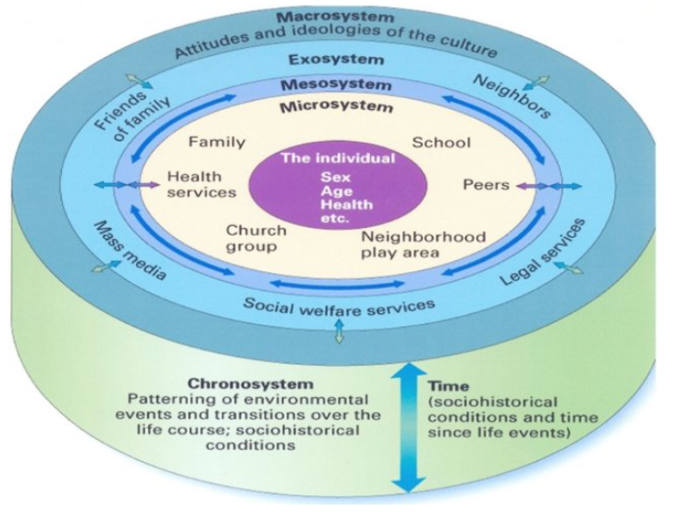
‌
(Carroll, 2019), p.1)

Appendix 2
Rates of enrolment in primary education for males and females in Pakistan

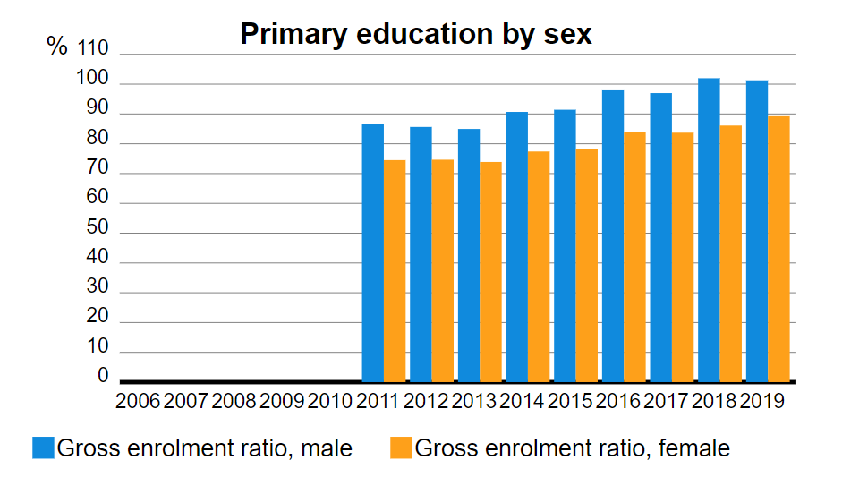
(UNESCO Institute of Statistics, 2022, p.1)

Appendix 3
Rates of enrolment in seccondary education for males and females in Pakistan

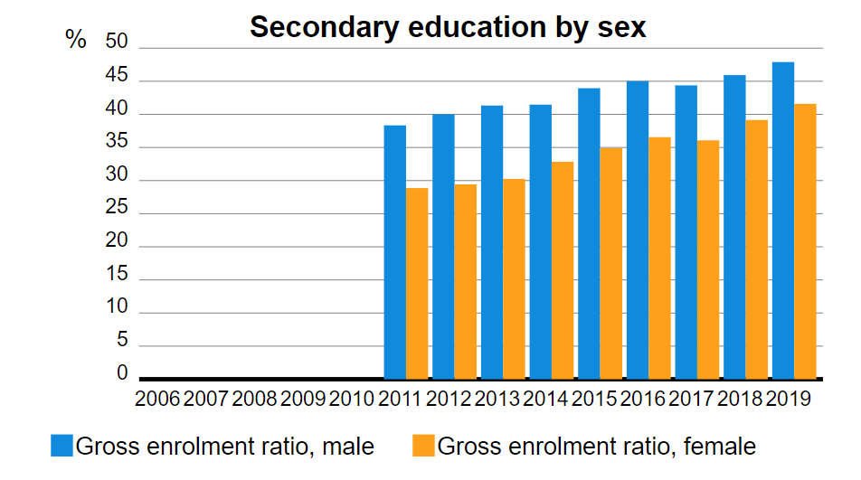
(UNESCO Institute of Statistics, 2022, p.1)

