THE GLOBAL BUSINESS ENVIRONMENT LCBB4005
ASSIGNMENT 1
STUDENT NAME : PETRONELA HURMUZACHE
STUDENT NUMBER : 2114679
TUTOR NAME: DR NADEEM MIRZA
01.05.2022

Executive summary
The report has concentrated on the global business environment and its transformation. It has also focused on the impact of the global business environment factors on a car manufacturing company. The report has analysed and evaluated the competitive business environment of the Japanese firm with the usage of Porter’s five forces, PESTLE analysis, Porter’s diamond, and Value chain models. It has also discussed the strengths, threats, weaknesses, and opportunities of the company with the utilisation of the SWOT analysis tool. The report has also presented an understanding of the challenges that a company faces during international trade. It has also discussed the market structure in which the organisation operates.

Table of Contents

Introduction 3
Key forces shaping the global business environment 4
PESTLE analysis 4
SWOT analysis 5
Porter’s diamond model 7
Value chain 8
Porter’s Five Forces 9
Conclusion 11
Reference list 12
Appendix 1: PESTLE analysis 16

Introduction
The report will present an understanding of the competitive environment of a firm. It will shed some light on micro and macro-economic factors and their impact on the working system of Toyota. The report will analyse and evaluate the global business environment with the utilisation of the PESTLE analysis. Various other models like SWOT analysis, Porter’s five forces, Porter’s diamond, and value chain analysis are also analysed regarding Toyota and its competitive environment. Toyota is a car manufacturing company that is based in Japan and was founded in the year 1937 (global.toyota, 2022). About 71,373 employees are working under the company which operates on a global level.

Key forces shaping the global business environment
The global business environment is about the surrounding nations which can influence the decision-making procedure of an organisation (Kosnikov et al., 2021). It plays a key role in the availability of raw materials, reliability of the supply chain, government regulations, and others. The global business environment also contributes to the development of new technology and trends in the market which influences the working system of an organisation. Various factors shape the global business environment such as economic, political, environmental, legal, technological, and sociocultural. An organisation needs to transform itself according to the business environment to attain success in the market they are operating.

PESTLE analysis
Currently, companies are utilising innovative technologies to gain a competitive advantage and enhance their performance (Moon, 2022). It is noted that the usage of technology is increasing in organisations around the world which are shaping the global business environment. According to Cherunilam (2021), the World Trade Organisation also shapes the global business environment. The World Trade organisation deals with or handles the global trade regulations between countries (wto.org, 2022). In this context, the application of the PESTLE analysing tool regarding the international business environment will. The PESTLE analysis tool helps in recognising the impact of factors like social, economic, political, legal, technological, and environmental on a business (Alanzi, 2018). It will assist in recognising the impact of the mentioned factors on Toyota.
[Refer to appendix 1]
From the PESTLE analysis, it can be analysed that the political and economical factors are hurting the global business environment. On the other hand, factors like social and technological are having a positive influence on the global business environment. Toyota must ensure that its working system and functions abide by the laws and regulations to avoid any legal challenges. The introduction of sustainability in business helps in enhancing the brand value and reputation (Sroufe and Gopalakrishna-Remani, 2019). Another factor that is shaping the global business environment is the coronavirus pandemic. Covid-19 has decreased the sales of companies all around the world by 50% (worldbank.org, 2021). This factor has led to an increase in the usage of the internet and technology. It is found that about 34% of companies around the world have adopted the usage of the internet in their working system. According to Nuruzzaman et al. (2020), international trading activities help firms in gaining a competitive advantage. It provides a greater market for organisations which increases their sales rate and consumer base. On the other hand, Bashynska et al. (2019), states that international trade has uncertainties. The presence of uncertainties can hamper the expansion of an organisation and can create disturbance in its financial condition.

SWOT analysis
The usage of the SWOT analysis tool will assist in identifying the weak points, strengths, threats, and opportunities Toyota has in the global business environment (Benzaghta et al., 2021).
Strengths  - Advanced technology  - Supply chain management | Weakness  - Bad reputation  - Cheating on emission
Opportunities  - Technology growth  - Increase in electric vehicle sales | Threats  - Competitors  - The increasing price of raw materials
Table 2: SWOT analysis of Toyota
(Source: Created by the Learner)
Toyota is a car manufacturing organisation that also innovate products which provides competitive advantage to them. The company utilises advanced technology to innovate new products (toyota, 2017). Toyota is currently working on an automated ‘driving technology’ with the utilisation of artificial intelligence and robotics. Toyota also has a supply chain risk management that deals with issues regarding suppliers. It will help them in overcoming the issue created by the Russia-Ukraine war. The car manufacturing company has continuous innovation, lean business procedures, a strong manufacturing system as well as effective ties with suppliers (Karp, 2021). After facing an issue in its supply chain, Toyota now keeps its inventory updated to avoid any issues or risks in its supply chain in the future.
The Japanese firm has a bad reputation which impacts its brand value and image. Toyota faced a fall in its reputation due to issues with its car’s accelerator pedals (Shaaban et al., 2019). The company had to halt its production and sales operation in America due to this issue. Toyota’s share and reputation of Toyota also decreased because of this factor. According to Trunina et al. (2019), the reputation of a company contributes to its competitive advantage. Toyota can face serious legal issues if they do not abide by rules and regulations. For example, the “Consumer Protection Act 1987” of the UK states that it is important for a manufacturer to focus on the safety of their products (gov.uk, 2019). The company can get sued if their products hamper the safety of the consumers.
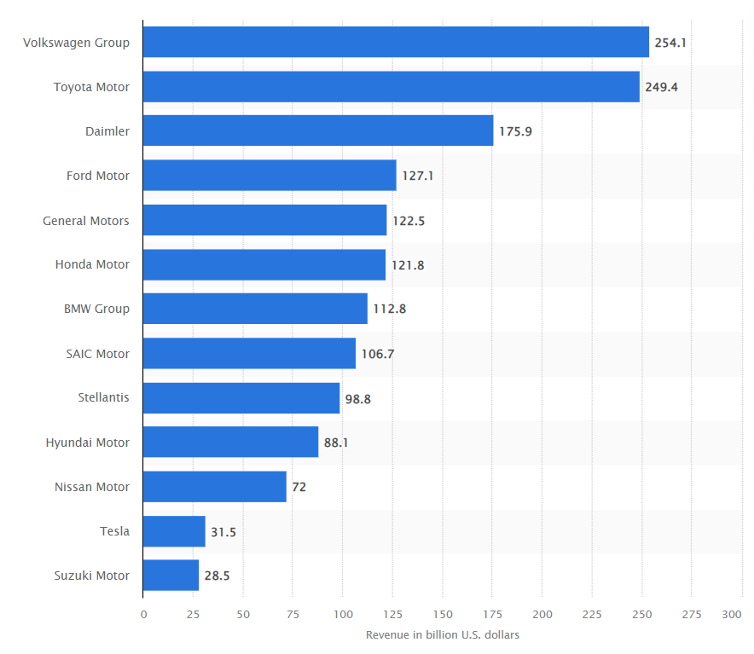
Figure 1: Leading car manufacturing company in the world
(Source: Carlier, 2021)
It is found that Toyota sold about 140,000 of its products in the USA and above 1 million over the world by greenwashing (Jansink, 2020). The car manufacturer stated that their products were environmentally friendly and it cleans the air which was false. Later, the company was backlashed due to its greenwashing advertisement. On the other hand, the electric vehicle market is about to increase to 34,756 thousand units in the year 2030 from 4,093 thousand units in the year 2021 (businesswire.com, 2021). Toyota has been able to utilise innovative technology and its business which will help increase its productivity and enhance performance (Mainwaring, 2018). In contrast, the existence of competitors like Volkswagen, Daimler, and more can hamper the growth of Toyota.
Volkswagen generated about$ 254.1 billion in revenues in the year 2020 in comparison to $249.4 billion by Toyota (Carlier, 2021). Hence, Toyota has strong competitors which can hinder the growth of the company by disturbing the customer base or demand. The increasing price of raw materials for manufacturing cars is also increasing on a global level and this can impact the production procedure of Toyota (Gibbs, 2022). High raw material costs can result in an increased price of finished products which can hamper the demand for Toyota cars or goods.

Porter’s diamond model
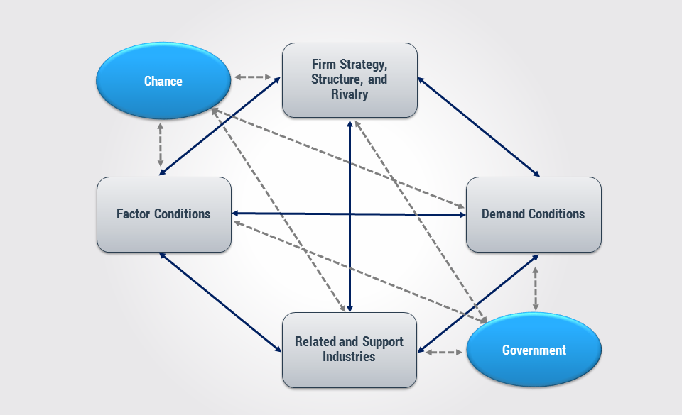
Figure 2: Porter’s diamond model
(Source: Juliana and Nyoman, 2019)
The usage of Porter’s diamond model will assist in gaining knowledge regarding its competitive advantage over Toyota (Fang et al., 2018). It consists of four elements which are rivalry, supporting industries, demand, and factor condition.
Rivalry: Toyota must compete with various competitors and the competition is very high which leads to the creation of innovative products and an increase in the usage of technology. The high rivalry keeps Toyota on its toes to create better products than its competitors. Toyota has been able to take the leading spot from Volkswagen in the car manufacturing industry on a global level (Lyon, 2021).
Demand: Toyota sold above 1.42 million of its vehicles in its home country (Gorka, 2022). The car manufacturer was the leading company in Japan which signifies that the firm can meet the demands of the consumers. It is found that the sales of Toyota were about 10.5 million units in the year 2021 which was about 9.53 million units in 2020 (Carlier, 2022). Hence, the company has been able to overcome the impact of the coronavirus pandemic on a global level. This also signifies that the demand for the company’s products is high in the global market.
Supporting industries: Toyota’s supporting and related industries are the steel and iron sector which provides the company with the needed raw materials for car manufacturing (toyota-global.com, 2022).
Input conditions: The increasing focus on innovation is helping Toyota to create innovative products and lead the car manufacturing industry. Innovation is assisting companies in penetrating markets on a global level (Henderson, 2017).

Value chain
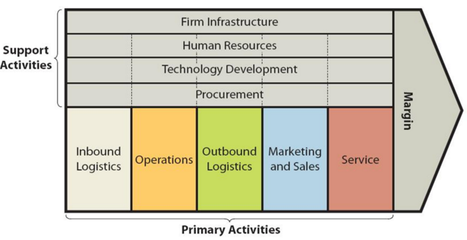
Figure 3: Value chain analysis of Toyota
(Source: Inspired by Fernandez-Stark and Gereffi, 2019)
The value chain is about the activities that a firm does to create its product (Fernandez-Stark and Gereffi, 2019). Toyota utilises both external and internal value network factors to increase the development of the company. The company offers a positive workplace that fosters transparency, communication, and a positive relationship between the company, supervisors, and subordinates (toyota-industries.com, 2022). This allows them to maintain an internal value network in the firm. On the other hand, the Japanese firm also has maintained a positive relationship with its consumers (toyota-industries.com, 2022). These relationships and interactions help the firm in creating innovative products which makes it a leading car manufacturing company in the world.
Toyota has steel and iron sheets suppliers and has an effective supply chain management which helps the company in leading the global market (toyota-global.com, 2022). This has helped the car manufacturing company in tackling its inbound logistics. Toyota has logistics in Japan as well as other countries which helps them in their product distribution (toyota-global.com, 2022). This firm sells its products through its outlets and its official website. The Japanese firm has a global distribution network and operation centres. It is found that the company spent about $43 million in the year 2019 on its marketing procedure (statista.com, 2022). The company provides various services related to car maintenance. There are various supporting activities of the company such as technology, human resources, and others (global.toyota, 2022). The presence of innovation has helped the organisation in increasing its sales and brand image which maintains sustainability in the firm.

Porter’s Five Forces
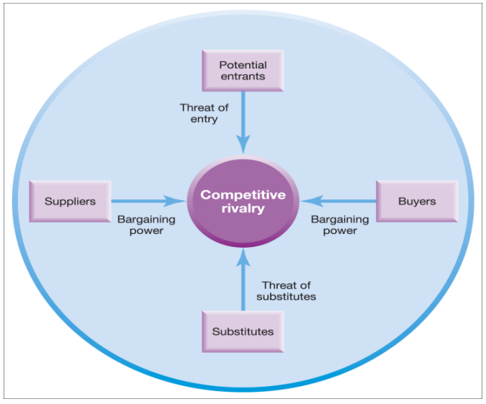
Figure 4: Porter’s five forces
(Source: Khurram et al., 2020)
The utilisation of Porter’s five forces model will assist in analysing the competitive landscape of the company (Bruijl, 2018). This model consists of four factors which are the bargaining power of suppliers and buyers, substitutes, and new entrants. The consumers of Toyota can switch to other car manufacturing companies without any extra costs which indicate the high bargaining power of buyers. The availability of raw materials is high in the market which decreases the bargaining power of the suppliers. Consumers can buy cars from Volkswagen, Honda, and more (Shale-Hester, 2021). This indicates that the organisation has various substitutes in the global market. There are various types of markets which are oligopoly, monopoly, perfect competition, and monopolistic competition. Toyota operates in an oligopoly market which consists of various firms producing the same products in a single marketplace. The firm creates innovative products to grab the attention of consumers and gain market leadership. Toyota has been able to become the leading car-producing organisation with the introduction of electric vehicles in the market (Lyon, 2021). This sustainable strategy has helped the firm in gaining a competitive advantage and leads the global car market.

Conclusion
The above discussion indicates that the presence of innovation has helped Toyota in creating a sustainable business that concentrates on fulfilling the needs of the consumers. Toyota utilises risk management strategies to overcome any issues in its supply chain which can help it tackle the impact of the Russia-Ukraine war. It is also noted that the company to create innovative products that help them to gain the attention of consumers and increase their sales rate. This sustainable strategy has helped the company in leading the global market. It is found that Toyota will be able to experience growth because of increasing population and technological escalation. Micro and macroeconomic factors like global GDP, supply and demand, and others also contribute to the growth of a company.

Reference list
Alanzi, S., 2018. PESTLE Analysis. Project Management.
Arnold, M. and Romei, V., 2022 Global trade falls 2.8% as Russia’s war in Ukraine hits container traffic [Online] Available at: https://www.ft.com/content/ae48f5b4-4928-4582-803c-6c2e02615154 [Accessed 9 April 2022]
Bashynska, I., Sokhatska, O., Stepanova, T.V., Malanchuk, M., Rybianets, S. and Sobol, O., 2019. Modelling the risks of international trade contracts.
bbc.co.uk, 2022 Technological influence on business activity [Online] Available at: https://www.bbc.co.uk/bitesize/guides/z4bjjhv/revision/1 [Accessed 9 April 2022]
Benzaghta, M.A., Elwalda, A., Mousa, M.M., Erkan, I. and Rahman, M., 2021. SWOT analysis applications: An integrative literature review. Journal of Global Business Insights, 6(1), pp.55-73.
Bruijl, G.H.T., 2018. The relevance of Porter's five forces in today's innovative and changing business environment. Available at SSRN 3192207.
businesswire.com, 2021 Global Electric Vehicle Market (2021 to 2030) - Rising Demand for Electric Vehicles in the Automotive and Transportation Sectors Presents Opportunities - ResearchAndMarkets.com [Online] Available at: https://www.businesswire.com/news/home/20210611005364/en/Global-Electric-Vehicle-Market-2021-to-2030---Rising-Demand-for-Electric-Vehicles-in-the-Automotive-and-Transportation-Sectors-Presents-Opportunities---ResearchAndMarkets.com [Accessed 9 April 2022]
Carlier, M., 2021 Revenue of leading automakers worldwide in 2020 [Online] Available at: https://www.statista.com/statistics/232958/revenue-of-the-leading-car-manufacturers-worldwide/ [Accessed 9 April 2022]
Carlier, M., 2022 Toyota's retail vehicle sales from 2017 to 2021 [Online] Available at: https://www.statista.com/statistics/267274/worldwide-vehicle-sales-of-toyota-since-2007/ [Accessed 9 April 2022]
Cherunilam, F., 2021. Business environment. Himalaya Publishing House Pvt. Ltd.
Fang, K., Zhou, Y., Wang, S., Ye, R. and Guo, S., 2018. Assessing national renewable energy competitiveness of the G20: A revised Porter's Diamond Model. Renewable and Sustainable Energy Reviews, 93, pp.719-731.
Fernandez-Stark, K. and Gereffi, G., 2019. Global value chain analysis: A primer. In Handbook on global value chains. Edward Elgar Publishing.
Gibbs, N., 2022 The impact of costlier raw materials on new car prices [Online] Available at: https://www.autocar.co.uk/car-news/business-tech%2C-development-and-manufacturing/impact-costlier-raw-materials-new-car-prices [Accessed 9 April 2022]
global.toyota, 2022 Employees [Online] Available at: https://global.toyota/en/sustainability/esg/employees/ [Accessed 9 April 2022]
global.toyota, 2022 Overview [Online] Available at: https://global.toyota/en/company/profile/overview/ [Accessed 9 April 2022]
Gorka, D., 2022 Leading car manufacturers in Japan in 2021, based on sales [Online] Available at: https://www.statista.com/statistics/348427/car-sales-in-japan-by-brand/#:~:text=In%202021%2C%20Toyota%20was%20the,631%20thousand%20vehicles%20in%202021. [Accessed 9 April 2022]
gov.uk, 2019 Product safety advice for businesses [Online] Available at: https://www.gov.uk/guidance/product-safety-advice-for-businesses [Accessed 9 April 2022]
Henderson, T., 2017 Why Innovation Is Crucial To Your Organization's Long-Term Success [Online] Available at: https://www.forbes.com/sites/forbescoachescouncil/2017/05/08/why-innovation-is-crucial-to-your-organizations-long-term-success/?sh=1e748c173098 [Accessed 9 April 2022]
Jansink, L.B., 2020. How does greenwashing affect the sustainability reporting of firms in the automotive industry to attain better sustainability performance? (Doctoral dissertation, University of Groningen. Faculty of Economics and Business).
Juliana, J.P.E. and Nyoman, Y.N., 2019. Factors influencing competitiveness of small and medium industry of Bali: Porter’s five forces analysis. Russian Journal of Agricultural and Socio-Economic Sciences, 89(5).
Karp, E., 2021 Your Supply Chain Doesn't Have To Be This Broken [Online] Available at: https://www.forbes.com/sites/ethankarp/2021/06/17/your-supply-chain-doesnt-have-to-be-this-broken/?sh=3ff7db1c193f [Accessed 9 April 2022]
Khurram, A., Hassan, S. and Khurram, S., 2020. Revisiting Porter five forces model: Influence of non-governmental organizations on competitive rivalry in various economic sectors. Pakistan Social Sciences Review, 4(1), pp.1-15.
Kosnikov, S.N., Shershukova, N.V., Sorgutov, I.V., Bessonova, T.V., Kobets, E.A. and Zatsarinnaya, E.I., 2021. Business education: global trends and prospect. Linguistics and Culture Review, 5(S1), pp.478-487.
Lyon, P., 2021 Toyota Grabs No 1 Spot From Volkswagen In 2020, GM Takes 4th [Online] Available at: https://www.forbes.com/sites/peterlyon/2021/01/28/toyota-grabs-no-1-spot-from-volkswagen-in-2020-gm-takes-4th/?sh=54f659c652e4 [Accessed 9 April 2022]
Mainwaring, S., 2018 Purpose At Work: How Toyota Is Driving Growth, Innovation And Impact [Online] Available at: https://www.forbes.com/sites/simonmainwaring/2018/11/13/purpose-in-action-how-toyota-is-driving-growth-innovation-and-impact/?sh=4927bd8647fb [Accessed 9 April 2022]
Moon, H.C., 2022. Global business strategy: Asian perspective. World Scientific.
Nuruzzaman, N., Singh, D. and Gaur, A.S., 2020. Institutional support, hazards, and internationalization of emerging market firms. Global Strategy Journal, 10(2), pp.361-385.
Plecher, H., 2021 Development of the world population from 1950 to 2050 [Online] Available at: https://www.statista.com/statistics/262875/development-of-the-world-population/ [Accessed 9 April 2022]
Roser, M., Ritchie, H. and Ortiz-Ospina, E., 2019 World Population Growth [Online] Available at: https://ourworldindata.org/world-population-growth [Accessed 9 April 2022]
Shaaban, K., Maher, A. and Singhapakdi, A., 2019. Effect of vehicle safety recalls on the perception towards other vehicles from the same country of origin. Journal of traffic and transportation engineering (English edition), 6(5), pp.493-503.
Shale-Hester, T., 2021 Best car manufacturers 2021 [Online] Available at: https://www.autoexpress.co.uk/best-cars/driver-power/91289/best-car-manufacturers [Accessed 9 April 2022]
Sroufe, R. and Gopalakrishna-Remani, V., 2019. Management, social sustainability, reputation, and financial performance relationships: An empirical examination of US firms. Organization & Environment, 32(3), pp.331-362.
statista.com, 2022 Toyota Motor Corporation's advertising spending worldwide fiscal years 2017 to 2019 [Online] Available at: https://www.statista.com/statistics/286518/toyota-advertising-spending-worldwide/ [Accessed 9 April 2022]
toyota, 2017 Toyota Announces Progress in Advanced Technology Research at Toyota Research Institute [Online] Available at: https://global.toyota/en/detail/18819382 [Accessed 9 April 2022]
toyota, 2017 Toyota Announces Progress in Advanced Technology Research at Toyota Research Institute [Online] Available at: https://www.theguardian.com/business/2010/jan/28/toyota-recall-widens-europe-china [Accessed 9 April 2022]
toyota-global.com, 2022 Materials [Online] Available at: https://www.toyota-global.com/company/history_of_toyota/75years/data/automotive_business/products_technology/technology_development/materials/metals/index.html [Accessed 9 April 2022]
toyota-global.com, 2022 Production Parts Logistics [Online] Available at: https://www.toyota-global.com/company/history_of_toyota/75years/data/automotive_business/production/logistics/production_parts/index.html [Accessed 9 April 2022]
toyota-industries.com, 2022 Relationship with Our Associates [Online] Available at: https://www.toyota-industries.com/csr/management/employees/ [Accessed 9 April 2022]
toyota-industries.com, 2022 Relationship with Our Customers [Online] Available at: https://www.toyota-industries.com/csr/management/customers/ [Accessed 9 April 2022]
trade.gov, 2022 Trade Agreements [Online] Available at: https://www.trade.gov/trade-agreements [Accessed 9 April 2022]
Trunina, A., Liu, X., Hafeez, M., Chen, J. and Sarker, S.A., 2019. Network, reputation, VC-financing: SME in Zhongguancun and Silicon Valley. Chinese Management Studies.
unfccc.int, 2022 The Paris Agreement [Online] Available at: https://unfccc.int/process-and-meetings/the-paris-agreement/the-paris-agreement# [Accessed 9 April 2022]
worldbank.org, 2021 How COVID-19 is Affecting Companies Around the World [Online] Available at: https://www.worldbank.org/en/news/infographic/2021/02/17/how-covid-19is-affecting-companies-around-the-world [Accessed 9 April 2022]
worldbank.org, 2022 GDP (current US$) [Online] Available at: https://data.worldbank.org/indicator/NY.GDP.MKTP.CD [Accessed 9 April 2022]
wto.org, 2022 Who we are [Online] Available at: https://www.wto.org/english/thewto_e/whatis_e/who_we_are_e.htm [Accessed 9 April 2022]

Appendix 1: PESTLE analysis
Factors |  | Influence
Political | Russia- Ukraine war | The war between the two nations had led to a fall of 2.8% in global trade which can have a huge impact on businesses (Arnold and Romei, 2022). It is found that the invasion of Rusia in Ukraine has resulted in a fall in shipping container traffic between the two nations. Hence, Toyota can face issues in its supply chain which can hamper the operating procedure of the company.
Economical | World GDP | The world GDP is facing a fall and is currently standing at $84.747 trillion in 2020 which was about $87.568 trillion in the year 2019 (worldbank.org, 2022). Decreasing world GDP can hamper the growth of Toyota in future.
Social | World population | It is noted that the current world population is about 7.9 billion people (Roser et al., 2019). This is assumed to increase to 8.55 billion in 2030 (Plecher, 2021). Increasing the population will help in expanding the base of the production and market. This will pose a beneficial factor for Toyota in enhancing its business.
Technological | Technological growth | It is found that the usage of technology has increased in the global business environment (bbc.co.uk, 2022). Digitalisation is helping firms in gaining a competitive advantage in the market they operate in. Toyota will be able to enhance its productivity and performance by the utilisation of digital tools and methods in its working system.
Legal | Child labour employment act | It is important for companies to abide by the international laws as per the ‘trade agreement’ and which is set out for 154 nations (trade.gov, 2022). Hence Toyota should abide by the laws and rules to avoid any issues.
Environmental | Paris agreement act | The Paris Agreement Act concentrates on controlling global warning and keeping it below 1 or 1.5 (unfccc.int, 2022). This act ensures that companies are taking action on reducing their greenhouse gas emission. Hence, Toyota must enhance its production and manufacturing procedure to reduce the emission of greenhouse gas emissions to zero. This will help Toyota in increasing brand value and reputation on a global level.
(Source: Created by the Learner)

