Name: Lucian – Mihai Ilie
Student Number: 2126669
__________________________________________________________

WORKSHEET 1 – TESTING (Using Variables)

- Original code:
print ("Enter your SurName:")
name = input()
while name == "":
print("Surname cannot be empty.")
name = input()

print ("Enter your National insurance number(e.g.PE23412B):")
nino =input()

print ("Enter your Age:")
age = int(input())
while age < 18:
print("Age must be between 0 and 80 inclusive.")
age = int(input("Please enter your age:"))
print ("You have successfully!")

print ("Enter your number of working hours per week (eg 37.5):")
number = int(input())
while number != 0:
print("Congratulations! You have successfully registered!")
number = input()

- Code Testing

For each test below, run your code and enter the values provided. Present a screenshot of the programme running. Did the programme behave correctly, or did it do something unexpected, and if so, why?

Surname:
- Enter JONES
- Leave blank
- Enter A
- Enter 123

National Insurance Number:
- Enter PE534121B
- Leave blank
- Enter AB11223344556677 (ie too long for National Insurance number format)
- Enter 22PE4088A (ie wrong format)

Age
- Enter 34
- Enter 150
- Enter -4
- Enter a letter

Number of working hours per week:
- Enter 37.5
- Enter 150
- Enter 0
- Enter -2

Fill in a box for each test above. You should present 16 separate boxes, 1 for each test. (Note: the first two boxes are provided as a template)

Test: Surname
i. Enter JONES

Screenshot(s) of output:
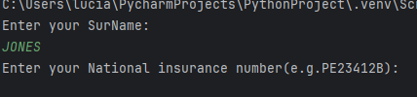
Result: Did the programme behave as expected ie syntactically and logically correct?
YES, the programme accepts “JONES” immediately and proceeds to the next input stage. This is syntactically and logically correct according to the programme’s current validation rules.

Test: Surname
ii. Leave blank

Screenshot(s) of output:
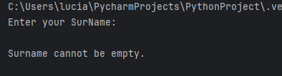
Result: Did the programme behave as expected ie syntactically and logically correct?
YES, the programme prints “Surname cannot be empty.” and repeatedly asks for the surname until the user enters a non-empty value.

Test: Surname
iii. Enter A
Screenshot(s) of output:
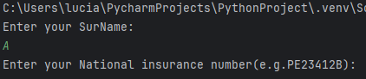
Result: Did the programme behave as expected ie syntactically and logically correct?
YES, the programme accepts “A” as a valid surname and continues, but from a real-world perspective this may be insufficient validation.

Test: Surname
iv. Enter 123
Screenshot(s) of output:
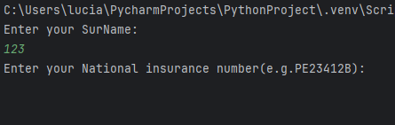
Result: Did the programme behave as expected ie syntactically and logically correct?
YES, but incorrect logically the programme accepts “123” and continues to the next stage
The program does not validate characters, only blank spaces.

Test: National Insurance Number
i. Enter PE534121B
Screenshot(s) of output:
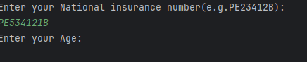
Result: Did the programme behave as expected ie syntactically and logically correct?
YES, when the user enters “PE534121B,” the programme accepts the value immediately and continues to the next stage without performing any structural or syntactical checks. This behaviour is consistent with the code design, because no validation mechanism exists

Test: National Insurance Number
ii. Leave blank
Screenshot(s) of output:
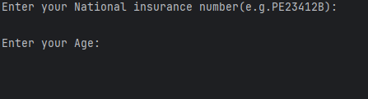
Result: Did the programme behave as expected ie syntactically and logically correct?
YES, If the user presses Enter without typing anything, the programme moves forward, but this is logically incorrect
NINO section contains no loop or conditional checks, allowing invalid and empty submissions to pass.

Test: National Insurance Number
iii. Enter AB11223344556677
Screenshot(s) of output:
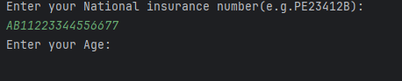
Result: Did the programme behave as expected ie syntactically and logically correct?
YES, the programme accepts the extremely long NINO without objection
The programme behaves as expected from the code’s perspective, but the outcome is logically incorrect. The lack of validation means that structurally impossible NINOs are accepted as valid entries.

Test: National Insurance Number
iv. Enter a letter
Screenshot(s) of output:
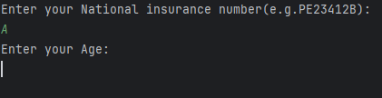
Result: Did the programme behave as expected ie syntactically and logically correct?
YES, the input “A” is accepted without any error messages.
Even though the format is invalid, the programme does not perform any pattern checking to detect this. Then logically is incorrect

Test: Age
i. Enter 34

Screenshot(s) of output:
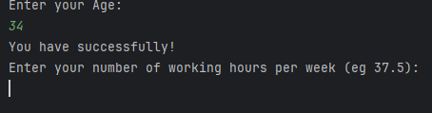
Result: Did the programme behave as expected ie syntactically and logically correct?
YES, the programme accepts the value “34” and proceeds to the next stage without triggering the validation loop
Since 34 < 18 is false, the programme does not enter the while loop. Although the prompt states that age “must be between 0 and 80 inclusive,” this rule is not enforced in the code. Therefore, the value is accepted even though no upper-bound checking is performed.

Test: Age
ii. Enter 150
Screenshot(s) of output:
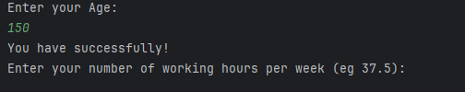
Result: Did the programme behave as expected ie syntactically and logically correct?
YES, The programme accepts “150” immediately, the only validation condition is age < 18.
The programme operates as coded, but it is logically incorrect because unrealistic or out-of-range ages are still accepted.

Test: Age
iii. Enter -4
Screenshot(s) of output:
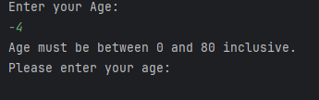
Result: Did the programme behave as expected ie syntactically and logically correct?
YES, the programme prints the message “Age must be between 0 and 80 inclusive.” and prompts the user repeatedly until a value of 18 or greater is entered.
Since −4 is less than 18, the programme enters the validation loop. You must be at least 18 years old to do this.

Test: Age
iv. Enter a letter
Screenshot(s) of output:
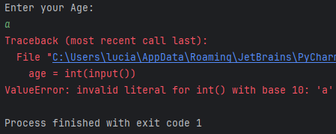
Result: Did the programme behave as expected ie syntactically and logically correct?
NO, the programme does not behave correctly. It fails with an input-conversion error because the original code does not include any mechanism to manage invalid (non-numeric) input.

Test: Number of working hours per week
i. Enter 37.5
Screenshot(s) of output:
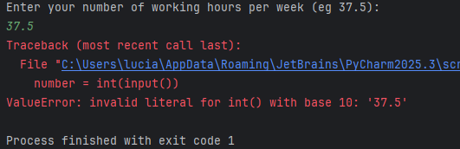
Result: Did the programme behave as expected ie syntactically and logically correct?
NO, the programme immediately crashes when the user enters “37.5”.
The programme does not behave correctly. There is a mismatch between the expected input format and the data-conversion method used in the code

Test: Number of working hours per week
ii. Enter 150
Screenshot(s) of output:
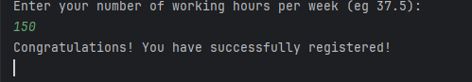
Result: Did the programme behave as expected ie syntactically and logically correct?
YES, the programme accepts “150” as a valid integer and enters the loop because 150 != 0 is true.
Infinite loop due to type change from int to string

Test: Number of working hours per week
iii. Enter 0
Screenshot(s) of output:
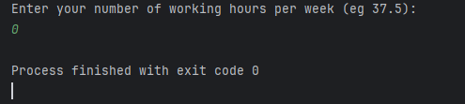
Result: Did the programme behave as expected ie syntactically and logically correct?
YES, the programme accepts “0” and does not enter the loop. It immediately proceeds to the next part of the programme
This is the only input that allows the user to proceed without triggering the infinite-loop issue.

Test: Number of working hours per week
iv. Enter -2
Screenshot(s) of output:
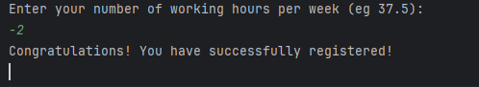
Result: Did the programme behave as expected ie syntactically and logically correct?
YES, the program working and go to the next step but logically is incorrect
Same infinite-loop issue as with 150.

- Consider the results of the above tests and revisit your code in order to solve the problems. (Note: you may not be able to solve all of them, but solve as many as you can.)

Paste your revised code here:

print("Enter your Surname:")
surname = input().strip()
while surname == "" or not surname.isalpha():
if surname == "":
print("Surname cannot be empty.")
else:
print("Surname must contain alphabetic characters only (A–Z).")
surname = input("Please enter your Surname again: ").strip()

print("Enter your National Insurance Number (e.g.PE23412B):")
nino = input().strip().upper()
nino_pattern = r"^[A-Z]{2}\d{6}[A-Z]$"
import re
while nino == "" or not re.match(nino_pattern, nino):
if nino == "":
print("National Insurance Number cannot be empty.")
else:
print("Invalid format. A valid NINO must be in the form AB123456C.")
print("It must contain:")
print("- Two starting letters")
print("- Six digits")
print("- One final letter")
nino = input("Please re-enter your National Insurance Number: ").strip().upper()

while True:
raw = input("Enter your Age (0–80 inclusive): ").strip()
try:
age = int(raw)
except ValueError:
print("Invalid input: please enter a whole number (e.g., 34).")
continue
if not (0 <= age <= 80):
print("Out of range: age must be between 0 and 80 inclusive.")
continue
if age < 18:
print("You must be 18 or older to register.")
continue
break
print("Age accepted:", age)

print("Enter your number of working hours per week (e.g., 37.5):")
hours_text = input().strip()
pattern = r'^\d+(\.\d{1,2})?$'
while hours_text == "" or not re.match(pattern, hours_text):
print("Invalid input. Please enter a numeric value (e.g., 37.5).")
hours_text = input("Enter your number of working hours per week: ").strip()
hours = float(hours_text)
while hours < 0 or hours > 80:
print("Out of range. Working hours must be between 0 and 80 inclusive.")
hours_text = input("Please re-enter your working hours (0–80): ").strip()
while hours_text == "" or not re.match(pattern, hours_text):
print("Invalid input. Please enter a numeric value (e.g., 37.5).")
hours_text = input("Please re-enter your working hours (0–80): ").strip()
hours = float(hours_text)
print("Congratulations! You have successfully registered!")

