BMSW4003 : Digital Skills and Research Methods

Virtual Learning Impact on Students
Student Name: Mahoule Olympio
Student ID : 1816877

[Abstract]
Virtual learning has now become a vital part in learning as well as organizational training. VLE is delivered via different electronic media such as extranets, internet, and interactive television. It is a kind of customised learning that allows students to select and review different materials at their own pace. Virtual learning is vital as it shortens the amount of time required to update students. It provides real time education of significant just in time knowledge. Besides with the covid-19 pandemic most learning institutions have shifted to virtual learning.

Contents
Introduction 3
Rationale of the study. 4
Aims and objectives 5
Methodology 6
Analysis 8
Primary analyses 8
Secondary Data analyses 11
Conclusion 12
Recommendations 12
REFERENCES 13
APPENDIX (Questionnaire) 15

Introduction
(Eardley, 2020), suggests that virtual learning environment is more of a platform that offers students the opportunity to interact with their teachers with the help of the internet. It has assisted professors to generate teaching materials as well as foster interactions with students. This report will discuss the experience of students while doing virtual learning. A survey will be used to conduct the existing research on virtual learning environment of students. Also the report will include both primary and secondary data. An analysis of the quantitative data will also be collected via a questionnaire. Before completing the report recommendations will be provided. VLE is described to be a technology which provides students and their teachers with a platform to continue with their studies.

Rationale of the study.
According to (Shevchenko, 2016) virtual classrooms are mainly used to supplant or rather imitate the traditional ways of reading in classrooms. Even so VLE is used to enhance the learning experiences as it can be used both with virtual and physical classrooms. In simple words it creates a more of multi-directional approach in learning. While most people are appraising the introduction of VLE some researchers like Munro, (2013) argue that education requires physical interactions between the learners and the instructors. Take for instance university students are in most cases allowed to interact with their instructors outside school. Even so in virtual learning, students are still able to reach out to their instructors via social media platforms and email. The disadvantage comes in when the teacher might not be online at that particular moment. (Simpson, 2017), stated that being hackneyed from the classroom needs physical space that might be limited due to the available number of students. The challenge comes in at selecting the students who will have access to classrooms, colleges and universities through implementing the GGPA method (Zoega, 2015). Considering it is not possible to confine students in classrooms more than the available space in the classroom. A significant number of students are most likely to be left behind. This is one o the key reasons as to why virtual learning is vital. There are various arguments closely associated with VLE. They include affordability, life long learning, flexibility and policy are some of the primary arguments that are closely associated with this type of learning (Guo, 2015). This type of learning even though it is not easily accessible in rural areas it is a cheaper mode education mode as it is lower in terms of transportation and accommodation as compared to the overall cost of institutionalised kind of learning. Flexibility is another vital aspect of VLE. A student can easily plan their own time to finish assignments or an online course. In addition, combining technology and face to face learning environment increases potential of students to learn more. Students are able to learn from anywhere at anytime thus developing new skills in the long run process. Besides now that the world is moving to a digital era most governments are increasing online writing in the current dynamic world.
Due to the Covid-19 pandemic, most learning institutions have been closed thus making students and their teachers to result to home schooling or online. The idea of virtual learning is not new but due to the current circumstances most learning institutions and organizations have been left with no choice other than to carry out their activities from home (Nahai and Kenkel, 2020). Therefore, the rationale of this research is to provide an understanding on the efficacy of education on online platforms. In addition, the primary purpose of the above research is to at least bring out the impact of virtual learning on education. To discover whether or not students find this mode of learning to be better as compared to the traditional ones that involved going to school and sitting in classrooms.

Aims and objectives
- To discover students responses in regards to VLE
- To figure out some of the cons associated with VLE
- To discover the VLE efficacy
- To establish some suggestions that will foster improvement

Methodology
Methodology in research is a term used to define the different techniques and approaches that are used to analyse and collect data (Read the full definition., 2020). The concept is mainly associated with research, data collection methods, types of data as well as sampling methods. In research methods there are two primary things that every researcher is expected to focus on? One being the numeric pattern while the other is the flow.
In research, there exist two primary methods. The primary aim of quantitative is to collect and analyse data than locate a pattern in the collection that will bring out the impact of the situation at hand (Qualitative vs. Quantitative Research | Differences & Methods, 2020). On the other hand, quantitative data, does not necessarily reveal the underlying causes. Instead, it has its main focus on the reasons as to why the situation is the way it is. Therefore, the method that will be used on this survey will mainly focus on the cause as well as provide a detailed analysis and not just the severity of the challenge or situation.
This type of research method is mainly associated with the flow. Here, flow can be categorised into two the movement from data to theory and vice versa (Contributor, 2020). If for instance the research flows from theory to data, it is regarded as inductive. If instead the research establishes a theory then seeks out to collect data then it is regarded to be deductive
For this survey the selected methods are quantitative research and deductive method considering it involves the use of a questionnaire to collect the data. The collected data has been analysed numerically.
Collected data can be both numeric and non-numeric. Numeric kind of data is collected through quantitative data while the other one is via qualitative data (Wood, n.d.).
Primary data is described as the type of data that is engendered only by the investigator while secondary data is gamed by a previous research investigator.
While conducting the above research, numeric approach has been utilised mainly because the researcher has collected information via a structured questionnaire and then summarised the data in a numeric manner to bring out the results. Even so, the data has been gathered online considering the respondents received the questionnaire via WhatsApp group and email. In this case both primary and secondary data have been utilised. Secondary type of data has been gathered from published articles online. The population here is defined to be the circle that is comprised of all the respondents involved in the study. Even so, it is challenging or rather time consuming to reach out to all the respondents. In this case, the pragmatic approach has been used to collect information from a portion of the sample. Random sampling technique has been applied in this case. The size of the sample comprises of 15 respondents.
Considering data has been gathered through online activities, privacy has been upheld. The questioners have no display of personal information such as IDs and Emails of the respondents. The consent of the respondents has also been collected considering their responses are going to be revealed.

Analysis

Primary analyses
Question 1: Has VLE improved the experience of Learning?
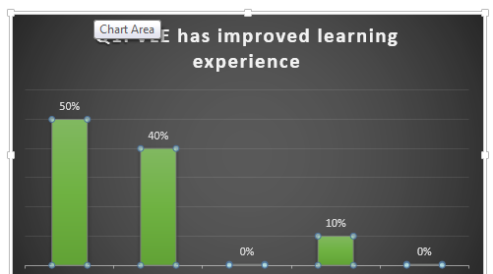
The above figure has demonstrated that 50% of those asked the question strongly agreed and supported, whereas 40% agreed and the other 10% disagreed. In addition to the above data the above data, students can easily access the resources of the VLE that’s why almost 90% of the students replied in favour as it gives them better understanding of the subject matter. For example, the video animation audio would portray a more descriptive subject topic
Question 2: How accessible is VLE

The above diagram shows 40% of the students strongly agreed, 30% of them agreed whereas 15% disagreed with 10% neutral and 5% strongly disagree. The response is justified by the fact that most students take different online courses and are conversant with the VLE. The neutral comments came as result of poor internet speed among some students. The 20% who disagreed felt that the materials cannot be accessed by all especially by students outside the university.
Question 3: How students use VLE to further their understanding?

In the above figure, 70% of the students replied in favour of the questions, whereby 40% agreed and 30% strongly agreed.20% of the students disagreed while the other10% strongly disagreed and none was neutral. The justification of the above response is that 70% of the respondents felt they were not able to consult their professors

Question 4: Do you just use VLE to demonstrate your engagement with learning?

35% agreed, 25% strongly agreed, 5% neutral while 15% disagreed and 20% strongly disagreed. The reason to the response is that most of the students claim to engage with the VLE to have the lecture materials. Their intensions was not to learn but gather materials. The ones that did not agree showed that they used the platform comprehend the matter of the subject. This means their main intention was to acquire more knowledge.
Question 5. Has VLE reduced the significance of teaching?

When the question was asked 20% agreed, 20% strongly agreed, 35% disagreed, 25% disagreed and 0% neutral. Their response showed a mixture of reaction in agreement and disagreement. The reason of this percentage is that about 40% of the people believed that .they can learn through maximizing of VLE .Therefore, the use of classrooms and teachers has gone down as others actually think it’s helpful to provide continues mentorship and solutions to difficult questions related to VLE. This means that the teachers are still needed.

Secondary Data analyses
How Popular VLE is in various geographic locations
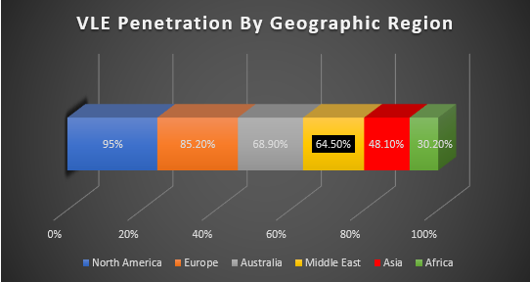
Source: Google, 2020.
The above figure shows the percentage of various universities in diverse regions that are using VLE. The graph demonstrates that North America is one of the most frequent VLE user.

VLE frequency
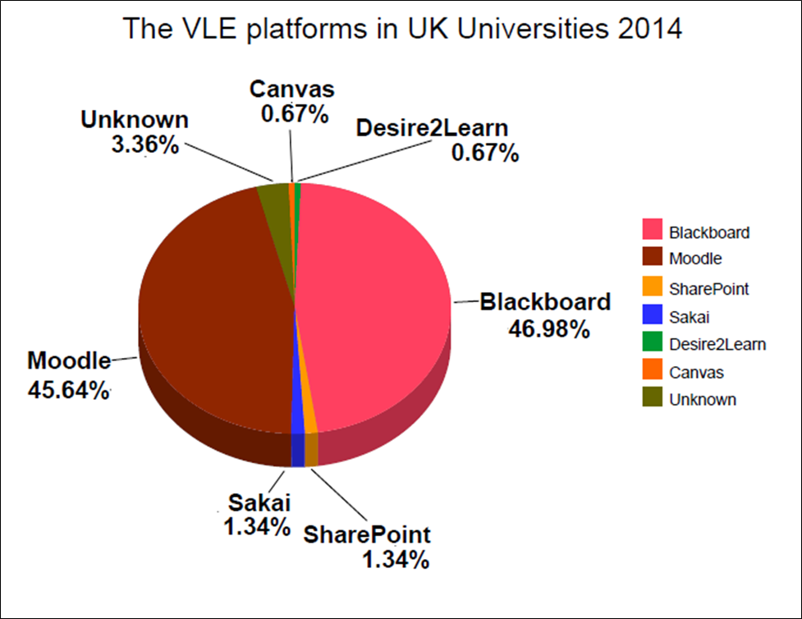
Source: (Shevchenko, 2016)
The diagram above demonstrates that about 90% of the students participate actively with virtual learning at least every month that reveals virtual learning is a vital learning process. The above picture has demonstrated the popularity of various virtual platforms among learning institutions in the United Kingdom. Also, it shows that Blackboard and Moodle are the most used tools in the platform.

Conclusion
In summation the above report has provided a detailed research on the impact of virtual learning. The report has used both secondary and primary data. The primary data has been achieved with the help of Excel. In addition the data in the report has been presented virtually. The response of students in regards to VLE has also been depicted in the secondary data. The research also involved quantitative research where data has been collected through a questionnaire. Ethical considerations have also been observed keenly.

Recommendations
The two most popular VLE platforms used are the blackboard and Moodle. Even so it is advised that professors and teachers consult students on the one that they prefer to use. Also this platform should not be used to conduct exam sessions considering there might be cases or rather opportunities for students to cheat. The platform needs to have options where questions can be stored so that the professors can come up with database that stores complex problems and questions as well as their solutions. In addition, VLE has the potential to provide students with the opportunity to not attend classes, therefore a way that assures students attendance needs to be developed. The materials in VLE can be accessed by students who belong to a different learning institution. Therefore, students might be asked to come up with a nominal account that they can use to access the VLE materials that are used by the university.

REFERENCES

BusinessDictionary.com. 2020. Read The Full Definition.. [online] Available at: <http://www.businessdictionary.com/definition/research-methodology.html> [Accessed 12 August 2020].
Contributor, A., 2020. Deductive Reasoning Vs. Inductive Reasoning. [online] livescience.com. Available at: <https://www.livescience.com/21569-deduction-vs-induction.html> [Accessed 12 August 2020].
Eardley, I., 2020. A New Normal?. BJU International, 126(2), pp.215-217.
Foss, J., 2009. Lessons from learning in virtual environments. British Journal of Educational Technology, 40(3), pp.556-560.
Guo, B., 2015. Technology Effects on Trade Virtual Factor Advantages by Technological Differences. SSRN Electronic Journal,.
Munro, E., 2013. Why Physical Education?. Journal of Health, Physical Education, Recreation, 32(9), pp.28-28.
Nahai, F. and Kenkel, J., 2020. Accelerating Education During COVID-19 Through Virtual Learning. Aesthetic Surgery Journal Open Forum, 2(2).
Scribbr. 2020. Qualitative Vs. Quantitative Research | Differences & Methods. [online] Available at: <https://www.scribbr.com/methodology/qualitative-quantitative-research/> [Accessed 12 August 2020].
Shevchenko, D., 2016. Competitive Advantages of a Modern University: A Virtual University. SSRN Electronic Journal,.
Simpson, D., 2017. Advantages and disadvantages of international virtual project teams. International Business And Global Economy, 36(1).
Wood, B., n.d. Review Of Scientific & Technical Numeric Data Base Activities.
Zoega, G., 2015. Productivity and Institutions. Veftímaritið Stjórnmál og stjórnsýsla, 11(2), p.375.

APPENDIX (Questionnaire)
Questionare
Question | Agree | Disagree | Neutral | Strongly Agree | Strongly Disagree
Has VLE improved the experience of Learning?

How Accessible is VLE
How students use VLE to further their understanding.
Do you just use VLE to demonstrate your engagement with learning?
Has VLE reduced the significance of learning

