Effective Team-working and Communication - Task 2

Effective Team-working and Communacatoins – Task 2
Student Name: Noemi Bagi
Student ID: 2330383

Table of Contents
Introduction 3
What we have learnt about effective teams. 4
Conclusion 7
References 8

Introduction
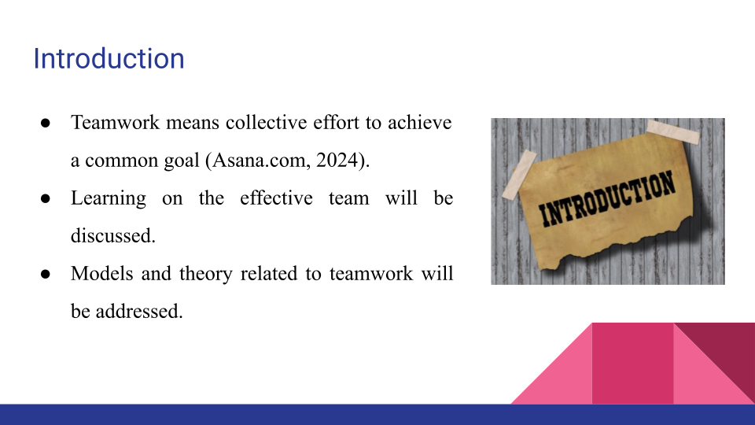
Bullets Points:
- Teamwork means collective effort to achieve a common goal (Asana.com, 2024).
- Learning on the effective team will be discussed.
- Models and theory related to teamwork will be addressed.
Teamwork is a collaborative effort of a group of individuals with the aim of attaining common objectives (Asana.com, 2024). In the presentation, the lessons I have learnt about effective teams will be addressed in detail. Furthermore, the insights of the models and theory will be discussed with examples of how they improve teamwork, flexibility, and outcomes.

What we have learnt about effective teams.
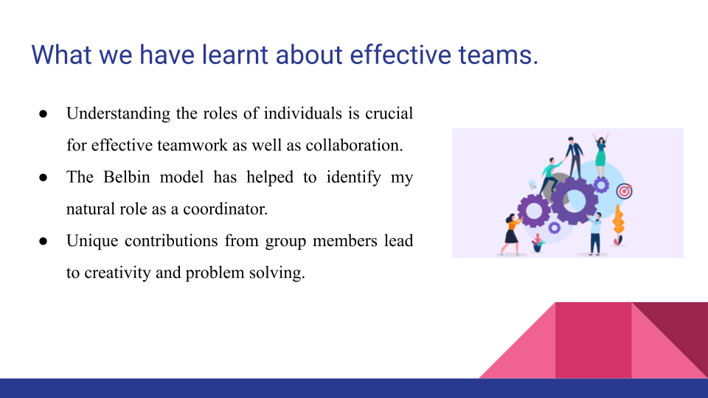
Bullets Points:
- Understanding the roles of individuals is crucial for effective teamwork as well as collaboration.
- The Belbin model has helped to identify my natural role as a coordinator.
- Unique contributions from group members lead to creativity and problem solving.
In relation to the concept of effective teamwork, I have learned operational aspects of teams and factors that support them. The significance of understanding individual roles within a team is one of the key lessons. For instance, belbin’s team role model has helped me to further identify my roles as a coordinator that focuses on integration and activities achieving (Icehrm.com, 2024). This awareness helps me to actively employ the skills such as planning and delegation and making sure everyone is working in harmony. Moreover, I also realise that every individual working in a group has unique contributions that can be utilised for enhancing efficiency, creativity and problem solving.

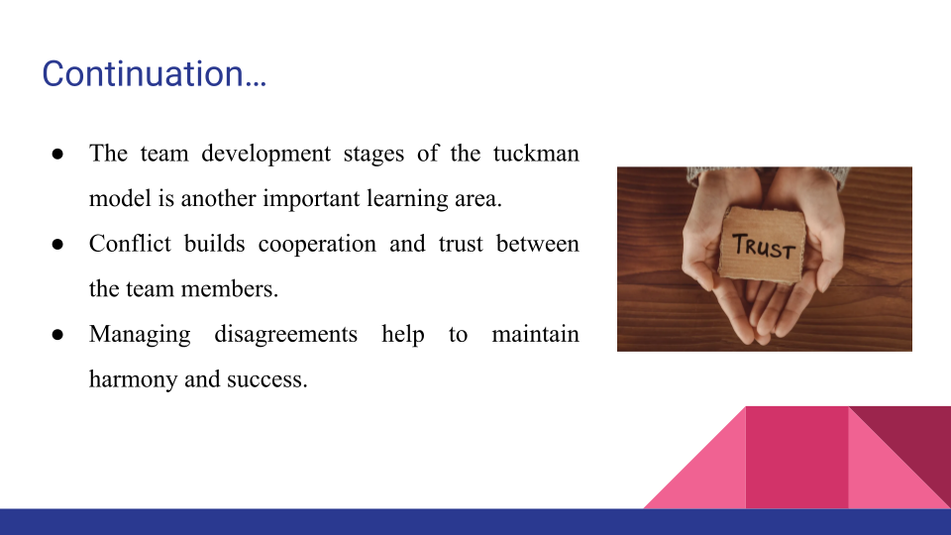
Bullets Points:
- The team development stage of the tuckman model is another important learning area.
- Conflict builds cooperation and trust between the team members.
- Managing disagreements help to maintain harmony and success.
Another important learning area is the team development stage as captured in the tuckman team development model. Earlier, I used to think that conflicts during team development stages hinder the process, but now I think that it helps build cooperation and trust between the team members. For instance, managing disagreement has given me practical lessons on how to manage expectations in the group transaction from forming to performing phases. This model enables me to deal with challenges patiently and with a long-term vision as well as maintaining team harmony.

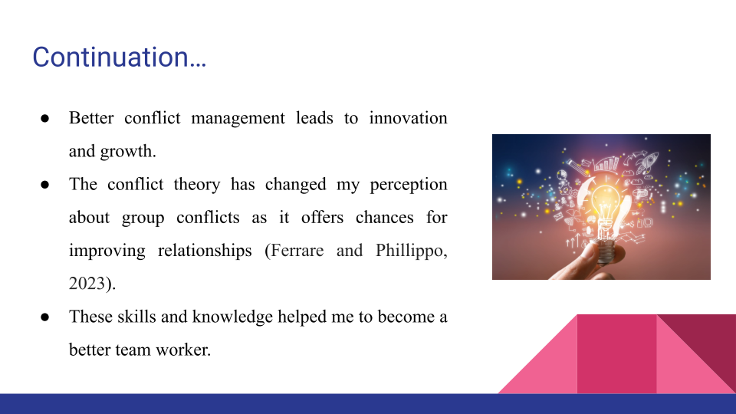
Bullets Points:
- Better conflict management leads to innovation and growth.
- The conflict theory has changed my perception about group conflicts as it offers chances for improving relationships (Ferrare and Phillippo, 2023).
- These skills and knowledge helped me to become a better team worker.
Moreover, I have also learned that better conflict management is also a source of innovation and growth. The conflict theory has helped me to change the way I look at conflicts, and realise that they are in fact the chances to solve misunderstandings and improve relationships (Ferrare and Phillippo, 2023). Now, I handle the conflicts through active listening as well as promote open communication to solve the issues properly. I have acquired more self-understanding, emotional skills and beliefs which enhance equal and collaborative teamwork. All these skills have helped me alter my working style when it comes to working in a team and thus now I am a better team worker.

Conclusion
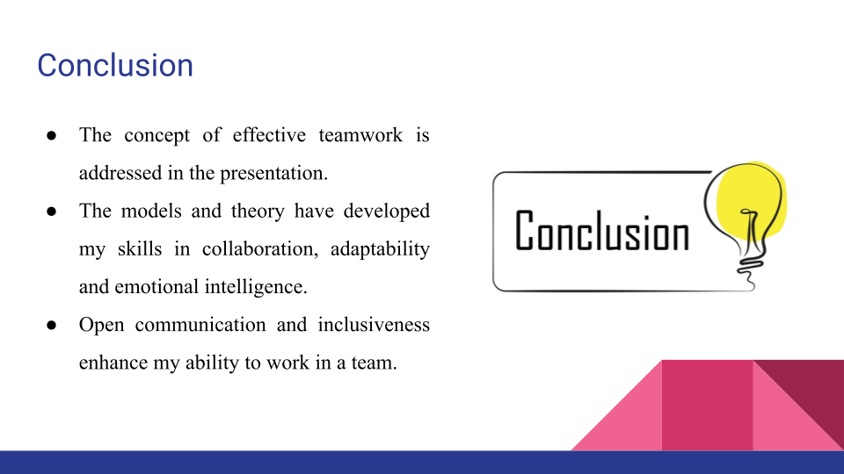
Bullets Points:
- The concept of effective teamwork is addressed in the presentation.
- The models and theory have developed my skills in collaboration, adaptability and emotional intelligence.
- Open communication and inclusiveness enhance my ability to work in a team.
The lessons that I have learned about effective teamwork are explained in the presentation. Theoretic models such as Belbin and Tuckman as well as conflict theory have helped me develop more skills in collaboration, adaptability as well as emotional intelligence. Furthermore, the development of inclusiveness and open communication make me better placed to perform a cohesive and high performing team in any environment.

References
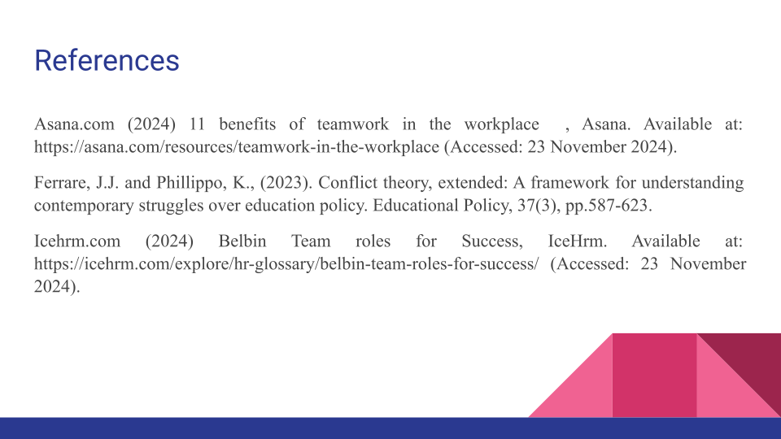
Asana.com (2024) 11 benefits of teamwork in the workplace , Asana. Available at: https://asana.com/resources/teamwork-in-the-workplace (Accessed: 23 November 2024).
Ferrare, J.J. and Phillippo, K., (2023). Conflict theory, extended: A framework for understanding contemporary struggles over education policy. Educational Policy, 37(3), pp.587-623.
Icehrm.com (2024) Belbin Team roles for Success, IceHrm. Available at: https://icehrm.com/explore/hr-glossary/belbin-team-roles-for-success/ (Accessed: 23 November 2024).



