Shay, Pippa
2417658
Computational Modelling of Ballistic Impact
Physics ACDB4007

Contents
Section 1: Abstract 2
Section 2: The Importance of Johnson- Cook 2
Section 3: Types of Stress 2
3.1 Maximum Principal Stress 2
3.2 Shear Stress 3
Section 4: Simulation 1 3
4.1 The Background 3
4.2 Results 4
4.3 Analysis of Results 9
Section 5: Simulation 2 9
5.1 The Background 9
5.2 Results 10
5.3 Analysis of Results 14
Section 6: Conclusion 15
Section 7: References 15

Figure 1 – Johnson-Cook Formula [1] 2
Figure 2 – Maximum Principal Stress Formula [3] 3
Figure 3 – Shear Stress Formula [5] 3
Figure 4 – Properties of 304 Stainless Steel [6] 4
Figure 5 – More Properties of 304 Stainless Steel [7] 4
Figure 6 – Maximum Principal Stress at First Impact 5
Figure 7 – Shear Stress at First Impact 5
Figure 8 – Maximum Principal Stress as Bullet Moves Through Armour Plate 6
Figure 9 – Shear Stress as Bullet Moves Through Armour Plate 6
Figure 10 – Maximum Principal Stress as Bullet Slows in Armour Plate 7
Figure 11 -Shear Stress as Bullet Slows in Armour Plate 7
Figure 12 – Maximum Principal Stress of Armour Plate as Bullet Leaves 8
Figure 13 – Shear Stress of Armour Plate as Bullet Leaves 8
Figure 14 – Three Velocities of Bullet 9
Figure 15 – Singular Velocity of the Bullet 9
Figure 16 – Maximum Principal Stress Upon First Contact 11
Figure 17 – Shear Stress Upon First Contact 11
Figure 18 – Maximum Principal Stress as Bullet Enters Armour Plate 12
Figure 19 – Shear Stress as Bullet Enters Armour Plate 12
Figure 20 – Maximum Principal Stress as Bullet Fully Entering Armour Plate 13
Figure 21 -Shear Stress as Bullet Fully Entering Armour Plate 13
Figure 22 – Maximum Principal Stress as Bullet Stops 14
Figure 23 – Shear Stress as Bullet Stops 14
Figure 24 – Velocities of the Bullet 15
Figure 25 – Vertical Velocity of Bullet 15

Section 1: Abstract
In this report the software Abaqus has been used to model a bullet hitting an armour plate. The model has been changed by the student to give examples of different speeds of bullet and different properties making up the bullet. Research has been done in Johnson-Cook values of different steels. This report covers whether it was maximum principal stress that caused the armour plate to fail or shear stress.

Section 2: The Importance of Johnson- Cook
The Johnson-Cook values of a material are established with this formula:
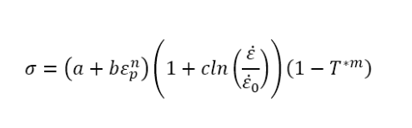
Figure 1 – Johnson-Cook Formula [1]
The key components of the formula are: the equivalent plastic strain, the strain rate and the temperature [2]. The Johnson-Cook formula is important as it describes the behaviours of metals under large strains and high stress rates [1]. This formula is used by engineers and scientists to predict how a material will respond to different loading conditions [2].

Section 3: Types of Stress

3.1 Maximum Principal Stress
The maximum principal stress can also be described as the maximum normal stress [3], this is because it is the normal stress acting onto the principal plane that has zero shear stress [3]. A principal plane is an oblique plane is classed as anything that is not horizontal or vertical [3,4]. The formula used to calculate the maximum principal would be:
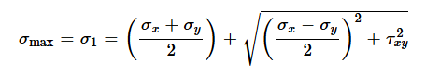
Figure 2 – Maximum Principal Stress Formula [3]

3.2 Shear Stress
The other type of stress being investigated in this report is shear stress. This type of stress is not as commonly known as the maximum principal, it is also not quite as intuitive because it is a force acting along the surface of an object rather than directly onto it [5]. The formula used to calculate shear stress is:
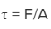
Figure 3 – Shear Stress Formula [5]

Section 4: Simulation 1

4.1 The Background
For the first simulation the bullet was moving at 800ms⁻¹, and the armour plate was made with 304 stainless steel. The properties of this particular steel were researched by the student prior to beginning the simulation. The below properties were found and used for the 304 stainless steel:
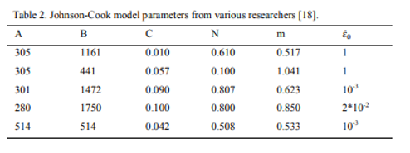
Figure 4 – Properties of 304 Stainless Steel [6]
Other necessary properties of 304 stainless steel such as specific heat were found on a sperate research paper, some of the properties are shown below:
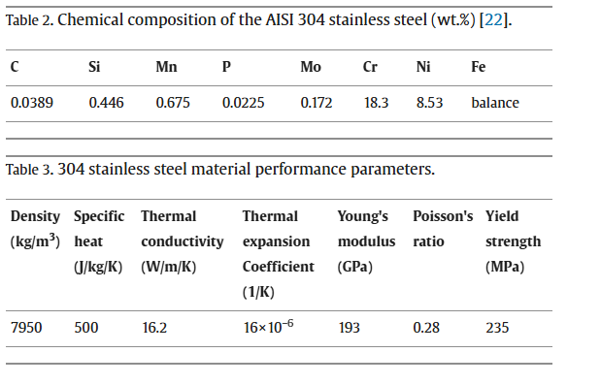
Figure 5 – More Properties of 304 Stainless Steel [7]
The student picked this type of steel as it was a very common type of steel used for kitchen equipment, machinery, nuts, bolts and roofing. The student thought this would then make this a relatable simulation as it would represent what would happen if someone was to use what was to hand to make an armour plate.
The mesh for this simulation was redesigned from the original model given. This mesh was created to be finer in the middle as the create a more accurate picture of what was happening as the bullet hit the armour plate.
The student viewed the results cross sectionally to be able to view the stress throughout the armour plate rather than just on top.
Once viewing the results, the student changed the range of the key on the side to help more accurately show the magnitude of the stress experienced by the bullet and armour plate.

4.2 Results
Upon first impact the armour plate experiences more maximum principal stress than shear stress. This can be seen in the images below:

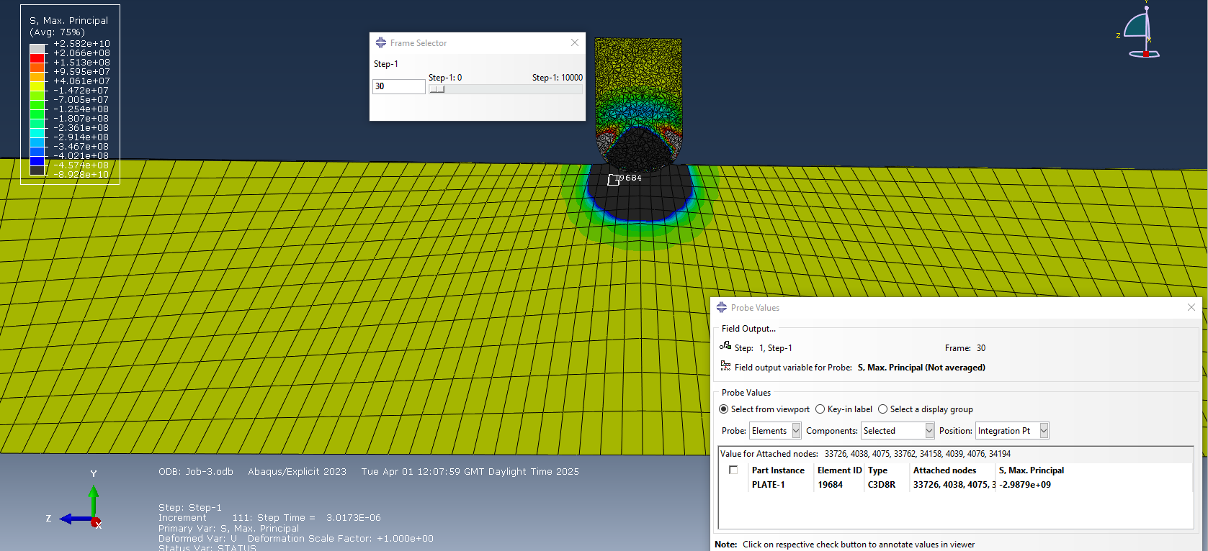
Figure 6 – Maximum Principal Stress at First Impact
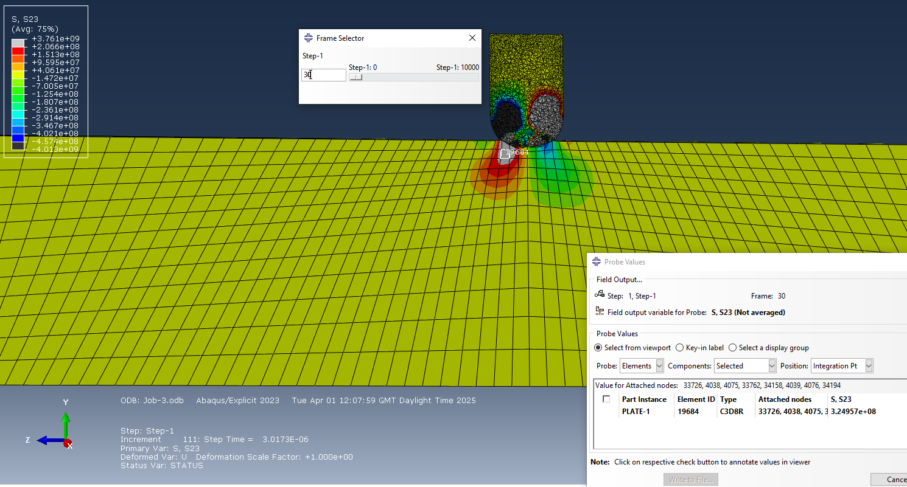
Figure 7 – Shear Stress at First Impact
This stayed the same with the armour plate experiencing more maximum principal stress than shear stress as the bullet began to move through the armour plate, this can be seen below:
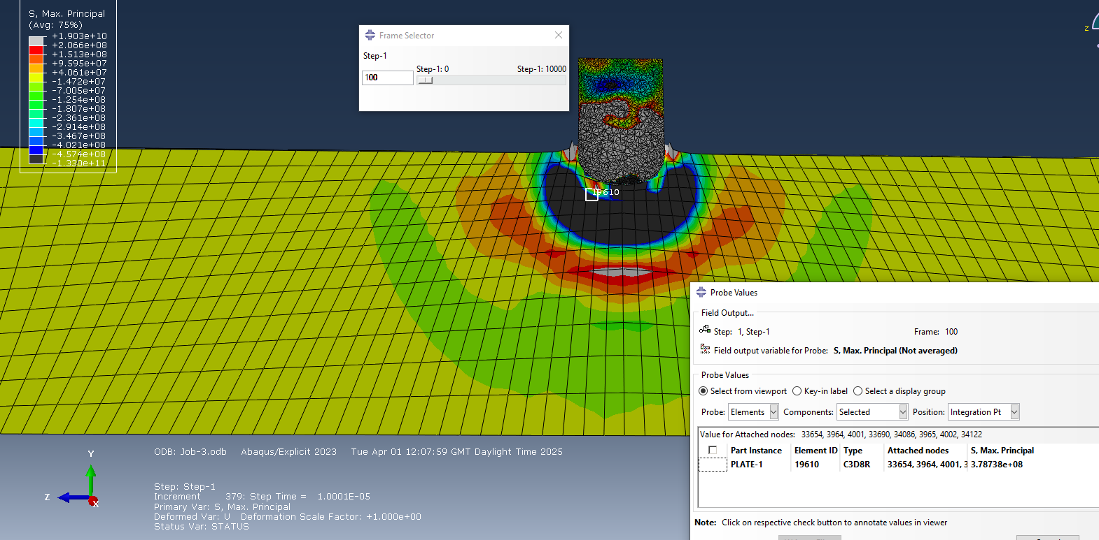
Figure 8 – Maximum Principal Stress as Bullet Moves Through Armour Plate
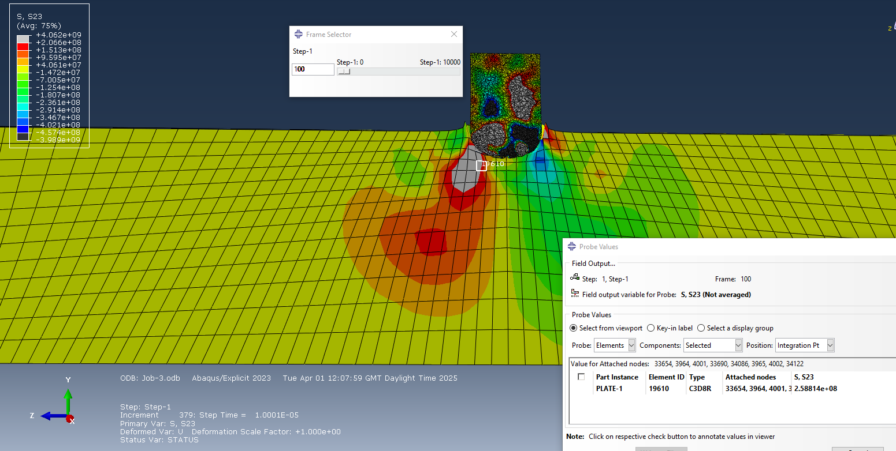
Figure 9 – Shear Stress as Bullet Moves Through Armour Plate
As the bullet began to slow as it moved down through the armour plate the trend stayed the same with the armour plate remaining to experience more maximum principal stress than sheer stress, this can be seen below:
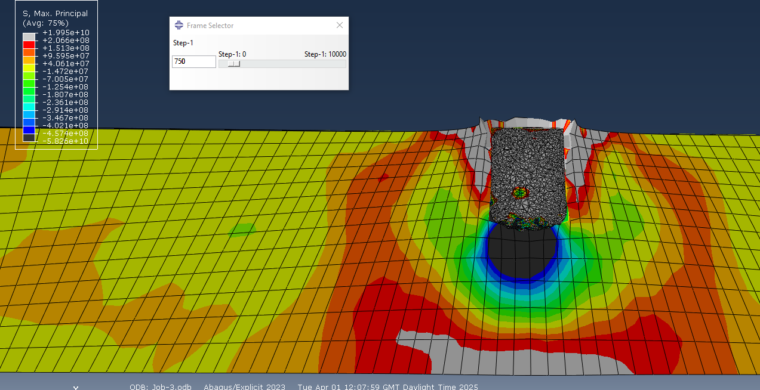
Figure 10 – Maximum Principal Stress as Bullet Slows in Armour Plate
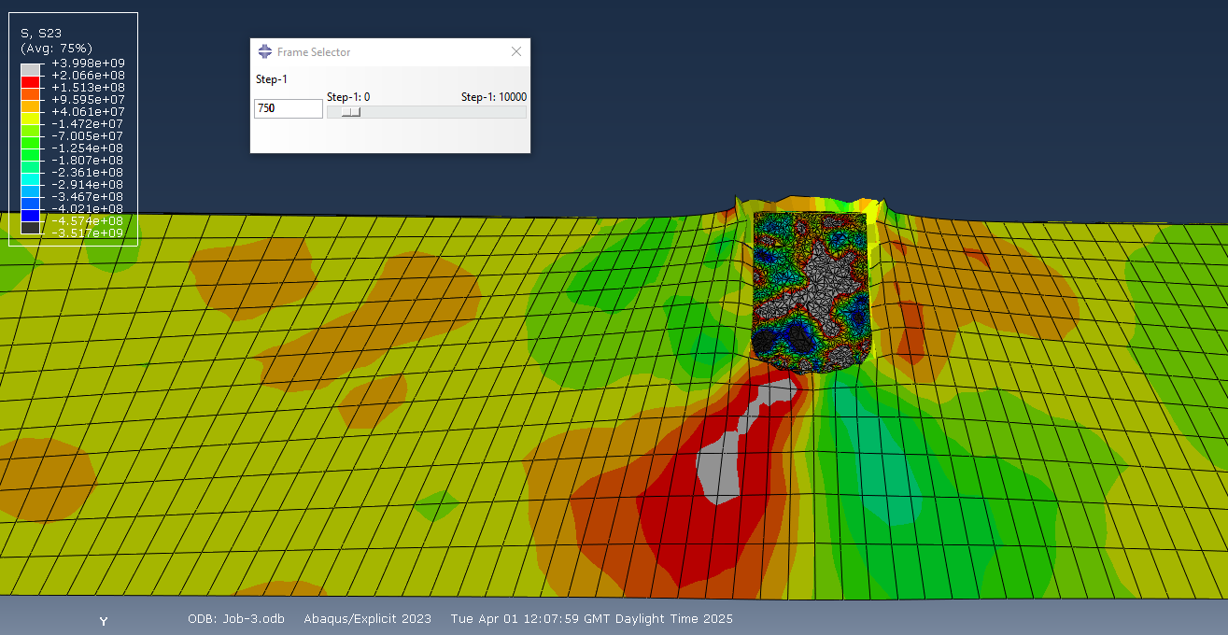
Figure 11 -Shear Stress as Bullet Slows in Armour Plate
As the bullet exits the armour plate, back through the way it went it as it could not penetrate though fully, the stresses are still rippling through the armour plate, this can be seen below:
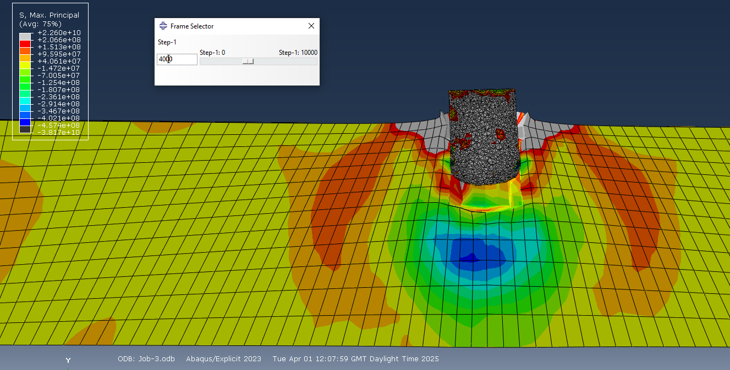
Figure 12 – Maximum Principal Stress of Armour Plate as Bullet Leaves
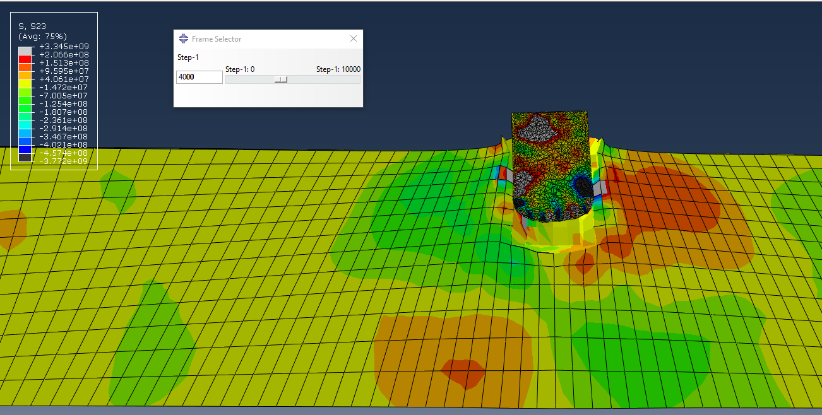
Figure 13 – Shear Stress of Armour Plate as Bullet Leaves
The velocity of the bullet could also be plotted, this is shown on the graph below:
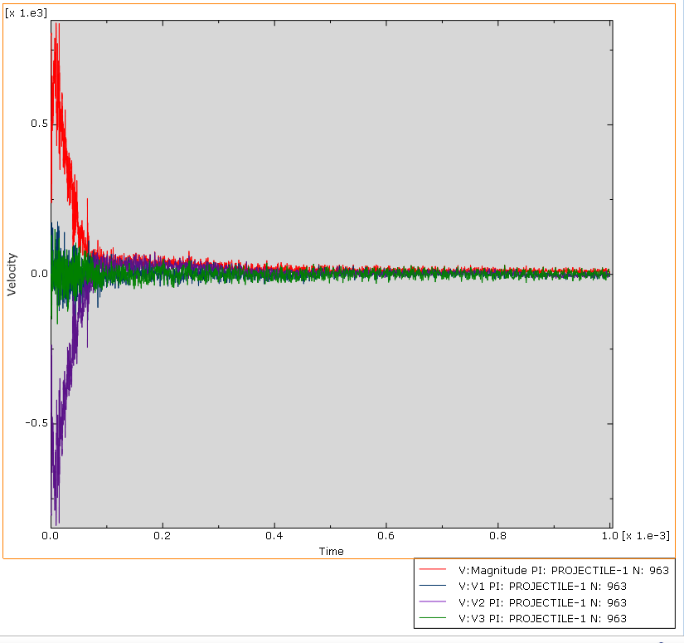
Figure 14 – Three Velocities of Bullet
Looking more closely at just one velocity, the one going in the opposite direction to the beginning of the bullet’s movement, there is both positive and negative velocities showing how the bullet bounced back out a little bit after slowing down to a stop in the armour plate, this can be seen below:
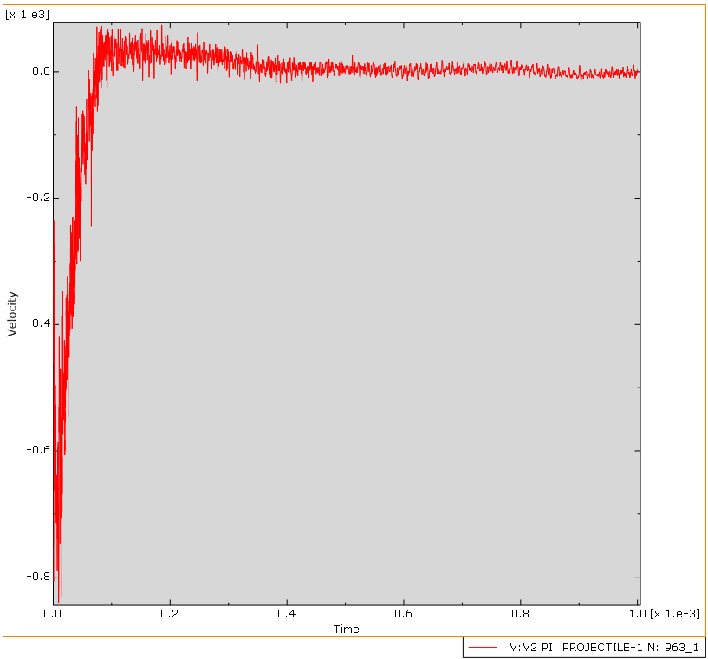
Figure 15 – Singular Velocity of the Bullet

4.3 Analysis of Results
As can be seen above at every stage the armour plate experienced a greater force from the maximum principal stress than the shear stress. During the initial impact the element selected was experiencing -2.99 x10⁹ Pa of maximum principal stress whilst for shear stress the same element was only experiencing 3.25 x10⁸ Pa of stress.
This trend continues throughout with there always being a dark circle or curve under the bullet in the armour plate for the maximum principal stress meaning it was experiencing a force of magnitude around -2 x10⁹ Pa .Whilst for the shear stress there is usually red and green sections coming from it meaning the most amount of shear stress usually experienced is 1.25 x10⁸ Pa which is a considerably smaller stress than the armour plate experiences from maximum principal stress. This shows it was likely the maximum principal stress that caused the armour plate to fail.

Section 5: Simulation 2

5.1 The Background
For the second simulation the bullets speed was changed to 1200ms⁻¹. The armour plate properties were kept as 304 stainless steel. The mesh was kept as had been designed previously by the student, with the finer mesh on to top of the armour plate in the middle to create a more accurate picture of what would happen as the bullet penetrated the upper layers on the armour plate.
Once viewing the results, the student changed the range of the key on the side to help more accurately show the magnitude of the stress experienced by the bullet and armour plate.

5.2 Results
Similarly to simulation 1 this simulation also experienced more maximum principal stress than shear stress upon first contact, this can be seen below:
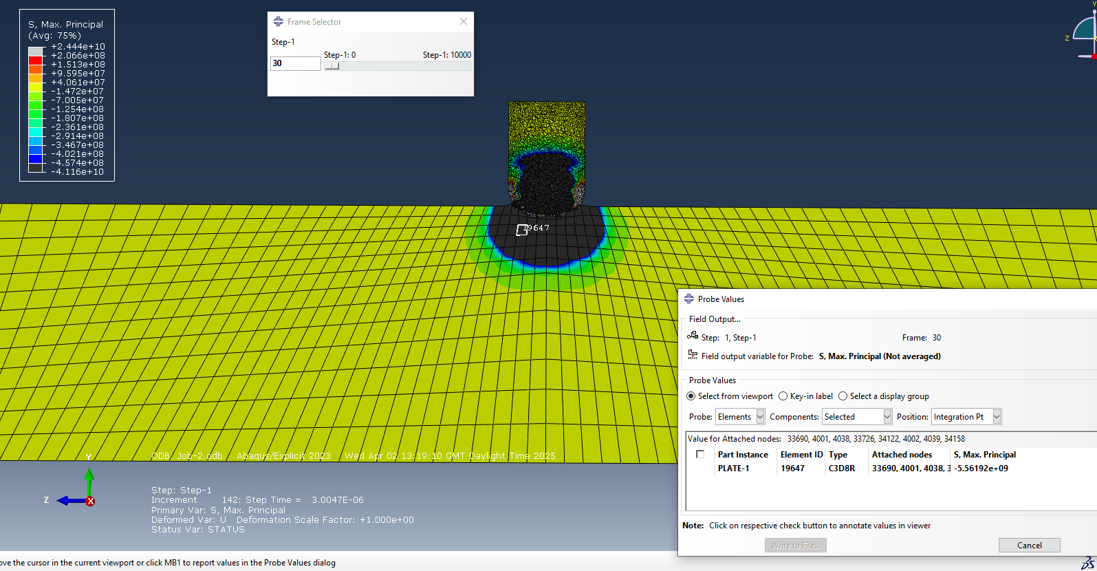
Figure 16 – Maximum Principal Stress Upon First Contact
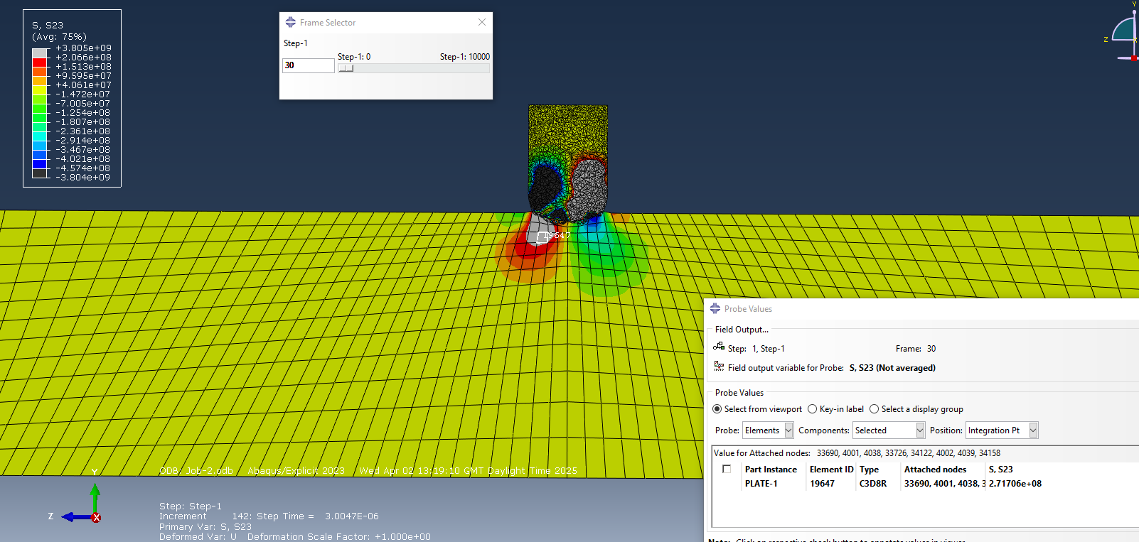
Figure 17 – Shear Stress Upon First Contact
As the bullet continues to move though the armour plate the trend continues where the maximum principal stress experienced by the armour plate is higher than the shear stress. However, interestingly in the maximum principal stress it can be seen a second wave of stress travelling through the armour plate, this can be seen below:
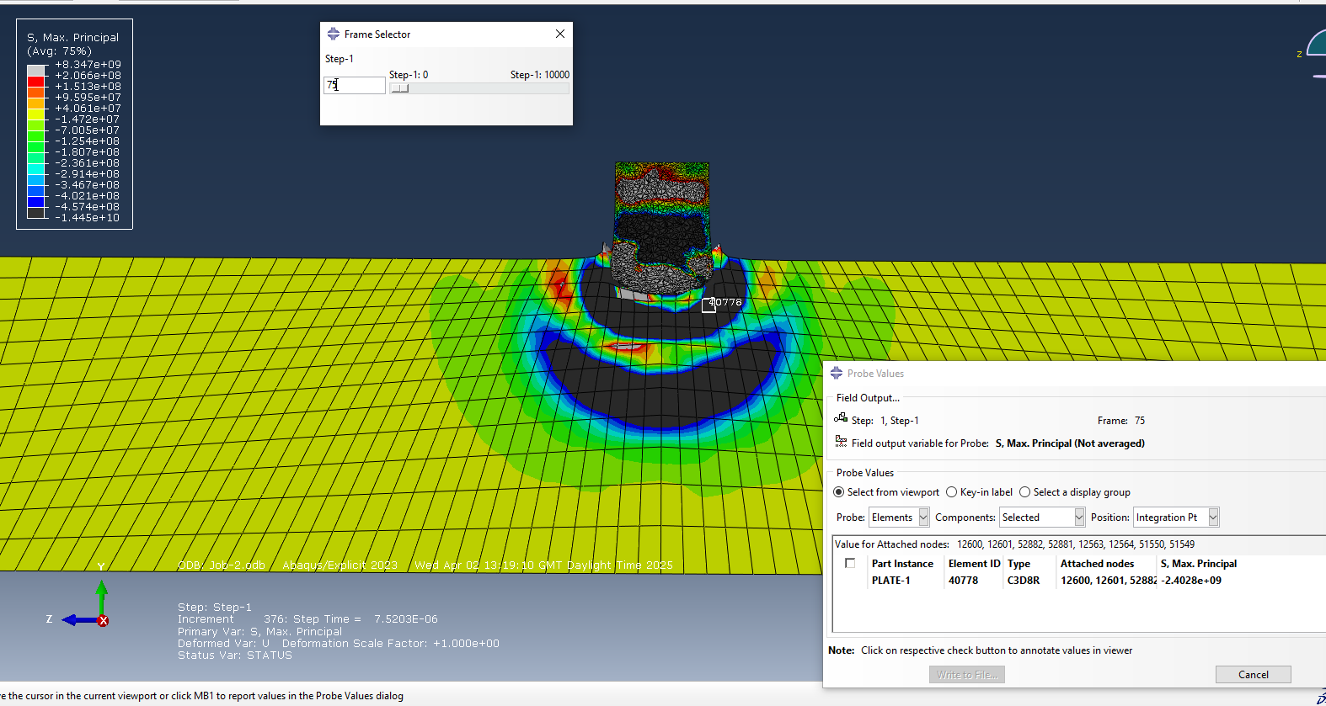
Figure 18 – Maximum Principal Stress as Bullet Enters Armour Plate
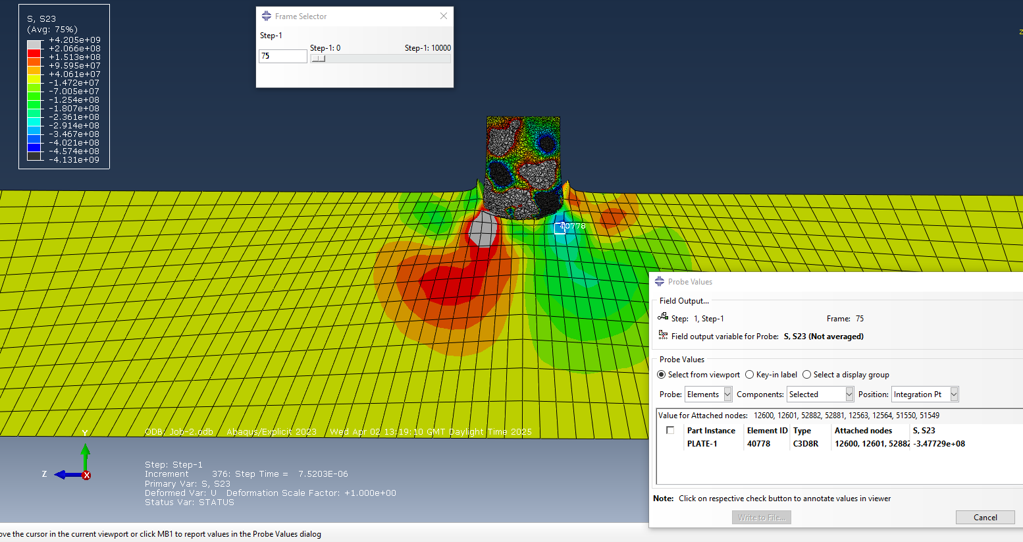
Figure 19 – Shear Stress as Bullet Enters Armour Plate
As the bullet enters fully into the armour plate the two ripples of negative maximum principal stress join. However, the bullet is experiencing a lot of change in shear stress on the right-hand side compared to the left-hand side, with one side being roughly positive 4 x10⁹ Pa and the other side being negative 4 x10⁹pa. The trend of the armour plate experiencing slightly more maximum principal stress than shear stress, this can be seen below:
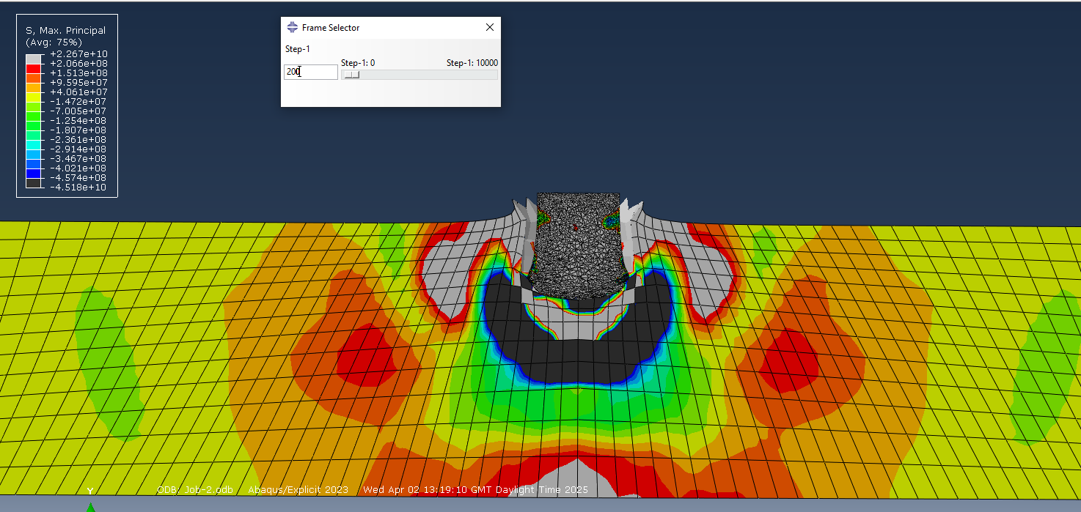
Figure 20 – Maximum Principal Stress as Bullet Fully Entering Armour Plate
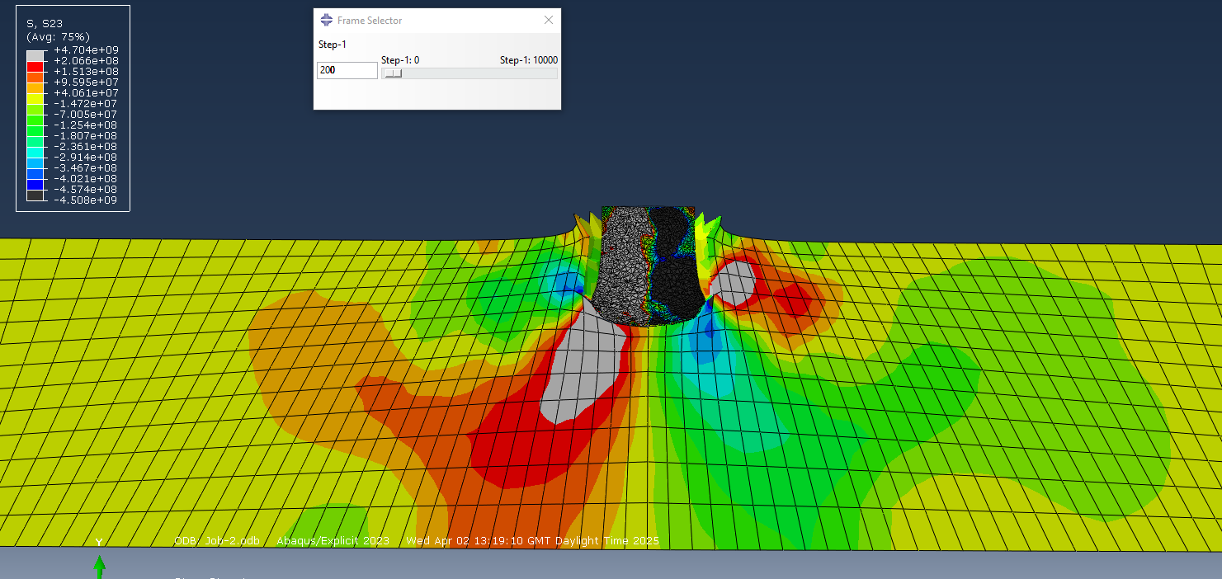
Figure 21 -Shear Stress as Bullet Fully Entering Armour Plate
As the bullet stops in the armour plate the bullet is still experiencing a lot of range in shear stress and the armour plate is experiencing a lot of both stresses but more maximum principal stress, this can be seen below:
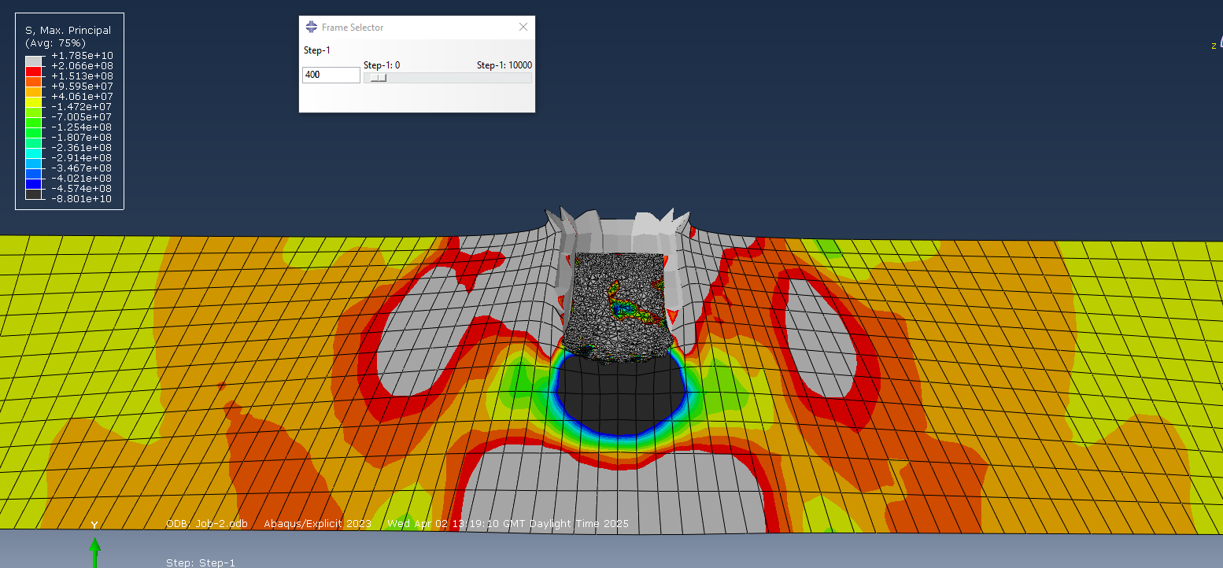
Figure 22 – Maximum Principal Stress as Bullet Stops
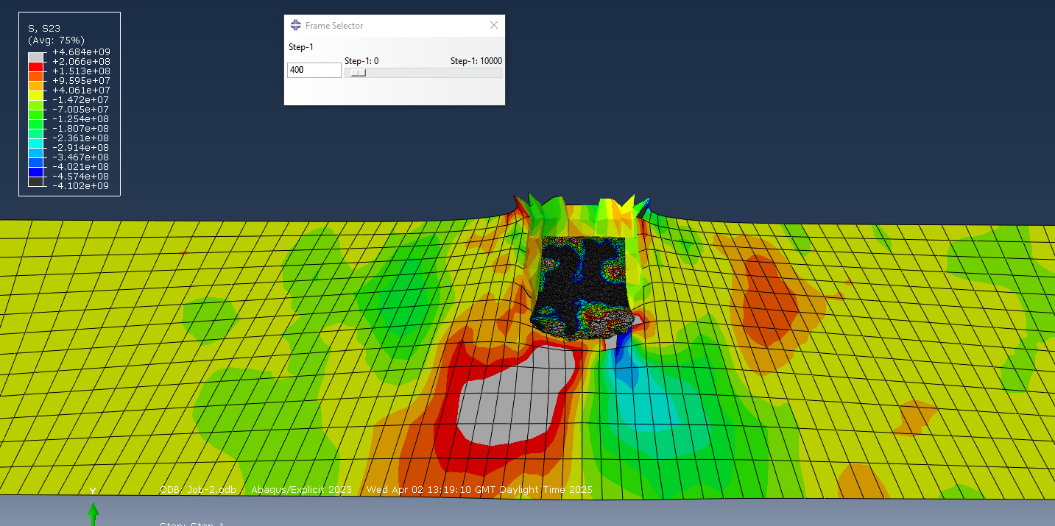
Figure 23 – Shear Stress as Bullet Stops
The velocities of the bullet could also be plotted, this can be seen below:
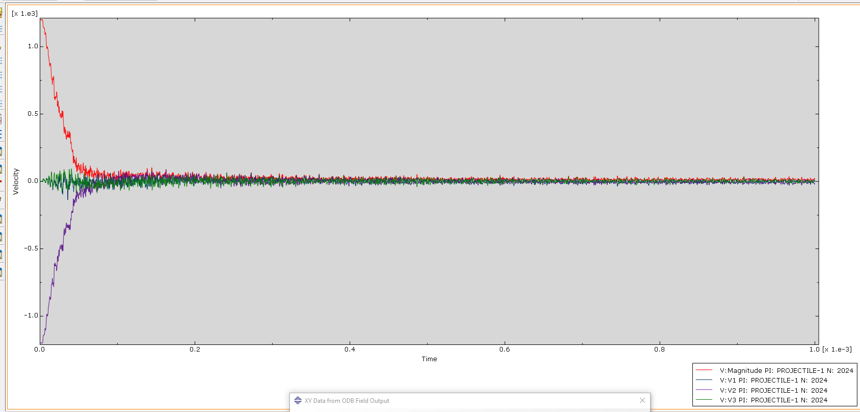
Figure 24 – Velocities of the Bullet
Looking more closely at just one velocity, the one going in the opposite direction to the beginning of the bullet’s movement, there is both positive and negative velocities showing how the bullet bounced back out a little bit after slowing down to a stop in the armour plate, this can be seen below:
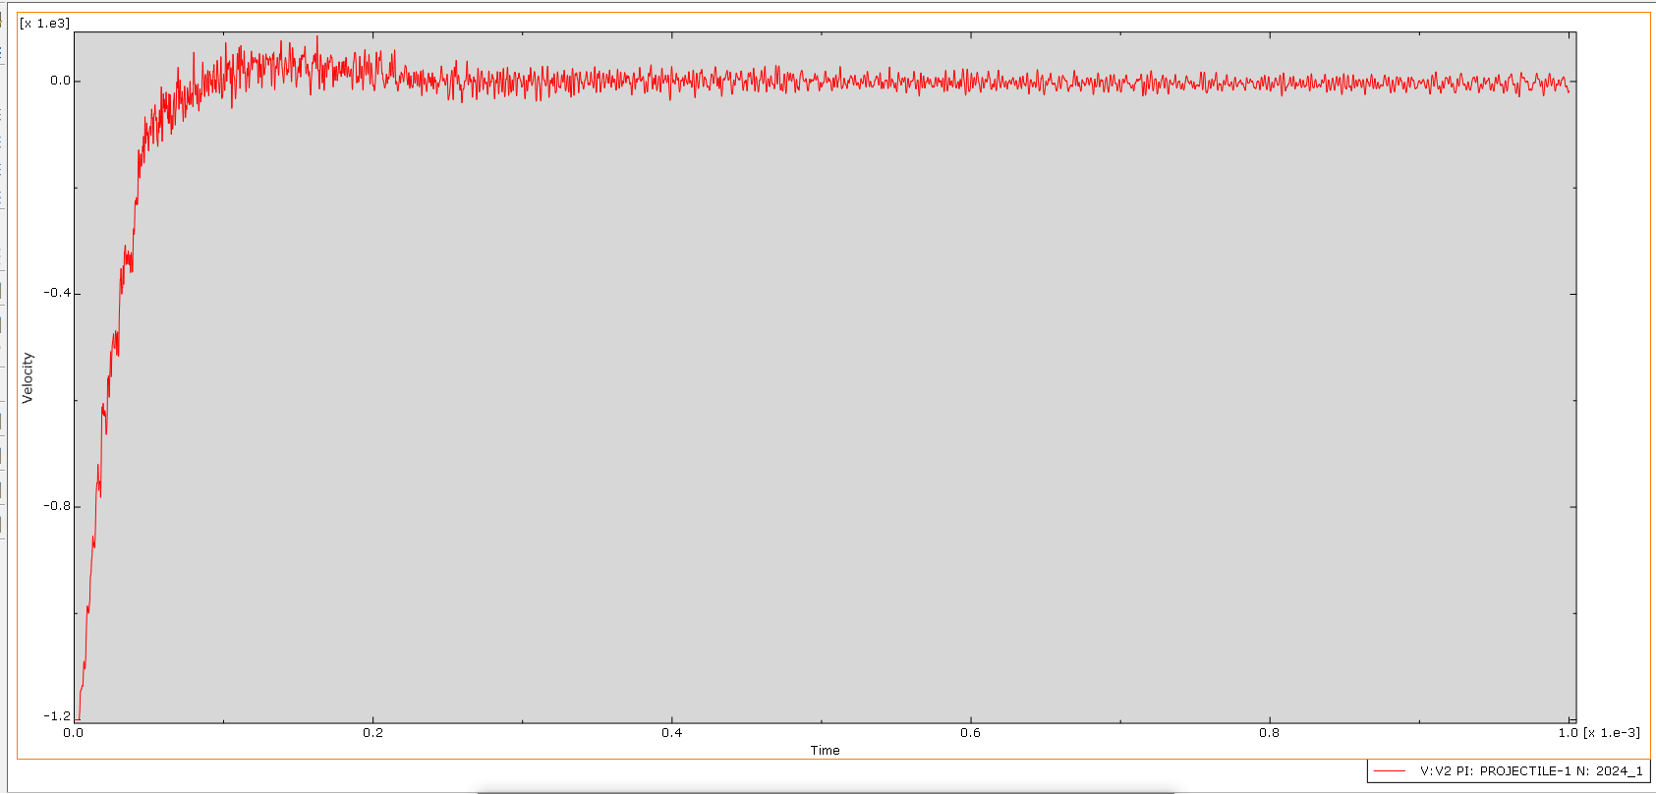
Figure 25 – Vertical Velocity of Bullet

5.3 Analysis of Results
The armour plate throughout the whole simulation experienced more maximum principal stress than shear stress. This can be seen at the first impact of the bullet, one of the elements in the armour plate is experiencing -5.56 x10⁹ Pa of maximum principal stress while the same element is only experiencing 2.71 x10⁸ Pa of shear stress. This difference carries on throughout the simulation, however with the difference in amount of force from each type of stress it was under slowing getting smaller, the armour plate overall experiencing more maximum principal stress than shear stress. The armour plate is experiencing at most 1.8 x10¹¹ Pa of maximum principal stress and 4.7 x10⁹ Pa of shear stress. However, it is to be noted that the bullet experienced a lot of range in shear stress throughout the simulation, with some of the forces being nearly as big as the maximum principal stress forces on the armour plate.

Section 6: Conclusion
For both simulations it was the maximum principal stress was the greater stress on the armour plate. This means it was the maximum principal stress that caused the armour plate to fail and allow the bullet to penetrate. This shows that it was the force directly onto the armour plate rather than the forces along the armour plate that caused it to fail.
If this simulation was the be done again further research should be done into why there was such high levels on shear stress in the bullet and what amount of shear stress the bullet could handle before it failed itself.

Section 7: References
[1] S. Dasanayaka, (2023, January. 31.) Introduction to the Johnson-Cook Material Model [Online]. Available: Introduction to the Johnson-Cook Material Model – Algo Engineering
[2] L. S. Easily, (2025) What is: Johnson-Cook [Online] Available: What is: Johnson-Cook Model Explained in Detail
[3] Pratik (2025) Principle Stress: Definition, Equation, Example, Explained [Online] Available: Principal stress: Definition, Equation, Example, Explained
[4] N. Sarah, (2025) Anatomical Body Planes and Sections – Anatomy and Physiology [Online] Available: Anatomical Body Planes and Sections – Anatomy and Physiology
[5] S. Net, (2025, March. 4.) Shear Stress [Online] Available: Shear Stress: Definition, Formula, and Example Problems
[6] N. E. Karkalos, A. P. Markopoulos, “Determination of Johnson-Cook material model parameters by an optimization approach using the fireworks algorithm” Procedia Manufacturing vol.22, pages 107-113, March 2018
[7] Z. Zou, L. He, T. Zhaou, W. Zhang, P. Tian, X. Zhou, “Research on Inverse Identification of Johnson-Cook Constitutive Parameters for Turning 304 Stainless Steel based on Coupling Simulation” Jornal of Materials Research and Technology volume 23, pages 2244-2262, March-April 2023

