
Individual business model canvas with entreprenorial reflection using appropriate business models
Entrepreneurship (BMIH5001)

Andreea mirica (2028692)
lecturer name: Neil Dyer
Word count: 2198

Hospitality Business Concept – Espresso Editions
Espresso Editions presents a convincing value proposition as a unique coffee shop placed in the vibrant heart of Cardiff. Distinctive in its ambiance and offerings, the café welcomes customers to an aesthetically pleasing space enhanced with book-themed decor and cozy seating arrangements. Here, customers encounter an exclusive selection of high-quality coffee blends, including specialty options, complemented by a range of tasty pastries and desserts, with a particular focus on vegan and health-conscious choices. Beyond its culinary offerings, Espresso Editions serves as a retreat for students and book lovers alike, providing a relaxed environment favourable to both study and leisure. Through engaging events, such as book clubs and literary gatherings, the café encourages a sense of community and intellectual exploration.
Based on Appendix 1, the customer segments for Espresso Editions include demographics such as age and sex, in order to understand and address the current preferences of diverse consumers (Nica et al., 2020), increasing the coffee shop's relevance across different groups in Cardiff’s dynamic social and cultural landscape.
The main target is represented by university students. This demographic consists of young adults, ages 18-24, both male and female, enrolled in undergraduate or postgraduate programs. According to Marshalsey (2023), these students are often in search of quiet, comfortable places to study and collaborate outside university libraries and dormitories.
The second target is represented by university staff, ages 25-60. Including a broad range of ages and both male and female academics and administrative personnel, the staff is constantly balancing teaching, research, and administrative duties (Folabit et al., 2023).
The next segment is represented by book lovers, ages 18-65+. According to Lehan (2023), the UK has a rich literary tradition and a strong culture of reading. Given this, Cope (2023) argued that book lovers are always on the lookout for cozy, inviting spaces where they can read.
Another important customer segment is represented by the vegan and health-conscious customers, ages 18-45. This is because, according to Habib et al. (2024), the demand for vegan and health-conscious food options is on the rise in the UK, driven by a growing awareness of health, environmental, and ethical concerns.
Lastly, the target is also represented by remote workers, ages 22-45. This is because the trend towards remote work has been accelerated by recent global events, with more people in the UK seeking flexible work environments outside the traditional office (Lake, 2023).
Looking at the customer relationship tab in the Appendix 1, Espresso Editions must adapt its strategies to meet the unique needs and preferences of its diverse clientele, ensuring a personalized and engaging experience for each segment (Aaker & Moorman, 2023).
For university students, research (Çelik et al., 2023) has showed that dynamic connections can be established through platforms like Instagram and Snapchat, where they can receive exclusive loyalty programs and can plan for study nights.
Research (Stewart et al., 2022) has also showed that university staff are more engaged through informative email newsletters, providing updates on reserved workspaces and tailored events designed to accommodate their professional needs.
At the same time, studies (Sudharson et al., 2023) have identified that book lovers can be engaged through the café’ website, where monthly book clubs and literary events are announced.
Moreover, vegan and health-conscious customers are usually engaged through platforms like Instagram, as well as by workshops on vegan baking and nutrition (Guptill et al., 2023).
Finally, remote workers can benefit from personalized interactions on LinkedIn, where membership plans, networking events, and exclusive perks can be accessed (Andres et al., 2022). Through these tailored approaches, Espresso Editions ensures that each customer feels connected and valued by the café's offerings.
Multiple channels will be used to connect with the customers and enhance engagement. Firstly, Carah et al. (2022) argued that social media platforms like Instagram and Snapchat serve as perfect online spaces to showcase the café's aesthetic, special events, and promotions, encouraging an online community which will then become actual customers.
At the same time, Adwan et al. (2023) identified that targeted email newsletters keep customers informed about exclusive promotions, upcoming events, and reserved workspaces, providing a direct and personalized means of communication.
Moreover, according to Liu (2023), a website acts is mandatory, as it offers details about literary events, book recommendations, and the café's unique ambiance, while also facilitating online book sales and event registrations.
On the other hand, LinkedIn serves as a channel for professional networking, reaching remote workers with updates on membership plans, networking events, and productivity insights (Kashive & Khanna, 2022).
However, the most effective channels will remain the in-person events and collaborations within the community (Couillou et al., 2022), coupled with promotional materials in print and digital formats, which will further enhance visibility and attract a diverse audience to the café.
Espresso Editions must engage in different key activities to deliver a unique experience. Guptill et al. (2023) argued that from meticulous procurement of high-quality coffee beans and vegan ingredients to continuous menu innovation, the café must ensure a diverse and attractive culinary offering. Moreover, the maintenance of its distinctive interior design (Maspul, 2023), regular community events (Ferreira et al., 2021), and strategic marketing (Widadi & Dellyana, 2023) have all been confirmed as contributor to a coffee shop’s vibrant ambiance and cultural significance. At the same time, excellence in customer service (Kwame Opoku et al., 2022), operational efficiency (Pradana & Safitri, 2023), and strategic partnerships with local entities (Fontana & Pisalyaput, 2023) should further enhance the perception of Espresso Editions.
Espresso Editions relies on key resources to bring its distinctive coffee shop concept to life. The foundation is based on the procurement of high-quality coffee beans and ethically sourced ingredients, ensuring a consistently exceptional menu (Guptill et al., 2023). Secondly, distinctive interior design elements (Maspul, 2023), including book-themed tables and a curated library, create a unique atmosphere that requires ongoing investment for maintenance. Another key resource is the culinary team (Puspita & Wijaya, 2024), necessary to create an innovative menu development, such as diverse coffee blends, vegan options, and delectable pastries. At the same time, skilled event planners are necessary to create community events and workshops to solidify the café's role as a cultural and intellectual hub (Maspul & Almalki, 2023). However, the most important resources are represented by everyday staff, that must provide exceptional customer service (Lee & Ruck, 2022).
Espresso Editions strategically cultivates meaningful partnerships to improve its offerings and establish a deeper connection within the Cardiff community. By forming alliances with local universities, the café can easily integrate into the academic landscape, offering student-centric initiatives, exclusive discounts, and co-hosted events that not only attract university students but also contribute to the intellectual and cultural atmosphere of the space (Maspul & Almalki, 2023). Moreover, collaborations with ethical vegan suppliers and local artisans not only ensure a sustainable and diverse menu but also reinforce the coffee shop's commitment to supporting local businesses and promoting ethical practices (Fuller et al., 2023). At the same time, Caine (2023) argued that engaging with book publishers and local authors can establish a strong literary network, allowing Espresso Editions to host book launches, author readings, and feature a comprehensive selection of books in its library. All these partnerships extend beyond transactional exchanges, representing the café's dedication to quality, community engagement, and the creation of an inclusive space that resonates with customers of diverse interests and backgrounds (Ferreira et al., 2021).
By looking at costs, Espresso Editions manages a comprehensive cost structure essential for sustaining its unique coffee shop concept. Key elements include procurement costs, covering high-quality coffee beans and ethically sourced ingredients for vegan options (Puspita & Wijaya, 2024). Operational costs include staff salaries, utilities, and insurance (Puspita & Wijaya, 2024). Marketing and promotion costs support the café's visibility through social media campaigns, collaborations, and event expenses (Widadi & Dellyana, 2023). The distinctive interior design, maintained through one-time and ongoing expenses, contributes to the café's unique ambiance (Maspul, 2023). Community engagement costs cover event planning and collaboration expenses, while technology and software costs support efficient sales and inventory management systems (Widadi & Dellyana, 2023). Regulatory compliance and licensing ensure adherence to safety standards (Widadi & Dellyana, 2023). Maintenance and repairs are needed for regular upkeep of the café's interior and equipment (Maspul, 2023), while training and development costs support ongoing staff education (Puspita & Wijaya, 2024). Contingency and miscellaneous funds provide flexibility for unexpected expenses (Puspita & Wijaya, 2024). This comprehensive cost structure reflects Espresso Editions' commitment to delivering a high-quality and sustainable coffee shop experience.
On the other hand, Espresso Editions strategically creates diverse revenue streams to cover its operational costs and ensure financial sustainability. The primary revenue source will come from coffee sales, contributing approximately 50% of total revenue, with a range of high-quality blends and specialty drinks catering to various taste preferences (Ummah & Santoso, 2023). Food sales, accounting for 30%, include pastries, desserts, and a menu featuring vegan and health-conscious options (Ummah & Santoso, 2023). Book sales and event hosting generate an additional 10%, with fees for book clubs, author readings, workshops, and private event rentals (Ummah & Santoso, 2023). Membership plans for remote workers, contribute around 5% of revenue (Maspul & Almalki, 2023). Collaborations and sponsorships, merchandise sales, loyalty programs, and online sales each constitute around 1-2% of (Maspul & Almalki, 2023). This diversified revenue approach ensures flexibility against market fluctuations, providing flexibility to adapt and optimize income streams (Maspul, 2023) for Espresso Editions.
In conclusion, Espresso Editions aspires to be more than just a coffee shop, but to be a cultural and intellectual hub in Cardiff, offering a unique blend of high-quality coffee, exclusive aesthetics, and a welcoming space for diverse customers. With a strategic focus on customer engagement, community partnerships, and operational efficiency, the coffee shop wants to create an inclusive environment that resonates with university students, staff, book lovers, vegans, and remote workers alike.
Reflective Essay
Based upon the findings of the GET2 questionnaire (see Appendix 2), which I completed in class, I will apply Gibbs's (1988) reflective model, a six-step model, to critically assess my intrapreneurial motivation and traits. The steps include description, feelings evaluation, analysis, conclusion, and action plan.
Early research indicates that entrepreneurial decisions are influenced by various factors including human traits, personal and commercial environment, goals, feasible company concept, opinions on outcomes, and personal expectations. (Cohen and Bacdayan, 1994 as cited in Estay, Durrieu, & Akhter, 2013)
Based on my GET2 test results, I have a modest level of entrepreneurial characteristics, as shown by my total score of 43%. Due to lifestyle limits or other objectives, I prefer working on self-employment, and I would rather support businesses than create them. Several traits were emphasised, including moderate levels of a need for accomplishment, no need for independence, cautious risk-taking, moderate locus of control, and low creative aptitude.
A complete approach to entrepreneurship, the Entrepreneurial Personality System (EPS) integrates entrepreneurial and psychological viewpoints, focusing on changeable traits such as enthusiasm, self-efficacy, risk-taking, locus of control, and need for accomplishment (Obschonka, Stuetzer, 1017).
Reflecting on this assessment created a mix of emotions. While I am happy to acknowledge existing entrepreneurial qualities, I also realise that there is more to learn. I am also feeling curious and determined to improve.
The evaluation indicates a moderate achievement motivation level with strengths in task-oriented behaviour but room for improvement in optimism and determination. While preferring teamwork, a reduced need for autonomy may limit leadership opportunities. Limited creative thinking suggests reliance on conventional approaches, restricting exploration of alternatives. The low projected risk-taking score points to uncertainty due to ongoing obligations or a lack of funding.
With a medium locus of control score suggesting a level of confidence, the analysis revealed that in order to thrive in a potential entrepreneurial venture, I need to improve my innovative skills and self-confidence. The assessment indicates a need to take more ownership of ideas while cautioning against excessive reliance on others. The low inclination toward creativity highlights an opportunity to encourage innovation by using traditional techniques.
In conclusion, the test has given me substantial fresh perspectives on my enterprising traits. Although I must admit that stability is essential to me, I also need to realise that for both my professional and personal development, I might gain just as much from having more autonomy, taking cautious risks, and using my creative thinking.
My action plan is focused on improving motivation, by setting ambitious yet achievable goals, improving task orientation, and adopting a positive mindset to meet my needs (Kholifah et al., 2023). Improving leadership skills and taking initiative will fulfil my desire for autonomy, contributing to long-term personal development (Watson, 2022). To navigate calculated risk-taking, I plan to analyse risks on personal and professional fronts, with time gaining confidence in handling challenges (Watson, 2022). Building a locus of control involves boosting entrepreneurial flair, gaining confidence, and actively seeking opportunities to take initiative (Watson, 2022). Developing an innovative mindset requires embracing creative problem-solving, fostering creative thinking, and prioritizing relaxation (Kholifah et al., 2023).
In summary, the process of reflection allowed me to identify areas where my entrepreneurial traits may be strengthened. This will help me to approach my future work and prospective career as an entrepreneur with a more adaptability and knowledgeable mindset.

Appendices
1.
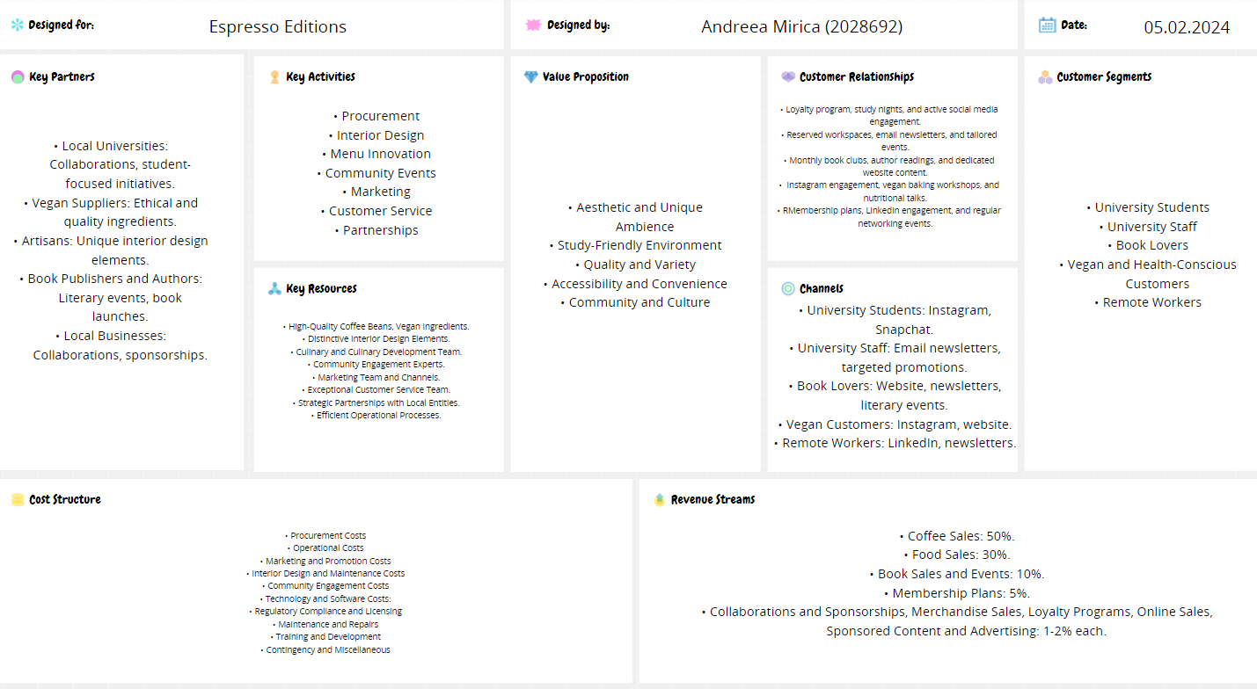

2.
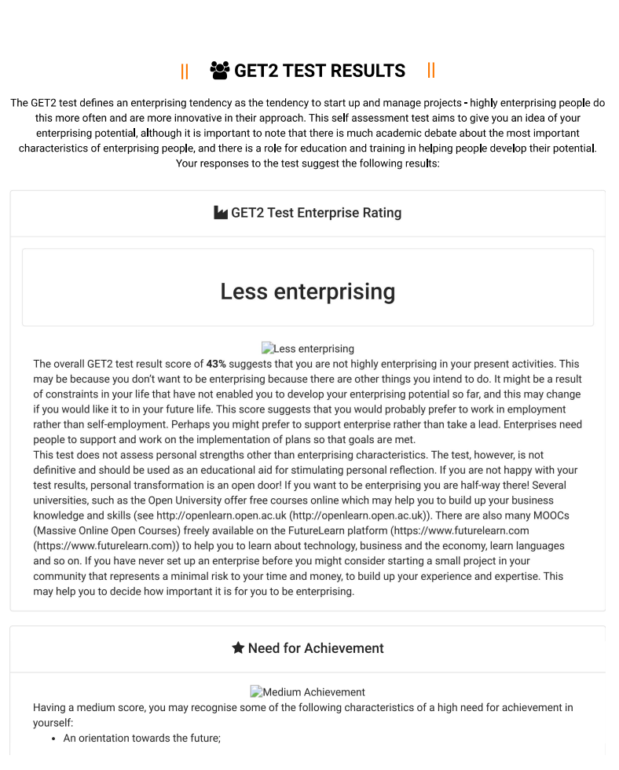

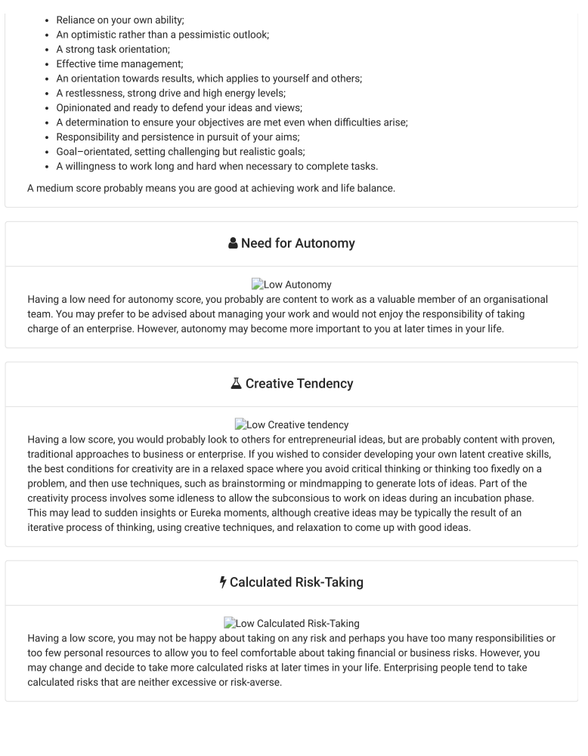

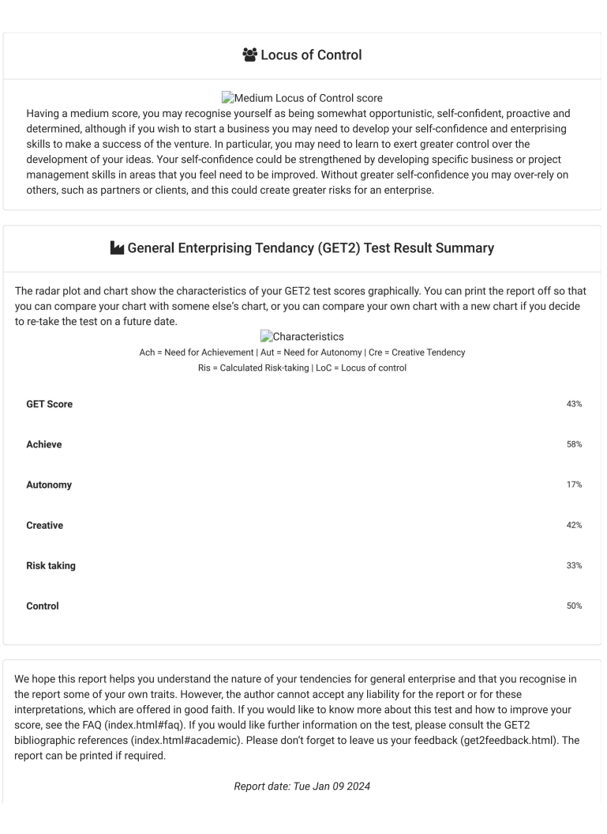

References
Aaker, D. A., & Moorman, C. (2023). Strategic market management. John Wiley & Sons, Inc.
Adwan, A. A., Kokash, H., Adwan, R. A., & Khattak, A. (2023). Data analytics in digital marketing for tracking the effectiveness of campaigns and inform strategy. International Journal of Data and Network Science, 7(2), 563–574. https://doi.org/10.5267/j.ijdns.2023.3.015
Andres, L., Bryson, J. R., Graves, W., & Warf, B. (2022). Urban value chains and re-framing agglomeration-centric conceptions of urban theory. Urban Geography, 44(8), 1–22. https://doi.org/10.1080/02723638.2022.2125665
Caine, D. (2023). How to protect bookstores and why: The present and future of bookselling.
Carah, N., Brown, M.-G., & Hickman, S. (2022). Optimizing looking and buying on instagram: Tracing the platformization of advertising and retail on mobile social media. Television & New Media, 24(4), 380–396. https://doi.org/10.1177/15274764221123033
Çelik, B., Uzunboylu, H., & Demirbaş-Çelik, N. (2023). Higher education students’ social media platform preferences for educational purposes. Revista de Educación a Distancia (RED), 23(72). https://doi.org/10.6018/red.491551
Concept Board (2024) Business Model Canvas. Available at: https://app.conceptboard.com/board/6e0e-mys9-hcu5-13ko-oh79 (Accessed: 20 January 2024).
Cope, E. (2023). The book lover’s guide to Paris. White Owl.
Couillou, R. J., McGee, B. L., Carr, A. S., & Lamberth, T. (2022). Pandemic partnerships: Community/University experiences with community-based learning in the COVID-19 era. Journal of Experiential Education, 46(3), 105382592211459. https://doi.org/10.1177/10538259221145935
Estay, C., Durrieu, F. & Akhter, M. Entrepreneurship: From motivation to start-up. J Int Entrep 11, 243–267 (2013). https://doi.org/10.1007/s10843-013-0109-x
Ferreira, J., Ferreira, C., & Bos, E. (2021). Spaces of consumption, connection, and community: Exploring the role of the coffee shop in urban lives. Geoforum, 119, 21–29.
Folabit, N., Reddy, S., & Jita, L. (2023). Understanding delegated administrative tasks: Beyond academics’ professional identities. African Journal of Inter-Multidisciplinary Studies, 5(1), 1–11. https://doi.org/10.51415/ajims.v5i1.1321
Fontana, E., & Pisalyaput, N. (2023). Understanding the importance of farmer–NGO collaboration for sustainability and business strategy: Evidence from the coffee supply chain. Business Strategy and the Environment, 32(6), 2715–2735.
Fuller, J. L., van Putten, I., Kraan, M., Bjørkan, M., & Dankel, D. J. (2023). “Sustainability is not a vegan coffee shop.” eliciting citizen attitudes and perspectives to localize the UN sustainable development goals. Journal of Environmental Planning and Management, 1–22. https://doi.org/10.1080/09640568.2023.2223761
GET2 (2024) GET2 TEST RESULTS. Available at:
http://www.get2test.net/get2result.html (Accessed: 9 January 2024).
Gibbs G (1988). Learning by Doing: A guide to teaching and learning methods. Further Education Unit. Oxford Polytechnic: Oxford. (Accessed: 20 January 2024).
Guptill, A. E., Copelton, D. A., & Lucal, B. (2023). Food & society : Principles and paradoxes. John Wiley & Sons.
Habib, M. D., Alghamdi, A., Sharma, V., Mehrotra, A., & Badghish, S. (2024). Diet or lifestyle: Consumer purchase behavior of vegan retailing. A qualitative assessment. Journal of Retailing and Consumer Services, 76, 103584.
Kashive, N., & Khanna, V. T. (2022). Emerging HR analytics role in a crisis: An analysis of linkedin data. Competitiveness Review: An International Business Journal, 33(6). https://doi.org/10.1108/cr-03-2022-0029
Kholifah, S. A., Noviekayati, I., & Santi, D. E. (2023). Improve future orientation with goal setting training is viewed from internal locus of control. Uniglobal Journal of Social Sciences and Humanities, 2(2), 23–30.
Kwame Opoku, E., Tham, A., Morrison, A. M., & Wang, M. S. (2022). An exploratory study of the experiencescape dimensions and customer revisit intentions for specialty urban coffee shops. British Food Journal, 125(5). https://doi.org/10.1108/bfj-04-2022-0361
Lake, A. (2023). Beyond hybrid working. Routledge.
Lee, K.-S., & Ruck, K. J. (2022). Barista diary: An autoethnography studying the operational experience of third-wave coffee shop baristas. International Journal of Hospitality Management, 102, 103182. https://doi.org/10.1016/j.ijhm.2022.103182
Lehan, R. D. (2023). The city in literature : An intellectual and cultural history. University of California Press.
Liu, M. (2023). In the post-pandemic and internet 4.0 era, cafes’ new operation mode of compound space. Frontiers in Business, Economics and Management, 7(1), 24–33.
Marshalsey, L. (2023). Sensory affect, learning spaces, and design education. Taylor & Francis.
Maspul, K. A. (2023). Cultural exchange and resilience: Shaping coffee consumption in saudi arabia’s coffee shops. J-CEKI Jurnal Cendekia Ilmiah, 2(6), 693–707. https://doi.org/10.56799/jceki.v2i6.2351
Maspul, K. A., & Almalki, F. A. (2023). From cafés to collaborative hubs: Empowering communities and transforming the coffee value chain in buraydah. EKOMA: Jurnal Ekonomi, Manajemen, Akuntansi, 3(1), 179–206.
Nica, E., Gajanova, L., & Kicova, E. (2020). Customer segmentation based on psychographic and demographic aspects as a determinant of customer targeting in the online environment. Littera Scripta, 12(2). https://doi.org/10.36708/littera_scripta2019/2/9
Obschonka, M., Stuetzer, M. Integrating psychological approaches to entrepreneurship: the Entrepreneurial Personality System (EPS). Small Bus Econ 49, 203–231 (2017).
https://doi.org/10.1007/s11187-016-9821-y
Pradana, B. I., & Safitri, R. (2023). Business orientation and innovation capability in improving operational performance. International Journal of Professional Business Review, 8(5), e01136–e01136. https://doi.org/10.26668/businessreview/2023.v8i5.1136
Puspita, P. A., & Wijaya, F. (2024). Bussiness development strategy in coffee shop (study on berawal coffee & dimsum in Bagusrangin disrict, Bandung city). Journal of Management Science (JMAS), 7(1), 188–196.
Stewart, E. C., Davis, J. S., Walters, T. S., Chen, Z., Miller, S. T., Duke, J. M., Alexander, L. R., Akohoue, S. A., Russell, R., Rowan, N., Campbell, L., Baxter, I., Tolbert, S., & Erves, J. C. (2022). Development of strategies for community engaged research dissemination by basic scientists: A case study. Translational Research, 252. https://doi.org/10.1016/j.trsl.2022.09.001
Sudharson, K., Prasad, A., & Smriti, S. (2023, February). A survey on reader’s society: New social network of book swapping platform. 2023 IEEE International Students’ Conference on Electrical, Electronics and Computer Science (SCEECS).
Ummah, K., & Santoso, R. A. (2023). Revenue in service quality perspective at a traditional coffee shop in Balongpanggang village. Innovation Research Journal, 4(1), 11–11. https://doi.org/10.30587/innovation.v4i1.5358
Watson, G. (2022). Developing skills for business leadership: Building personal effectiveness and business... acumen. Cipd Kogan Page.
Widadi, T. H., & Dellyana, D. (2023). Proposed business strategy for coffee shop based on customer preferences. Fair Value: Jurnal Ilmiah Akuntansi Dan Keuangan, 5(8), 3291–3305.

