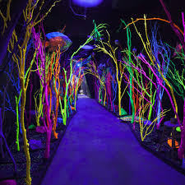
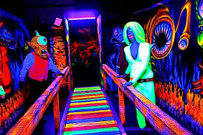

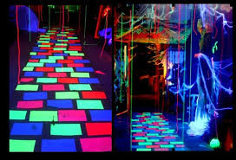
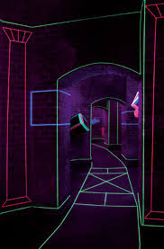

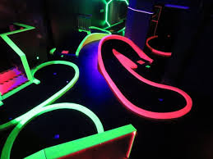

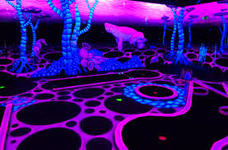

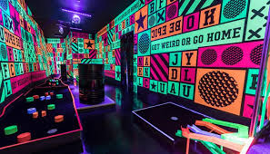
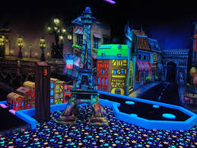

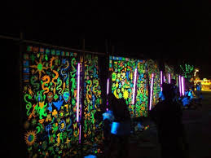
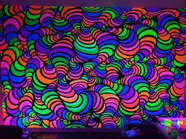

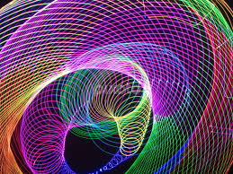
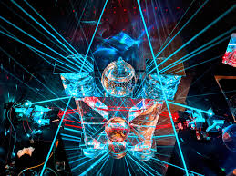

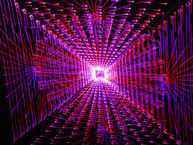

https://mymodernmet.com/uv-paint-wall-murals-bogi-fabian/

Hungarian artist Bogi Fabian uses her own self-developed UV paint to create mesmerizing wall murals that come to life after dark. By day, seemingly blank walls appear as normal, but with the flick of a switch, the artist’s painterly strokes and spray-painted textures start to glow. Her works illuminate entire rooms, transforming ordinary spaces into spectacular cosmic worlds teeming with spiral galaxies, glittering stars, and dazzling clouds of dust and gas.
Calling her process the “multiluminous” technique, Fabian’s immersive environments change colors depending on if they’re viewed in natural darkness or with a UV light. She explains, “I am trying to create dreamy atmospheres, paint walls and floors and manage to enlighten my art with and without a source of energy. Thus, the spectator can experience the result in the daylight as well as in the dark, and in that way enjoy it in all its facets. My goal is to create unique spaces and rooms giving them an identity and a soul, where relaxing and living become an experience.”
As well as murals, Fabian also produces multiluminous prints. From a radiant moon to glimmering forest skies, each artwork is printed on canvas and changes color depending on the light source. You can check out the full collection on Fabian’s website.
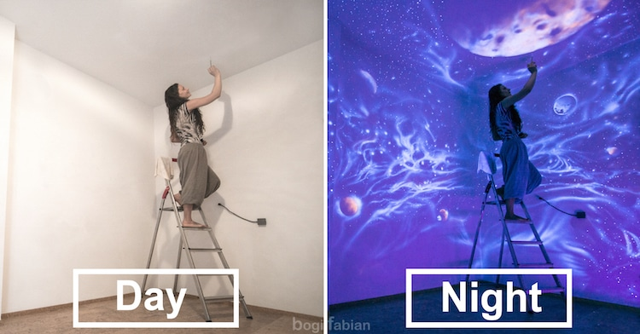
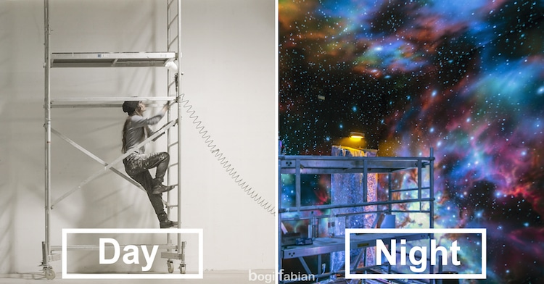

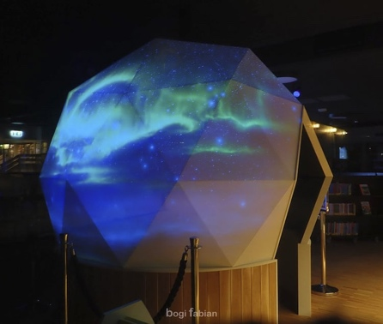
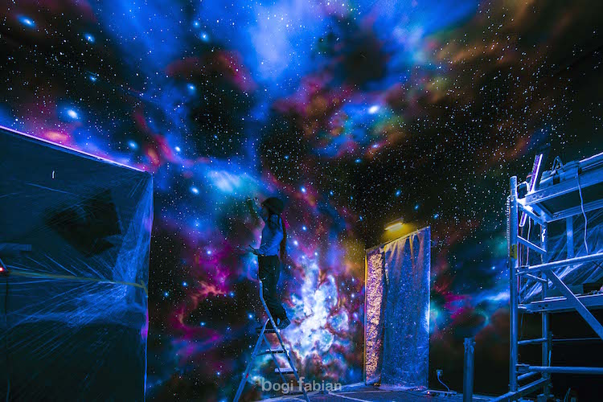

As an artist, I have to believe that I can make the otherwise invisible images in my head visible for everyone. I think that is what an artist do and that is why we try to come up with something unique, something original, something that has never seen by anyone, not even by us, artists.
Also, seeing is just part of believing. When we look at something, we only see a reflection of it under specific circumstances. We do not use all our senses to experience something real and even then that reflection is limited by our very eyes. The spectra of light that goes unnoticed by human beings is often seen by other animals and a few chosen ones of us. We call this spectrum of light the ‘ultraviolet’.
The use of ultraviolet technique in imaging sheds light to wherever we would otherwise be unable to behold a single ray of it, enriching the overall experience of visual perception by adding a brand new dimension to it. We can see colours that we would not be able by any other means, different contours, shapes and patterns reveal themselves. As if we were locked in a dark room since birth with a black and white TV and suddenly someone opened the doors to have a look at the outside, the real world.
Seeing - therefore, at its best - is only believing that there is a lot more to see :)
When ultraviolet went mainstream, it quickly turned into a cheap commercial stunt, a gimmick to be used in discos and clubs as an effect among many other lighting technologies. Science, however, has been using the ultraviolet technique in many areas of our lives we would not imagine, but they were not meant to be spectacular by any means.
Art has just been rediscovering the technique, thanks to constantly developing technology.
My mission with using ultraviolet and photo-luminescent or glow in the dark techniques in my art pieces is to elevate those fantastic and largely unused colors back into where they should belong: something that we can enjoy, something that opens up our perception to the world surrounding us.
By learning having a lot more things to experience that meets our mortal eyes, we might just have a better understanding of how the world really presents itself and that there are a lot more happening even on the surface than we imagined before. I am hoping that this experience will take us back to a more harmonic unison with nature and each other by revealing, presenting and sharing that extra dimension that further connects us.
Seeing should be believing there is room left for the invisible, believing is making the invisible visible.

ULTRAVIOLET
Ultraviolet light is one type of electromagnetic wave. Electromagnetic waves are different than waves on a string or waves that you see in water because they don't need anything to travel through. They are waves of pure energy and because of this, they can travel through empty space.
They also move really quickly, traveling through space at the speed of light. All visible colors of light, as well as microwaves, X-rays, and radio waves, are also electromagnetic waves. The only difference between these types of electromagnetic waves is their frequency and wavelength.
UV radiation is present in sunlight, and also produced by electric arcs and specialized lights such as mercury-vapor lamps, tanning lamps, and black lights. Most of us are exposed to large amounts of UVA throughout our lifetime. A black light, also referred to as a UV-A light, Wood's lamp, or simply ultraviolet light, is a lamp that emits short wave (UV-A) ultraviolet light and not much visible light. The lamp has a violet filter material, either on the bulb or in a separate glass filter in the lamp housing, which blocks most visible light and allows through UV, so the lamp has a dim violet glow when operating.

A second type of bulb, which is also called a black light, produces ultraviolet but does not have the filter material, so it produces more visible light and has a blue colour when operating. Although many other types of lamp emit ultraviolet light with visible light, black lights are essential when UV-A light without visible light is needed, particularly in observing fluorescence, the coloured glow that many substances emit when exposed to UV. Black lights are employed for decorative and artistic lighting effects, diagnostic and therapeutic uses in medicine, the detection of substances tagged with fluorescent dyes, rock-hunting, the detection of counterfeit money, the curing of plastic resins, and attracting insects.

