
review of industry skills



Executive Summary
Olivia Griffiths 1703630

This report looks at the skills required to be successful in the Leisure Industry. It looks at job specifications listed on Merlin Entertainments website which are included in the Appendix and focuses on the skills that the candidate must be in possession of to be successful of the role. The two jobs which are focused on are Rides and Attractions Team Leader at LEGOLAND Windsor Resort and Operations Manager at the Blackpool Tower Ballroom. The report looks at whether the two job roles require the same skills as they’re both quite different roles, however both in the leisure industry and for the same company. It also features a cover letter aimed at the role of ‘Rides and Attractions Team Leader’ which will highlight the writer’s skills in accordance with the job description that the cover letter is aimed at.

Table of Contents
Executive Summary 0
Introduction 3
Conclusion 7
Bibliography 8
Reference List 10
Appendices 11
Appendix 1 - Job Description – LEGOLAND Rides and Attractions Team Leader 11
Appendix 2 - Job Description – Operations Manager Blackpool Tower Ballroom 12
Appendix 3 – Cover Letter for Rides and Attractions Team Leader at LEGOLAND Windsor Resort. 13
Appendix 4 – CV Error! Bookmark not defined.

Introduction

The leisure industry is fast growing and new attractions are being built at a rapid pace. Roughly 10% of the working population are employed by the leisure industry, roughly 2.5 million people in the UK (Target Jobs, 2018).
As well as the amount of attractions increasing, the quality of guest service expected is also increasing.
There are a diverse range of roles in the leisure industry, from careers in leisure centres, activity centres, working in a cinema/entertainment venue, airlines as well as theme parks and attractions. This report will focus on the latter, theme parks and attractions. It will be centred towards two job descriptions and the requirements set out by Merlin Entertainments, the company which owns both the attractions that the jobs are positioned in, LEGOLAND Windsor and Blackpool Tower Ballroom and is classed as one of the main employers in the leisure industry field, along with British Airways, Centre Parks, Hilton and TUI (Graduate Prospects, 2018).

Looking at the job description in Appendix 1, Rides and Attractions Team Leader, LEGOLAND Windsor we see the mains skills the company are requiring are: Self-motivating, strong leadership, excellent communication and organisational skills (LEGOLAND, 2018).
The first skill this report is going to focus on, is self-motivation. Self-motivation is important as it is the skill that drives you to do things. The two types of motivation, intrinsic and extrinsic, are important as it means the person is more likely to do certain tasks, either because they want to or because they have to. It means that these individuals are more likely to work harder and strive for promotion (Skills You Need, 2018). The writer achieved management in a restaurant at the age of twenty, which portrays somebody who is highly motivated. As well as this, the writer also competed to a high level in cycling between the ages of eleven and seventeen, winning many awards such as Welsh champion in a variety of disciplines, which shows an extremely motivated and hardworking individual always aiming to achieve the best possible results.

The advertisement also wants the candidate to have strong leadership skills so that they can lead the team from the front, which is enabled by having strong communication skills. Communications is a key attribute that many employers will look for when recruiting. The advertisement is looking for somebody who can communicate well within a team and lead them, as well as communicating updates to the whole team as well as management in a professional manner. The writer already has experience of communicating well between a team and to people in management, by both the job as Front of House Management, and the current role of Ride Operator, having to communicate and lead any assistants that the writer may have on a day to day basis.
They explain how the successful candidate should also be confident in decision making and possess the ability to find creative solutions to problems. Having experience as a ride operator means the writer has the confidence in having to make decisions in sometimes vital situations as well as having to find creative solutions when situations arise with customers.
The successful candidate will also have to possess a good level of customer service in being able to handle all complaints effectively, something the writer has had to do in all of their roles working in the food and beverage industry. They require somebody who has the ability to use one’s own initiative and is able to co-ordinate ride breakdowns and evacuations in a calm manner. The role the writer already has, as a ride operator, means they are already experienced with co-ordinating evacuations with engineering as well as dealing with ride breakdowns and remaining calm so that everybody remains safe and the quickest and safest solution can be undertaken.
The description also explains how the candidates would need to be a responsible individual as they will be responsible for training, coaching and developing members of the team and ensuring safety standards are met as well as being an organised individual as they require somebody who is able to deliver briefings to the team. In previous roles held by the writer, training and developing new members to the team has been something in which they have experience of, which would prove valuable.
Although the role is full time, it is clear that flexibility is a key requirement in working in the leisure industry. Flexibility is required in most jobs, however with many jobs in the leisure industry being a range of hours and shifts this is highly vital. During the summer, ‘peak season’, occasionally the park will stay open later than planned as the visitor numbers estimation could be exceeded and they often do this to help with traffic congestion leaving the resorts. As the writer has previous experience in working in a park they already are used to having to be fully flexible.
Other roles in the leisure industry will require most of these skills, however some of these are tailored towards the individual job specification. Teamwork is vital in any job, unless you’re working individually. Most industries require you to work as part of a team, whether that’s as management, or even as a basic starter job. People that have good team work skills also have the following attributes: trustworthy, good at resolving conflict and healthy risk takers (Sandler.com, 2018).

Another job role which will be looked at, is the Operations Manager at Blackpool Tower Ballroom, also owned by Merlin Entertainments. As we can see in Appendix 2, the role differs from the Team Leader role, as it is a management role, in an attraction which isn’t a resort which cannot hold anywhere near the number of visitors that LEGOLAND can. Although they are two very different roles, they do however require many of the same skills. This role also requires somebody with leadership skills, good communication and organisational skills. The customer service is a key requirement, and is noted that it will be demanded in a fast-paced environment. A good level of computer skills is also required in this role. As this job is for management position, an ability to work to budgets have a good level of commercial awareness is vital. This is typical in many jobs, but in the leisure industry where providing entertainment to guests, being commercially aware is one of the skills that recruiters look for in the leisure industry according to Target Jobs (2017). Being commercially aware could be the different between having too many staff per visitor number, and not managing a budget well, or the opposite being too cost cutting conscious and not having enough staff to manage and provide entertainment for your visitor numbers.
Other companies in the leisure industry do require many of these skills as well. According to Graduate Prospects (2018), communication skills, problem solving skills, flexibility as well as language and organisational skills are the main combination of skills required for a career in the industry. Another theme park which are recruiting for staff list the highest required skills needed for a job in this industry as communicative skills and leadership skills (Drayton Manor, 2018).

Conclusion
From looking at the two job roles attached in the Appendix, we see that employers in the leisure industry all want a mix of the same attributes and skills. Communication is the highest required skill, as most of the roles in the leisure industry are customer facing, or working in a team, both which require good communication skills. Commercial awareness is only required in management level, where the employee would be deciding rotas and staffing numbers. Leadership skills and organisational skills are mainly required in team leader or management positions as these employees will often need to train staff and organise the training as well as monitoring progress. According to many other websites that have been visited, they also list the above skills as the main ones required in the leisure industry.

Bibliography

Assets.publishing.service.gov.uk. (2018). [online] Available at: https://assets.publishing.service.gov.uk/government/uploads/system/uploads/attachment_data/file/306403/briefing-paper-ssa12-hospitality-sport-tourism.pdf [Accessed 1 May 2018].

Blackpool Tower (2018) Operations Manager [online] Available at: https://merlin.taleo.net/careersection/4/jobdetail.ftl?job=THE0000K4&tz=GMT%2B01%3A00 [Accessed 1 May 2018].

Careerswales.com. (2018). Careers in Sport and Leisure : Careers Wales. [online] Available at: https://www.careerswales.com/en/your-career/features-1/careers-in-sport-and-leisure/ [Accessed 2 May 2018].

Deloitte United Kingdom. (2018). Leisure sector grows to £117 billion as UK consumers prefer pleasure to shopping | Deloitte UK. [online] Available at: https://www2.deloitte.com/uk/en/pages/press-releases/articles/leisure-sector-grows-to-117-billion.html [Accessed 2 May 2018].

Drayton Manor. (2018). Job Description / Person Specification. [online] Available at: https://www.draytonmanor.co.uk/media/upload/files/Rides_Guest_Host_-_JD.pdf [Accessed 13 Apr. 2018].

Graduate Prospects (2018). Overview of the leisure, sport and tourism sector in the UK | Prospects.ac.uk. [online] Available at: https://www.prospects.ac.uk/jobs-and-work-experience/job-sectors/leisure-sport-and-tourism/overview-of-the-leisure-sport-and-tourism-sector-in-the-uk [Accessed 1 May 2018].

LEGOLAND (2018). Rides and Attractions Team Leader [online] Available at: https://merlin.taleo.net/careersection/4/jobdetail.ftl?job=LEG000320&tz=GMT%2B01%3A00 [Accessed 1 May 2018].

Linkedin. (2018). Importance of Self Motivation. [online] Available at: https://www.linkedin.com/pulse/20140924190350-59817714-self-motivation-importance-of-self-motivation [Accessed 1 May 2018].

Sandler.com. (2018). 6 Benefits of Teamwork in the Workplace. [online] Available at: https://www.sandler.com/blog/6-benefits-of-teamwork-in-the-workplace [Accessed 2 May 2018].

Skills You Need (2018). Self-Motivation [online] Available at: https://www.skillsyouneed.com/ps/self-motivation.html [Accessed 1 May 2018].

TARGETjobs. (2018). How do I get a job in hospitality, leisure and tourism?. [online] Available at: https://targetjobs.co.uk/career-sectors/hospitality-leisure-and-travel/advice/286355-how-do-i-get-a-job-in-hospitality-leisure-and-tourism [Accessed 1 May 2018].

Reference List

Blackpool Tower (2018) Operations Manager [online] Available at: https://merlin.taleo.net/careersection/4/jobdetail.ftl?job=THE0000K4&tz=GMT%2B01%3A00 [Accessed 1 May 2018].

Drayton Manor. (2018). Job Description / Person Specification. [online] Available at: https://www.draytonmanor.co.uk/media/upload/files/Rides_Guest_Host_-_JD.pdf [Accessed 13 Apr. 2018].

Graduate Prospects (2018). Overview of the leisure, sport and tourism sector in the UK | Prospects.ac.uk. [online] Available at: https://www.prospects.ac.uk/jobs-and-work-experience/job-sectors/leisure-sport-and-tourism/overview-of-the-leisure-sport-and-tourism-sector-in-the-uk [Accessed 1 May 2018].

LEGOLAND (2018). Rides and Attractions Team Leader [online] Available at: https://merlin.taleo.net/careersection/4/jobdetail.ftl?job=LEG000320&tz=GMT%2B01%3A00 [Accessed 1 May 2018].

Sandler.com. (2018). 6 Benefits of Teamwork in the Workplace. [online] Available at: https://www.sandler.com/blog/6-benefits-of-teamwork-in-the-workplace [Accessed 2 May 2018].

Skills You Need (2018). Self-Motivation [online] Available at: https://www.skillsyouneed.com/ps/self-motivation.html [Accessed 1 May 2018].
TARGETjobs. (2018). How do I get a job in hospitality, leisure and tourism?. [online] Available at: https://targetjobs.co.uk/career-sectors/hospitality-leisure-and-travel/advice/286355-how-do-i-get-a-job-in-hospitality-leisure-and-tourism [Accessed 1 May 2018].

Appendices

Appendix 1 - Job Description – LEGOLAND Rides and Attractions Team Leader (LEGOLAND, 2018).
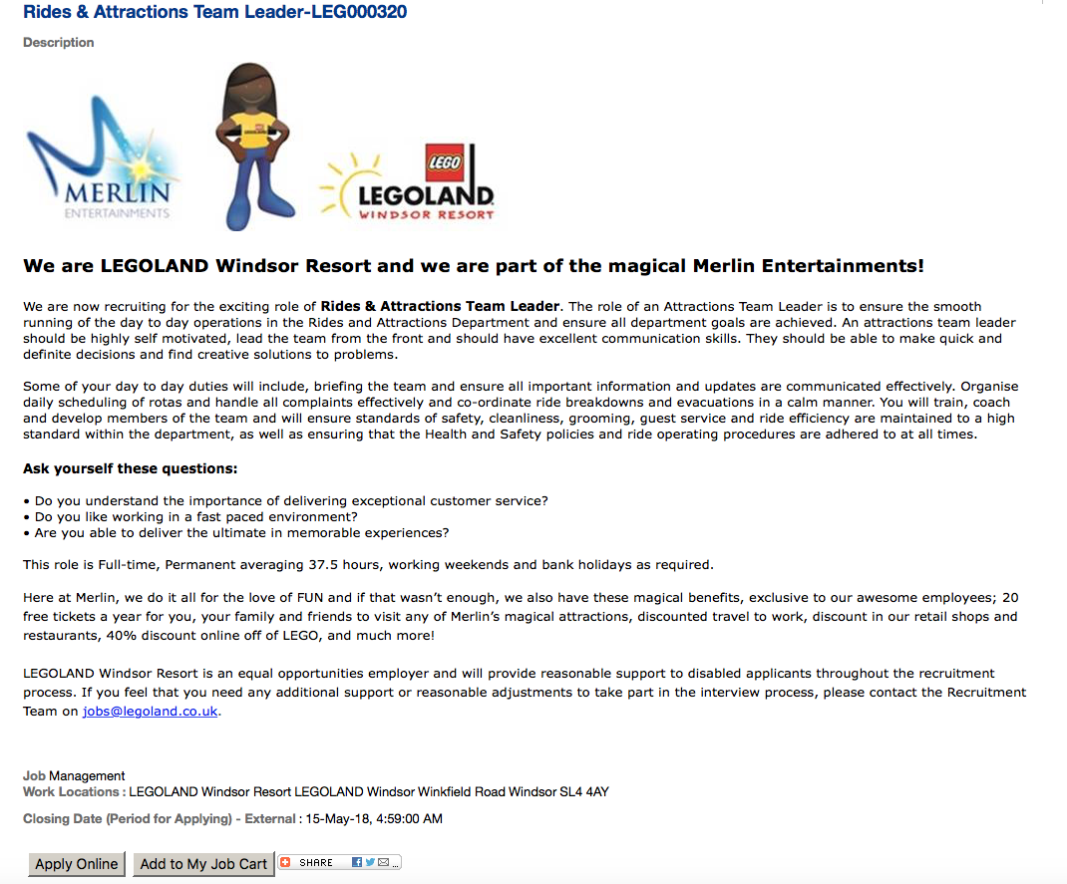

Appendix 2 - Job Description – Operations Manager Blackpool Tower Ballroom (Blackpool Tower, 2018).
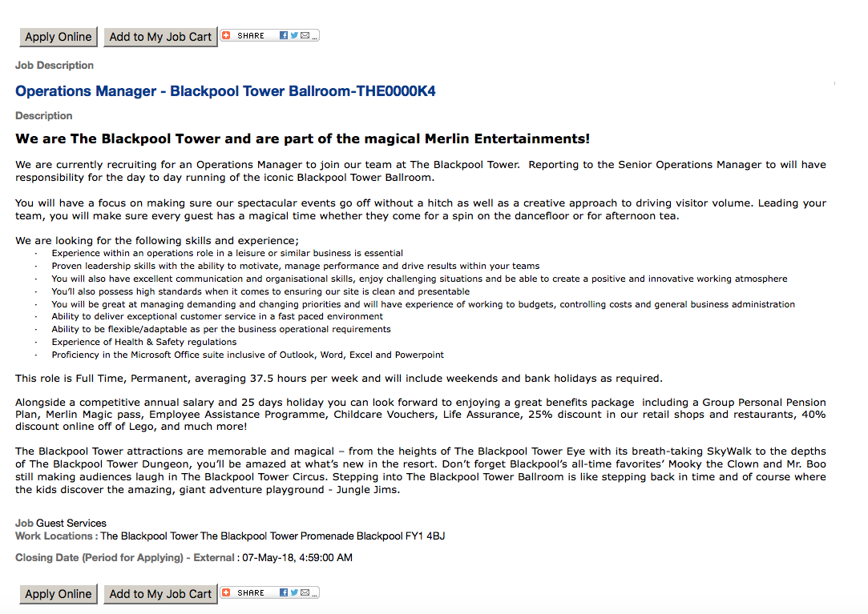

Appendix 3 – Cover Letter for Rides and Attractions Team Leader at LEGOLAND Windsor Resort.

Olivia Griffiths
Shorncliffe
College Road
Carmarthen
SA31 3EE
02.05.2018
07557654695
olivikat@hotmail.co.uk
Andy Owen
LEGOLAND Windsor
Winkfield Road
Windsor
SL4 4AY

Dear Mr Owen,

I am writing to you to apply for the position of Rides and Attractions Team Leader. I have worked in the leisure industry for two years, working as a ‘Ride Operator’ in a theme park and am extremely well suited to it. Through my enjoyment of the industry, I decided to start a degree at UWTSD in ‘Leisure Management’ with the aim of undertaking the Merlin Accelerate Graduate Scheme once I graduate aiming for a future in Merlin Entertainments. I feel this role would be extremely beneficial for my future, and the skills I would learn would be invaluable. I also feel I would be able to bring a lot to the job from my experience as well as my passion and enthusiasm, for the role as well as for the company.

From the skills listed in the job description, I feel I possess all of them and have demonstrated this in my past roles. I have worked in a team since I was 15, in both the food and beverage industry as well as working in the rides team. I was also in a management role at the age of twenty in a restaurant, as front of house manager. This role increased my team leadership skill, organisational skill as well as my communication skills as I was in charge of any customer issues and using my own initiative to find solutions. In my role as a ride operator, I currently train members of staff as well as liaising with engineers during ride breakdowns and am trained to evacuate rides so have first-hand experience in this. I feel these experiences, as well as my passion would make me the ideal candidate.

I am available to start any time from the 1st June 2018 and have enclosed my CV. I would look forward to meeting you.

Thank you very much for your time, I look forward to hearing from you soon.

Olivia Griffiths
Olivia Griffiths

