Student Name: Julian Gjoka
Student ID Number:2230507
Module Title: Marketing Essentials BMIH4005
Lecturer’s Name:Gayathri Mudiyanselage

Table of Content

Introduction: 3
Situational analysis of Hilton hotel: 3
Company: 3
Customers: 3
Competitors: 4
Collaborators: 4
Climate: 4
Objectives: 5
SMART target: 5
Strategy: 5
Tactics of Hilton hotel: 6
Marketing mix: 6
Action: 7
Control: 8
Conclusion: 8
References: 9

Introduction:
The key aim of making this marketing plan for Hilton hotel is to make a situation analysis through the 5 Cs. The marketing plan has an objective with the help of a SMART target and with that, there is a strategy for the company. Not only that, the marketing plan consists of tactics through the marketing mix. There is an action plan and control.
The marketing plan is being prepared for the Hilton hotel.
5 Cs are for helping to perform situational analysis (Corporate Finance Institute, 2022).
Marketing mixes are the actions that a business uses for promoting its brand in the market (Goi, 2019).
SMART targets to understand the goals clearly and achieve them in time (Bridgewater, 2021).

Situational analysis of Hilton hotel:

Company:
SWOT analysis:
Strengths:
The company has a strong portfolio in property and has some effective schemes for customer relations (Research, 2019).
Weaknesses:
The company has a lack of flexibility and has a huge level of debt in the business organisation. Hilton hotel is over-dependent on the US market (Research, 2019).
Opportunities:
The company can expand in the international market and format a strategic alliance (Research, 2019).
Threats:
The company has a threat of political instability and terrorism (Research, 2019).

Customers:
Segmentation:
The geographic segmentation of the company is the well known as well as popular places for the choice of the targeted customers. The demographic segmentation of the company is senior and middle-aged people (Research, 2020).
Targeting:
The target market of the company consists of the customers or clients that have a high level of income and give value to multiculturalism (Bowie et al., 2017). The service the company is for offering its products and services to tourists, business customers, conference guests, musicians, head of state, and actors. The target clients of the company have various kinds of needs and they need the utmost care (Research, 2020).

Competitors:
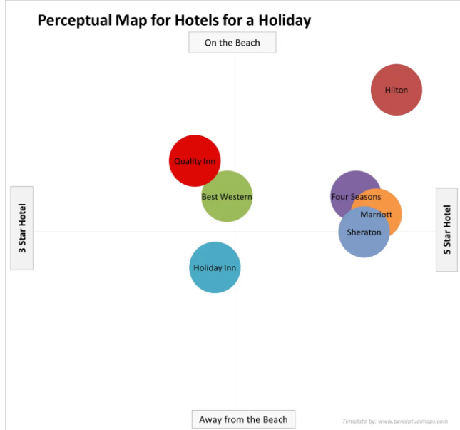
Figure 1: Perceptual map of Hilton hotel
(Source: Segmentation Study Guide, 2022)

Collaborators:
The company is doing B2B business as the company can offer a perfect platform for the business organisations for launching comprehensive analytical programs (Hilton, 2022).

Climate:
PESTLE analysis:
Political factors:
The company engages actively in lobbying for influencing some political factors to a certain extent upon the business (Embapro, 2022).
Economic factors:
In the time of financial crisis, the sales of the company went down by twenty and forty per cent also.
Social factors:
Changes in the patterns of family and their values in society such as same-sex marriage, and single people impact a lot to the performance of the company (Embapro, 2022).
Technological factors:
The bookings of the company's hotels have become more sophisticated with a single tap through the internet.
Legal factors:
There are a lot of restriction rules in various countries that impact the overall performance of the company.
Environmental factors:
The hotels of the company contribute a big amount of carbon emissions to the environment (Embapro, 2022).

Objectives:

SMART target:
Goal: 15 per cent Profit
Specific: | The goal is to make a promotion of the brand of Hilton hotels to attract more new customers and achieve 15 per cent more profit for the business organisation
Meassurable: | The company is successful in achieving at least 10 per cent of new customers every month for the hotels of the company.
Achievable: | The company is at least able to attract 10 per cent of new customers and able to attract five per cent of the customers in the business organisation.
Relevant: | At the end of eight months, the company is able to attract 20 per cent of new customers and achieve 12 per cent more profits.
Time bound: | The time period needed for achieving the goal behind making this marketing plan is eight months.

Strategy:
The goal of the company is to create value for different constituents such as owners, customers, employees, and shareholders by providing a consistent value proposition to them. Other than that, the company differentiates their business organisation from other business organisations by implementing some new strategies in the business organisation such as offering free wine tastings and giving free gifts in every hotel room to encourage mingling (Jobber and Ellis-Chadwick, 2020). Not only that, the company develop a Hilton Honors program in their hotels to make an improvement the stickiness of the customers as well as this programme incentivises the customers to return to the brand or company again and again since the customers get points that lead to getting free room stays in the nights and perks such as room upgrades, wifi, and many more things. Along with that, the company maintains customer satisfaction by offering high-end hotels and high-quality services in the hotels (Business Wire, 2019).

Tactics of Hilton hotel:

Marketing mix:
Product strategy:
The company offers unrivalled services for each individual customer and the company ensures that they give a positive as well as unique experience to every customer. Not only that, the services of the company added value to every product that the company offers to the clients. Not only that, the company provides laundry services to their customers. Sometimes the company also offers transport services to customers (Notesmatic, 2023).
Price strategy:
Every product and service of the company is of a premium quality and the price of every product and service of the company has positive attributes (Smith and Zook, 2020). There are different ranges of price rates for the hotels of the company and that is based upon the quality of service, comfort, and exclusivity the company offers to the customers through their hotel rooms. The price strategy of the company is relative to the customers that belong to the upper-income segment in society (Notesmatic, 2023).
Place strategy:
The company accessed their customers through different kinds of social media applications. Not only that, customers can make online bookings with the help of the website of Hilton Hotels in various kinds of locations in the whole world (Ghauri, 2014). Other than that, the customer care attendants of the company are always responsible for any kinds of inquiries of the customers regarding the products and services (Notesmatic, 2023).
Promotion strategy:
The company airs adverts and publishes them in specific media and locations. Not only that, the company participates in different kinds of trade exhibitions in various places of the world where the customer representatives sell the products to the clients (Chaffey and Ellis- Chadwick, 2019). Other than that, the company also makes partnerships with the tour as well as airline promoters for marketing their products to the target customers of the company. The company also makes some public relations functions to make a strong customer relationship by offering satisfaction to the customers (Notesmatic, 2023).

Action:
Marketing activities | Week 1 | Week 2 | Week 3 | Week 4 | Week 5 | Week 6 | Week 7
Social media marketing
Email marketing
Sms marketing
Tv ads
Content marketing
Search engine marketing
Print marketing
In week 1, there is social media marketing and email marketing in week 2. Not only that, the company in weeks 3 and 4, there are sms marketing and Tv ads. Other than that, content marketing and social media marketing are done by the company in weeks 5 and 6. Along with that, in week 7, there is print marketing.

Control:
To measure the success of the marketing plan of a business organisation, the business organisation of Hilton Hotels can check the cost-per-lead as well as check the performance against return on investment and return on engagement as well. Not only that, the company can check the number of cost-per-sales as well as the lifetime value of a customer (Ryan, 2012). Other than that, the company can measure the success of a marketing plan in a business organisation by checking the repeat purchase rate and churn rate. Along with that, the company can check its success by checking the growth of the sales, funnel velocity, and ROMI in the business organisation (Clow and Baack, 2013).

Conclusion:
Hilton hotel has effective customer relations schemes and there is a lack of flexibility in the company for the big size and has a huge level of debt. Along with that, the company can expand its business in the international market. With that, the company has the threat of political instability. Other than that, the company is over-dependent on the US market. Other than that, the target customers of the company have a high level of income and the customer values multiculturalism. Not only that, the company makes some public relations functions to make strong customer relationships. The company contributes a huge amount of carbon emissions to the environment.

References:
Bowie, D. Buttle, F. Brookes, M & Mariussen, A (2017), Hospitality Marketing. 3 rd ed, Routledge, London
Bridgewater, P., (2021). SMART or CUTE–what makes a good target?. Botanical Journal of the Linnean Society, 166(3), pp.240-249.
Business Wire (2019) Hilton worldwide changes the game with a revolutionary new midscale brand, Hilton Worldwide Changes the Game with a Revolutionary New Midscale Brand | Business Wire. Available at: https://www.businesswire.com/news/home/20160125005564/en/Hilton-Worldwide-Changes-the-Game-with-a-Revolutionary-New-Midscale-Brand (Accessed: March 2, 2023).
Chaffey, D and Ellis- Chadwick, F. (2019) Digital Marketing. 7 th ed, Pearsons, London.
Clow, K & Baack, D (2013), Integrated Advertising, Promotion and Marketing Communications. 6 .th ed, Pearson, London
Corporate Finance Institute (2022) 5C analysis, Corporate Finance Institute. Available at: https://corporatefinanceinstitute.com/resources/management/5c-analysis-marketing/#:~. (Accessed: March 2, 2023).
Embapro. (2022) Hilton Worldwide (United States) Pestel / Pest / step analysis, embapro.com. Available at: https://embapro.com/frontpage/pestelcoanalysis/28811-hilton-worldwide (Accessed: March 2, 2023).
Ghauri, P N (2014) International Marketing, 4 th Ed, McGraw Hill, London
Goi, C.L., (2019). A review of marketing mix: 4Ps or more. International journal of marketing studies, 1(1), pp.2-15.
Hilton (2022) Welcome to Hilton, Hilton Brands | Global Hospitality Company. Available at: https://www.hilton.com/en/corporate/#:~:text=. (Accessed: March 2, 2023).
Jobber, D. and Ellis-Chadwick, F (2020), Principles and practice of marketing. 9th ed. London:
Notesmatic. (2023) Hilton Hotels and resorts marketing mix, Notesmatic. Abhijeet Pratap. Available at: https://www.notesmatic.com/hilton-hotels-and-resorts-marketing-mix/ (Accessed: March 2, 2023).
Research (2019) Hilton SWOT analysis - research-methodology, Research. Available at: https://research-methodology.net/hilton-swot-analysis/ (Accessed: March 2, 2023).
Research (2020) Hilton Hotels segmentation, targeting and positioning - research-methodology, Research. Available at: https://research-methodology.net/hilton-hotels-segmentation/ (Accessed: March 2, 2023).
Ryan, D. (2012) Understanding Digital Marketing: Marketing Strategies for Engaging The Digital Generation. Kogan Page, London.
Segmentation Study Guide (2022) Market segmentation study guide, Market SegmentationStudyGuide. Available at: https://www.segmentationstudyguide.com/understanding-perceptual-maps/ (Accessed: March 2, 2023).
Smith PR & Zook ZE (2020) Marketing Communications. 7 th ed, Kogan Page, London

